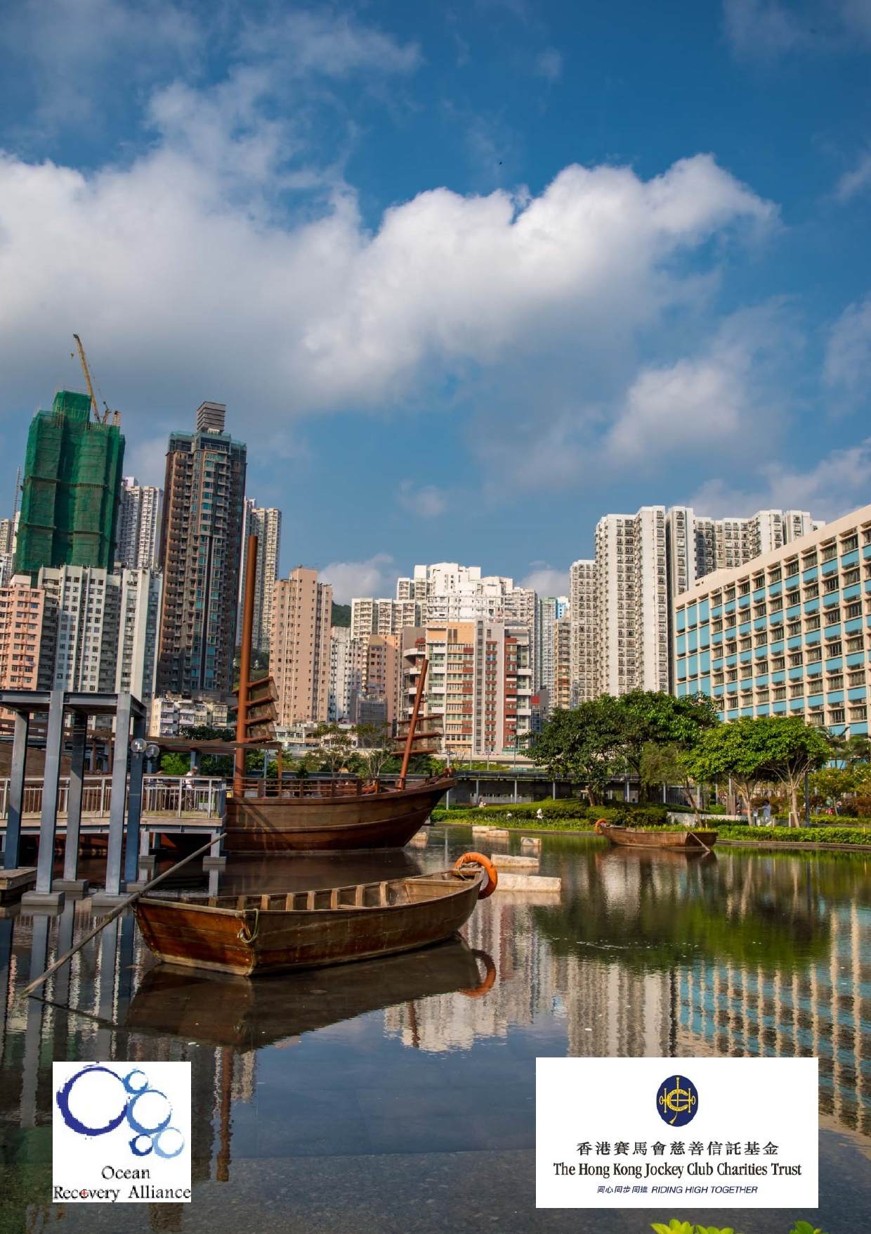Jockey Club Water Caretakers of
Tomorrow Programme
Waterwise: Water as Resource - Unit 5

Organised by

Funded by

1

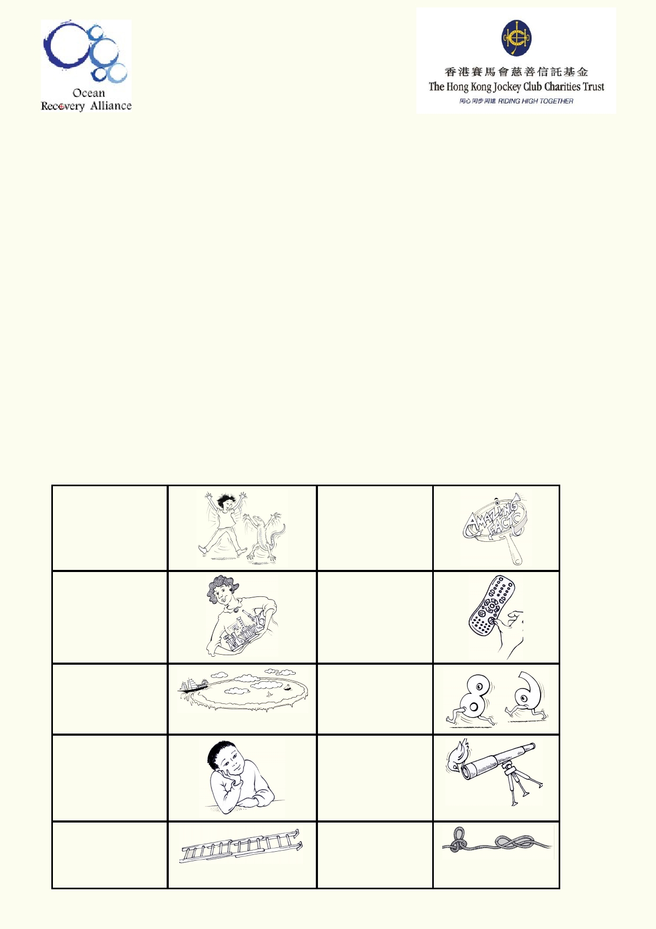About The Jockey Club Water Caretakers of Tomorrow Programme:

Jockey Club Water Caretakers of Tomorrow Programme is organised by Ocean Recovery
Alliance, Ltd and funded by The Hong Kong Jockey Club Charities Trust. There are eight units in
this program, and each of them is designed with you, a student in Hong Kong, in mind.

These are the goals for your lessons, to:
• Understand and appreciate how our water systems function on a local and global scale.
• Understand how watersheds function, and the interconnections of life within and between
these watersheds.
• Be able to assess threats, such as pollution and habitat destruction, and learn how to lessen
these effects.
• Be empowered to take an active role as caretakers of our water resources by sharing your
commitment with your communities.

Student introduction
• You will need access to the internet.
• In some activities using the camera in your smart phone or tablet will be useful.
• Your teacher will tell you if your work will be done on your computer, printed paper or
notebooks.

Start of a new A new amazing activity. f act .

Get ready to do an experiment.

Identify your
misconceptions
before your move on.
Identify your
prior learning.

An extension
activity

Fast forward to
make your
contribution to improving our world.
Data will be used
to solve
problems.

These are the goals for this unit.

A cross-
curricular
activity

2

Student aims:
At the end of this unit, I will be able to:
• Identify the sources of clean water on Earth
• Manage multiple uses for a limited renewable resource
• Explain how we maintain clean water
• Anticipate the consequences of changes to the water supply
• Develop a plan for responsible personal use of water
• Participate in a community effort to use water responsibly

Glossary

Agriculture

Aquaculture

Arid

Blackwater

Condensation

Cost Benefit
Analysis

Dam

Desalination

Disinfection

Distillation

Domestic

Drip

Filtration

Fog

Geomorphology

Green Roofs

Greywater

Groundwater
Hydropower

The cultivation of crops and animals for food, medicine and materials
used to enhance and sustain human lives.

The cultivation of fish for the purpose of food.

This describes a dry region that receives very little average rainfall
each year.

Waste water from the toilet that becomes our sewage.

Process of water vapour (gas state) turning into droplets (liquid state).

Weighing the pros and cons of an action before it is implemented by
comparing how expensive it is to how much people can gain from it.

A large, walled construction to contain a freshwater supply.

The process of removing salt from seawater for use as freshwater.

Process of cleansing something to kill harmful bacteria or viruses.

Process of purifying a liquid by heating and cooling it.

Relating to anything in your home.

The action of water droplets falling to the ground.

The process of separating out solid material in a liquid or gas.

Thick cloud of water droplets suspended in the atmosphere at ground
level.

The study of the formation of Earth's landforms and the processes that
shaped them.

Rooftops designed to soak up rain by means of growing plants and vegetation, as opposed to draining it as quickly as possible.

All wastewater from the household that does not include water from the toilet.

Permanent water stored in the ground.
Power derived from moving water.

3

Industrial

Irrigation

Permaculture

Plumbing

Potable

Precipitation

Primary Treatment

Recharge

Recreation

Recycle

Renewable Resource

Reservoir

Saltwater Intrusion

Secondary Treatment

Surface Water

Tertiary Treatment

Water Tanks

Water Treatment
Economic activities that turn raw materials into goods in factories.

The process of watering a piece of land, either for agricultural or commercial use.

Agricultural systems intended to be sustainable and permanent.

The network of pipes used to drain and direct water from a household.

Freshwater that is suitable for drinking by people.

Process of water falling from the sky in the form of rain, snow, hail, sleet, or condensation.

The first stage of removing contamination from sewage water, including removal of solids and harmful organisms.

The rate at which something is filled back up.

Activities pursued purely for enjoyment.

Repurpose a waste product into something useful.

A resource that can be used and replenished.

A natural or artificial body of water on the surface of the land that is used as a supply of freshwater.

The contamination of a freshwater source by seawater.

The second stage of removing contamination from sewage water using biological methods.

Water that is found above ground such as rivers and lakes.

The final stage of removing contamination from sewage water, which creates high quality water.

A construction designed to hold and store water.

The processing of water for a particular end use. This might include agriculture, drinking or return to a natural waterway.

4

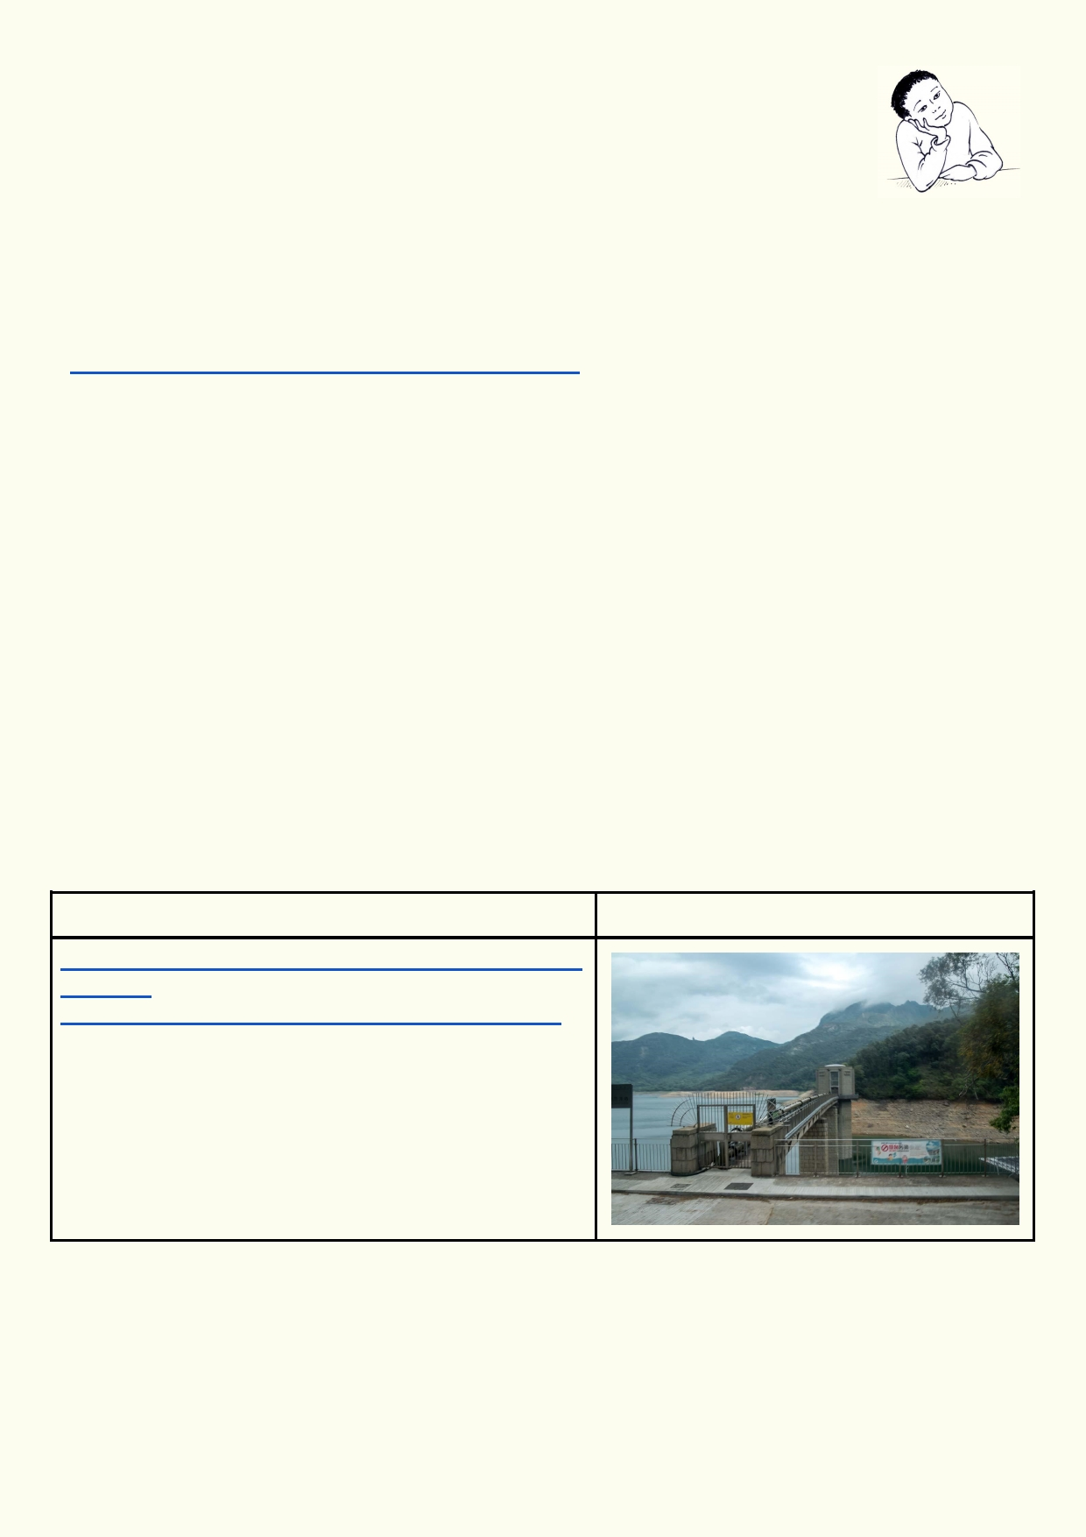What do I know?
On this website you need to match the item with the amount of water needed to
produce it. The activity is in gallons and pounds. Here is a quick conversion:
1 gallon is about 4 litres
1 pound is about ½ kilogram

For each item you have four choices. Make sure you press the button and choose the number of gallons before you click on the submit button at the bottom.
https://water.usgs.gov/edu/activity-watercontent.html

The two biggest surprises about how much water is needed to produce a food or another product
were:

____________________________________________________________________________

____________________________________________________________________________

Lesson 1 - How we use water

Activity 1. How we use it

Describe how water is being used in these photos. In some photos are products. How do we use
water to make these products? Some of the water uses have web links if you want to find more
information. Some of the photos may have several answers.

How we use water

http://www.wsd.gov.hk/en/publications_and_statistics/
statistics/
capacity_of_impounding_reservoirs_in_hong_kong/

5

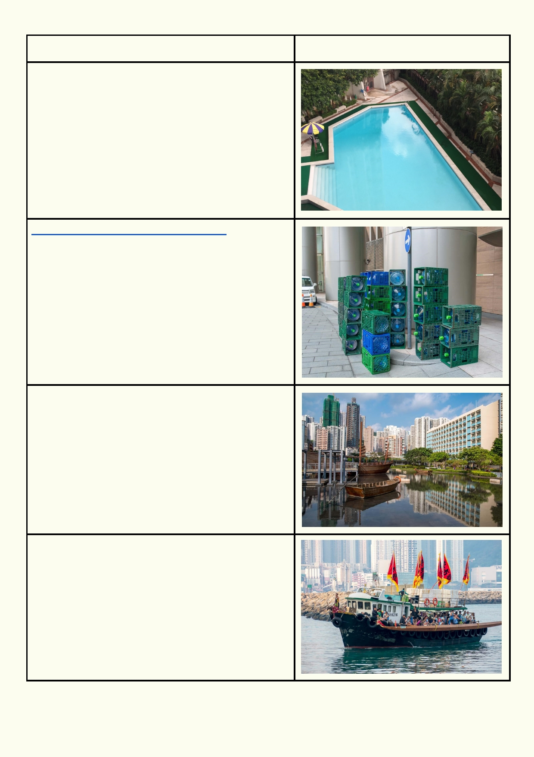How we use water

http://www.naturalspringshongkong.com/

6

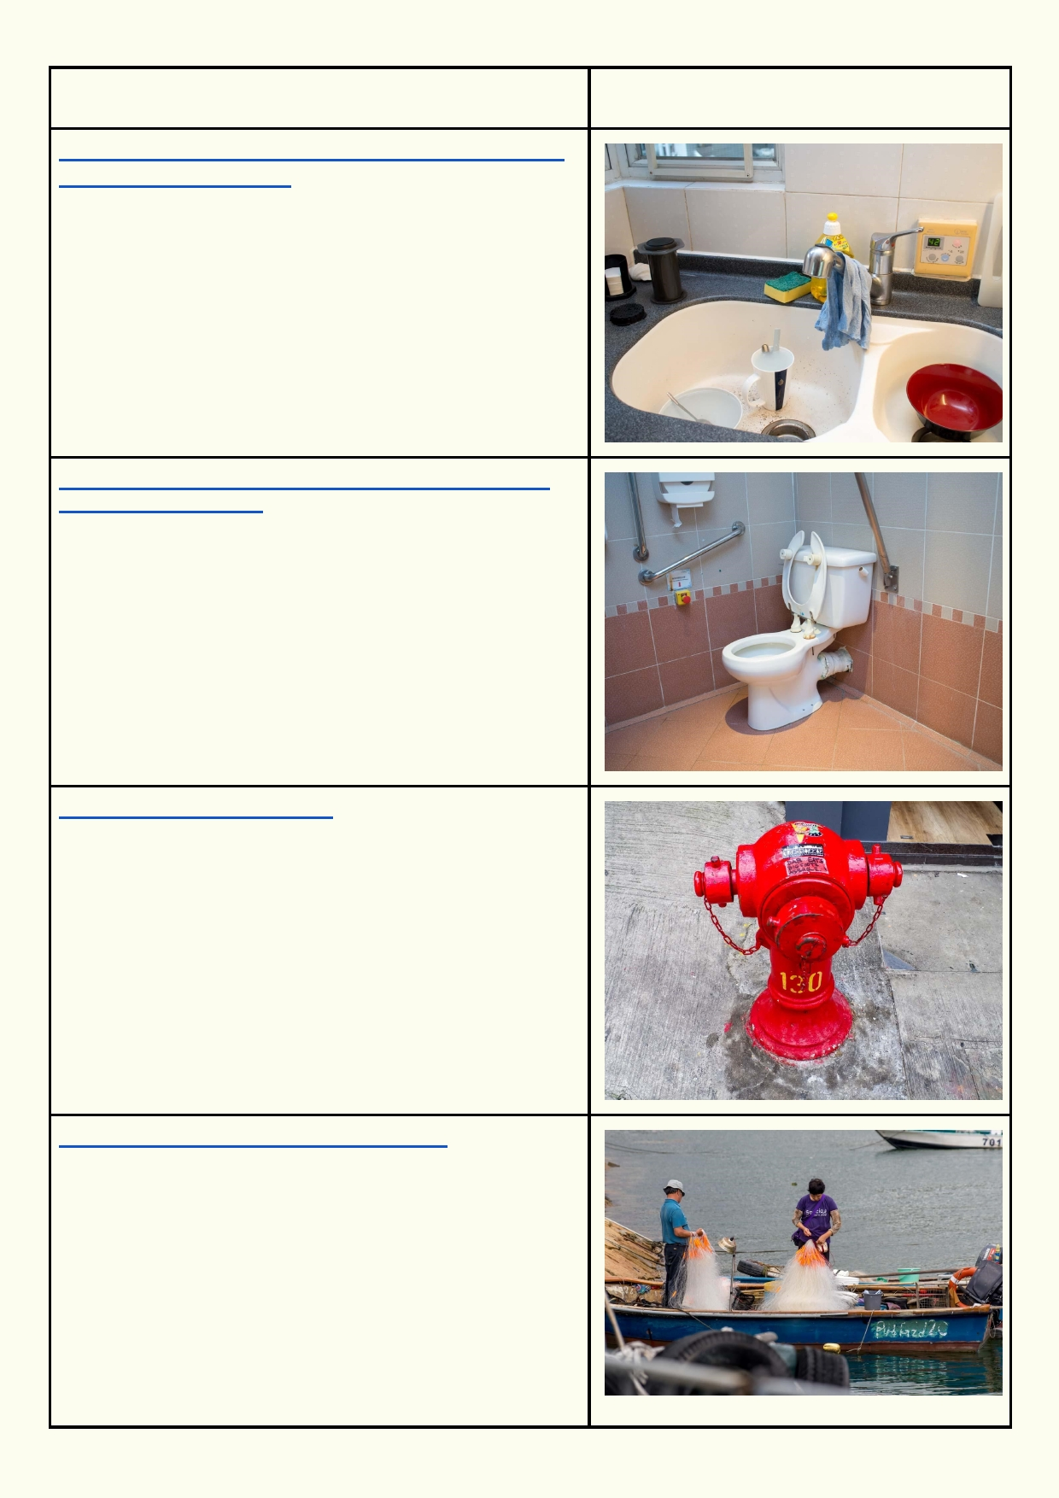How we use water

https://blogs.unicef.org/east-asia-pacific/clean-hands-
healthy-lives-timor-leste/

http://home.howstuffworks.com/home-improvement/
plumbing/sewer1.htm

http://www.hkfsd.gov.hk/eng/

http://www.tackletour.com/reviewHK.html

7

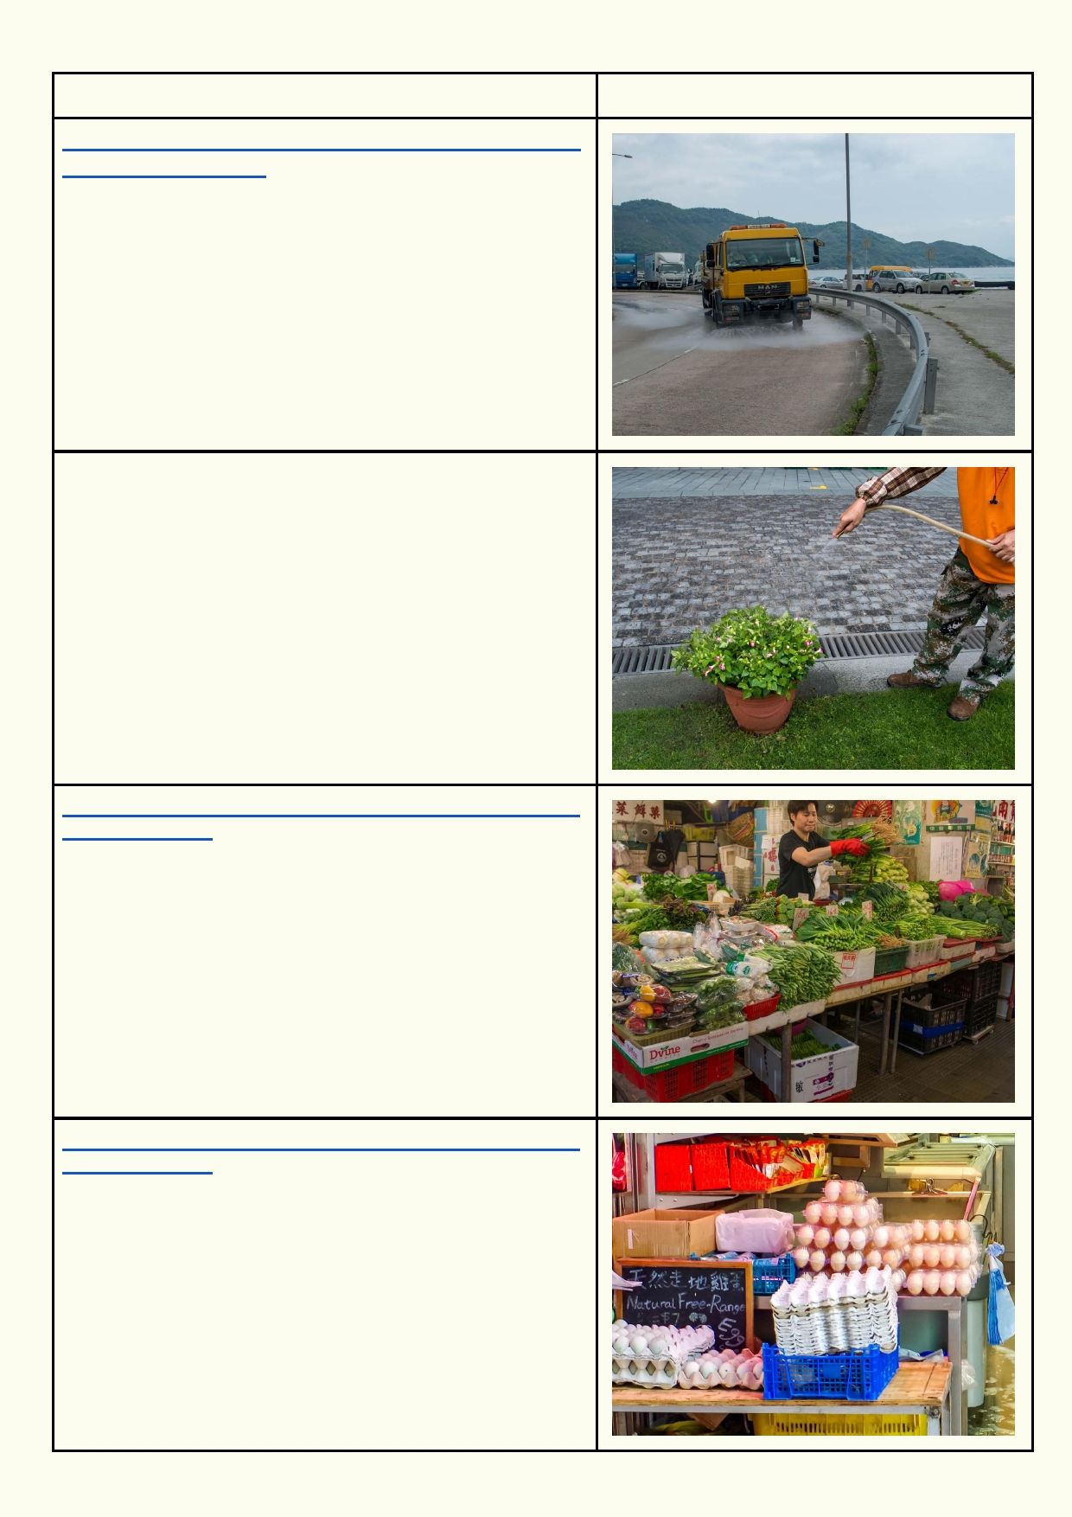How we use water

http://www.fehd.gov.hk/english/pleasant_environment/
cleansing/clean1.php

http://waterfootprint.org/en/resources/interactive-tools/
product-gallery/

http://waterfootprint.org/en/resources/interactive-tools/
product-gallery/

8

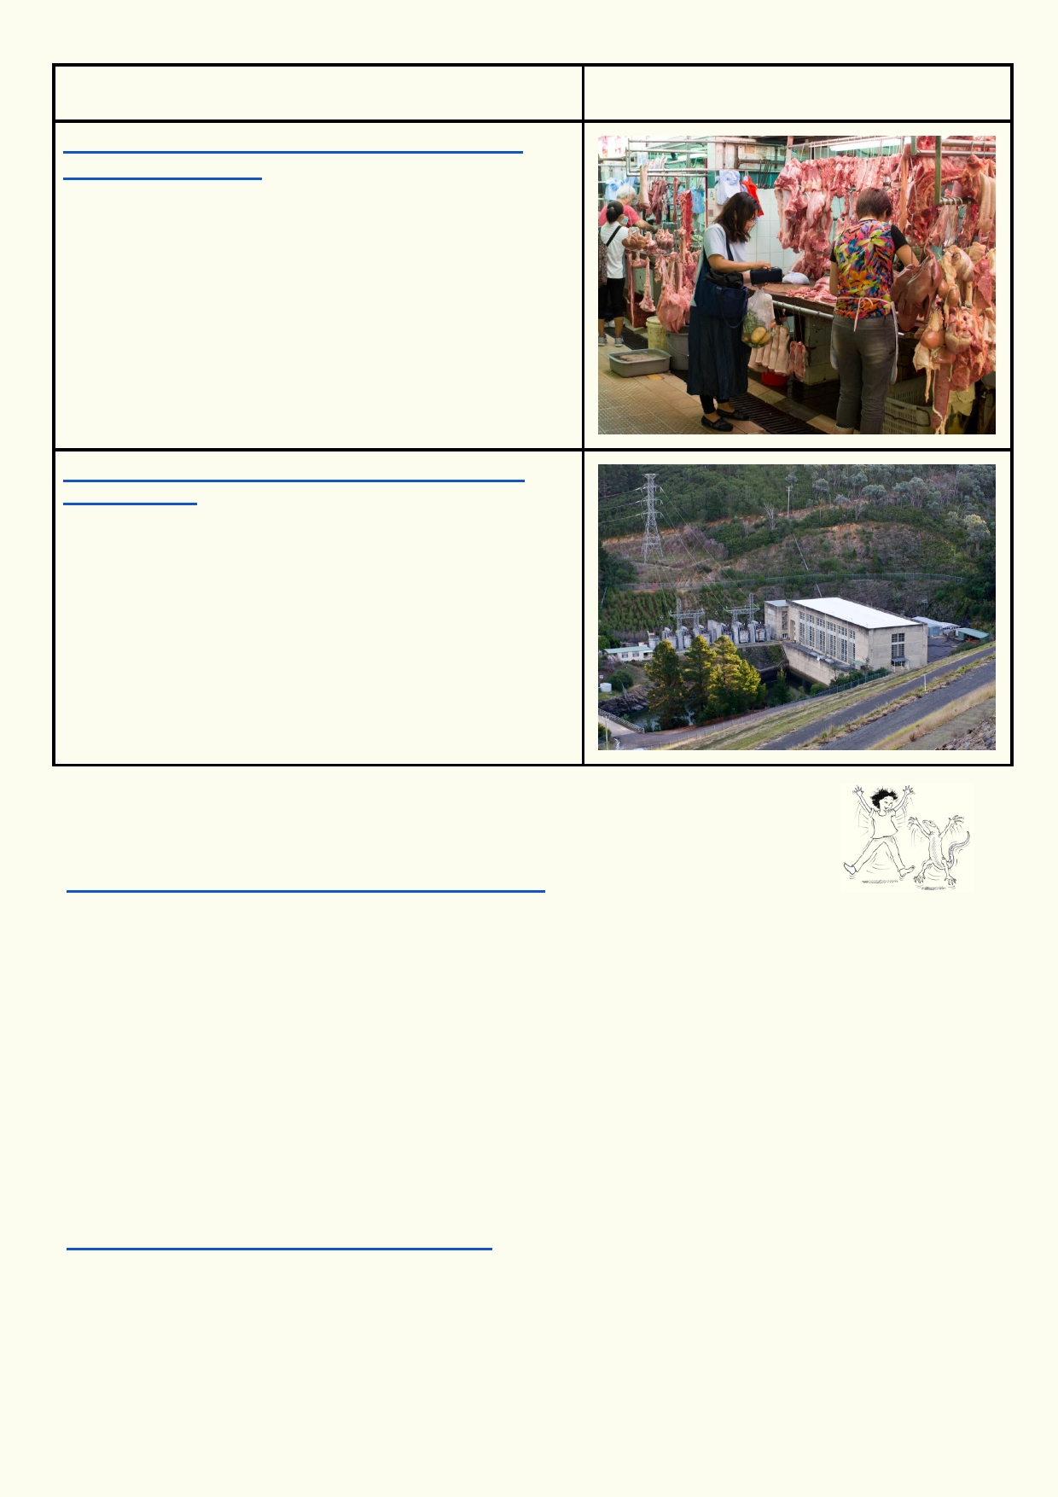How we use water

http://waterfootprint.org/en/resources/interactive-
tools/product-gallery/

http://re.emsd.gov.hk/english/other/hydroelectric/
hyd_tech.html

Activity 2. Bruce Lee says, "Be as water, my friend"

Look at the video of Bruce Lee describing water.
https://www.youtube.com/watch?v=cJMwBwFj5nQ

What does Bruce Lee say is so special about water?
____________________________________________________________________________
____________________________________________________________________________
Write three haikus that deal with the special qualities of water, or describe the water we
encounter in our lives. If there is time, make a simple illustration to go with each haiku. Think back
to the unit on Miraculous Water and what properties of water you learned about. Perhaps you
would like to make each haiku represent a different state of water, or each haiku can describe a
different place where you experience water in a different context. It is up to you!
Look at "Wikihow" that explains how to write a haiku and also provides some examples of haiku
poems:
http://www.wikihow.com/Write-a-Haiku-Poem

9

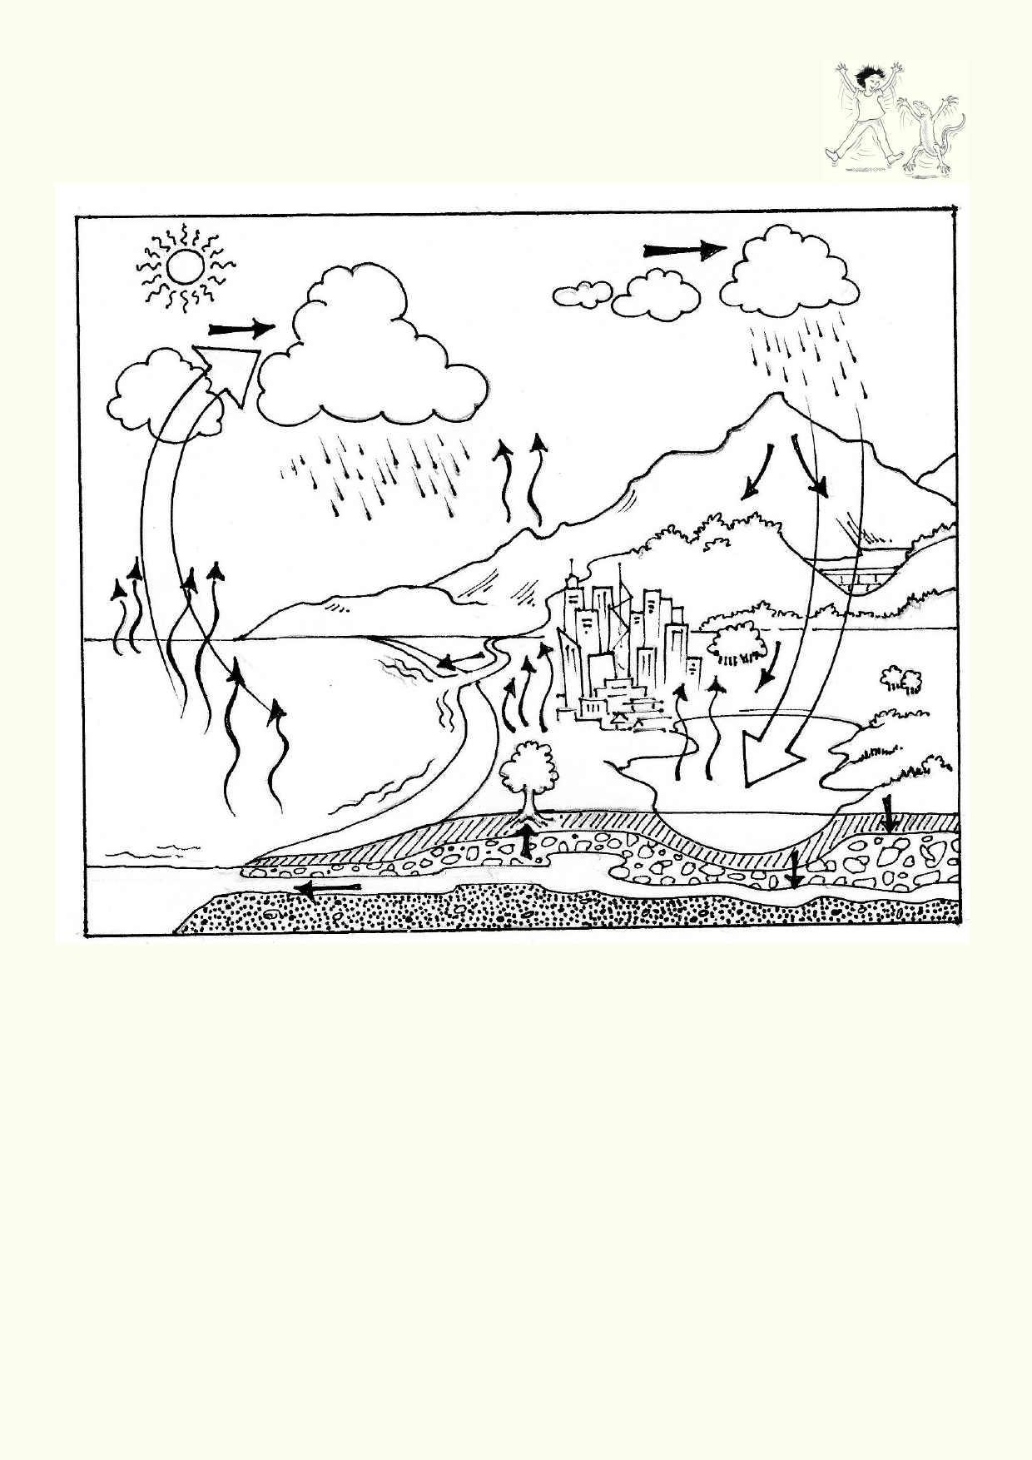Activity 3. A limited renewable resource
Review the water cycle by labelling the diagram below.

Use the water cycle to explain why water is a renewable resource.
_____________________________________________________________________________
_____________________________________________________________________________

If water is a renewable resource, why do we talk about water "running out"?
_____________________________________________________________________________
_____________________________________________________________________________

_____________________________________________________________________________

10

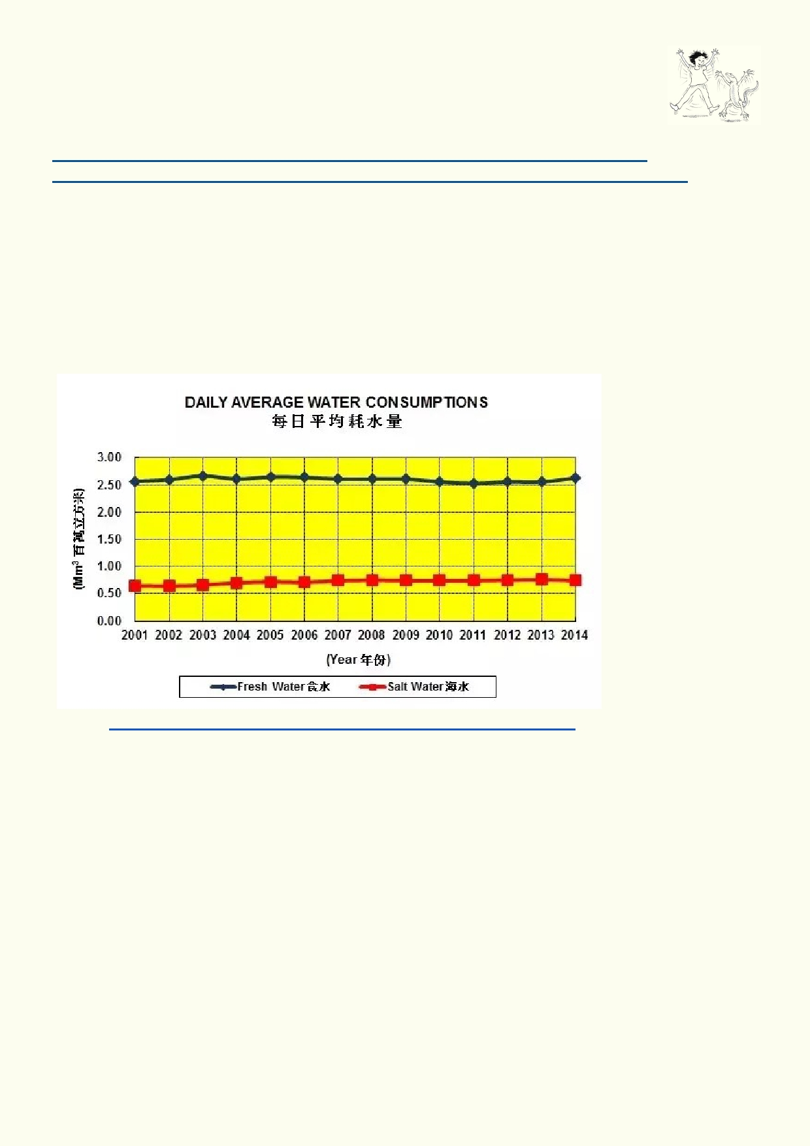Activity 4. Hong Kong water supply

Use this web page to answer the following questions about Hong Kong's water
supply:
http://www.wsd.gov.hk/en/publications-and-statistics/statistics/key-facts/index.html
http://www.wsd.gov.hk/en/core-businesses/total-water-management-strategy/index.html

The number of litres of water each Hong Kong person uses: __________________

The number of dams in Hong Kong: _____________________

The percentage of water coming from Dongjiang (outside Hong Kong): ___________________

Can Hong Kong build more dams? _____________________

Source https://www.quora.com/Is-Hong-Kongs-water-supply-sustainable

The graph shows the consumption of water in Hong Kong over the past 15 years. Has the
consumption of water increased over this time? How would the graph look if it were extended
another 15 years? What does the graph tell us about the future consumption of water for Hong
Kong?
_____________________________________________________________________________

_____________________________________________________________________________

_____________________________________________________________________________

11

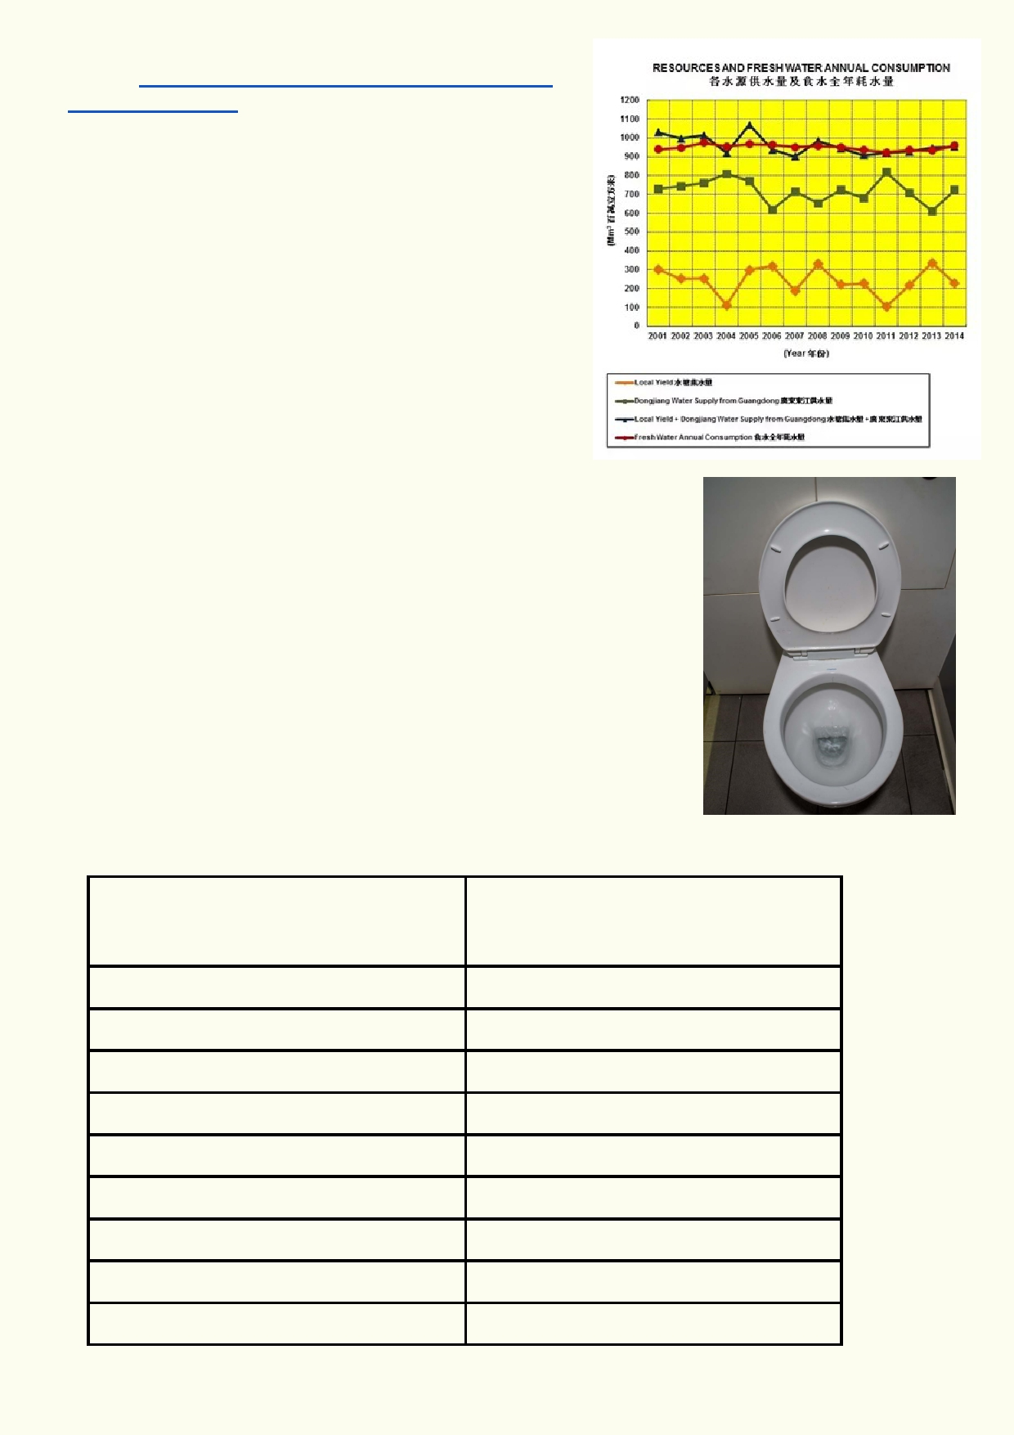Source https://www.quora.com/Is-Hong-Kongs-water-
supply-sustainable
The bottom orange line is the water that is being supplied
from Hong Kong Reservoirs. The rest of the water comes
from outside Hong Kong. Suggest some reasons why the Hong Kong water supply from reservoirs varies so much
from year to year.
_____________________________________________

_____________________________________________

_____________________________________________

_____________________________________________

_____________________________________________

How dependent do you think Hong Kong is on obtaining water from
Dongjiang?

_______________________________________________________

_______________________________________________________

Use the data below to make a graphs or chart to display the
information. Choose the appropriate type of graph, e.g. bar graph or
chart, e.g. pie chart, to best display the information. Compare the
graphs and charts chosen and discuss which best displays the
information.

Reservoir Supply Capacity
cubic metres

Pok Fu Lam 233,000

Tai Tam Upper

Tai Tam Bywash

Tai Tam Intermediate

Kowloon

Tai Tam Tuk

Shek Lei Pui

Reception

Aberdeen (2 Res.)

1,490,000

80,000

686,000

1,578,000

6,047,000

374,000

121,000

1,259,000

12

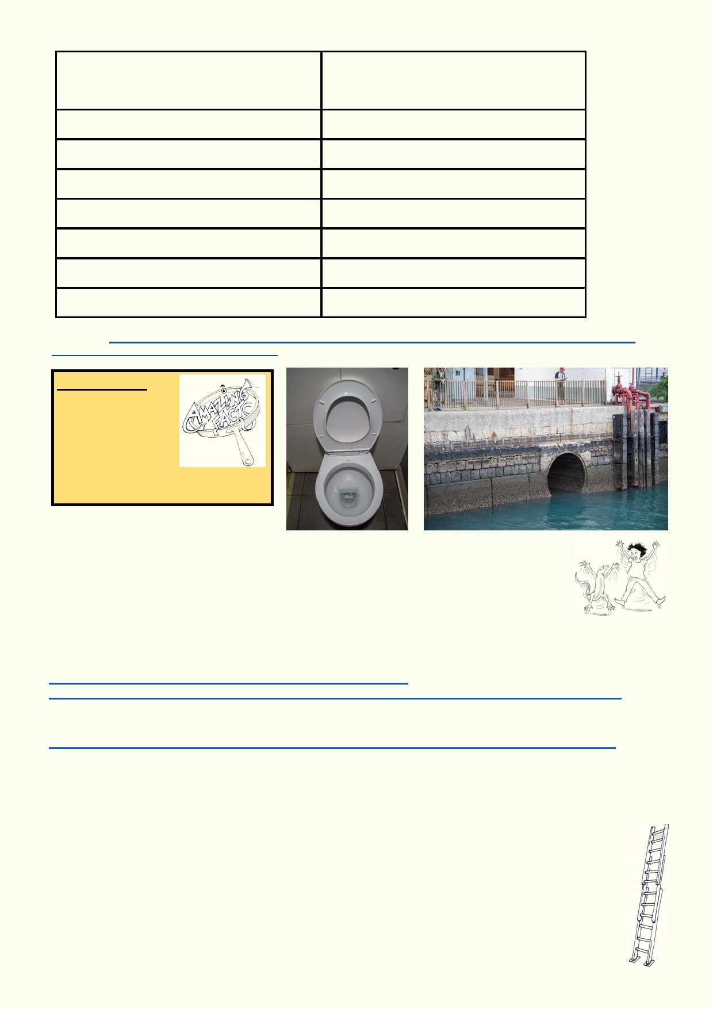Reservoir Supply Capacity
cubic metres

Kowloon Bywash

Shing Mun (Jubilee)

Tai Lam Chung

Shek Pik

Lower Shing Mun

Plover Cove

High Island

800,000

13,279,000

20,490,000

24,461,000

4,299,000

229,729,000

281,124,000

Source: http://www.wsd.gov.hk/en/core-businesses/operation-and-maintenance-of-waterworks/waterworks/capacity-of-
impounding-reservoirs-in-hong-kong/index.html

Amazing fact
Many Hong Kong
buildings are
supplied with
seawater to flush toilets.

Activity 5. Water isn't cheap

Hong Kong's large population and lack of natural freshwater supply means that most of its water supply must come from outside of Hong Kong. The Hong Kong
government must have an agreement with Dongjiang in Mainland China to supply water. Hong
Kong is dependent on Dongjiang. Read the articles below.
http://www.china.org.cn/english/government/165557.htm
/www.scmp.com/news/hong-kong/economy/article/2088144/change-unfair-water-import-deal-mainland-china-hong-kong

Additional reading about water supply in Hong Kong:
www.scmp.com/magazines/post-magazine/article/1937523/why-hong-kong-shouldnt-take-clean-plentiful-water-granted

After reading the two websites and doing further research, discuss what your class thinks about the supply and price of water from Dongjiang.

Extension: Making water work
Water is not only an important resource for consumption. It is also an important source of energy. Using moving water as a source of energy is what hydropower is all about.

13

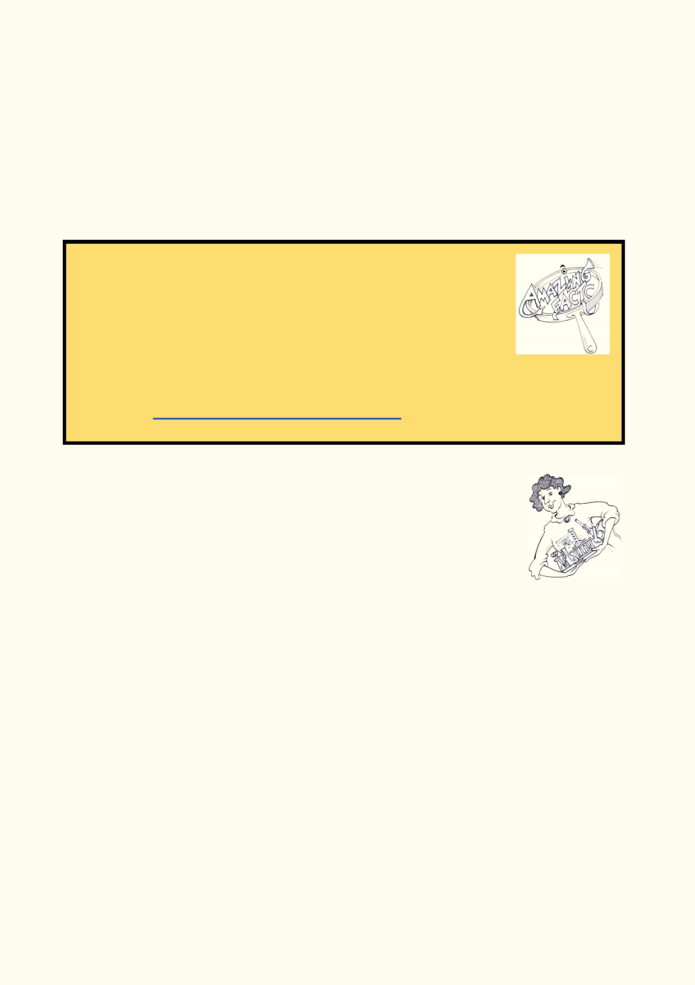Answer some or all of the following questions and making a model or a poster:

• How does hydropower work?
• Make a model of a water wheel or
• Make a poster showing how it works.
• Is hydropower a good source of energy?
• Are very large dams environmental disasters? eg. Aswan dam, Three Gorges dam

Lesson 2. The Where and the How

Amazing facts

1.

2.

3.

4.
Of all the water in the world, 97% is seawater. We can't drink
seawater or use it for agriculture on land.
Most of the freshwater is locked into ice. This is 2.4% of the total
water.
Most of the remaining 0.6% of the planet's water is locked away
underground where it can't be easily reached.
The amount of easily available freshwater is just 0.003% of the total water on Earth.
(source https://ndep.nv.gov/edu/docs/bucket.pdf)

Activity 1. Water, water everywhere

A drip is approximately 0.05ml.
Calculate how many drips are in 1 litre. (One litre is 1000 ml)
___________________

Conducting experiments

1.
2.
3.
4. 5.

6. 7.
Read through the setup for the experiment.
Record your prediction for the outcome of the experiment.
Gather the materials that are needed.
Find a suitable location to conduct the experiment.
Review all safety requirements including handling glassware safely and using heat and
heated substances. Ask your teacher if you are not sure. Report any accidents.
Record your observations as you complete the experiment.
Clean and return equipment.

In this activity, using one litre of water to represent all the water on Earth, how much of the one
litre is available for humans and life on land to use?

14

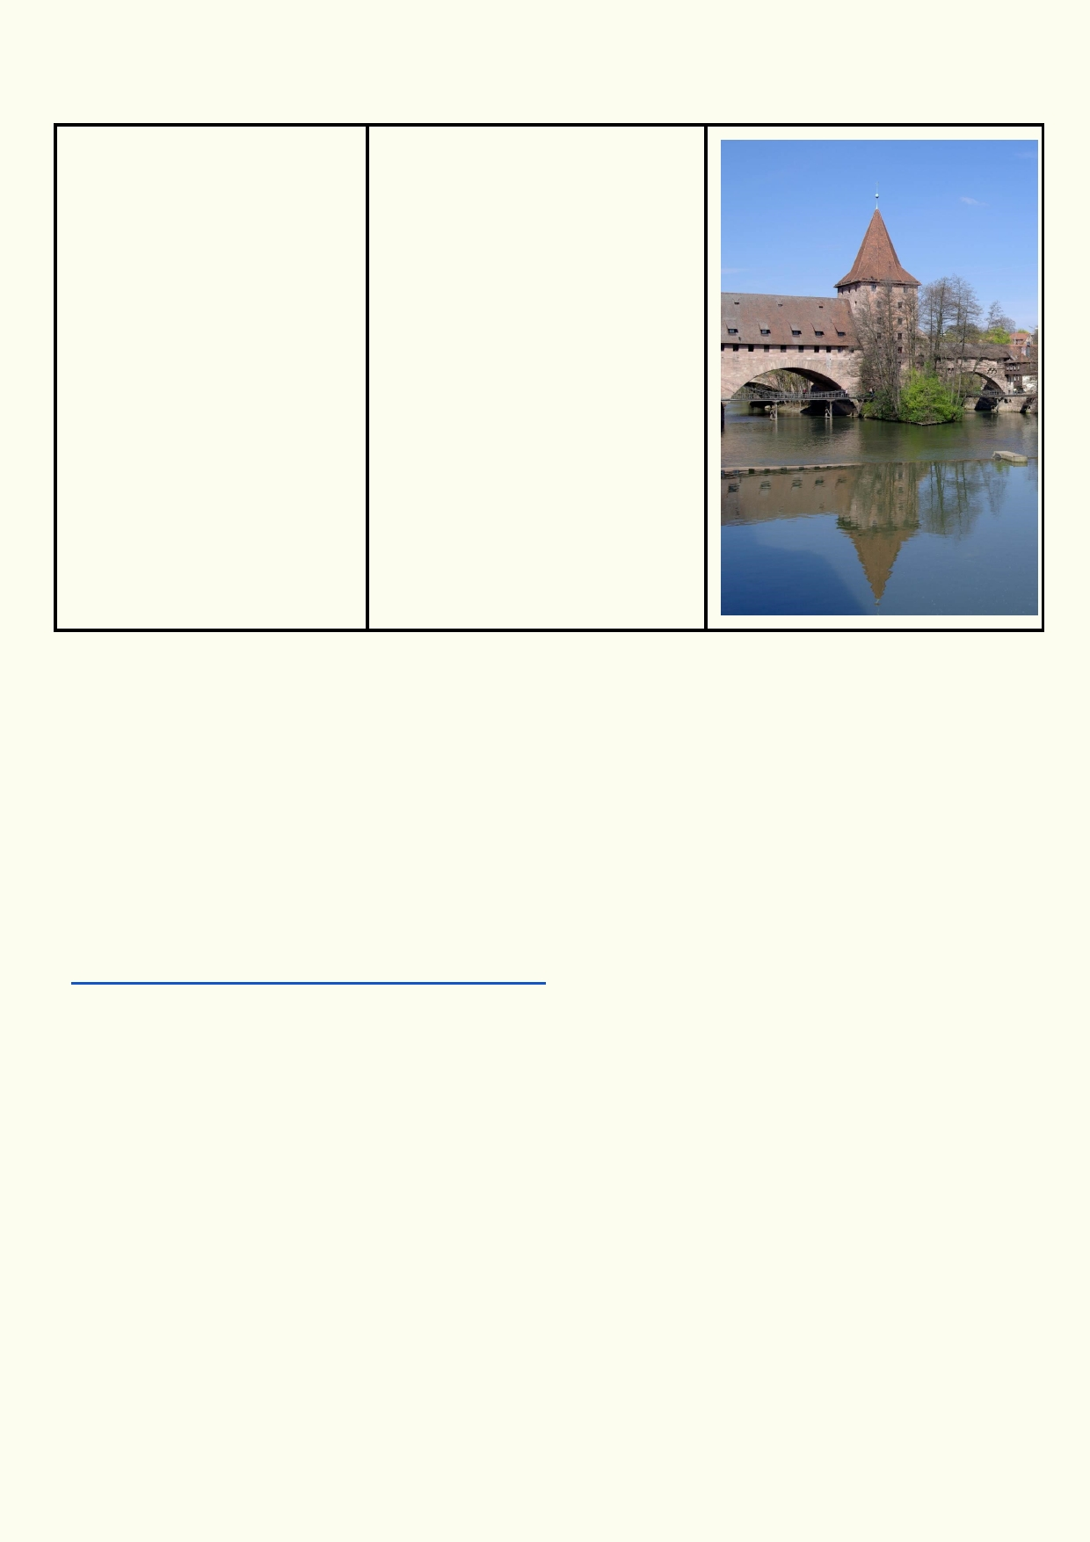Experiment: How much water?

Materials: Method:
• Litre container of water 1.Remove 3% of the water from
• 100 ml graduated the one litre container and place
cylinder in a beaker (represents
• Two 150 ml beakers freshwater). What is 3% of one
• Small dish litre?
• Dropper 2. From the beaker remove
6 ml of water. This is the
freshwater that is not frozen.
Place in the second beaker.
3.Remove a single drop from
the second beaker and place on
the dish. This represents the
amount of water left available to
humans and life living on land
and in freshwater.

Prediction: How many drops represent the amount of clean water available to life on land?

____________________________________________________________________________

Calculation: _________________________________________________________________

____________________________________________________________________________

Now look at this webpage that compares the various forms of water found on Earth. Compare these graphs and percentages with the results from the activity you have just done.
https://water.usgs.gov/edu/earthwherewater.html

____________________________________________________________________________

____________________________________________________________________________

____________________________________________________________________________

15

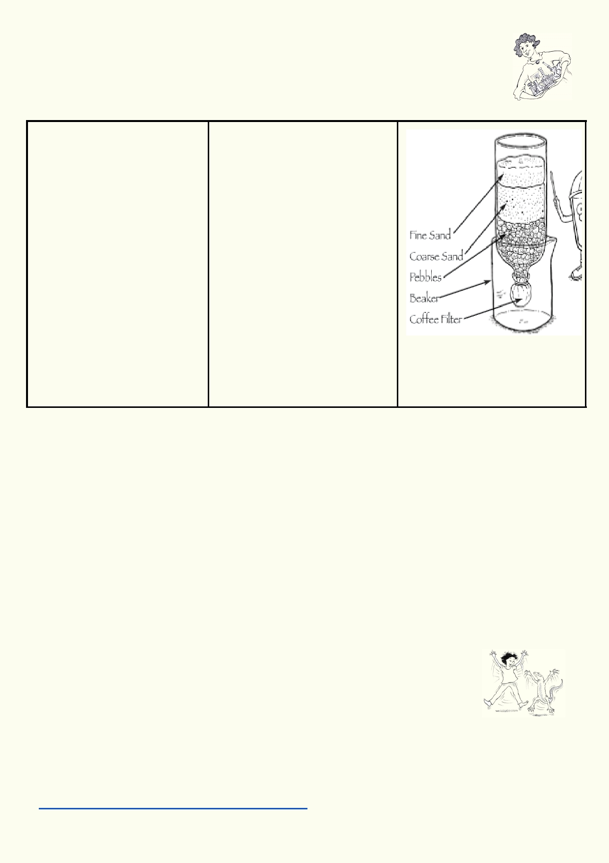Activity 2. Filtering water

Experiment: making a water filter

Materials: Method

•

•

•
−
−
−
−

•
−
−

Plastic bottle with bottom
cut out
Flask that can hold
upside down plastic bottle
In each small container:
Gravel 100 ml
Charcoal 100ml
Sand 100ml
Water mixed with soil
50ml
In each larger container
Gravel 200 ml
Charcoal 100ml
Sand 200ml
Water mixed with soil
100ml
1. In an inverted plastic bottle
with the bottom cut out, place a
layer of charcoal, then sand and
on top gravel.
2. Place the inverted plastic
bottle into a beaker.
3. Pour half of the dirty water
into the top of the filter. Make
sure to the limit the amount of
water so it doesn't overflow from the beaker.
4. Compare the water that has
come out of the filter into the
beaker with the original dirty
water.

Prediction:
__________________________________________________________________________

Observation:
__________________________________________________________________________

__________________________________________________________________________

Are there any other characteristics of the water that might need further cleaning? How would you
accomplish this?
__________________________________________________________________________

__________________________________________________________________________

Activity 3. Water treatment in Hong Kong

All the water being used in Hong Kong is monitored so that it is clean and free of dangerous bacteria and other contaminants. The reservoirs where the water
is captured and stored are in watersheds that have low human impact. This
makes it relatively clean to begin with.

Watch the video and then study the diagram to understand the processes used to maintain a
clean water supply in Hong Kong:
https://www.youtube.com/watch?v=zYZLqYhrlOE

16

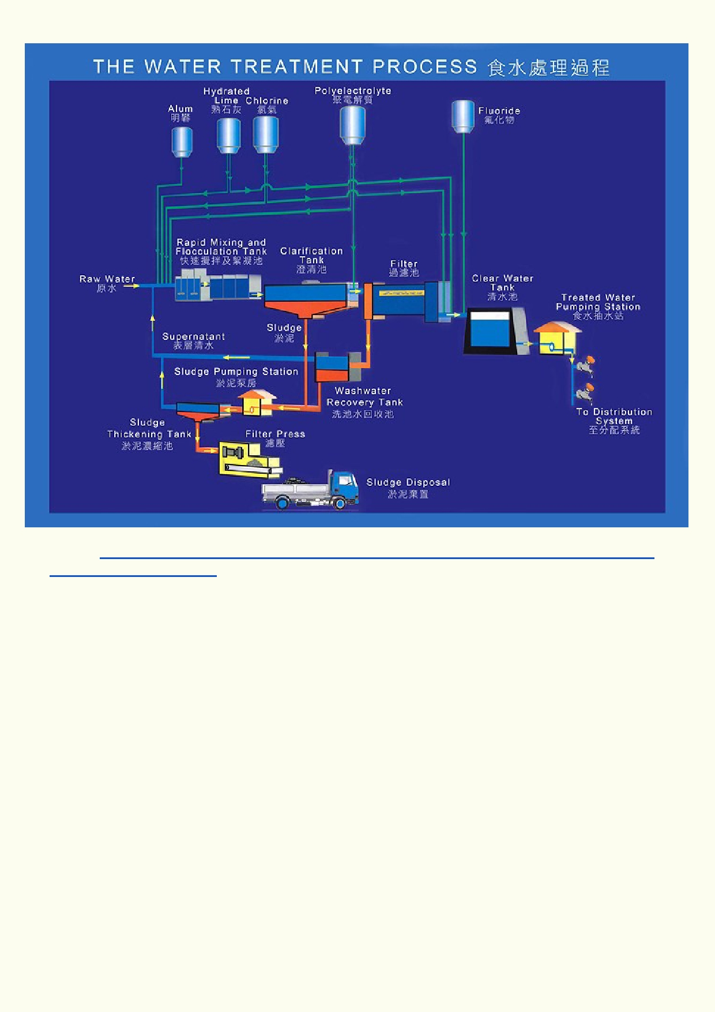
Source http://www.wsd.gov.hk/en/water_resources/water_treatment_and_distribution_process/
water_treatment_process/

What is added to the water and when is it added?

____________________________________________________________________________

____________________________________________________________________________

What is removed from the water and when is it removed?

____________________________________________________________________________

Alum, hydrated lime and polyelectrolyte are used to take unwanted chemicals and suspended particles out of the water. Chlorine kills bacteria that could be living in the water.

After the water has passed through the Hong Kong treatment plants, it is safe enough to drink.

17

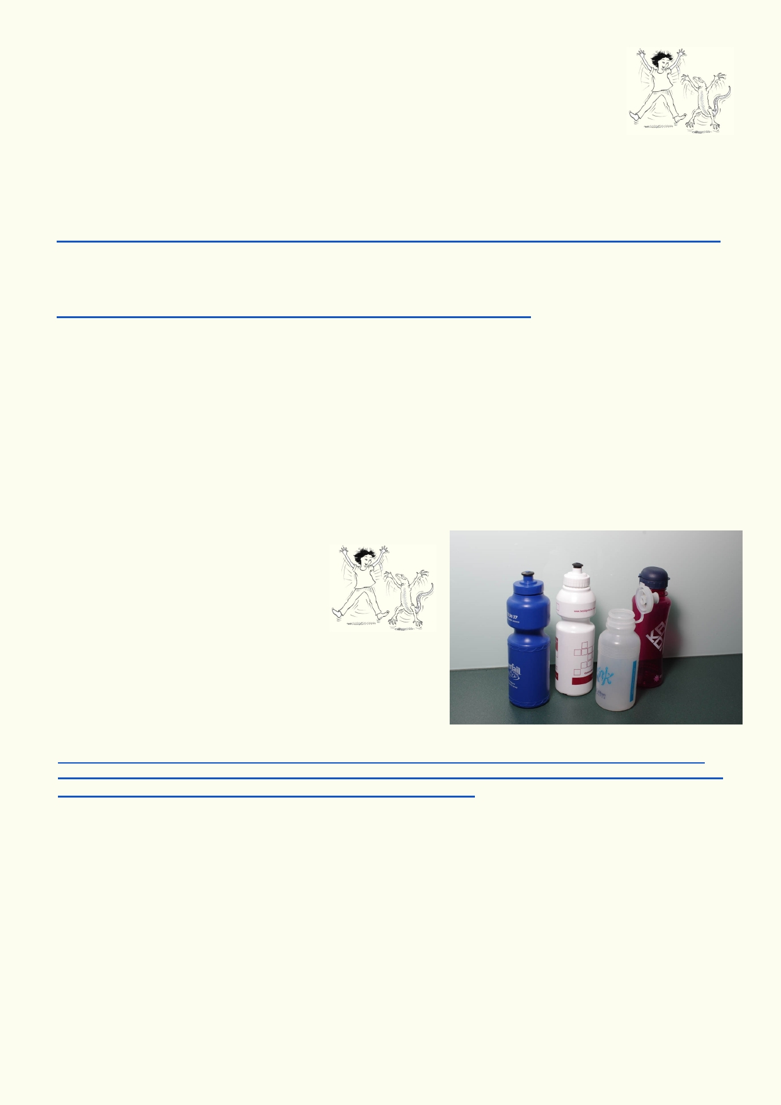Activity 4. Water monitoring in Hong Kong

Quotation from Hong Kong's Water Supply Department:

"Water quality throughout the entire treatment, supply and distribution system is
systematically monitored by means of physical, chemical, bacteriological, biological and
radiological examinations of water samples taken at catchment, intakes, Muk Wu Pumping Station
receiving Dongjiang water, impounding reservoirs, water treatment works, service reservoirs,
distribution systems and consumers' taps."
http://www.wsd.gov.hk/en/water_resources/water_quality/my_drinking_water_quality/index.html

The Water Supply Department is constantly monitoring the quality of water being supplied to all Hong Kong consumers. Look at the PDF file that has data of the parameters being measured.
http://www.wsd.gov.hk/filemanager/en/content_135/drinking_b-e.pdf

How many parameters are being measured? _________________________________________

Which guidelines are used to confirm that the water is safe? _____________________________

Why do you think it might be important to understand how safe Hong Kong's water supply is?

____________________________________________________________________________

Produce a pamphlet that explains why Hong Kong water is safe to drink.

Activity 5. Bottled water

While one billion people in the world
don't have access to clean drinking water, many of
those that buy bottled water have access to clean
water from their taps. Use these three websites to find
out why buying bottled water is a controversial issue.

http://www.scmp.com/comment/insight-opinion/article/1928230/no-good-reason-hongkongers-buy-bottled-water
http://www.scmp.com/news/hong-kong/health-environment/article/2081218/university-hong-kong-bans-sales-disposable-bottled
http://oceancrusaders.org/plastic-crusades/plastic-statistics/ (go down to bottled water story)

What are some of the issues involved in buying bottled water?

____________________________________________________________________________

____________________________________________________________________________

____________________________________________________________________________

18

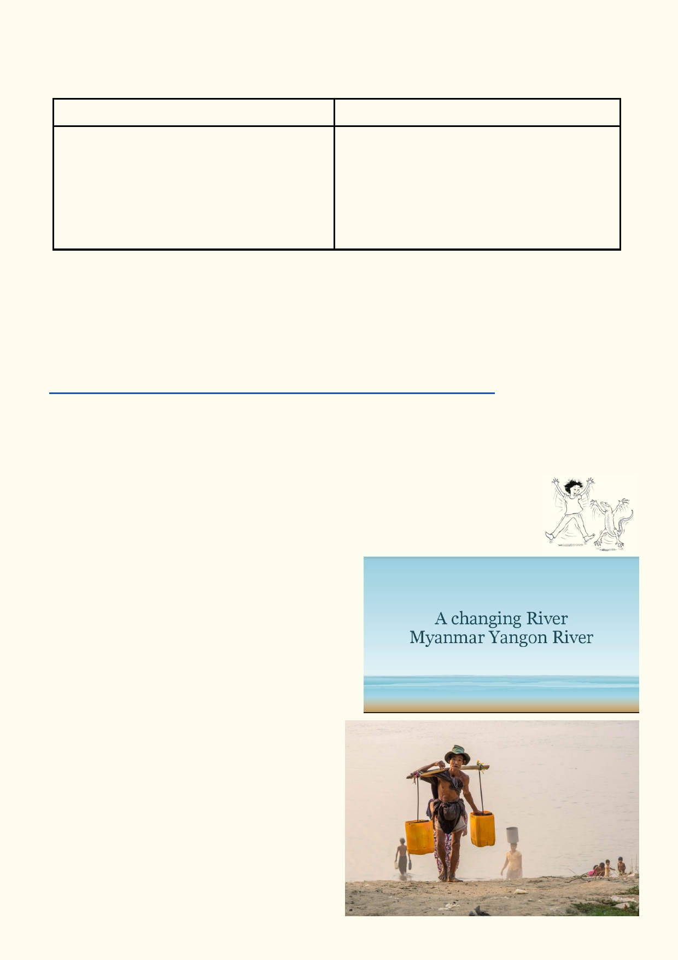Have a class discussion about the issues. Record the arguments for and against using bottled
water.

For using bottled water For using tap water

What are your alternatives to buying bottled water?

____________________________________________________________________________

____________________________________________________________________________

Download the PDF file of the "Tap Water Rap".
http://metrocwf.org/wp-content/uploads/2013/03/Tap-Water-Rap-lyrics.pdf
Get into groups of three or four. Write an extra verse to go at the end that explains what people in
Hong Kong can do to use less bottled water.

Activity 6. Water Use in Myanmar - Then and Now

Exploring the clash between Myanmar traditional water use and use in the 21st century.

Download the PowerPoint "Waterwise - A
Changing River"
• Use the photos in this PowerPoint to describe
how life has changed along the Yangon River
over the past 100 years. What do you think
hasn't changed?
• Move the photos around. Delete the photos
you don't want to use.
• How do people use the river?
• Why might people be washing in the river?
• What changes might have occurred to the
quality of the water?
• Was plastic litter a problem 100 years
ago?
• How do you think litter plastic has changed
in the past years?

19

Lesson 3 - Water Conservation and Management

Activity 1. International water dilemma

Many of the world's major watersheds occupy more than one country. The water
being used by countries at the bottom of large watersheds often originate as rain and melted
snow from countries higher up. Watersheds can often cross international boundaries. What happens when countries higher in the watershed start using the water that affects countries
lower down? The website below provides three examples of water use problems that might arise
in the future.
https://www.geopoliticalmonitor.com/three-international-water-conflicts-watch/

As a class suggest what rights two countries might have if they share water resources in the
same watershed?

Country A wants more water resources
because the source of the water is located in
their country and they need more water for
development.

What rights does Country A have?

Country B is downstream of Country A.
Country B needs to receive the same water
resources as they used in the past.

What rights does Country B have?

Is it clear which country has a right to the water when there isn't enough to go around?

As a class decide what factors should be considered when countries negotiate about water
rights. List them below:

____________________________________________________________________________

____________________________________________________________________________

____________________________________________________________________________

What does the United Nations have to say about the right of all people to have access to clean
water?
http://www.unric.org/en/water/27360-making-water-a-human-right

____________________________________________________________________________

____________________________________________________________________________

____________________________________________________________________________

20

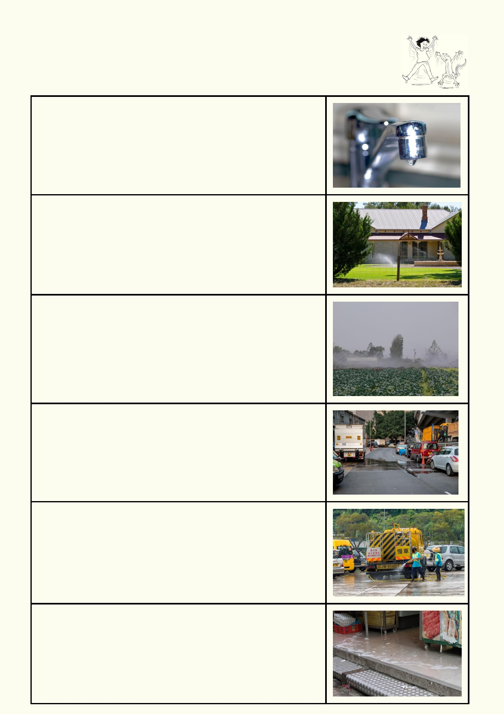Activity 2. What a waste
Describe how water might be wasted in each of these photos:

21

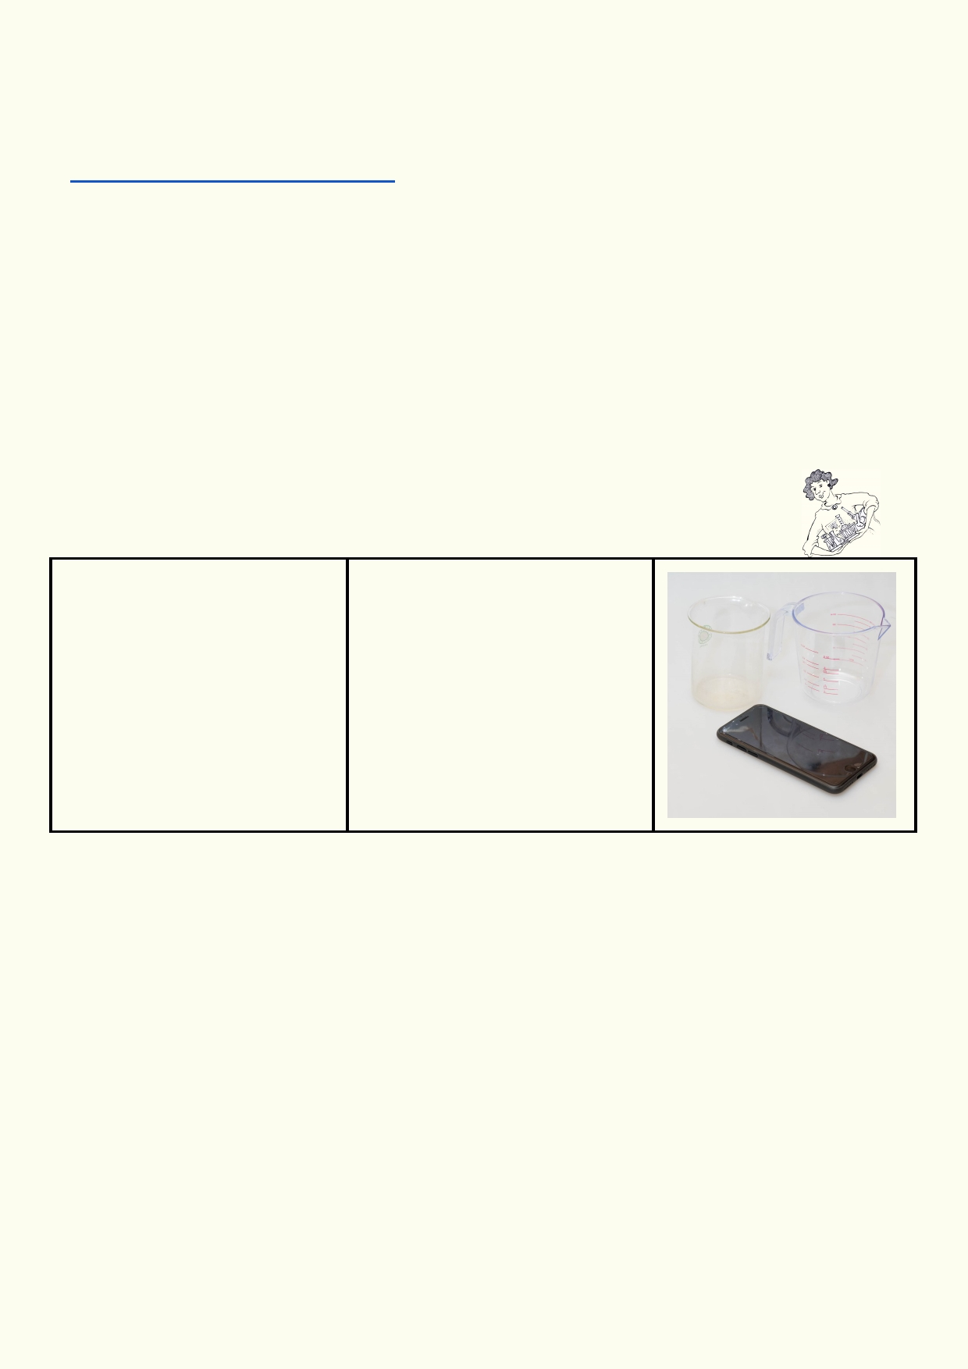These are the top 25 ways people waste water in Sacramento, California in the USA. Many of the ways people waste water in this community are very different from the ways people might
waste water in Hong Kong. Look at the list on this website. List 10 of the 25 ways people might
waste water in Hong Kong:
http://sswd.org/index.aspx?page=322

________________________________________ __________________________________

________________________________________ __________________________________

________________________________________ __________________________________

________________________________________ __________________________________

________________________________________ __________________________________

Experiment: It's only a drop

Materials: Method
1. Allow a tap to drip in a beaker

•
•
•
•
T ap
100 ml graduated cylinder
150 ml beaker
calculator
at a rate of around one drip per
second for 5 minutes.
2. Measure the total water
amount in a graduated cylinder.

3. Calculate how many litres of
water would be lost over one
year.

Prediction: How many litres do you estimate might be lost in one year?
__________________________________________________________________________

Calculation: (The number of 5 minutes in one year multiplied by the volume of water measured) Ask your teacher for help if you are not sure how to convert millilitres to litres.

__________________________________________________________________________

__________________________________________________________________________

22

Activity 3. Let's find out: school and home audit

School water leak audit
Get into your group and decide how you will divide up the task. Look at all the
plumbing in your school. You may need to get permission to enter staff rooms

Type of plumbing

Hand basin tap
Hand basin tap
Hand basin tap
Hand basin tap Hand basin tap

Water fountain
Water fountain
Water fountain

Water fountain
Water fountain
Toilet

Toilet
Toilet
Toilet

Toilet
Sink
Sink

Garden tap
Garden tap
Other

Location

Reason:
such as plumbing needs
fixing, wasn't turned off

23

Gather all the data from all the groups. Classify the reasons why water is being wasted in your school, e.g. plumbing requires maintenance, taps not turned off properly.

How is water wasted in your school? Summarize your findings below:

___________________________________________________________________________

___________________________________________________________________________

How water is used in the home: domestic audit
Choose to do a domestic or waste water audit as described below:

1. Home water use in the home audit
In this activity you will estimate the amount of water used at home over a 24 hour period during
a weekend at home. Discuss the activity with your family. Explain what you would like to do.
Ask your family how you can avoid intruding or embarrassing them. Make sure you are
sensitive to the needs of your family before you start.

Record how many times each activity is done. Record each time the toilet is flushed. Record how long a tap or the shower is running. Estimate how much water is used by the end of the day.

Water use in one day for one person

Toilet flushing (toilet could be using
seawater)

Shower or Bath

Hand washing
Brushing teeth

Cooking
Drinking water, tea, coffee etc

Washing dishes

Washing clothes
Washing floors

Running water in the sink

Watering plants, water for pets

Other:
Other:

Number of
times or time
water is

Litres used
each time

Estimated
total litres for
each wat er

24

Ask your teacher to show you the average number of litres used for typical domestic
water use, after you have completed your estimates. Were there many surprises?

Add the class' data together and produce a pie graph. Compare your class' pie graph with the
pie graph that can be found on the website below. This graph shows how people in Great
Britain consume water:
http://www.waterwise.org.uk/pages/at-home.html

What does your data have in common with the data from Great Britain?

____________________________________________________________________________

____________________________________________________________________________

Explain why some of your data is very different from the data from Great Britain.

____________________________________________________________________________
Or:
2. How water is wasted in the home audit
Over a day watch how your family might be wasting water and note if any of the plumbing in your home is leaking.

Ways of wasting water Yes No

Leaking hand basin tap
Leaking sink tap

Leaking toilet

No plug with hand basin

Tap left running while brushing teeth
Family regularly takes showers longer than 6 minutes

Fruit and vegetables washed under running tap

Dishes washed under running tap
Washing machine isn't full when it's turned on

Tap left running before glass of water is filled

Food defrosted under running tap

Cooking pots overfilled with water (e.g. water level much higher than
vegetables)

Dual flush toilet not used properly
Other things you noticed:

25

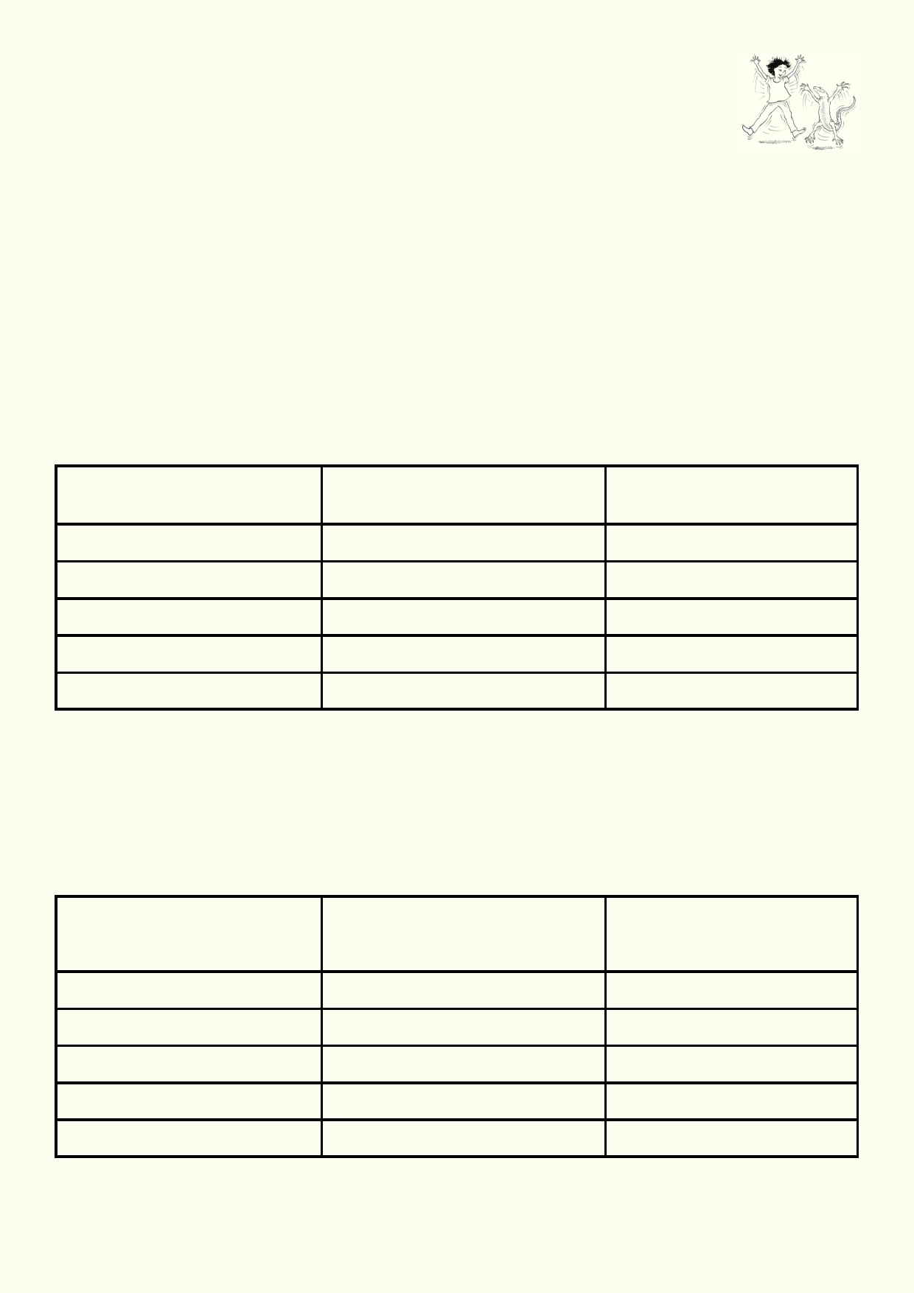Activity 4. We can help fix it at school and home

Using less water at school

How does your school go about fixing leaking plumbing? Is there a way you can
help your school to
get plumbing fixed as soon as there is a problem?

Find out who you can report to when there is a plumbing problem.

_______________________________________________________________________________

Using your research, list the ways students waste water, e.g. leaving taps on. Design ways to Remind students (and school staff) how they can prevent water wastage. Examples might be
simple reminders beside taps, at school meetings, school bulletins or presentations you can
conduct for every class. If there is more than one class doing this unit, combine with the other
classes to help the school to reduce their water use.

How water is being wasted What do you want students How will you remind them
at school and staff to do? to reduce water waste?

Using less water at home

Water is wasted when more water is used than is required to perform the job. How do you think you and your family are wasting water? Explore your home and find out how the water is being used.

Sometimes water is wasted because of leaking plumbing that needs fixing. When exploring water use at home remember to respect your family's privacy and don't embarrass anyone.

How water is being wasted How can the family reduce the What does the family think
at home waste of water? about ways to use less

26

Lesson 4: Everyone needs to help

Activity 1. Research

Introduction
We all live in communities. Our community includes government. Governments need to do
some jobs which are paid for by our taxes. These jobs include making sure we have access to
clean water, removal of all kinds of waste, looking after roads and making sure all forms of
transport operate safely. Governments can't do everything. We, as individuals, also need to be
part of keeping our communities functioning. How do we all work together to look after our water
resources and watersheds?

Materials
Computers or tablets connected to the internet

Research and reporting

1.
2.
3.
4.
5.
•

•
Get into small groups of 2 or 3.
As a class decide which groups will research each of the topics below.
Use the links to start your research.
If you have time, make your own searches for more information.
Gather information about:
What is being done to help improve water quality in the environment and for people's
consumption.
Which organisations are doing the work.

Role of government to protect water resources:
Monitoring
http://www.epd.gov.hk/epd/mobile/english/environmentinhk/water/river_quality/
rwq_monitoring.html
http://wqrc.epd.gov.hk/en/water-quality/toxic.aspx
http://www.wsd.gov.hk/en/water_quality/index.html
Policy and laws
http://www.dsd.gov.hk/EN/Sewerage/Sewerage_Strategy/index.html
http://www.epd.gov.hk/epd/english/laws_regulations/enforcement/laws_eflhk.html
www.buildingmgt.gov.hk/en/daily_operation_of_building_management/6_3_15_2.htm
Providing appropriate infrastructure and services
https://www.youtube.com/watch?v=BF2uWyM4WYs
https://www.youtube.com/watch?v=xj5q_TNxZ6Q
http://www.dsd.gov.hk/Documents/AnnualReports/0809/sew_content.html
Charging for sewerage services so there is money to build and service infrastructure
http://www.dsd.gov.hk/EN/Sewage_Services_Charging_Scheme/index.html
Fixing up problems e.g. street cleaning
http://www.fehd.gov.hk/english/pleasant_environment/cleansing/clean1.php
www.wsd.gov.hk/en/contact_us/by_phone/customer_services_hotline/index_t.html
http://chinadigitaltimes.net/2012/10/photo-firefighters-try-to-control-water-bursting-
from-broken-fire-hydrant-in-shanghai-october-10-by-remko-tanis/

27

Law enforcement catching those who break the law
http://www.police.gov.hk/ppp_en/11_useful_info/filming/laws.html
http://www.fehd.gov.hk/english/pleasant_environment/library/fixed_penalty/1.html
http://www.scmp.com/lifestyle/article/1802374/10-laws-are-broken-hong-kong-
every-day
https://www.fastcocreate.com/3045403/a-hong-kong-clean-up-campaign-identifies
-litterbugs-through-dna
Educating the community to look after water resources
http://www.gov.hk/en/residents/environment/public/index.htm

Role of community to help protect water resources:
Do the right thing: What should the community be doing?
www.scmp.com/lifestyle/article/1802374/10-laws-are-broken-hong-kong-every-day
http://www.dailymail.co.uk/news/article-2223482/How-growing-trend-using-wet-
wipes-instead-toilet-roll-costs-Thames-Water-12m-year-fix.html
What individuals can do
www.gov.hk/en/residents/environment/public/enquiries/logpollutioncomplaint.htm
http://www.epd.gov.hk/epd/english/greenconstruction/poll_pro/
wastewater_management.html

Community action groups that fix problems:
Help restore the natural environment
http://hkcleanup.org/event-info/
http://www.oceanrecov.org/
http://www.epd.gov.hk/epd/clean_shorelines/index-2.html
https://www.tnc.org.hk/our-work/by-country/hong-kong/hong-kong-clean-up/
http://www.greencouncil.org/en/index.php

Some education programs:
Long term behaviour change of communities by educating them about how to look after
the environment
http://www.info.gov.hk/gia/general/201611/17/P2016111700393.htm
http://www.info.gov.hk/gia/general/201507/10/P201507100521.htm
http://www.ecc.org.hk/english/publicity/publicitya916.html?id=44

28

Activity 2: Reporting back

1. 2.

3. 4. 5.

6. 7.

8.
9.

You will have up to two minutes for your group to make its presentation. Decide how you will present your information. Your teacher may tell you
what you can use or you may need to ask. You could make a powerpoint,
produce a poster, etc.
Make sure you finish preparing your group presentation in the allocated time.
Start your presentation with a title. It might be the heading you chose.
Organise your information to tell a story about how water resources are being protected
and improved.
Share your information using the presentation method your group chose.
In your group decide how you will take turns to present your material. Everyone in your
group must participate.
Wait for your teacher to give your group its turn to present.
While other groups make their presentation, write a list of things you could do to help
protect our water resources, based on what you learn from the presentations.

1. __________________________________________________________________________

2. __________________________________________________________________________

3. __________________________________________________________________________

4. __________________________________________________________________________

5. __________________________________________________________________________

6. _________________________________________________________________________

7. _________________________________________________________________________

Activity 3 - Looking forward
Create a postcard with a photo that explains how we can use our water better, for
the benefit of people, wildlife and the environment.

When the postcards are completed, give them to someone or to people you know.

29

Acknowledgements
The Ocean Recovery Alliance thanks The Hong Kong Jockey Club Charities Trust for their
generous funding support on this education programme.

Project manager: Doug Woodring
Writer, photography and design : Bob Winters
Curriculum manager and editor : Charlotte Charny Nielsen
Editor and school outreach: Alex Hale
Additional thanks: Jasmine Nunns and Sandra Merazzi

© 2017 Ocean Recovery Alliance and Authors.
Outside the school environment, the text, photos and artwork may not be reproduced, except
where permitted by the relevant Copyright Act. These materials may not be modified and
distributed by print or electronic means without written permission. Teachers may modify these
education materials for the use of their students and school provided it is not distributed any
further. Those wishing to reproduce part of this publication must submit their application to the
Ocean Recovery Alliance. www.oceanrecov.org/contact-us.html

30

