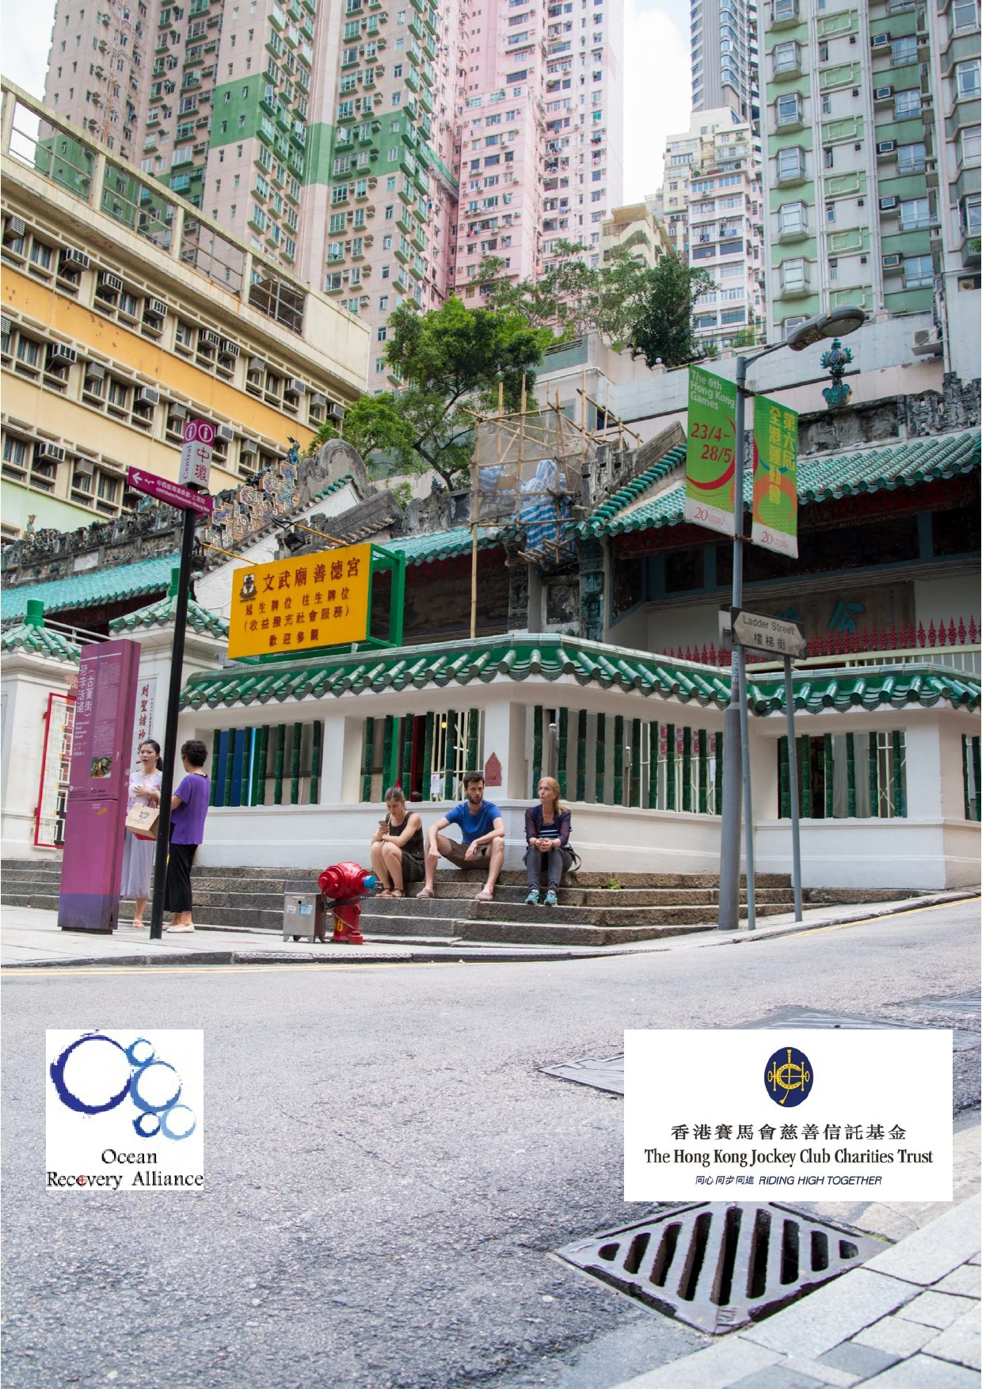Jockey Club Water Caretakers of
Tomorrow Programme
Down the Drain - Unit 6

Organised by

Organised by

Funded by

1

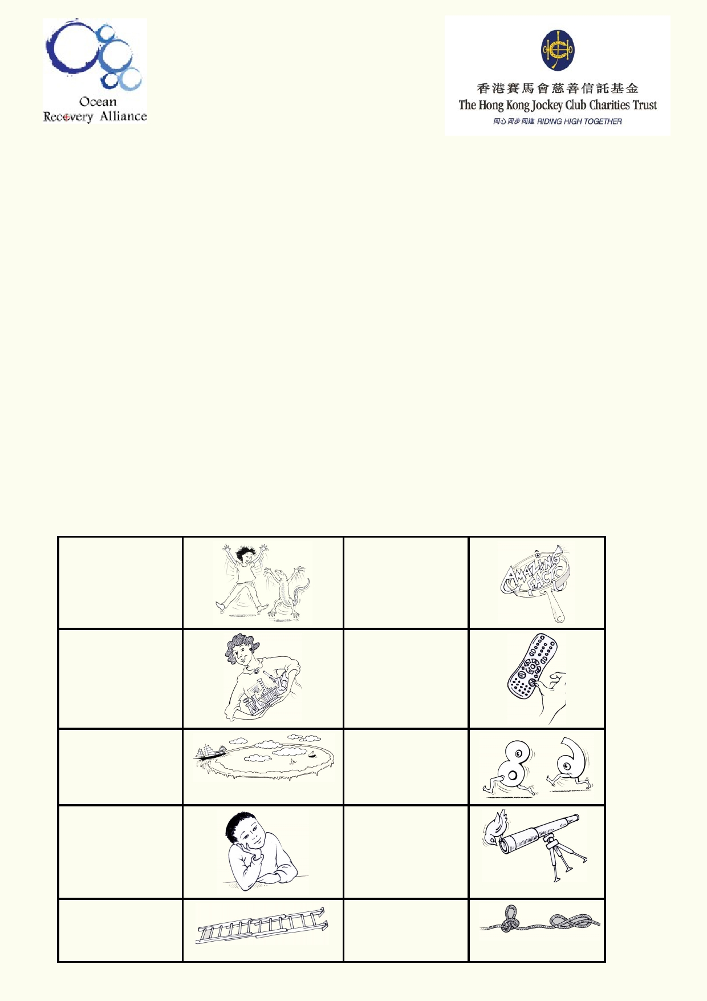About The Jockey Club Water Caretakers of Tomorrow Programme:
Jockey Club Water Caretakers of Tomorrow Programme is organised by Ocean Recovery
Alliance, Ltd and funded by The Hong Kong Jockey Club Charities Trust. There are eight units in
this program, and each of them is designed with you, a student in Hong Kong, in mind.
These are the goals for your lessons, to:
• Understand and appreciate how our water systems function on a local and global scale.
• Understand how watersheds function, and the interconnections of life within and between
these watersheds.
• Be able to assess threats, such as pollution and habitat destruction, and learn how to lessen
these effects.
• Be empowered to take an active role as caretakers of our water resources by sharing your
commitment with your communities.

Student introduction
• You will need access to the internet.
• In some activities using the camera in your smart phone or tablet will be useful.
• Your teacher will tell you if you if your work will be done on your computer, printed paper or
notebooks.

Start of a new A new amazing activity. f act .

Get ready to do an experiment.

Identify your
misconceptions
before your move on.
Identify your
prior learning.

An extension activity.

Fast forward to
make your
contribution to improving our world.
Data will be used
to solve
problems.

These are the goals for this unit.

A cross-
curricular
activity

2

At the end of this unit I will be able to:
• Understand how to find and identify the location of sewage and drainage
systems in my neighbourhood.
• Explain the purpose of drainage and sewage systems
• Design a fieldwork activity to gather data that answers questions about
stormwater pollution.
• Identify issues related to drainage and sewage.
• Identify ways to reduce water pollution related to drainage.
• Develop a communication project that educates a section of my community about reducing
the community's impact on water pollution.

Glossary

Data

Drain

Climate

Climate change

Groundwater

Gutter

Inorganic

Litter

Organic

Permeable
and Impermeable

Pollution

Sewage

Sewer or
sewerage system

Stormwater

Waste

Watershed

Weather

Systematic recording of observations.

Enclosed (pipe) structure that channels running water.

The average weather for a region over many years.

Refers to changes in the average weather as a result of natural variations
such as changes in the sun's radiation or human influences such as the
release of greenhouse gases.

Permanent water stored in the ground.

Open structure that channels running water on buildings, streets etc.

Material that does not come from living matter.

Waste that has been allowed to escape into the environment where it can
cause pollution or injure wildlife, etc.

Material and products that are living matter or have been produced from
living matter.

Gas or liquid can pass into or through material Gas or liquid can't pass into or through material

Contamination of the air, water or soil from human activity.

Wastewater from communities and businesses toilets, bathrooms, kitchens
and often industry.

Pipes that channel wastewater from toilets, bathrooms, kitchens and
laundries to a sewage treatment plant.

Water that collects during and after rain.

Any material no longer needed for its original purpose.

The boundary of land that marks where the passage of water will drain in a landscape.

Daily, weekly and seasonal changes in temperature, humidity, wind,
precipitation, etc.
3

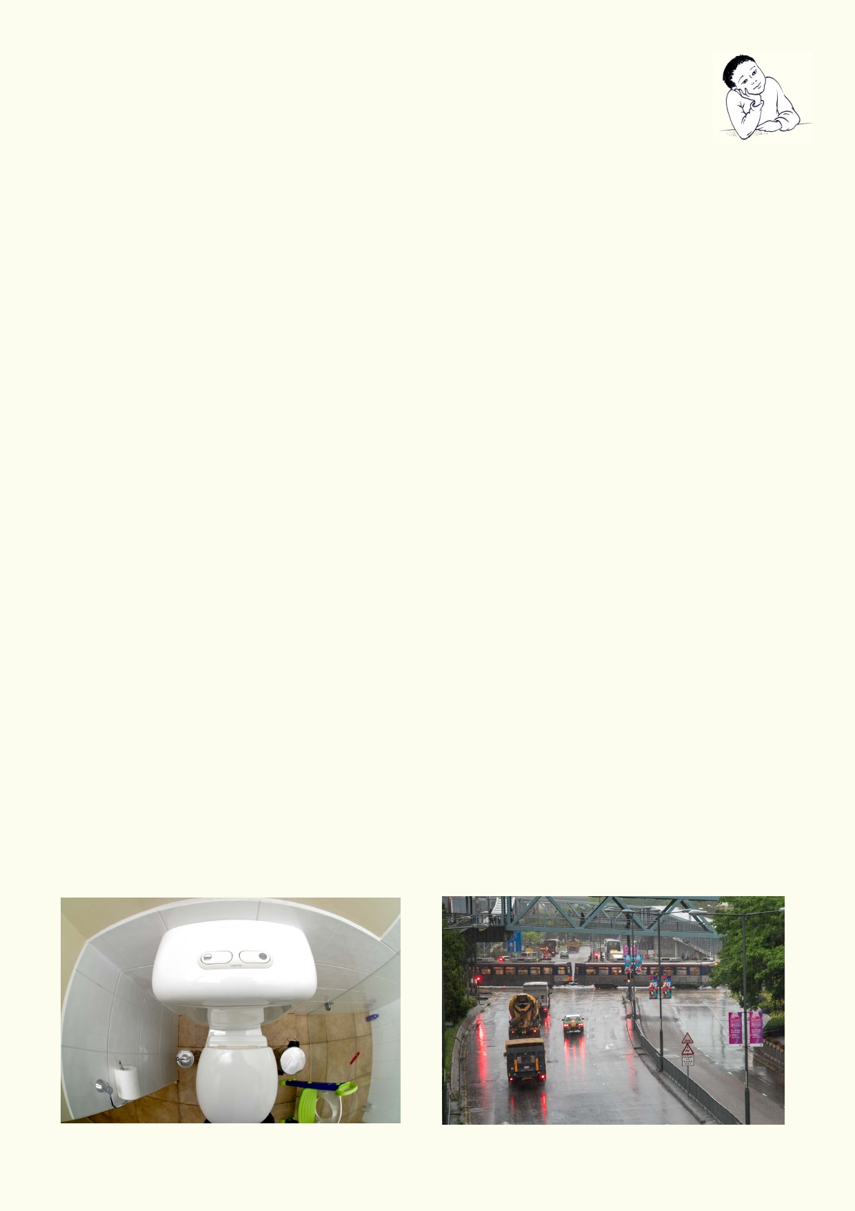What do I know?
Where does rainwater flow after it rains?

________________________________________________________________________

________________________________________________________________________

What stories have you heard about floods in cities and towns?

________________________________________________________________________

_________________________________________________________________________

Why is litter on land a problem for waterways?

_______________________________________________________________________

_______________________________________________________________________

What other things can cause water pollution besides litter?

_______________________________________________________________________

_______________________________________________________________________

Where does the water used at home and school come from?

_______________________________________________________________________

_______________________________________________________________________

What is the difference between stormwater and sewage?

_______________________________________________________________________

_______________________________________________________________________

4

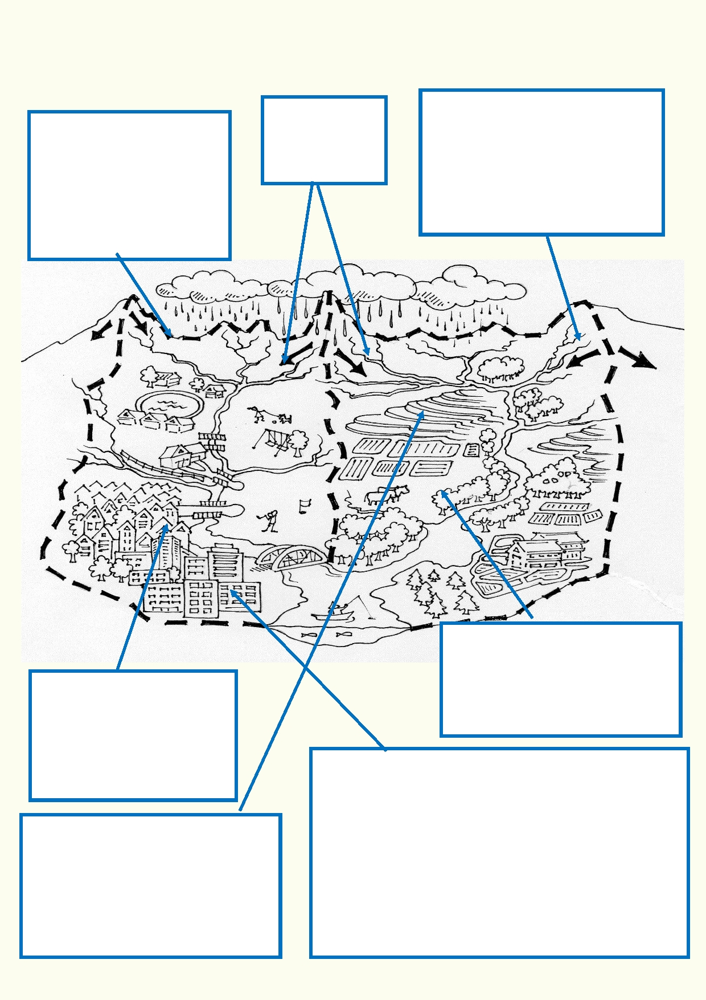Lesson 1 - All washed out
We live in a watershed

A watershed is the boundary of land that marks where the
passage of water will drain in
a landscape. A valley is an

Rainwater that
doesn't soak into
the ground runs
downhill.

Hong Kong has very steep slopes
allowing heavy rainfall after it hits the
ground to rush downhill. To reduce
the chance of floods, concrete
barriers over gullies hold back the

example of a watershed. The
water ends up in a stream,
river, lake or sea.
.
water, allowing the water to drain out
slowly.

Where land is farmed, heavy rain
has more chance of running off the land because land with crops does

Any polluting materials on the
ground, including on streets
and farms will be collected by
rainwater and washed into the
streams, rivers, lakes and the sea.

Some of the rainwater that soaks into
the ground will collect as groundwater. This underground water is also part of
the watershed. This water moves very
slowly downhill. Where the water table reaches the surface, we have a spring.
not absorb water as well as forested
or uncultivated land.

Where there are towns, cities and many streets, rainwater
hits many hard surfaces. There is less chance of water
soaking into the ground and much of the water needs to
go somewhere. People have constructed stormwater
drains so rainwater can harmlessly travel to the closest
stream, river, lake or into the sea. If there is more
rainwater than can be carried in the stormwater pipes,
then the streets will flood. Rising water can then flood
buildings. Traffic will come to a standstill and people
caught in the flood can drown.

5

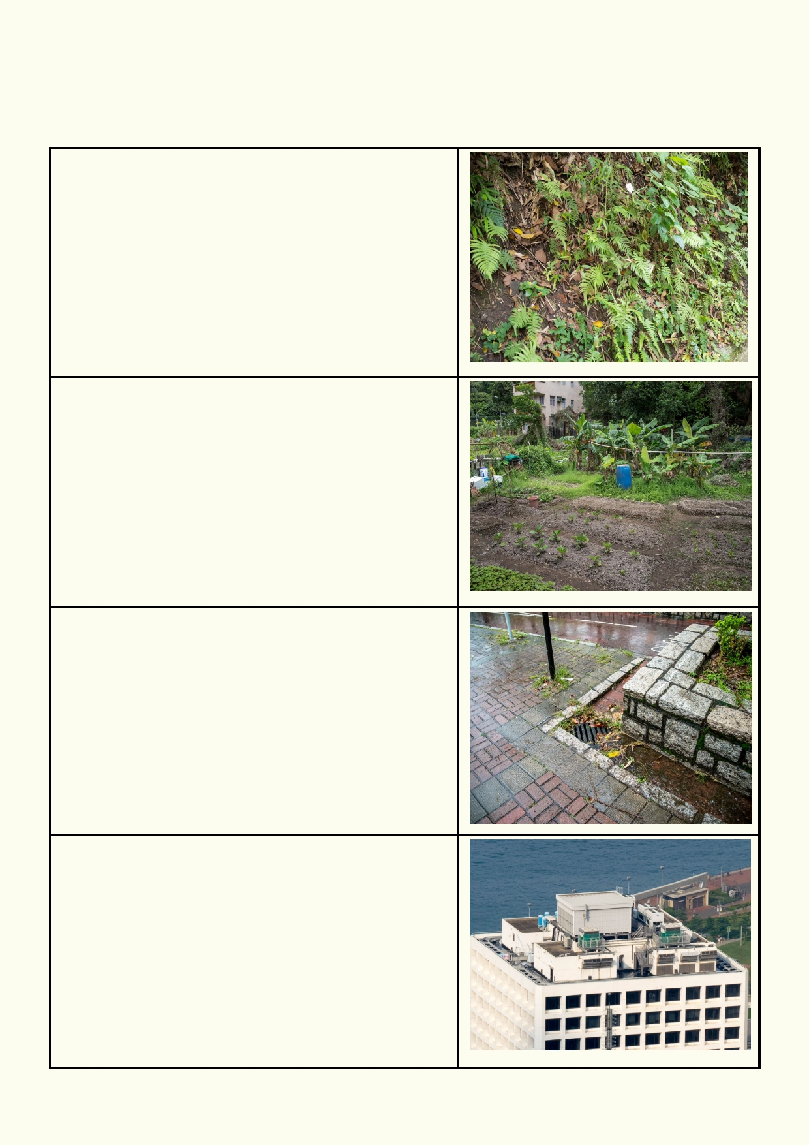Activity 1. Where does the rain go?

Explain what will happen when it rains on these surfaces in the photos.

6

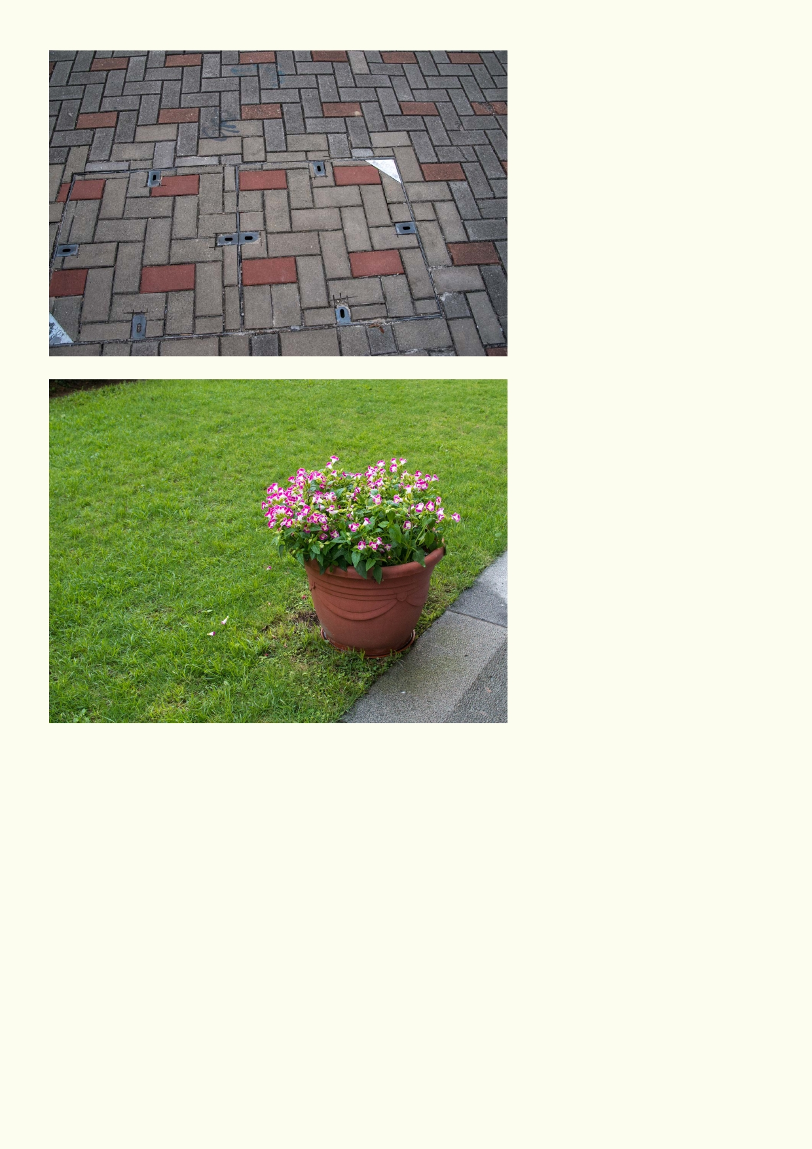
How would you describe these
two surfaces?

1. ___________________________________________________________________________

2. ___________________________________________________________________________

Explain which surface is more permeable to water.

_____________________________________________________________________________

_____________________________________________________________________________

7

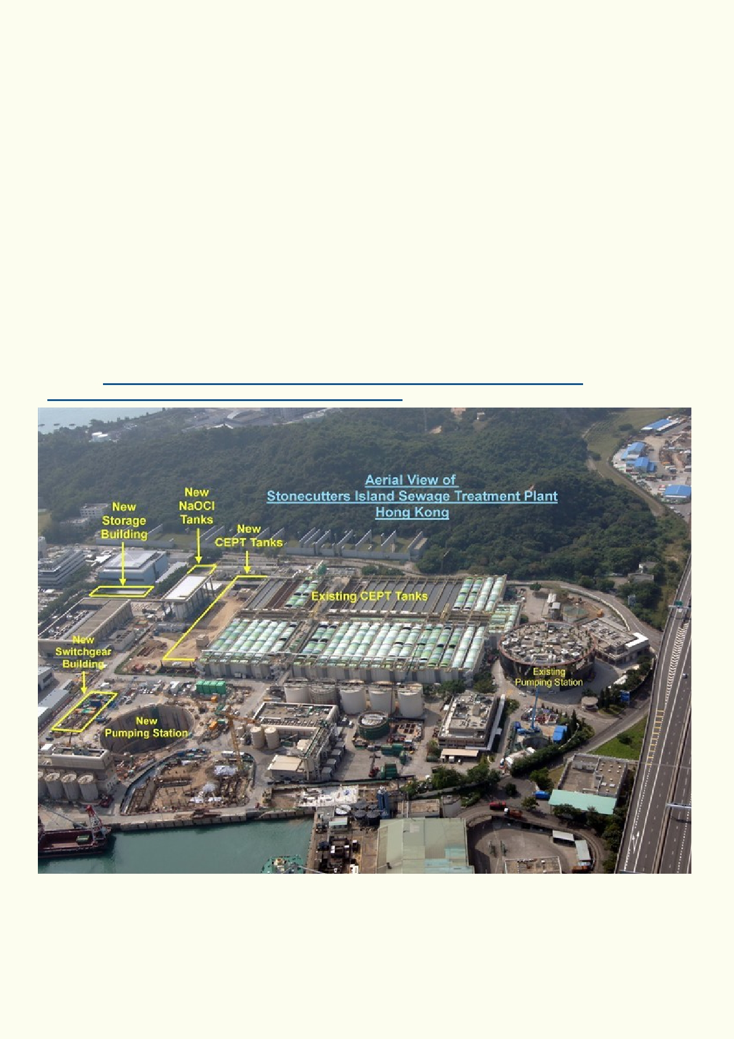Disposing of water

Once people start living in cities, they need to access clean water and to get rid of waste in order
for the population to remain healthy. Waste can include dirty water, sewage, unwanted food,
packaging, garden waste, etc.

Buildings and roads don't absorb rain so cities need a system to remove rainwater quickly. The heavier the rain, the more important the removal of the water is, to prevent flooding.

In modern cities, water is piped to the buildings. Often the water is treated before it is piped so it is safe to drink. Safe drinking tap water is referred to as "potable water".

Wastewater from dwellings and workplaces needs to be safely disposed of. "Blackwater" is the name given to wastewater from toilets. "Greywater" is the water from showers, baths, sinks and
washing machines, among other domestic sources. To protect our own health and the
environment, both black and grey wastewater must be treated so it is safe to release back into
the environment. This wastewater is called sewage and the pipes it travels through is part of the
sewer system. Below is an example of a sewage plant where sewage is treated.
Source: http://www.biwater.com/Articles/325198/Biwater/BW_Home/waste_water/
waste_water_projects/Stonecutters_Island_STW.aspx

8

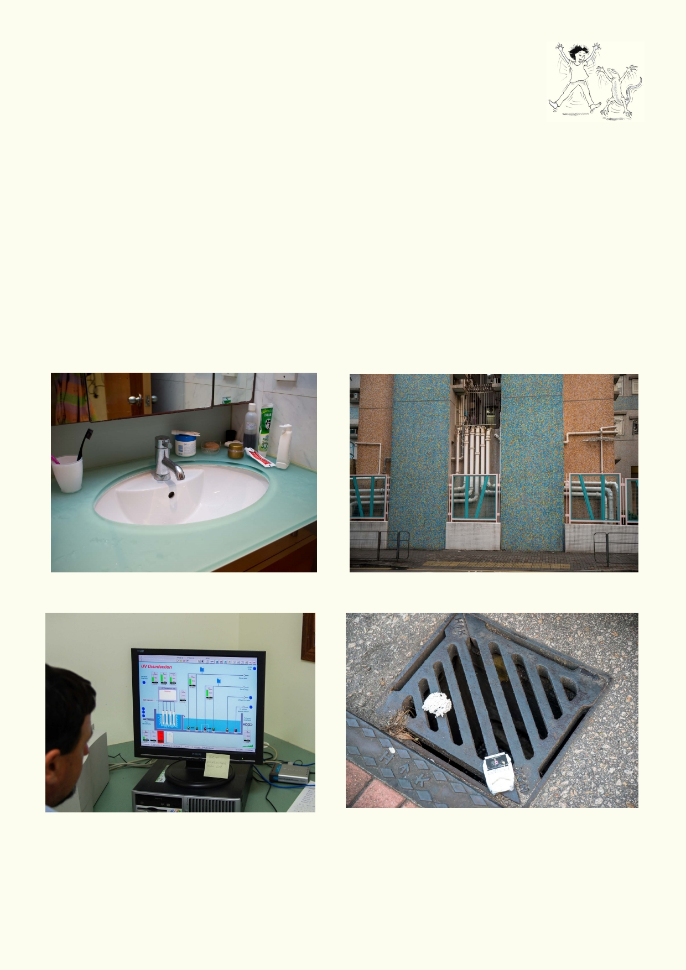Activity 2. Stormwater and sewage system

When our towns and cities are constructed, stormwater pipes are laid under our
roads and pavements. They are organised so that gravity will take the water to
the nearest stream, river, lake, dam or the sea.

Along the roads are stormwater entrances to collect water from the road. Buildings have pipes that directly connect to the underground stormwater pipes.

Any untreated wastewater being released from homes, industry or farms can also pollute the
streams, rivers, lakes and the sea. If it soaks into the ground, it will pollute the groundwater as
well.

Greywater and blackwater are carried in separate pipes to a sewage treatment plant. Where necessary, pumps will help to transport the sewage.

This waste water is treated as sewage. There are stormwater, sewage and water pipes.

Operating a sewer from a computer. Litter in the stormwater will go into the sea.

9

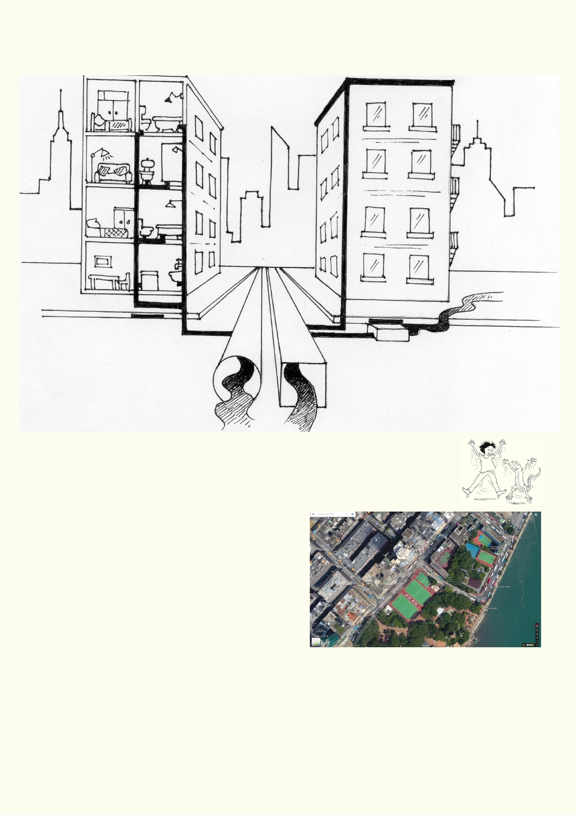Complete the drawing and label how the pipes in a home are linked to the separate sewerage
and stormwater systems.

Activity 3. Where are the drains?
Using online maps, you will guess where your school's stormwater drains go.
Revise fieldwork preparation and personal safety before venturing outdoors.

Equipment:
Camera in mobile phone or tablet

Method:
• Get into groups of three.
• Use Google street maps to see your school
and neighbouring streets.
• Go outdoors to view the school, local buildings
and the streets. Take a mobile phone or tablet
to take photos.
• Find gutters and evidence of rainwater coming off roofs and the road.
• Find grills on the ground that enter into the stormwater pipes below.
• Look for large stormwater pipes on the sides of buildings.
• Take photos of gutters, drains, grills and exposed pipes on buildings. Identify what direction
slopes downhill.
• Back in class, use an online map (e.g. Google Maps). Suggest in what direction stormwater
pipes will direct stormwater from your school and local streets.

10

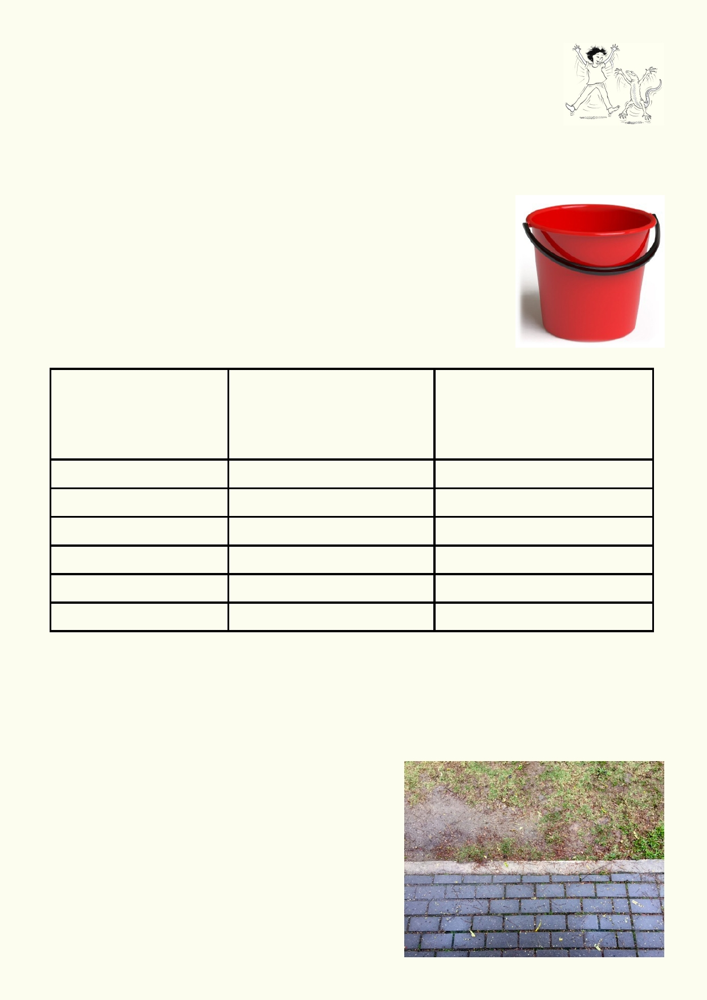Activity 4. What happens to water when it hits the ground?

In small groups you will find out which surfaces around the school are permeable and impermeable to water.

Equipment: Buckets of water, phone or tablet with camera, data sheet and pencil

Method:

1.
2.
3.
4.

5.

6.
Get into small groups
Identify what kind of ground surfaces are around the school.
Each group, fill a bucket or another container with water.
Go outdoors and tip the water onto different surfaces. Surfaces can
include soil, footpaths, sand, etc as well as flat and sloped surfaces.
Record and photograph your observations of water on different
surfaces.
Record which surfaces are permeable and impermeable to water.

Type of surface

Flat surface or sloped

Observation
Describe what happened to
the water, e.g. soaks into
ground, stays on surface, flows
away

Which surfaces soak up rain?

_________________________________________________________________________

Which surfaces allow rain to run away?

____________________________________________

Which types of surfaces increase the amount of water
that can sink into the ground?

____________________________________________

____________________________________________

____________________________________________

____________________________________________

____________________________________
11

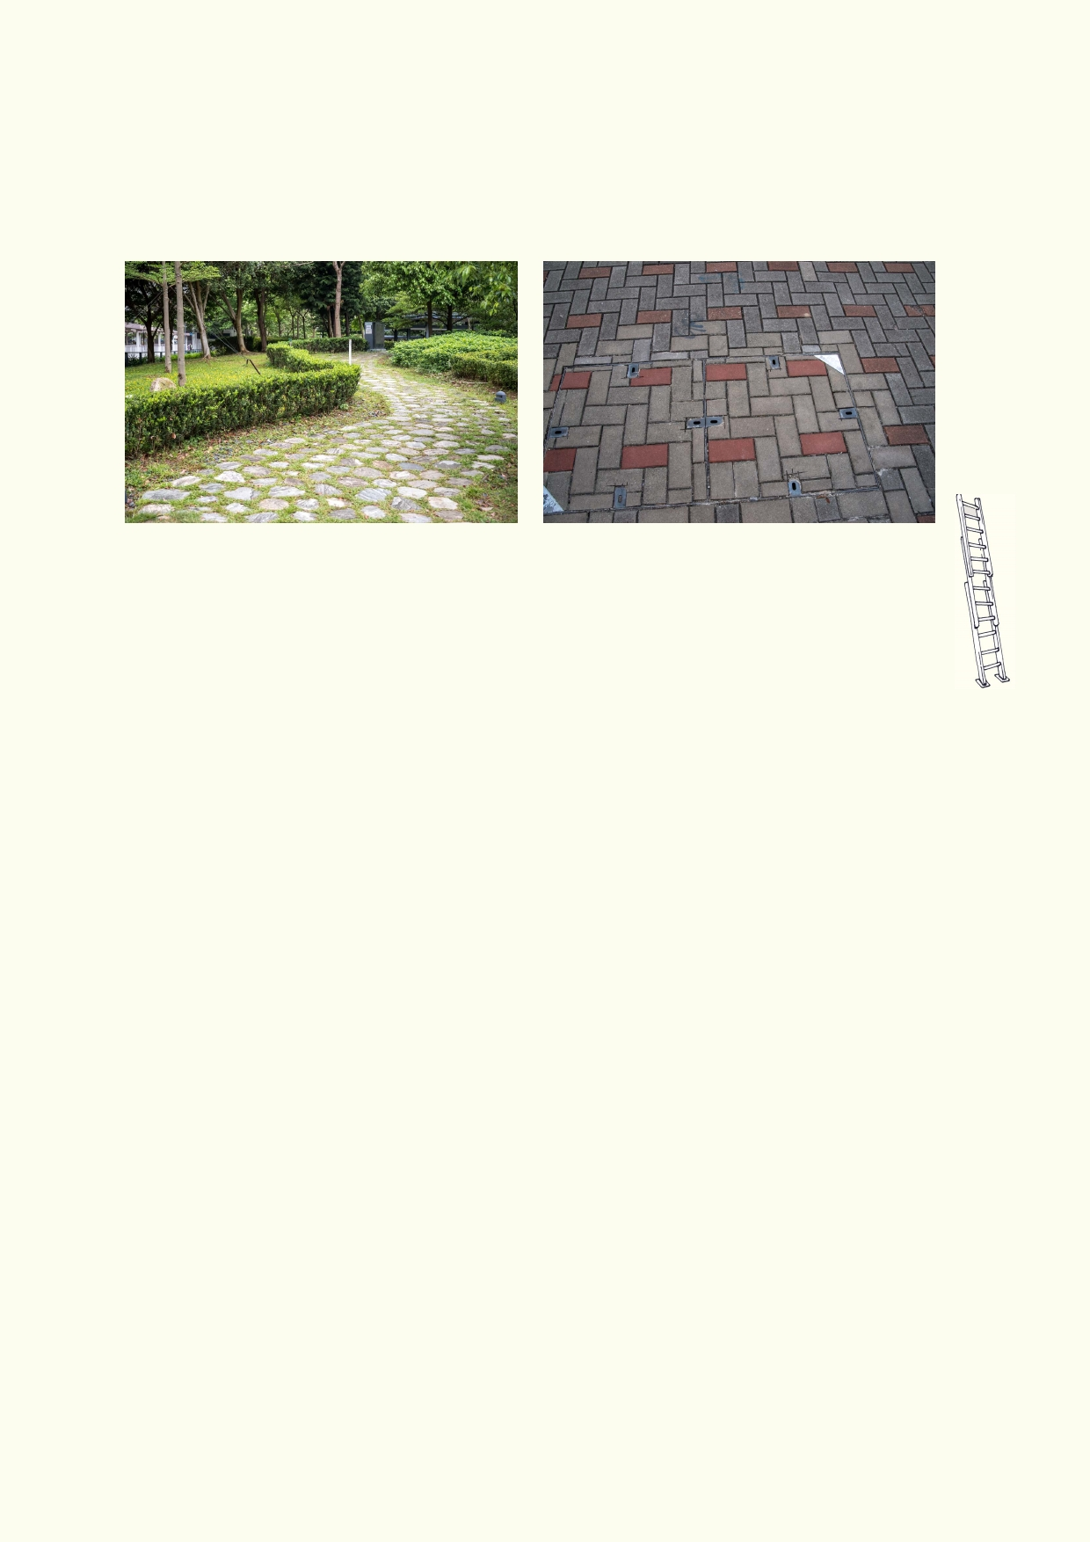Why is it important to soak up water rather than letting it run off the land's surface?

___________________________________________________________________________
___________________________________________________________________________

___________________________________________________________________________

Extension:
1. Use a phone or tablet to take photographs of different surfaces and put in order of
least to most permeable.
2. Research and describe at least three strategies to increase permeability of surfaces
in a city.
___________________________________________________________________________

___________________________________________________________________________
___________________________________________________________________________ ___________________________________________________________________________

___________________________________________________________________________
___________________________________________________________________________

Activity 5. Where do the stormwater and sewage end up?

Equipment: writing material, access to computers or tablets to get access to online maps

Make a list of the different sources of wastewater from the home and the community:

___________________________________________________________________________

___________________________________________________________________________

___________________________________________________________________________

___________________________________________________________________________

___________________________________________________________________________

___________________________________________________________________________

___________________________________________________________________________

12

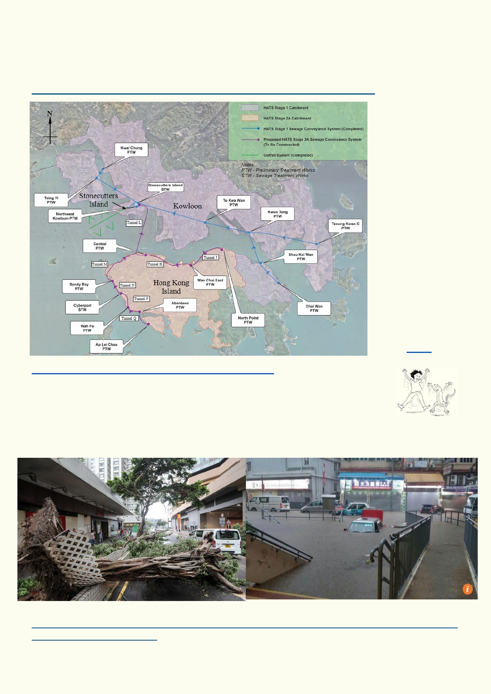These sources of waste are all bound for a sewage treatment plant.
All the smaller sewer pipes are connected to major pipe lines. Use the map below to find which of
the major sewer pipe lines your area is connected to. Locate your sewage treatment plant using
this link and Google Maps .
http://www.dsd.gov.hk/EN/Sewerage/Sewage_Treatment_Facilities/index.html

Source: http://

www.tunneltalk.com/HongKong-HATS-Programme.php

Activity 6. Potential impact of climate change - can our stormwater system
cope?

We will always have variable weather. We will continue to have storms and
typhoons causing a lot of destruction. Can we claim that climate change makes some of these
events worse?

Source: South China Morning Post
http://www.scmp.com/news/hong-kong/health-environment/article/2000460/little-damage-typhoon
-nida-due-extensive-disaster

13

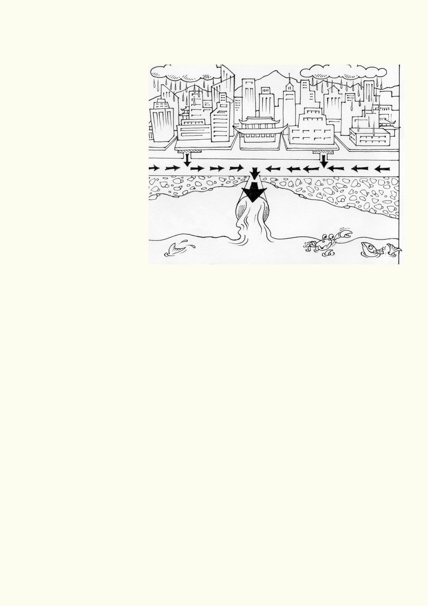When our streets flood, it is because our stormwater systems can't cope with the volume of
water. There are many causes for our stormwater being unable to carry the water away during
heavy downpours:
• Sometimes the drains are
blocked with litter.
• Often the stormwater
pipes just aren't large
enough to remove water that quickly.
• During a storm, the
outlets of the stormwater
pipes might be below the
water level due to high rivers and the sea.
Water pressure from the
rivers and sea can
prevent stormwater
escaping quickly.

What is your opinion? If we
have storms that produce even more rain, what might we expect in our drainage of cities, towns
and countryside?

___________________________________________________________________________
___________________________________________________________________________
___________________________________________________________________________

___________________________________________________________________________

What kind of evidence would you need to support your opinion?
___________________________________________________________________________

___________________________________________________________________________
___________________________________________________________________________

How could we reduce the impact of bigger storms?
___________________________________________________________________________
___________________________________________________________________________

14

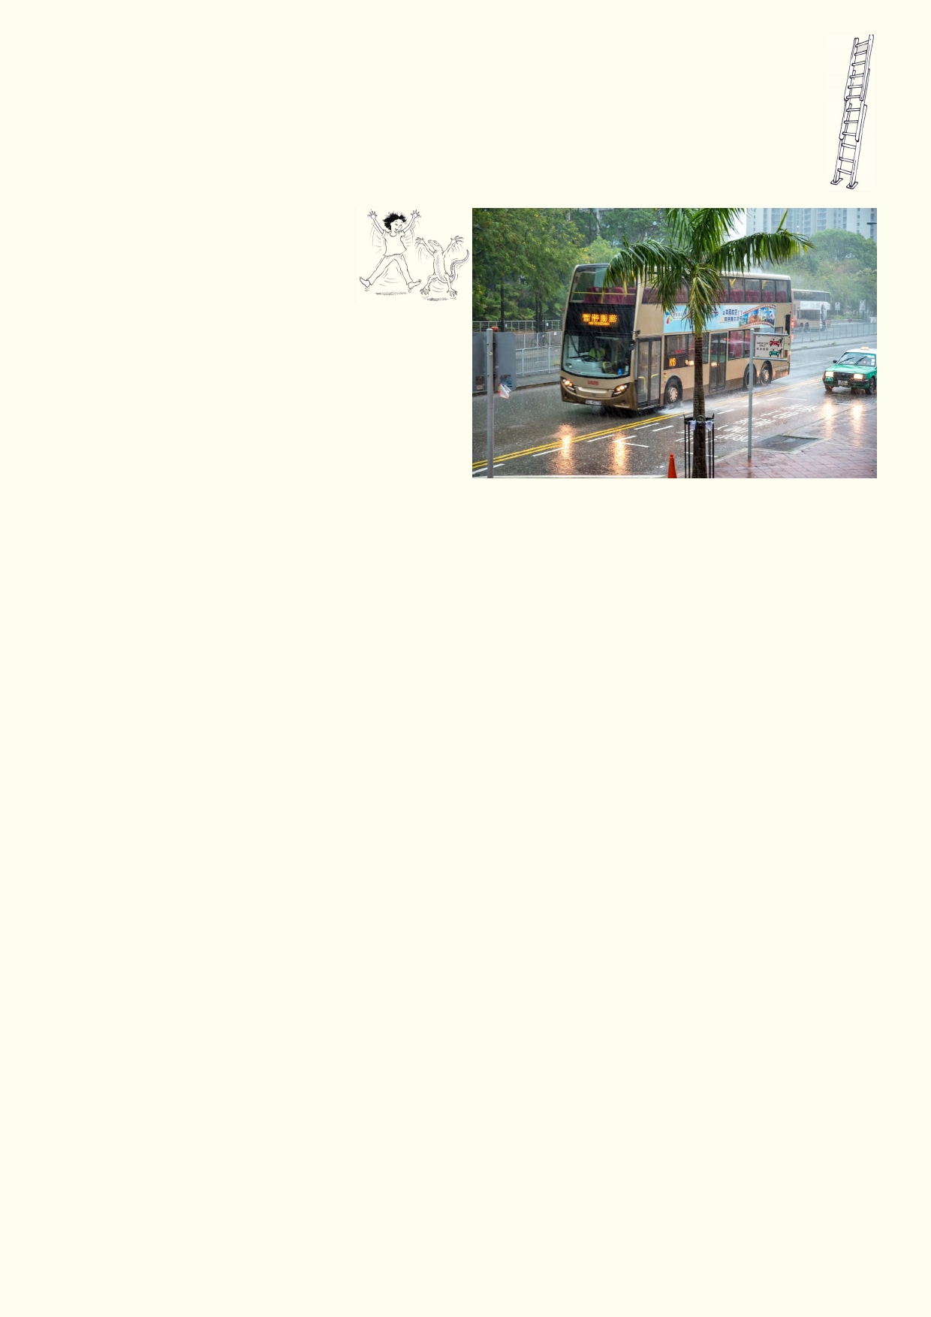Extension - Local floods

Do some research about past floods that have occurred in Hong Kong and China. Find
examples that were caused mostly by heavy rain. Find examples where high tides and big
waves also contributed to a flood. What is the difference between a flood caused by storms
and a tsunami?

Lesson 2. It stinks
Activity 1 - It stinks

Recall the weather when it's been
hot and dry in Hong Kong for weeks. There has
just been a heavy downpour of rain in Hong
Kong.

1. Describe how Hong Kong feels, smells and
looks after many hot days.

_____________________________________________________________________________
_____________________________________________________________________________
_____________________________________________________________________________ _____________________________________________________________________________

_____________________________________________________________________________
_____________________________________________________________________________
2. How does Hong Kong feel, smell and look after heavy rain?

_____________________________________________________________________________

_____________________________________________________________________________
_____________________________________________________________________________
_____________________________________________________________________________
3. Describe what happens to the rivers and the sea after the land has been washed clean.

_____________________________________________________________________________

_____________________________________________________________________________
_____________________________________________________________________________
_____________________________________________________________________________

_____________________________________________________________________________
_____________________________________________________________________________

15

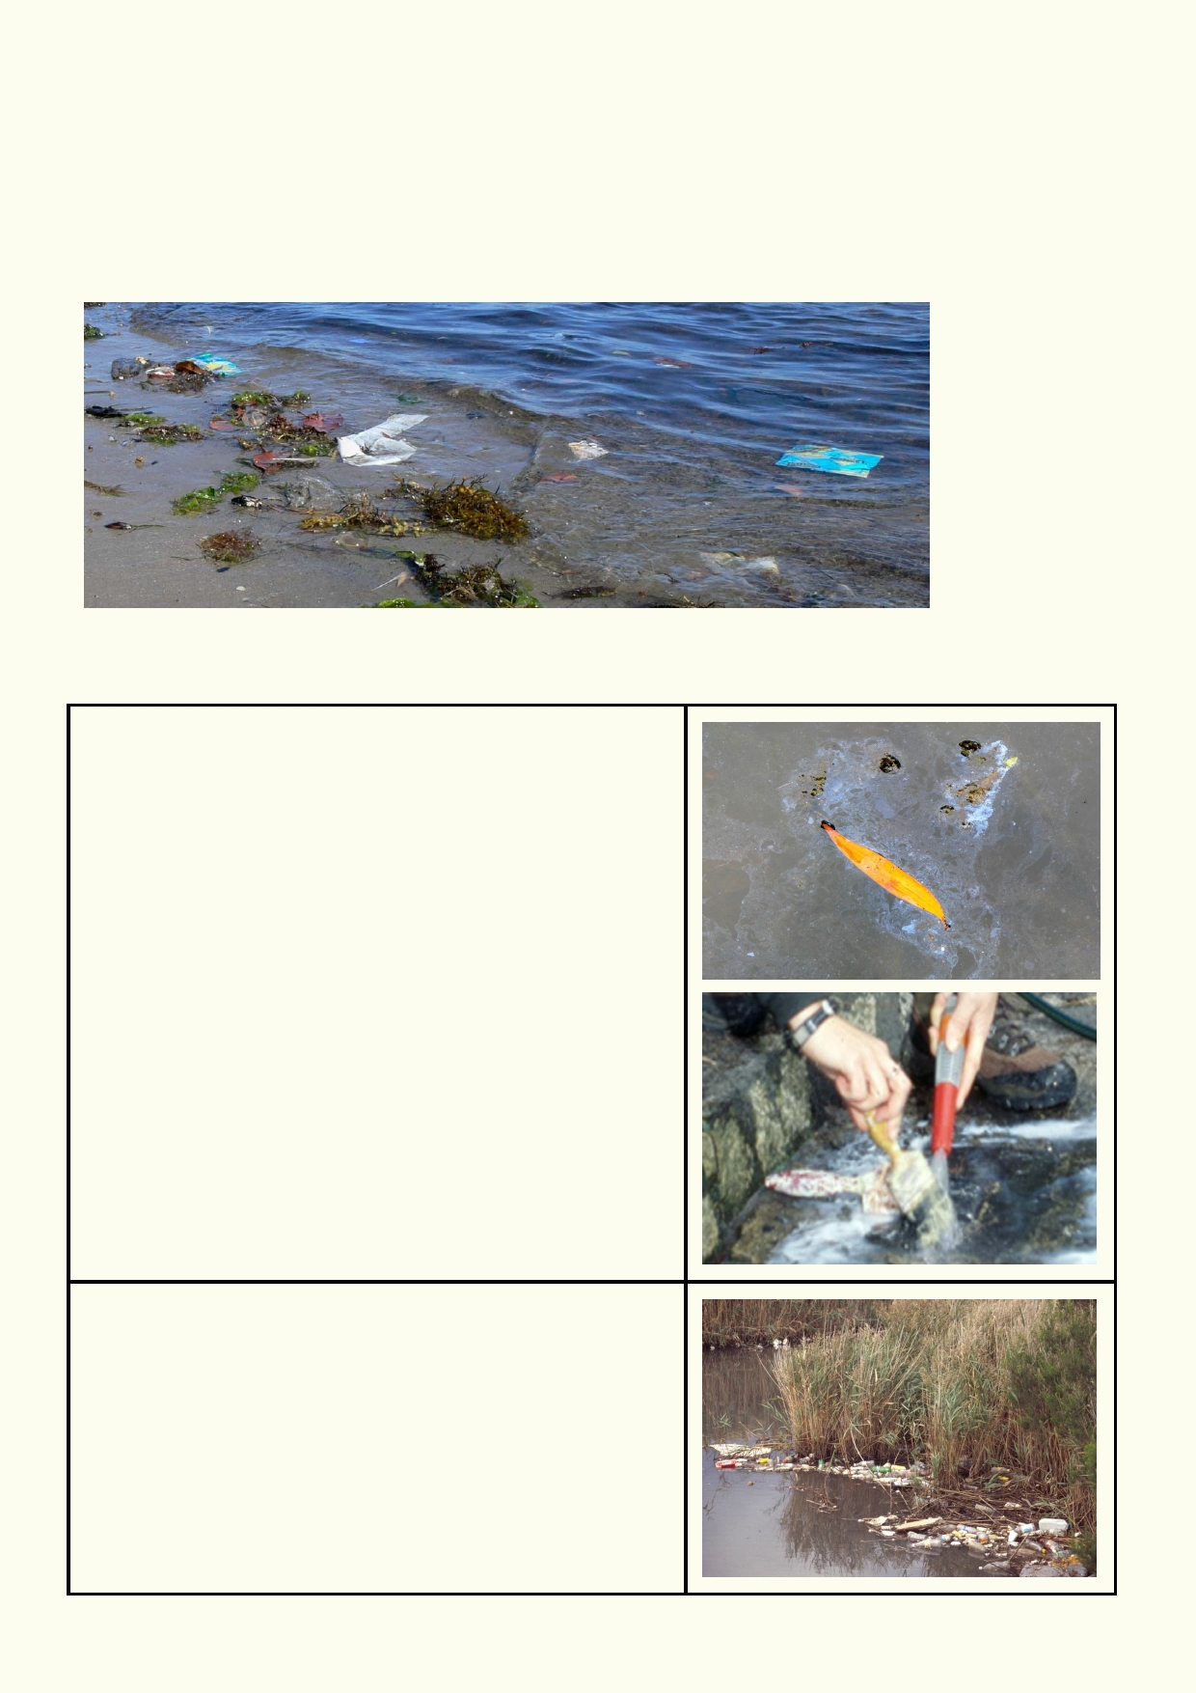4. Suggest how life in the rivers and seas are affected by polluted stormwater.
_____________________________________________________________________________ _____________________________________________________________________________
_____________________________________________________________________________

_____________________________________________________________________________

Main sources of stormwater pollution

Chemicals including oil, detergent, etc
Chemicals change the water quality. A small amount of
some of these chemicals such as oil can kill most of the
small creatures downstream. Some chemicals get into
the streams when cars leak oil, but sometimes people
dispose of oil down stormwater drains. No chemicals should ever be disposed of down drains.

Litter
Plastic, paper, metal and food are just some of the litter
that is dropped in the environment. When they reach
the water the items that rot contaminate the water.
Items that don't rot can hang around for many years,
injuring and killing wildlife.

16

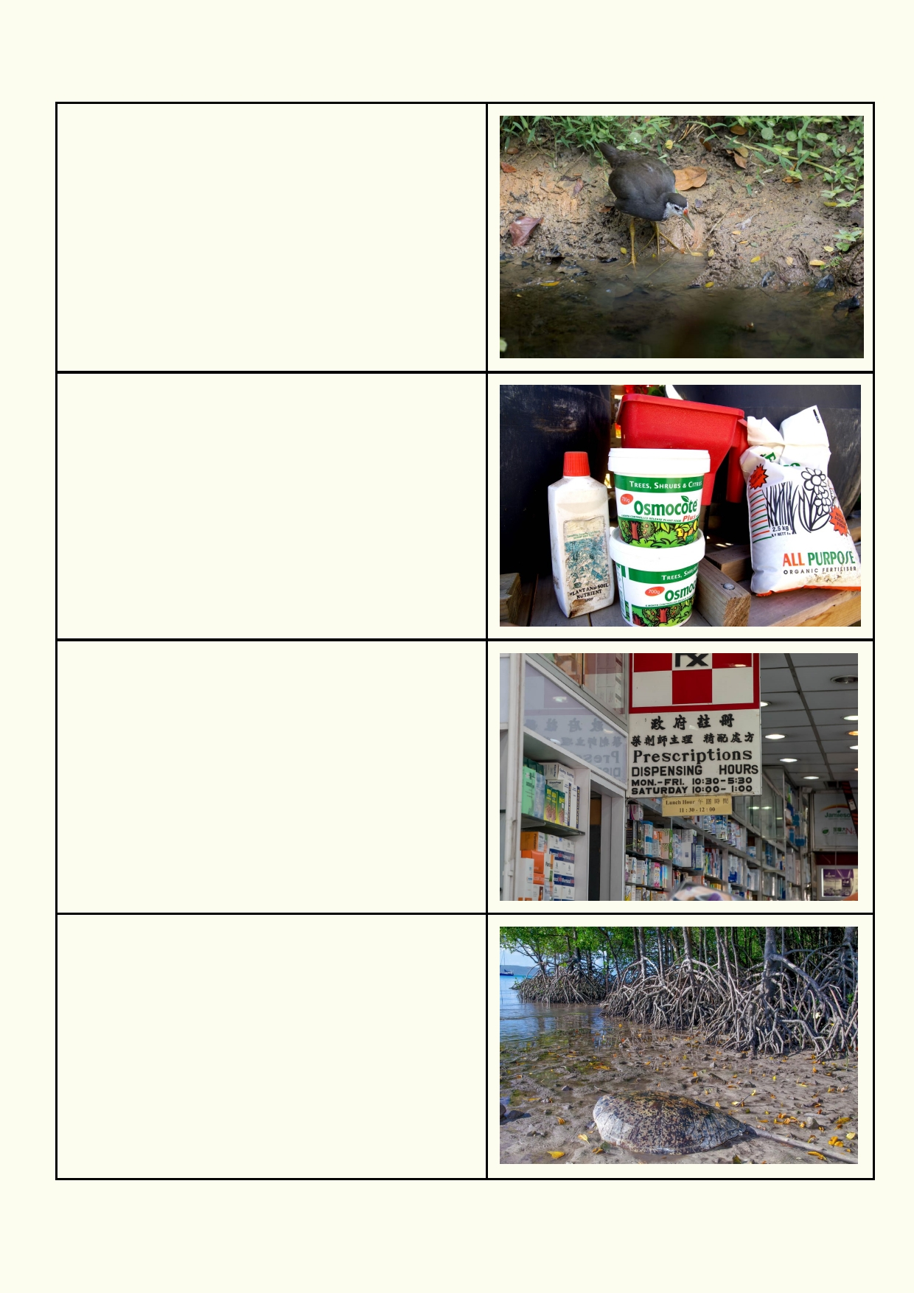Main sources of storm water pollution continued.

Soil and erosion
Soil washed into streams, rivers and the sea,
reduces the depth sunlight can penetrate into the
water. Aquatic plants beneath the surface have
less light to grow.

Fertiliser and insecticide
Fertilizers and insecticides used on farms, parks
and gardens cause problems once they have
been washed into streams, rivers and the sea.
Fertilizer and some insecticides increase the
growth of some aquatic plants and bacteria,
upsetting the ecological balance and even
reducing the oxygen level. Insecticides and
herbicides can destroy some of the aquatic
wildlife.

Hormones, antibiotics
Much of the medication we consume is excreted in
our urine. Even though it is treated in a sewage
treatment plant, some of the active chemicals can
make its way into the rivers and sea. The tiniest
concentration of some medications can have a big impact of the lifecycle of some animals. Antibiotics
released into the environment increase the rate at
which bacteria become resistant, leading to more
resistant diseases infecting humans.

Specific plastic issues
Plastics in the rivers and sea have become a
silent killer. Larger items of plastic can choke
aquatic and marine animals. 50% of dead birds
washed up on the beach have plastic in their
stomach. Animals can also get entangled in plastic. As plastic breaks down into smaller
pieces, polluting chemicals stick to them. When
eaten, the animals ingest higher and higher levels
of pollution.

17

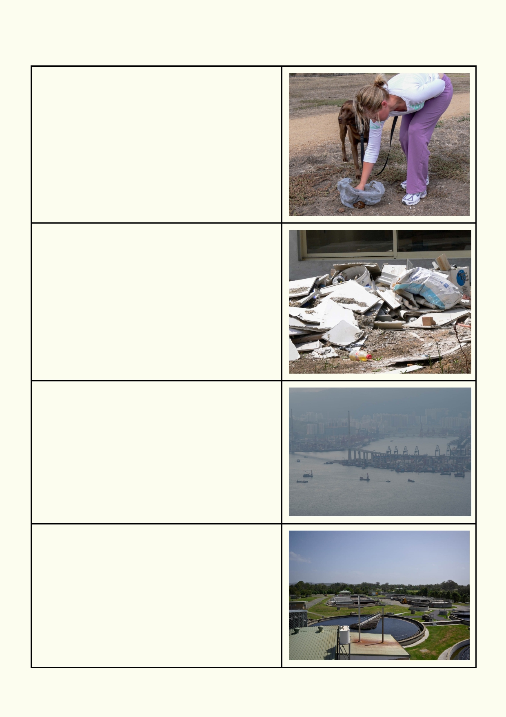Main sources of storm water pollution continued.

Domestic animal and human excrement
In some cities pet droppings along the footpath and
drains are a major source of water pollution. Rain will
dissolve the animal dropping and wash the material
down stormwater drains.

Building sites
Unless all materials including the waste are carefully
looked after on a building site, some of the polluting
waste will be washed down the drains or blown
away.

Air Pollution
Many of the more complex chemicals that pollute the
air will come down with the rain. Different chemicals
will have different impacts. Some chemicals come
down as acid rain, others are poisonous and some of
the most poisonous chemicals can build up in the streams, rivers and the sea.

Factory or sewage outfall
When factories or transport have accidents, polluting
liquid chemicals can quickly flow into the stormwater
system causing major pollution. Laws require
everyone, including industry, to dispose of polluting
chemicals responsibly. Sewage will overflow when
heavy rain flows into the sewage pipes and the
treatment plant can no longer hold all the fluid.

18

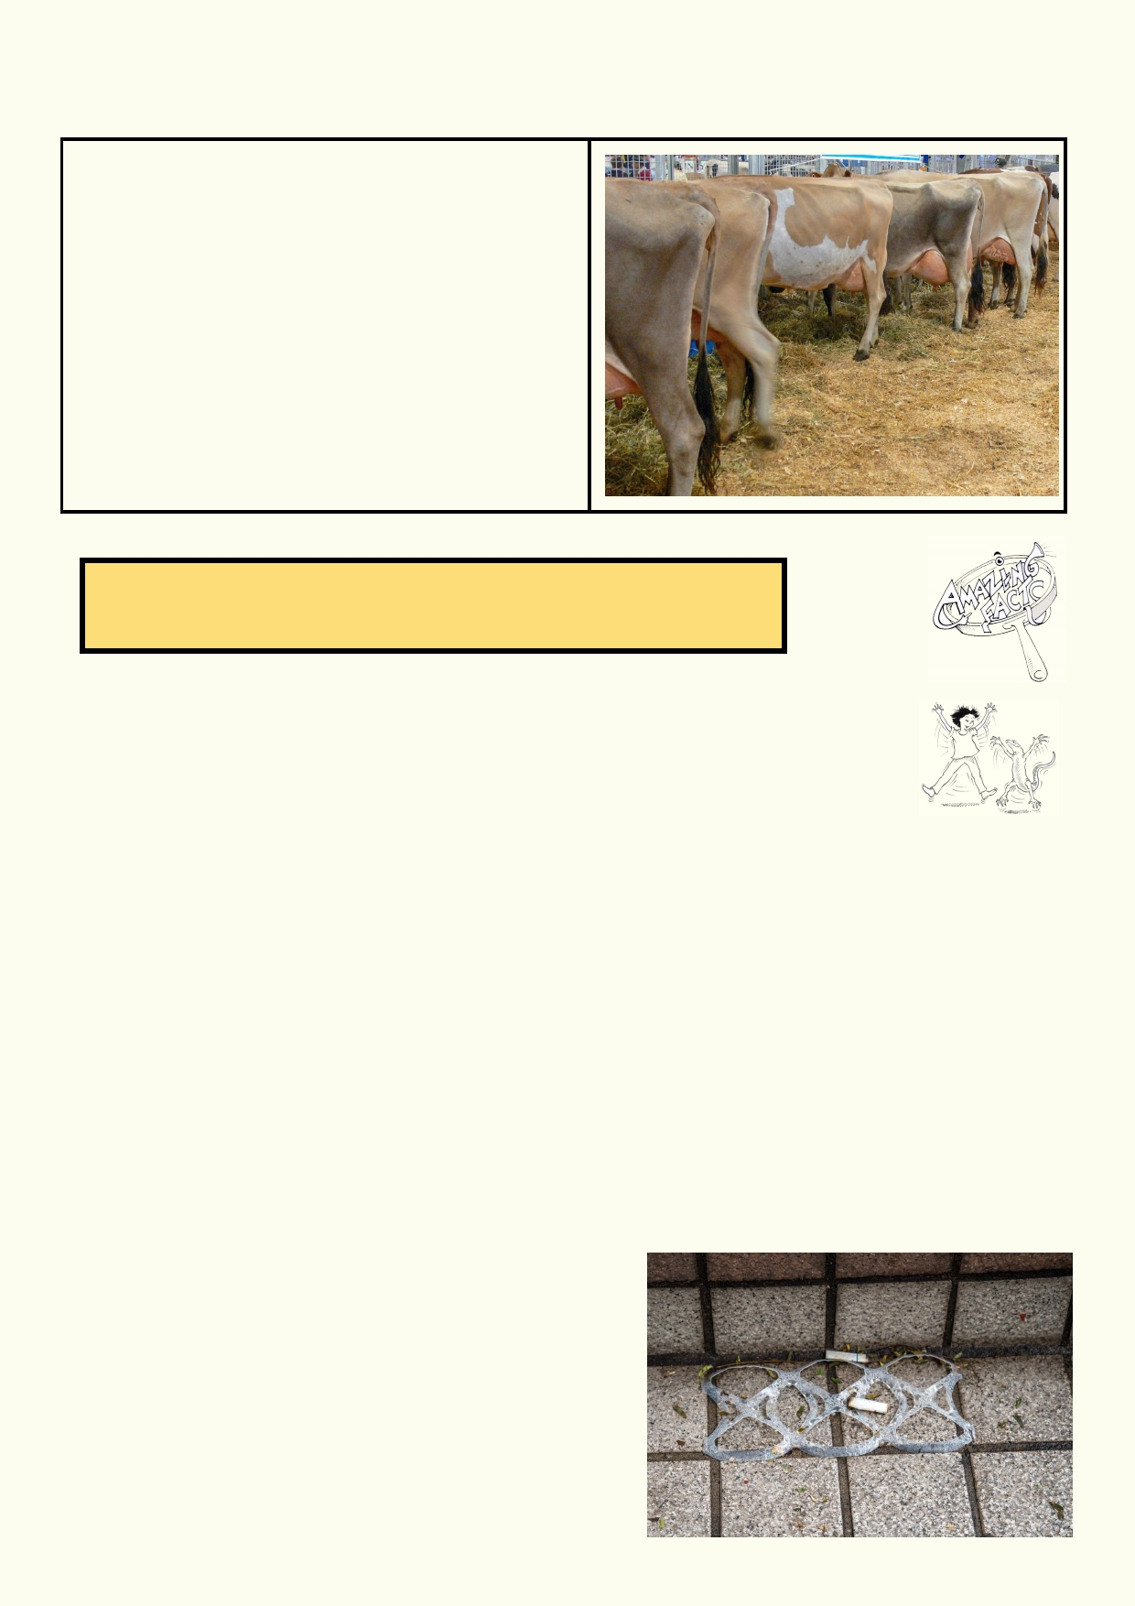Main sources of storm water pollution continued.

Sewage from feedlots
Pigs are usually raised in pens. Cattle and sheep
can also be raised in small enclosures. Food and
water are supplied to the animals. Their
enclosures need to be regularly cleaned,
removing their droppings and urine. If this sewage
is not properly treated, it will get into the water
table or the local streams and rivers. In the
manure are hormones and antibiotics fed to the
animals to make them put on weight. The
hormones can affect many water creatures and
antibiotics in the environment decrease the
effectiveness of these drugs.

Disgusting fact. The amount of visible litter in an urban river or a beach indicates the amount of dissolved pollution you can't see.

Activity 2: Litter and pollution survey
Litter is one form of pollution.

Before you investigate litter outdoors:
Which three kinds of litter do you think are most common around Hong Kong?

1. ________________________________________________________________________

2. ________________________________________________________________________

3. ________________________________________________________________________

What do you think is the most dangerous litter for people?

____________________________________________________________________________

Why is this plastic litter, pictured below, deadly for some wildlife?

_________________________________________

_________________________________________

If you do a litter cleanup outside your school grounds, you must always discuss with responsible adults how you will remain safe.

19

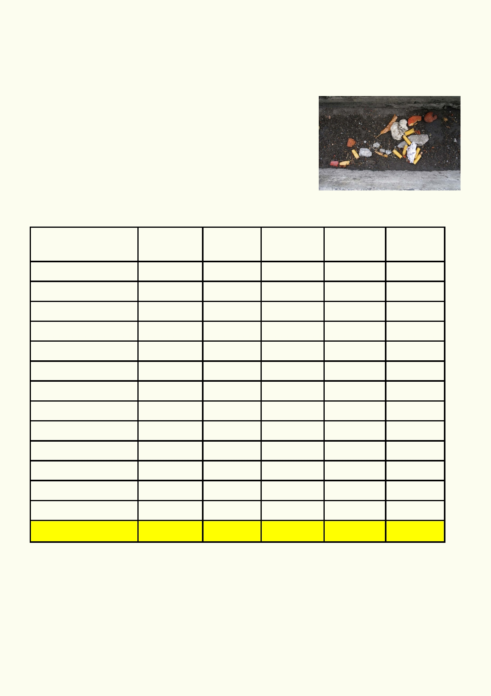Its stinks: Litter and pollution survey sheet

Location_____________Date _____________ Time ___________

Equipment: Clip board, pencil and record sheet. A tablet or phone for taking photos

Method:

1.
2. 3. 4.
5.
Review safety when working outdoors.
Choose where the survey will be done.
In each location count the number of different items of litter. Record what was found.
Photograph any locations where there is a lot of litter.

What is available in your neighborhood to help reduce litter and other forms of pollution getting
into storm water? hint: do you see trash cans, grills over stormwater drains, etc.

Type of litter or Footpath Gutter School Park Total
pollution

Metal can

Plastic bottle

Plastic wrapping
Plastic straw

Other plastic
Cigarette butts
Paper packaging

Other paper
Glass

Oil

Dog droppings

Other

Totals

_____________________________________________________________________________
_____________________________________________________________________________
_____________________________________________________________________________
_____________________________________________________________________________ _____________________________________________________________________________
__

____________________________________________________________________________20 _

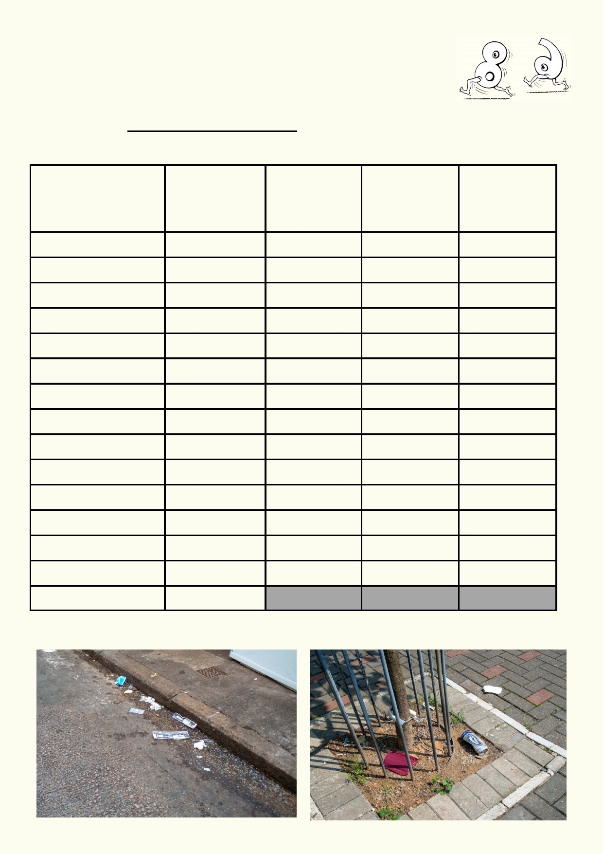Analysing the litter and pollution data

Fill in the table below, calculating the percentage of each type of litter, how
litter got to be there, and who or what caused the litter.

To calculate % Number of litter items for a type multiplied by 100
Total amount of litter Total of all litter

Type of litter or Total number Number of How the litter Who or what
pollution of items items % got there caused the
See above litter
chart

Metal can

Plastic bottle

Plastic wrapping

Plastic straw

Other plastic

Cigarette butts

Paper packaging

Other paper

Glass

Oil

Dog droppings

Other

T o t al

21

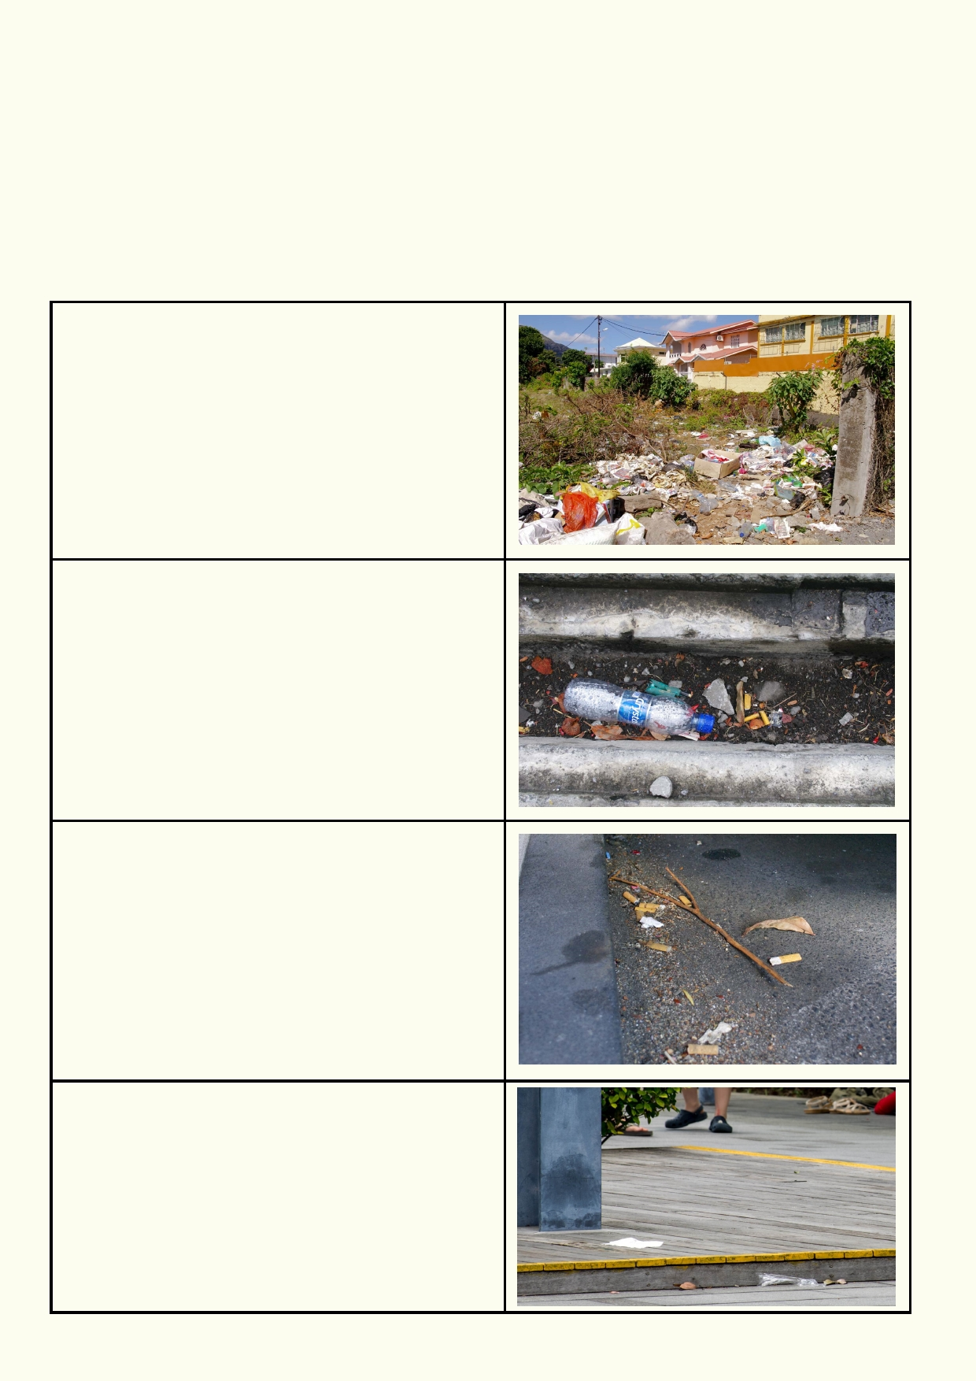Data analysis

Where is litter most likely to be found?

_____________________________________________________________________________

_____________________________________________________________________________

Use the ranking below to rank the level of litter found around your community:

Extreme
Piles of litter

Very high
Large amounts of litter in gutters, streets and
footpaths

High
Scattering of litter
More than 2 items of litter every metre

Moderate
Up to two items of litter every metre

22

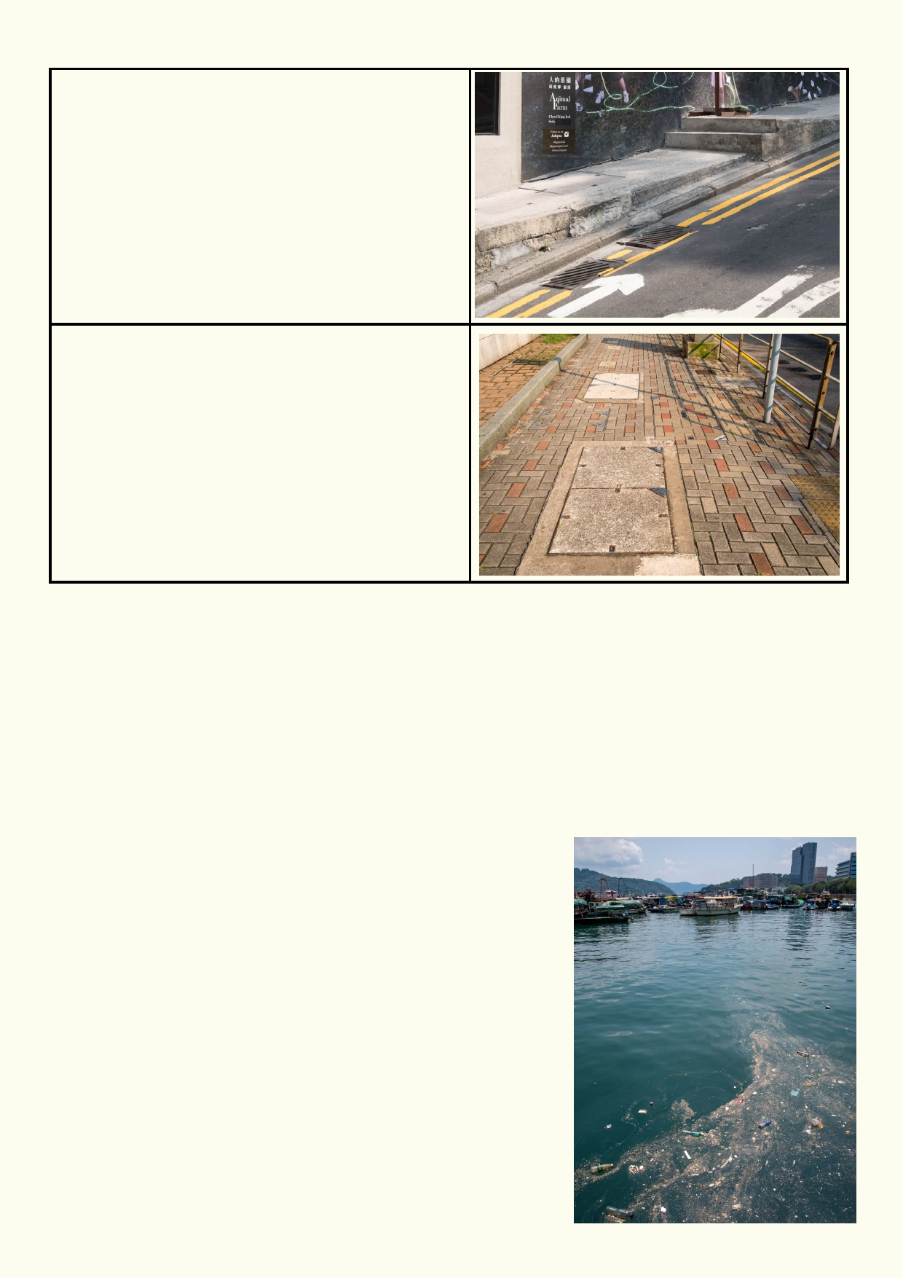Low
Less than one item of litter every 10 metres

Zero

The ranking for my neighbourhood was: __________________

What evidence was there for other forms of pollution that could end up down the drain?

_____________________________________________________________________________

_____________________________________________________________________________

_____________________________________________________________________________

__________________________________________________

The photo of this pollution was taken just as it poured out of a stormwater drain. Besides a lot of litter, there was a lot of dirt
and grease. Suggest where the dirt and grease came from.

__________________________________________________

__________________________________________________

__________________________________________________

23

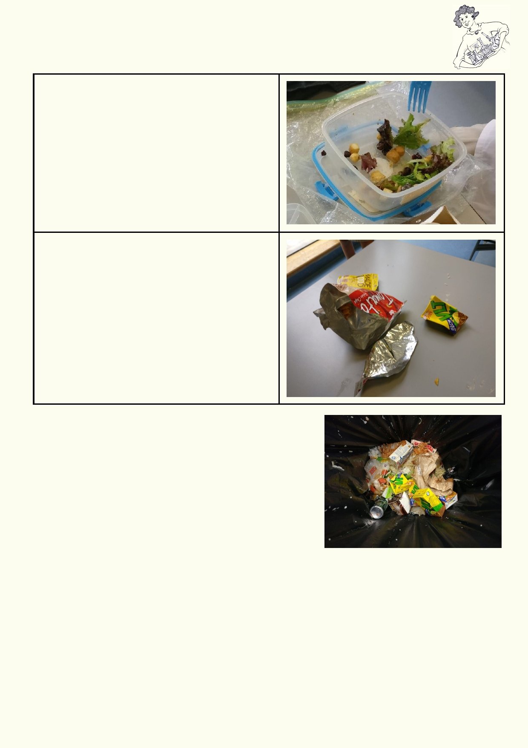Activity 3 - How water pollution works

Organic waste
Organic material comes from animals or plants. It
can include garden waste, vegetable waste, food scraps such as bread, meat products, vegetable
oils and fats.

In a student's lunch, organic waste mostly
consists of fruit scraps and uneaten lunch. Some
of this waste can be composted or fed to worms.

Inorganic waste
Inorganic material does not come from animals or
plants. Much of the inorganic waste we produce
comes from packaging which includes glass
bottles, cardboard, metal cans and a wide range
of plastics.

In a student's lunch, the common items of
inorganic waste includes plastic packaging and
drink containers. Some of this waste can be
recycled.

Equipment:
• Recording material
• Collect some of the class's lunch waste that normally
goes into the school's waste system, e.g. fruit peel, paper, plastic wrapper, unwanted food, etc.
• Common items of organic and inorganic waste from
student lunches
• Large glass jar with lid or small aquarium

Method

1.

2. 3.

4.
Collect samples of waste after students have finished
their lunch.
As a class review the difference between organic and inorganic material.
Place the organic and inorganic waste in separate small aquariums or jars of water in a safe
place for a week.
Record your observations.

Which materials are organic?

_____________________________________________________________________________

_____________________________________________________________________________

24

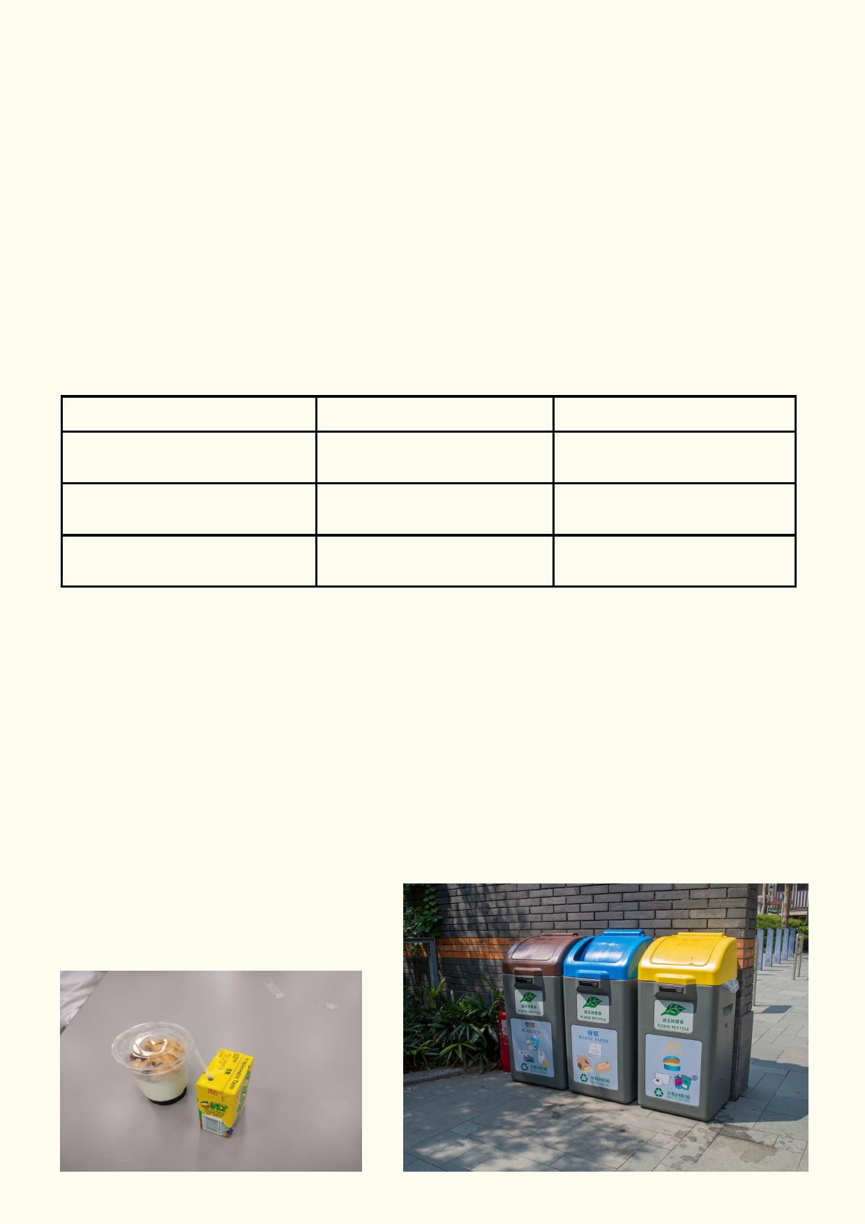Which items are inorganic?

_____________________________________________________________________________

_____________________________________________________________________________

Predict what will happen to the two types of waste when placed in water. What will happen to the
water?

_____________________________________________________________________________

_____________________________________________________________________________

Place the organic and inorganic waste in separate small aquariums or jars of water in a safe
place for a week and then record your observations:

Observations Organic Inorganic

Changes in the material?

Changes in the water?

Change of smell?

How do you think organic waste affects the water and the things that live in it?

_____________________________________________________________________________

_____________________________________________________________________________

How do you think inorganic waste affects the water and the things that live in it?

_____________________________________________________________________________

_____________________________________________________________________________

By always disposing of your waste correctly you will be helping many parts of your watershed.

25

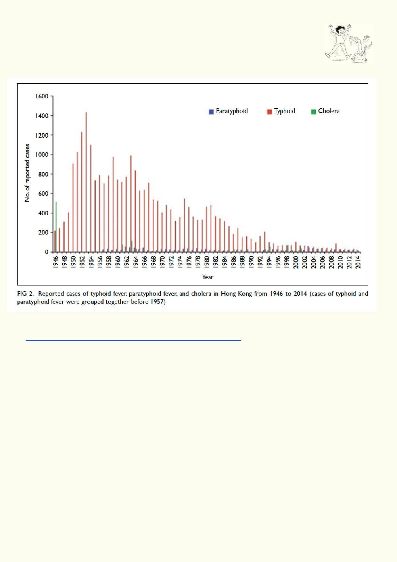Lesson 3: The dark mystery
Activity 1. Staying alive
Examine the graph below published by the Hong Kong Medical Journal.

Source: Hong Kong Medical Journal
http://www.hkmj.org/system/files/hkmj-v21n6-hkmms-fig2.jpg

Use the graph to explain the change in diseases over time.

_____________________________________________________________________________

_____________________________________________________________________________

_____________________________________________________________________________

These diseases are largely waterborne diseases. Suggest what could cause the trend you observed in the graph above.

_____________________________________________________________________________

_____________________________________________________________________________

26

History of sewage contamination
Use Google Images and use the search words: History sewage contamination

What kinds of images do you see that indicates that sewage is harmful?

_____________________________________________________________________________

_____________________________________________________________________________

_____________________________________________________________________________

_____________________________________________________________________________

Staying alive
Read examples of waterborne diseases from this website: "Biomedical Science - The Key to the
Diagnosis of Food and Waterborne Diseases" http://www.hkimls.org/links-20020415.HTM

If you were in an area that had waterborne diseases, list five ways of preventing and/or reducing the chances of getting a waterborne disease.

1. ___________________________________________________________________________

2. ___________________________________________________________________________

3. ___________________________________________________________________________

4. ___________________________________________________________________________

5. ___________________________________________________________________________

Non-human effects of untreated sewage in waterways

Do a Google search using Google News to search the words: sewage sick wildlife. Read some of the articles and share with the class.

From what the class found out, how does sewage affect wildlife?

1. ___________________________________________________________________________

2. ___________________________________________________________________________

3. ___________________________________________________________________________

4. ___________________________________________________________________________

5. ___________________________________________________________________________

27

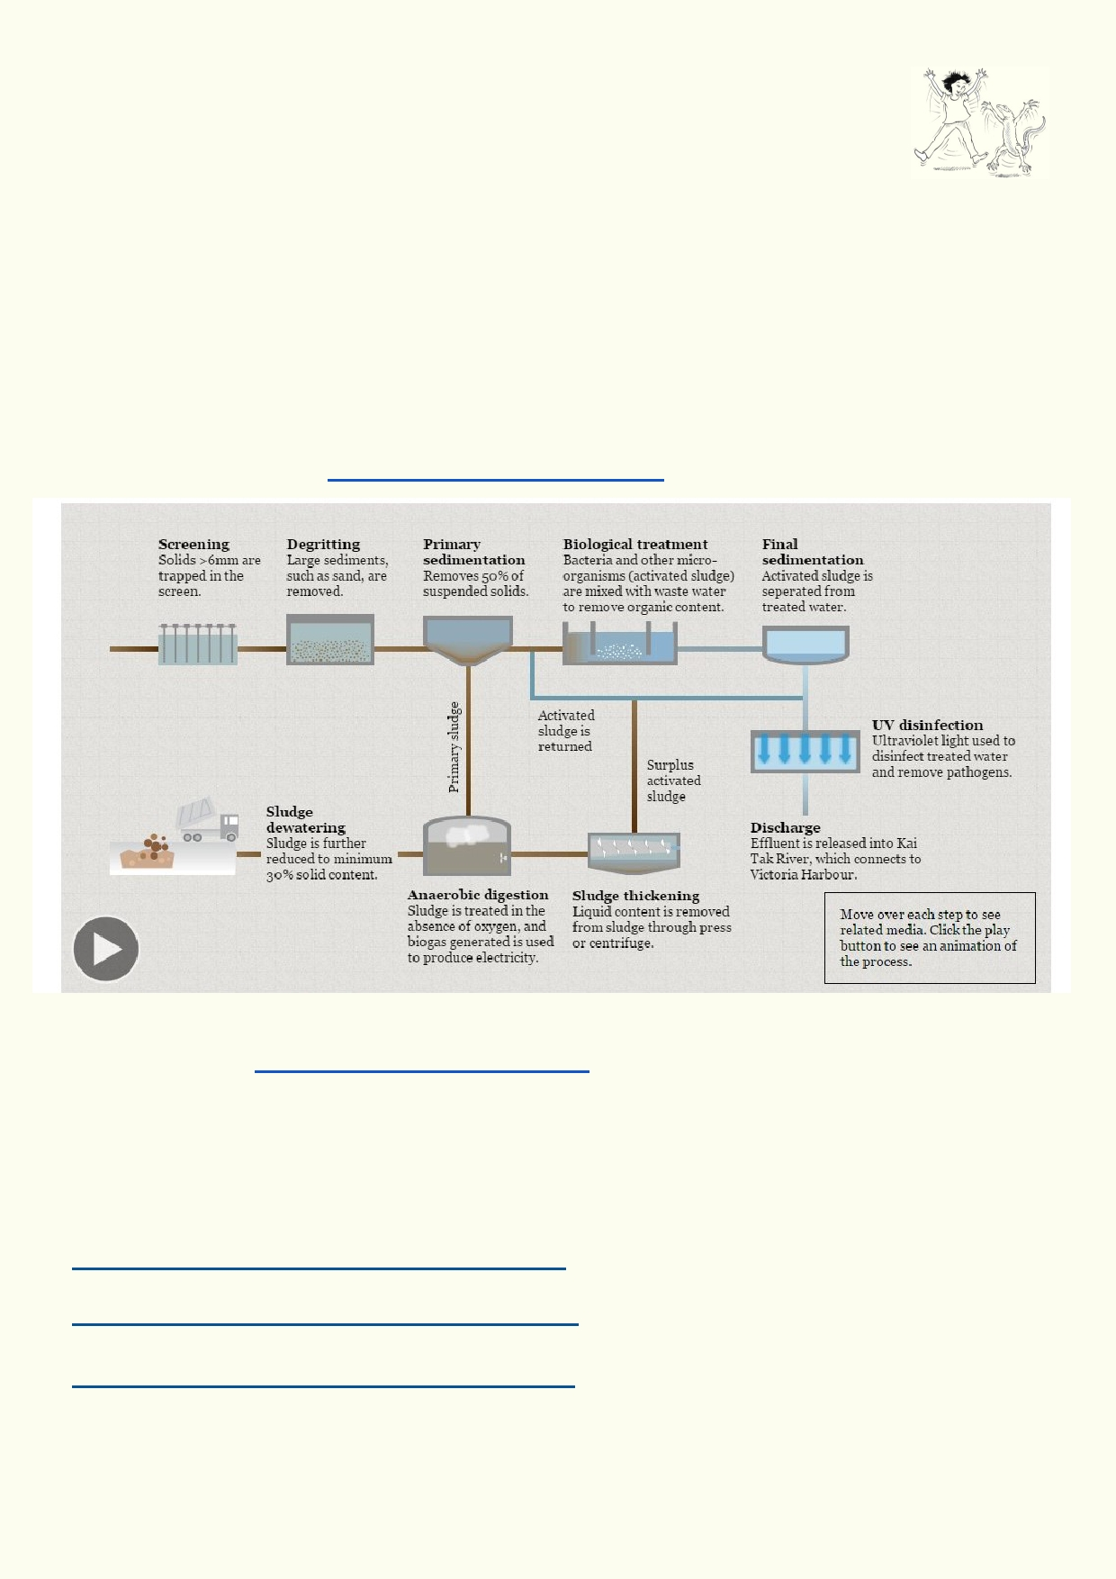Activity 2: How to treat sewage

Background information
Good hygiene requires that we have access to clean water, food that isn't
contaminated and the safe removal of sewage.

When hygiene can't be maintained, diseases quickly spread through communities. Wastewater
must be treated so that when the final liquid is released back into the environment it will not
cause the spread of disease or pollution of the environment.

In this lesson you will research the requirements for dealing with sewage so people and their environment remain safe from contamination.

Finding out more: Steps taken to make sewage safe
Source 21HK multimedia http://multimedia.scmp.com/21hk/

Go to the website http://multimedia.scmp.com/21hk/
• Scroll down until you see the image above.
• Click the play button on the bottom left for the text to appear.
• Place the cursor over each image to play the video.

Further research links
Sewage treatment hits new milestone (24.9.2014)
https://www.youtube.com/watch?v=xj5q_TNxZ6Q
A waste-to-energy journey in Hong Kong
https://www.youtube.com/watch?v=i8KRnQYEpRA
Hong Kong Walk Tour】The Shatin Sewage Treatment Works
https://www.youtube.com/watch?v=72PpN2ryLmQ

28

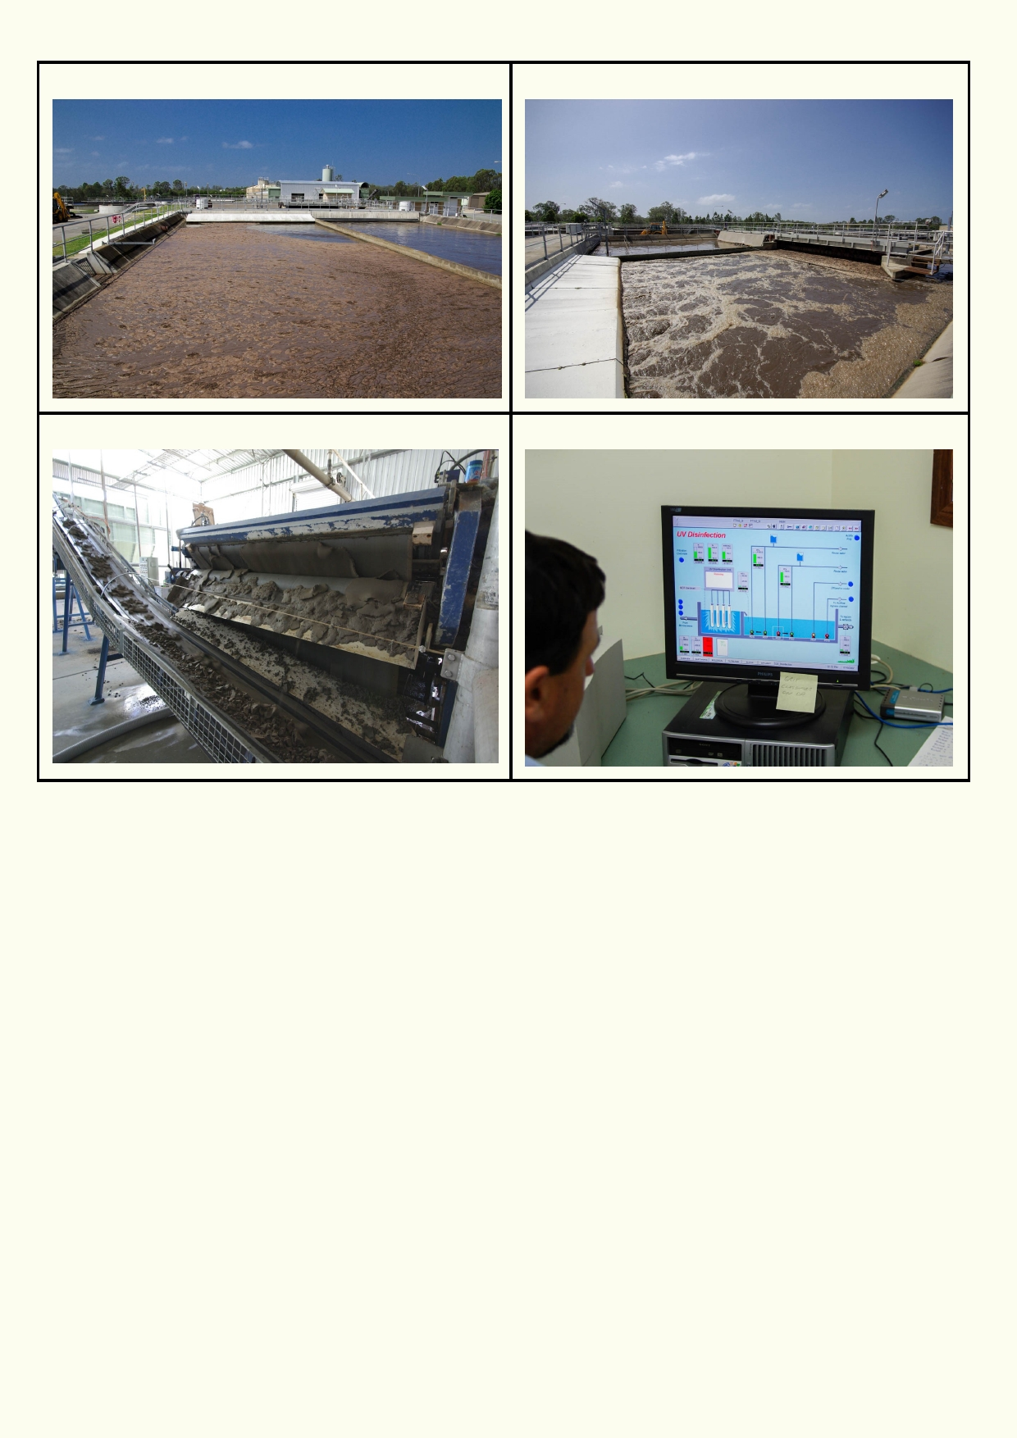Settlement pond Aeration

Removing sludge Controls for UV disinfection

What is sludge?

_____________________________________________________________________________

_____________________________________________________________________________

How do we get rid of sludge?

_____________________________________________________________________________

_____________________________________________________________________________

How does bacteria help in the process of cleaning up sewage?

_____________________________________________________________________________

_____________________________________________________________________________

Why is UV light used in the final treatment stage?

_____________________________________________________________________________

_____________________________________________________________________________

29

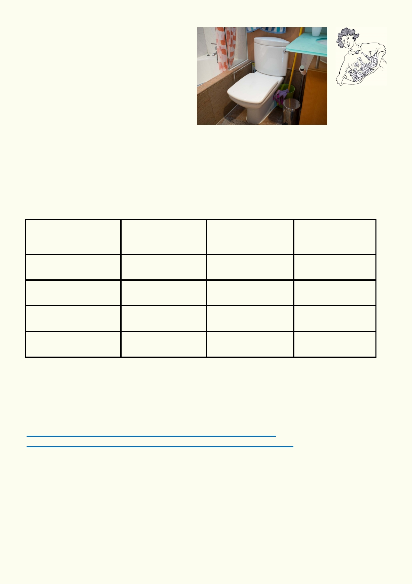Activity 3: Only the right kind of crap

Equipment:
• 4 jars with water
• toilet paper
• tissue paper
• a wet-wipe
• a cotton bud.

Method

1.
2.
3. 4.
5.
6.
Half fill each of the four jars with water.
In each jar place separate materials, toilet paper, tissue paper, a wet-wipe and a cotton bud.
Use the chart to predict if the materials will change and how they might change. Leave the experiment for a day.
After a day or more observe and record on the chart any changes.
Suggest which materials could block sewage pipes and could be a problem in sewage
treatment plants.

Explain the consequences of flushing the wrong materials down the toilet:

Material

Toilet paper

Tissue

Hand/baby wipe

Cotton bud

Predict if or how
the material will
change

Did the material
change? How did it
change?

Could the material
block sewage
pipes?

_____________________________________________________________________________

_____________________________________________________________________________

What might happen if large volumes of old cooking oil or poisonous liquids are poured down the
sink?
https://www.iconwater.com.au/My-Home/Caring-for-your-drain.aspx
https://www.itsdone.com/what-you-can-and-cannot-flush-down-the-toilet/

_____________________________________________________________________________

_____________________________________________________________________________

30

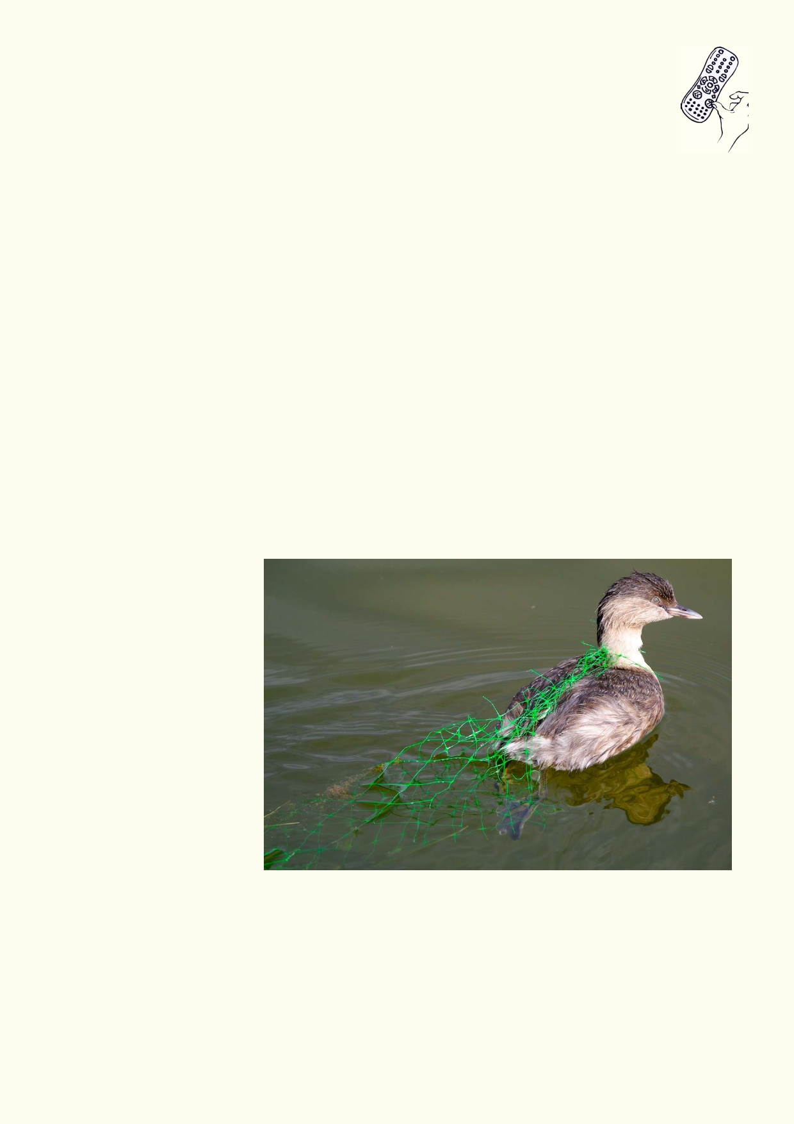Activity 4: Looking forward

List at least three things you think would help to decrease water pollution due to
stormwater runoff in your city:

1. __________________________________________________________________________

2. __________________________________________________________________________

3. ___________________________________________________________________________

Develop a public information campaign to address one of the things that lead to contamination of our waterways through drainage systems in Hong Kong.

Suggestions might include:
• Replacing harsh chemical cleaning products with more environmentally friendly products.
• Bringing awareness to what we put down stormwater drains.
• Identifying ways to reduce, reuse and recycle in order to limit the waste entering the
waterways.

Identifying appropriate media that link the message and the interest of their audience.
Communication products can include:

a.
b.
c.
d.
e.

f.
g.
h.

i. j.
k.
l.
Posters
Billboards
Radio commercials
TV commercials
Newspaper
advertisements
Press releases
Musical jingles
PowerPoint
presentations
Web page
Newsletter
Email letter
Competition

m. Postcard

This Little Grebe is entangled in a discarded net used for packaging plastic

31

Acknowledgements
The Ocean Recovery Alliance thanks The Hong Kong Jockey Club Charities Trust for their
generous funding support on this education programme.

Project manager: Doug Woodring
Writer, photography and design : Bob Winters
Curriculum manager and editor : Charlotte Charny Nielsen
Editor and school outreach: Alex Hale
Additional thanks: Jasmine Nunns and Sandra Merazzi

© 2017 Ocean Recovery Alliance and Authors.
Outside the school environment, the text, photos and artwork may not be reproduced, except
where permitted by the relevant Copyright Act. These materials may not be modified and
distributed by print or electronic means without written permission. Teachers may modify these
education materials for the use of their students and school provided it is not distributed any
further. Those wishing to reproduce part of this publication must submit their application to the
Ocean Recovery Alliance. www.oceanrecov.org/contact-us.html

32

