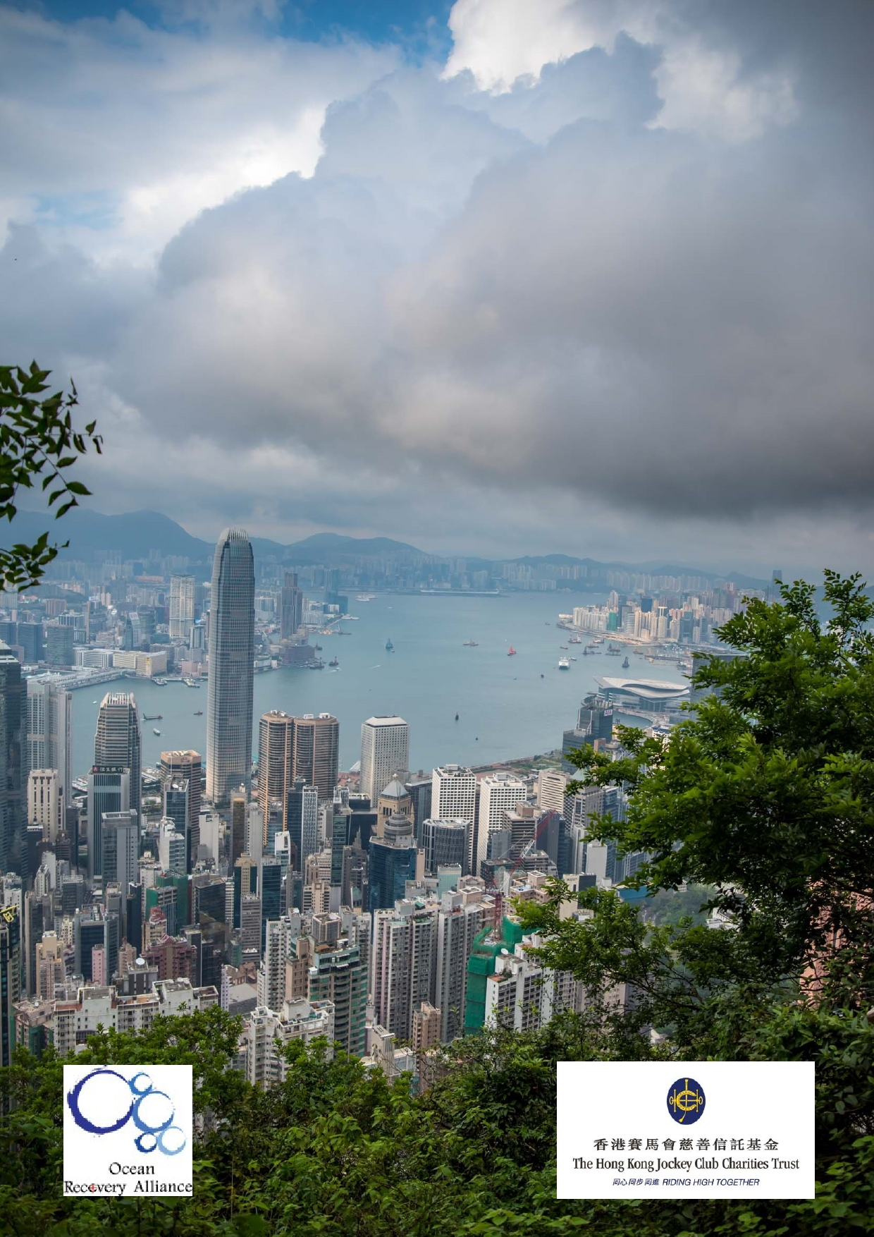Jockey Club Water Caretakers of
Tomorrow Programme
It's all Downhill - Unit 2

Organised by

Funded by

1

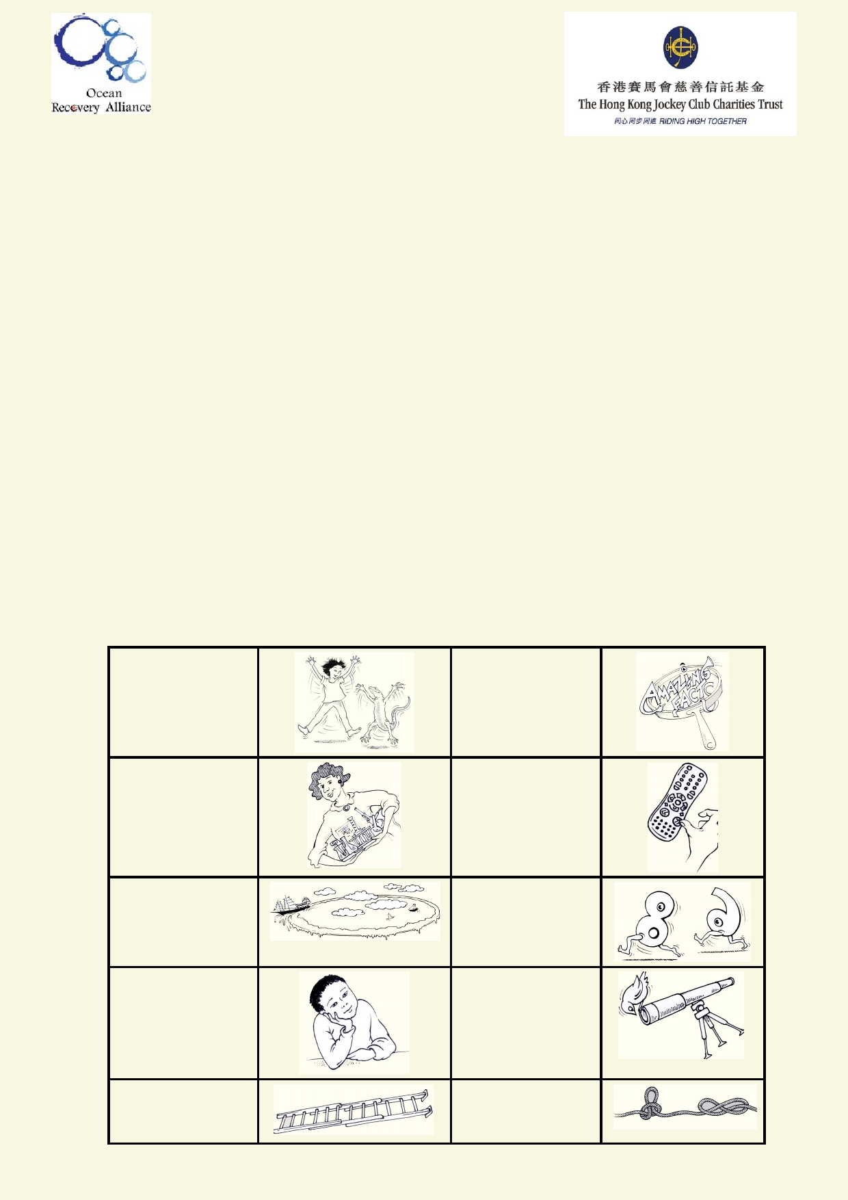About The Jockey Club Water Caretakers of Tomorrow Programme:
Jockey Club Water Caretakers of Tomorrow Programme is organised by Ocean Recovery
Alliance, Ltd and funded by The Hong Kong Jockey Club Charities Trust. There are eight units in
this program, and each of them is designed with you, a student in Hong Kong, in mind.

At the end of the unit, I will be able to:
• Understand and appreciate how our water systems function on a local and global scale.
• Understand how watersheds function, and the interconnections of life within and between
these watersheds.
• Be able to assess threats, such as pollution and habitat destruction, and learn how to
lessen these effects.
• Be empowered to take an active role as caretakers of our water resources by sharing your
commitment with your communities.

Student introduction
• You will need access to the internet.
• In some activities using the camera in your smart phone or tablet will be useful.
• Your teacher will tell you if you if your work will be done on your computer, printed paper or
notebooks.
• Below is a key to the illustrations found in the student notes.

Start of a new A new amazing activity. f act .

Get ready to do an experiment.

Identify your
misconceptions
before your
move on.
Identify your
prior learning.

An extension
activity

Fast forward to
make your
contribution to
improving our
world.
Data will be used
to solve
problems.

These are the goals for this unit.

A cross-
curricular
activity

2

Student aims:

At the end of this Unit I will be able to:
• describe the physical features of the watershed and its relationship to the
water cycle
• show the links and interactions in a watershed
• identify and describe the watershed I live in, using maps • connect land use with impact on the watershed
• design a product or develop an outdoor activity that communicates an understanding of
watersheds.

Glossary

Agriculture The cultivation of crops and animals for food, medicine and materials used to
enhance and sustain human lives.
Aquifer Underground layer that stores water and lets water flow through it.
Climate vs. weatherClimate is the average weather over a year. Weather refers to the day-to-day
climatic conditions such as wind, rain cloud, humidity and temperature.

Commercial
Condensation
Creek
Drainage basin
Ephemeral
Estuary
Referring to trading business or making money.
Water from the air that collects as droplets and changes from gas into liquid.
A small waterway, usually sheltered and narrow. The area of land that water drains from.
Is only present for part of the year.
Where a river mouth meets the sea.

Evapotranspiration The process of water going from liquid to gas by the sun's heat and by
plants.

Geoengineering

Groundwater
Impermeable
Industrial Infiltration
Large-scale modification of a landscape's natural processes to better suit
people's living conditions and counteract climate change.
Permanent water stored in the ground.
A material that does not allow water to pass through it.
Economic activities that turn raw materials into goods in factories. The downward movement of water from the surface to below ground.

Landslip/mudslide The collapse of earth or rock down a slope.
Meteorological The science of studying the atmosphere and its processes.
Parks/conservation Areas of land that are protected for the purpose of maintaining their natural
state.

Percolate
Perennial
Permeable
Precipitation
Recharge
Recreational
Movement of water through a porous surface or material.
Present all year round.
A material that allows water to pass through it.
When water falls from the sky as a liquid or a solid.
The rate something is filled back up.
Used for the purpose of fun, entertainment, or leisure.

3

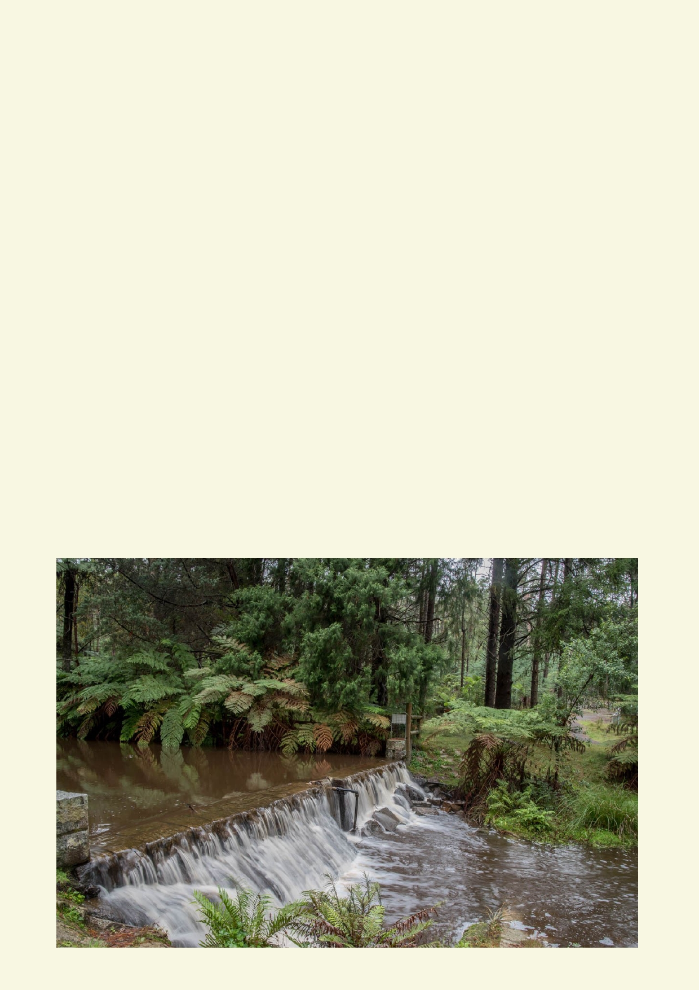Reservoir A natural or artificial body of water on the surface that is used as a supply of
freshwater.
Residential Refers to the size of the buildings where people live. (high vs low rise)
River A flowing body of water in a channel.
Saltwater Intrusion The contamination of a freshwater source by seawater.

Solar radiation
Spring
Stream
Sublimation
Surface runoff
Topography
Transport
Typhoon Velocity
Water cycle
Water table
Watershed

Weather
Wetland
Various rays from the sun entering the atmosphere.
Where freshwater wells up from the ground to the surface.
A flowing body of water in a channel that is smaller than a river. Solid turning into gas without becoming a liquid.
The movement of water above ground after a rain event.
The study of the surface shape of the land.
Movement of a substance or object.
A big storm in the Western Pacific region of the world. The speed and direction at which something moves.
The circular movement of water around our planet.
The level of water under the surface of the earth.
The boundary of land that marks where the passage of water will drain in
a landscape.
Changes in the physical atmospheric conditions over the hours of the day.
A piece of land that is always or periodically submerged in water.

4

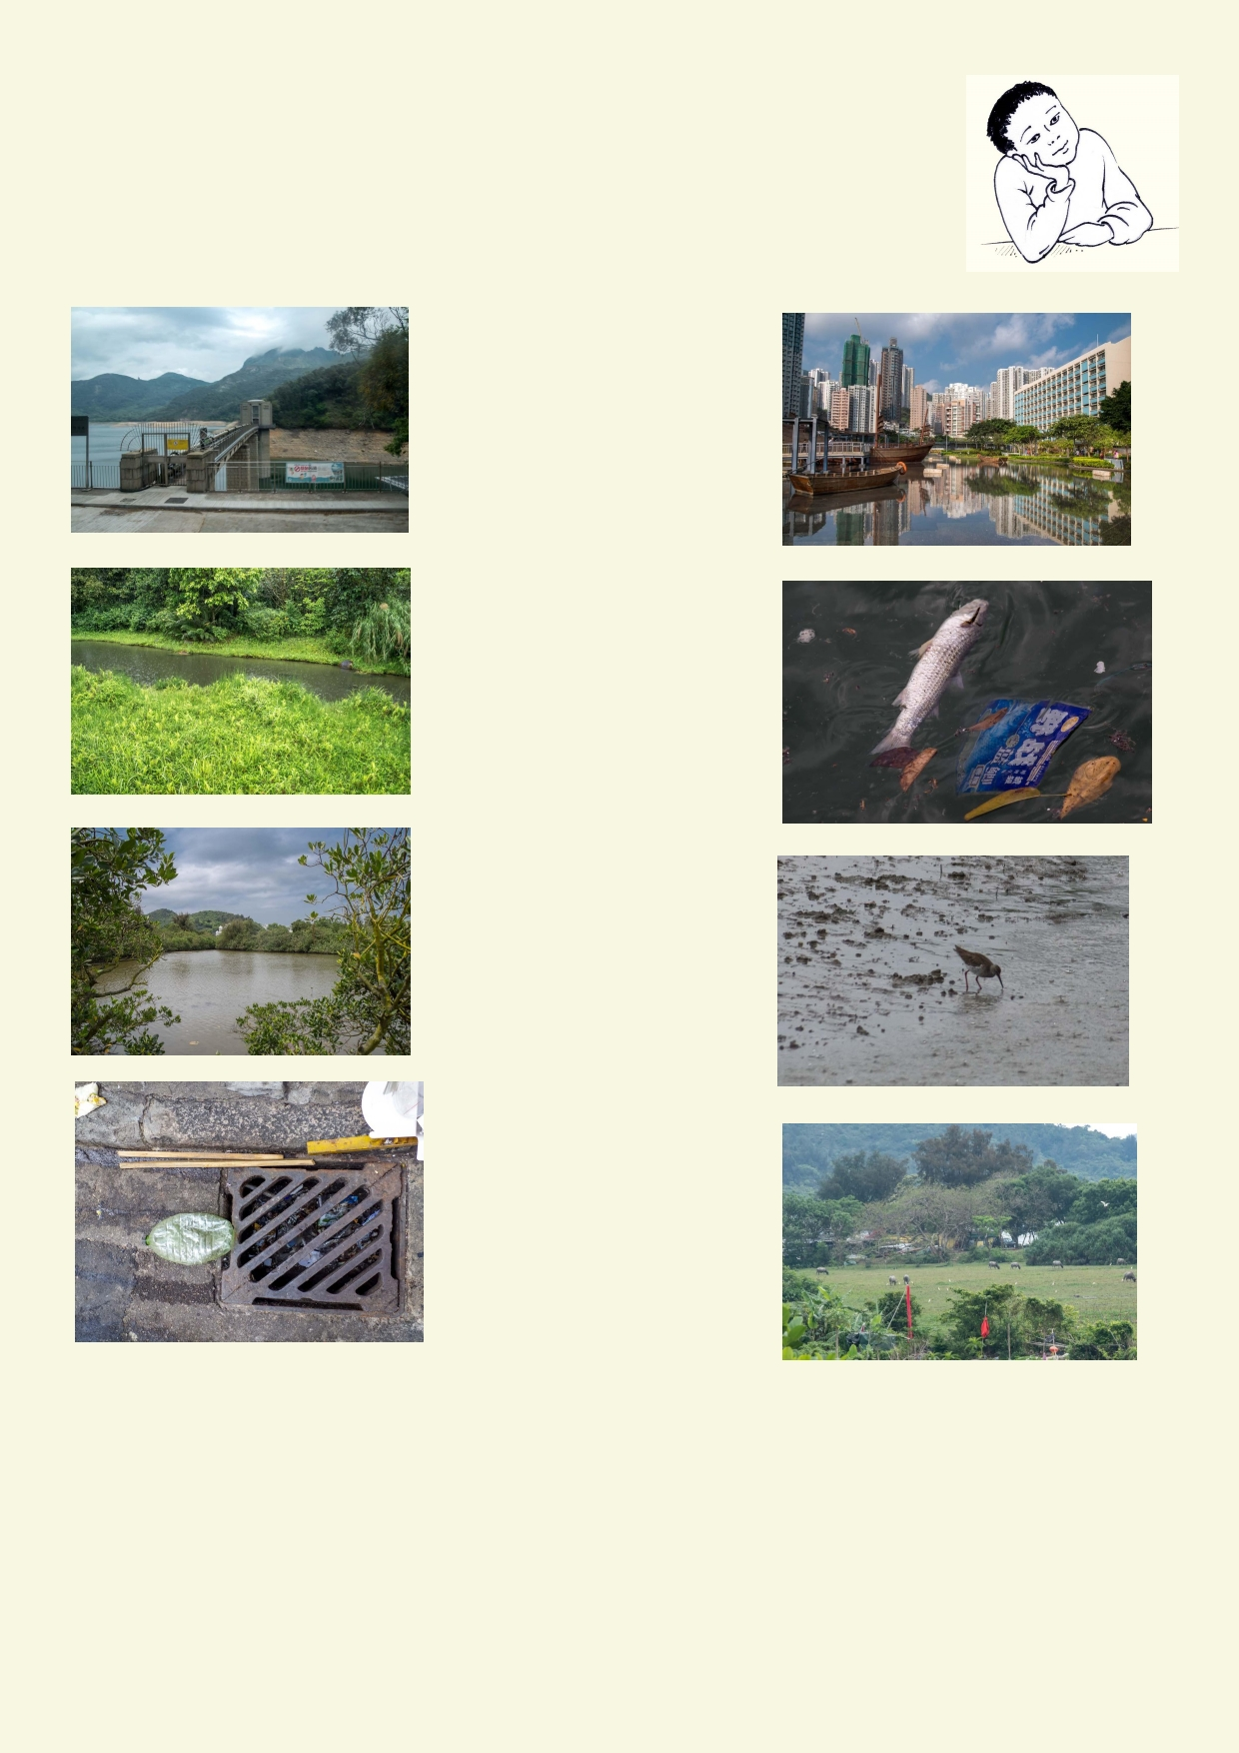Lesson 1 - Flowing water carves out a watershed
What do I know?

Photo match - Draw a line between the word and the best matching photo.

Agriculture

Estuary

Drain

Stream

River

Reservoir

Pollution

Ornamental pond

5

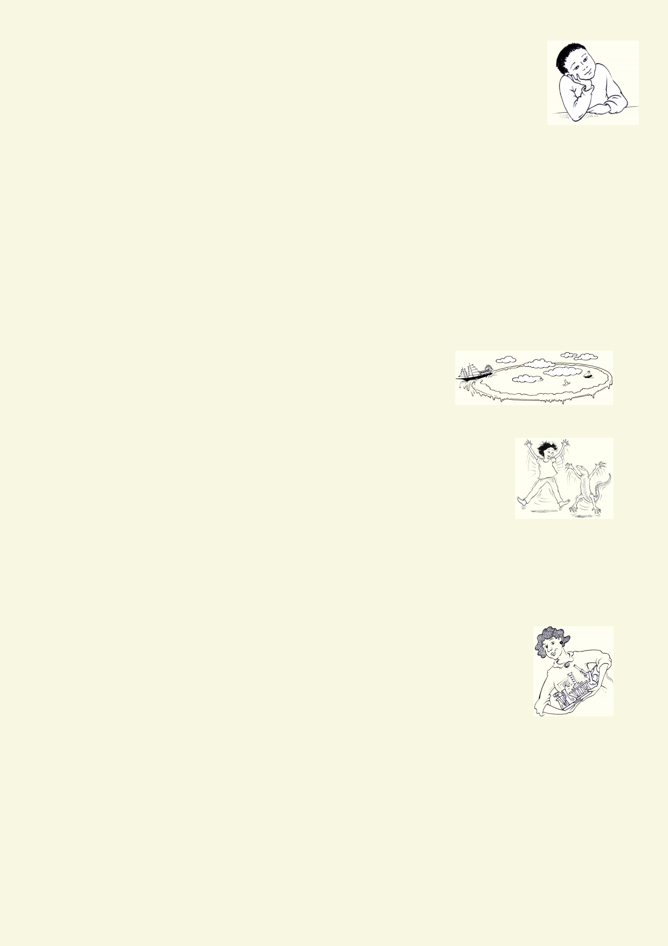What do you know?

Interview the person next to you and record their answers:

1.
2.

3. 4. 5.
6.
7.

8. 9.
Why is the Earth called the water planet?
What is so unusual and special about water compared to other substances on
Earth?
Where is most of the Earth's freshwater supply stored?
What is the water cycle?
Why do we say that the Earth's water is recycled?
What is evaporation? What causes it on Earth?
If oceans are always losing water through evaporation, why aren't they becoming more and
more salty and shallow?
What happens to precipitation after it falls to the Earth?
What is groundwater and why is it important?

10. Why does some water run over the ground, seep into the ground or stand on the ground?
11. Why is the pollution of groundwater so serious?
12. How is water purified during the water cycle?
13. What are some examples of different types of land use around where you live?
14. Name three ways to preserve Earth's water supplies from pol-
lution.

Activity 1 - I'm on a roll
If this activity were to be done with water, the classroom would quickly
become messy. In this experiment round objects rolling down a slope will be
used to simulate water. Gravity is a force that will make any material get as
close as it can to the centre of the Earth unless there is a force (such as
something getting in the way) preventing it from going any further. You will make observations of
how the angle of the ground affects the speed of an object and what force it can apply to other
objects that get in its way.

Conducting experiments

1.
2.
3. 4.
5.

6. 7.
Read through the setup for the experiment.
Record your prediction for the outcome of the experiment.
Gather the materials that are needed.
Find a suitable location to conduct the experiment.
Review all safety requirements including handling glassware safely and
using heat and heated substances. Ask your teacher if you are not sure.
Report any accidents.
Record your observations as you complete the experiment.
Clean and return equipment.

6

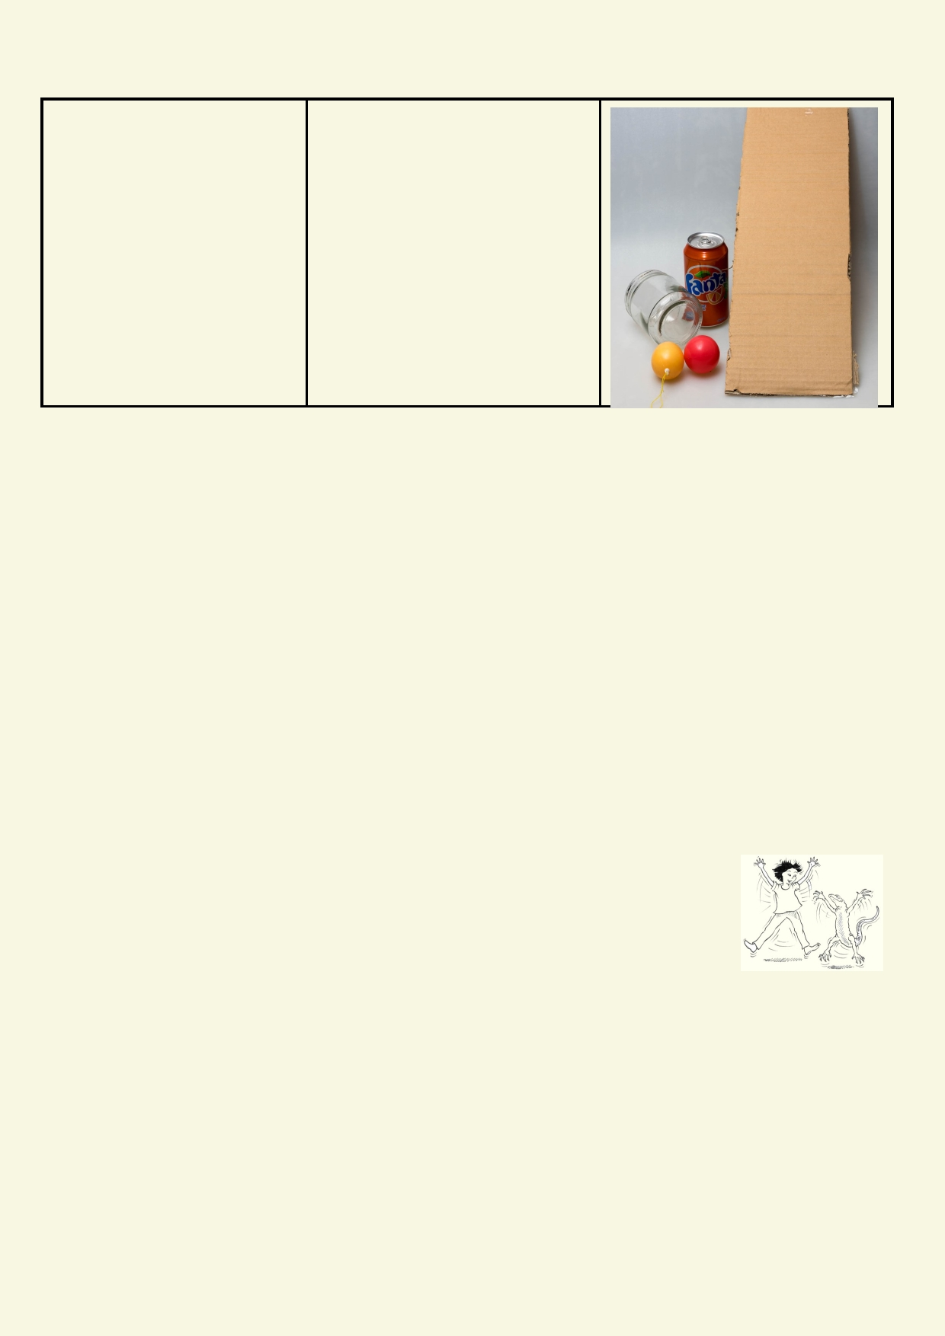Experiment: Rolling downhill

Materials: Method

• Jars cylinders, balls 1. Use a surface that can have
• Long flat surface that its angle changed
can be angled e.g. 2. Roll a round object down the
moveable tabletop, sloping surface.
tray, large book, long 3. Change the angle of the slope
wide ruler and observe any difference in
speed.
4. Place an upright object at the
bottom of the slope to stop the rolling object.

Prediction:
___________________________________________________________________________

Observation: How does the increased angle of the slope affect the force the rolling object has
when hitting the stationary object?

___________________________________________________________________________

___________________________________________________________________________

Explain how increased slope affects the speed and force of water moving downhill.

___________________________________________________________________________

___________________________________________________________________________

Activity 2 - Connect the dots

A watershed is an area of land in which all the water collects together. Its starts
from the top of the ridgeline of hills or mountains. The water starts flowing in
small streams or collects underground. Often the surface water flows into rivers
and moves to lakes, estuaries or the sea.

In this activity try to make the outline of one or two watersheds by drawing the ridge line that encloses a watershed.

1.

2. 3.

4. 5.

Download the map from the website. The digital map is very detailed. You can crop and print a small section of the catchment you want to work om.
Find the ridge lines that enclose the catchment.
Use a fine pencil to draw dashes or place dots on the ridgeline. If you can't see all of the
ridgeline guess how ridge lines connect.
Draw an arrow where you think the water will flow into the sea.
Compare the watershed you drew with the watersheds other students made.

7

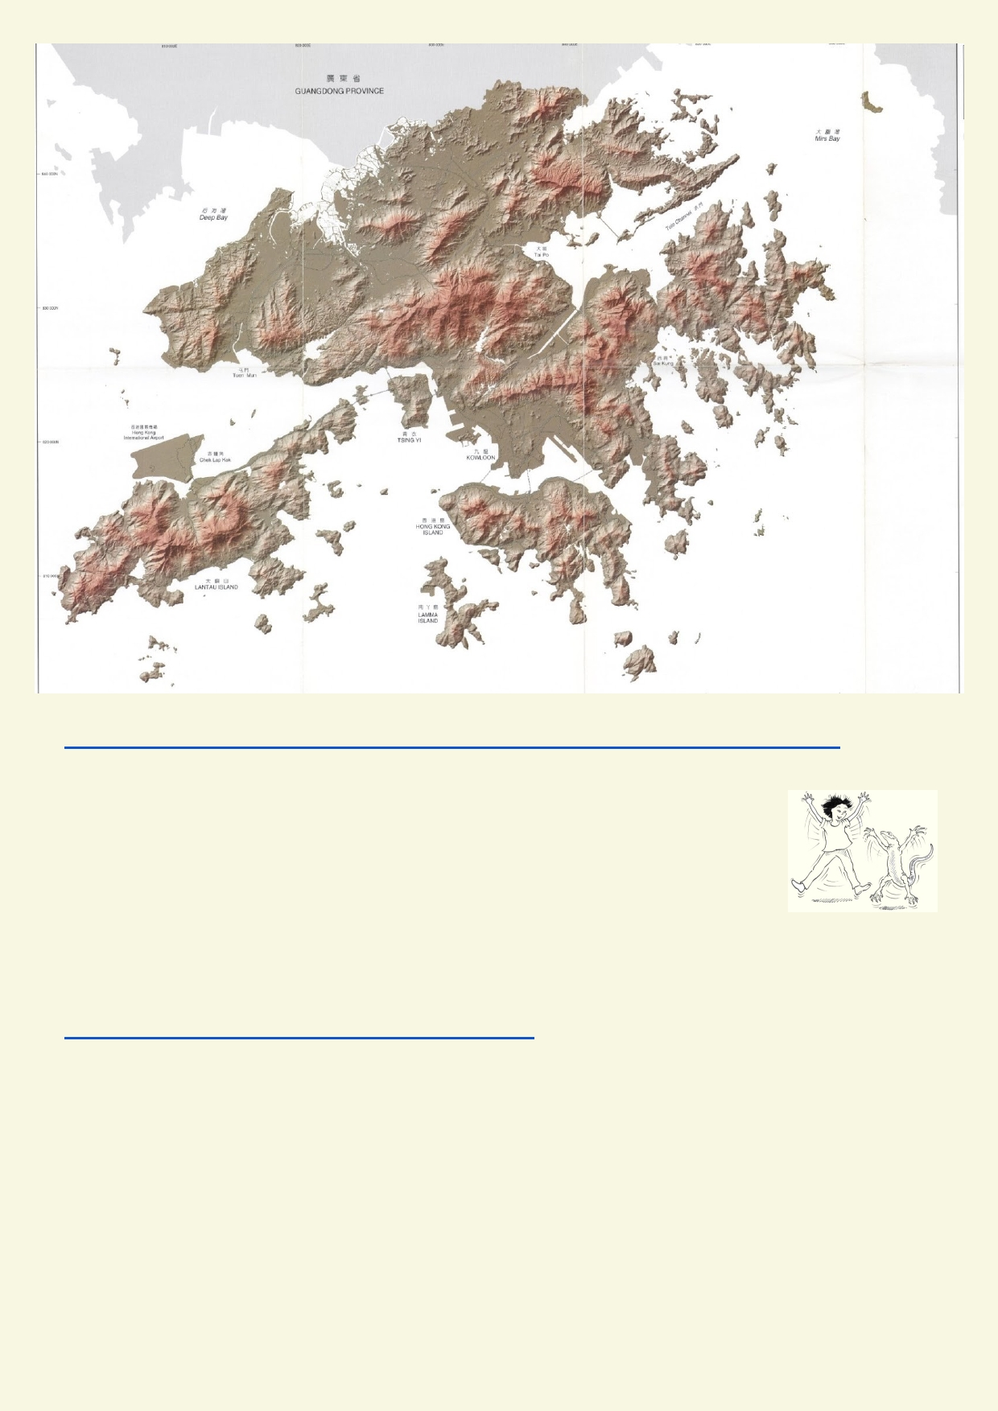
Use this link for more information about determining the boundaries of a watershed:
http://www.geo.brown.edu/research/Hydrology/FTP_site_5099-05/maine_appD_watershed-delineate.pdf

Activity 3 - That is a whopping big watershed

Choose one of the world's largest rivers and find out how big its watershed is.
Examples of the world's largest rivers are:
• Amazon
• Yangtze
• Nile
• Mississippi
• Congo
• Volga
• Murray Darling
https://en.wikipedia.org/wiki/List_of_rivers_by_length

Name of watershed ___________________________________________________________

Area of watershed ____________________________________________________________

Where the river flows out _______________________________________________________

Some countries that are part of the watershed ______________________________________

8

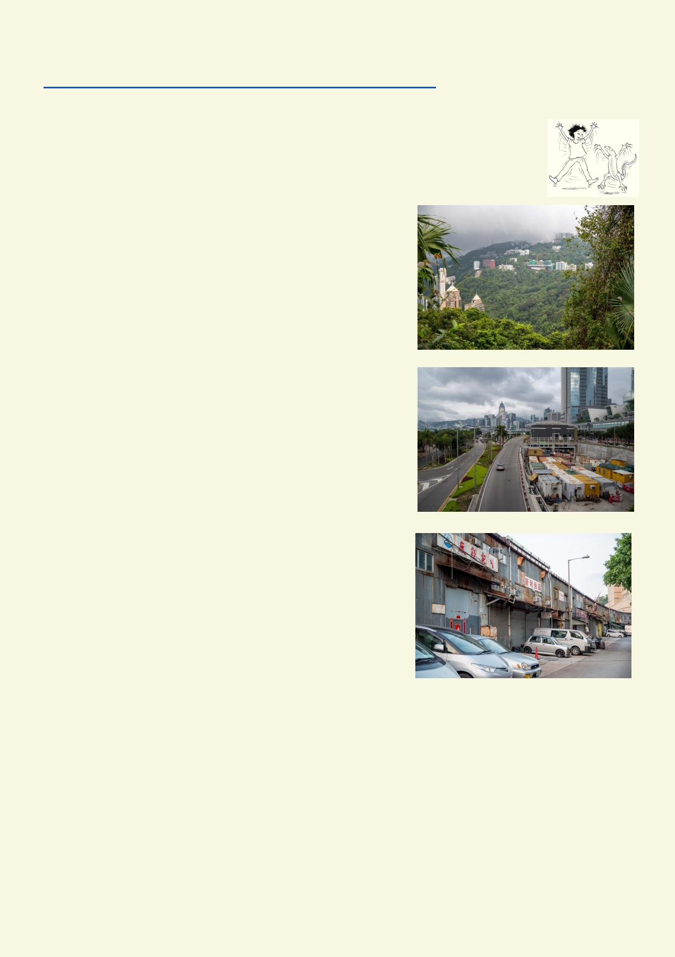Or use the activity on the National Geographic website
https://www.nationalgeographic.org/activity/mapping-watersheds/

Activity 4. What's inside my watershed?

Use Google Maps or Google Earth to find out what is
inside your watershed. You will need to use your
Activity 2 catchment to locate the boundaries of the
watershed you live in.
◻ Forests
◻ Lakes
◻ Estuaries ◻ Rivers
◻ Agriculture
◻ Reservoirs
◻ Urban parks ◻ Roads
◻ Freeways
◻ Trains
◻ Shipping ports
◻ High rise housing
◻ Low rise housing
◻ High rise offices
◻ Open car parks
◻ Light industry
◻ Heavy industry
◻ Shopping areas

◻ ____________________

◻ ____________________

◻ ____________________

Describe your watershed using some of the terms above:

____________________________________________________________________________________

____________________________________________________________________________________

____________________________________________________________________________________

9

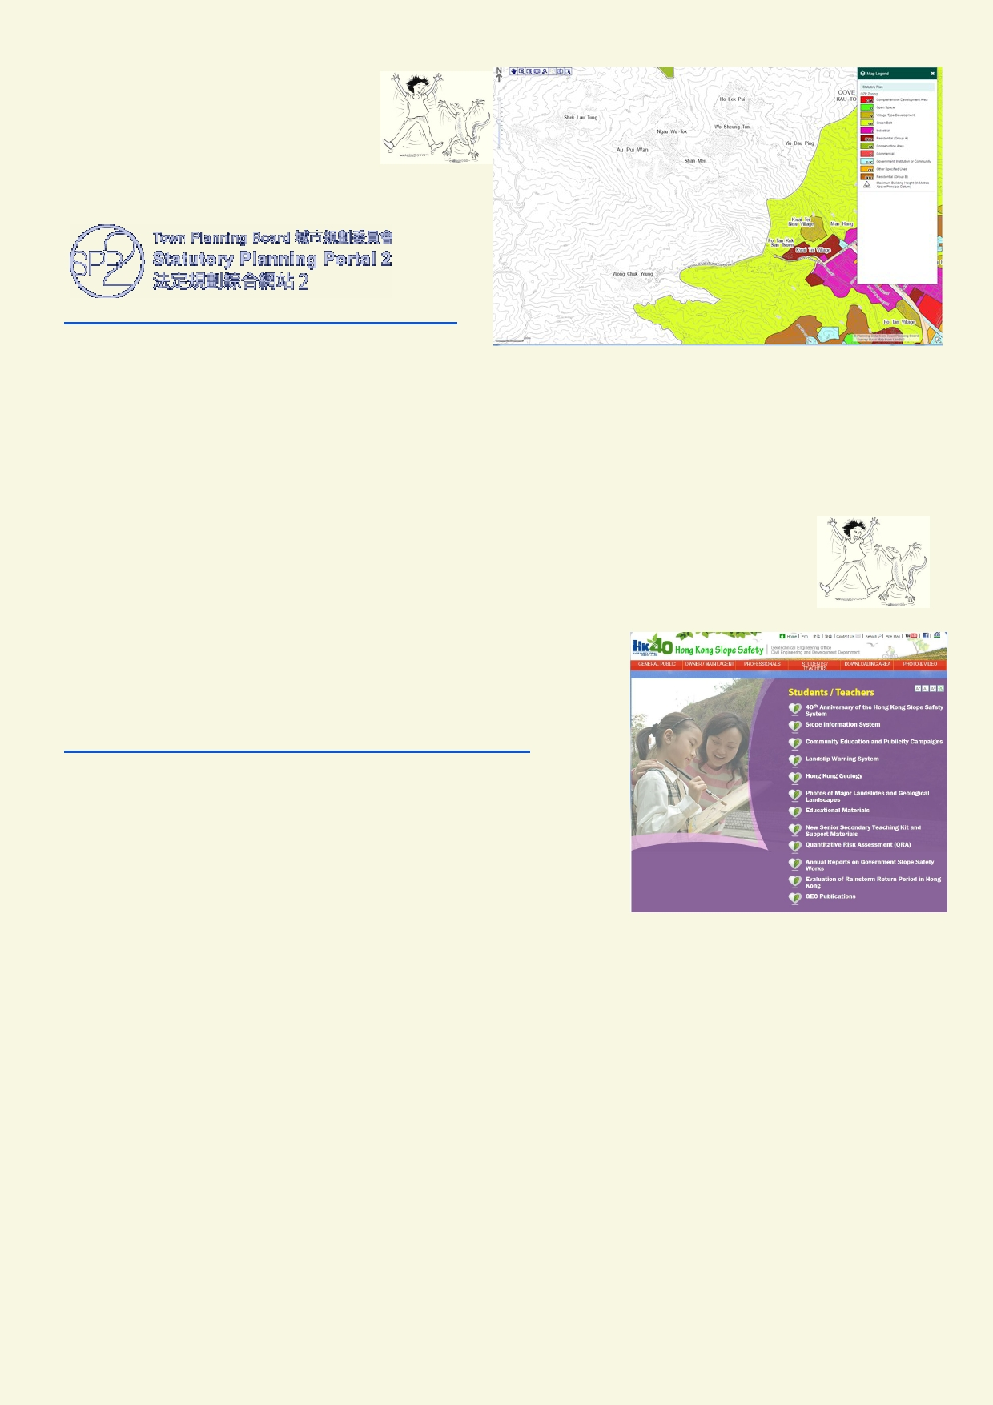Activity 5. Hong Kong contours

The Statutory Planning Portal has
maps with detailed contours. Did
you know that the closer the
contours are, the steeper the slope?

http://www1.ozp.tpb.gov.hk/gos/default.aspx

Using the contour map, identify some steep places around Hong Kong.

_______________________________________________________________________________

_______________________________________________________________________

Activity 6. Slip sliding away

Very steep land and high density populations around Hong Kong could be a serious risk. What kind of work is involved to keep people in Hong Kong and their buildings
safe from landslips, mudslides and falling rocks?

The image on the right is from a website called Hong Kong
Slope Safety:
http://hkss.cedd.gov.hk/hkss/eng/student_page.aspx
It has twelve items in the menu. The first link doesn't have
much information. In your group, find three or more interesting facts to share with the class.

______________________________________________________________________________

______________________________________________________________________________

______________________________________________________________________________

______________________________________________________________________________

______________________________________________________________________________

______________________________________________________________________________

______________________________________________________________________________

______________________________________________________________________________

______________________________________________________________________________

10

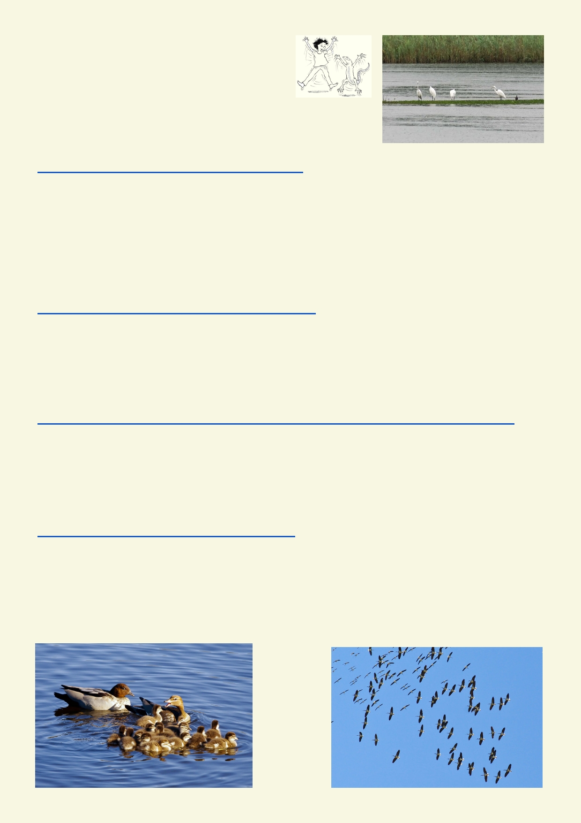Activity 7. The good news and bad news

Watch the first minute or two of some of these
videos and make some notes:

Youtube: Monster flood in China (June 2016) - How did the
flooding change? Were people at risk? What was at risk?
https://www.youtube.com/watch?v=ADnk1WXR9cs

___________________________________________________________________________________

___________________________________________________________________________________

___________________________________________________________________________________

BBC News: China flooding: Wuhan on red alert for further rain - How did the flooding affect
people? How many people were affected? How did people respond?
http://www.bbc.com/news/world-asia-china-36721514

___________________________________________________________________________________

___________________________________________________________________________________

The Guardian: Thousands of birds flock to Australia's inland lakes after record rain - How were
people affected by this flood? How did the flood help wildlife?
https://www.theguardian.com/environment/2017/apr/03/thousands-of-birds-flock-to-australias-inland-lakes-after-record-rain

___________________________________________________________________________________

___________________________________________________________________________________

Youtube: From floodplain to wetland wonderland (8.5.2016) - How has the area been changed?
Would it be a big problem for people if the area got flooded?
https://www.youtube.com/watch?v=v_EG8JyskF8

___________________________________________________________________________________

___________________________________________________________________________________

11

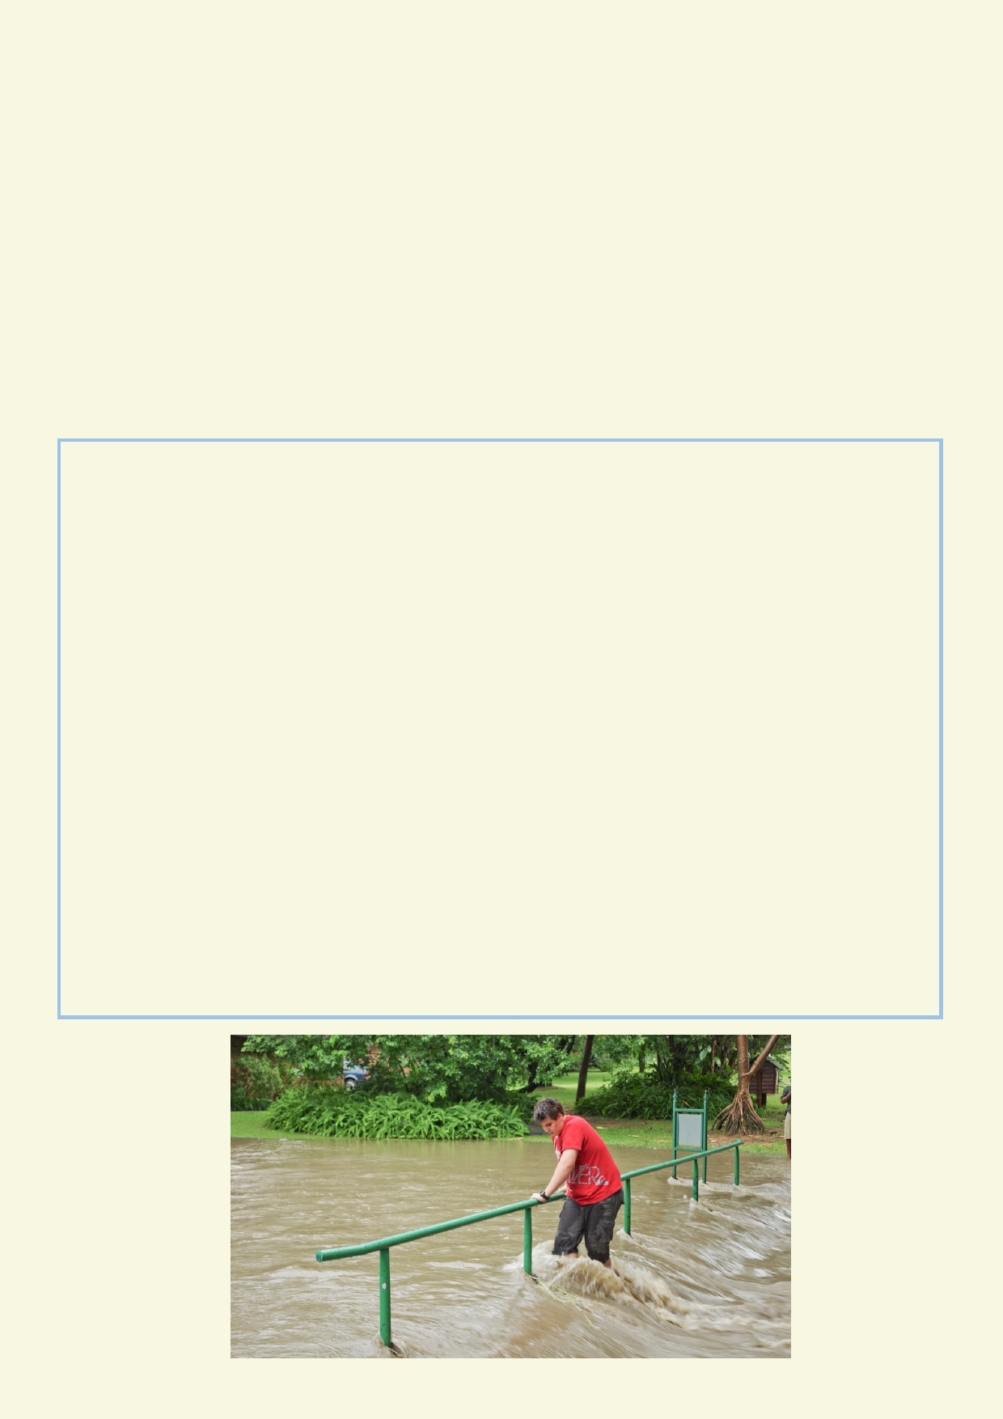Choose one of the quotes below. Then make a drawing or sketch to explain the quote. On the
Gallery Walk, be prepared to explain how your drawing represents the main ideas behind the quote you chose.

•
•
•
••

Quote

Moving water can have a great impact on the way we live - both positive and negative. Humans can have great impacts on the quality and quantity of moving water.
Moving water does not stay the same. It is itself always changing.
Moving water can help communities and it can also hurt them.
Moving water has great impacts on both the natural and human world.

______________________________________________________________________________
Sketch

12

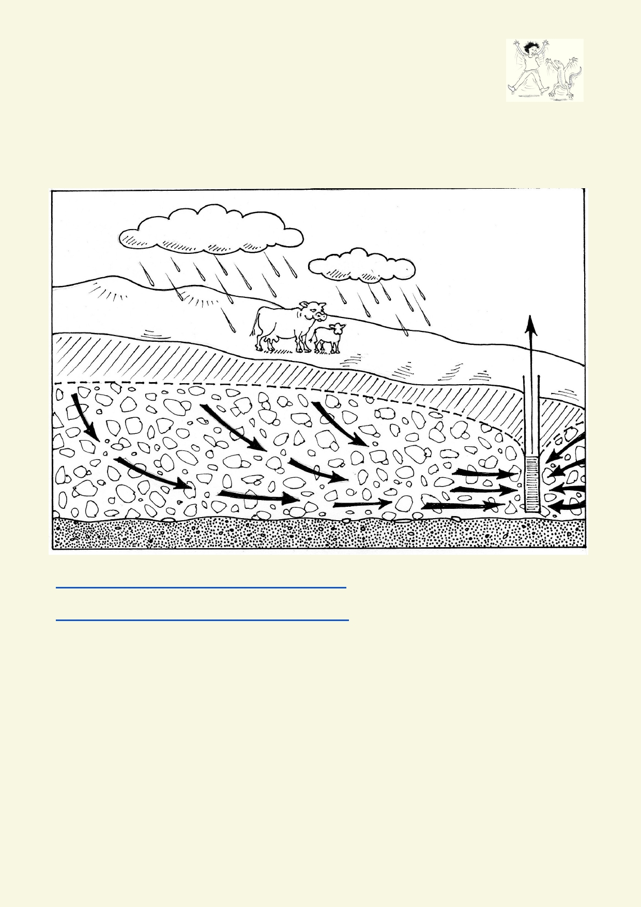Lesson 2. Water travels underground too

Activity 1. Aquifer

Where does all the water go when it soaks into the ground? It travels down into the ground until it reaches rock that is impervious to water. It is stored in the rock and soil above the impervious
rock. The top of the underground water is called the water table. When the water table meets the surface of the soil there is a spring with water flowing out.

Watch this video to see how water travels in a hilly aquifer.
https://www.youtube.com/watch?v=RUt43dSOsZQ
And more information about groundwater
https://www.youtube.com/watch?v=NWCj2wlMDsQ

Where does the water contained in an aquifer come from?

_______________________________________________________________________________

What are some ways in which the water table can drop?

_______________________________________________________________________________

_______________________________________________________________________________

How can pollution get into an aquifer?

_______________________________________________________________________________

_______________________________________________________________________________
13

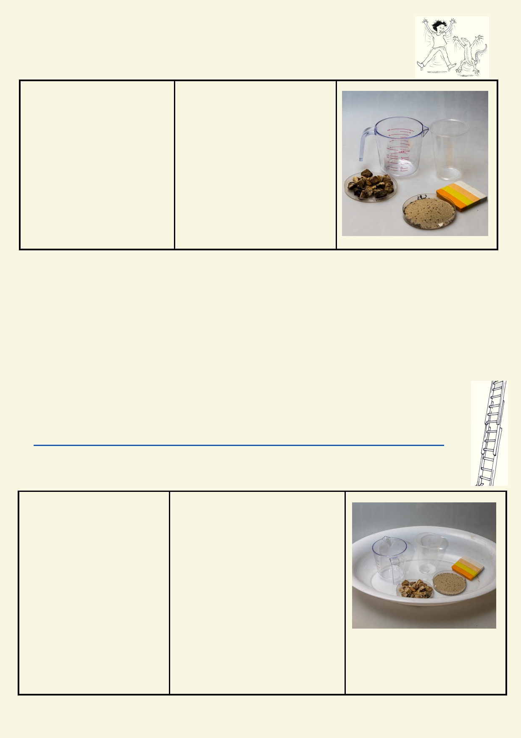Activity 2 - Aquifer in a plastic cup experiment

Experiment: Where did the water go?

Materials: Method
•
Clear plastic cups 1. Layer the clear plastic cup
• Small pebbles - 50 ml starting at the bottom with
• Sand - 50 ml some pebbles- 2cm.
• Clay eg modelling clay - 2. Press down a layer of clay -
50 ml 1cm and more pebbles—2cm.
• Jug of water - 200 ml 3. Cover with a layer of sand—
2cm.
4. Pour water over the sand and observe how far down the water
moves.
5. See how much of the water
can be poured out of the cup.

Prediction:
__________________________________________________________________________

Observation:
__________________________________________________________________________

__________________________________________________________________________

Where was the water held in the cup?
_________________________________________________________________________

Extension - For a more authentic aquifer make a more sophisticated model using the instruc-
tions on this website:
http://www.ngwa.org/Fundamentals/teachers/Pages/Make-Your-Own-Ground-Water-Model.aspx

Experiment: How fast will it drip out

Materials: Method

• Four clear plastic cups 1. Using scissors, cut two 5 mm
• Small pebbles - 50 ml hole at the bottom side of each
• Sand - 50 ml plastic cups.
• Soil - 50 ml 2. In each cup place one of the
• Clay eg modeling clay - items - pebbles, sand, soil and
50 ml clay.
• Measuring jug of water - 3. Be sure that each cup has the
250 ml or larger same amount of material.
• Scissors 4. In each cup pour the same vol-
• Tray that will hold water ume of water.
from experiment ruler 5. Compare how quickly the four
cups empty.
6. Use your own method or
measure the height of the water in
the cups as some start to empty.

14

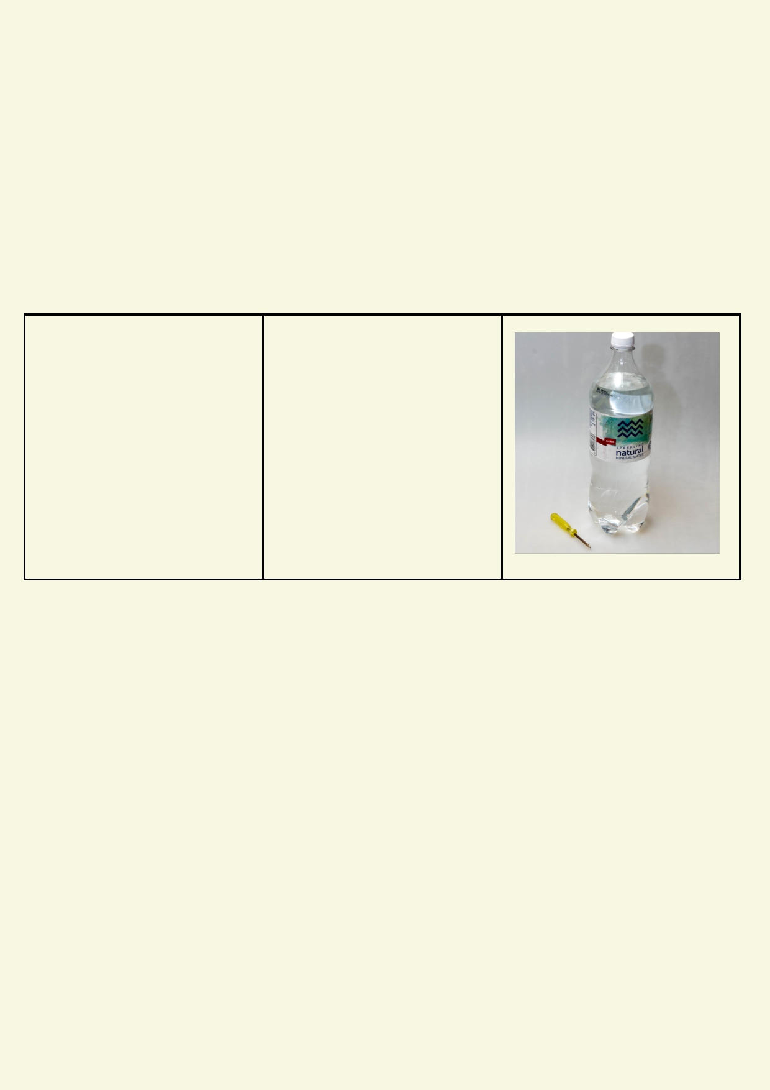Prediction:
__________________________________________________________________________

Observation:
__________________________________________________________________________

__________________________________________________________________________

Explanation?
__________________________________________________________________________

__________________________________________________________________________

Experiment: The big squeeze

Materials: Method

• Water bottle two thirds 1. Go outdoors with the water
filled with water bottle.
• Bottle top with small hole 2. Choose a garden area. Make
drilled in the top. sure the lid of the bottle is
screwed on.
3. Point the bottle towards the
gar den.
4. Squeeze the bottle, applying even pressure around the mid-
dl e.
5. Observe what happens to the
water when it is under pressure.

Prediction:
__________________________________________________________________________

Observation:
__________________________________________________________________________

__________________________________________________________________________

Explanation?
__________________________________________________________________________

__________________________________________________________________________

15

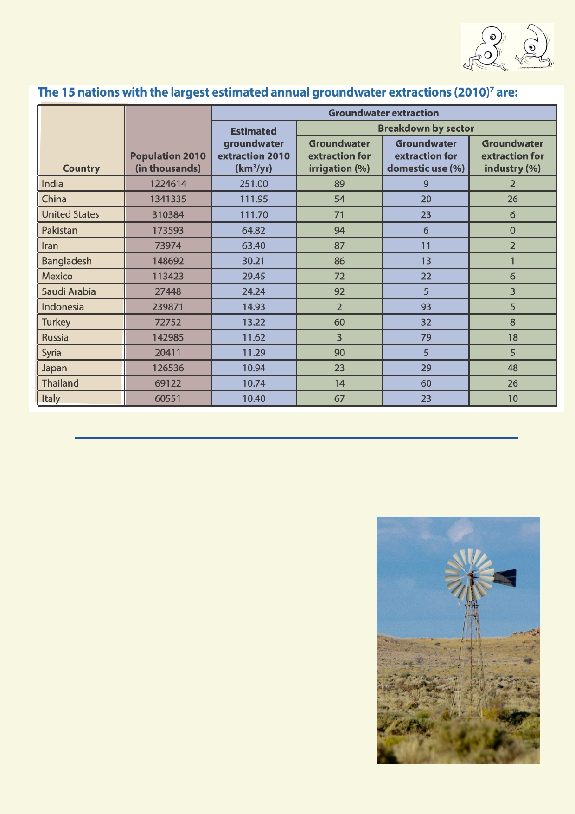Activity 3 - Who is using aquifers?

Source http://www.ngwa.org/Fundamentals/Documents/global-groundwater-use-fact-sheet.pdf

Which countries use their aquifers for supporting their industry?

_______________________________________________________________________________

Which three countries depend on aquifers for domestic use?

_____________________________________________

_____________________________________________

Which country uses the most groundwater per person? Figure out
how to calculate this and write the formula:
______________________________________________

______________________________________________

16

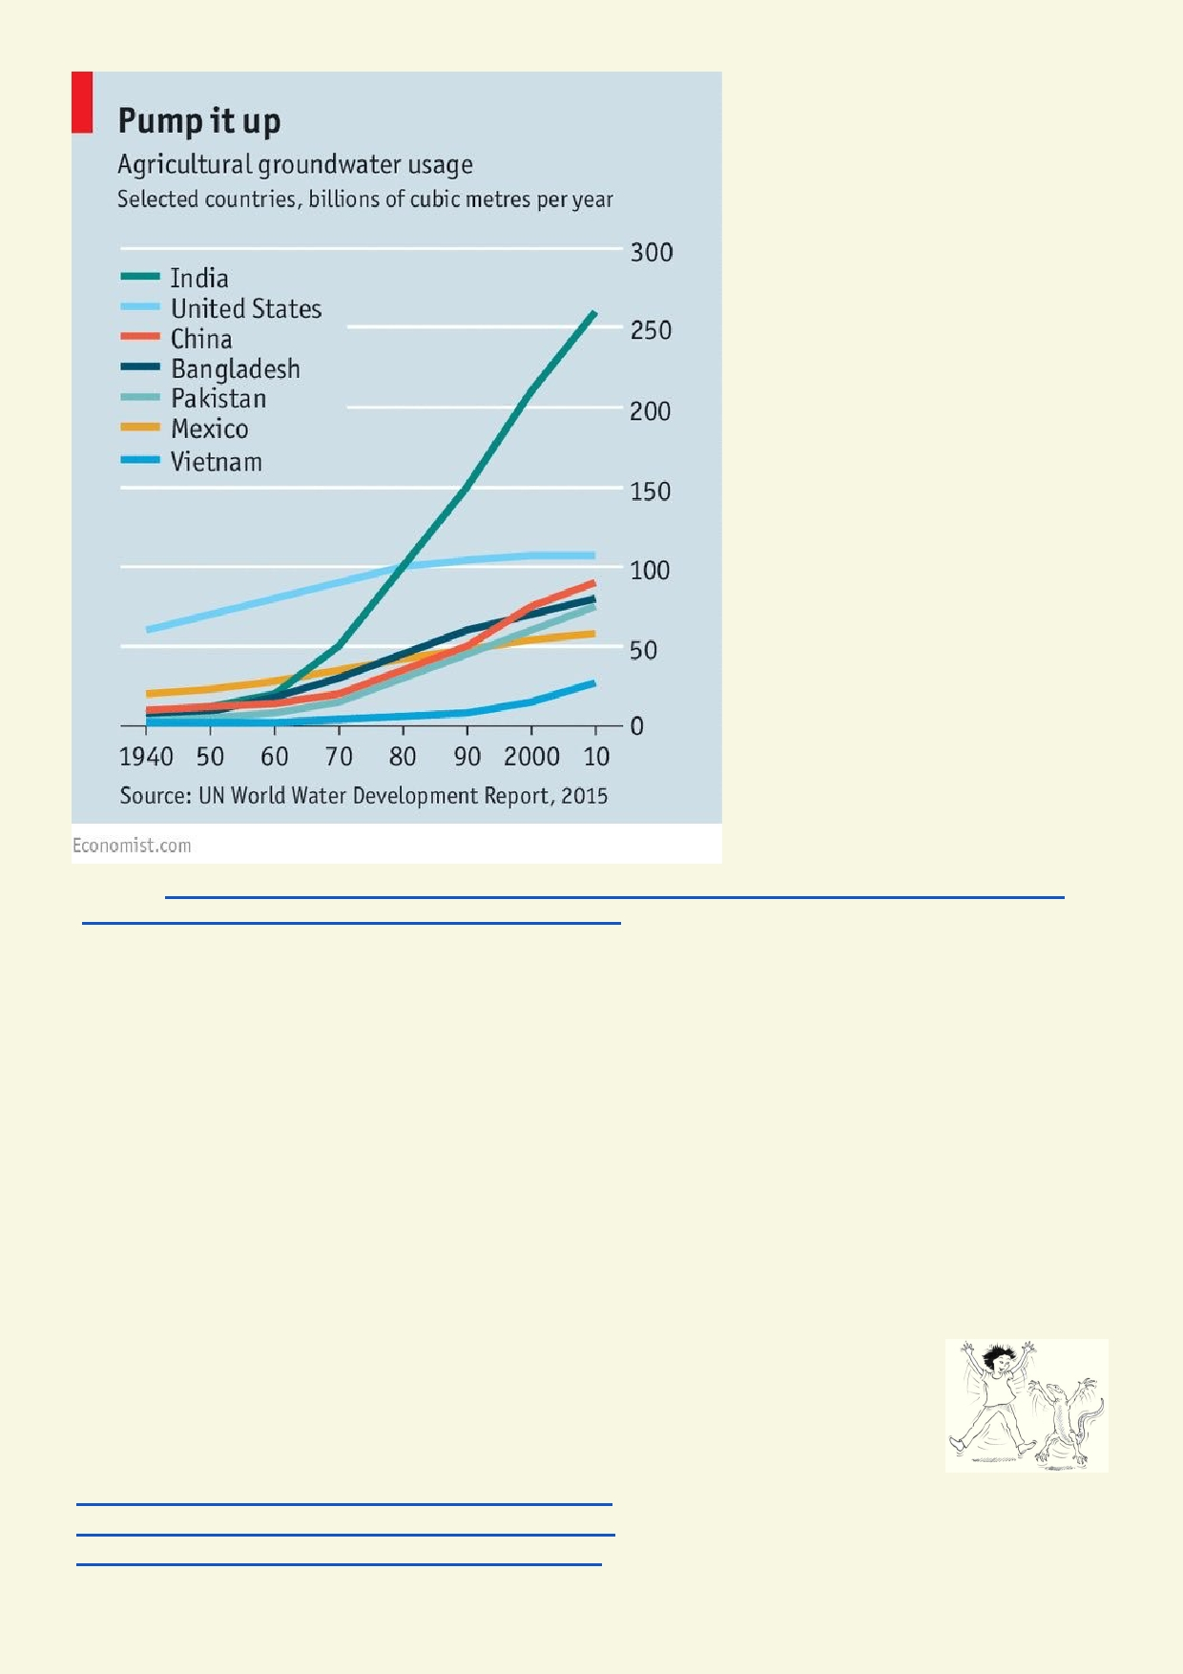
Source http://www.economist.com/news/briefing/21709530-water-becomes-ever-more-scant-
world-needs-conserve-it-use-it-more-efficiently-and

Which country is increasing the quantity of groundwater it uses the most? What do the slope of
the lines show about the use of groundwater over time?

_______________________________________________________________________________

In what year did China and India use the same amount of groundwater? _____________________

How much more groundwater did India use compared with China in 2015? __________________

Which other countries are still increasing the amount of groundwater they are using?

_______________________________________________________________________________

Activity 4. Recharging an aquifer

Watch these three videos to find out how water is recharged (replaced) as water is used and drains out of aquifers.
https://www.youtube.com/watch?v=RUt43dSOsZQ
https://www.youtube.com/watch?v=ZimRO31Nobw
https://www.youtube.com/watch?v=guqinVOHTqc

17

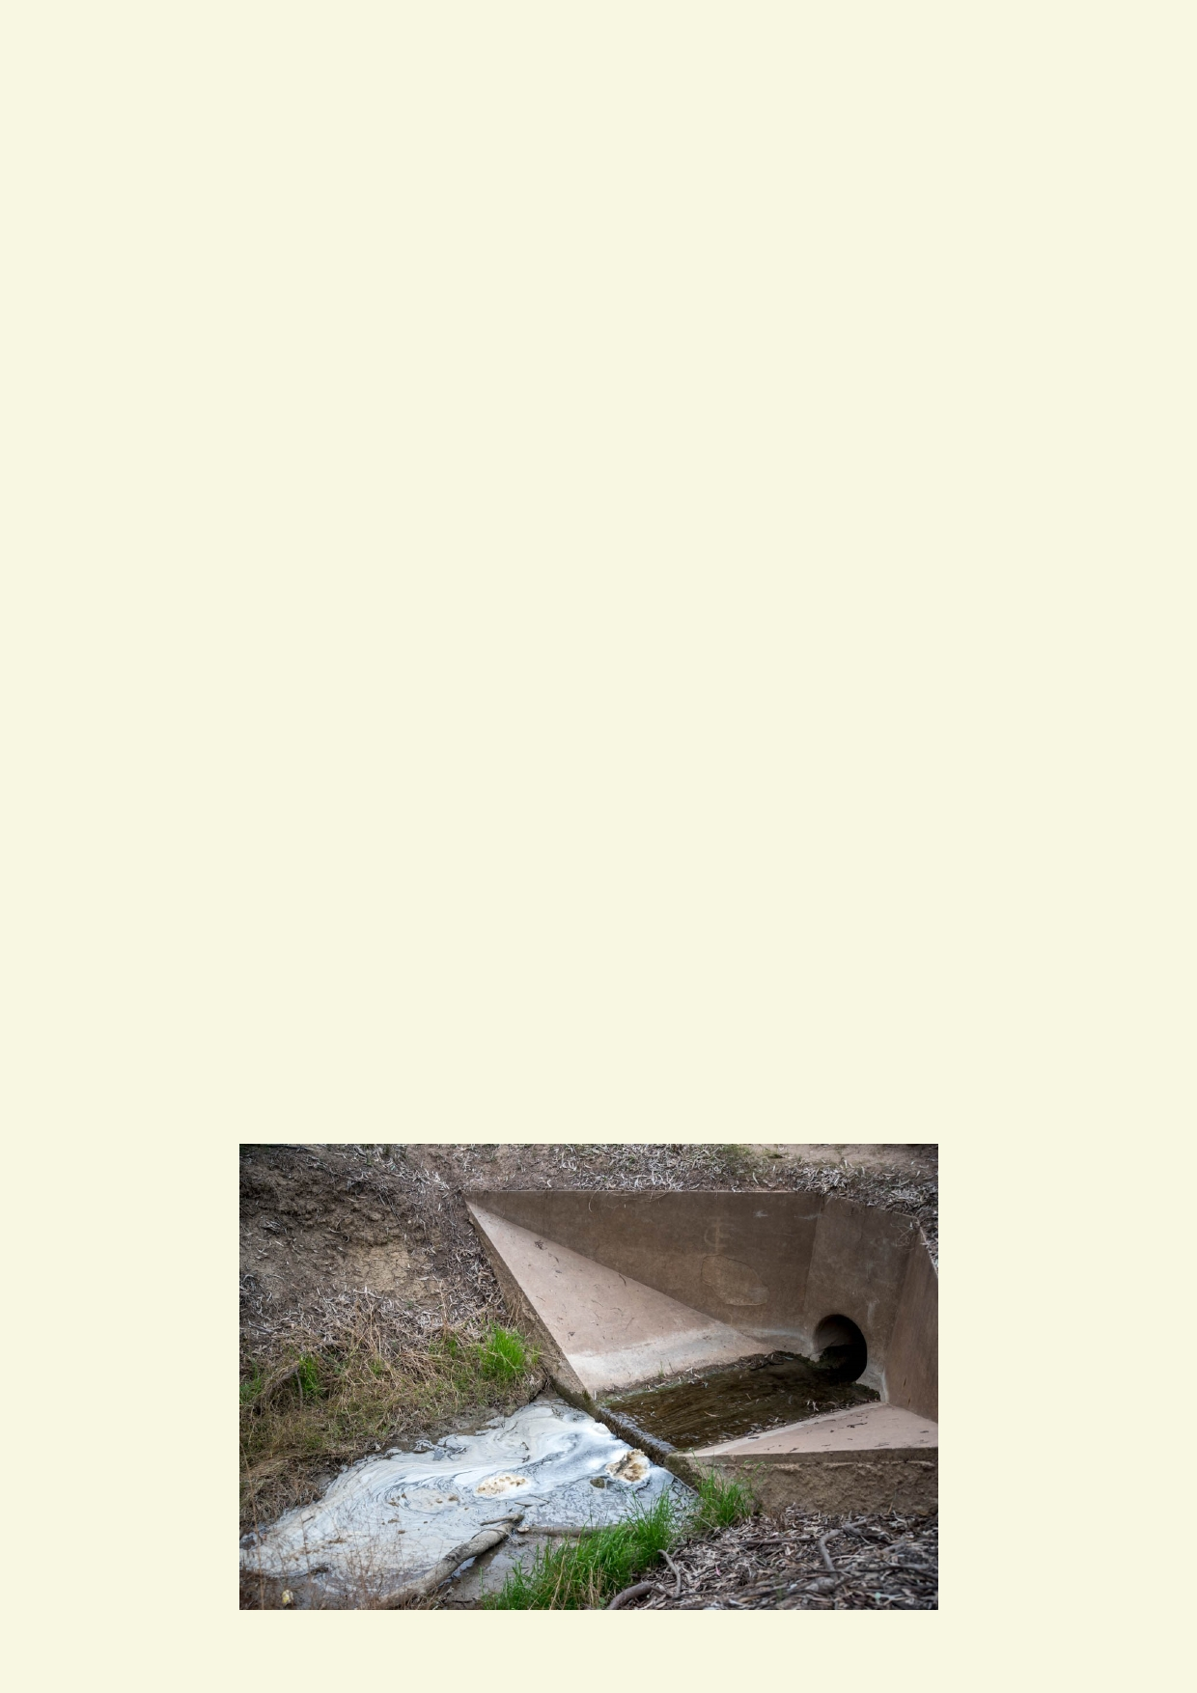Why are aquifers useful during a drought?

________________________________________________________________________________

________________________________________________________________________________

Where does the water in aquifers come from?

________________________________________________________________________________

________________________________________________________________________________

How can aquifers get polluted?

_______________________________________________________________________________

_______________________________________________________________________________

What will happen if the amount of water taken from an aquifer is greater than the recharge?

______________________________________________________________________________

_______________________________________________________________________________

Activity 5. Polluted aquifers

You will be making an aquifer in a cup that you can eat and drink. It will consist of layers that represent soil and rocks. Coloured cordial will show how water is moving through your aquifer.
Below are suggestions about how you can make your aquifer. You could choose to use what you
have learned about aquifers and make your own version.

Before you start this activity, wash your hands and make sure the surfaces you work on are clean. All the equipment you use must be clean and have never been used in a science laboratory.
Confirm with your teacher if you have any allergies that could be in the ingredients.

18

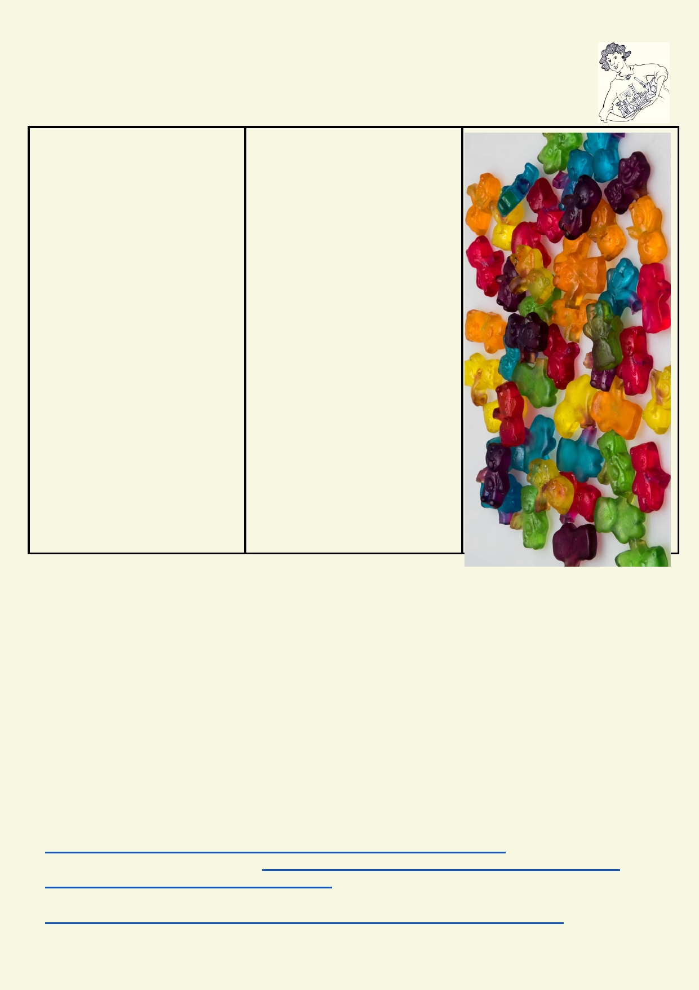The movement of cordial ice cream and crushed biscuits will simulate how water carries dissolved materials through the water table including pollution.
Experiment: Edible aquifer

Equipment: Method

• A small clear plastic cup 1. In a cup, layer the small
for each student gummy bears, chocolate chips,
• Tub of ice cream crushed cookies, breakfast
• Concentrated juice cereal, or crushed ice
• Tube of food colouring that (represents gravel and rock).
can be used by single 2. Pour some concentrated juice
drips to just cover the layer above
• Some of the following (groundwater).
Small gummy bears, 3. Place a scoop of ice-cream
• chocolate chips, crushed on the top (Confining layer).
cookies, breakfast cereal, 4. Place sprinkles on top
or crushed ice (grass).
• Cake sprinkles 5. Place one drop of food
• Straws colouring on top of the ice-
• Spoon cream to see how the ice-cream
moves through the material
below.
6. Observe what happens when
you use the straw to slowly drink
from the bottom of the cup. 7. What happens when the
aquifer is recharged with more
cordial?
8. Clean up after the
experiment.

Predict how this experiment simulates pollution.

__________________________________________________________________________

Observation of liquid and the materials that it carries when it is being drunk.

__________________________________________________________________________

__________________________________________________________________________

Explain how aquifers become polluted
Use the internet to find out more about how aquifers become polluted and what chemicals and
other materials can pollute aquifers.

Groundwater contamination
http://www.groundwater.org/get-informed/groundwater/contamination.html
How groundwater pollution occurs http://www.mnn.com/earth-matters/translating-uncle-sam/
stories/how-does-groundwater-pollution-occur
China Water Risk
http://chinawaterrisk.org/resources/analysis-reviews/the-state-of-chinas-agriculture/

19

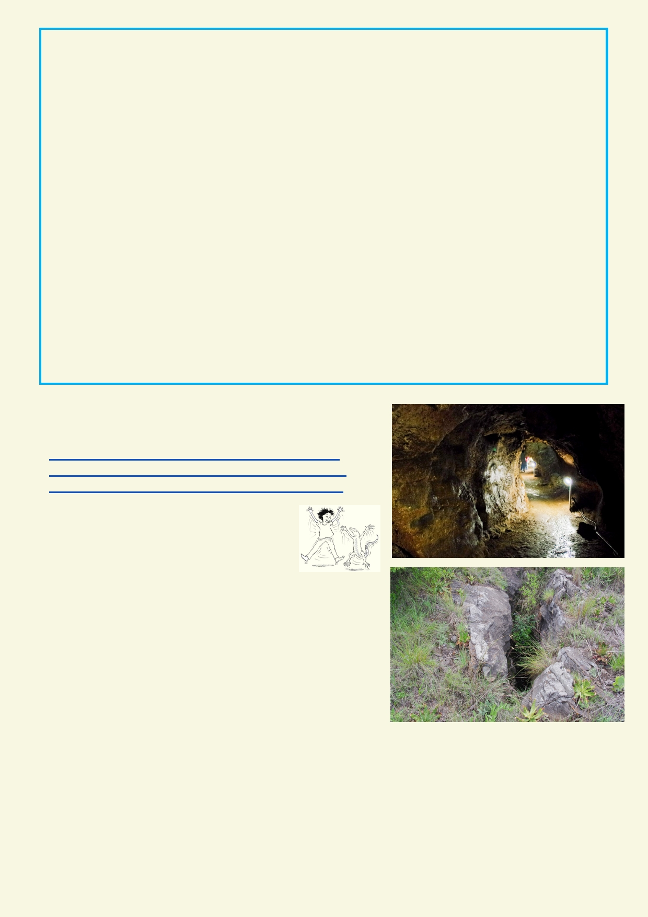Draw and label a diagram that shows where different sources of pollution enter into and moves
through the aquifer:

Activity 6. A drip at a time

Watch some of these videos
https://www.youtube.com/watch?v=j23TqoMNPY8
https://www.youtube.com/watch?v=PpbxFpAZmSQ
https://www.youtube.com/watch?v=HYV6gBssMFs

Tick the correct answer:

What does limestone come from?
◻ Volcanoes
◻ Rivers
◻ Shells of dead sea creatures

Limestone is made from
◻ Sand
◻ Calcium carbonate
◻ Carbon Dioxide

Solid limestone is dissolved by
◻ Carbon dioxide in water
◻ Calcium carbonate in water
◻ By water alone

Limestone caves are formed by
◻ Earthquakes ◻ Groundwater
◻ Geological faults

20

Watch some of these videos:
https://www.youtube.com/watch?v=nGkDouBVoLs
https://www.youtube.com/watch?v=Cp5S6WWZsWc
https://www.youtube.com/watch?v=JII0KLQqVR4

Write a fictional short story about a sinkhole opening up without warning on your school's grounds.

_______________________________________________________________________________

_______________________________________________________________________________

_______________________________________________________________________________

_______________________________________________________________________________

_______________________________________________________________________________

_______________________________________________________________________________

_______________________________________________________________________________

_______________________________________________________________________________

_______________________________________________________________________________

_______________________________________________________________________________

_______________________________________________________________________________

_______________________________________________________________________________

_______________________________________________________________________________

_______________________________________________________________________________

_______________________________________________________________________________

_______________________________________________________________________________

_______________________________________________________________________________

_______________________________________________________________________________

_______________________________________________________________________________

_______________________________________________________________________________

_______________________________________________________________________________

_______________________________________________________________________________

_______________________________________________________________________________

_______________________________________________________________________________

21

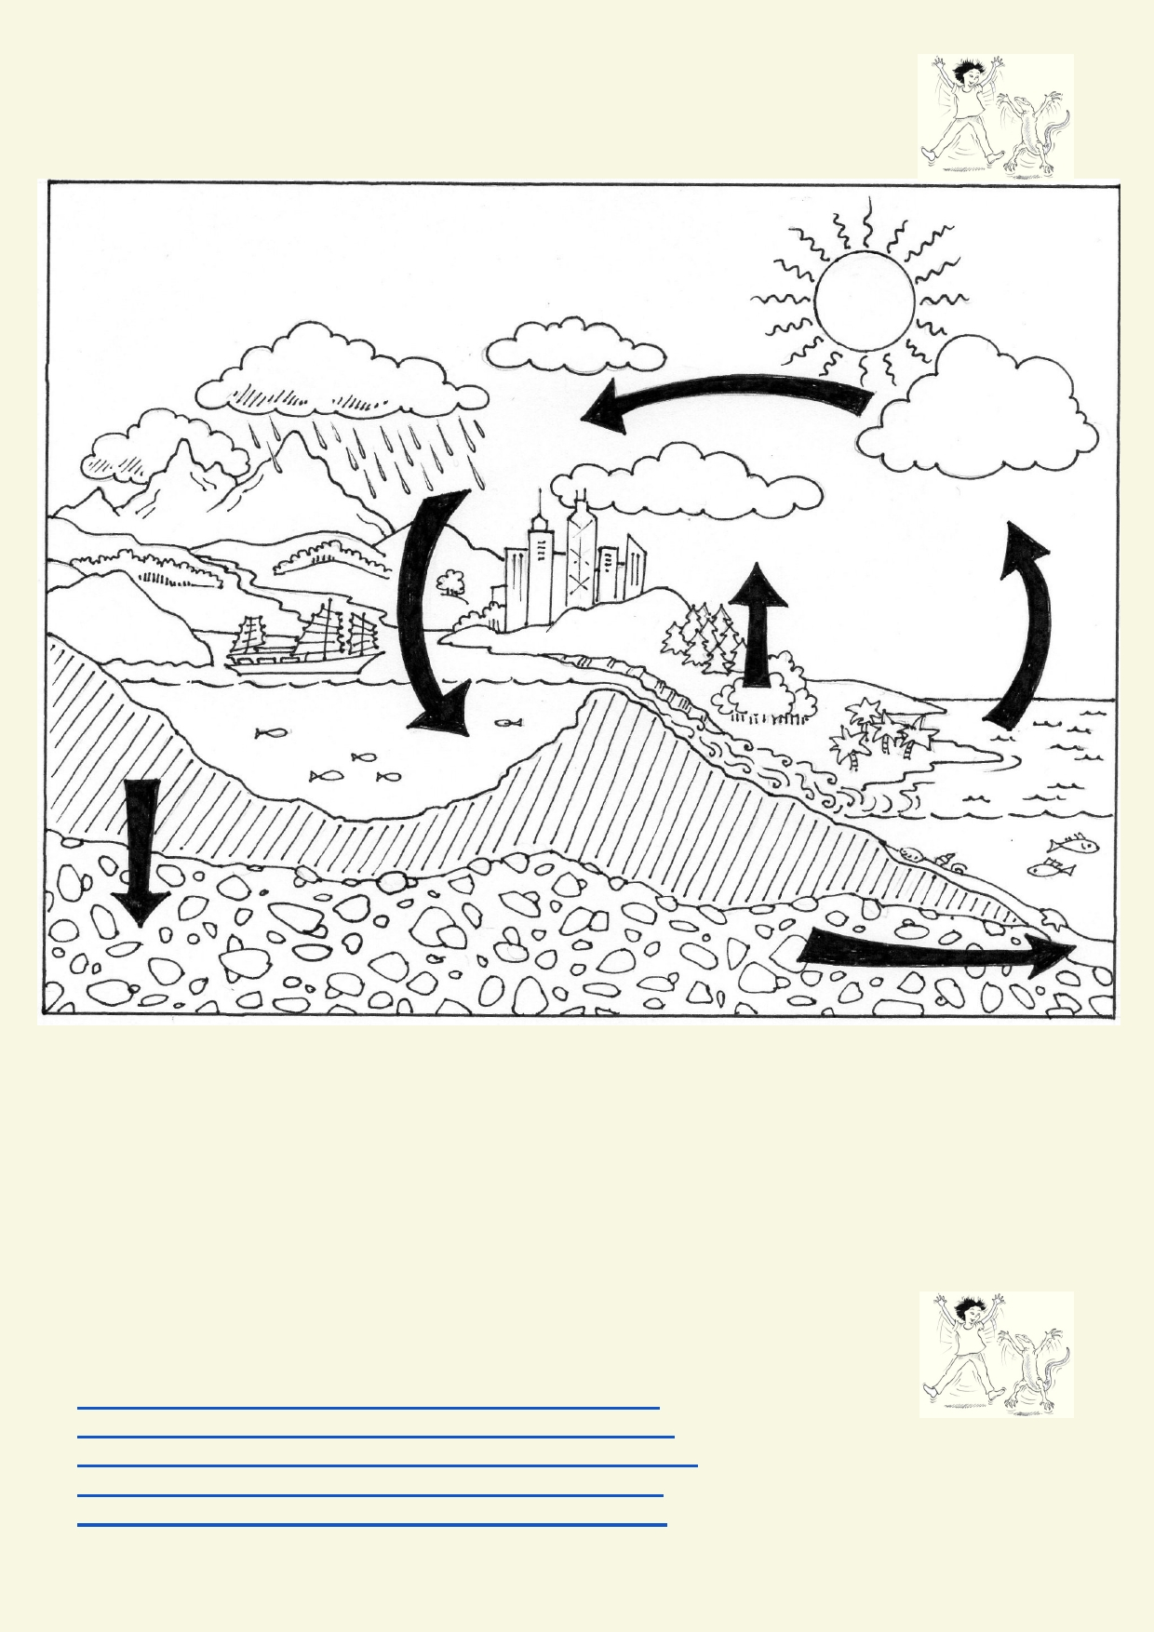Lesson 3 - Changing environment
Activity 1. Review the water cycle

Label this diagram and add more arrows. Use
this list of words . Refer to the glossary and the
internet for words you are not familiar with
Solar radiation
Evaporation
Condensation

Activity 2. Local and regional weather information

Transpiration
Sublimation
Surface runoff
Groundwater
Precipitation
Infiltration
River

Weather: use this website to see how daily weather is changing in your part of the world.
http://en.sat24.com/en/forecastimages/azie/forecastwind
http://en.sat24.com/en/forecastimages/azie/forecastprecip
http://en.sat24.com/en/forecastimages/azie/forecastlightning
http://en.sat24.com/en/forecastimages/azie/forecasttemp http://en.sat24.com/en/forecastimages/azie/forecastcloud

22

What changing weather conditions are being measured?

_____________________________________________________________________

________________________________________________________________________________

Over what time period are the weather maps being produced?

________________________________________________________________________________

How is this information useful?

________________________________________________________________________________

________________________________________________________________________________

Find out how much variation there was in temperature and humidity in your area by looking at the
graphs on the Hong Kong Observatory website link,
http://www.hko.gov.hk/wxinfo/ts/display_element_tt_e.htm

Maximum temperature __________________ Minimum temperature _____________________

Change in temperature in 24 hours _______________________

Maximum % humidity ________ % Minimum % humidity ________ % Change in humidity _________ %

Activity 3. Destructive weather events (Just another disaster)

This link to Wikipedia has a menu of 41 typhoons that have moved across Hong Kong.
Typhoons affect very large areas. Hong Kong is a small area compared with China so most of the
typhoons on this list will have done more damage to the greater China area.
https://en.wikipedia.org/wiki/Category:Typhoons_in_Hong_Kong

Each student picks a separate typhoon to investigate and report back to the class.

When did the typhoon occur? ___________ What name was it given? ____________________

Describe the weather conditions during the typhoon: ______________________________________

____________________________________________________________________________________

What damage did the typhoon do? _________________________________________________

____________________________________________________________________________________

Report about your typhoon to the class.

What has the class learned about the dangers of typhoons in general?

_____________________________________________________________________________

23

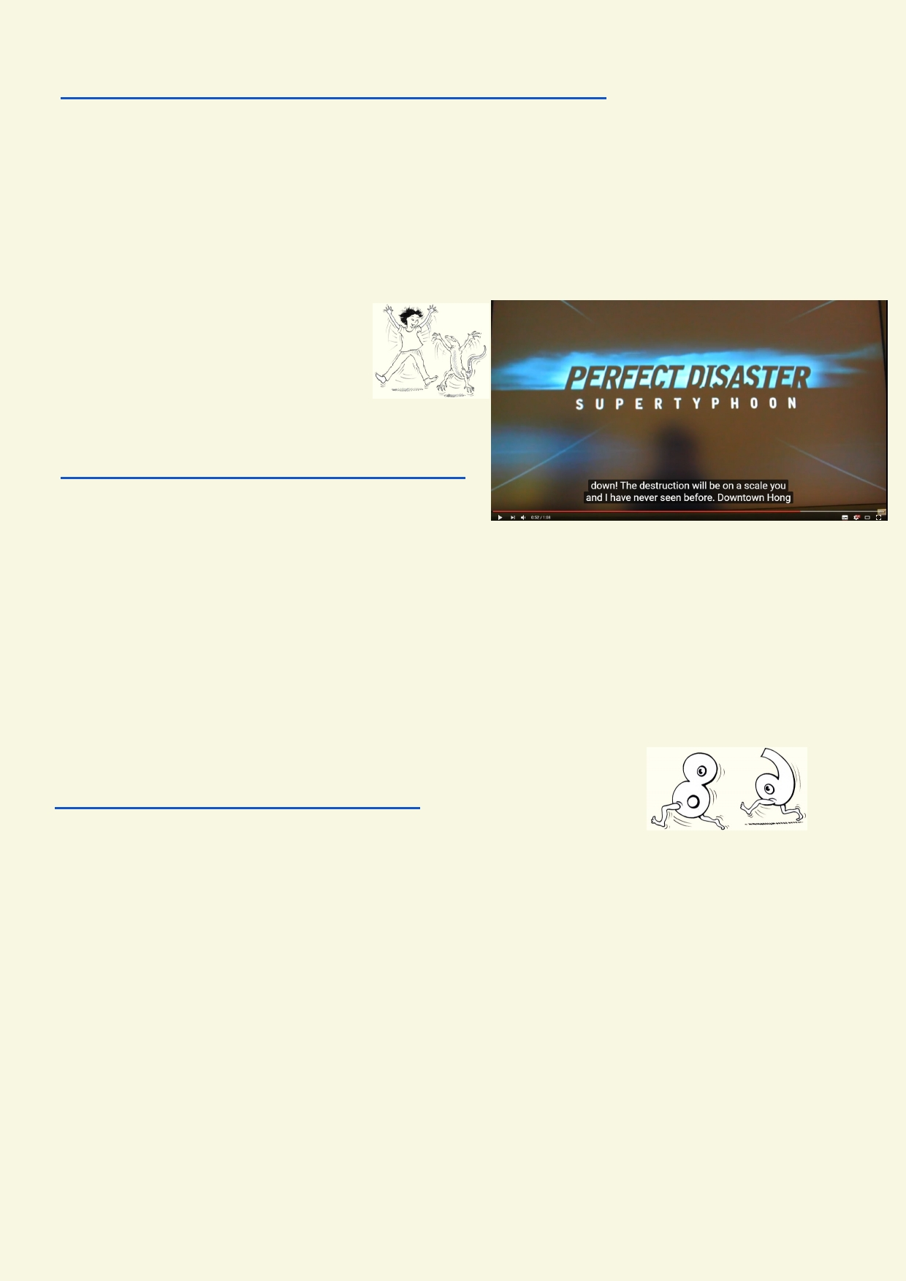This Wikipedia page describes some of Hong Kong's landslips.
https://en.wikipedia.org/wiki/1972_Hong_Kong_rainstorm_disasters

What kind of damage can a mudslide cause?

_____________________________________________________________________________

_____________________________________________________________________________

At the Edge of Your Seat

What disaster movies have you
seen? Do you think they are realistic? Can they become exaggerated or are
some actually ridiculous?
Look carefully at this video. Only look at the short
introduction.
https://www.youtube.com/watch?v=mLuvjTVHfSQ

Discuss as a class:
Why was this video made?

_____________________________________________________________________________

Give your reason why you think disaster movies might be a good idea or a bad idea.

_____________________________________________________________________________

Activity 4. What is climate?

Look at the climate images on this Hong Kong weather website.
http://www.weather.gov.hk/cis/climahk_e.htm

How does maximum temperature change over 12 months?

_____________________________________________________________________________

How does humidity change over 12 months?

_____________________________________________________________________________

How does rainfall change over 12 months?

_____________________________________________________________________________

Explain why some areas in Hong Kong get more rain:

_____________________________________________________________________________

Could you have come up with the right answers without looking at the images? ______________

24

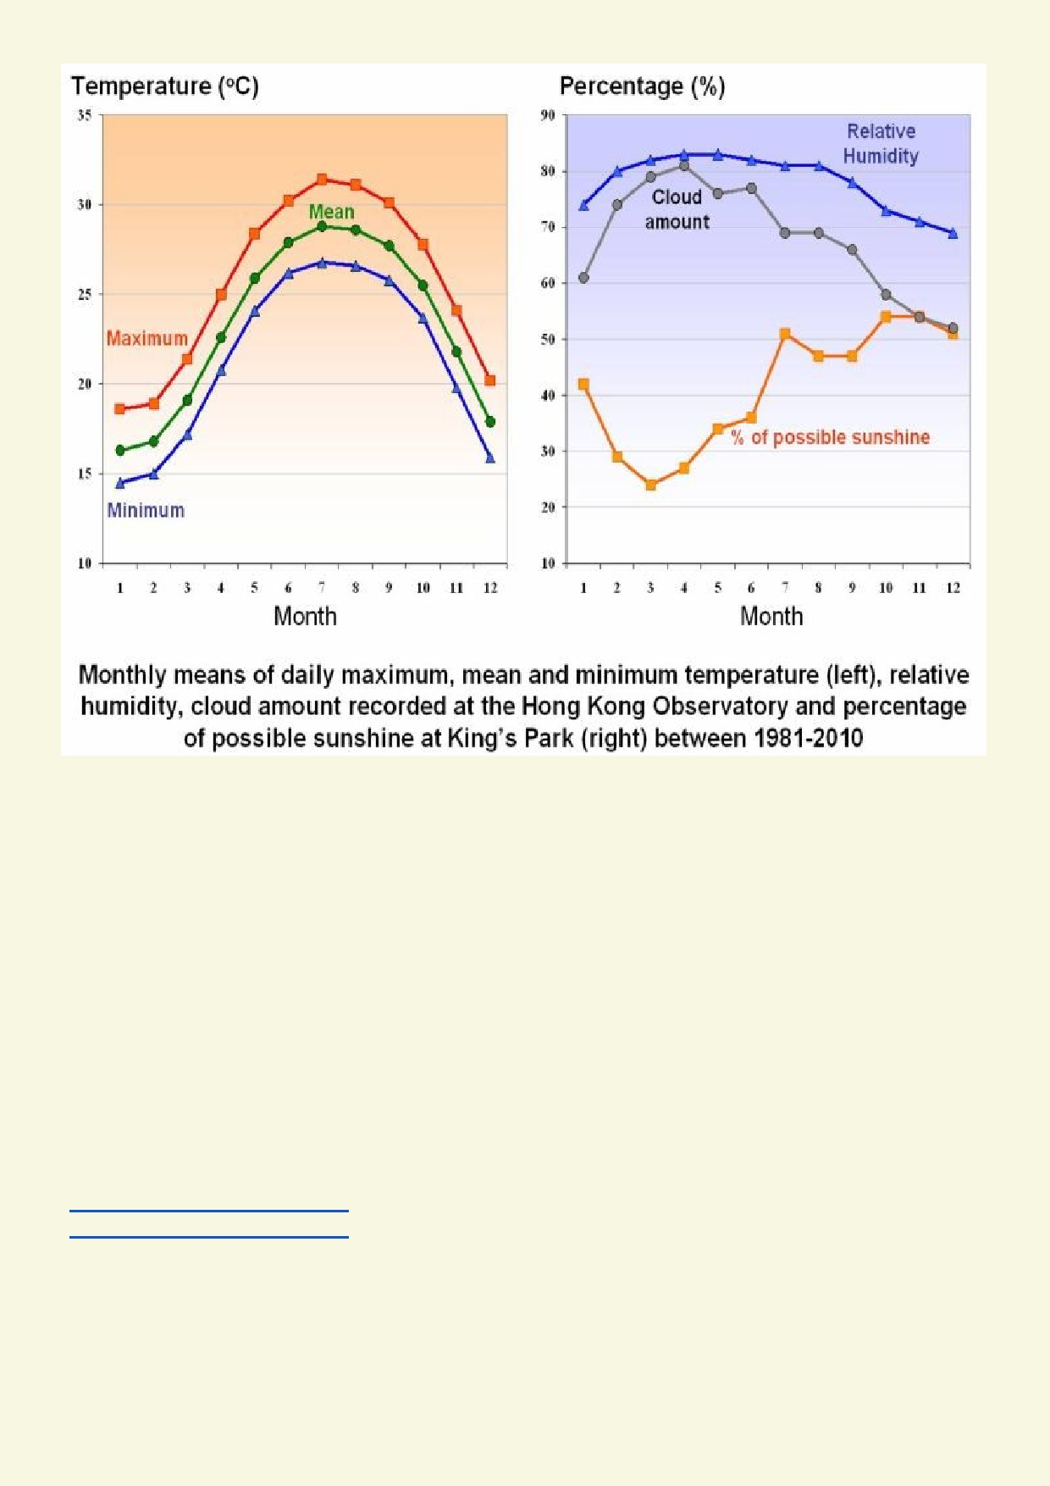
Reference http://www.weather.gov.hk/cis/climahk_e.htm

Explain how data over many years is used to describe climate.

_____________________________________________________________________________

_____________________________________________________________________________

_____________________________________________________________________________

What is the difference between weather and climate?

_____________________________________________________________________________

_____________________________________________________________________________

After watching these short videos, explain how temperature and CO2 in the atmosphere is chang-
ing. When has the change started to speed up?
https://vimeo.com/175317504 CO2 concentration
https://vimeo.com/175317500 Temperature

_____________________________________________________________________________

_____________________________________________________________________________

25

It only takes a couple of degrees change in the Earth's average temperature to have a dramatic
effect on the climate of most regions around the world. Research is being done to find how an
increase in average temperature could affect Hong Kong. Use this website to find out how a
change in Hong Kong's climate might affect its future.
http://www.weather.gov.hk/climate_change/climate_change_hk_e.htm

Summarise how Hong Kong's climate could be affected by more greenhouse gases.

_____________________________________________________________________________

_____________________________________________________________________________

_____________________________________________________________________________

Activity 5. Is geoengineering the solution?

Sea level rise is due to two factors. As the ocean's water warms, it expands. As
more ice on Greenland and Antarctica melts and falls into the ocean, the sea
rises even further. Over 100 years we can expect the sea level to rise by one
meter. One meter does not sound like much. Within 50 years the world's
coastal cities will be commonly flooding when there is a combination of big storms and high tides.
Many populated Pacific Islands will have to be abandoned because seawater will have flooded
the water table and crops can no longer grow. Within 100 years these cities will need drastic
action to save their lowest lying land from the sea.

One of the ideas being explored to prevent global warming is geoengineering. Some scientists have come up with many ideas to stop the climate getting warmer. These would be large scale
projects. More ideas are being developed all the time. One of the biggest dangers associated
with geoengineered solutions is that they are not possible to test on a large scale. Some
solutions could lead to even bigger, new problems that were impossible to anticipate.
These are some of the suggestions that are being seriously considered to reduce the effects of greenhouse gases or climate change. Their potential disadvantages are also included.

Class survey - tick up to two solutions you think are best for Hong Kong:
◻ Seawalls to protect Hong Kong's cities from storms and coastal surges. Seawall
would impact on intertidal zones, marine animals and birds.
◻ Reflectors positioned in space could lower the Earth's temperature. This could reduce sea
level rise and impact of storms. With the reflectors many regions may not necessarily keep
their previous climate. The cost of the sun reflectors in space would be very high.
◻ More pollution, particularly sulphur pollution would reduce temperature. It would, however,
also affect the health of people and the environment.
◻ Placing chemicals in atmosphere could lower the Earth's temperature. We may still have
changes in climate but not have the destructive impact that higher temperatures will cause. These chemicals may also cause pollution or affect the ozone layer.
◻ By fertilising the sea, some hope that more CO2 could be captured and the resulting dead
plants and animals settling on the bottom of the ocean would reduce CO2. We don't know if
it would really work and if it would have an impact on the oceans.
◻ Reducing greenhouse gases faster than we are already doing won't be too expensive over
the long term, but could have many economic consequences in the short term. It is very
difficult to get every country on board. Many poorer countries want to give their citizens
better lives so they need to be able to use more resources.
26

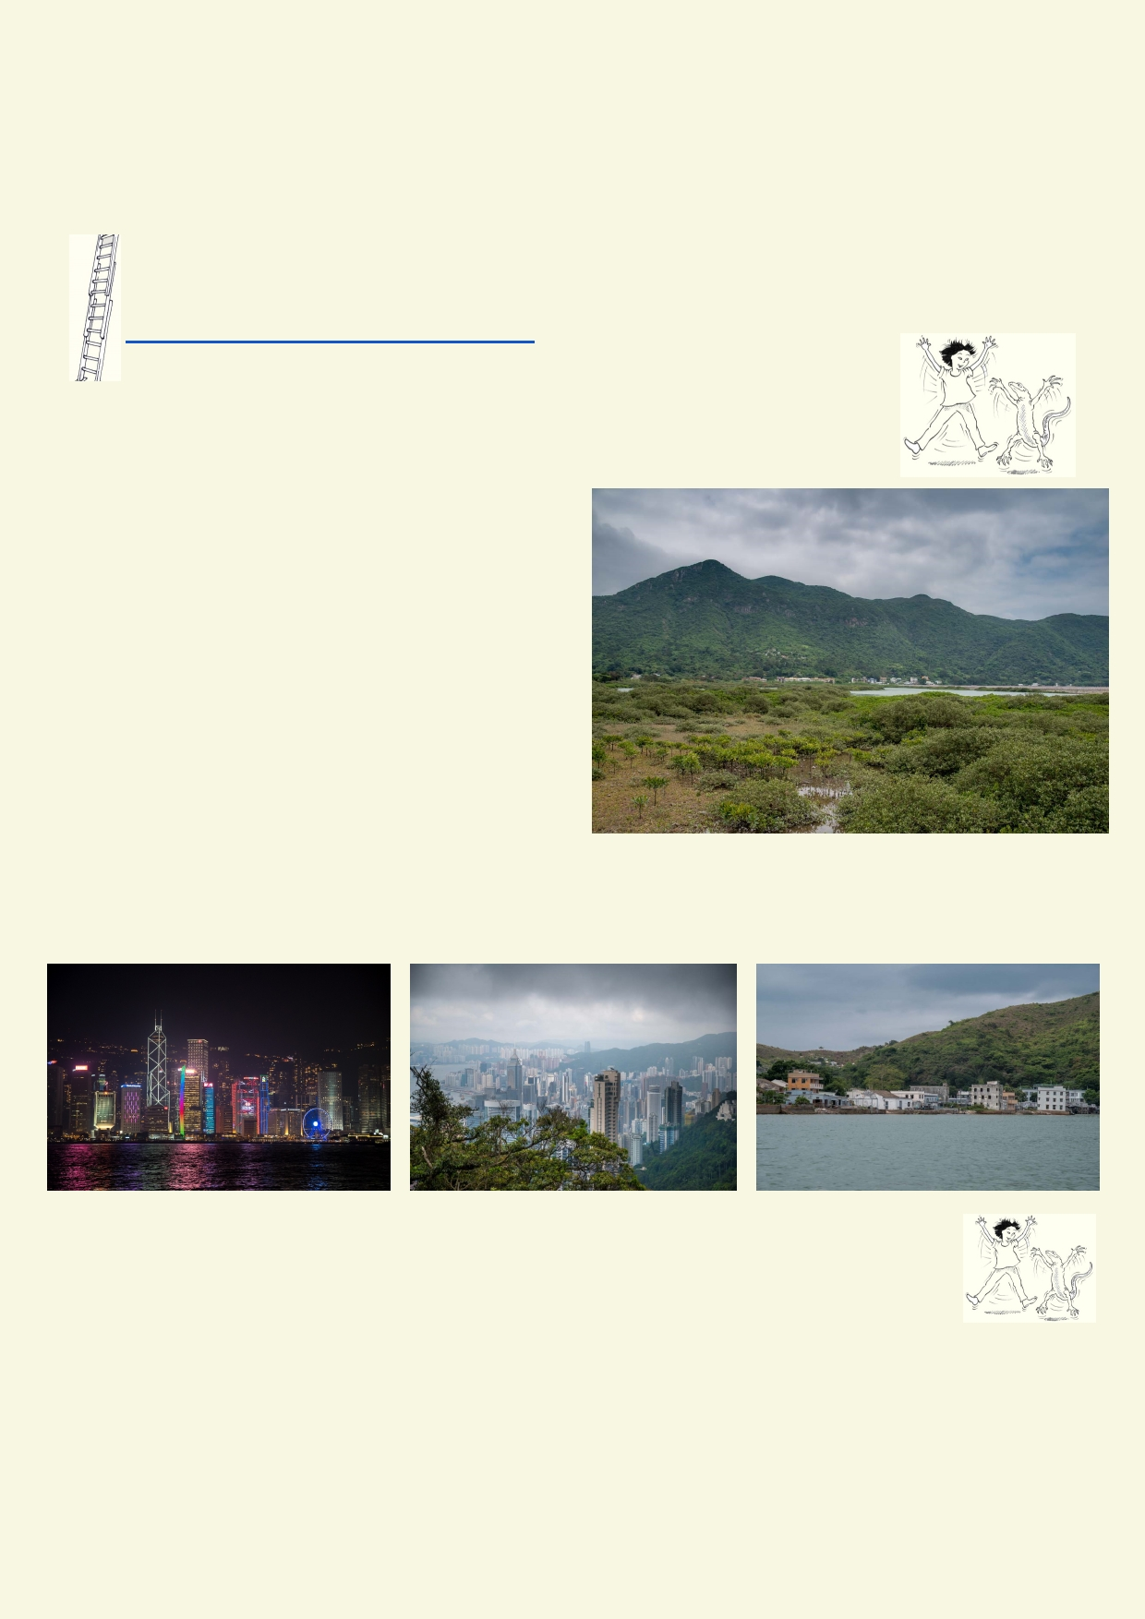Discuss your preferred options. Can you find other options for reducing climate change? What
conclusion did your class come to?

_____________________________________________________________________________

_____________________________________________________________________________

Extension - Meteorological research

Follow the path of a typhoon on a website
https://scijinks.gov/hurricane-simulation/

Lesson 4. Using the land wisely

Activity 1. Why we need regulations

What is your opinion about how the limited land
in Hong Kong is used?

____________________________________

____________________________________

____________________________________

____________________________________

____________________________________

______________________________________________________________________________

______________________________________________________________________________

Activity 2. The big land carve up.

The pie graph on the next page shows the percentage land use for Hong Kong.
Describe how the land is used in Hong Kong. What occupies most of the land?

_____________________________________________________________________________

_____________________________________________________________________________

_____________________________________________________________________________

_____________________________________________________________________________

27

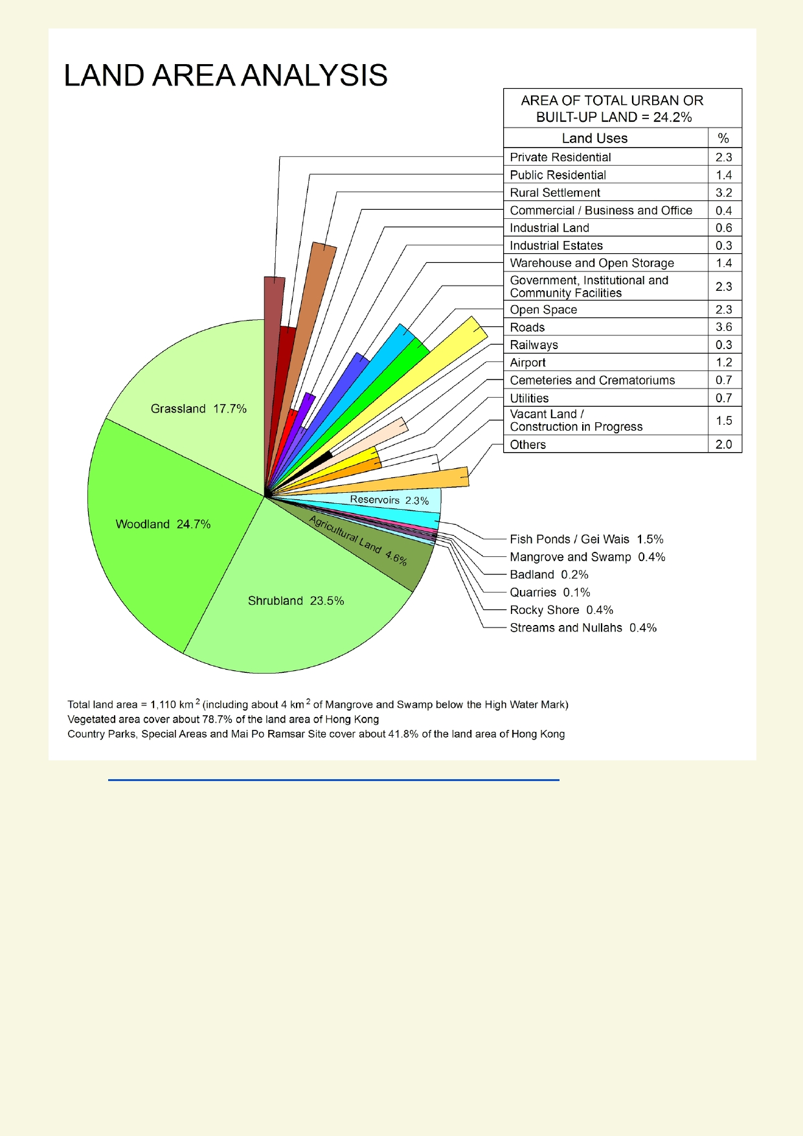

Source http://www.pland.gov.hk/pland_en/info_serv/statistic/landu.html

How much of the land in Hong Kong has been developed?

_____________________________________________________________________________

_____________________________________________________________________________

What part of Hong Kong would you expect to find the shrublands, woodlands and grasslands?

_____________________________________________________________________________

_____________________________________________________________________________
Why do you think the woodlands, scrublands and grasslands have not been cleared?

_____________________________________________________________________________

_____________________________________________________________________________

28

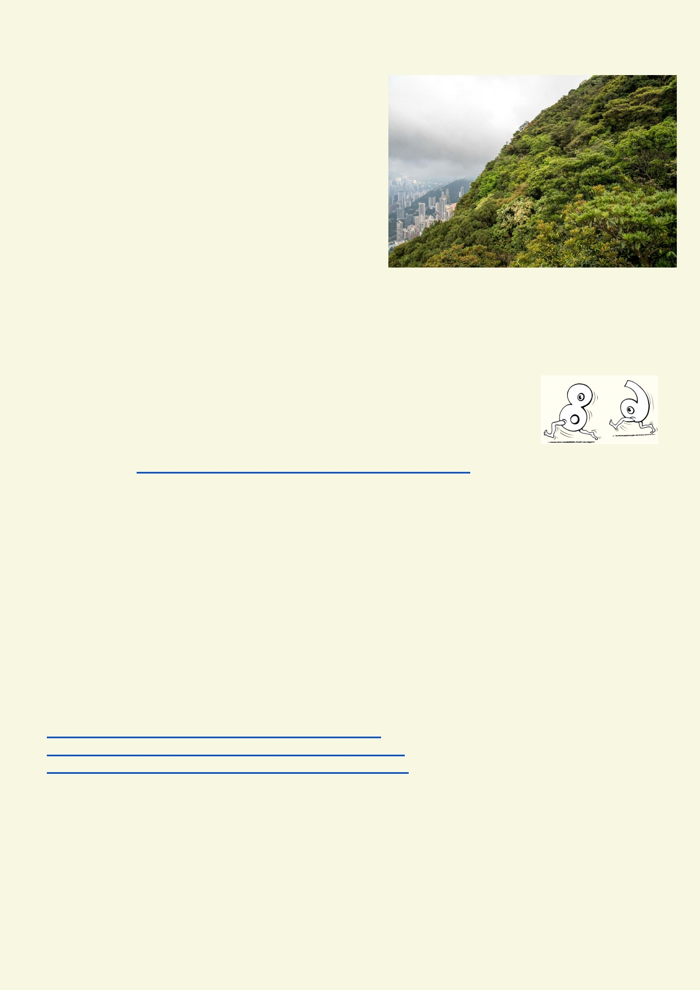How would the shrublands, woodlands and grasslands look if the government didn't regulate how
land can be used?

__________________________________________

__________________________________________

__________________________________________

__________________________________________

Look at the pie graph on page 28. Besides natural
areas and open space, what are the ten most com-
mon land uses in Hong Kong?

_____________________________________________________________________________

_____________________________________________________________________________

_____________________________________________________________________________

Activity 3. Avoiding danger

The Hong Kong Slope Safety website informs Hong Kong residents about the safety issues associated with steep terrain. Use the website to research some
safety issues. http://hkss.cedd.gov.hk/hkss/eng/natural_terrain.aspx

Use the website to find about Hong Kong's natural terrain and what topography (e.g. slope) this terrain occurs in.

_____________________________________________________________________________

_____________________________________________________________________________

Choose one safety issue to research on the webpage. Safety issues to be researched include:
• What is more dangerous - natural terrain landslides or failures of constructed (man made)
slopes?
• In what terrain are landslides most likely to occur?
• How can dangers be avoided when developing near natural terrain?

http://hkss.cedd.gov.hk/hkss/eng/natural_terrain.aspx
http://hkss.cedd.gov.hk/hkss/eng/communityEdu/HKL.pdf
http://hkss.cedd.gov.hk/hkss/eng/photovideo_gallery.aspx

_____________________________________________________________________________

_____________________________________________________________________________

_____________________________________________________________________________

_____________________________________________________________________________

29

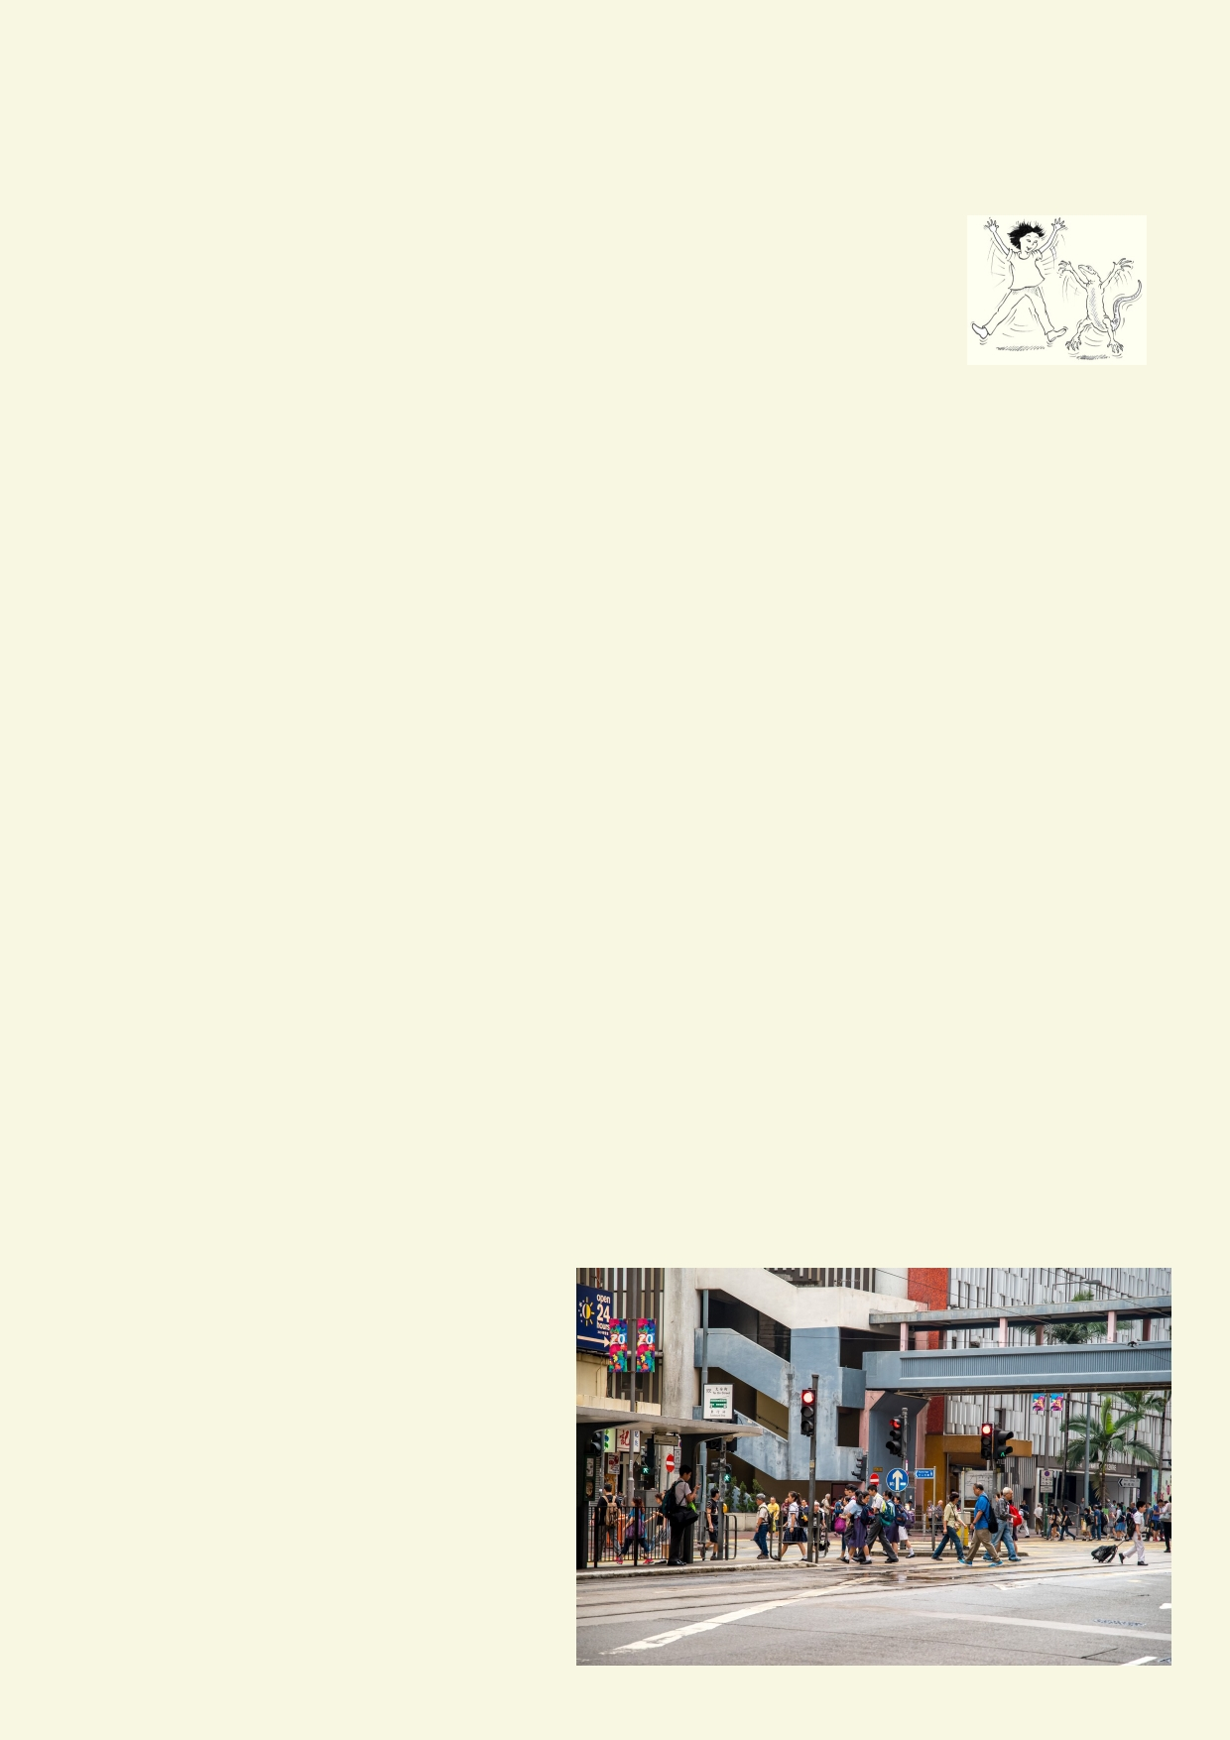Design a simple pamphlet using an illustration and text that explains the safety aspects of the
issue you chose to research.

Activity 4. Hong Kong land use

Land use classification
Land in the Hong Kong territories is divided according to land use by the Lands
Department and Planning Department. They determine which lands can be developed and which remain 'Green Belt'. Land use directly affects water's
ability to move over the landscape.

The idea of Green Belts are a legacy of the British occupation of the Hong Kong territories who used this strategy to limit urban development and allocate enough natural landscape to aid, in
part, water movement through the landscape to recharge water supplies.

How is Hong Kong planning benefiting your quality of life?

_____________________________________________________________________________

_____________________________________________________________________________

_____________________________________________________________________________

_____________________________________________________________________________

What would Hong Kong be like if there were fewer planning restrictions?

_____________________________________________________________________________

_____________________________________________________________________________

_____________________________________________________________________________

_____________________________________________________________________________

Activity 5. Effects of different land use on our watershed

From what you have learned, what are the effects (good or bad) on the watershed for the
different terrains pictured below? Consider the following issues:
• Recharging aquifers
• Polluting aquifers
• Increased risk of landslip
• Increased risk of floods • Surface water quality
• Amount of water in streams, rivers,

30

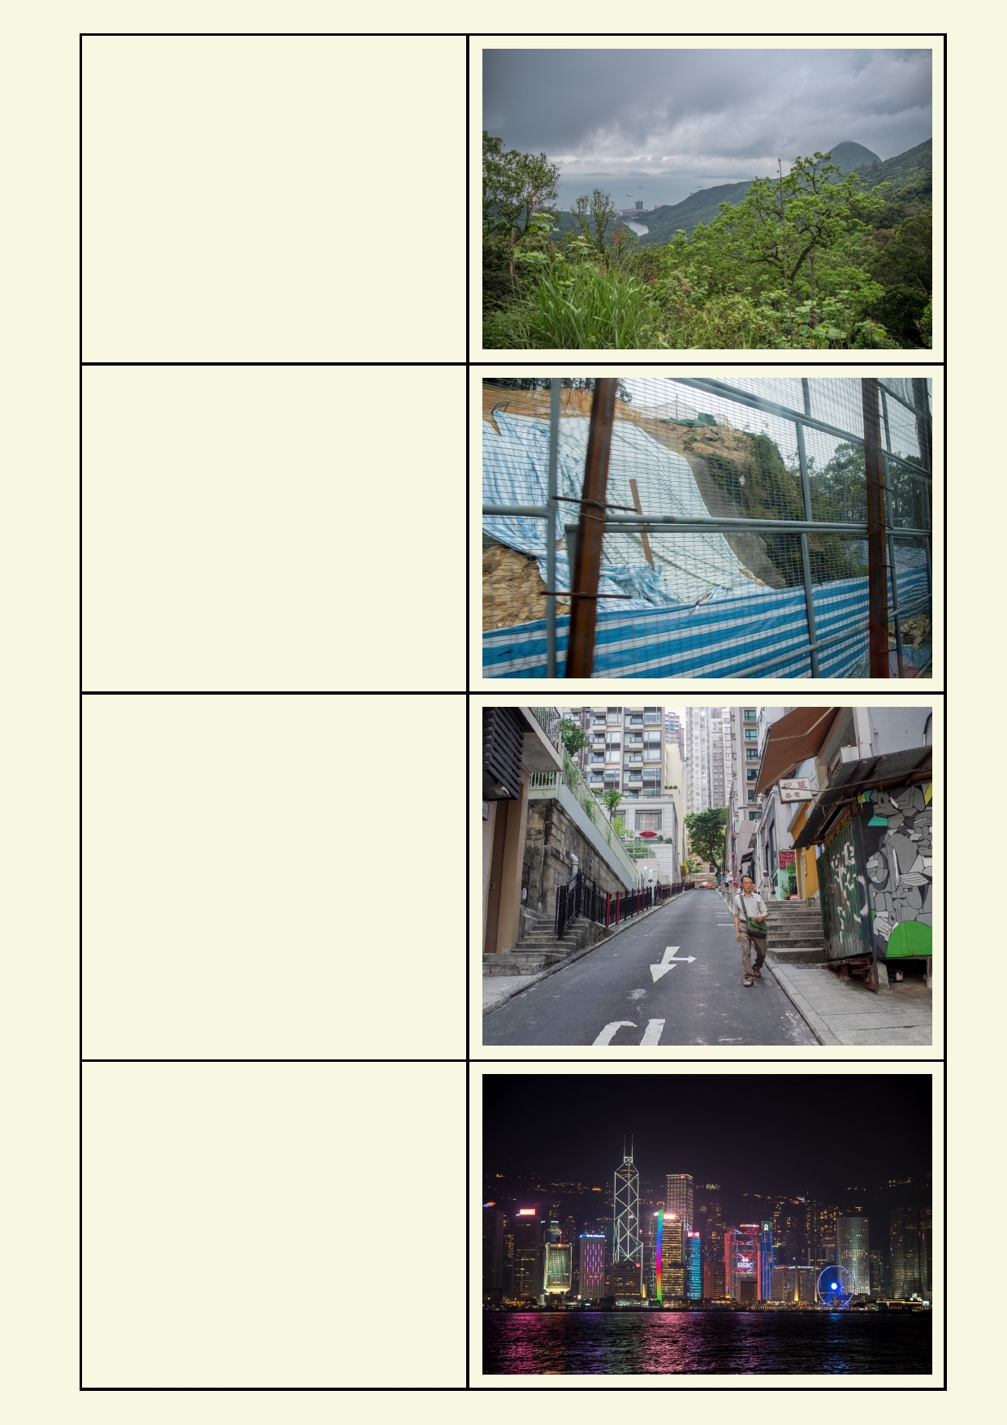Natural terrain

Roads on steep slopes

Large buildings on steep slopes

Large buildings on flat land

31

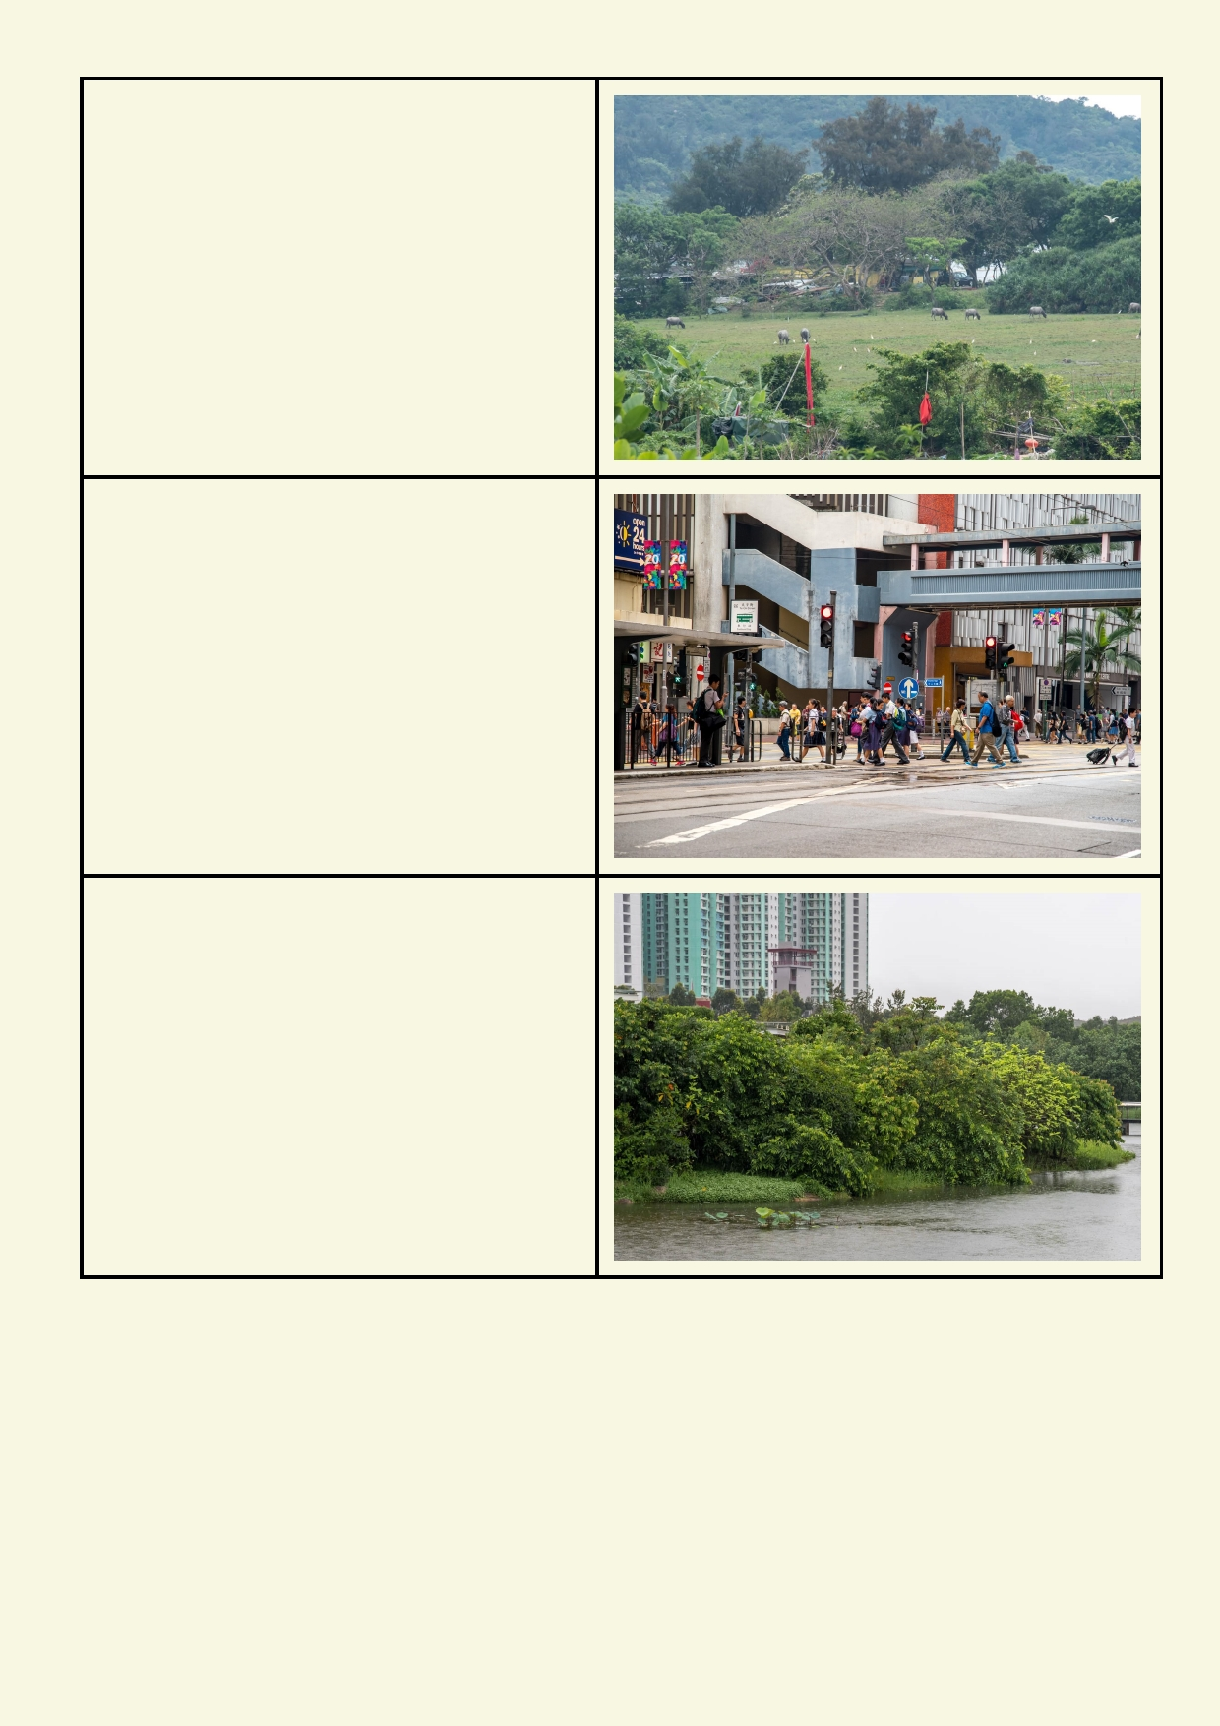Agriculture

Most of the land is covered by buildings,
roads and hard surfaces

Green belts separate dense living and other
constructed zones.

32

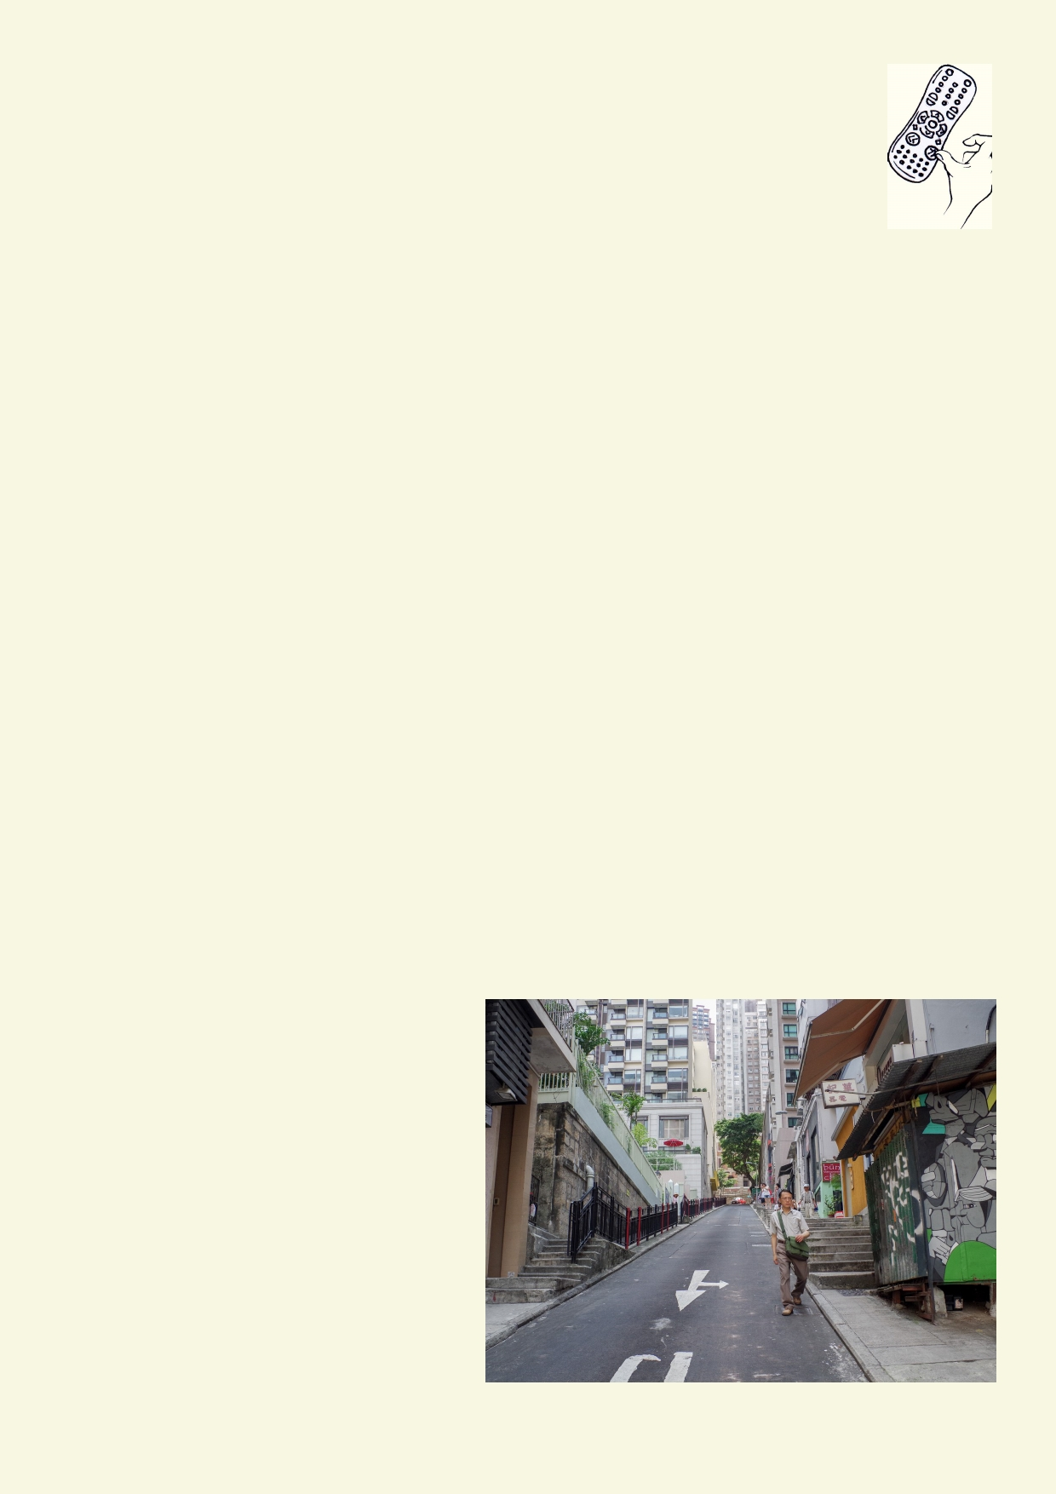Activity 6. Looking forward

Share your knowledge with younger students

Produce something for a younger audience that communicates the concept of watersheds.

Example 1. Use a shoebox to build a diorama of a watershed with mountains, valleys, streams and an outlet to the sea. Show natural, agricultural and constructed areas. Show the role of the
ridgeline in funnelling the water down through the landscape.

Example 2. Write and illustrate a children's story book about an engaging creature making their
way down through a watershed. Show some of the good things that the creature encounters in its environment. Create an adventure by identifying some of the hazards on the way to the sea.
Explain how the landscape changes as the creature travels.

Criteria for the book:
• Target audience can understand the concepts.
• Explains how watersheds work.
• Shows how people affect our watersheds.

Or Plan an education walk

Plan an educational walk relating to your local watershed - either organised for the class to door in your own time outside of school. It is to be a real experience.

Criteria for the walk:
• The walk is to be planned using a map.
• The walk starts from your home or school.
• It takes about 30 minutes to complete the walk and get back to the starting point.
• As part of the plan, it will be explained how you or your class will remain safe.
• Along the walk, various aspects of the watershed will be pointed out. Some features will
be up close while other features could be in the distance.
• The walk should attempt to point out the major watershed features in Hong Kong including
ridge lines, topography, natural
terrain, green belts, constructed
areas, stormwater system and any remnants of past streams.

33

Acknowledgements
The Ocean Recovery Alliance thanks The Hong Kong Jockey Club Charities Trust for their
generous funding support on this education programme.

Project manager: Doug Woodring
Writer, photography and design : Bob Winters
Curriculum manager and editor : Charlotte Charny Nielsen
Editor and school outreach: Alex Hale
Additional thanks: Jasmine Nunns and Sandra Merazzi

© 2017 Ocean Recovery Alliance and Authors.
Outside the school environment, the text, photos and artwork may not be reproduced, except
where permitted by the relevant Copyright Act. These materials may not be modified and
distributed by print or electronic means without written permission. Teachers may modify these
education materials for the use of their students and school provided it is not distributed any
further. Those wishing to reproduce part of this publication must submit their application to the
Ocean Recovery Alliance. www.oceanrecov.org/contact-us.html

34

