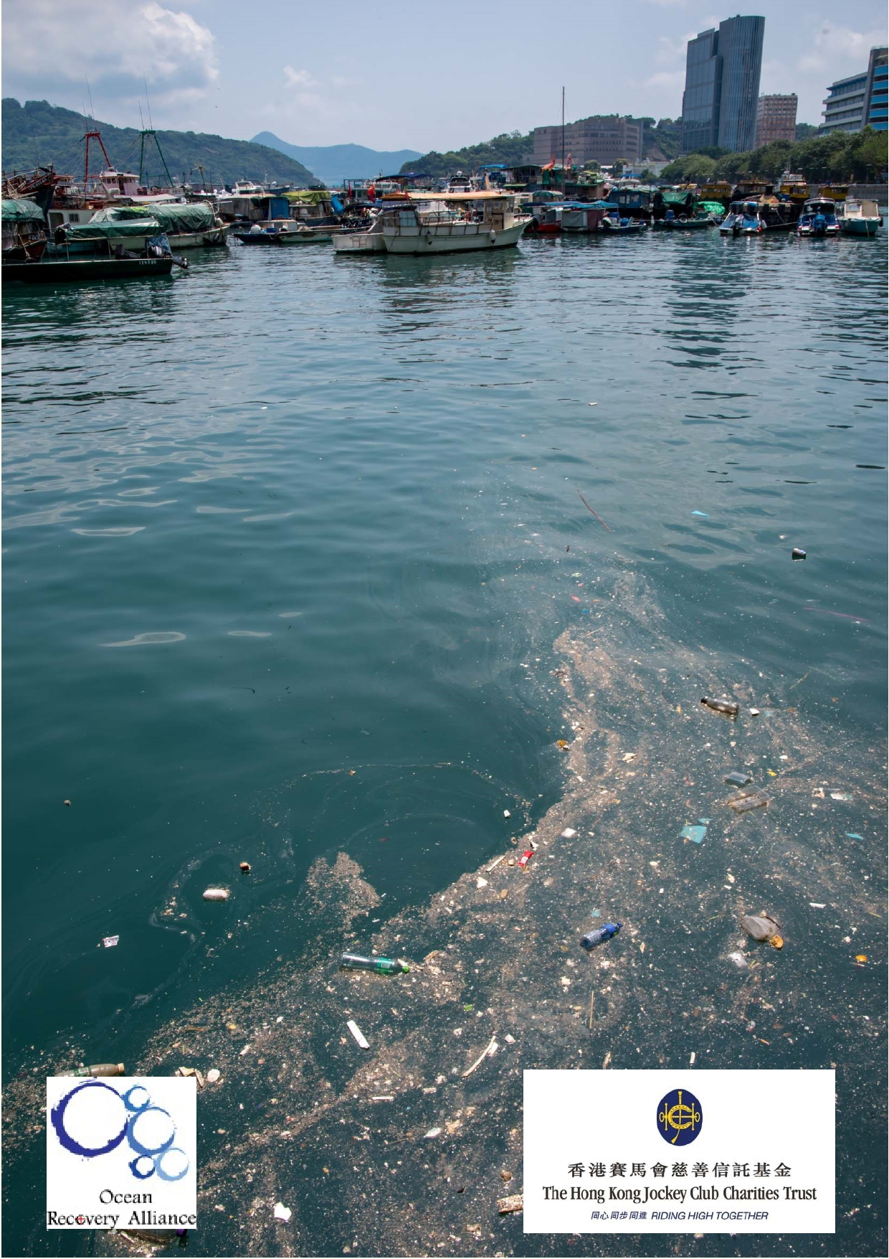Jockey Club Water Caretakers of
Tomorrow Programme
For Shore:
Looking after Coasts and Estuaries - Unit 7

Organised by

Funded by

1

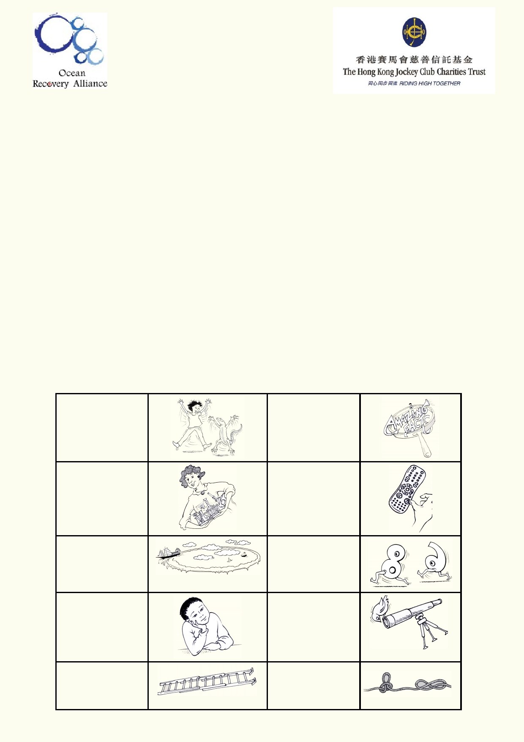About The Jockey Club Water Caretakers of Tomorrow Programme:

Jockey Club Water Caretakers of Tomorrow Programme is organised by Ocean Recovery
Alliance, Ltd and funded by The Hong Kong Jockey Club Charities Trust. There are eight units in
this program, and each of them is designed with you, a student in Hong Kong, in mind.

These are the goals for your lessons, to:
• Understand and appreciate how our water systems function on a local and global scale.
• Understand how watersheds function, and the interconnections of life within and between
these watersheds.
• Be able to assess threats, such as pollution and habitat destruction, and learn how to lessen
these effects.
• Be empowered to take an active role as caretakers of our water resources by sharing your
commitment with your communities.

Student introduction
• You will need access to the internet.
• In some activities using the camera in your smart phone or tablet will be useful.
• Your teacher will tell you if you if your work will be done on your computer, printed paper or
notebooks.

Start of a new A new amazing activity. f act .

Get ready to do an experiment.

Identify your
misconceptions
before your move on.
Identify your
prior learning.

An extension activity.

Fast forward to
make your
contribution to improving our world.
Data will be used
to solve
problems.

These are the goals for this unit.

A cross-
curricular activity.

2

Student aims:

At the end of this unit, I will be able to:
• Connect the uses upstream with the effects downstream on the coast.
• Describe different coastal habitats.
• Explain the functions of coastal wetlands, and other coastal environments.
• Suggest ways to balance competing coastal uses.
• Anticipate the consequences of changes to sea level, storms, etc.
• Produce a final action piece for your communities, to reduce coastal degradation.

Glossary

Aquaculture

Beach

Beach Hinterland

Boom

Coast

Coral

Degradation

Dredging

Dune

E. coli

Estuary

Intertidal Zone

Land Reclamation

Litter Trap

Littoral

Longshore Drift

Mangrove

Microplastics

The cultivation of fish for the purpose of agriculture.

A shoreline typically made up of sand or gravel.

The region just inland from the coast.

A chain of connected timber floating across a river, lake or sea.

Where the land meets the sea.

An organism that lives in warm seas characterised by its hard exterior and its clustering together to form reefs.

A decline or worsening of quality or condition.

When the bed of a river, lake, or the sea is shovelled up and collected by big machinery. Dredging is used to deepen channels or land reclamation.

A sand mound formed by the wind.

A type of bacteria that is normally found in the intestines of healthy
people and animals. Most varieties are harmless but food or water that is
contaminated with some strains of E. coli can cause serious illness.

Where a river mouth meets the sea.

The zone of coastline that is covered by the sea at high tide and exposed during low tide.

The action of building new land with sediments collected at sea.

An invention to capture litter in a waterway.

The area of land along the shore.

The process of waves moving material along the shore.

A shrub or small tree that grows in tidal and coastal areas.

Extremely small pieces of plastic in the environment that have been broken down and are less than 5 millimetres long.

3

Migratory

Mudflat

Nursery

Oil

Oil Spill

Prevailing Winds

Red Tide

Saltmarsh

Saltwater Intrusion

Sea Wall/ Rip Raps

Sediments

Shipping

Stormwater Drain

Tides

Waves
Referring to animals that travel from one place to another at
particular times of year and often over great distances.

Piece of exposed muddy land after high tide retreats.

A sheltered area used to start growing seedlings and other young
plants.

A form of fossil fuel.

When oil contaminates a body of water.

The dominant direction from which the wind blows.

An algal bloom in the sea usually created by excess fertilisers
draining from the land.

A habitat subjected to regular flooding of seawater.

The contamination of a source of freshwater by seawater.

An engineered coastal defence designed to absorb wave damage or
protect against flood.

Small particles and fragments of geological material.

A method of transporting goods around the world by boat.

Structures that transport excess rainwater from urban streets.

The rise and fall of the sea twice a day due to the gravitational
influence of the sun and the moon.

Waves are usually caused by wind moving over the water's surface.
A wave's size depends on wind speed, wind duration and the size of
the area over which it moves.

4

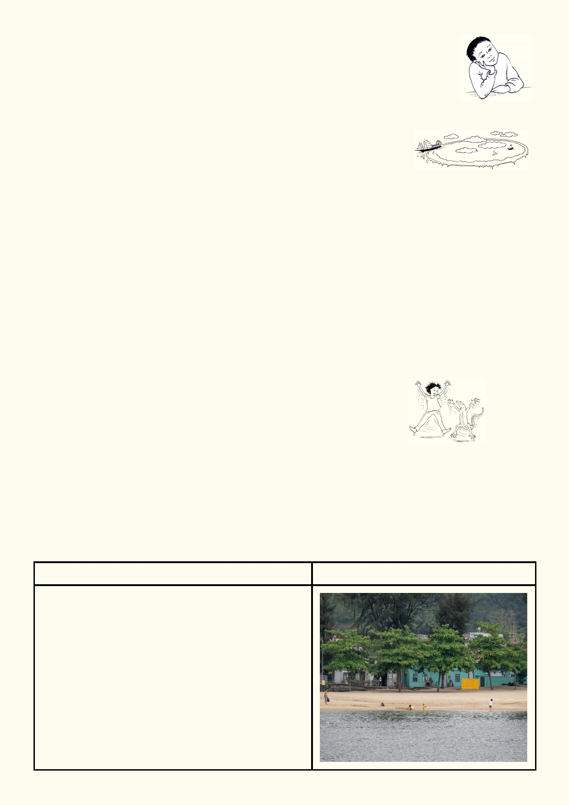Prior knowledge: Seaside sounds on holidays

Your teacher will play a soundtrack from the seaside.
Close your eyes and imagine you are on your dream holiday.
Your teacher will ask you to imagine some different things as you listen to the
sounds.
Recall your thoughts while listening to the soundtrack.

What did you see in your imagination?

___________________________________________________________________________

___________________________________________________________________________

___________________________________________________________________________

What might be some of the environmental threats or safety threats to the vision you had?

___________________________________________________________________________

___________________________________________________________________________

Lesson 1 - Coastal Habitats and uses

Activity 1: Habitat and uses

A habitat is an animal's or plant's home.

Look at each photo and
• Describe the main features you can see in each photo
• Describe what you know about the habitat and the wildlife that uses the habitat
• Describe how we use these places
• Follow your teacher's instructions about researching one or more of the habitats
• Add to what you knew about that habitat.
• After your classmates have shared what they learned, complete the rest of the worksheet.

Habitat
Beach
Key features of habitat:

Wildlife Uses:

Human Uses:

5

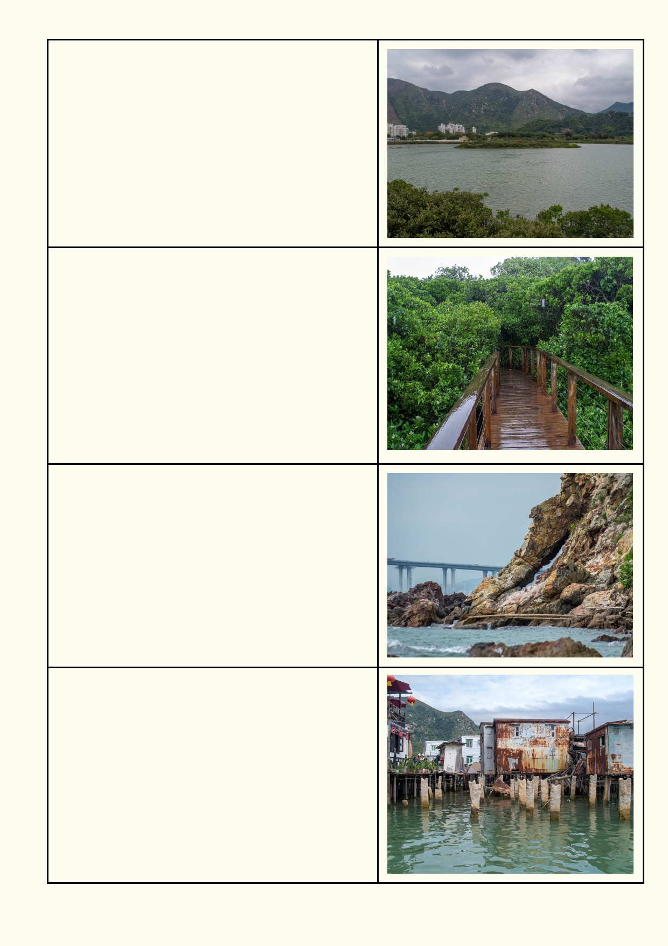Estuary
Key features of habitat:

Wildlife Uses:

Human Uses:

Mangrove
Key features of habitat:

Wildlife Uses:

Human Uses:

Cliff
Key features of habitat:

Wildlife Uses:

Human Uses:

Buildings and piers
Key features of habitat:

Wildlife Uses:

Human Uses:

6

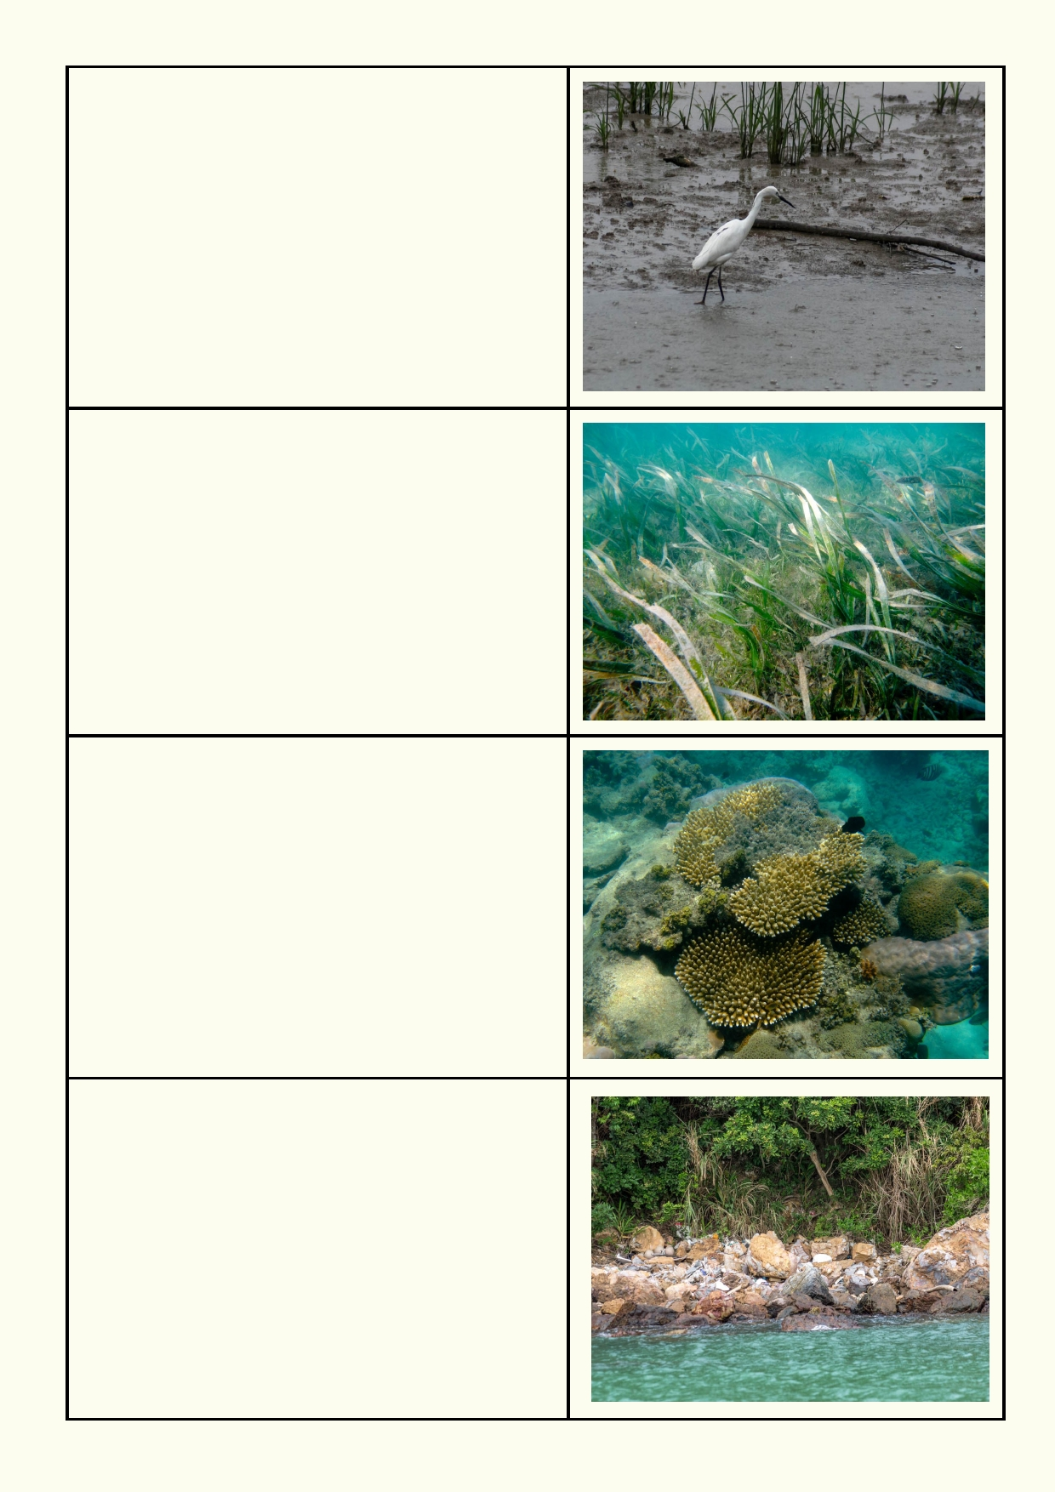Mudflats
Key features of habitat:

Wildlife Uses:

Human Uses:

Seagrass
Key features of habitat:

Wildlife Uses:
(hint: fish breeding)

Human Uses:

Coral reef
Key features of habitat:

Wildlife Uses:

Human Uses:

Rocky shore
Key features of habitat:

Wildlife Uses:

Human Uses:

7

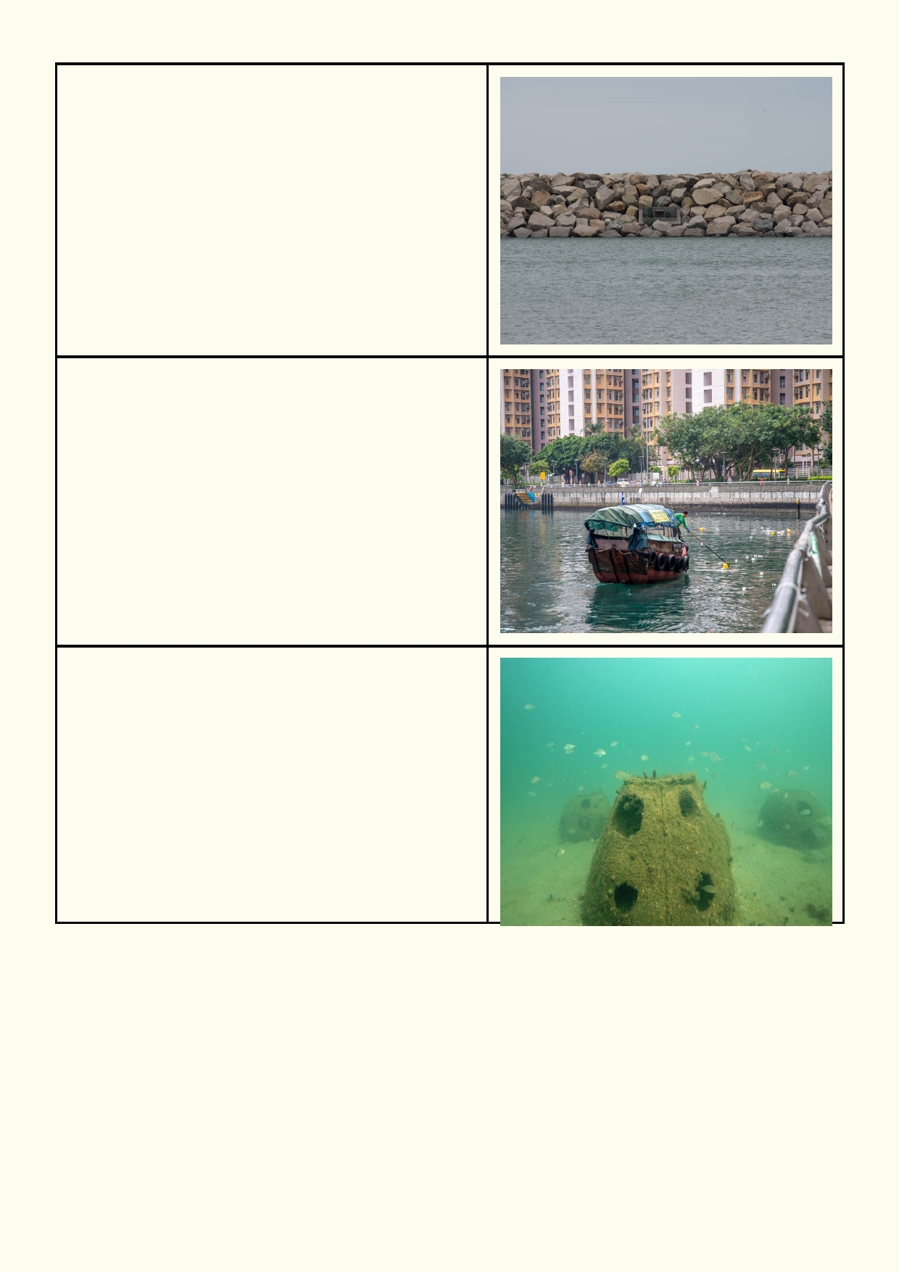Sea wall - boat harbour
Key features of habitat:

Wildlife Uses:

Human Uses:

Sea wall - city waterfront
Key features of habitat:

Wildlife Uses:

Human Uses:

Artificial reef
Key features of habitat:

Wildlife Uses:

Human Uses:

8

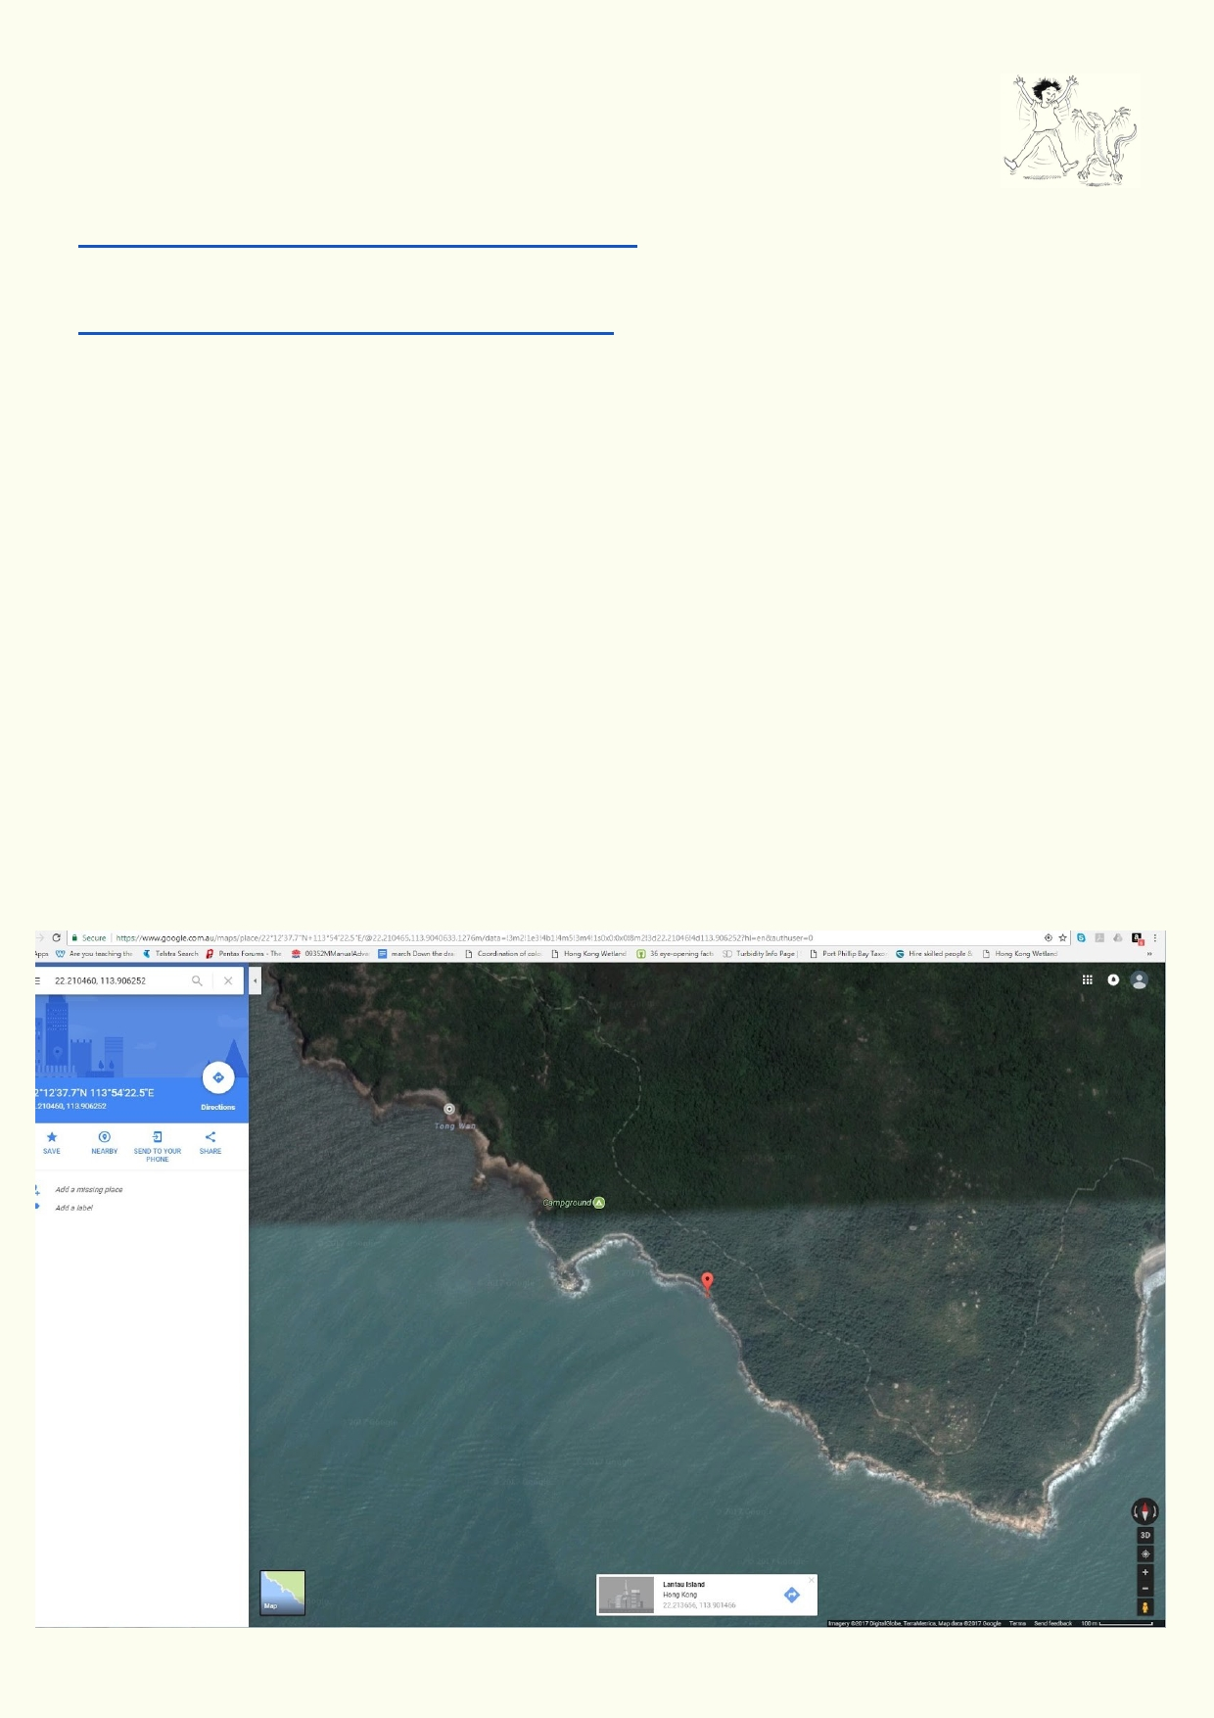Activity 2. Google maps habitats

Review as a class what you understand about longitude and latitude coordinates.

This website has a short explanation about longitude and latitude:
http://www.learner.org/jnorth/tm/LongitudeIntro.html

This short Youtube video also explains longitude and latitude:
https://www.youtube.com/watch?v=cTrsvGytGG0

In this activity you will use Google Maps to locate one or more coastal habitats by looking for
coastal features. Zoom in and find coastal features such as cliffs, reefs, coastal forests, beaches,
mangroves, estuaries, etc. Use the chart below to record the features, habitats and coordinates.
You do not need to find every habitat. Some habitats can only be observed if the satellite photos
were taken at low tide.

1. 2.
3.
4.
5.

6.

7. 8.
Open Google Maps in a web browser.
Click on satellite box at bottom left.
Move around map until you find a feature of interest.
Click on the location of the feature on the map.
A white box at the middle bottom provides a general location name and the exact
coordinates. Click on the coordinates.
These coordinates appear in the top left hand box. Copy the coordinates (highlight and use
Ctrl C).
Paste into your worksheet (Ctrl V).
Then describe the coastal feature and the kind of habitat or habitats that would be found in
these features.

9

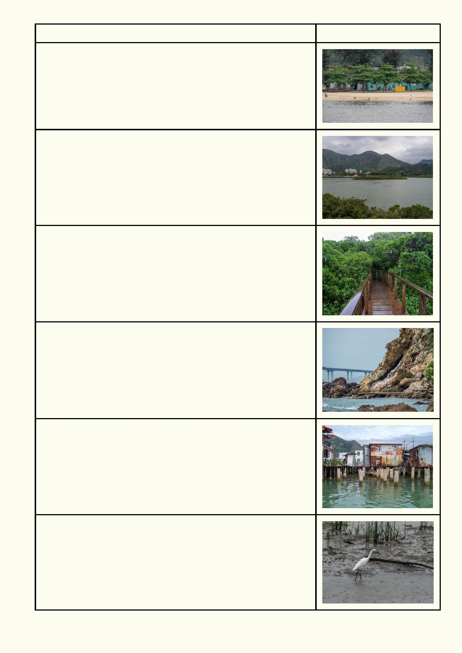Feature and Habitat
Beach
Coordinates:
Describe area:

Estuary
Coordinates:
Describe area:

Mangrove
Coordinates:

Describe area:

Cliff
Coordinates:
Describe area:

Buildings and piers
Coordinates:
Describe area:

Mudflats
Coordinates:

Describe area:

10

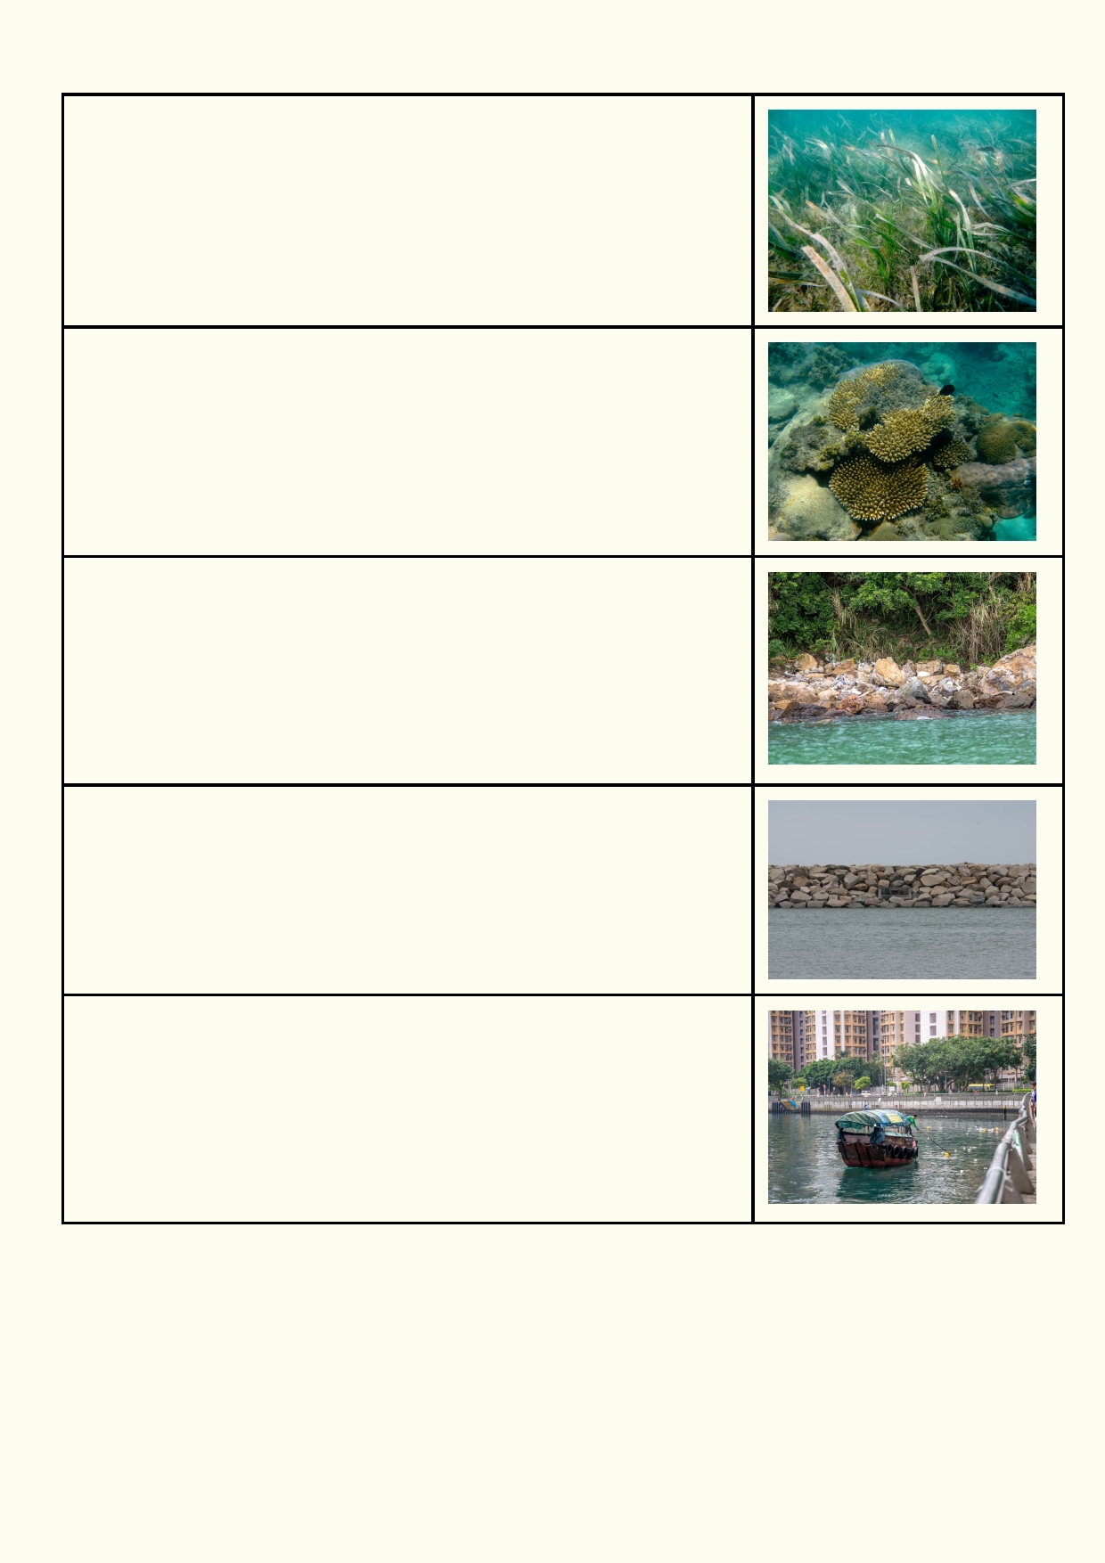Seagrass
Coordinates:
Describe area:

Coral reef
Coordinates:
Describe area:

Rocky shore
Coordinates:

Describe area:

Sea wall - boat harbour
Coordinates:
Describe area:

Sea wall - city waterfront
Coordinates:
Describe area:

11

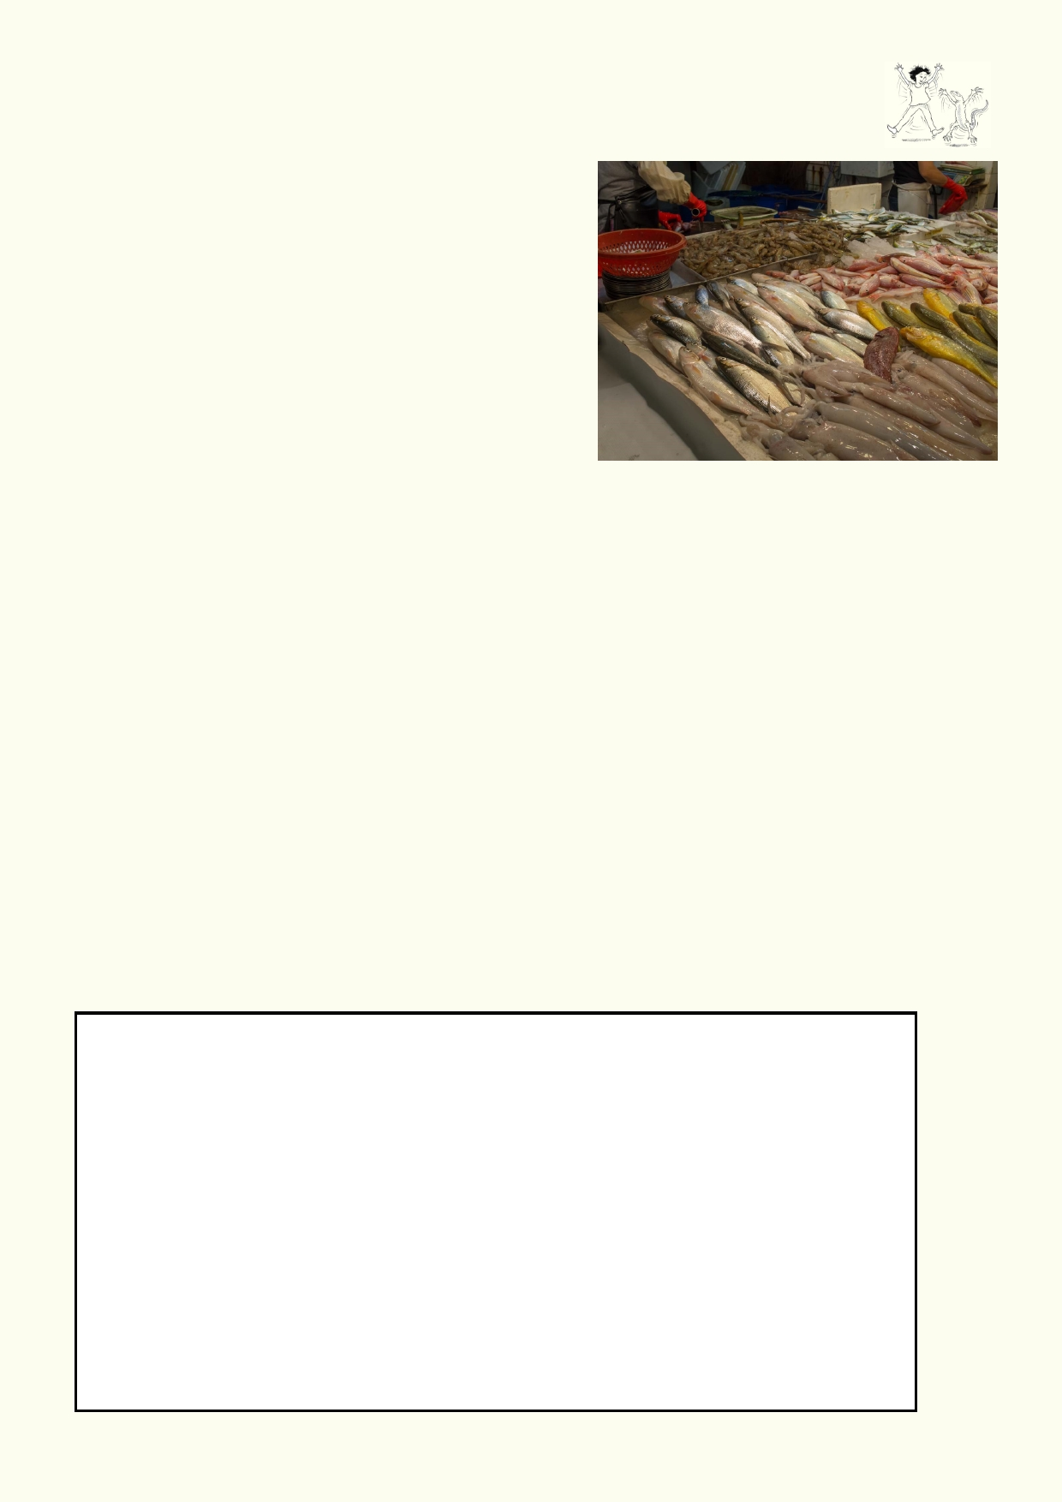Activity 3. Natural coastal habitats have many benefits

Beach - recreation, beach sand reduces coastal erosion, sand helps to clean water, sand is home to many marine and intertidal animals.
Estuary - sheltered waters which are safer from
storms for people and their buildings, place where
fishing and safe boating can occur, location where
some fish breed, home to many coastal marine
animals.
Mangrove forest - shelters coasts from major storms,
protecting people and buildings, major breeding
location for many fish we eat, one of the best ways to take carbon dioxide from the atmosphere.
Cliffs - barrier from the powerful sea.
Mudflats - store carbon in the form of dead plants in
the sediments, reducing our effect on climate change. They are a rich source of food for wading
birds including migratory waders which move across distances such as Siberia to southern
Australia.
Seagrass beds - hold the sand and mud together so the coast doesn't change too much and too often. Majority of fish you eat will spend some of their life cycle among the seagrass.
Coral reef - one of the most diverse ecosystems on Earth, a valuable tourist attraction if they are
in reasonable condition.
Rocky shore - reduces the impact of waves and storms on the coast, home to many marine and
intertidal animals.

Pick one of the coastal habitats listed above, that you have visited recently. Describe your impressions. Try to use as many of your senses as possible, in describing it.

_____________________________________________________________________________

_____________________________________________________________________________

Locate a specific place in Hong Kong that is classified as one of these types of habitats. Find some Google Images of the place that might indicate more than one of the benefits described above.

Insert a photo or draw the habitat.

12

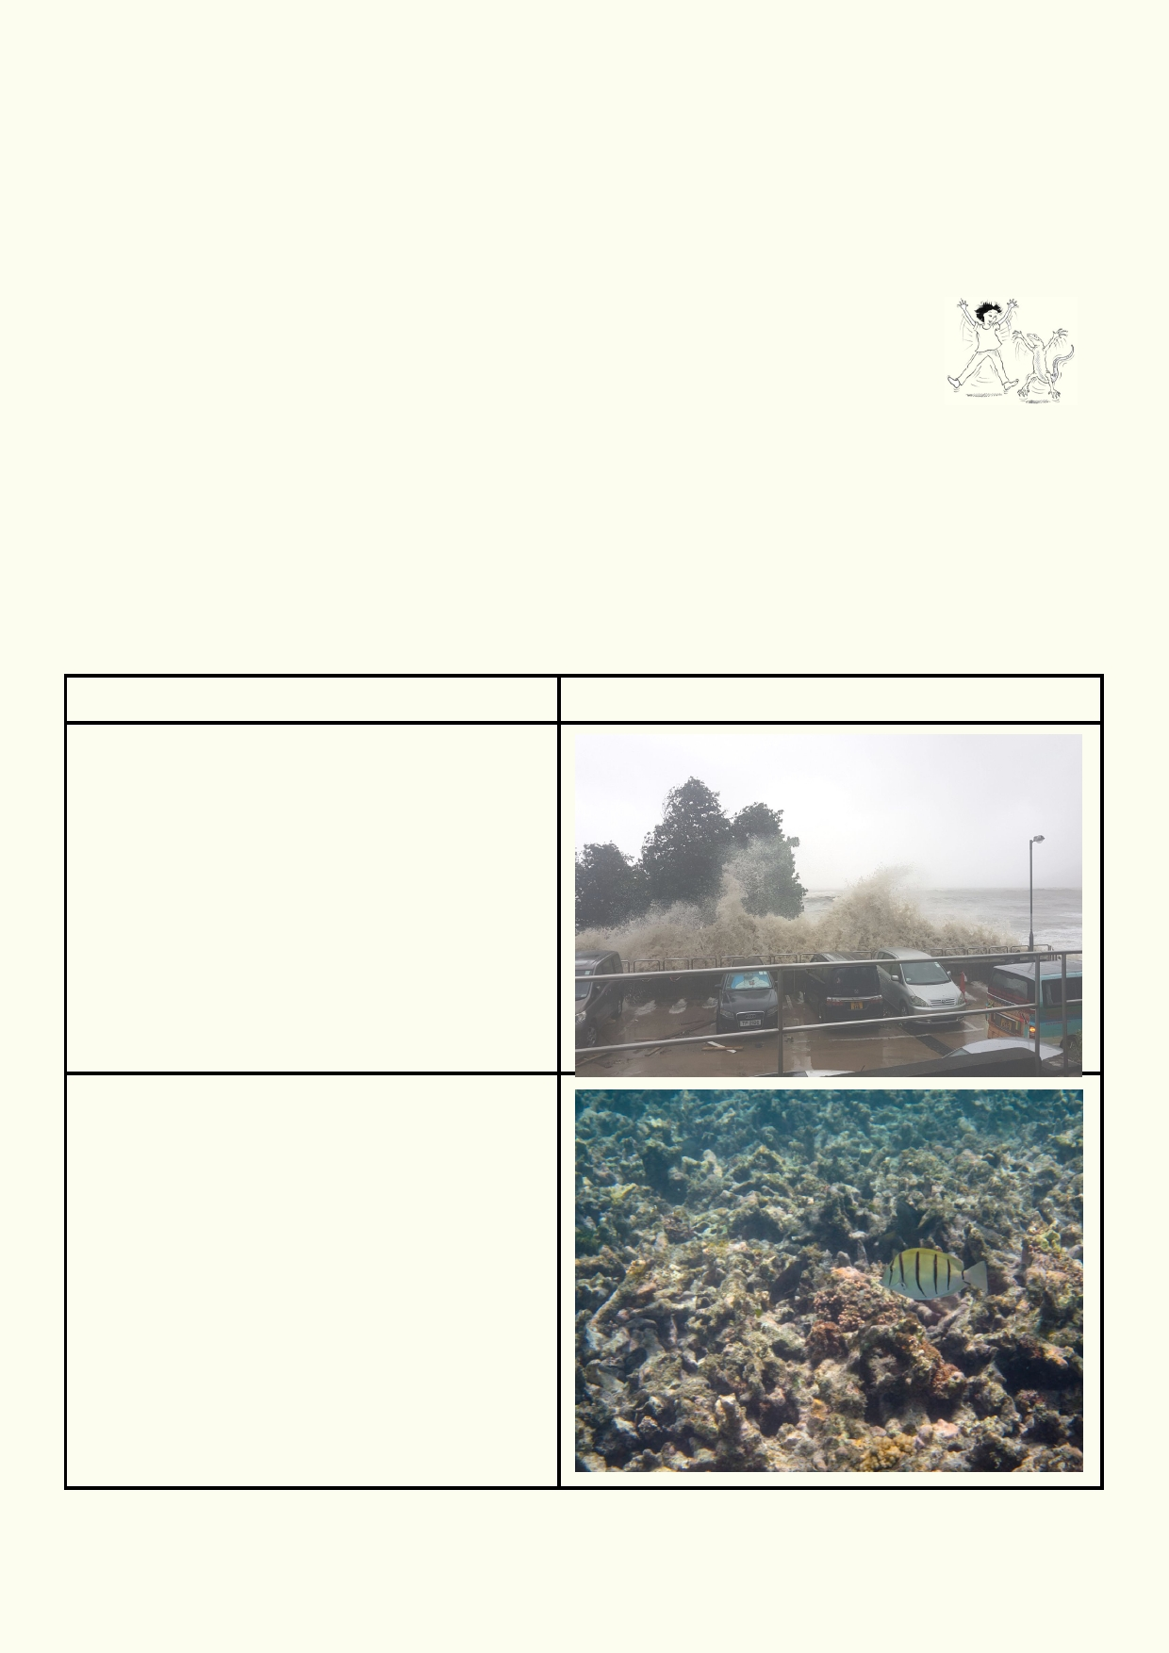Benefits of the habitat:

_____________________________________________________________________________

_____________________________________________________________________________

_____________________________________________________________________________

Activity 4. Habitat destruction - pick your disaster

The coastal environment is always changing from natural processes such as wave
action, weather and storms. Humans have also had an impact along the
coast. There are many threats to our coastal environment. In some cases, human
activities have indirectly affected the intensifying of natural processes such as beach erosion or
rising sea levels. Other activities such as dredging, trawling and land reclamation are uniquely
human impacts.
Each photo and text describes an environmental impact along our coast due to a combination of
natural and human causes. Explain how each of these disasters are made worse by human
impact and some of the problems it causes for people and marine life. Describe how each photo
is linked to human activity.

Disaster
Climate change - more powerful storms

Climate change - coral bleaching from higher
temperatures

13

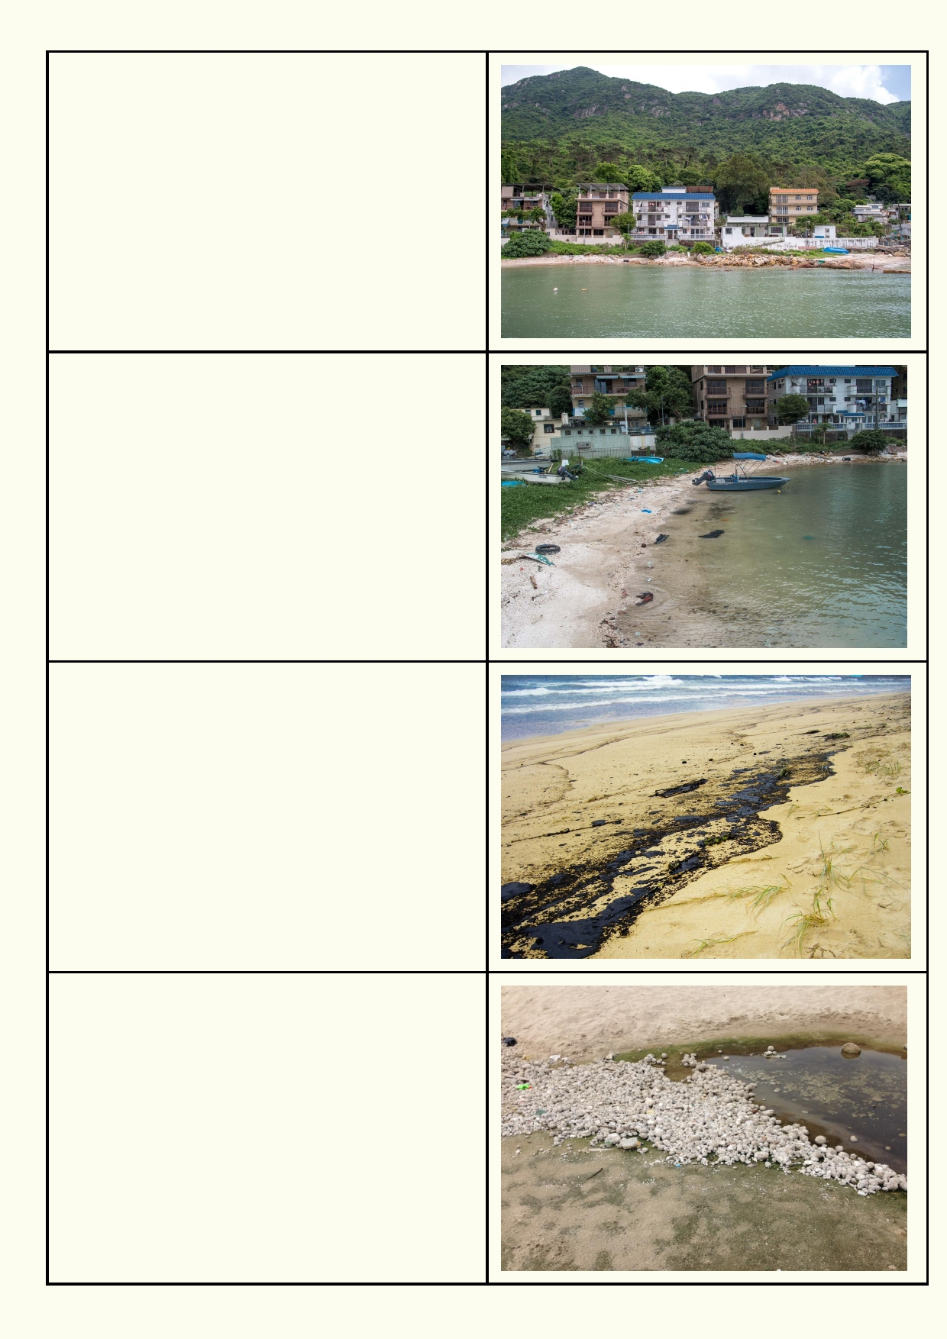Climate change - increase in sea level

Litter

Oil spills

Palm oil spill in Hong Kong

14

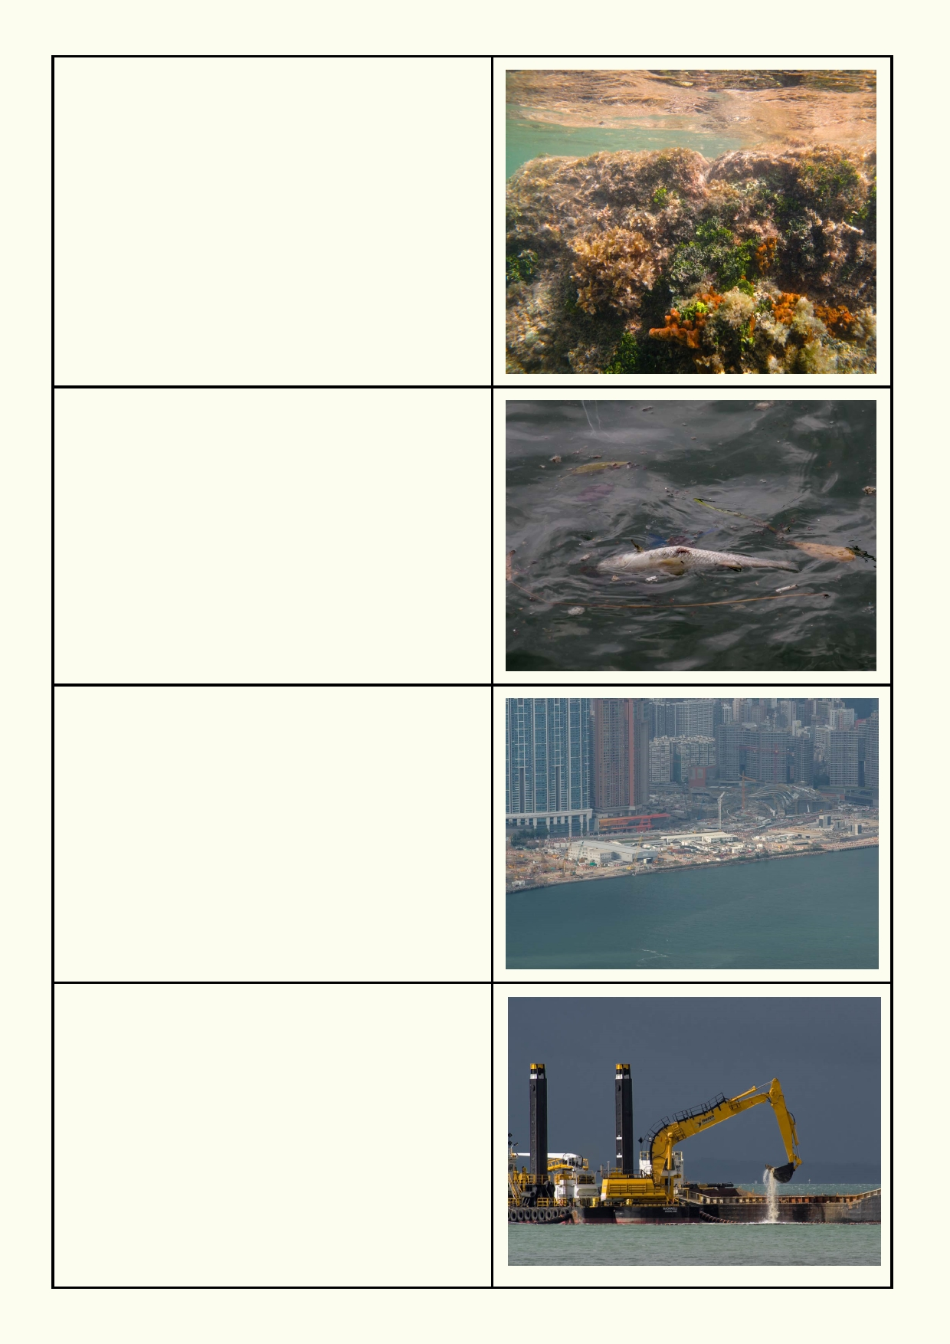Dead reef from river pollution - seaweed and
sponges growing on dead coral

Other pollution

Development

Seagrass destruction

15

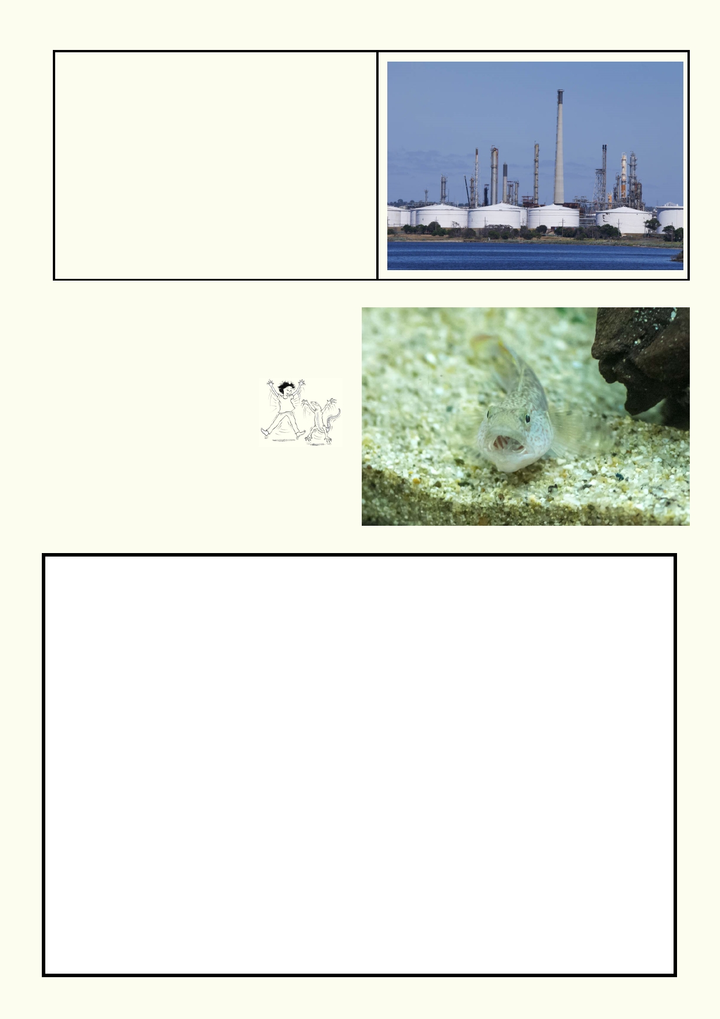Mangrove destruction (some mangroves in front
of refinery)

Activity 5. Welcome to my home
Choose any animal that lives along the coast. It
could live on the beach, in the intertidal zone, under the sea,
along a cliff, etc.

My marine animal is:

_________________________

Insert a photograph or draw the animal:

16

Find the answers to these questions to help you describe your chosen animal.

Search for an answer

How does the animal get
oxygen? What features does it
use?

How is the animal affected by
temperature? What climate is
it found? Can it cope with
extreme changes?

If it can survive out of the sea,
what features does it have to
help it?

Does it live in the intertidal
zone where the sea comes
and goes with the tides?

Where does it breed? What is
special about its breeding?

If it is being hit by waves, how
can it survive?

In what part of the marine
environment does it spend
most of its time?

What different ways can it
move? What features does it
have to help it move?

How does it protect itself?

What does it eat and what
features does it have to obtain
food?

What is special about where
your animal lives?

My research

17

Lesson 2 - Coastal Geomorphology

Activity 1. A changing coastal environment

Watch this video to see how erosion and the movement of sand and mud shapes
the coasts. https://www.youtube.com/watch?v=mUYnxbHeyi8

Conducting experiments:

1.
2.
3.
4.
5.

6. 7.
Read through the setup for the experiment.
Record your prediction for the outcome of the experiment.
Gather the materials that are needed.
Find a suitable location to conduct the experiment.
Review all safety requirements including handling glassware safely and using heat and
heated substances. Ask your teacher if you are not sure. Report any accidents. Record your observations as you complete the experiment.
Clean and return equipment.

Experiment: A model of coastal change

In groups you will build a clay model of a particular feature of coastal geomorphology.

Imagine how the coastal landscape might change over many decades. Changes could be due to
weather, storms, waves, currents, development, climate change etc. Show three different time
periods in which it is evolving into something different.

Materials:
• Modelling clay
• Large tray to make the model on
• Some blunt knives for scraping clay
• Digital camera e.g. tablet or smartphone

Method:

1.

2. 3.
4. 5.
6.
7.
8.
9.

Each group is provided with a lump of clay, a tray and a couple of blunt knives for shaping details in the clay. You could also use pencils and rulers to model the clay.
Decide in your group which landform you will model.
After making the model, take a photo. Remember at what angle the photo was taken.
Decide what kind of events (waves, storms, climate change etc.) are shaping the model. Remove or reshape the clay to show how the events have shaped the model.
Take another photo. You might like to place a note with the model describing the events.
Decide how future events might shape your model.
Shape the model again to reflect the events you have chosen.
Take another photo. You might like to place another note with the model describing the
events.

Write a short report using the photos that were taken, explaining your reasoning for the changes
in the landscape.
As a class share how all the models changed and what events led to the change.

18

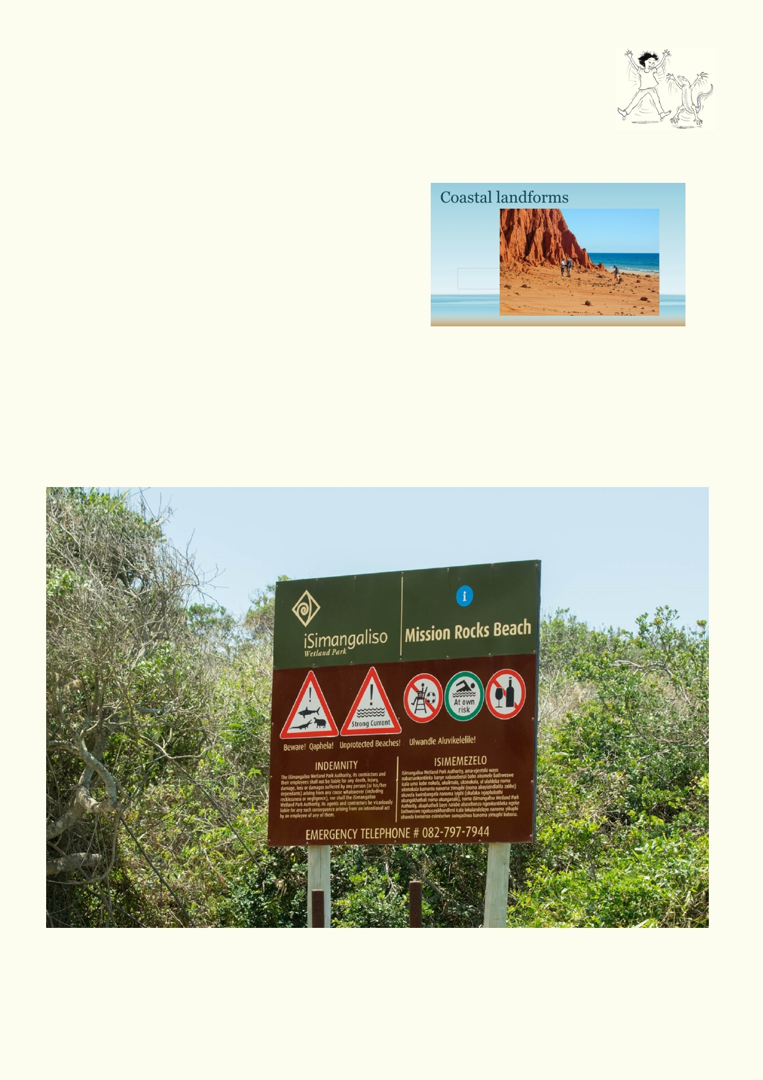Activity 2. Coastal landforms and their use

Use the powerpoint "Coastal landforms" to explore the different kinds of landforms
along the coasts. As a class answer the questions on each of the slides. Which
landforms are you familiar with and which examples have you been to? Look at
each slide for evidence of action from weather, waves, currents, people, etc.

Identify some of the ways people use different
landforms. Which landforms are used for:
• Recreation
• Housing
• Fishing
• Fish farming (aquaculture)
• Transport
• Kept as natural habitat

This sign is a safety and warning designed for another country. Choose a waterfront you are
familiar with around Hong Kong. List the things people do along that waterfront. Identify the risks and dangers in the area. Draw a safety sign to warn people of the dangers. Alternatively, draw a
sign that tells them what not to do in order to protect the environment. Try to provide compelling
reasons for taking good care of the area. Try to keep your words to a minimum.

19

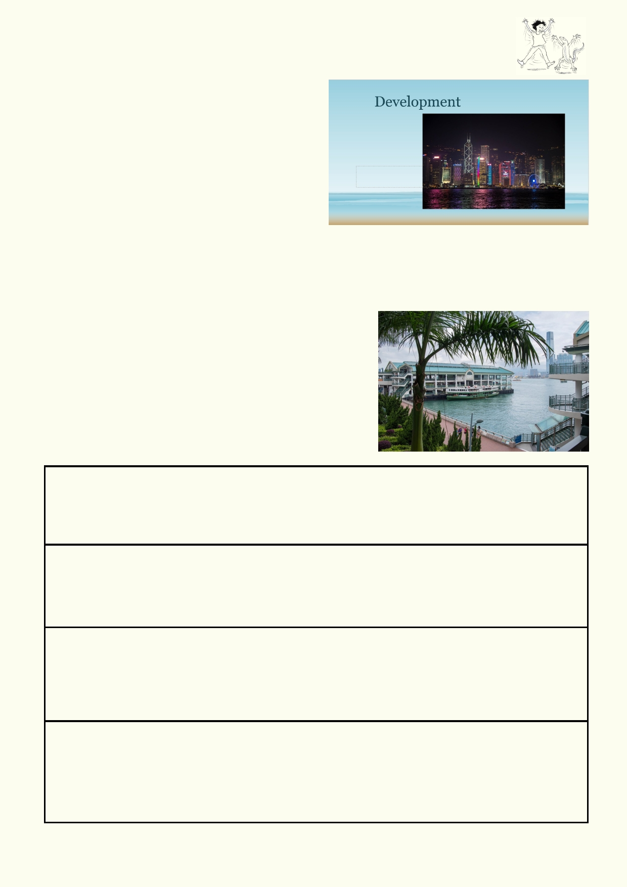Activity 3 - How much development is too much development?

Use the Powerpoint called "Development" along
with the activity sheet below, called
'"Development." Go through the Powerpoint and
discuss each image and compare the images.

Go through the Powerpoint again and choose one
of the images. Respond to the following:
• How is the area being used?
• How has the area been changed over time?
• What are the best features of the area?
• How might the particular use in the area affect the environment and the local community?
• Provide your opinion and reasons for whether or not you believe that the level of
development seen in the photo is too great.
• Suggest how government has controlled development.
•
How would the photo look different and how would the environment and community be affected if there were:
• A large factory near the coast?
• A large freeway built along the coast?

Development
Choose one photo from the powerpoint and respond to the
questions:

How is the area being used?

How has the area been changed over time?

What are the best features of the area?

How might the use in the area affect the environment and the local community?

20

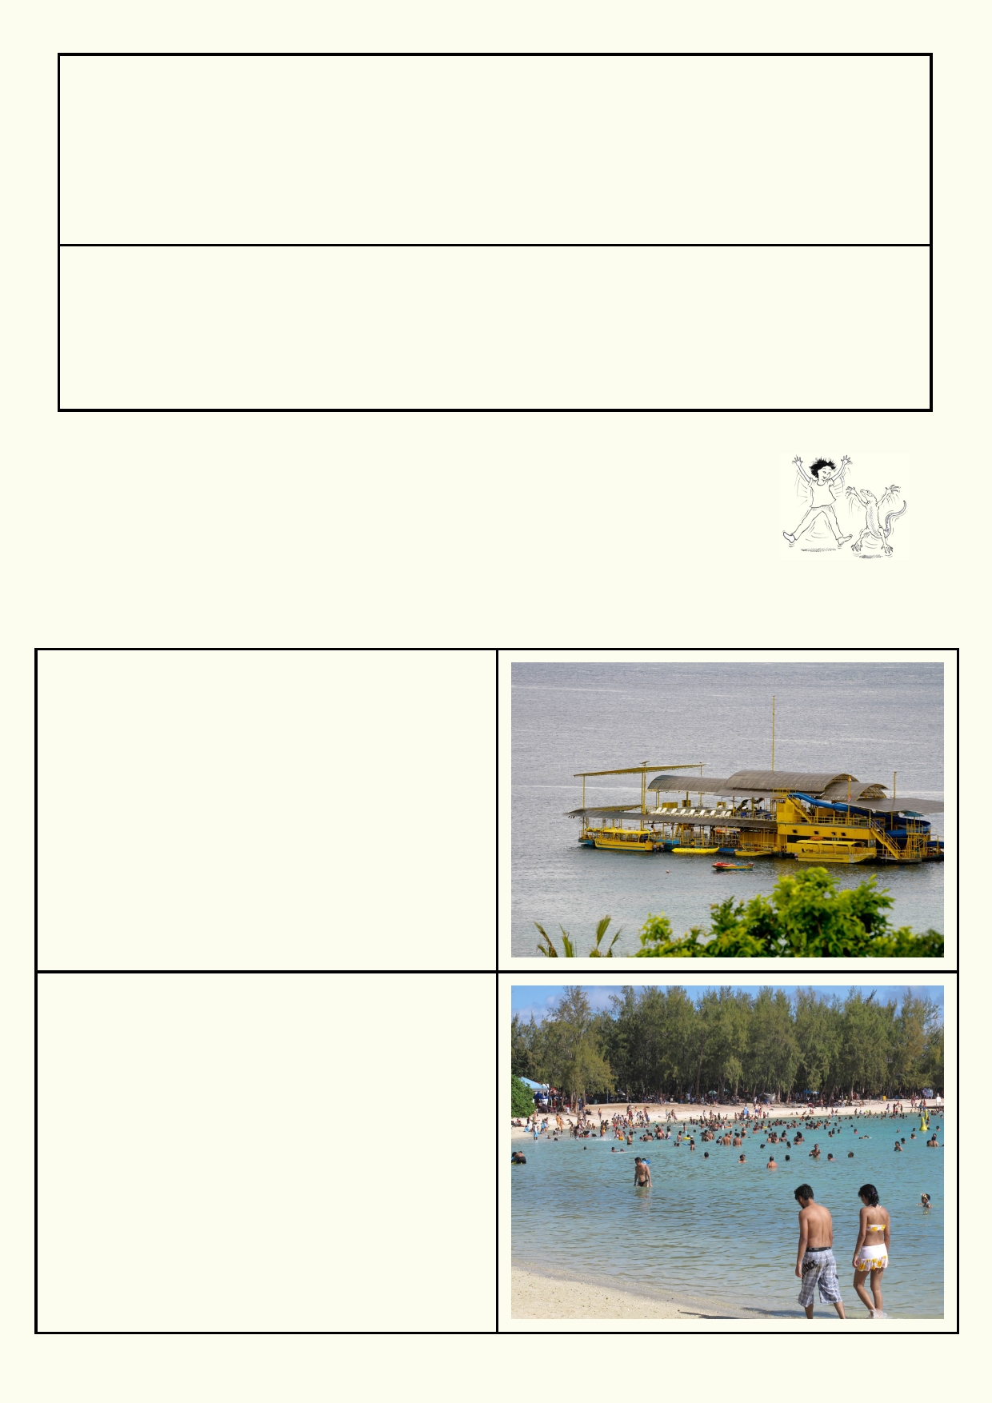Provide an opinion and give your reasons you believe if the level of development seen in the photo is too great.

Suggest how government is controlling the development at this location.

Lesson 3 - Coasts - Who Needs Them?

Activity 1. This is fun

The sea has a special attraction for many people around the world. Are you
attracted to the sea? What activities do you like to do? Which activities have you done? Which
would you like to do?

Pontoon used for snorkelling and diving on a
coral reef.

What would you like to do on a coral reef?

Can you have this experience in Hong Kong?

Busy beach during a Mauritian holiday
Would you see a busy beach like this in Hong
Kong?

Which are the best Hong Kong beaches?

21

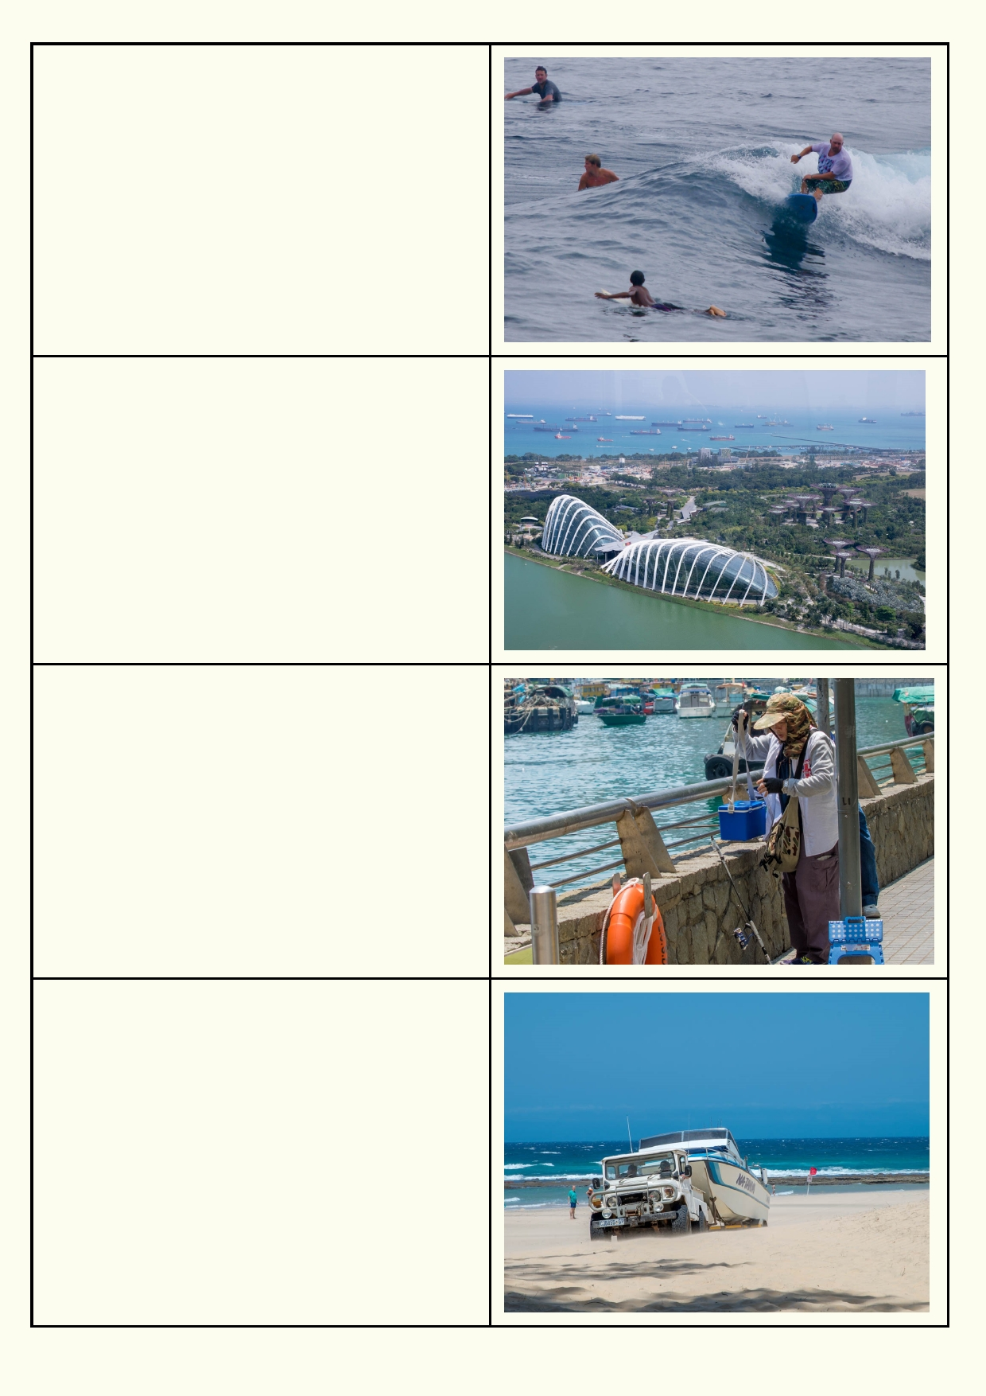Surfing in Bali

Would you like to try surfing?

Would you go to Bali to spend time on the beach
and in the sea?

Tourist attractions in Singapore

How do tourist attractions help the economy?

What would you like to do at a tourist attraction on
a coast?

Fishing in Hong Kong

Would you want to fish?

Why do some people like fishing?

Boating in South Africa

What kinds of boats have you travelled in?

What activities have you done on a recreational
boat?

22

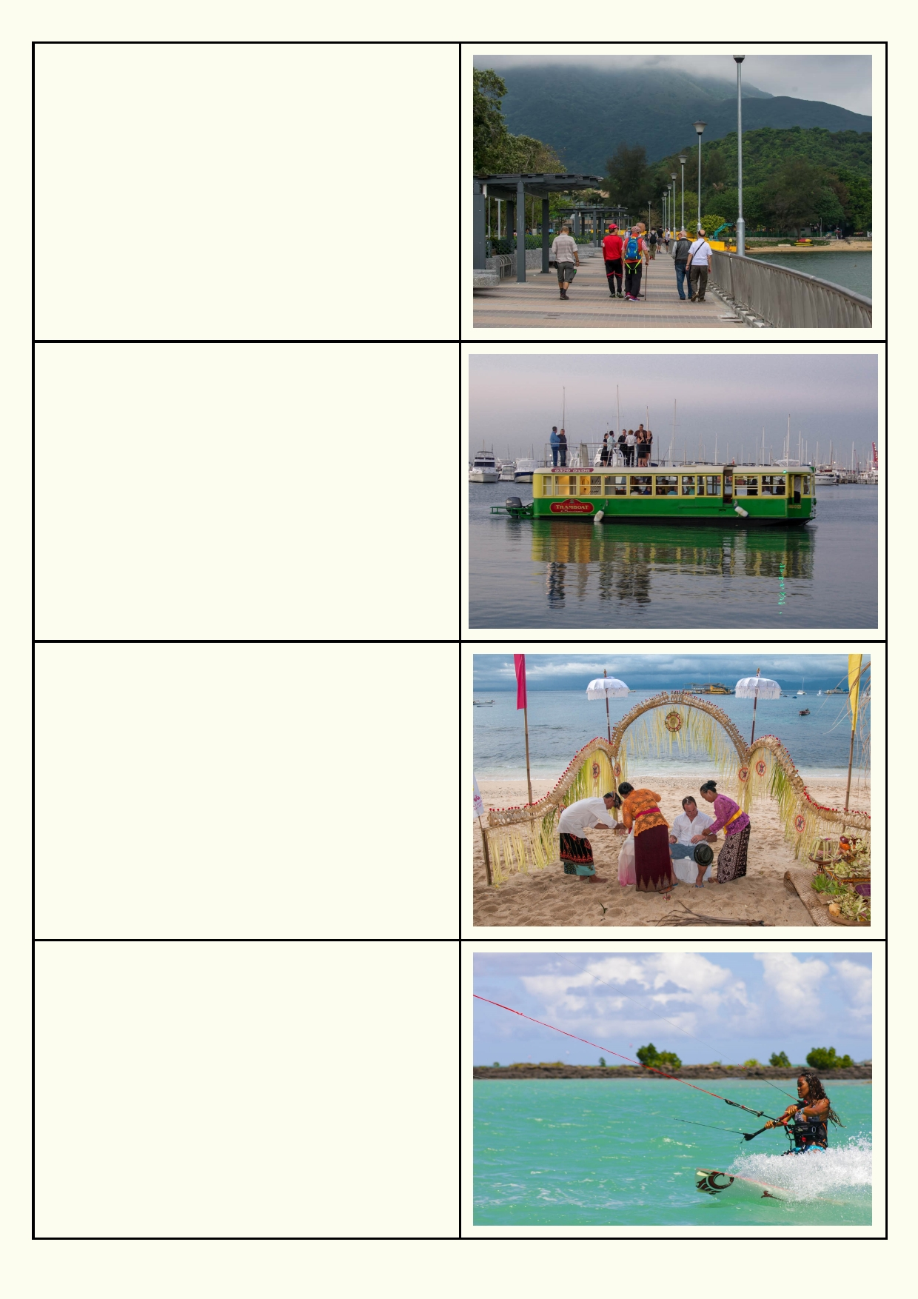Walking along a path in Hong Kong
How often do you go for a recreational walk?

What are the benefits of walking along the coast?

Party boat in Melbourne, Australia
What makes a party on a boat different?

What would you do if you organised a boat party?

Wedding on a Bali beach
Why do you think these people went to Bali to
have a wedding?

What special occasion would you like to celebrate
on a beach?

Windsurfing in Mauritius
Would it be safe to windsurf around Hong Kong?

Which water sports would you like to try?

23

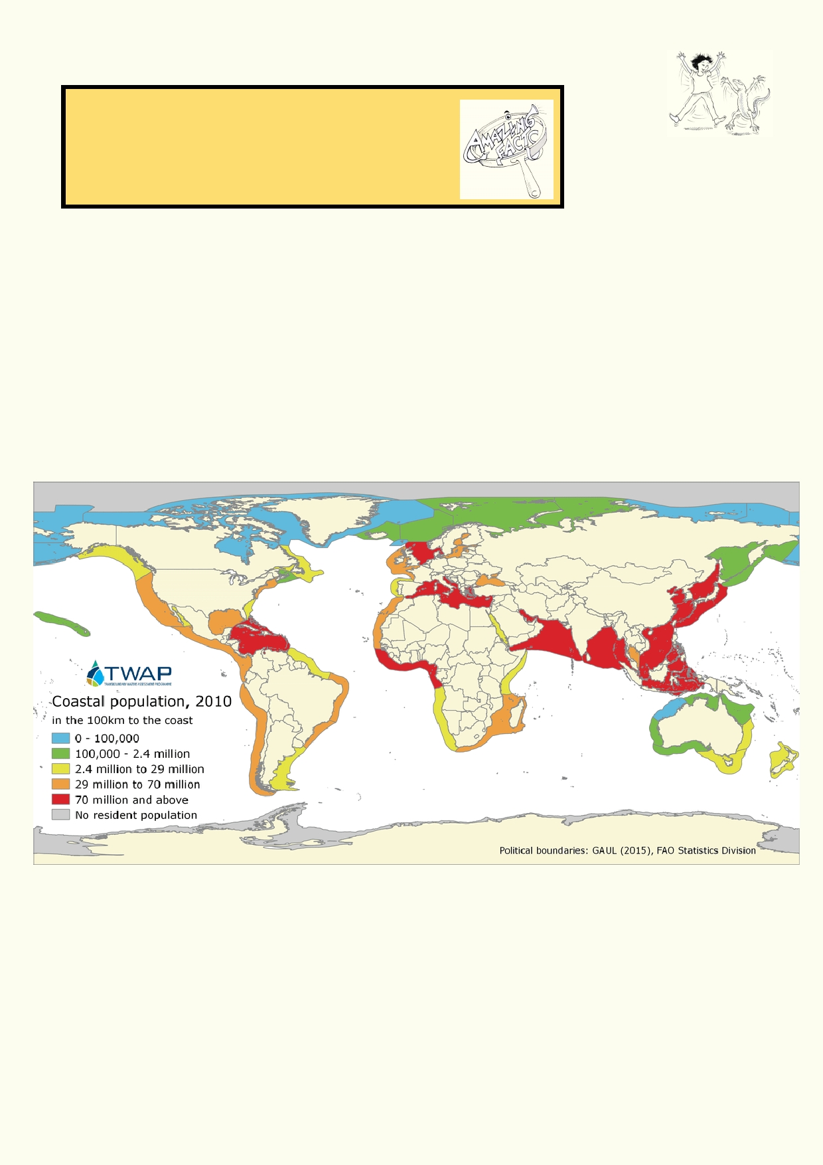Activity 2. World populations

Amazing fact
Half the world's population lives within 200 km of the
coast.

Why do you think so many people want to live on or near a coast?

___________________________________________________________________________

___________________________________________________________________________

These two maps use different criteria to show where populations are concentrated along the
coast. Large populations of people along the coast have a greater impact on the sea and coastal
habitat. Countries that can't provide services such as sewage and rubbish disposal will have an even a greater impact on the sea.

24

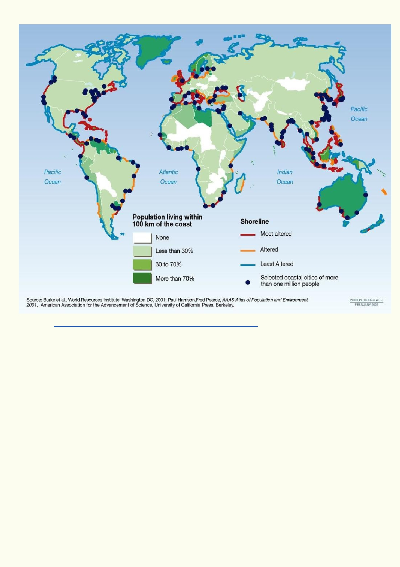
Source http://www.thegeographeronline.net/crowded-coasts.html

Interpret the two maps. Which regions have the highest coastal populations? Which regions would you expect to have the greatest impact along their coasts? Which regions would you
expect to have the least impact along their coasts?

_____________________________________________________________________________

_____________________________________________________________________________

_____________________________________________________________________________

_____________________________________________________________________________

_____________________________________________________________________________

_____________________________________________________________________________

_____________________________________________________________________________

25

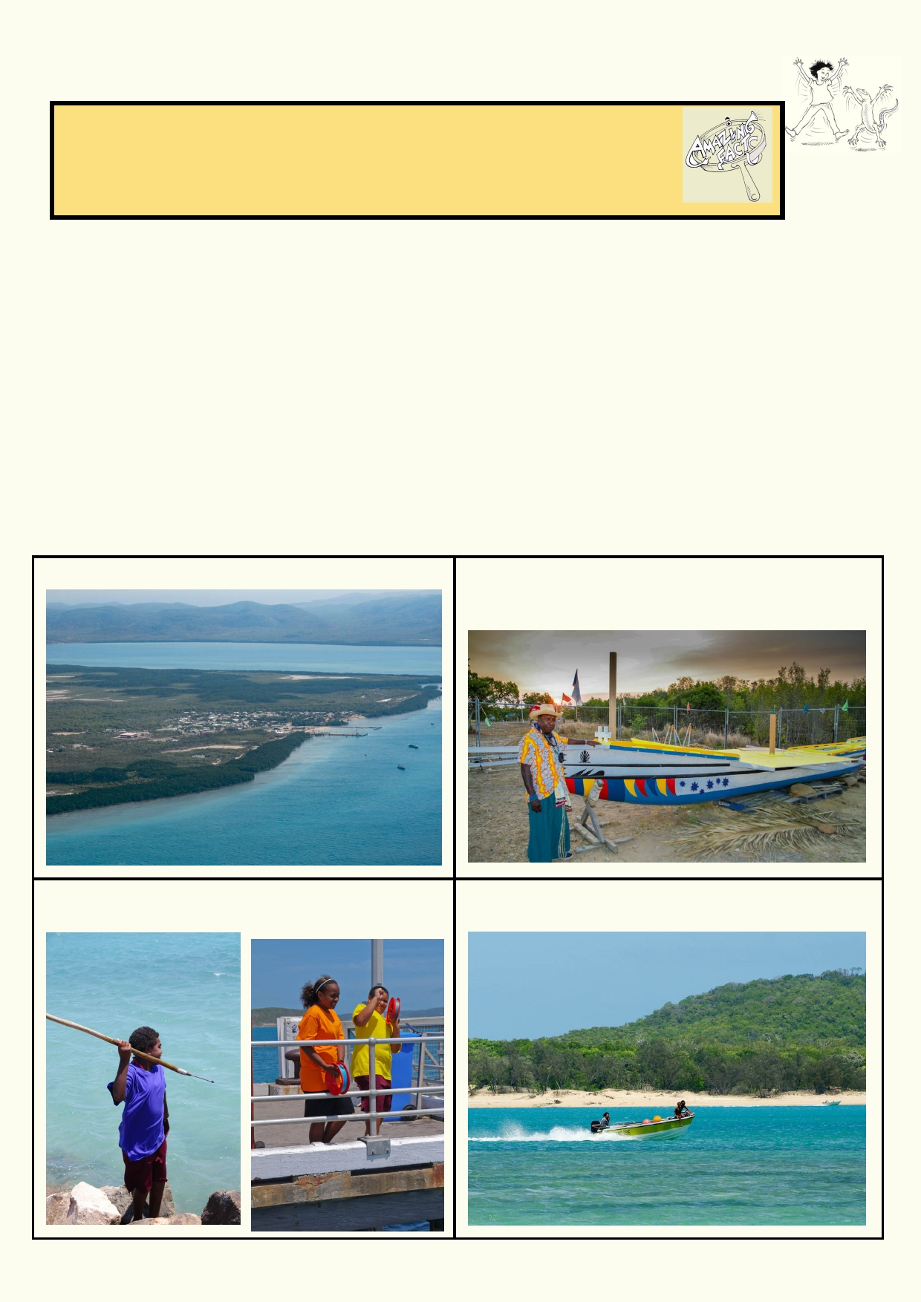Activity 3. Indigenous peoples

Amazing fact
The Australian Aboriginal peoples have had stable cultural groups for over
50,000 years. This means that before recorded history, this group of people
had traditions, language, and a way of life that has endured to this day.

What does the term "Indigenous people" mean?
Indigenous people are those people who are identified as the original inhabitants of a region.
They usually have cultural practices that go back thousands of years. There are Indigenous
groups across the world. Most are losing their unique languages and their cultural traditions.

Torres Strait Islanders
Torres Strait is located between Australia and Papua New Guinea. There are many islands within
the strait. It is part of Australia. Two islands have towns with large communities. Other islands
have small communities and many islands are not inhabited. The Indigenous people of Torres
Strait are seafaring, having always made their living from resources from the sea. Today, families
are more likely to own a small powered boat than a car. The people still prefer to eat traditional
foods from the sea.

Two of the Islands in Torres Strait. An Elder with a traditional boat under
construction. Locals have a deep understanding
of season change, currents and winds.

Using modern and traditional methods to catch Family members travelling on the sea between
fish. islands like people on land using cars

26

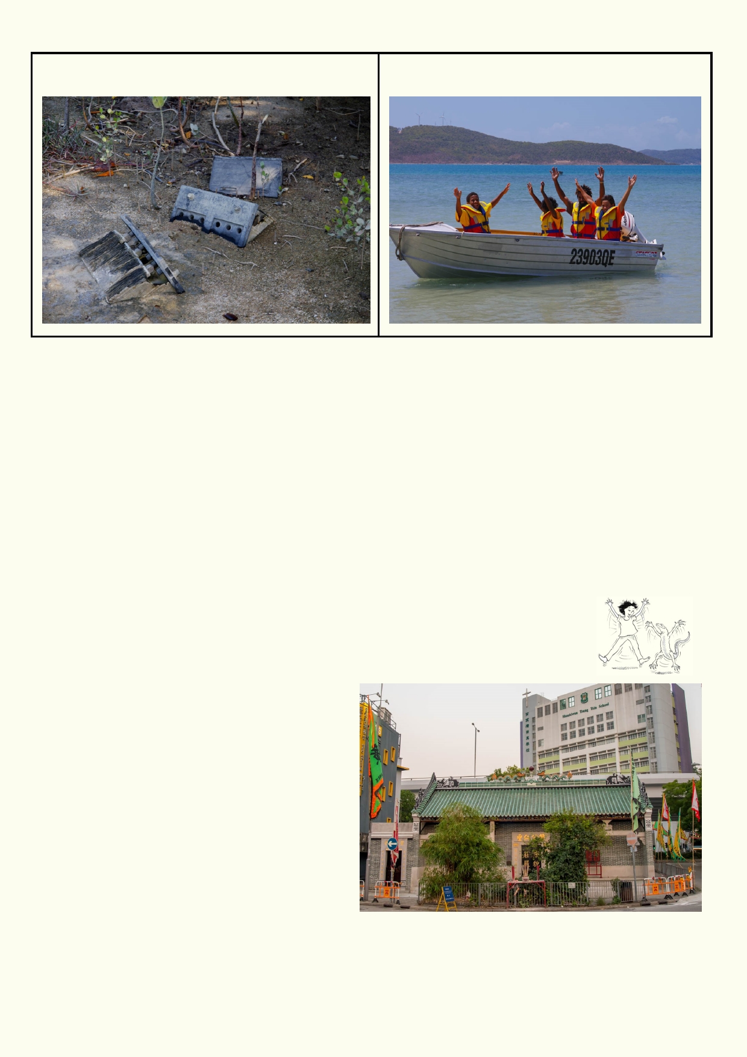The islands have not escaped the dumping of Students learning the different ways to stay
waste in inappropriate places. safe at sea and operate small boats.

Indigenous people using the sea: research.

Materials
Writing and drawing material
Large sheet of paper for illustrating

Choose an Indigenous people that live by the sea. Find out how these people lived in the past as
well as in the present. For Indigenous people living on many Pacific Islands, many of their
traditional ways of life are still practiced.

Produce a labelled diagram that shows how these people use the sea for food and cultural activities.

Activity 4. Spiritual meaning of the sea

The idea of "spiritual" for some people has ties to religion. For many people "spiritual" refers to how their spirit or soul provides a feeling of wellbeing and
understanding of their world. The opposite of
spiritual is material, which relates to things we
can perceive with our senses.

Hong Kong has a rich spiritual and cultural tie
with the sea. There are bronze age stone
carvings in three or four different sites around
the territories, most notably on Cheung Chau island or Clear Water Bay. The yearly festival
at Tin Hau temple is where people make
offerings to the god of the sea.

Are you one of the many people who have
spiritual feelings when you are deeply
immersed in a special place?

27

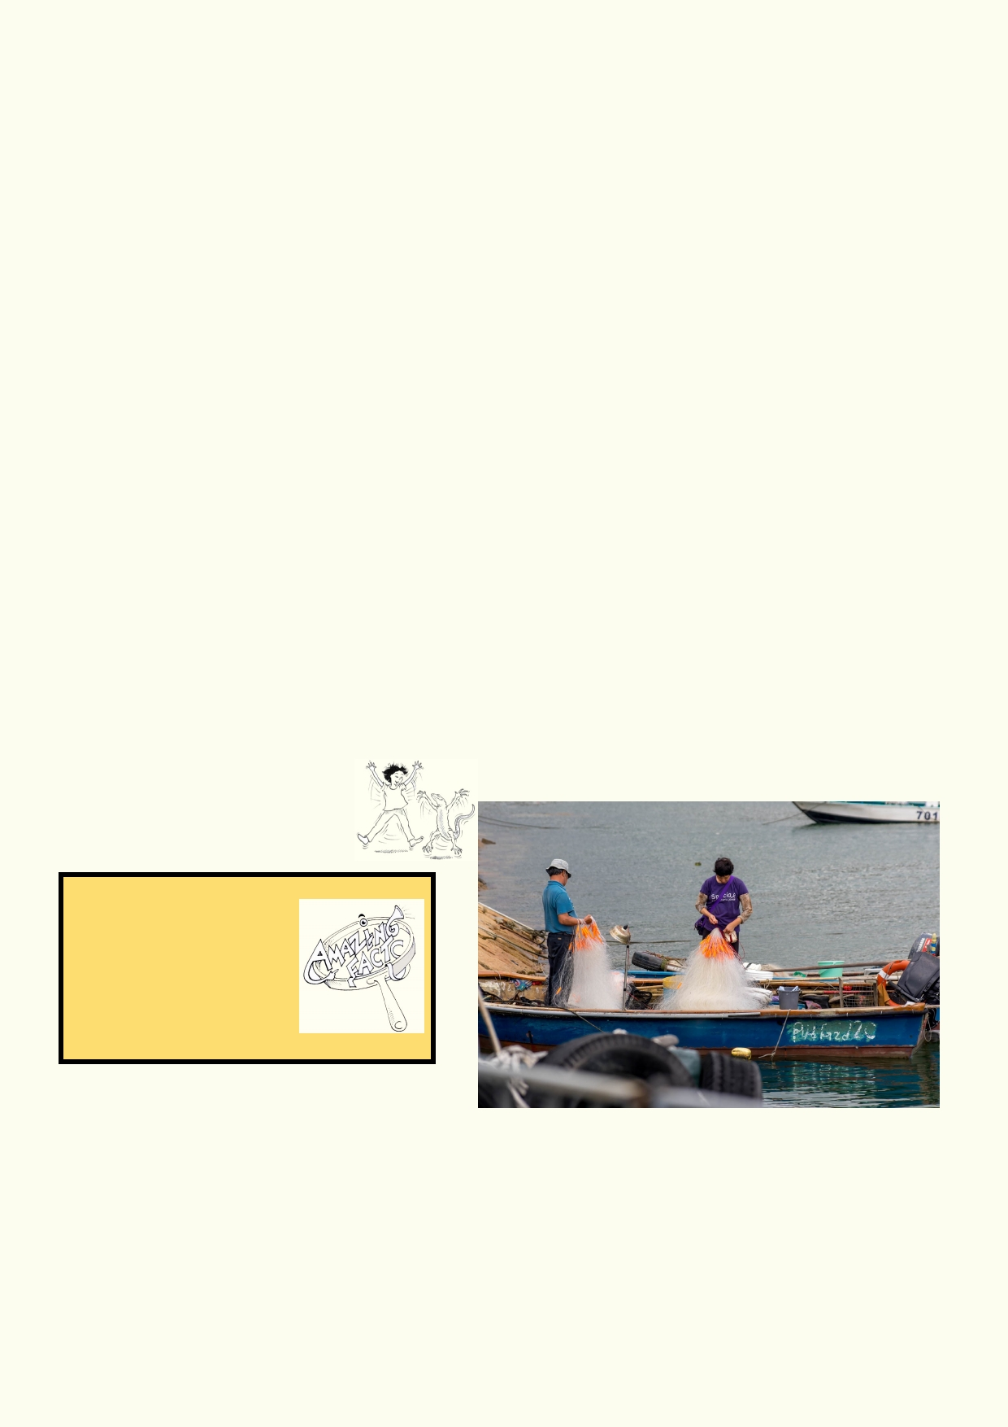The places that give me the deepest feelings are:
_____________________________________________________________________________

_____________________________________________________________________________

Tam Kung temple is close to the sea in Hong Kong 22°16'58" N 114°13'50" E (cut and paste
coordinates into Google Maps). It probably once had a beautiful view of the sea, but now you can
see that the area is full of light industry.

Use Google Images to find a photo of a temple by the sea that you think would make you feel
good. You could use the search words - "temple, sea". Where is the temple? What religion does it
represent?

_____________________________________________________________________________

_____________________________________________________________________________

Then use Google Images to search - "spiritual, sea". How are the photos different?

_____________________________________________________________________________

_____________________________________________________________________________

Looking at the photos, what kind of places by the sea might help you feel spiritual?

_____________________________________________________________________________

Activity 5. Feeding the world

Amazing fact
Most of the sea and
ocean fish we eat, spend
.
part of their early life
among sea grasses or
mangroves.

Will we run out of fish?

There seems to be plenty of fresh fish at the local market.

Fish consumption is highest in Asia followed by Europe. It's also important in island states and coastal regions in poorer countries.

However, some popular species of fish which were cheap to buy have now become expensive
because the great supply is no longer there. Some species have become more popular, but
these species are becoming harder to catch. In the past, the world's fishing industry consisted of
a large number of small fishing boats with basic fishing equipment. It provided millions of families
with an income.
28

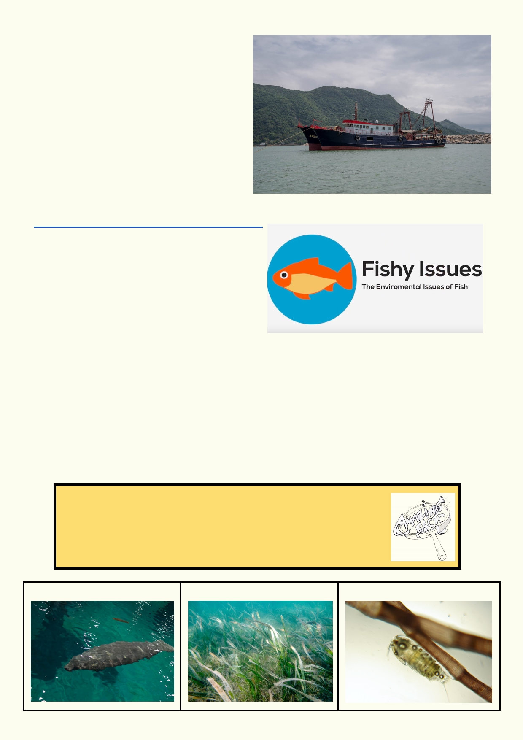More and larger boats were constructed and
they used larger nets and sonar to track the
fish. As they got even larger, some ships can
now operate as factories, packaging and
freezing the fish. These large ships take vast
quantities of fish. For many fishermen using
small boats from coastal fishing villages and
towns, their catch is dropping. In many cases, very large fishing vessels are taking more fish
than can be replenished.

Have a look at this short animated video
made by a Middle School student in Hong
Kong who is passionate about fish and the issue of seafood sustainability:
https://www.youtube.com/watch?v=r7E61IcQcNc

What is your favourite seafood?

_____________________________________________________________________________

Where does your favourite seafood come from and how is it caught? (hint: search on the internet
for the brand as well as the species)

_____________________________________________________________________________

_____________________________________________________________________________

_____________________________________________________________________________

Amazing facts: Seagrass food web
Seagrass is home to a huge variety of animals. Only dugongs and
some turtles eat seagrass. The seagrass is plastered with millions of
tiny animals. All the other animals find the seagrass meadows an
excellent home.

Dugong Seagrass Seagrass creatures

29

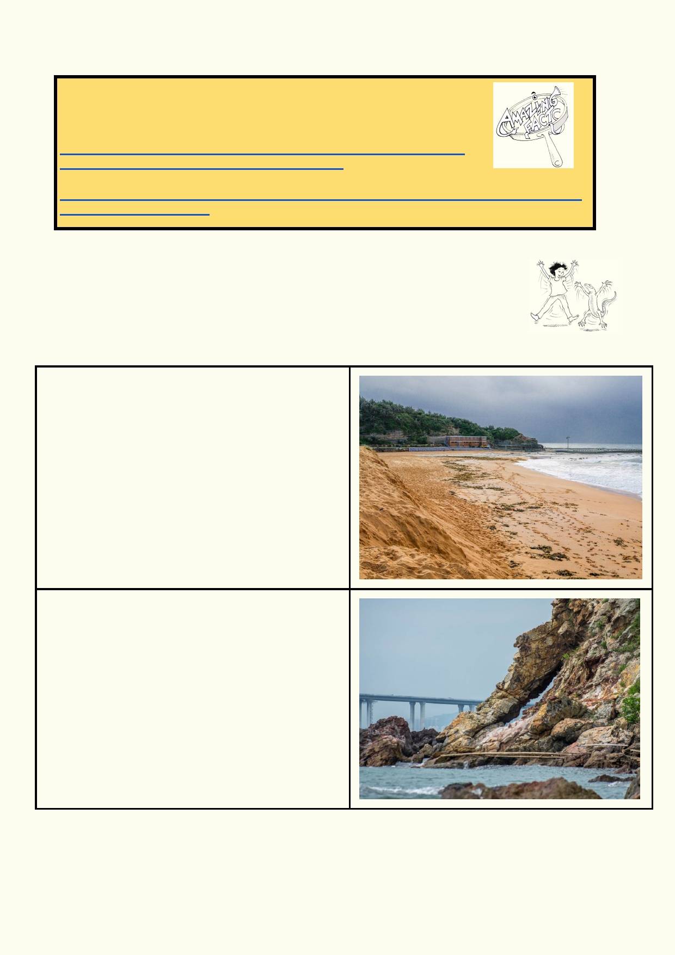Lesson 4 - Our changing coast

Disgusting fact
Over half the seabirds across the entire world have plastic in their
stomach. Within 30 years almost all seabird species will have plastic in
their stomach.
https://theconversation.com/seabirds-are-eating-plastic-litter-in-our-
oceans-but-not-only-where-youd-expect-46740

http://www.abc.net.au/news/2015-09-01/scientists-warn-almost-all-seabirds-will-ingest-
plastic-by-2050/6738862

Activity 1. Nature at work
Have you ever been knocked over by a big wave? Big waves are very powerful
and they are constantly changing the coast. They move around thousands of
tonnes of sand, eat away at cliffs and grind rocks down to sand.

Hundreds of metres of beach and a big sand
dune have been eaten away in one big storm.
Can you explain the consequence of this change?

How has the rock been shaped by waves, wind
and changing temperatures? What will happen to
the hanging rock over time?

30

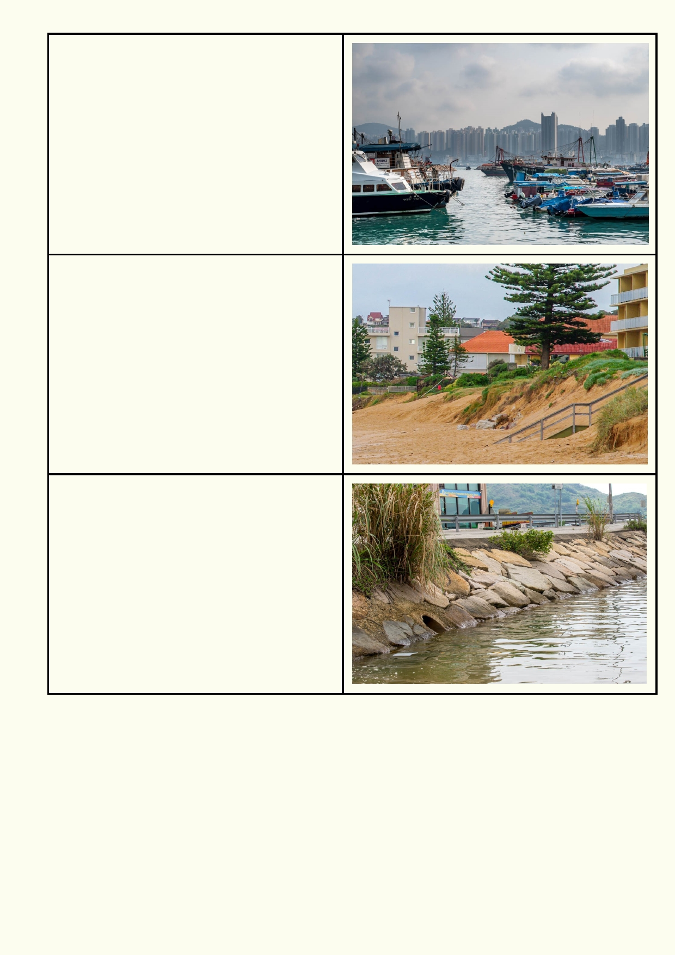Why are small boats placed in ports
surrounded by sea walls?

What do you predict will happen along this
beach over the next 10 years? Do you give the
tree any chance to survive?

Why have these rocks been cemented into a
sloping wall?

Coastlines get rough treatment so its inhabitants need to be rather special. Imagine being any animal living in the intertidal zone. This is the area between high tide and low tide. The animals
must cope with:
• Crashing waves
• Hot summer days in the scorching sun
• High levels of salt as the they dry out in the sun
• Freshwater rain
• Getting covered in sand
• Birds and other animals trying to eat you
• Pollution in the water

31

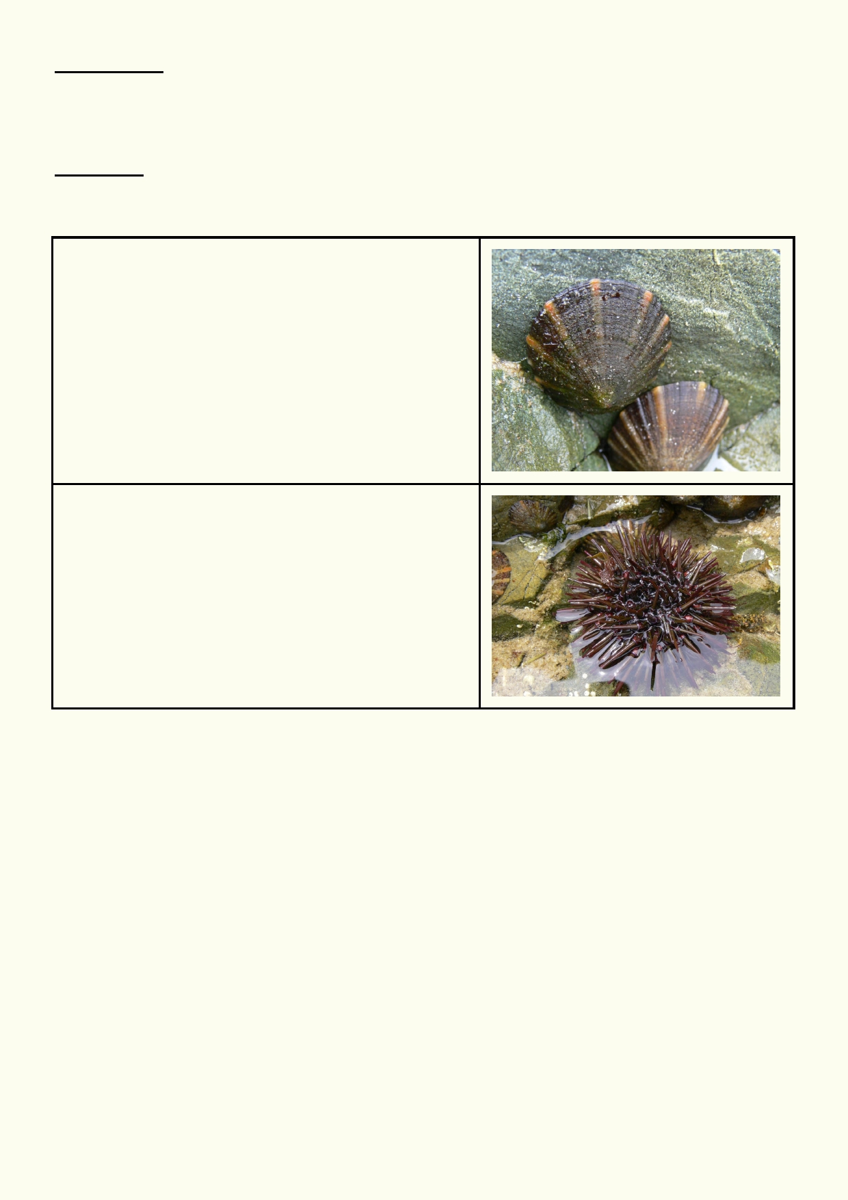A Closer Look
How do these two animals survive the intertidal zone? Remember learning about adaptations in
Unit 4? Can you see any adaptations that might make life easier for them in the intertidal zone?
Write this in the boxes below.

Learn More
Research limpets and sea urchins and add a few bullet points for each in the boxes below.

Limpet

Sea urchin

32

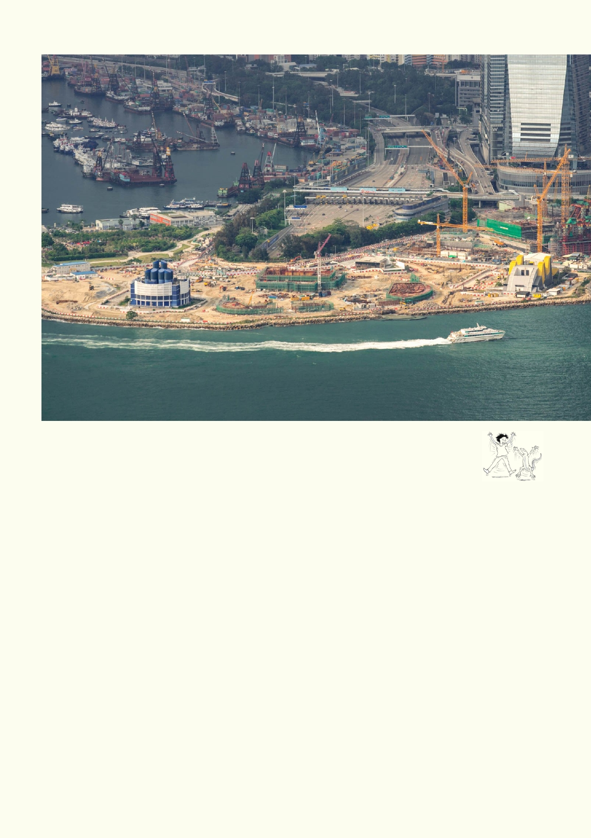Activity 2. Land reclamation

There is a lot going on in this photo. It was taken from The Peak, looking over Kowloon.

How are the land and sea being used?

_____________________________________________________________________________

_____________________________________________________________________________

_____________________________________________________________________________

What changes have been made to this area?

____________________________________________________________________________

_____________________________________________________________________________

_____________________________________________________________________________

What areas do you think have been reclaimed from the sea?

_____________________________________________________________________________

_____________________________________________________________________________

33

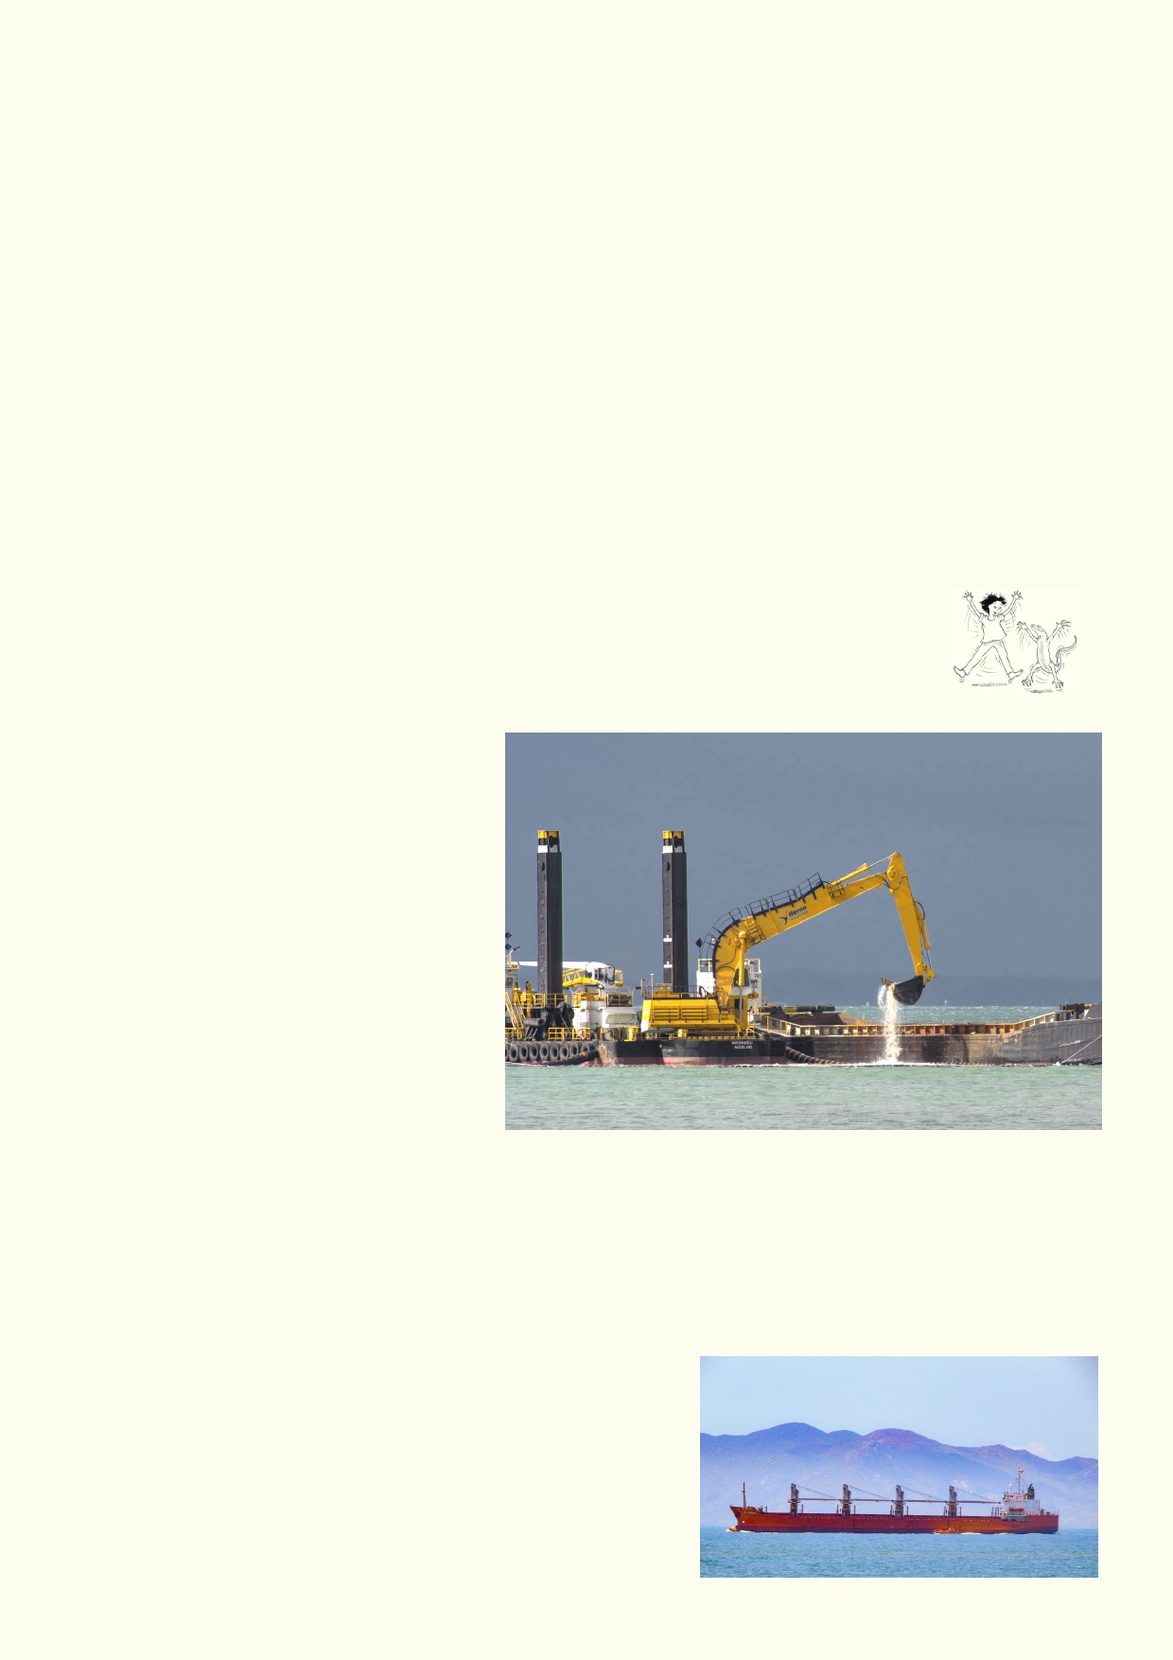Hong Kong is a growing city by the coast. Like many coastal cities around the world it has few
options for growth. One of these options is to keep building out into the sea. What is your opinion
about the best way to manage Hong Kong growth? Is land reclamation an appropriate way to go
or should there be limits? Do you think the effects of climate change might be a future issue for
these areas?

_____________________________________________________________________________

_____________________________________________________________________________

_____________________________________________________________________________

_____________________________________________________________________________

_____________________________________________________________________________

_____________________________________________________________________________

Activity 3. Dredging our ports - good or bad?

Dredging in the sea is usually the removal of sand but sometimes mud from the bottom of the shallow sea. It is done for a number of reasons.
• In ports, the channels where ships need to pass fills up with sand and other
sediment. These channels must
remain deep or ships will become
grounded.
• Dredging is also done for land
reclamation projects. The land
needs to be built up, so the
dredging materials are used as
landfill.
• In some places around the world,
recreational beaches lose their sandy material during storms.
Dredging is used to replace the
lost beach sand.

Hidden in this sand and mud are our polluting chemicals. Dirty industrial processes from the past
to the present that have built up, don't cause much trouble until stirred up by the dredging
process.

Class discussion
Is it better to dredge channels for ships or to stop dredging so the sea isn't polluted from the
nasty chemicals in the sand and mud? Which might be the
bigger danger, pollution in the sea or ships running
aground? What is your opinion about other impacts of
dredging on the environment?

34

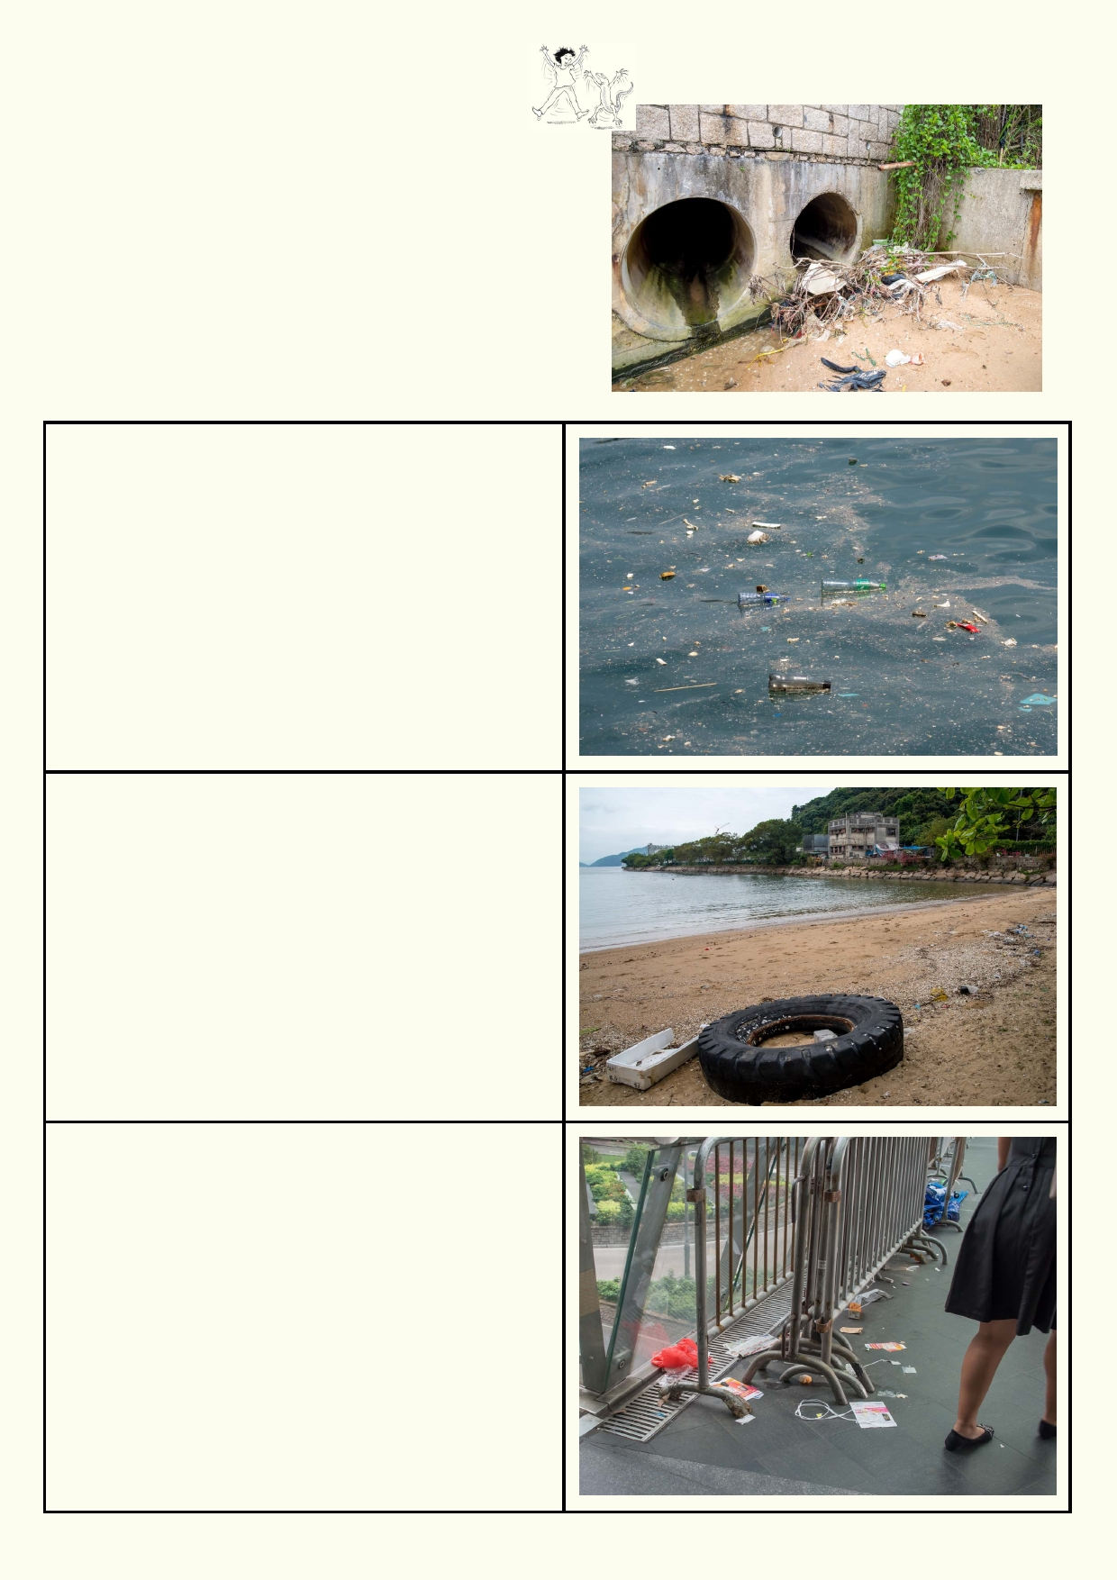Activity 4. Litter disaster

It isn't hard to find the effects of litter around
Hong Kong. Litter along with other pollution gets
washed down into the drains. The drains run into the
sea or rivers. After rain the roads are washed clean,
but the sea becomes more polluted. When lots of
litter and pollution come out of drains on dry days, it
is often because people have washed their dirty
pavements and gutters and poured oil and grease
down the stormwater drains.

Your bay:
What can you see?

Where did it come from?

Your beach:
What can you see?

Where did it come from?

Your walkway:
What can you see?

Where did it come from?

35

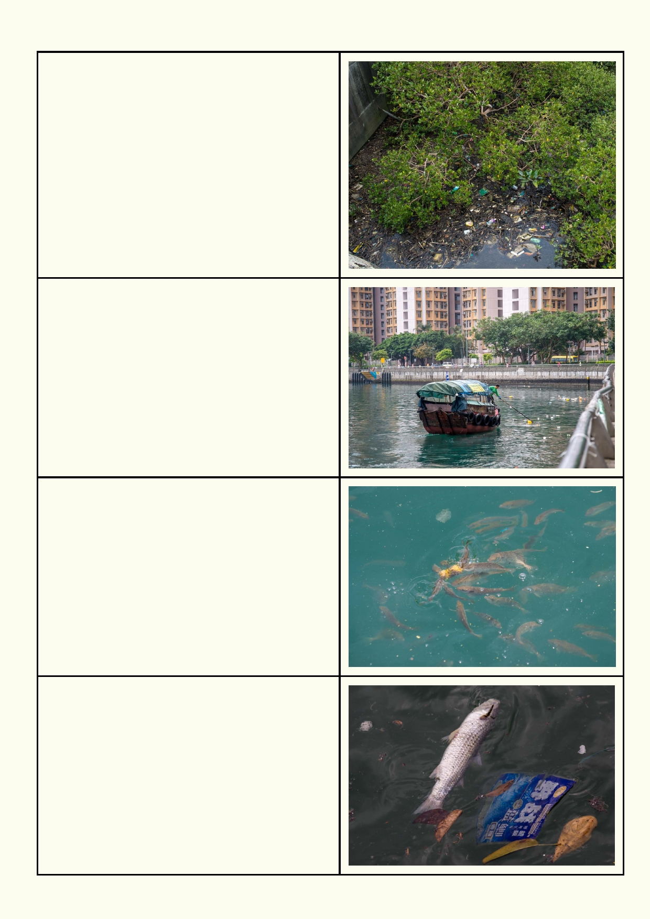Your mangroves:
What can you see?

Where did it come from?

Cleaning up some of the litter:
What can't this boat clean up?

Fish eating litter:
How might it affect the fish?

How might it affect people eating the fish?

What happens when this dead fish which died
from pollution, is eaten by an eagle?

36

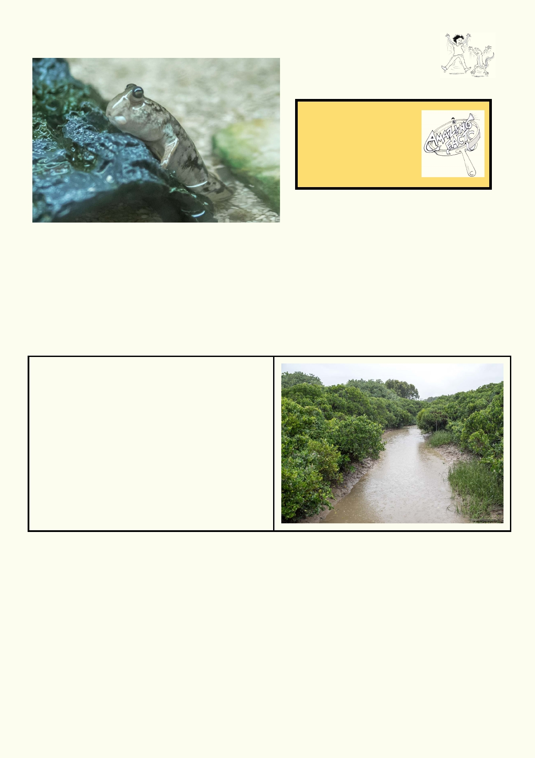Activity 5. Finding better solutions

Amazing fact
Mangroves can store
more carbon in the form
of dead leaves and
branches than a
rainforest.

Protecting our coasts

Hong Kong will always be lashed by monster storms which can damage our buildings and roads along the coast. We could get even bigger storms due to climate change.

Mangroves are one of nature's ways of protecting the coast. They grow in the intertidal zone and
their roots need to be regularly covered by water and also exposed to the air. The roots hold
together all the nutrient-rich mud. The mud is home to an amazing range of animals.

Why should we protect mangroves and encourage more mangroves to grow?

Mangroves
How do you think these small trees protect the
land during big storms?

_____________________________________________________________________________

_____________________________________________________________________________

_____________________________________________________________________________

37

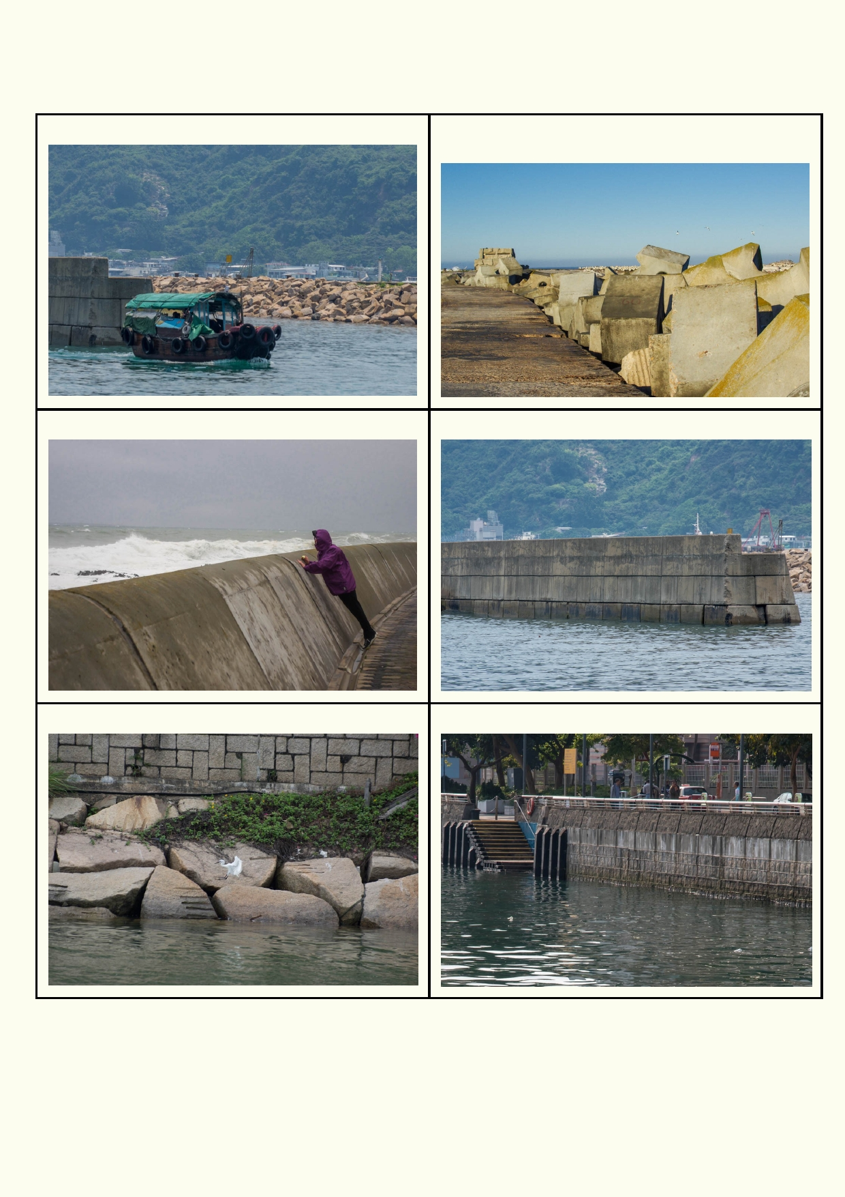If we build roads and buildings by the sea, we must then protect them from the sea. These are
some structures that are used to stop the sea from reclaiming the land.

Rubble rock seawall Jumbled up, odd shaped, interlocking concrete
blocks

Concrete sea wall Harbour wall

Large, carefully placed rocks Coastal wall to stop the land behind falling in

Which of these structures are best to stop storms causing damage? Think about what happens when you spill water on a floor, on a carpet or on soil.

_______________________________________________________________________________

_______________________________________________________________________________
38

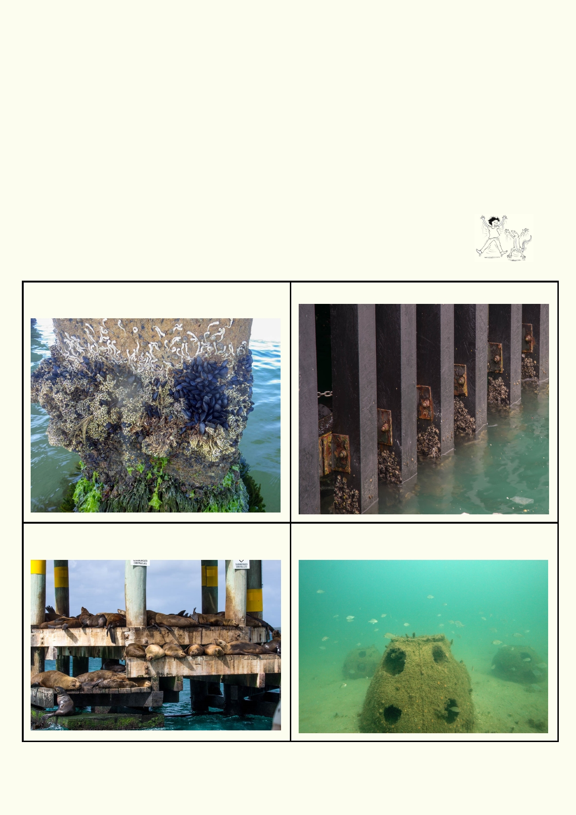Which of the structures do you think would be better for wildlife and why?

____________________________________________________________________________

____________________________________________________________________________

Which structures do you think would have the least wildlife and why?

____________________________________________________________________________

____________________________________________________________________________

Activity 6. Design a reef that protects the coast

These are examples of structures that marine animals including marine birds live and breed on.

The pylon on this pier is encrusted with seaweed, These pylons are home to oysters. marine worms and shellfish.

These seals live and breed on this special These large concrete domes are one type of platform built just for them. artificial reef.

39

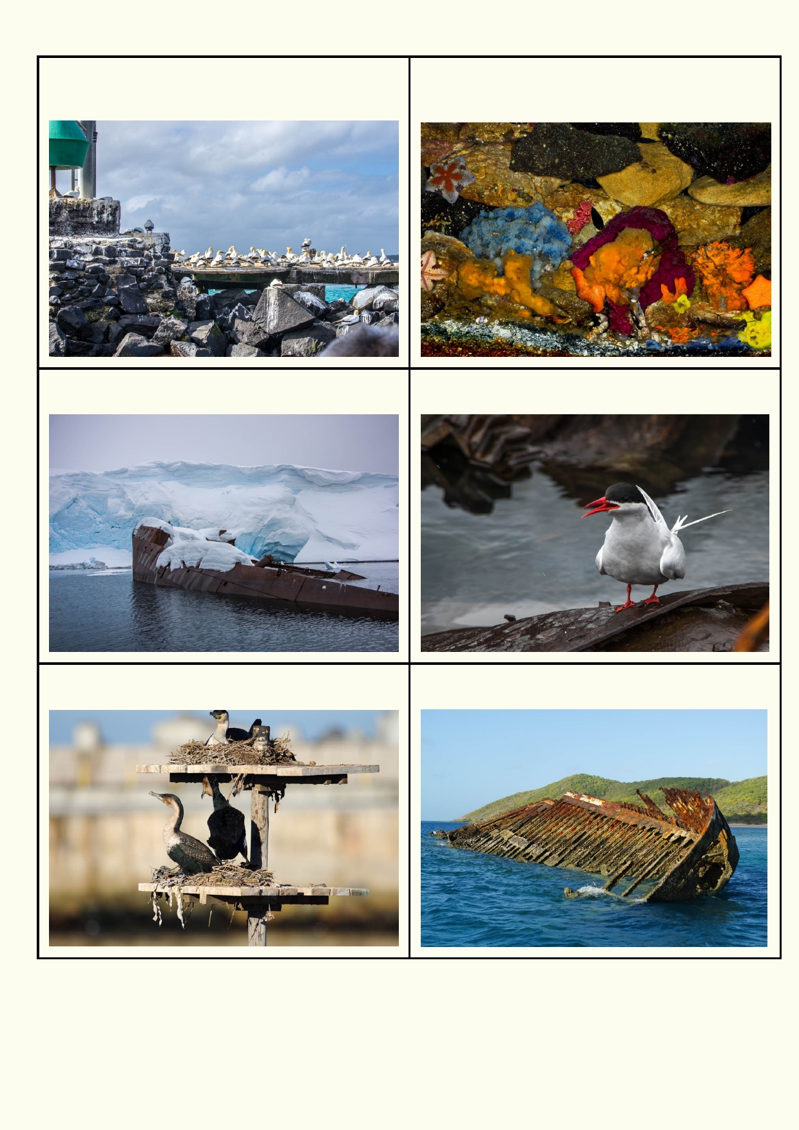Thousands of birds nest on this artificial island. This what it looks like below the artificial island.
Underwater are magnificent seaweeds, sponges,
fish and much more.

This 100 year old Antarctic shipwreck is home for One of the many breeding terns.
a colony of terns.

These platforms have been constructed for Shipwrecks quickly become home to an amazing
cormorants to build their nests. range of marine life.

40

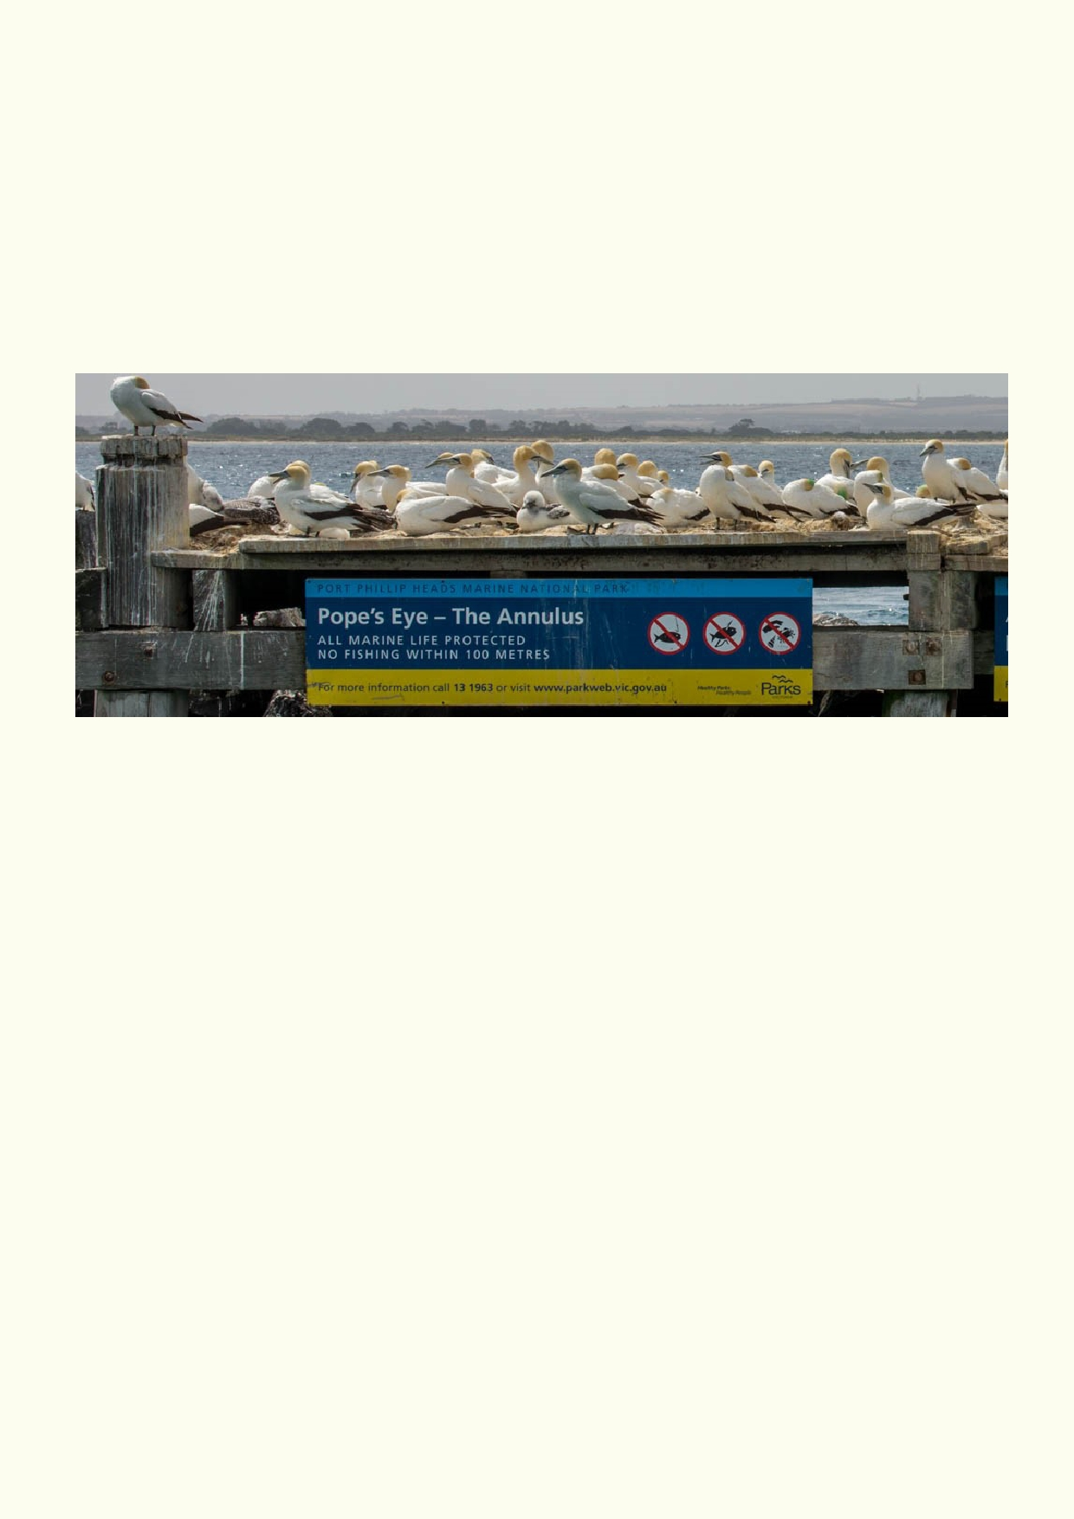Design an artificial reef

1.
2.
3.
4.
5.
6.
7.
What will your reef be made from?
How will the reef be built without polluting the sea?
What animals and plants would you like to live on your reef?
Where will your reef be built?
How will you prevent boats and ships from running into it?
Will your reef need protection from fishing and other human activities?
How large will the reef be?

Make a labelled diagram of your reef and include some of the animals above and below water and any signs or signals you would have around the reef.

Lesson 5 - Balancing competing interests

Activity 1. Flash points
Choose one of these issues that requires solutions or pick an issue of your choice that affects the marine environment. Do not have more than three people in your research group and make sure
the tasks are divided evenly.

When doing your research about marine issues, eg animals, plants, beach etc:
• How does it depend on the marine environment?
• What is special about it?
• Do we get benefits from it?
• How is it being affected by people?
• What is being done to reduce the impact?

What are your recommendations? Explain how we might be able to have development and still
look after the animal, plants, beach, etc. that you have been investigating. The following are
some examples of issues you might research:

41

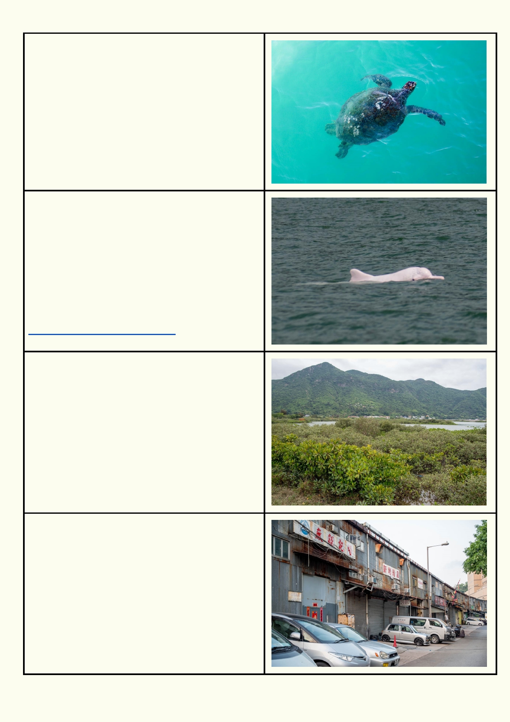Sea turtles
Sea turtles are in decline.
Many of the beaches that they once nested on have been developed.
When nesting, turtles get confused by street lights
and head inland instead of back to sea.
People and their pets disturb their nests.
They get hit by boats.
They eat plastic because it looks like jellyfish.

Pink Dolphin
The number of pink dolphins around Hong Kong
waters have been steadily declining. There are
less than 100 of these dolphins left. The few that
are left are tourist attractions.
They remain inshore so they are vulnerable to
human activity.
Dredging the seabed stirs up the old
pollution hidden in the mud and sand from many
years ago affecting the health of all sea life.
http://www.hkdolphinwatch.com/

Mangroves
Mangroves protect the land behind them from big
storms. They are also home to many juvenile fish.
Mangroves have been cleared for land
reclamation, to construct ports and because
people in the past didn't understand their value.
Often mangroves die and we have no idea why.

Beach access
On the other side of these light industry buildings
is the sea. Hong Kong provides good access to
the waterfront, but there are many places people
are blocked off from going. In other countries there
are private beaches that are parts of resorts and
other people are blocked from using them.

42

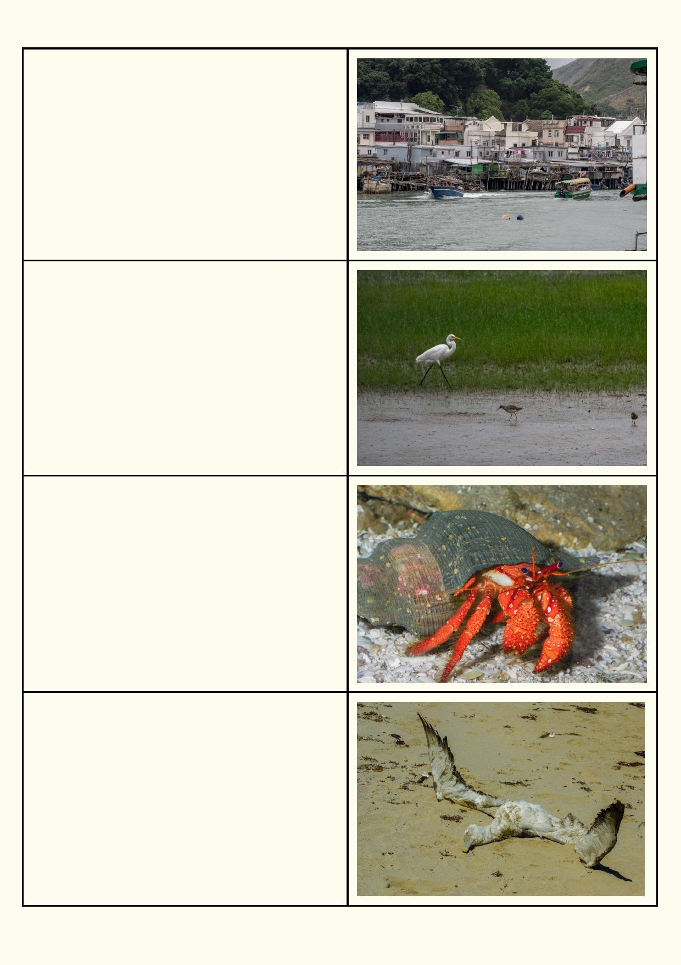Residential development
In the past, most people lived in small dwellings
and built whatever they wanted on their land. Areas with large populations require good planning. Does
Hong Kong have good solutions for protecting the
environment when they build new residential
areas? What can be improved?

Loss of mudflats
Mudflats may not look attractive to you, but they
are home to vast numbers of mud-loving creatures
which are food for some of the world's most
amazing animals. Hong Kong mudflats are used by
migratory waders as they move between the
northern hemisphere where they breed (e.g.
Siberia and Alaska) and places like Australia where
they holiday. When mudflats disappear, the birds
that stop over to recover can also disappear.

Save our hermit crabs
Have you ever played with a hermit crab by the
sea? They are found around rocky areas in the
intertidal zone and down below the waves. When
their rocky homes get covered during development
there are fewer homes for hermit crabs and many
other fascinating marine creatures.

Nothing is safe
This is a dead albatross on a beach. It's likely its
death isn't natural. It may have swallowed fish
hooks or litter drifting in the sea. There may have
been a fish shortage and it starved. It could have
crashed into a ship's mast at night. They normally
have a long life, so we can assume this albatross
death was premature.

43

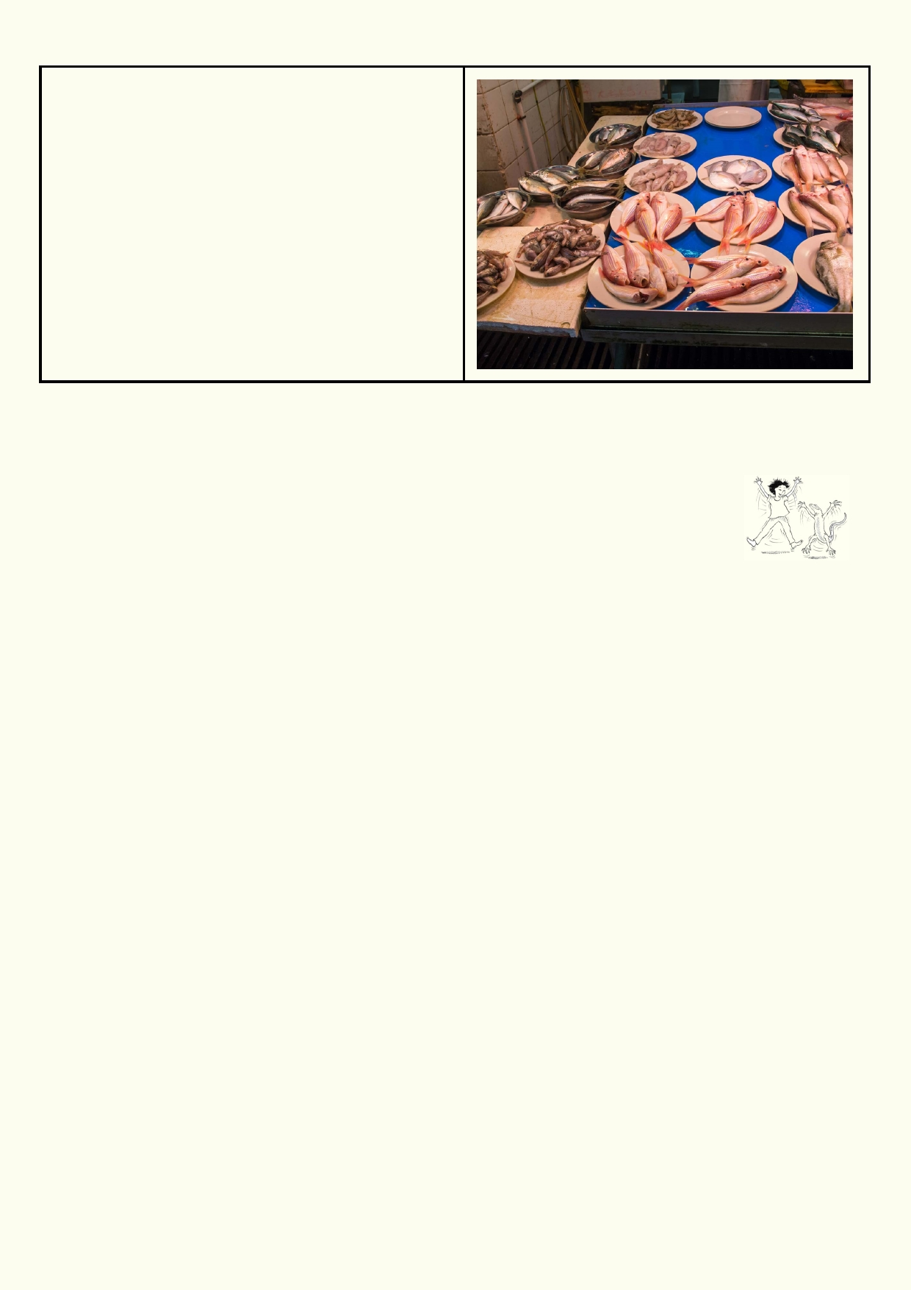Marine fish need somewhere to breed and
grow
There can be many reasons why some fish
stocks in the sea are lower than others. Besides
fishing sustainably, we need to protect the
habitats where fish breed and their young grow.
The small young often live in nutrient-rich habitats
such as mangroves, seagrass and estuaries.
These habitats need protection if we want to
catch fish in the sea.

Decide how you will present your report on your research topic. You could use a Powerpoint
presentation, a poster, write as a formal report, make a podcast, do a TV interview using a video
camera etc.

Activity 2. Plan a coastal excursion

Planning to visit the sea
Design your own study of a seashore ecosystem and gather data to be analysed, interpreted and presented back at school.

What will you investigate? Here are just some suggestions:
• Describing how organisms are adapted to living in the intertidal zone.
• Mapping how organisms are distributed in the intertidal zone.
• Measuring the species biodiversity.
• Describing the difference between organisms.
• Comparing niches along the coast.
• Comparing the diversity of living molluscs in a pools and rocky platforms with the dead
empty shells on the beach.
• Finding evidence of human impact.
• Recording the type and density of litter that is found.
• Comparing rocky areas where people walk and don't walk.
• Recording visitors' behaviour including what they allow their dogs to do.
• Evaluating the signs on the beach if they are effective in encouraging safety and
conservation.

Develop an investigation to gather and record data
Divide up into groups in which you are likely to be most productive.
You will be developing at least two agreed investigations to be done on the coast. You will need
to submit your plan for investigations so the teacher can make comments and ask for
modifications.
What is your brief? An example of an investigation brief is below.

44

Getting organised:
• Who is in the group?
• Describe what the group will be investigating.
• Describe the kind of data the group will record.
• List any units of measurement students will be using.
• Explain how the group will go about gathering data.
• Explain how the students' method of collecting data is scientific.
• Design a data record sheet for the data. How will the data sheets remain dry?
• Identify what information the group needs to gather the data.
• Identify what equipment the group needs.
• Design simple equipment if needed.
• Identify other equipment that is required.
• Explain how sensitive equipment will remain safe, eg cameras.
• Explain how the group will remain safe.
• Explain how the group will avoid damaging the area.
• How long will the investigation take?
• Provide the teacher with the plan for the investigation for the teacher's comment.
• Depending on the teacher's feedback make modifications to the investigation plan.

Gather necessary equipment:
• Gather the equipment you need.
• Decide what equipment is too risky to take to a wet, sandy and salty environment.
• Discuss the best way to transport equipment.
• Identify the best way to keep equipment safe.
• Identify the best way to make sure equipment is not
lost.
This is a photo of a moderately expensive digital camera
that has fallen into the sea and is destroyed. The owner
understood their camera could not be fixed when it fell into
the water and didn't bother to fish it out.

Gathering data in the field:
• If there aren't toilet facilities at a safe walking
distance from the coast, make sure you use the
closest public toilet facility before you arrive at the coast.
• On arrival at the coast revise the most important issues starting with where students may go
and can't go. Remind yourselves of the safety and conservation codes. Secure food from the sun, birds and the wind.
• Go over the time you have on the coast and when you need to start the investigation.
• Ask your teacher for help as soon as you feel stuck over what you need to do next.
• The teacher may prefer to gather all the data sheets before you return to school.
• Confirm all the equipment is back at school.

Analysing data and presenting to class
• Present and describe your data. Where appropriate, data should be presented in a
graphical form along with tables explaining what their data means.
• Analyse your data: What conclusions does the data enable you to reach?
• Develop a short report that can be written or presented as a PowerPoint, etc. to the class.

45

Activity 3: Your Coastal Visit
This activity involves producing a small booklet about your coastal visit. Follow
your teacher's instructions about this.

Activity 4. Looking forward
There are many community projects you can become involved in, or you can start your own
community project. Before you get started, define your goals and the amount of time you will be
able to spend on your project. Have a look at the following suggestions:

Ready-to-go community projects:
• Beach cleanups: Join Hong Kong Cleanup http://hkcleanup.org/
• Use your smartphone to monitor your most littered coastlines. Watch this video from
Ocean Recovery Alliance
https://www.youtube.com/watch?v=ABXANevSYyg and
https://vimeo.com/132602003 and then download the app to your smartphone.
• Grate art: Use your artistic talents to explain to your community that their litter and pollution
goes down the stormwater drains and pollutes the sea.
http://www.oceanrecov.org/other-projects/hong-kong/grate-art.html and
https://www.youtube.com/watch?v=plII3YjRylM

Design your own community project
The following are just some suggestions. You can come up with some of your own as
well!
• Educate on plastics: Design your own community education project on
plastics. You might like to use available resources such as
https://www.youtube.com/watch?v=ABXANevSYyg on social media or other
methods for
networking with your community
• Recreational opportunities: Make an online travel guide on the best places for your
community to enjoy their coastal environment. Provide examples of what people can do to enjoy the coast.
• Field trips to the coast: Suggest field trips to other schools so they can also appreciate
and learn about our coasts
• Storm surge protection ideas: Suggest ideas to your community about how we can
reduce the impact of storm surges. Collect a wide range of ideas from around the world so
your community can see what is possible.
• Tree planting/habitat improvement possibilities. Have a look at what other countries are
doing to use nature to help protect their coasts. Make your own version that suits the
community and environmental needs of Hong Kong. Go out and sell your ideas. Anyone can
make a start.
• Compare nature at work on our coast. Use cameras and GPS coordinates to document
the most impressive coastal land formations carved out by waves, storms, wind and rain. Share the photos on the internet and get others to contribute.
• Crystal ball predictions: Predict how the coast will change over time due to natural events,
human activity and climate change impact. Be realistic. Explain the dangers but don't
exaggerate the problems. Look at the alternative future scenarios.

46

Acknowledgements
The Ocean Recovery Alliance thanks The Hong Kong Jockey Club Charities Trust for their
generous funding support on this education programme.

Project manager: Doug Woodring
Writer, photography and design : Bob Winters
Curriculum manager and editor : Charlotte Charny Nielsen
Editor and school outreach: Alex Hale
Additional thanks: Jasmine Nunns and Sandra Merazzi

© 2017 Ocean Recovery Alliance and Authors.
Outside the school environment, the text, photos and artwork may not be reproduced, except
where permitted by the relevant Copyright Act. These materials may not be modified and
distributed by print or electronic means without written permission. Teachers may modify these
education materials for the use of their students and school provided it is not distributed any
further. Those wishing to reproduce part of this publication must submit their application to the
Ocean Recovery Alliance. www.oceanrecov.org/contact-us.html

47

