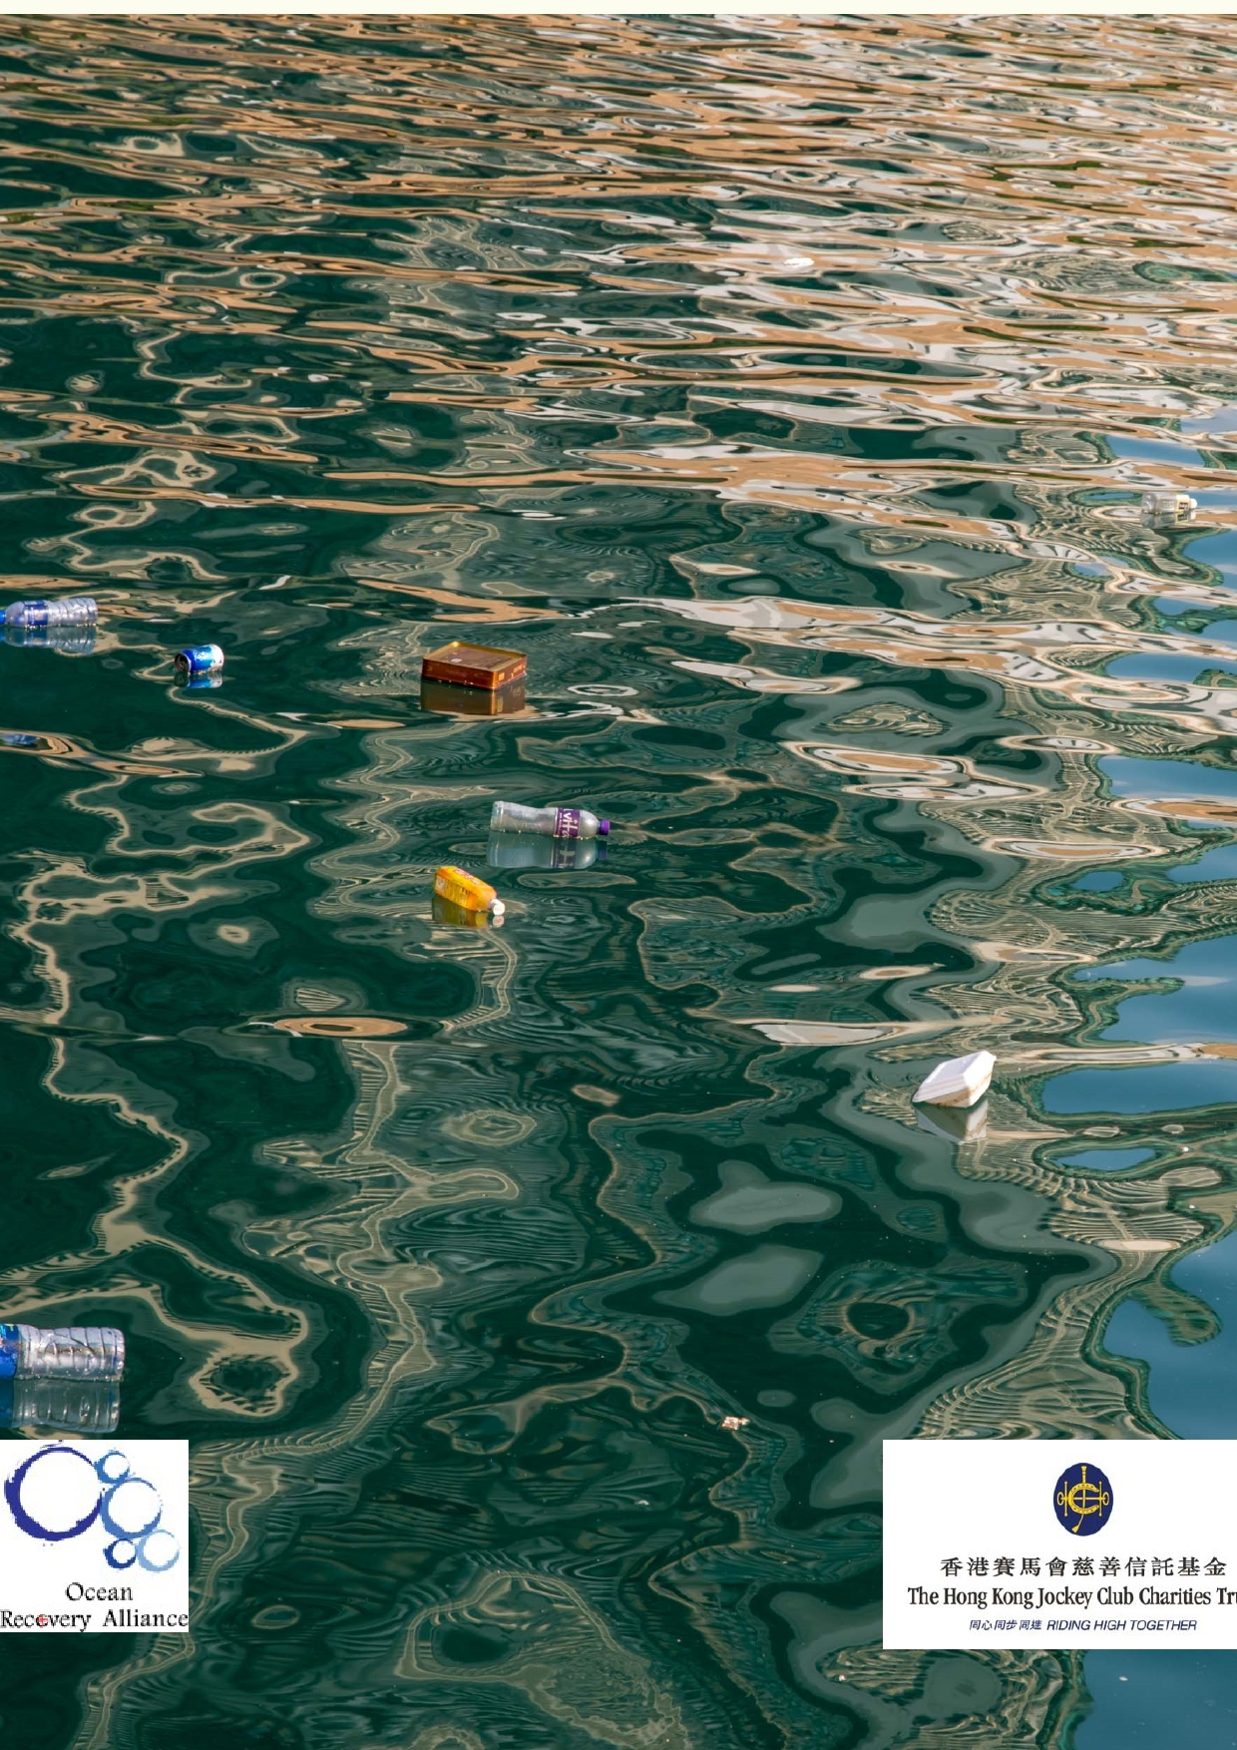Jockey Club Water Caretakers of
Tomorrow Programme
Stressed-out Watershed - Unit 3

rganised by

Funded by

1

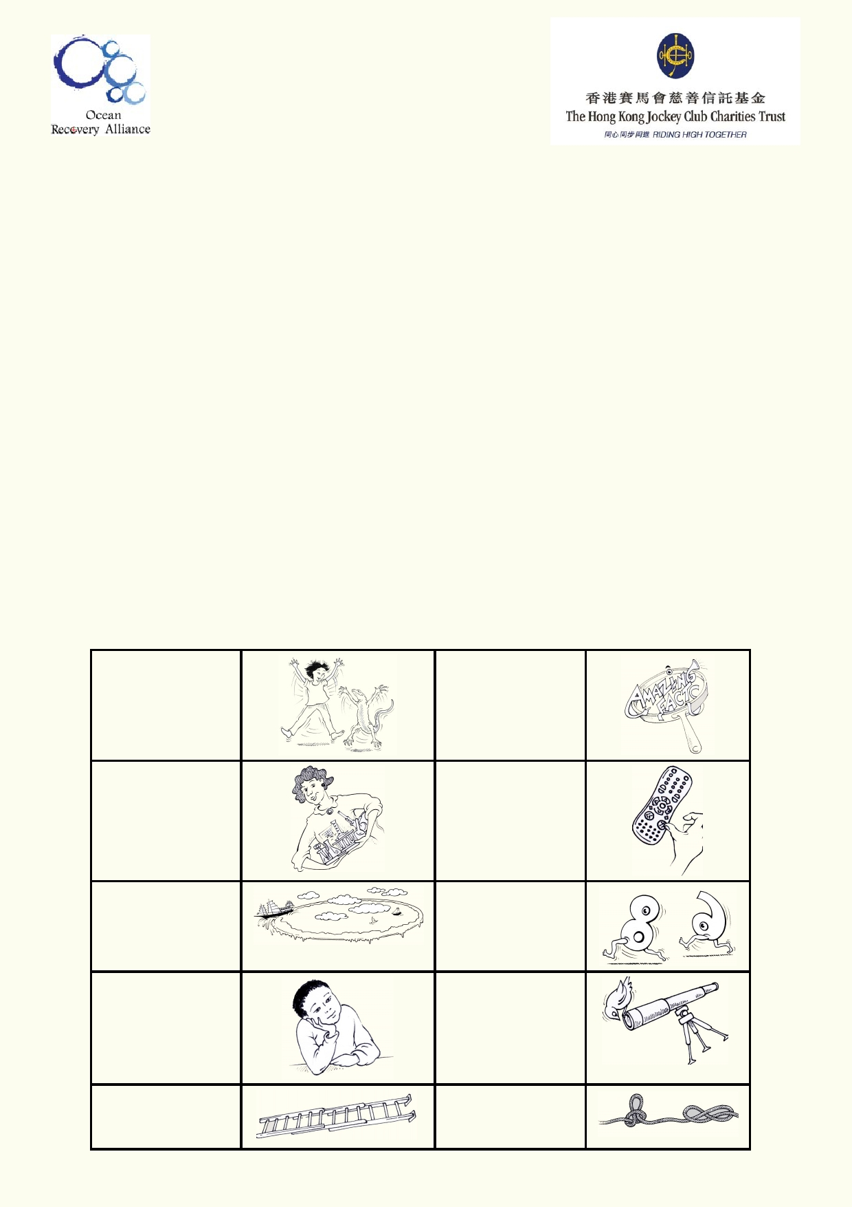About The Jockey Club Water Caretakers of Tomorrow Programme:
Jockey Club Water Caretakers of Tomorrow Programme is organised by Ocean Recovery
Alliance, Ltd and funded by The Hong Kong Jockey Club Charities Trust. There are eight units
in this program, and each of them is designed with you, a student in Hong Kong, in mind.

These are the goals for your lessons, to:
• Understand and appreciate how our water systems function on a local and global scale.
• Understand how watersheds function, and the interconnections of life within and between
these watersheds.
• Be able to assess threats, such as pollution and habitat destruction, and learn how to
lessen these effects.
• Be empowered to take an active role as caretakers of our water resources by sharing your
commitment with your communities.

Student introduction
• You will need access to the internet.
• In some activities, using the camera in your smartphone or tablet will be useful.
• Your teacher will tell you if you if your work will be done on your computer, printed paper or
notebooks.
• Below is a key to the illustrations found in the student notes.

Start of a new A new amazing activity. f act .

Get ready to do an experiment.

Identify your
misconceptions
before your move on.
Identify your
prior learning.

An extension
activity

Fast forward to
make your
contribution to improving our world.
Data will be used
to solve
problems.

These are the goals for this unit.

A cross-
curricular
activity

2

Student aims:
At the end of this unit I will be able to:
• Sequence change in land use in my watershed.
• Track the sources and effects of pollution in my watershed.
• Suggest ways to balance uses in a watershed and provide reasons
for best practices.
• Appreciate the changes in attitude about watershed modifications.
• Create a video that informs the community about the stresses in your watershed.

Glossary

Acid Rain

Agriculture

BOD

Channelisation

Climate Change

Colonisation

Creek

Desalination

Diffuse

Dissolved
Oxygen

E. coli

Environment

Erosion

Fertiliser

Flooding

Greenhouse Gas

Created when water in the atmosphere becomes acidified by pollutants in
the air.

The cultivation of crops and animals for food, medicine and materials used
to enhance and sustain human lives.

Biological Oxygen Demand is the amount of oxygen needed by organisms
to break down organic matter in a water system over a given temperature
and time.

Human management of a river channel usually involving modifying and
concreting rivers or streams.

Alteration of the Earth's weather patterns.

The process of taking control of an indigenous people's land through
invasion and settlement.
A small waterway, usually sheltered and narrow.

The process of removing salt from seawater for use as freshwater.

A pollution input to a water system that comes from surrounding landscape.

The amount of oxygen in a water body that is available for plants and
animals to use.

A type of bacteria that is normally found in the intestines of healthy people
and animals. Most varieties are harmless but food or water that is
contaminated with some strains of E. coli can cause serious illness.

The natural world in a given geographical area.

Applied to a watershed, it's the weathering of the landscape, the process
by which sediment is picked up and moved from one place to another.

A chemical or natural substance used to encourage and enhance plant
growth.

The overflow of water from a water body when its limit is exceeded.

Refers to gaseous emissions largely responsible for the warming effect it
creates in the Earth's atmosphere.

3

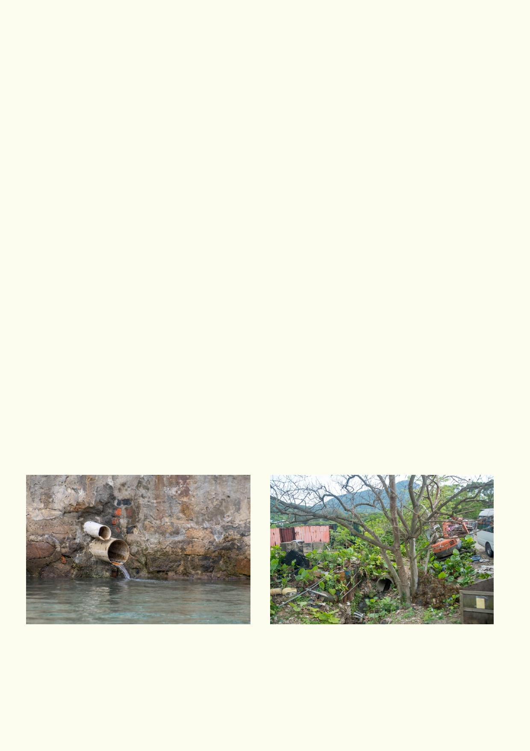Gully

Irrigation

Landslide
A deep channel in the landscape that has been carved out by flowing
water.
The practice of diverting water for use in growing crops and supporting
agricultural practices.

The collapse of a piece of land usually due to heavy rain.

Migratory Waders Birds that fly in for part of the year to use wetlands and other water bodies
to forage and hunt for food by walking through the water.

Natural/modified

Nitrates

Phosphates

Point Source

Pollution

Salinity

pH

Tanning Industry

Turbidity

Watershed
Whether a landscape has remained untouched by people or changed by
people to suit us.

Form of the element Nitrogen, utilised by plants for growth.

Form of the element Phosphorous, utilised by plants for growth.

A pollution input to a water system that comes from a single place.

Contamination from human activities into a natural system.

Concentration of dissolved salts and minerals in a water body.

A term used to explain how acidic or basic (alkaline) a solution is. 7
indicates neutral; numbers lower than 7 are more acidic the closer they get
to pH 1; numbers higher than 7 are more basic the closer they get to pH
14.
Refers to the treatment of animal skins to make them into leather products
for us to use.

Measure of the murkiness or clarity of water.

The boundary of land that marks where water will drain in a landscape.

4

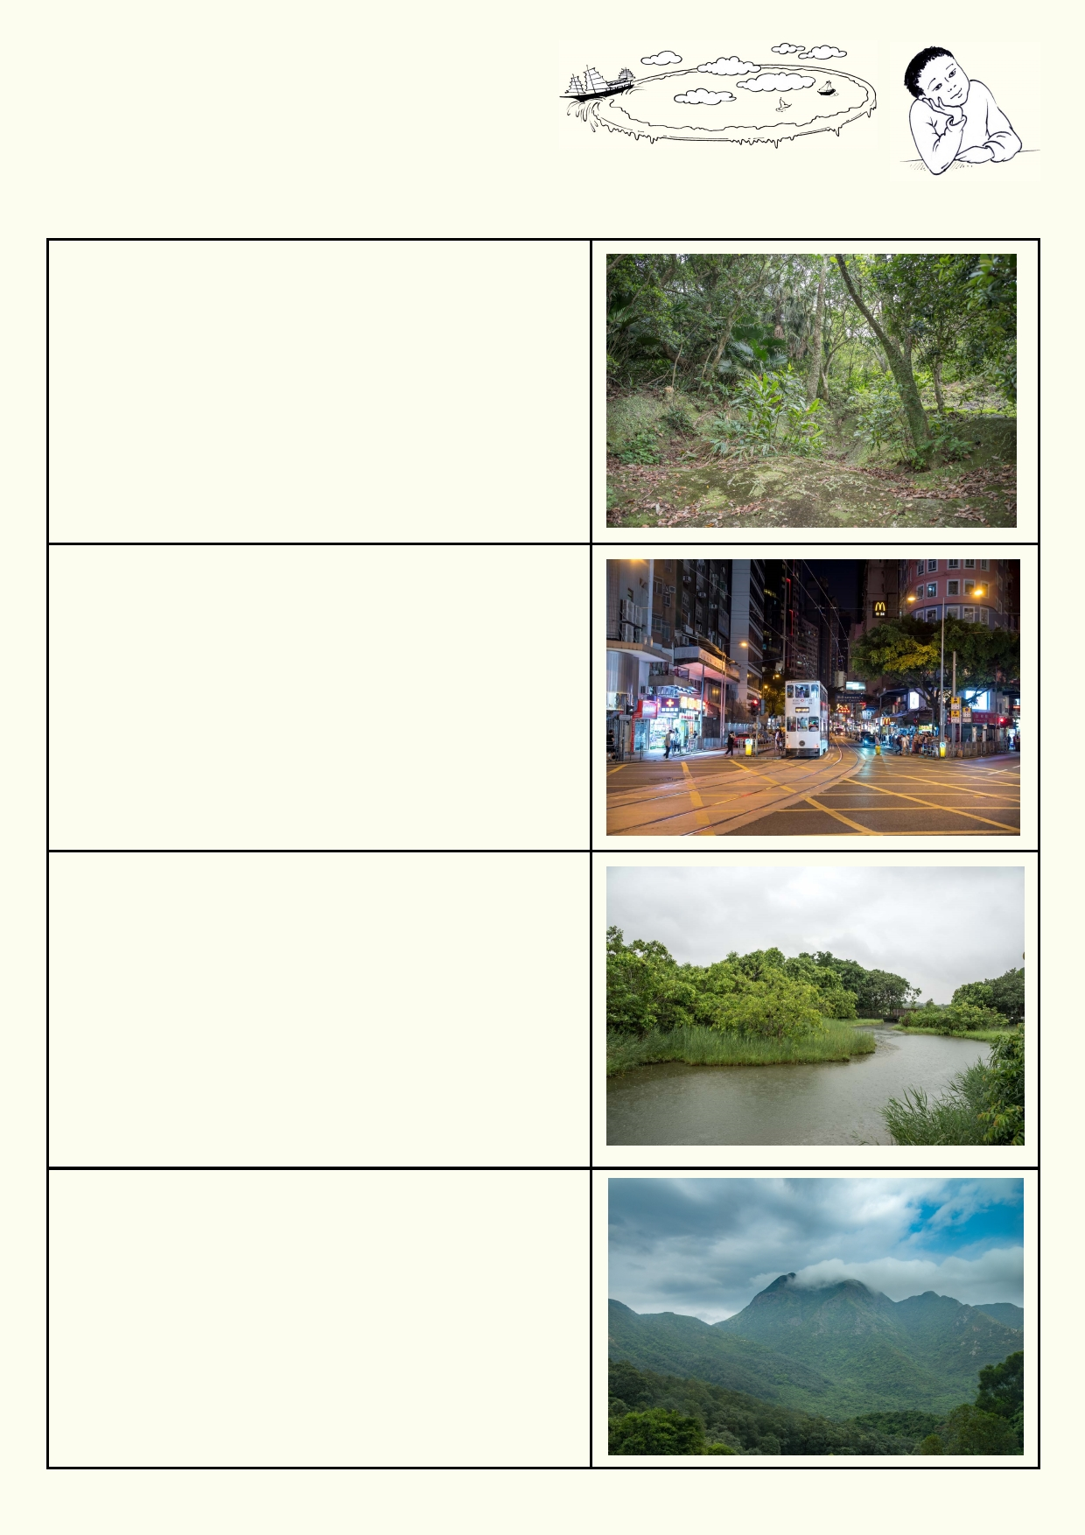What do I know?
Look at each photo. Suggest where rainwater
flows in each of the environments. Describe any
problems you can see when rainwater flows away.

5

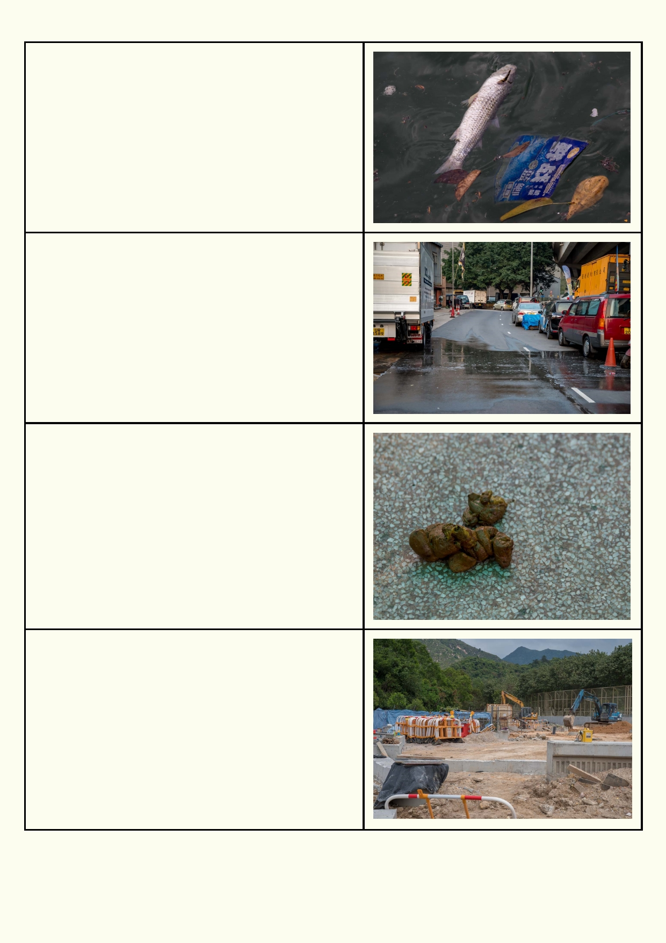

6

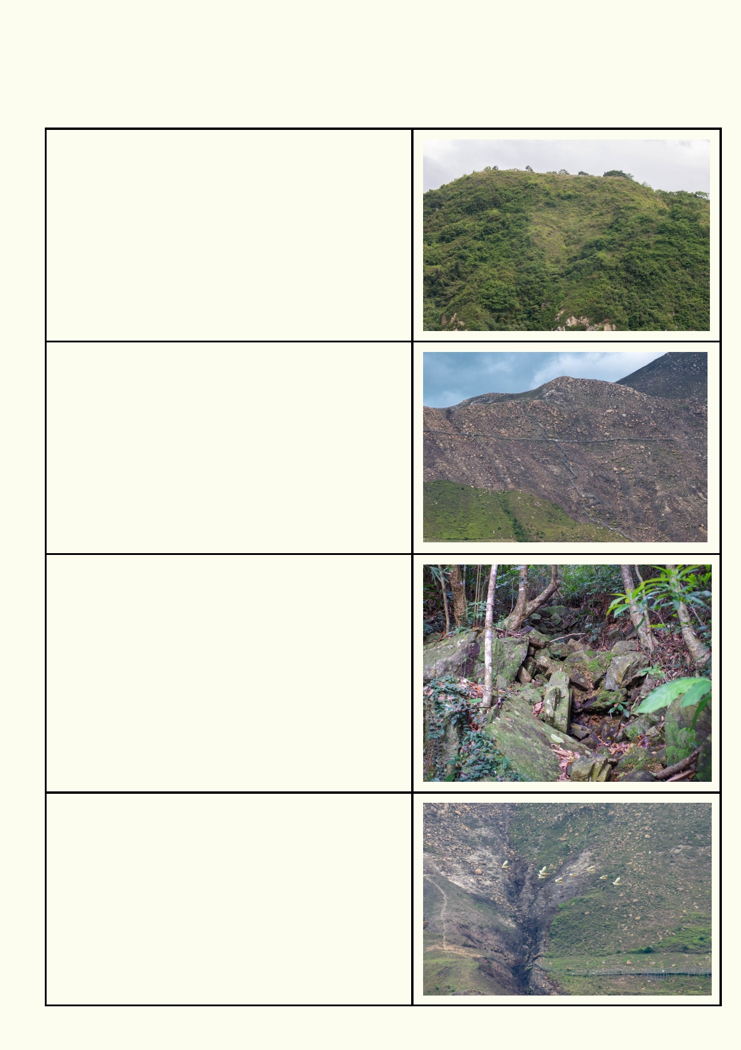Lesson 1. Go with the flow
Hong Kong is dominated by very steep hills and mountains. Wise landuse planning has allowed
most of the steep areas to keep their vegetation.

The gullies down this steep hillside retain their vegetation.

Most of the rocky streams only flow when there is rain. Large volumes of water with immense power
can roar down the rocky creeks.

The trees, grasses and shrubs hold the soil and the rocks together, reducing erosion and the chance of
landslides.

This hillslope has recently been affected by seasonal forest fire after the long dry winter period.

Steep slopes and heavy rain over the summer has
caused a lot of topsoil and organic matter to be
washed away, making long term natural forest
establishment difficult.

This doesn't look like a creek at the moment. When it
rains, however water thunders down this gully. The
rocks and plants slow the passage of water and lessen erosion of the topsoil.

This hill has also lost its soil after the trees were cleared.

Fast moving streams during heavy rains have eroded the hillside to form a deep gully. The eroded gully will
become deeper and wider unless the area is
repaired. To repair the gully, trees could be planted
and barriers could be used to stop water from
rushing down too fast.

7

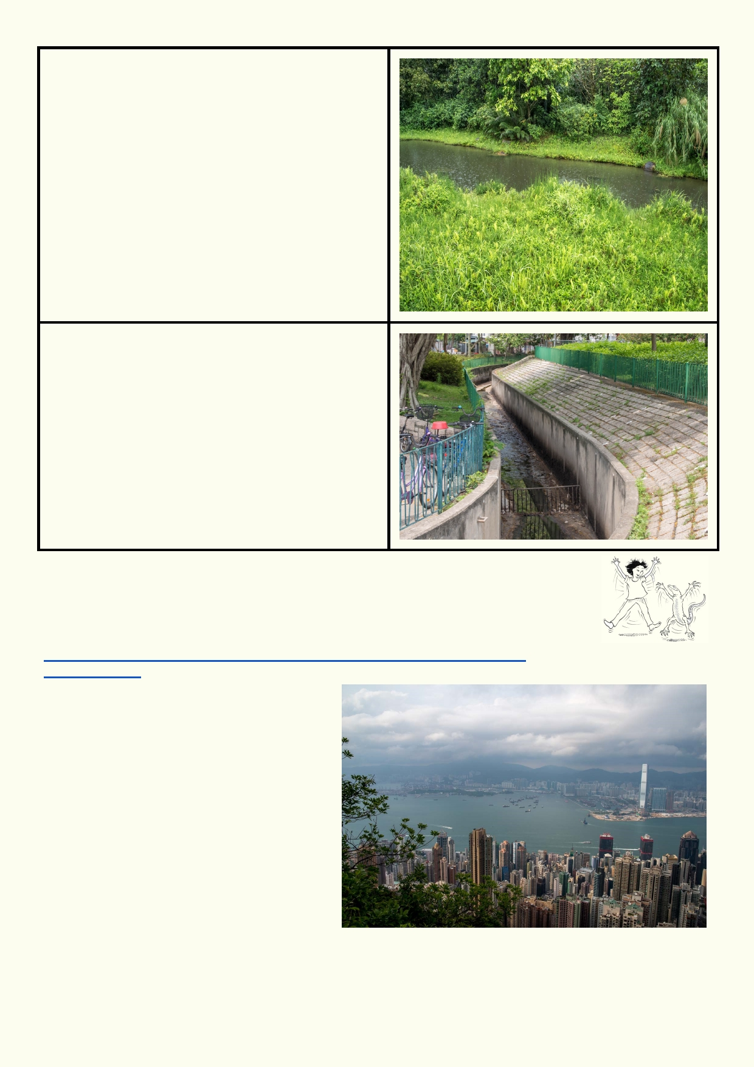The banks of a natural stream are protected by
plants. The plants have access to permanent
water so they can be very dense. The plants also
help to clean the water. The plants absorb
nutrients such as fertiliser and animal manure.
They can also absorb some of the pollutants and
catch some of the litter.

Vegetated streams also slow down rushing water
after heavy rain. This can reduce the impact of floods by making the water pass through more
slowly and helping more water soak into the
gr ound.

Streams that pass through communities are
managed by people. Nowadays, many
settlements are planned and designed with drainage in mind, in order to more efficiently
remove our waste and drain our urban areas.
When a natural river gets converted into a
concrete channel, this is called channelisation.

You can see the amount of litter and pollution in the bottom of this concrete stream.

Activity 1. Hong Kong Landscape
You have your own experiences and ideas about Hong Kong's landscape. Use
the information you have just read and the website below to learn more about the
landscapes around Hong Kong.
http://www.pland.gov.hk/pland_en/p_study/prog_s/landscape/pamphlet/
e_content.htm

Describe the Hong Kong landscape you
know by using these words:
Steep
Forest Gullies
Gradient
Bay
Wetland
Coastline
Buildings
Roads

8

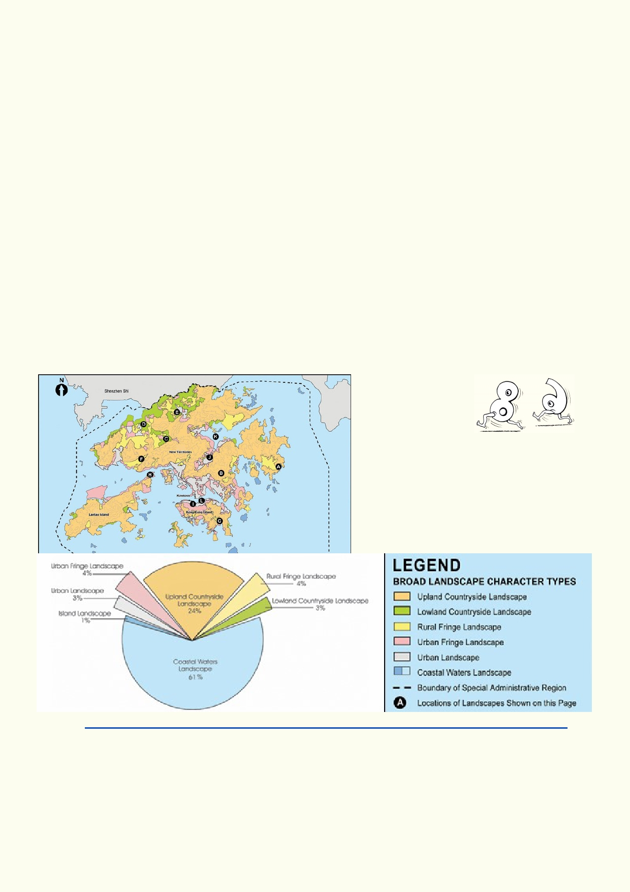_____________________________________________________________________________
_____________________________________________________________________________

_____________________________________________________________________________
_____________________________________________________________________________
_____________________________________________________________________________ _____________________________________________________________________________

_____________________________________________________________________________
_____________________________________________________________________________
_____________________________________________________________________________

_____________________________________________________________________________

Look at the pie chart below. Most of the area is represented by the sea.

Source http://www.pland.gov.hk/pland_en/p_study/prog_s/landscape/pamphlet/e_content.htm

Compare the area of land used for urban landscape with upland countryside landscape using the
pie chart.
_____________________________________________________________________________ _____________________________________________________________________________

9

Activity 2. Why isn't Hong Kong a disaster?

Hong Kong is a busy high-rise city. Land is at a premium, but much of Hong Kong is too steep for development. You will have seen from the pie chart in
Activity 1. that only a small proportion of Hong Kong is built on. In some other
cities these areas may have been built on even though there
are problems with landslips, drainage, etc. In some countries,
areas close to cities are used by the poorer people as shanty
towns. Hong Kong has avoided most of these problems.

Watch both videos to summarise the recent history of Hong Kong.
https://www.youtube.com/watch?v=8Pl7r892cEk or https://www.youtube.com/watch?v=p0NZMyMQR5A

Draw and label a timeline of the major land use events for Hong Kong over the past 160 years

Look at the video and the photos on these two links. The buildings are very different. Look carefully at the hills and mountains in the background for any changes you can see.
https://www.youtube.com/watch?v=2b9aLLl0BaQ
http://stock-images.antiqueprints.com/stock/prints/china-prints.html

What has changed most about Hong Kong's landscape?
______________________________________________________________________________

______________________________________________________________________________
What has changed least about Hong Kong's landscape?
______________________________________________________________________________

______________________________________________________________________________
Were Hong Kong's forested hills protected during colonization?
______________________________________________________________________________

Are Hong Kong's hills still being protected?
______________________________________________________________________________

10

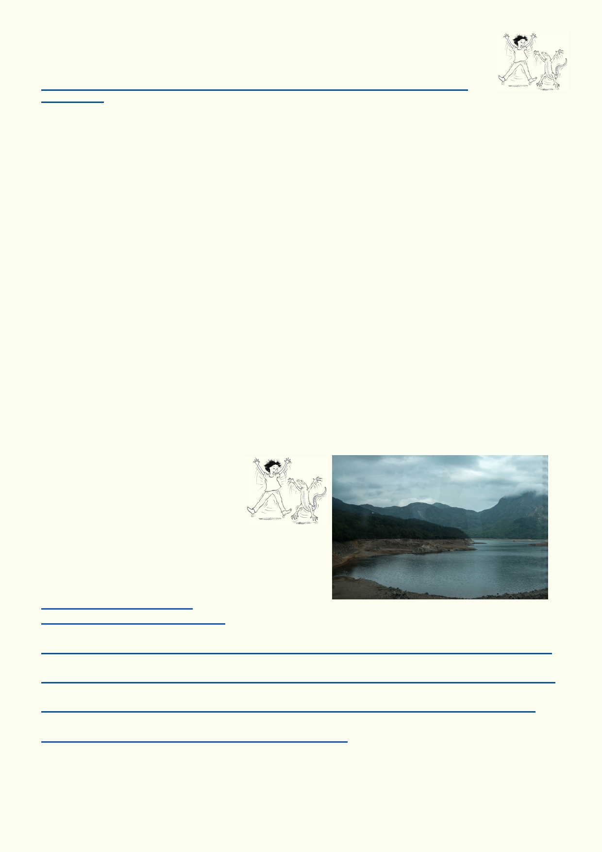Activity 3. The big transformation

Use this website that explains how the region around Hong Kong has changed:
https://www.theguardian.com/cities/2016/may/10/china-pearl-river-delta-then-and-now-
photographs
Make up a newspaper headline about the changes in Hong Kong's landscape, with just a few
words. Then provide five of the most interesting pieces of information you would include if you
wrote an article on the topic.
Headline:

_______________________________________________________________________
1.
____________________________________________________________________________
2.
____________________________________________________________________________
3.
____________________________________________________________________________
4.
____________________________________________________________________________
5.
____________________________________________________________________________

Activity 4. Water detour

Hong Kong has a very high
population for its total land area. To
meet its water needs, Hong Kong
needs to have many ways to provide
enough water to go around. Below are some
examples:

Dams are constructed to store rainwater.
https://en.wikipedia.org/wiki/
List_of_reservoirs_of_Hong_Kong
Many buildings are supplied with seawater to flush toilets.
www.wsd.gov.hk/en/core-businesses/total-water-management-strategy/seawater-for-flushing/index.html
Water is piped in from mainland China.
http://www.wsd.gov.hk/en/core-businesses/total-water-management-strategy/dongjiang-water/index.html
There are future plans to use desalination to turn seawater into freshwater.
http://www.wsd.gov.hk/en/core-businesses/total-water-management-strategy/desalination/index.html
Water conservation is encouraged.
http://www.wsd.gov.hk/en/education/water_conservation/

11

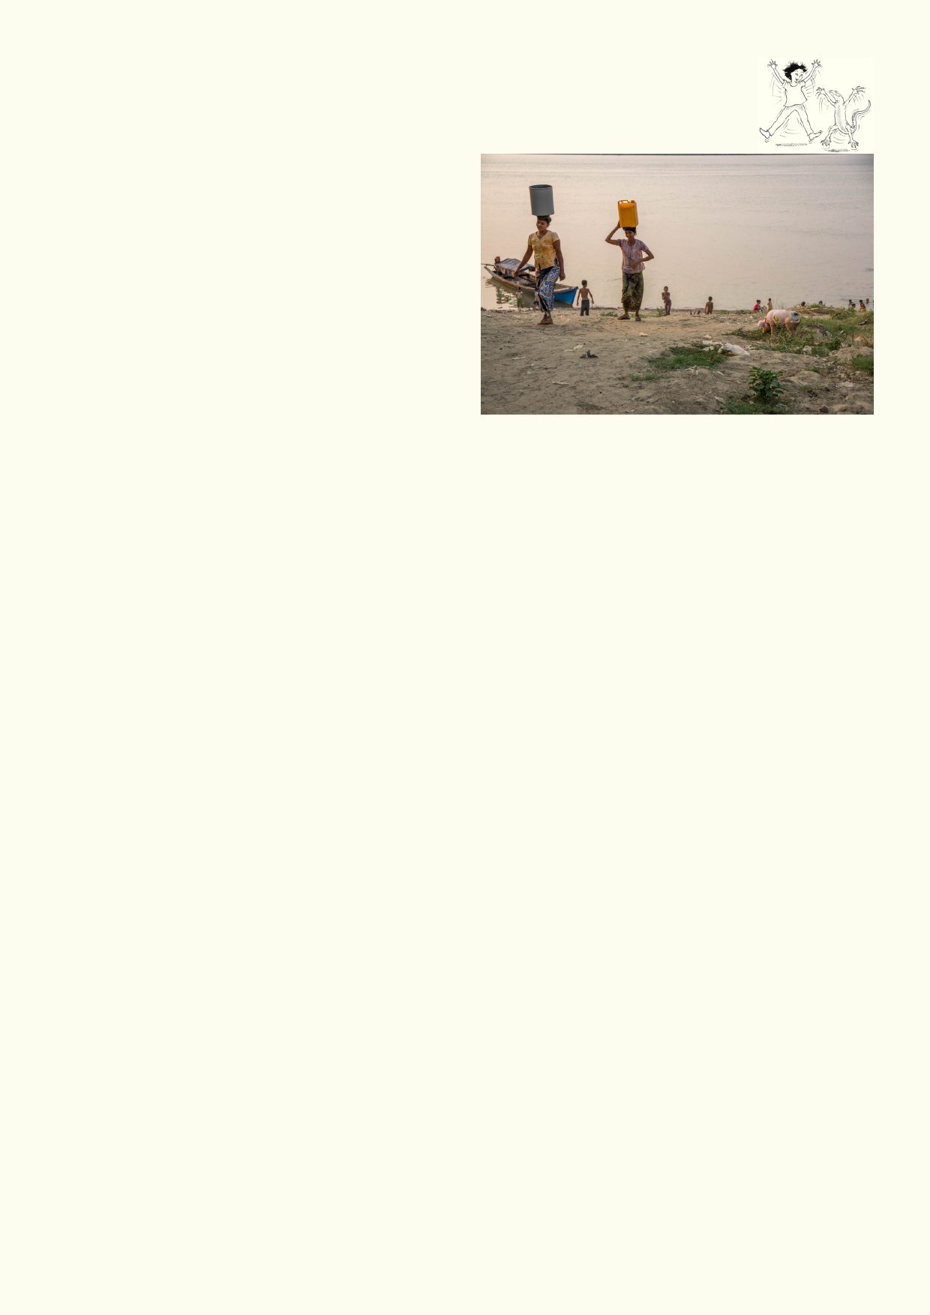Activity 5. Agriculture

Agriculture supplies us with our food. The advent of agriculture allowed us to shift
from small nomadic hunter-gatherer groups into
larger societies that built permanent settlements.
Our impact on the watershed changed
dramatically when this happened. Today
traditional agricultural techniques have been
replaced with more modern and industrialised
versions of these techniques. All forms of
agriculture have some kind of impact on the
watershed because water is a key resource for
growing food. As time passed, however our
methods of agriculture became more efficient and
large-scale.

Traditional Vs. Modern Agricultural Practices
Traditional agricultural practices required many hands to manage the heavy workload of feeding
a large population. Over time, planting and farming techniques were invented to make these
practices more efficient. After the industrial revolution, people were able to design and build
large machinery to take over the often laborious and difficult tasks we had to perform each year.
We could farm larger and larger areas of land using fewer people to do the same amount of work.
Despite the many advantages that technology, machinery and chemicals bring, there are still
negative environmental impacts associated with these newer methods. Larger quantities of
groundwater are used and pollutants are released into the waterways.

Agricultural impact polluting the watershed
Some forms of agriculture have the potential of causing pollution, including water pollution. The
common forms of watershed pollution from agriculture are:

1.

2.

3.
Manure from farm animals. This can be a source of fertiliser for crops, but when mismanaged, can end up contaminating our groundwater, rivers and lakes.
Insecticides, herbicides, fungicides and chemical fertiliser applied to crops are washed into
waterways and groundwater.
Soil disturbed by ploughing, heavy machinery and animal hooves can wash into rivers and
waterways. This can potentially release contaminants from the soil into the water.

Fertiliser, insecticide and herbicide pollution of watersheds can be reduced by only using the amount needed and spraying on days with no wind and little rain.

Agricultural Impact: Irrigation and Desertification
All forms of agriculture require some amount of water to grow crops and supply water to animals.
Poor irrigation practices have been linked to negative environmental consequences like
desertification. Desertification is the process of once productive land drying up, becoming a
desert. This can occur when more water is being drawn out than is being replenished, or
recharged, in the watershed. There are some well documented cases in history where once
prosperous ancient civilisations have collapsed because of, among other factors, bad irrigation
and agricultural practices.

12

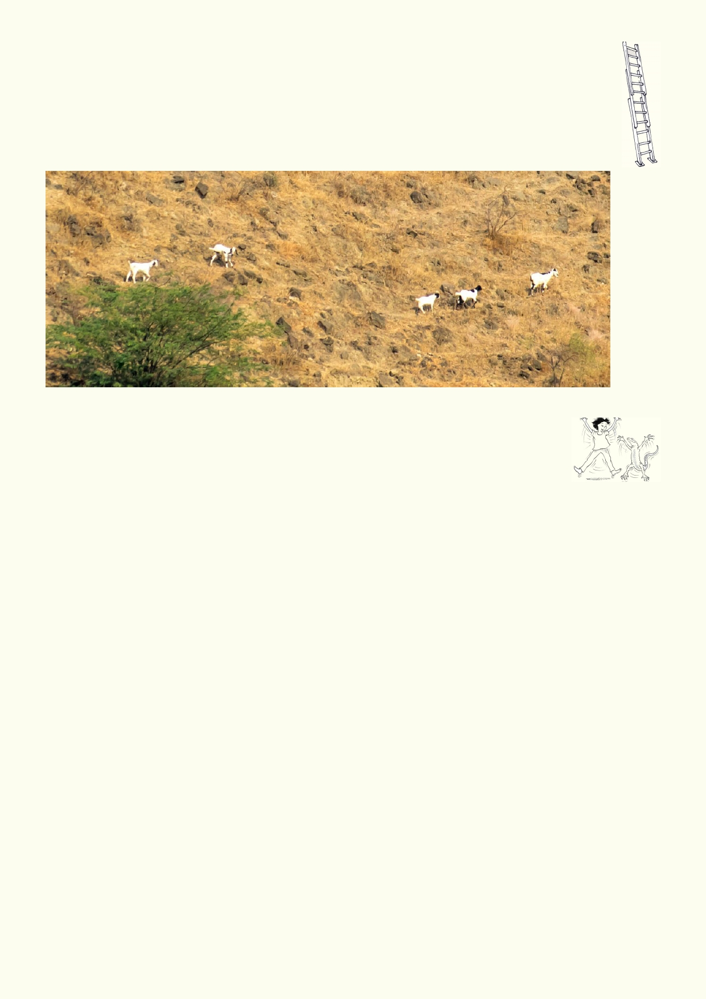Extension: Desertification

Research an ancient civilisation whose agricultural practices led to desertification and
ultimately the collapse of that civilisation, e.g. Easter Island, Mesopotamia, Mayans,
Minoans etc. What were the chief causes of the demise of the civilisation? What strategies
could you suggest that would have helped avoid their collapse?

Activity 6. What's happening with water supplies?

To keep a constant supply of water for all our needs we must have a good supply of water. This will depend on the water resources that are available including the
reliability of rain and ways we can extract or store water. Not only does agriculture
need water. We also need water for domestic and industrial and uses. Some of the water, after it
has been used, becomes a waste product that can pollute the environment.

Use the diagram on the next page. Label it to show how water is diverted for our needs. Also show what happens to the water when we have finished using it.

When we have finished using water, what kind of pollutants do you think it might contain?

____________________________________________________________________________

Can you imagine using wastewater on a farm for any of it for other purposes before it is cleaned?
Give an example:

____________________________________________________________________________

Look up the term "greywater" on the internet. Can you suggest three safe uses for greywater?

1. __________________________________________________________________________

2. __________________________________________________________________________

3. __________________________________________________________________________

13

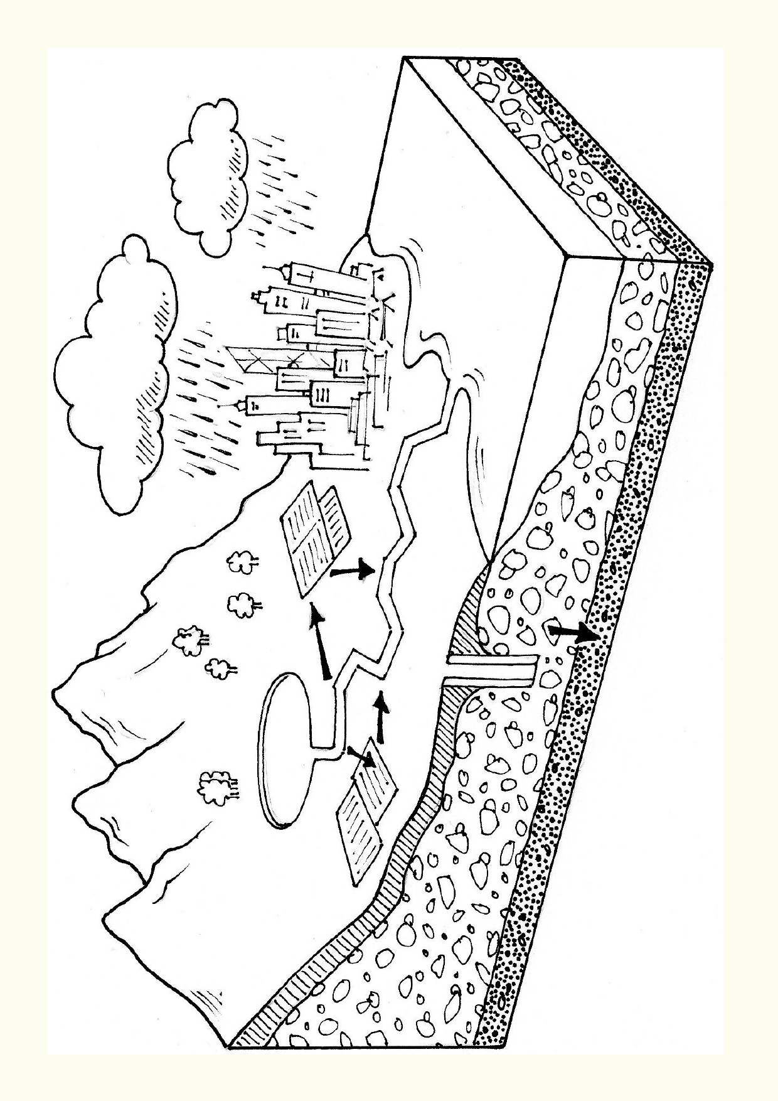

14

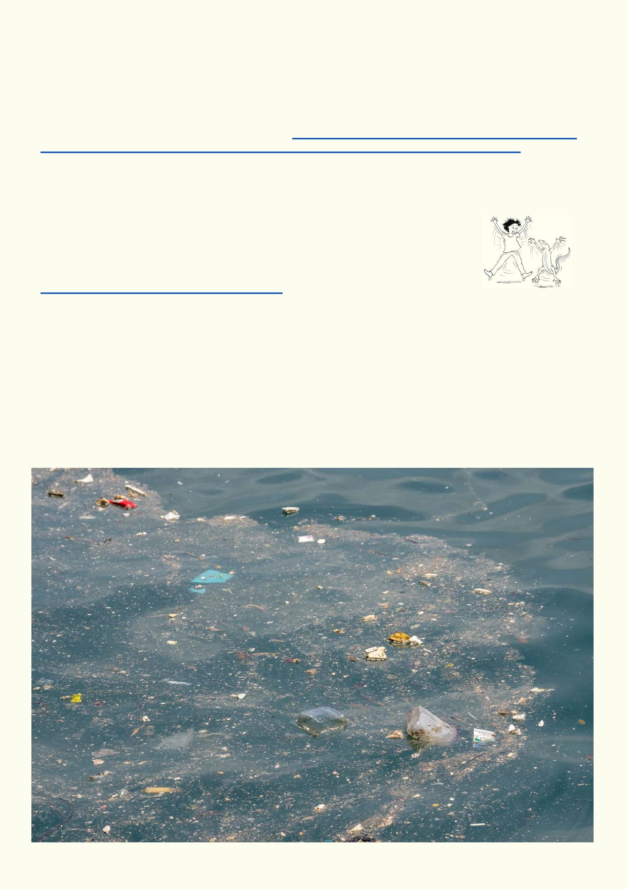Lesson 2. Changing Waterways - Water Pollution and Channelisation

Pollution of watersheds is not new. Some of the historical problems have been fixed. For
example, Hong Kong once had a tanning industry. For much of the previous two centuries there
were no pollution controls when tanning animal skins. Toxic waste polluted the rivers and sea.
The tanning process is toxic for its workers as well as the environment. This is what a tanning
operation with no pollution control looks like: https://www.wired.com/2017/01/adib-chowdhury-a-
thousand-polluted-gardens-inside-bangladeshs-polluted-billion-dollar-leather-industry/

Many of Hong Kong's major polluting industries have either had to clean up their processes or close down entirely.

Activity 1. What is HKEPD?

It is the job of the Hong Kong Environmental Protection Department to monitor and protect the Hong Kong environment from pollution.
http://www.epd.gov.hk/epd/english/top.html

Use the website above to find out what the Environmental Protection Department protects. List
the areas that this Department is concerned with:

_____________________________________________________________________________

_____________________________________________________________________________

15

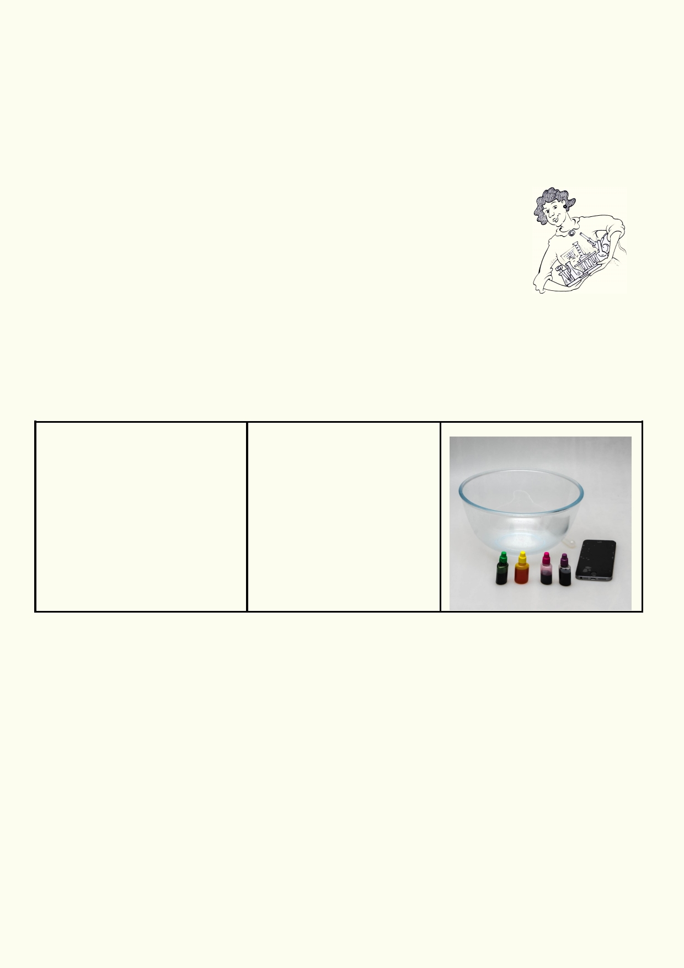What are some of the things you can see in the photo that are polluting the water?

_____________________________________________________________________________

_____________________________________________________________________________

What you can't see includes, bacteria and other germs, poisonous substances, chemicals, animal droppings, grease from food, etc.

Conducting experiments

1.
2.
3. 4.
5.

6. 7.
Read through the setup for the experiment.
Record your prediction for the outcome of the experiment.
Gather the materials that are needed.
Find a suitable location to conduct the experiment.
Review all safety requirements including handling glassware safely and
using heat and heated substances. Ask your teacher if you are not sure. Report any
accidents.
Record your observations as you complete the experiment.
Clean and return equipment.

Experiment: Chemical dispersion

Materials Method
• Food colouring 1. Place one drop of food
• Clear bowl with water colouring in the middle of a
• Smart phone with video bowl of water.
2. Film the process and time
how long it took for the colour
to spread throughout the
container.
3. Observe how the food
colouring disperses and an- swer the questions below.

How did the food colouring disperse? _______________________________________________

Describe the movement of food colouring (straight lines, curves, whirls). Did it first go across the
surface, sink, or evenly spread?

______________________________________________________________________________

How long did it take before the water was evenly coloured?

______________________________________________________________________________

Based on what you have observed, what can you infer about some kinds of pollution in water
compared to pollution on land?

______________________________________________________________________________

16

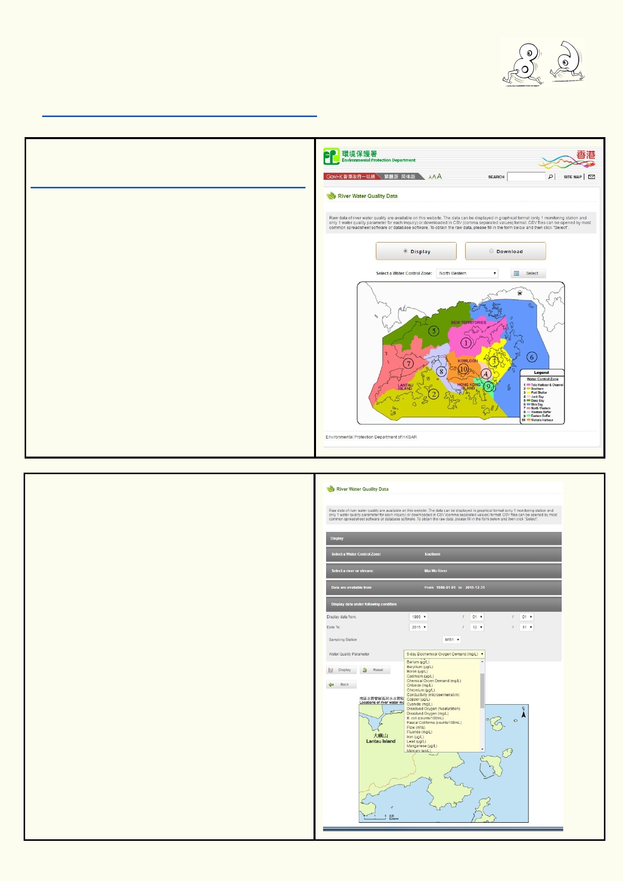Activity 2. Hong Kong water quality
The Environmental Protection Department provides data about the health of the
rivers in Hong Kong.
http://epic.epd.gov.hk/EPICRIVER/river/?lang=en

Use this link to access the data for water quality in Hong Kong.
http://epic.epd.gov.hk/EPICRIVER/river/?lang=en

Hong Kong has been divided into nine zones. Choose one of the nine zones with data.

The next screen will show a map with the river
watersheds that are being monitored. To choose
a river system, click on it.

The third screen has the watershed river system map with menu choices.

The bottom menu is labelled Water Quality
Parameter. When it is clicked on, a drop down
menu provides all the various parameters that
have been measured. There are a large number
of chemicals being measured along with bacteria,
water flow, etc.

To get a graph, click on the parameter and then
on the display button. A new window will come up
showing a graph.

Scientists can use these parameters to measure
the health of a river system and identify some
sources of pollution. They can find out if there is a
new change or event when one of the parameters
spike.

17

Use the menus to choose a Hong Kong river
system.
Use the Water Quality Parameters to obtain data
about E.coli bacteria, dissolved oxygen levels,
salinity, phosphate, nitrates, mercury, flow,
turbidity.
The data page will bring up a graph like this example on the right.
Explain what the graph tells you.

In the graph above, it would appear that the river was contaminated with mercury in the 1990s.
The source of the mercury pollution has stopped and there has been minimal mercury in the
water ever since.

Which river have you chosen? ____________________________________________________

Look up the following parameters and explain the graphs that go with each parameter.

Information about the Water Quality
Parameter

E. coli bacteria are the bacteria that live in our
gut. When there is a large amount of E.coli in a
river, it means that the river is being polluted by
sewage or animal waste. Higher levels of E.coli
increases the chance of disease-causing bacteria
also being in the river water.

Dissolved oxygen levels measure the amount of
oxygen available to animals like fish and
tadpoles. Cold water can hold more oxygen than
warmer water. High levels of oxygen indicate a
healthier river. Very low levels of dissolved
oxygen will have a great effect on all river plants and animals.

Salinity is a measure of salt in the water. High
concentrations of salt will affect many plants and
animals in water systems. Salts can come from
industry and soil. Tidal areas will get salt from the
sea.

Nitrates also accelerate the growth of living
things and reduce oxygen levels. High levels of
nitrates in drinking water are harmful to people.
These high levels come from fertiliser, industry
and human waste.

1. Explain the graph:
2. Are there great changes in the graph?
3. What might the changes mean?

18

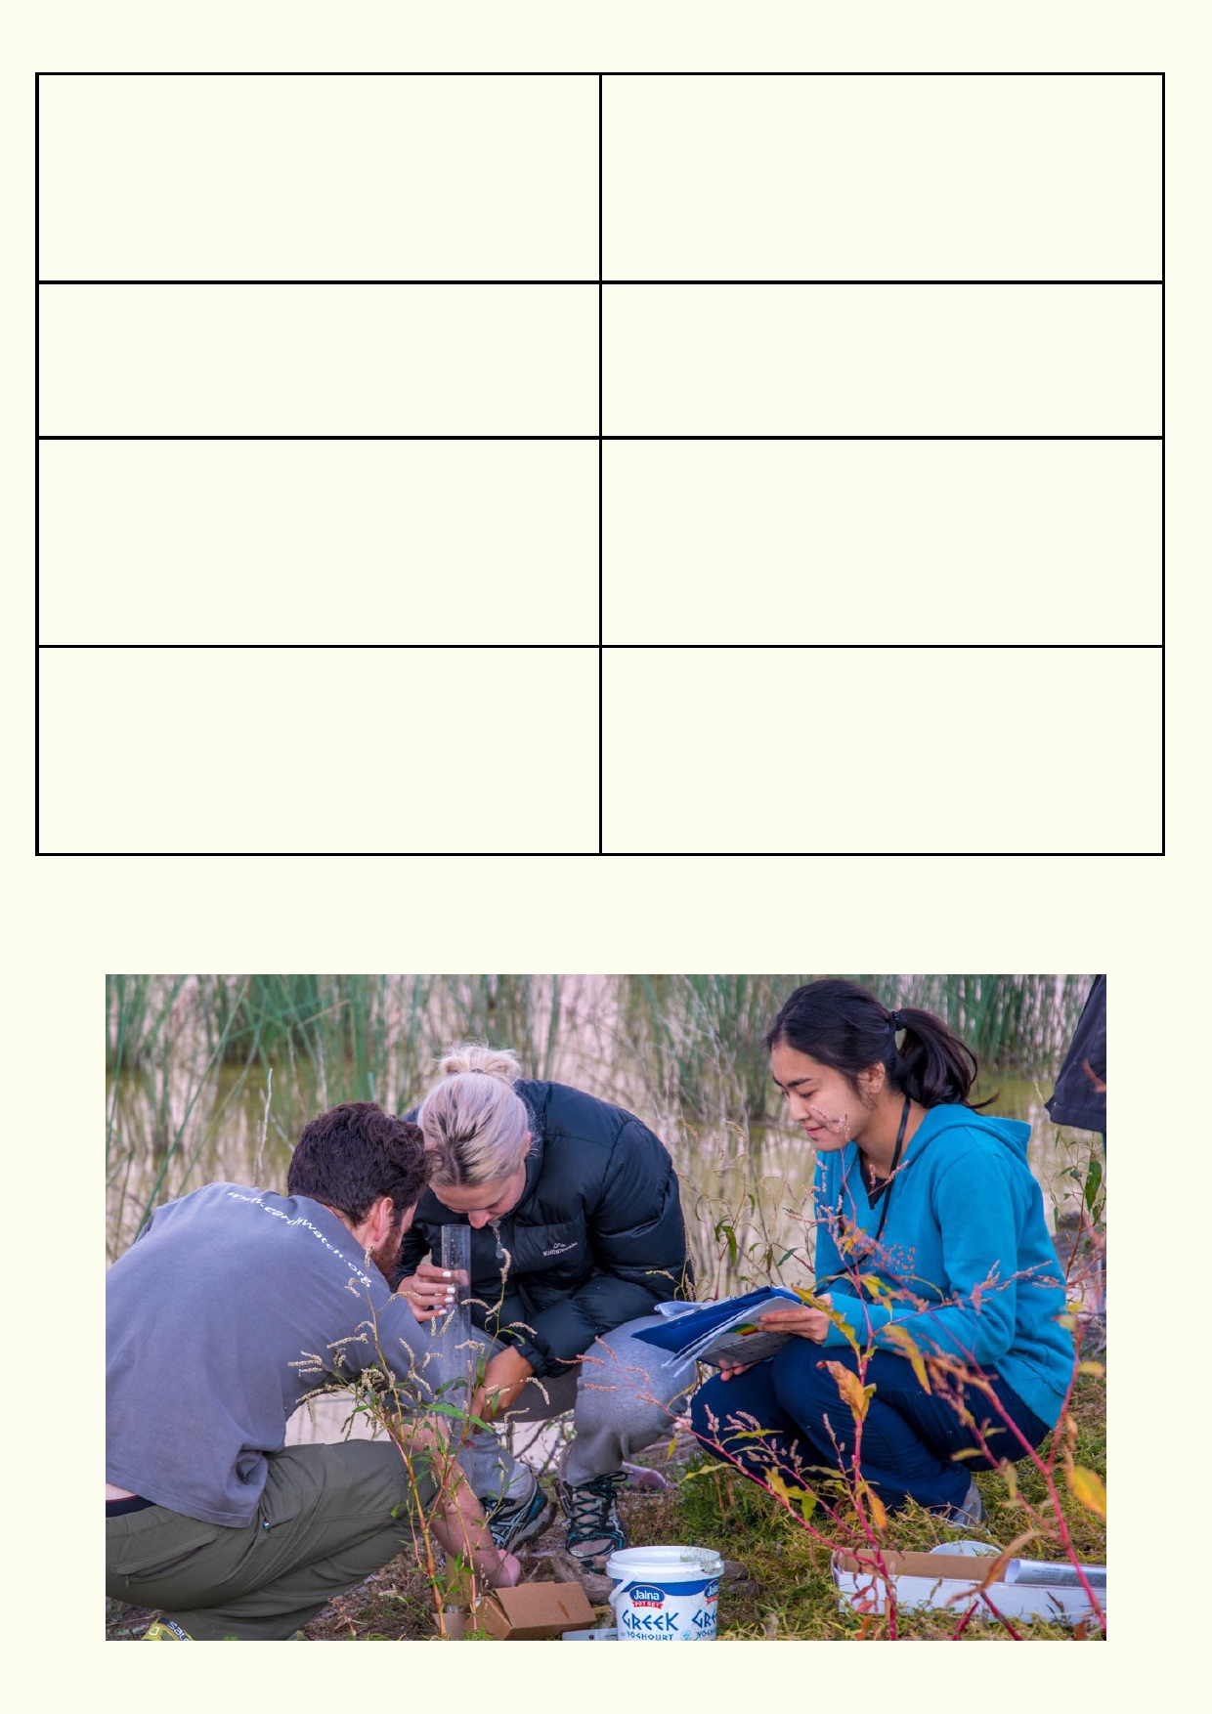Phosphates accelerate the growth of many
living things in a river. This in turn can use up all
the
oxygen in the water. When this happens, most of
the life in a river can die. Excess phosphorous
usually comes from fertilisers applied to crops or lawns.
Mercury is a dangerous heavy metal that can af-
fect our nervous system. It builds up in the food
chain so that larger fish can have dangerous
amounts when they live in mercury- polluted wa-
ters.
Flow is the amount of water passing along a
river. Flow is affected by rain, the amount of
water being released from aquifers, water being
stored in dams, clearing of land and human
structures like roads and buildings. Human
structures and clearings are likely to make floods more devastating.

Turbidity is the measure of how far light can
travel through water. Dirty-looking water has a
high turbidity and it is more difficult for aquatic
plants to grow. Turbidity will be highest after
heavy rain when the dirt and pollution has been
washed from our roads and buildings, as well as loose soil and sediment in the landscape.

19

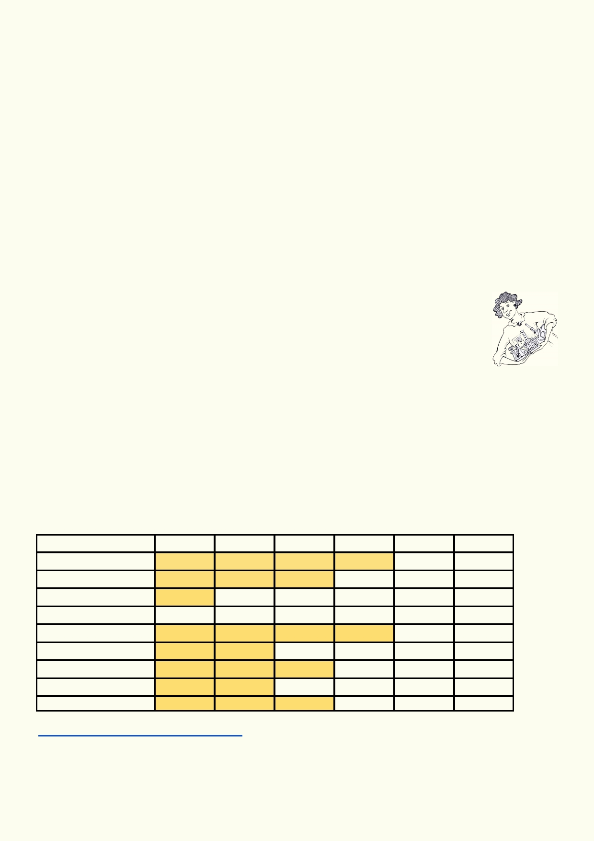Activity 3: Acid Rain

Air pollution also has a harmful effect on the bodies of water in our watersheds. Chemical com-
pounds such as sulphur dioxide and nitric oxide are released from fossil fuel-burning power plants
and vehicles. These compounds react with water vapour in the atmosphere to make something we
call "acid rain". This rain has a more acidic pH than water normally has.

Acid rain can travel far from the source of the pollution. Wind can blow the compounds in the air for hundreds of kilometers.

Effects of Acid Rain
Acid rain can kill trees. In the Black Forest in Germany, the loss of thousands of acres of trees due
to acid rain spurred the country to increase its use of solar and wind power. Acid rain also makes
it difficult for many animals to live in streams, lakes and wetlands. Also, when it enters the soil it
can cause larger amounts of aluminium to be released. This too can harm plants and animals.

Experiment:
Different plants and animals have different tolerance for acidic water. Sometimes a
species of animal can tolerate a higher amount of acidity than usual, but the organ-
ism that it eats cannot. This will also affect its survival.

In this experiment, you will test the pH of four different samples of water. Then you will determine which organisms would be able to survive in water that has that pH. You will use the table below to determine this.

pH is a measurement of how acidic or basic a water solution is.
1. pH 7 is neutral; it is neither an acid or a base
2. pH between 1 and 6 is acidic. pH of 1 is very strong acid. pH of 5 is a weak acid. 3. pH between 8 and 14 is basic. pH of 14 is a very strong base. pH of 9 is a weak base.

Aquatic animal sensitivity to water pH

Trout
Bass
Perch Frogs
Salamanders
Clams
Crayfish
Snails Mayfly

pH 4.0
dead
dead dead

dead
dead dead dead dead

pH 4.5
dead
dead

dead
dead dead dead dead

pH 5.0
dead
dead

dead

dead

dead

pH 5.5
dead

dead

pH 6.0

pH 6.5

Source of table:

http://www.lakescientist.com/acid-rain/

20

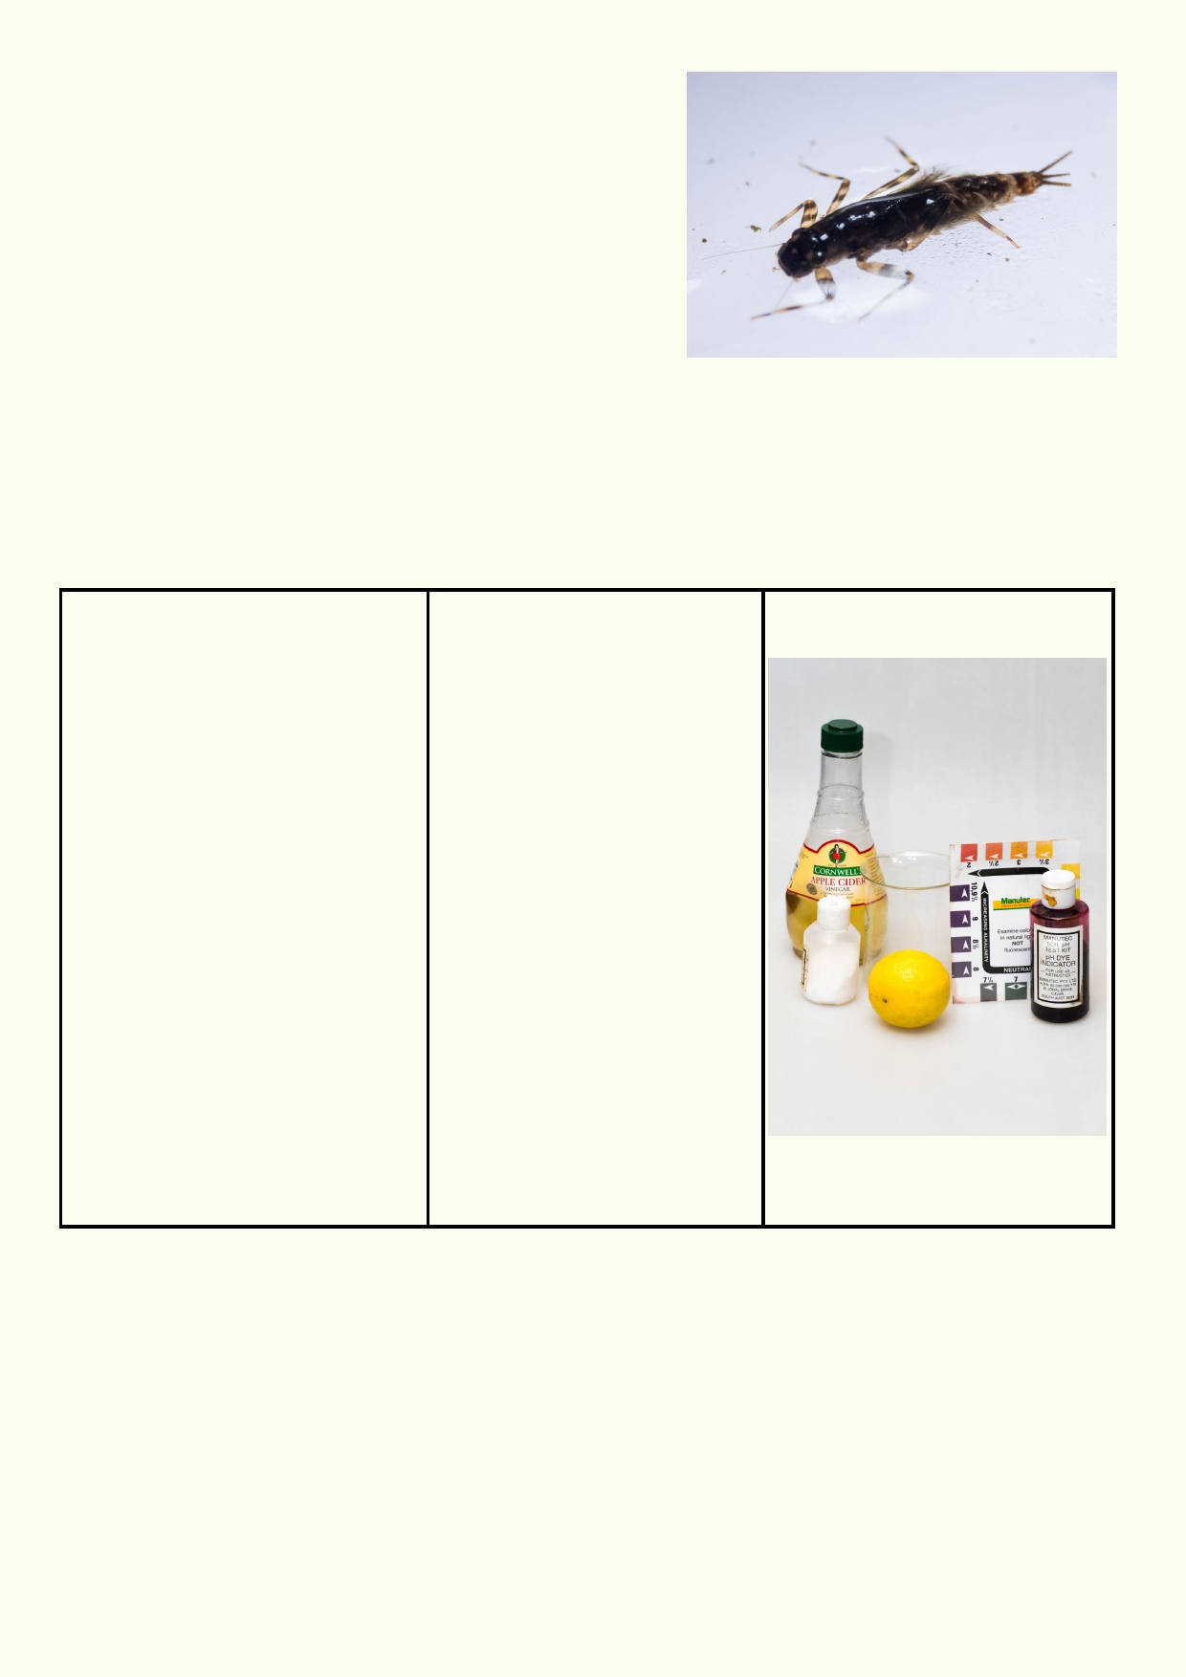Mayfly
Look at the table on page 20. It shows that the mayfly is
very sensitive to acidity. If there are mayfly in a river or
stream, what does this indicate about the acidity of the
water?

____________________________________________

___________________________________________

You will need a pH indicator for this experiment. A pH indicator has a chemical that changes
colour when it is exposed to acids or bases. For example, Litmus Paper turns red in strong
acids and blue in strong bases. Colour pH indicators only give us a general, approximate
measurement of the pH, or the strength of the acid or base but this is suitable for our purposes.

Experiment Test pH:
Which if any of the animals on the table on page 20 could survive in your lemon juice of vinegar
Materials: Method

•

•

••
•

Litmus paper or other pH paper with its colour chart
or
pH indicator solution with
its colour chart
Lemon juice
Vinegar
4 small beakers

1. Fill up one of the four
beakers with 150 ml of tap water.
2. Add 1 ml of lemon juice to
second beaker and fill up to a
total of 150 ml with tap water.
3. Add 2 ml of lemon juice to
third beaker and fill up to a
total of 150 ml with tap water. 4. Add 1 ml of vinegar to third
beaker and fill up to a total of
150 ml with tap water.
5. Test the pH of each of
these beakers and record. 6. Determine which of the
organisms in the table on
page 20 would be able to
survive in the pH of each of
your beakers of water.

solution?

Lemon ____________________________________________________________________

__________________________________________________________________________

Vinegar ___________________________________________________________________

__________________________________________________________________________

21

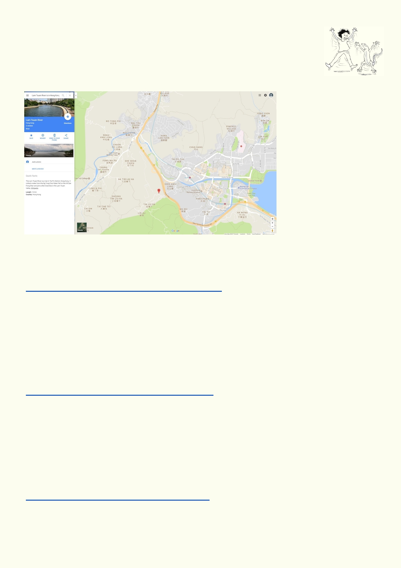Activity 4. Case Study: A Hong Kong River

Locate where the Lam Tsuen River is in Hong Kong by typing these words into
Google Maps search engine. You may need to expand the map and look for the
blue of the river on the map.

__________________________________________________

Use this website to find out which parts of the Lam Tsuen River appear more natural and which parts no longer look like a river.
http://www.greenpower.org.hk/river/eng/lamtsuens.asp

Where do the natural parts of the river occur?

_____________________________________________________________________________

Where do the concreted parts of the river occur?

_____________________________________________________________________________

How is the land being used along Lam Tsuen River? http://www.greenpower.org.hk/river/eng/landuse.asp

_____________________________________________________________________________

_____________________________________________________________________________

_____________________________________________________________________________

_____________________________________________________________________________

What are some of the sources of pollution along the course of this river?
http://www.greenpower.org.hk/river/eng/human.asp

_____________________________________________________________________________

_____________________________________________________________________________
22

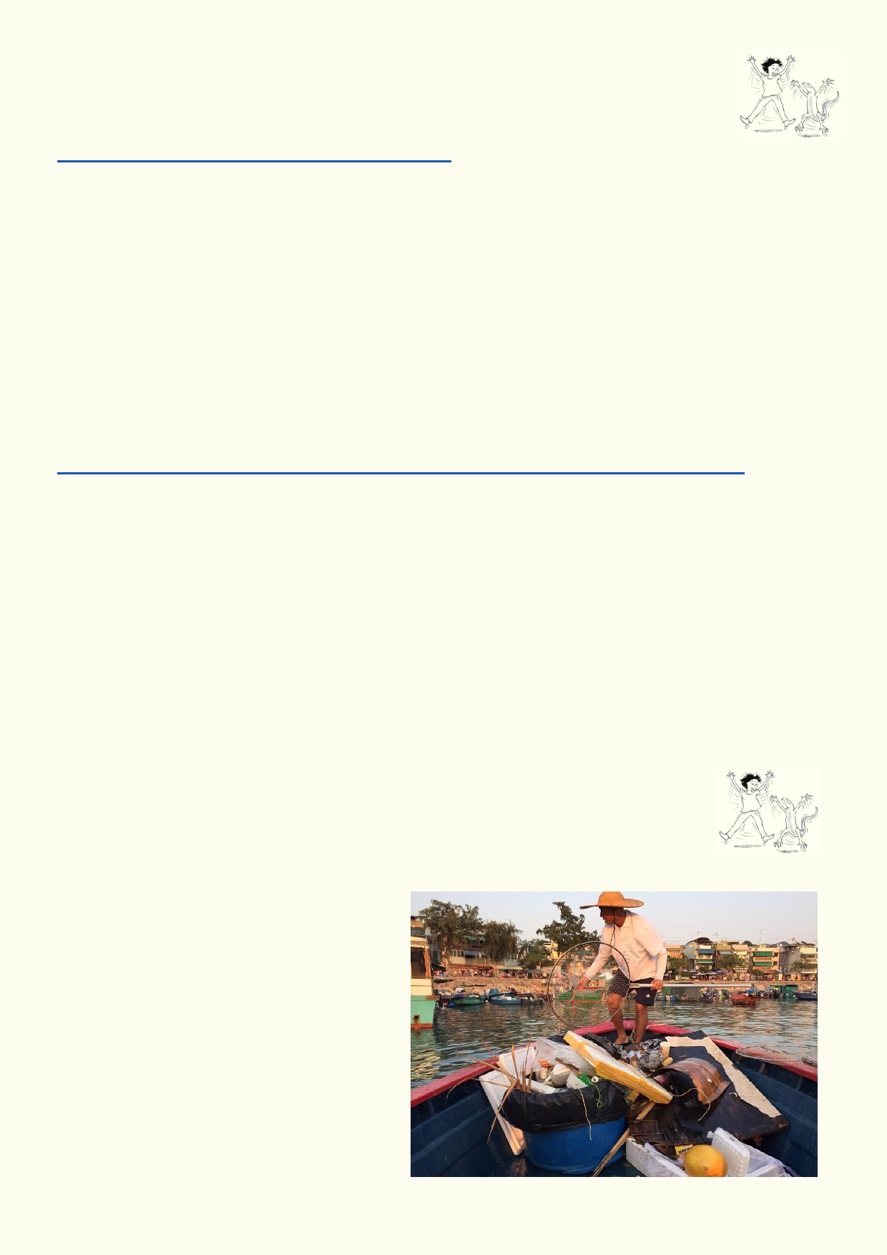Activity 5. Channelisation - is it the death of a river?

This video takes us on an aerial journey of the Shan Pui River from high up at the
Wong Nai Tun reservoir in Tai Lam to the sea:
https://www.youtube.com/watch?v=QLPPfsxDQf0

How does the river system change on its way to the sea?

_____________________________________________________________________________

_____________________________________________________________________________

What is channelisation?

_____________________________________________________________________________

_____________________________________________________________________________

Look at this online powerpoint:
http://www.legco.gov.hk/yr03-04/english/panels/ea/papers/eaplw0223cb1-1035-3-e.pdf

Which solutions do you agree with and why?

_____________________________________________________________________________

_____________________________________________________________________________

What would you do that is different from the recommendations?

_____________________________________________________________________________

_____________________________________________________________________________

Activity 6. Visiting one of the world's major rivers

What would it be like to visit one of these major rivers?
• Ganges watershed
• Pearl River Delta
• Tisza River
• Mississippi River
• Doce River in Brazil
• Citarun River in Indonesia
• Sarno River in Italy

23

Use Google Images to look at each of these rivers. Ignore the maps of these rivers displayed in
Google Images. Categorize the first 50 photos into the headings in the chart below. Tally the
number of photos for each category.
River Natural City, Farming Recreation Polluted
housing, and fishing
industry
Ganges
watershed

Pearl River
Delta
Tisza River

Mississippi
River
Doce River in
Brazil

Citarun River
in Indonesia

Sarno River in
Italy

Which two rivers looked like they would be enjoyable to visit?

_______________________________________________________________________________

Which two rivers do you think would have the greatest health risk for their communities?

_______________________________________________________________________________

Divide the rivers among your classmates.
In groups of two produce a short guide for tourists visiting one of the rivers. Do some more internet
research. Include in the guide:
1. Attractions of the river
2. Attractions of the local culture
3. Health precautions for visitors

Extension: Compare different places in the world in terms of water pollution/modification.
What factors are involved in making these pollution hotspots?

- Choose one of the rivers on the website below.
- Why have they been classified as one of the top 10 polluted rivers in the world?
- What has contributed to their pollution?
- You may need to do some more research using other websites.

https://soapboxie.com/social-issues/What-Are-the-10-Most-Polluted-Rivers-in-the-World

24

Lesson 3. Is there a perfect solution?

Solutions to watershed problems must be solved by people. Your community may not have much
knowledge about pollution in watersheds but will understand how flooding will impact on them.
Your community may want more done to prevent flooding.

Activity1. Values activity - Control flooding

In this "values activity" you will compare your values with those in your
class. If there is room in your classroom, you will move across the room
and stand in the area that you think expresses best how you feel. Where you stand will
depend on how strongly you agree or disagree with a particular statement. If you are not
sure or don't have enough information, you will stand in the middle. As you move to your
position, ask those around you what they are thinking. When the teacher asks some of the
students why they are standing in a certain position you may feel you want to change where you
stand. You have the chance to do so. You are encouraged to clarify your views as you learn
more from other students' point of view.

Our urban environment must be protected ftom all flooding.

Strongly agree Strongly disagree
I____________________I____________________I___________________I__________________I
Our urban environment must only be protected from flooding if the protection work does not
destroy the river's environment.
Strongly agree Strongly disagree
I____________________I____________________I___________________I__________________I
We should allow places to flood where streets and buildings have been constructed in
inappropriate places.
Strongly agree Strongly disagree
I____________________I____________________I___________________I__________________I
The priority is to protect the river environment and not worry about flooding.

Strongly agree Strongly disagree
I____________________I____________________I___________________I__________________I
We should work with nature to reduce flooding and restore our rivers.
Strongly agree Strongly disagree
I____________________I____________________I___________________I__________________I
It's not possible to have natural rivers and no flooding.
Strongly agree Strongly disagree
I____________________I____________________I___________________I__________________I

It's not possible to prevent all floods.
Strongly agree Strongly disagree
I____________________I____________________I___________________I__________________I

25

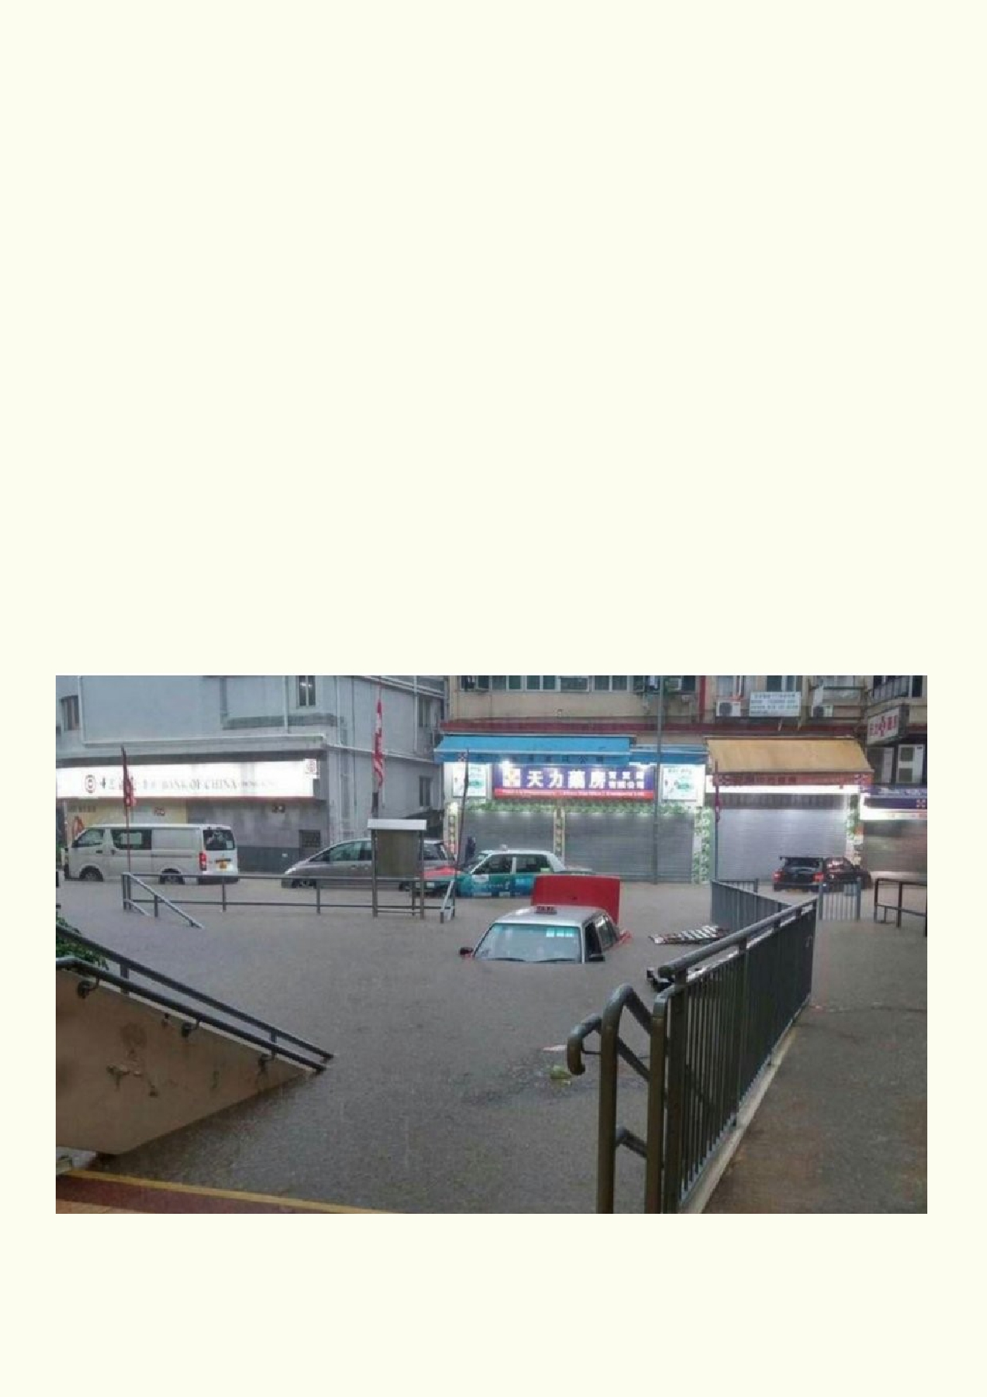Governments should get blamed when there is a flood of a city or urban area.
Strongly agree Strongly disagree
I____________________I____________________I___________________I__________________I

We can find better ways of looking after a river's environment and also reduce the impact of flooding.
Strongly agree Strongly disagree
I____________________I____________________I___________________I__________________I

Did you change your opinion about this same statement after thinking about all the other issues?
Our urban environment must be protected from all flooding.
Strongly agree Strongly disagree
I____________________I____________________I___________________I__________________I

How did you change your opinion, if you did so?

_______________________________________________________________________________

_______________________________________________________________________________

Source: South China Morning Post http://www.scmp.com/news/hong-kong/health-environment/
article/2095537/hong-kong-grinds-halt-amid-rainstorm-leaves-social

26

Activity 2. My opinion

Some of our opinions are very personal and have no effect on others. However some
activities we might be involved in can have a great impact on others. While smoking
will affect personal health, it also has negative effects on those nearby.

In the chart, decide what your opinion is on each of the questions. Can personal opinions about
the questions affect other people?

Question

My favourite music is

My favourite food is

Should smoking should be
banned in all public places?

What punishment should violent
people be given?

How should we fix up the envi-
ronment?

Students should be given a job
for six months when they leave
school.

Should cars be taken away from
dangerous drivers?

No new people should be allowed
to live in Hong Kong.

What is something you would like
banned?

Schools should teach students
how to drive cars.

Meat should be taxed so fewer
pigs, cattle and sheep take up the
land and cause pollution.
Heavier punishments are needed
for those who pollute.

My opinion

Would lots of people
with this opinion
affect other people?

27

Activity 3. Do I need evidence?

Class discussion
There are many crime shows on TV that use
forensic science as part of the plot. How much
evidence would be required to convict someone of murder?
What is the best form of evidence in a murder case? Would the
trial require every kind of possible evidence to prove the case?

Not everyone agrees that climate change is caused by greenhouse gases produced by humans.

What do you think can be used as evidence for and against humans causing climate change:

_____________________________________________________________________________

_____________________________________________________________________________

_____________________________________________________________________________

_____________________________________________________________________________

_____________________________________________________________________________

When the class gets together, discuss the evidence available for and against human-induced climate change.

What evidence do you think you would need to show that greenhouse gases can change the
climate?

____________________________________________________________________________

____________________________________________________________________________

____________________________________________________________________________

____________________________________________________________________________

What does the Hong Kong Government think about its responsibility towards climate change?
https://www.climateready.gov.hk/

_____________________________________________________________________________

_____________________________________________________________________________

_____________________________________________________________________________

28

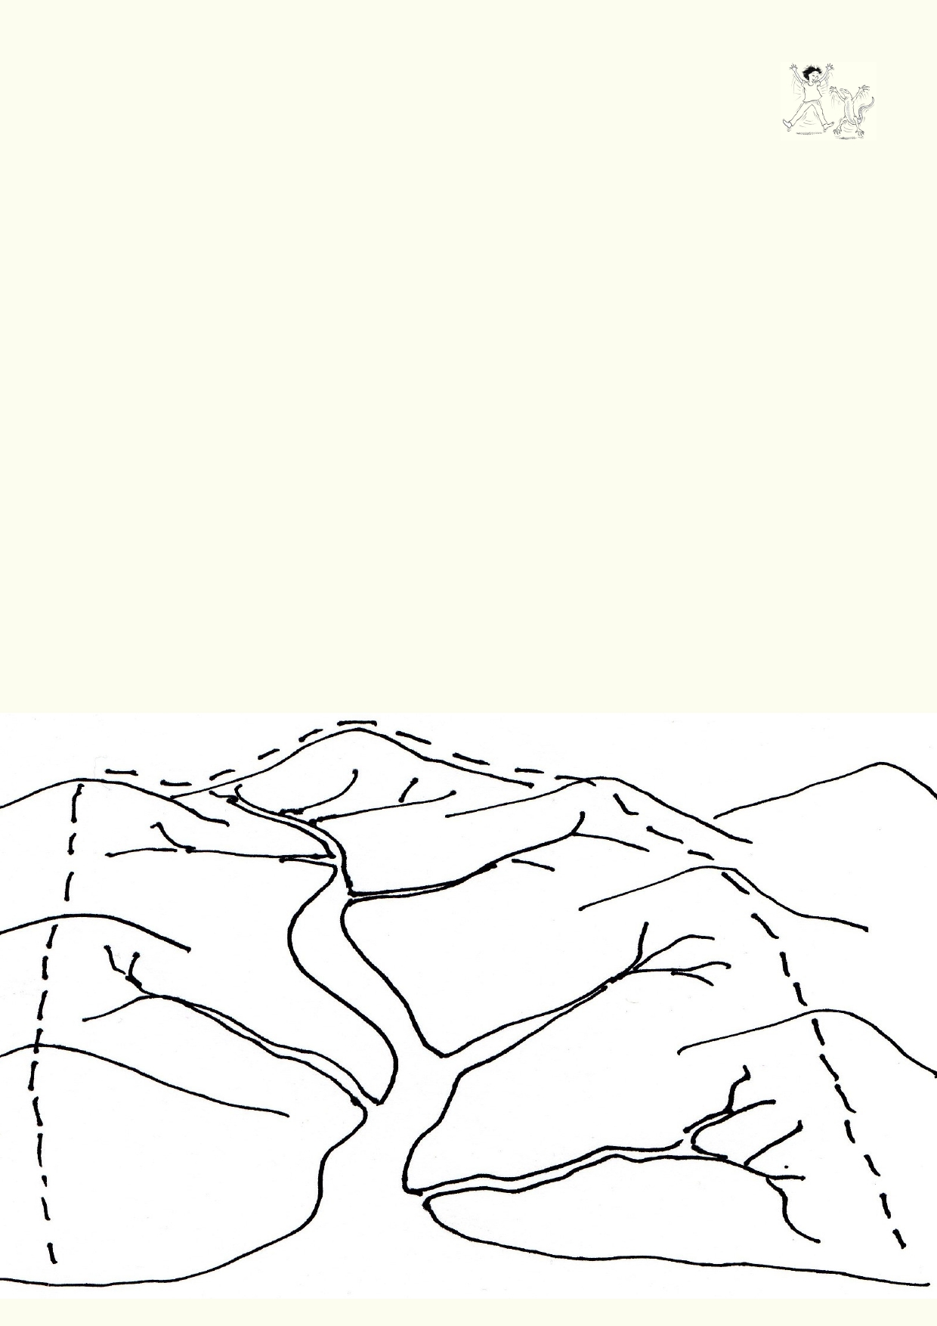Activity 4. Managing a watershed

You have a map of a watershed. The map is blank except for the streams, rivers and
the coast. How would you plan the watershed to provide, housing, work, food for a
large population while also protecting the most sensitive parts of the watershed?

• The map is small so you could make a larger copy or have less detail on the small map.
• Decide if you will illustrate the map or use shading.
• Decide if you will label the map, use a legend or rely on your illustrations.

Which criteria would you use in managing a watershed?

Use the drawing below to plan how you would manage a Hong Kong watershed. How could
water be obtained while protecting the environment? How will wastewater be treated and
disposed?

1.

2. 3.

4. 5.
6.
7.
8.
Draw where you would place dams, a city, 2 towns, agriculture and some industry. You
may want to include 1 port, 2 to 3 main roads and a train line.
The plan for the watershed should be environmentally friendly.
You need to include living space for people's homes and places where they work, shop and
have recreation.
The steep hills are prone to landslip if they are cleared.
A major road is needed to link up with other towns and public transport is required.
The river and coastal area is environmentally sensitive.
Show where the water for the town is coming from and what happens to all waste water.
Labels can be used, but are not necessary.

29

Discuss as a class if it is easier to look after a watershed if people live in high-rise apartments or
if they are spread out in smaller buildings.

Activity 5. Is this a good project?

Look at the project that is being done on the Shing Mun River.
http://www.epd.gov.hk/epd/english/news_events/current_issue/shingmunriver.html

After reading about the project, provide your opinion about what the positive and possible negative aspects of the project are.

Positive aspects of the project Negative aspects of the project

Explain why on balance this is a good project or an inappropriate project:

_____________________________________________________________________________

_____________________________________________________________________________

_____________________________________________________________________________

Extension:
Organize a debate based on the questions above. Have teams divided up and provide the
format of: a) opening statement b) argument c) rebuttal d) closing remarks.

Speakers deliver 2 minute, timed speeches in strict order. NO extra time allowed.

30

Speakers Order (2 minutes each)

Speaker Time Who What Details

1 2 min PRO Introduction Main thesis, we are go-
ing to show you, define
topic

2 2 min CON Introduction Main thesis, we are go-
ing to show you, define
topic

3 2 min PRO List Proof Supporting facts, statis-
tics, quotes

4 2 min CON List Proof Supporting facts, statis-
tics, quotes

5 2 min PRO Rebuttal to other Prepared counter argu-
gr oup ments, quotes, facts, on
your feet response to
speakers 2 and 4

6 2 min CON Rebuttal to other Counter arguments,
gr oup quotes, facts, on your
feet response to speak-
ers 1 and 3
7 2 min PRO Final Summary Last chance at re-
rebuttal, summing up.
last appeal

8 2 min CON Final Summary Last chance at re-
rebuttal, summing up.
last appeal

31

Lesson 4 - We can't do this alone

Activity 1. Our government and their agencies

Use these websites to help understand how the Hong Kong Government takes responsibility for protecting the environment.
https://www.gov.hk/en/residents/onlineservices/
http://www.epd.gov.hk/epd/english/laws_regulations/laws_maincontent.html
http://www.epd.gov.hk/epd/english/laws_regulations/enforcement/laws_eflhk.html

Identify and record five ways the Hong Kong government protects the watershed. Include what is being monitored.

1. ___________________________________________________________________________

2. ___________________________________________________________________________

3. ___________________________________________________________________________

4. ___________________________________________________________________________

5. ___________________________________________________________________________

Who makes sure that the public and businesses obey the regulations?

_____________________________________________________________________________

_____________________________________________________________________________

Activity 2. Working together

There are many Hong Kong organisations run by the community (non-
governmental organizations) that also have activities that protect and restore the
environment. Choose one organisation from this list or find another on the
internet that cares for the Hong Kong environment or environments in other
places.

Ocean Recovery Alliance
http://www.oceanrecov.org/
River Net (Greenpower)
http://www.greenpower.org.hk/river/eng/index.asp
Conservancy Society Hong Kong
https://www.cahk.org.hk/
Environment Campaign Committee
http://www.ecc.org.hk/english/index.html
Green Council
http://www.greencouncil.org/eng/index.html

32

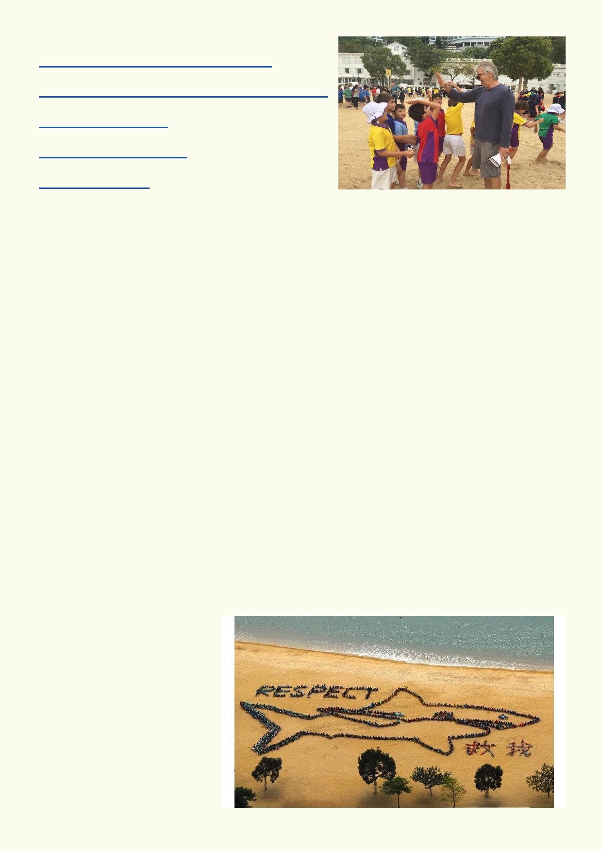Green Council
http://www.greencouncil.org/eng/index.html
Friends of the Earth Hong Kong
http://www.foe.org.hk/c/default.asp#.WUDdKeuGMuU
Earth Care Hong Kong
http://www.earth.org.hk/
Ocean Recovery Alliance
http://www.oceanrecov.org/
Hong Kong Cleanup
http://hkcleanup.org/

Name of the organisation _________________________________________

What activities does the organisation do to prevent environmental damage?

_____________________________________________________________________________

_____________________________________________________________________________

_____________________________________________________________________________

What activities does the organisation do to improve the environment?

_____________________________________________________________________________

_____________________________________________________________________________

_____________________________________________________________________________

Which of their activities helps watersheds?

_____________________________________________________________________________

_____________________________________________________________________________

Report back to the class with your research.

33

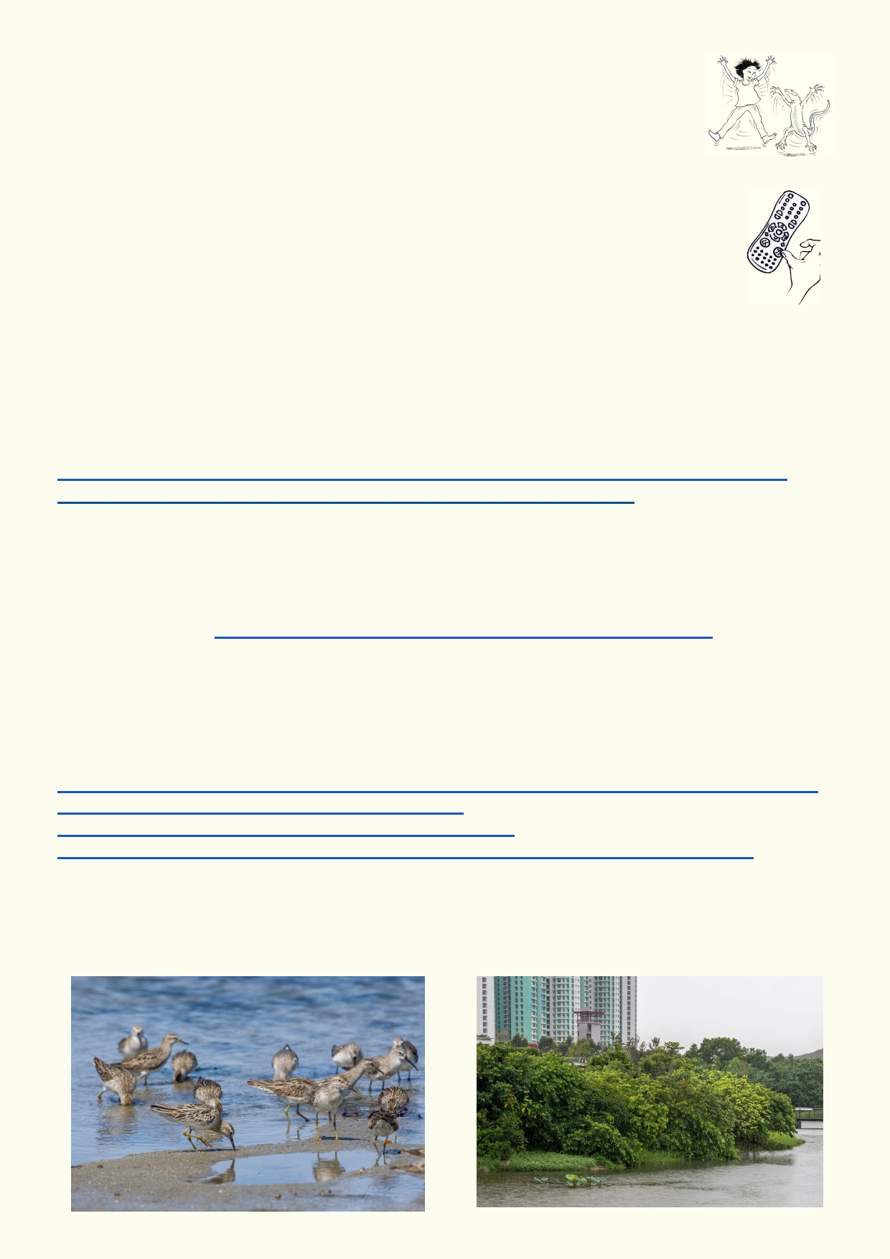Activity 3 - Now I Know Better

Return to the first activity called What do I know?
Add information and make changes to what you initially wrote. Get into small
groups of four and discuss how your ideas about watersheds have changed.

Activity 4. Looking forward

Plan a project about your local stressed-out watershed. Get into small teams. Choose
one of these three projects or come up with your own project. Project ideas might
include:

Oral history of your watershed
Put together your community's ideas about the problems with your watershed and how your
watershed has changed. Conduct interviews using a combination of video, photographs and
record audio, etc. For example, ask people what they are fishing, how the area looked some
years ago, how the area could be improved, etc. These websites will help in recording oral
history.
https://museumvictoria.com.au/education/learning-lab/history-skills/creating-a-digital-history/
https://storycorps.org/discover/storycorpsu/effective-interview-questions/

Re-designing your local area
Choose a local area that includes local rivers or other water habitats. Make plans to redevelop the area. What parts of the area would stay as it is? What parts could be changed? How could
the rivers and channels be improved? Is there room for more parks? See Hong Kong's landscape
planning summary. http://www.hkip.org.hk/En/Content.asp?Bid=7&Sid=25&Id=151

Migratory waders
Find out what is special about migratory waders. Investigate where migratory waders would feed
and rest in your local catchment. Are their feeding grounds vulnerable to development, boating
or other human activities? How can the area be better protected? Can more wader habitat be
created?
http://www.wwf.org.hk/en/news/_m.cfm?2680/A-New-Chapter-Opens-on-Wader-Migration-Research-in-Hong-Kong
http://awsg.org.au/wader-flagging/migration-routes/
http://birdlife.org.au/documents/Shorebirds-FactSheet.pdf
http://news.nationalgeographic.com/2015/09/15092-plastic-seabirds-albatross-australia/

34

Acknowledgements
The Ocean Recovery Alliance thanks The Hong Kong Jockey Club Charities Trust for their
generous funding support on this education programme.

Project manager: Doug Woodring
Writer, photography and design : Bob Winters
Curriculum manager and editor : Charlotte Charny Nielsen
Editor and school outreach: Alex Hale
Additional thanks: Jasmine Nunns and Sandra Merazzi

© 2017 Ocean Recovery Alliance and Authors.
Outside the school environment, the text, photos and artwork may not be reproduced, except
where permitted by the relevant Copyright Act. These materials may not be modified and
distributed by print or electronic means without written permission. Teachers may modify these
education materials for the use of their students and school provided it is not distributed any
further. Those wishing to reproduce part of this publication must submit their application to the
Ocean Recovery Alliance: www.oceanrecov.org/contact-us.html

35

