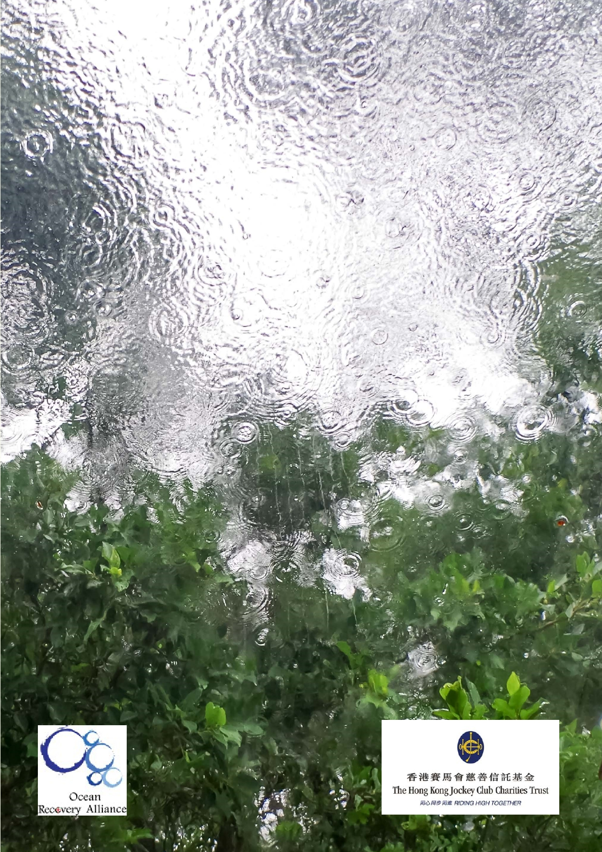Jockey Club Water Caretakers of
Tomorrow Programme
Miraculous Water - Unit 1

Organised by

Funded by

1

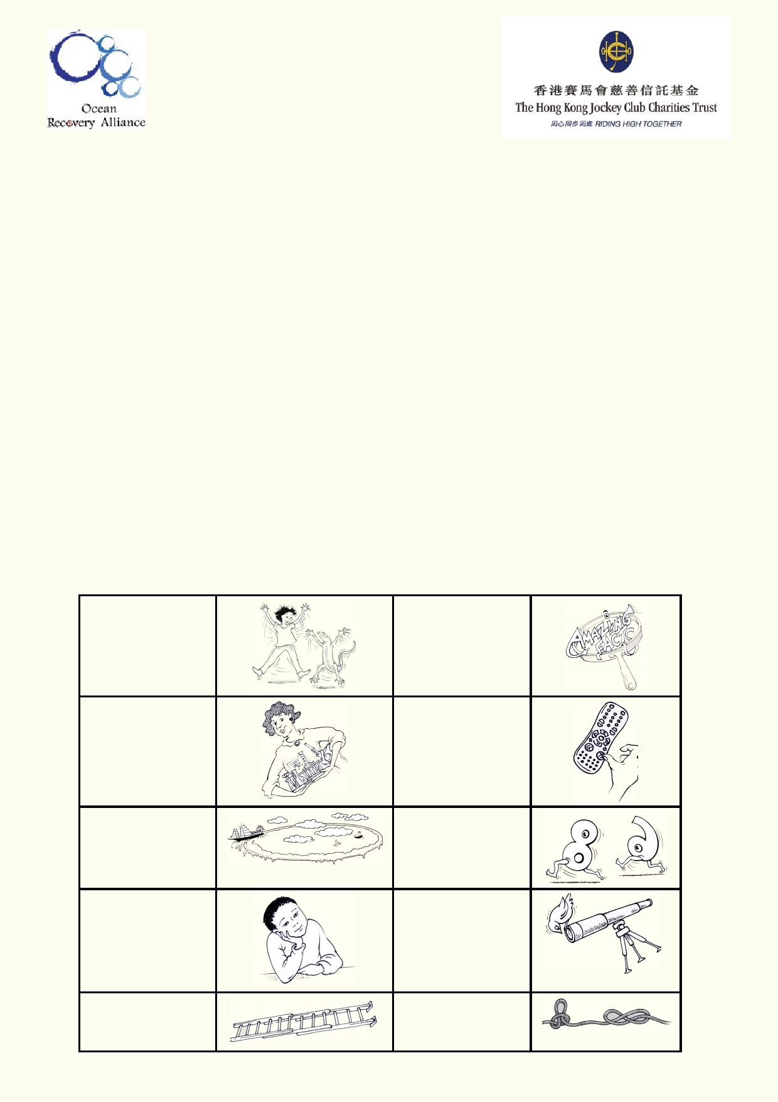About The Jockey Club Water Caretakers of
Tomorrow Programme:

Jockey Club Water Caretakers of Tomorrow Programme is organised by Ocean Recovery
Alliance, Ltd and funded by The Hong Kong Jockey Club Charities Trust. There are eight units in
this program, and each of them is designed with you, a student in Hong Kong, in mind.

These are the goals for your lessons, to:
• Understand and appreciate how our water systems function on a local and global scale.
• Understand how watersheds function, and the interconnections of life within and between
these watersheds.
• Be able to assess threats, such as pollution and habitat destruction, and learn how to
lessen these effects.
• Be empowered to take an active role as caretakers of our water resources by sharing your
commitment with your communities.

Student introduction
• You will need access to the internet.
• In some activities using the camera in your smart phone or tablet will be useful.
• Your teacher will tell you if you if your work will be done on your computer, printed paper or
notebooks.

Start of a new A new amazing activity. f act .

Get ready to do an experiment.

Identify your
misconceptions
before your move on.
Identify your
prior learning.

An extension
activity

Fast forward to
make your
contribution to improving our world.
Data will be used
to solve
problems.

These are the goals for this unit.

A cross-
curricular
activity

2

Student Aims

At the end of this Unit on Miraculous Water, I will be able to:
• Describe the main physical and chemical properties of water
• Use experimental methods to demonstrate the properties of water
• Define the role of water in the environment
• Apply my knowledge of the water cycle

Glossary

Aquifer

Cohesion

Condensation

Dissolve

Erosion

Evaporation

Evapotranspiration

Freshwater storage

Gas

Groundwater

Groundwater
discharge

Humidity

Infiltration

Liquid

Permeable/
Impermeable

Underground layer that stores water and lets water flow through it.

Sticking together of particles of the same substance.

Process of water vapour (gas state) turning into droplets (liquid state).

Process by which a substance mixes evenly into a liquid.

When landforms on the surface of the Earth get broken down and the
smaller fragments are transported away by wind, water and other
natural processes.

The changing of a liquid into a gas.

The process by which water evaporates into the atmosphere from land,
water and plants.

A large enclosure that stores freshwater, e.g. a dam.

A substance that keeps expanding until it fills a space.

Permanent water stored in the ground.

Where groundwater comes back to the surface via a spring or filling a
lake and when people pump water from the ground.

The amount of water vapour in the atmosphere. Warmer air can hold
more vapour.

The filtering of water into the soil and rocks.

A substance that flows freely which has a constant volume. It takes the
shape of its container.

Permeable - a material or substance that allows liquid or gas to pass
through.
Impermeable - a material or substance that is a barrier and stops a
liquid or gas passing through.

3

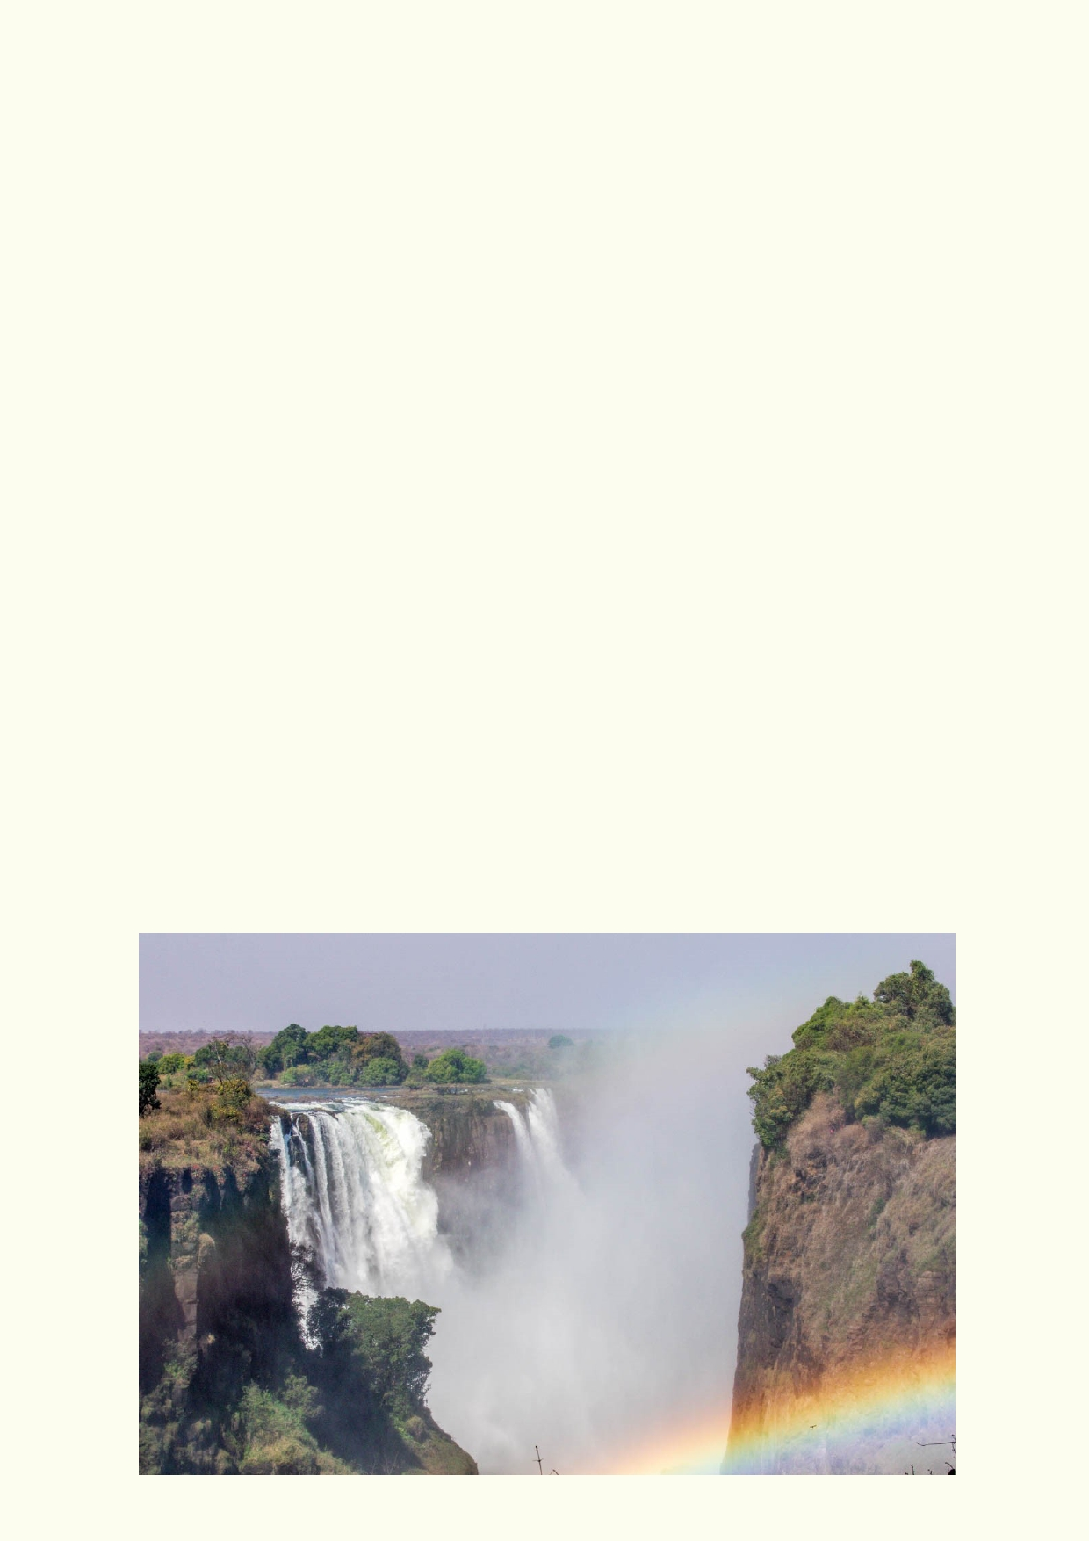Polarity

Precipitation

Runoff

Sediment

Solution

Sublimation

Suspension

Turbidity

Water cycle

Water table

Watershed
A molecule or object that has different magnetic or electrical charges
over itself.
Any type of liquid or solid water that falls to Earth, such as rain, snow
and hail. Also is the process of a substance settling out of a solution.
The draining away of water (and materials dissolved within it) from the
surface of the land.
Small fragments of solid materials such as silt, sand, gravel, carried by
water or air that settle in water or on the ground.

A mixture in which particles of one or more substances (the solute) are
distributed evenly throughout another substance (the solvent).

The process by which a solid turns into a gas without passing through
the liquid state, e.g. frozen carbon dioxide.

A mixture containing a liquid, in which visible particles slowly settle due
to gravity.

Measurement of how clear a liquid is. Particles in a liquid prevent some
or all of the light from passing through. This is a key test of water
quality.

Describes how water moves on Earth, due to weather, evaporation,
rain, etc.

The highest part in the ground that is saturated (completely filled with
water).

The boundary of land that marks where the passage of water will drain

4

What do I know?

Water Interview
• Get into groups of two.
• The first student asks the
other student the first three questions.
• The first student records the answers.
• Then the second student asks the first
student the next three questions and
records their answers.

1. Why is Earth called the water planet?

__________________________________________________________________________

__________________________________________________________________________

2. What is so unusual and special about water compared to other substances on Earth?

__________________________________________________________________________

__________________________________________________________________________

3. Where is most of the Earth's freshwater found?

__________________________________________________________________________

__________________________________________________________________________

4. What is evaporation? What causes it on Earth?

__________________________________________________________________________

__________________________________________________________________________

5. What is groundwater and why is it important?

__________________________________________________________________________

__________________________________________________________________________

6. Why does some water run over the ground, seep into the ground or pool on the ground?

__________________________________________________________________________

__________________________________________________________________________

5

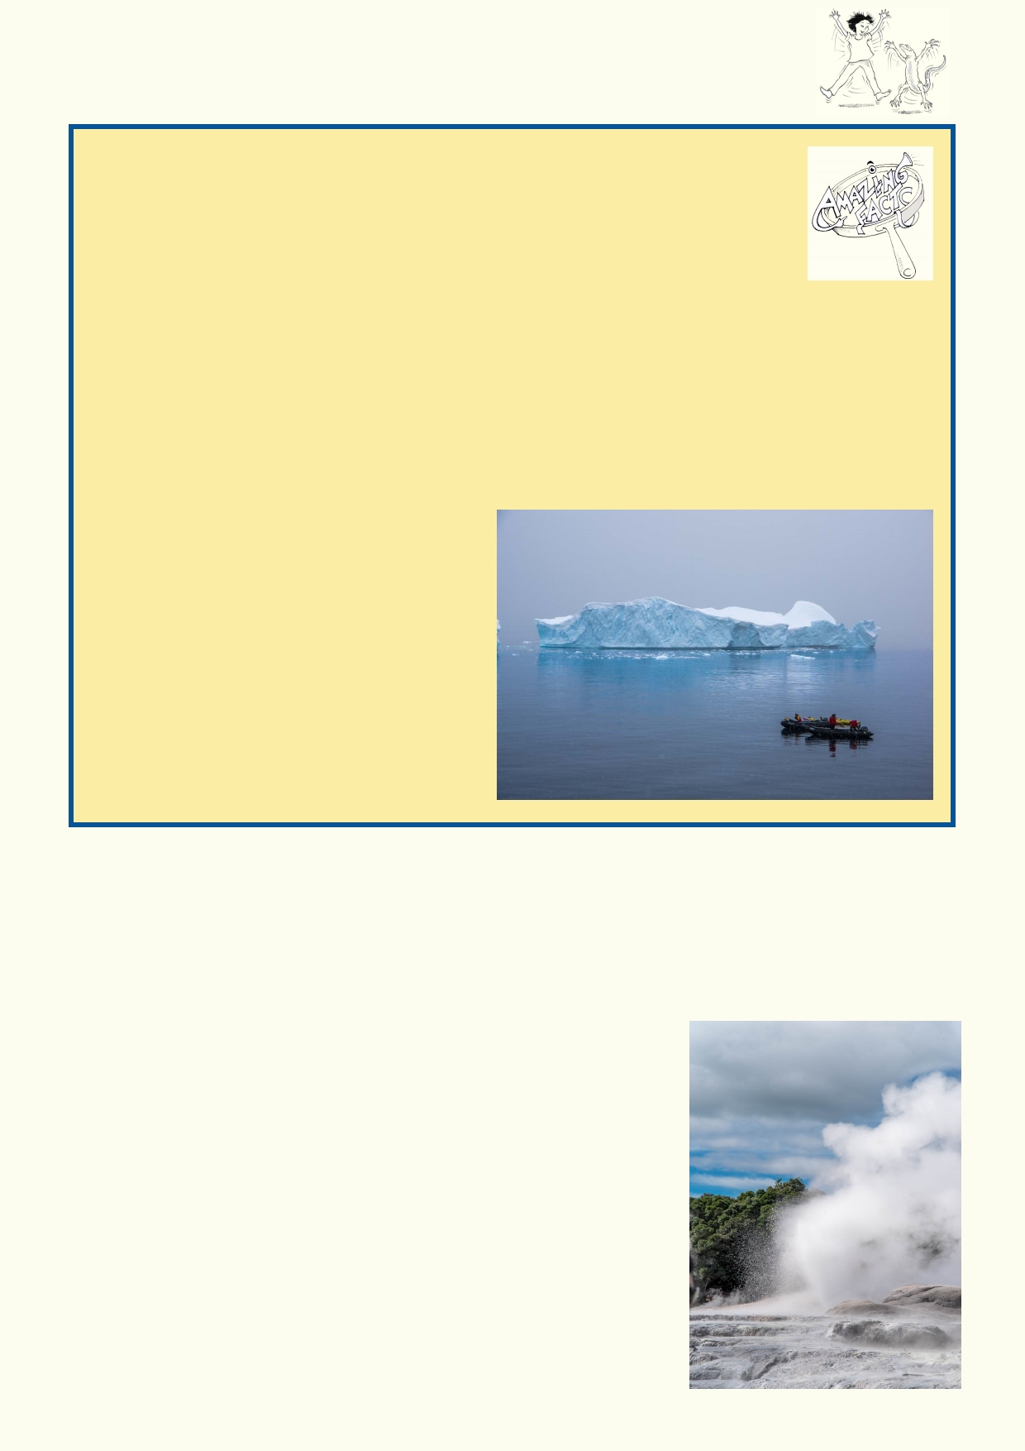Lesson 1 - Water is amazing

Amazing facts

• More than 50% of your body is water and your brain is 70% water.
• 1 cubic centimetre of water weighs exactly 1 gram. A cubic meter of water
weighs a ton but only at sea level and at a temperature of 17 degrees.
• Water contracts as it gets colder and then below 4 degrees it starts to
expand.
• Ice is less dense than water so it floats. If ice didn't float, the bottom of our seas and
oceans would be solid ice.
• A faucet dripping one drop per second will use almost 10,000 litres in a year.
• Worldwide, polluted water kills around 200 children an hour.
• In the USA, to grow the food for a family of 4 for a day requires up to 3,000 litres of water.
• Steel ships float because their weight is less than volume of water they float in because
the ship is hollow and full of air. So,
when a ship gets a leak, the water
rushing in makes the ship heavier.
• Water in the atmosphere is a
greenhouse gas, keeping the planet
warmer.
• Some types of clouds can hold the heat
below them, adding to the global
warming while other clouds can reflect
heat back into space, reducing the
impact of global warming.

Search the internet for three more amazing facts about water. You could use search words such as "water amazing facts". Share your amazing facts with the class.
1. ________________________________________________________________________

__________________________________________________________________________

2. _______________________________________________

_________________________________________________

_________________________________________________

3. _______________________________________________

_________________________________________________

_________________________________________________

6

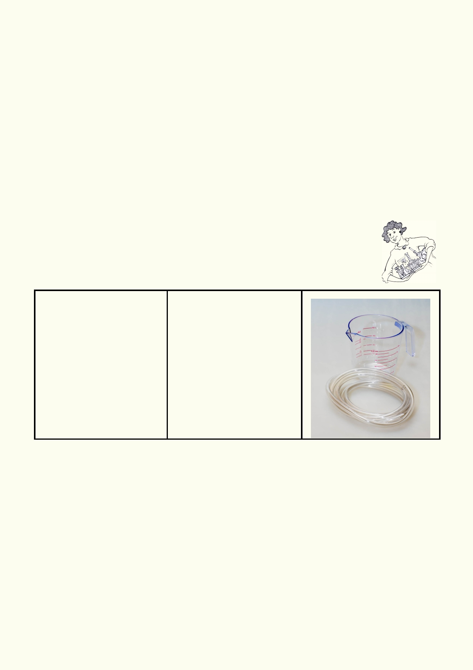Water is the only substance on Earth that naturally occurs in all three states:
• Liquid: People think of water as a liquid. A liquid flows and takes the shape of its container.
Gravity will force water to flow to the lowest level.
• Gas: We have different names to describe water as a gas. We call it steam when it is very
hot, and water vapour and humidity at normal temperatures.
• Solid: When water freezes we call it ice. Ice has unusual properties. It is less dense than
water so it floats.

Conducting experiments

1.
2.
3.
4. 5.

6. 7.
Read through the setup for the experiment.
Record your prediction for the outcome of the experiment.
Gather the materials that are needed.
Find a suitable location to conduct the experiment.
Review all safety requirements including handling glassware safely and using heat and
heated substances. Ask your teacher if you are not sure. Report any accidents.
Record your observations as you complete the experiment.
Clean and return equipment.

Activity 1: Physical properties of water experiments - Liquid Water

Experiment: Gravity affects water

Materials: Method

•

•

60 cm clear plastic
tubing
Water, up to 100ml
1. Half fill clear plastic hose
with water. Note the water
level on each side of the
tube.

Place where it doesn't matter
if some water is spilled.

Prediction:
2. Raise and lower each end
of the tube and note what
happens to the water levels
at both ends.
3. How will you get the water
out of the tube?

__________________________________________________________________________

Observation:
__________________________________________________________________________

__________________________________________________________________________
Explanation:
__________________________________________________________________________

__________________________________________________________________________

7

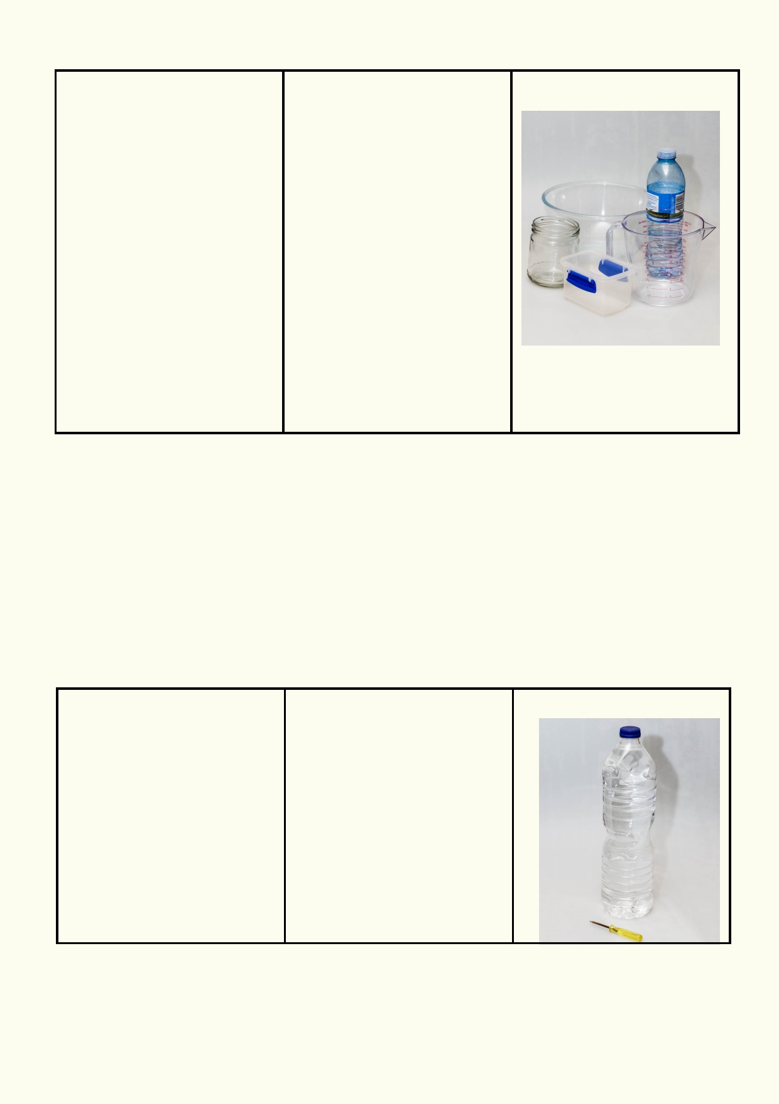Experiment: Changing shape
Materials: Method

• Different shape 1. Measure a volume of water.
containers that are 2. Pour this water in different
waterproof shaped containers.
• Measuring jug or large 3. Tip the container by a small
beaker angle.
• Supply of water 4. Tip the container by a large
angle over another container.
5. Find out if the shape
changes if you use a larger or
smaller volume of water.
6. Observe how the water
occupies the container.
7. Observe the surface of the
water when the container is
tipped.

Prediction:
__________________________________________________________________________

Observations:
__________________________________________________________________________

__________________________________________________________________________
Explanation:

__________________________________________________________________________

Experiment: Water pressure
Materials: Method

•

Plastic bottle with two small holes, one hole
near the top and one
near the bottom

1.Pour water into bottle.

2.Observe how the water
flows out of the holes.

(discuss with teacher how to
safely make two small holes).

3.Explain how the weight of

•
Water - enough to fill the
container e.g. 1 l of
water for a 1 l container.
the water above affects the
flow out of the lower hole.

Prediction:
__________________________________________________________________________

__________________________________________________________________________

8

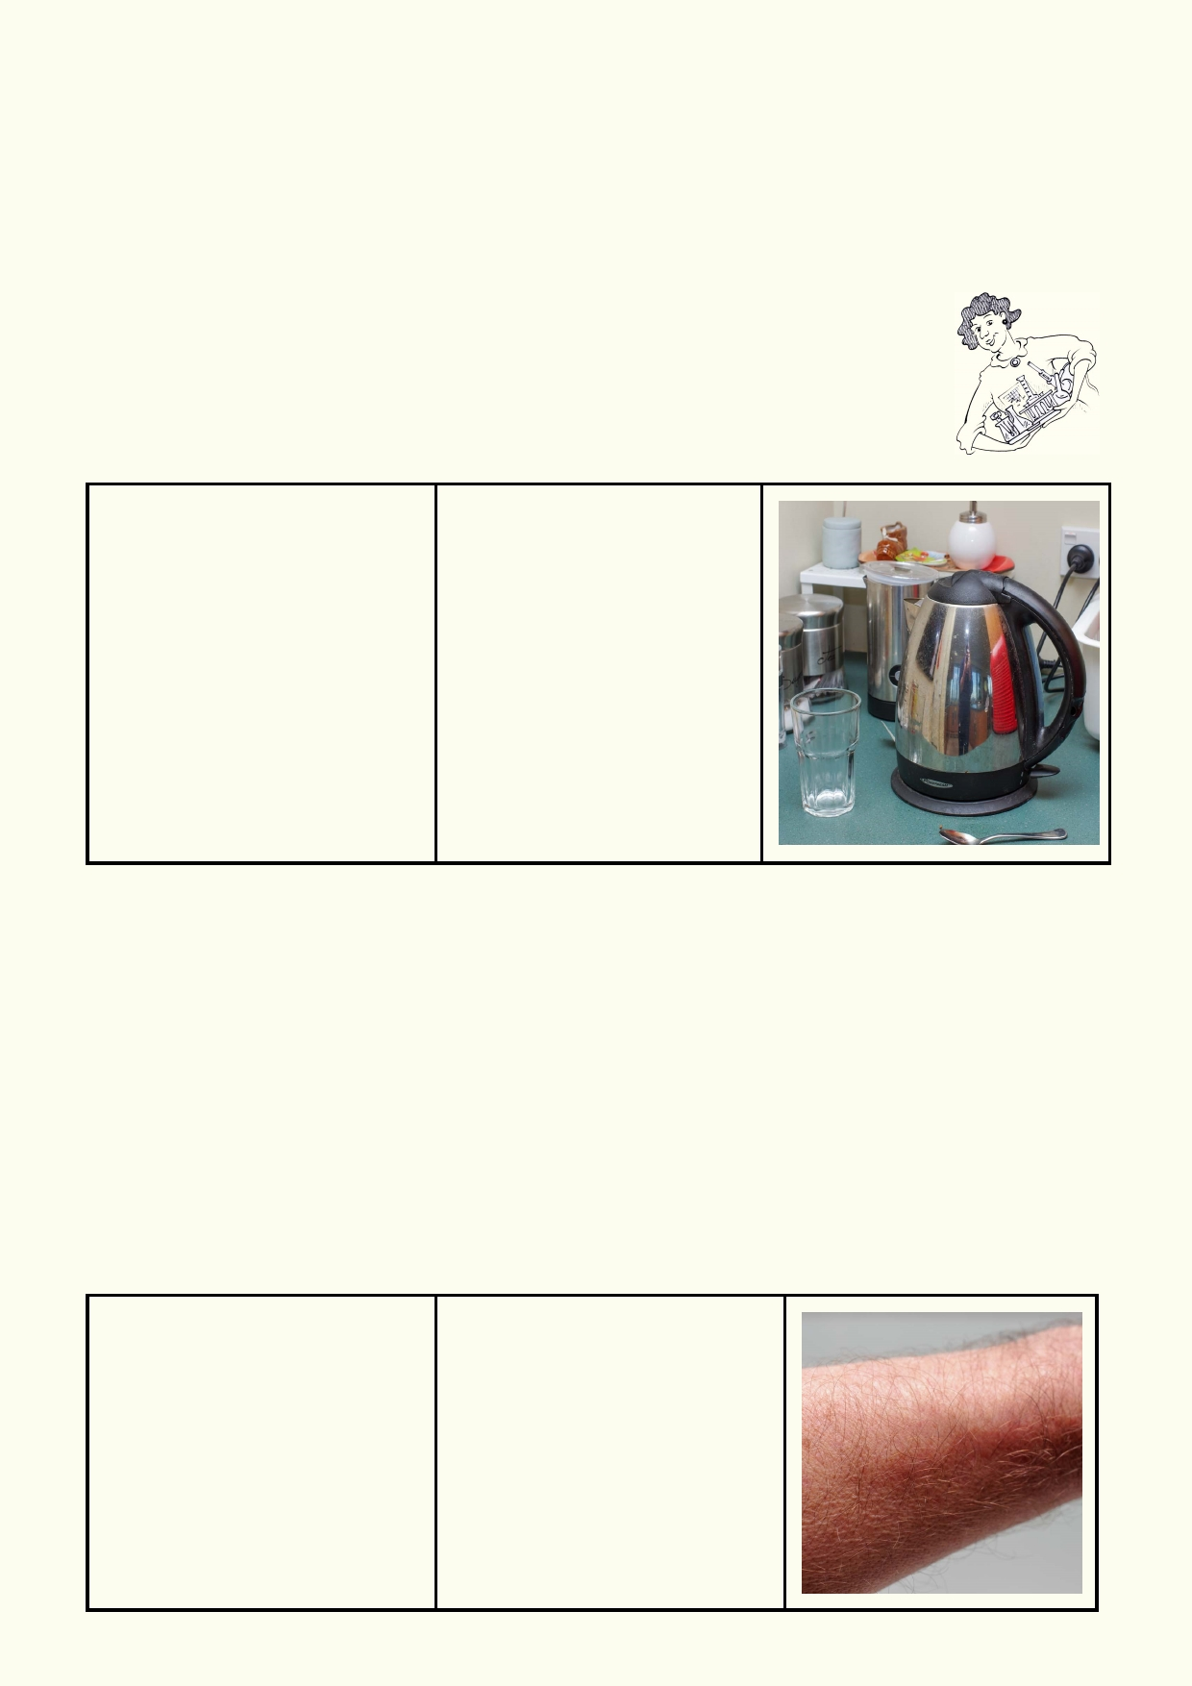Observation:
__________________________________________________________________________

__________________________________________________________________________

Explanation:
__________________________________________________________________________

_______________________________________________________________

Activity 2: It's a Gas

Experiment: Boiling hot

Materials: Method

•

•

•

Equipment for safely
boiling water
Beaker to contain boiled
water
A cold drinking glass

1. Boil water.
2. Making sure the skin of
the arm and hand does not
come into contact with the
steam, allow the steam to
flow over the cold glass for
around 5 seconds.
3. Describe the change in
the appearance of the drinking glass.

Prediction:
__________________________________________________________________________
__________________________________________________________________________
Observation:
__________________________________________________________________________
__________________________________________________________________________

Explanation:
__________________________________________________________________________
__________________________________________________________________________

Experiment: That's cool
Materials: Method:
• Clean damp cloth or 1.Using the mouth, blow air
tissue across a dry forearm .
2.Make the forearm damp
using the cloth.
3. Blow across the damp
forearm.
4.Try to explain the reasons
for any differences you
observed.

9

Prediction:
__________________________________________________________________________

__________________________________________________________________________

Observation:
__________________________________________________________________________

__________________________________________________________________________

Explanation:
__________________________________________________________________________

Experiment: Cloud in a bottle
Materials: Method:

• 1 Litre clear plastic 1. Pour a small amount of
bottle with cap warm water into the plastic
• Matches bottle.
• About 3 ml warm 2. Put the cap back on, but
water leave it loose.
3. Light the match, then blow it
out so it smokes.
4. Squeeze the bottle gently a
few times to suck in the smoke.
5. Close the cap.
6. Squeeze the bottle and then
release it.
7. Repeat step 6 several times.
Prediction:
__________________________________________________________________________

__________________________________________________________________________

Observation:
__________________________________________________________________________

__________________________________________________________________________

Based on your experiment, what do you think clouds need to have in order to form?

__________________________________________________________________________

__________________________________________________________________________

__________________________________________________________________________

10

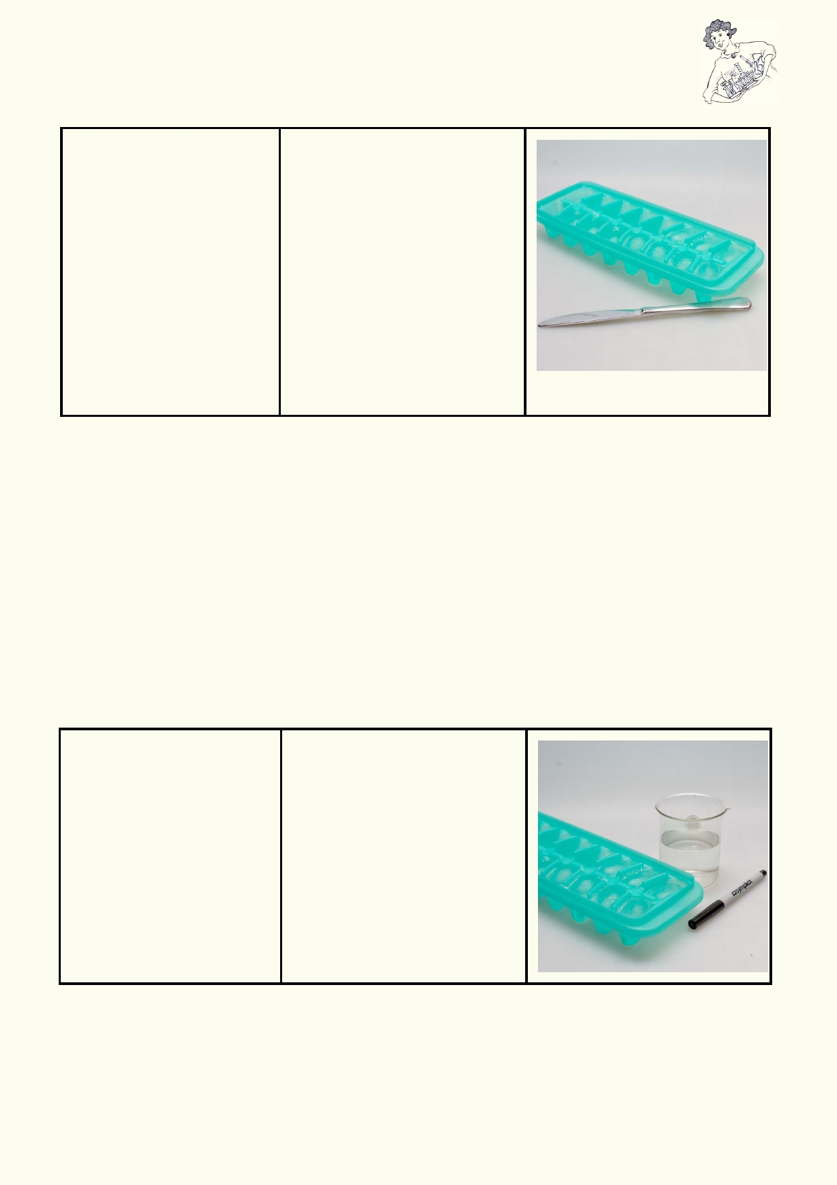Activity 3: Solid water - it's real cool
Experiment: Under pressure

Materials: Method

• Ice cube tray 1. Use different parts of the
• Blunt dinner knife knife to press down and move
it back and forward
on the ice block
- side of knife
- back of knife
- cutting edge of knife
2. Observe how the knife
moves and if the ice melts
when it is being pressed down
onto the block. (The sharp end
of the knife will have the
greatest pressure).

Prediction:
__________________________________________________________________________

__________________________________________________________________________

Observation:
__________________________________________________________________________

__________________________________________________________________________

Explanation:
__________________________________________________________________________

Experiment: Water level
Materials: Method:
• Beaker 1. Place about 150 ml water
• Ice - 4 ice cubes and 4 ice cubes into a beaker. • Water - 150ml 2. Using a marker, mark the
• Marker water level.
3. Allow the ice to melt.
4. Observe if the water level
changes.

Prediction:
__________________________________________________________________________

Observation
__________________________________________________________________________

__________________________________________________________________________
11

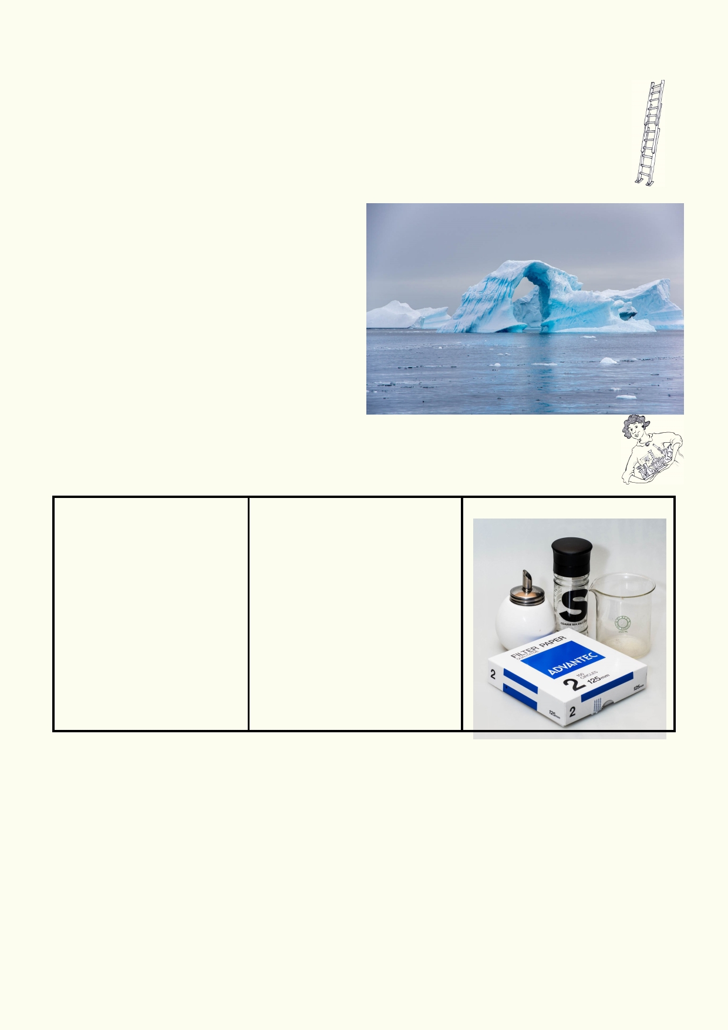Explanation:
_____________________________________________________________________

_____________________________________________________________________

Extension Question:
Why are ice-skaters able to glide on the ice? Hint: It is for the same reason that glaciers
move downhill just like water does!

Calculate this:
If an iceberg is in saltwater, only ⅛ of the
iceberg can be seen above water. The rest of it
is invisible, under the water's surface.

For the following icebergs, calculate how much
of the ice is hidden under water:
1. Iceberg made of 1400 cubic meters of ice
2. Iceberg made of 2200 cubic meters of ice
3. Iceberg made of 16,000 cubic meters of
ice

Activity 4: Chemical properties of water

Experiment: Making a solution
Materials: Method
• Water: 20 ml per trial 1. In a beaker of water stir salt
• Sugar: 5 g per or sugar until it dissolves.
experiment 2. Note if the liquid looks
• Salt: 5 g per different.
experiment 3. Pass the liquid through filter
• Beaker paper and observe if the salt
• Filter paper or sugar has been left on the
• Source of heat paper .
4. Evaporate the liquid by
heating it or leaving it in a
shallow dish at room
temperature.
Prediction:
__________________________________________________________________________

__________________________________________________________________________

Observation:
__________________________________________________________________________

__________________________________________________________________________

Explanation:
__________________________________________________________________________

12

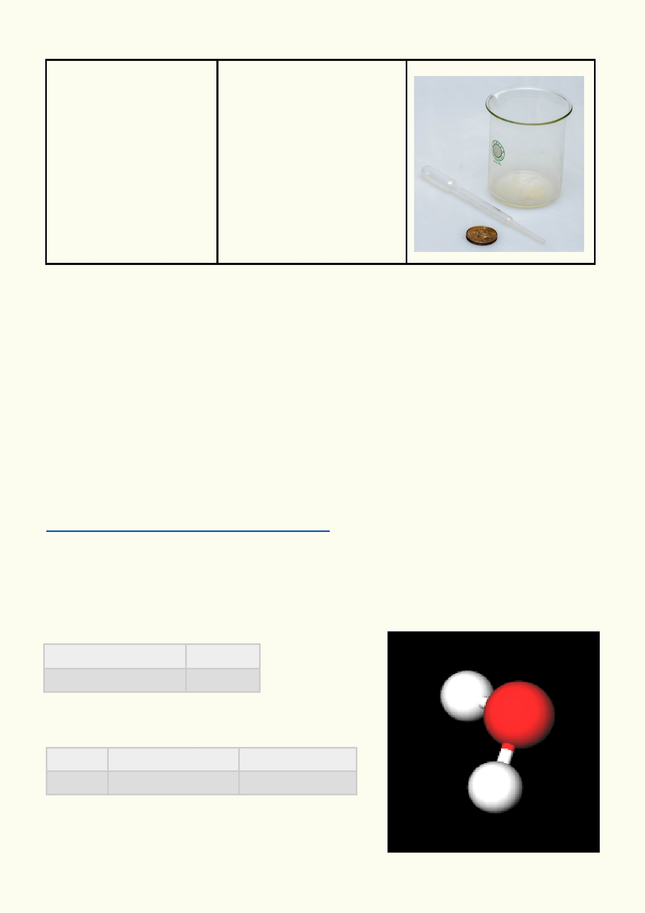Experiment: Water tension
Materials: Method
• Large round coin 1. Slowly drop water onto a
• Pipette or dropper coin.
• Water: 10 ml 2. Count the number of drops
• Alcohol: 10 ml the coin holds before the
water spills over. Try to add as
many drops as you can.
3. Explain why so much more
water than alcohol can sit on a
coin.
4. Repeat the experiment
using alcohol.

Prediction:
__________________________________________________________________________

__________________________________________________________________________

Observation:
__________________________________________________________________________

__________________________________________________________________________

Explanation:
__________________________________________________________________________

Watch this video to see how salt dissolves in water.
https://www.youtube.com/watch?v=xdedxfhcpWo

In this diagram, the water molecule has two hydrogen atoms (white) and one oxygen atom
(red), the two hydrogen atoms form a V shape with the oxygen. This shape makes the
electrons around the hydrogen slightly positive and around the oxygen slightly negative. This is
called a bipolar molecule. The bipolar nature and the shape of the molecule give water many
of its properties.

Formula HO 2
Molecular weight 18.015 u

Percent composition

H 1.00794 u × 2 11.190 %
O 15.9994 u × 1 88.810 %

13

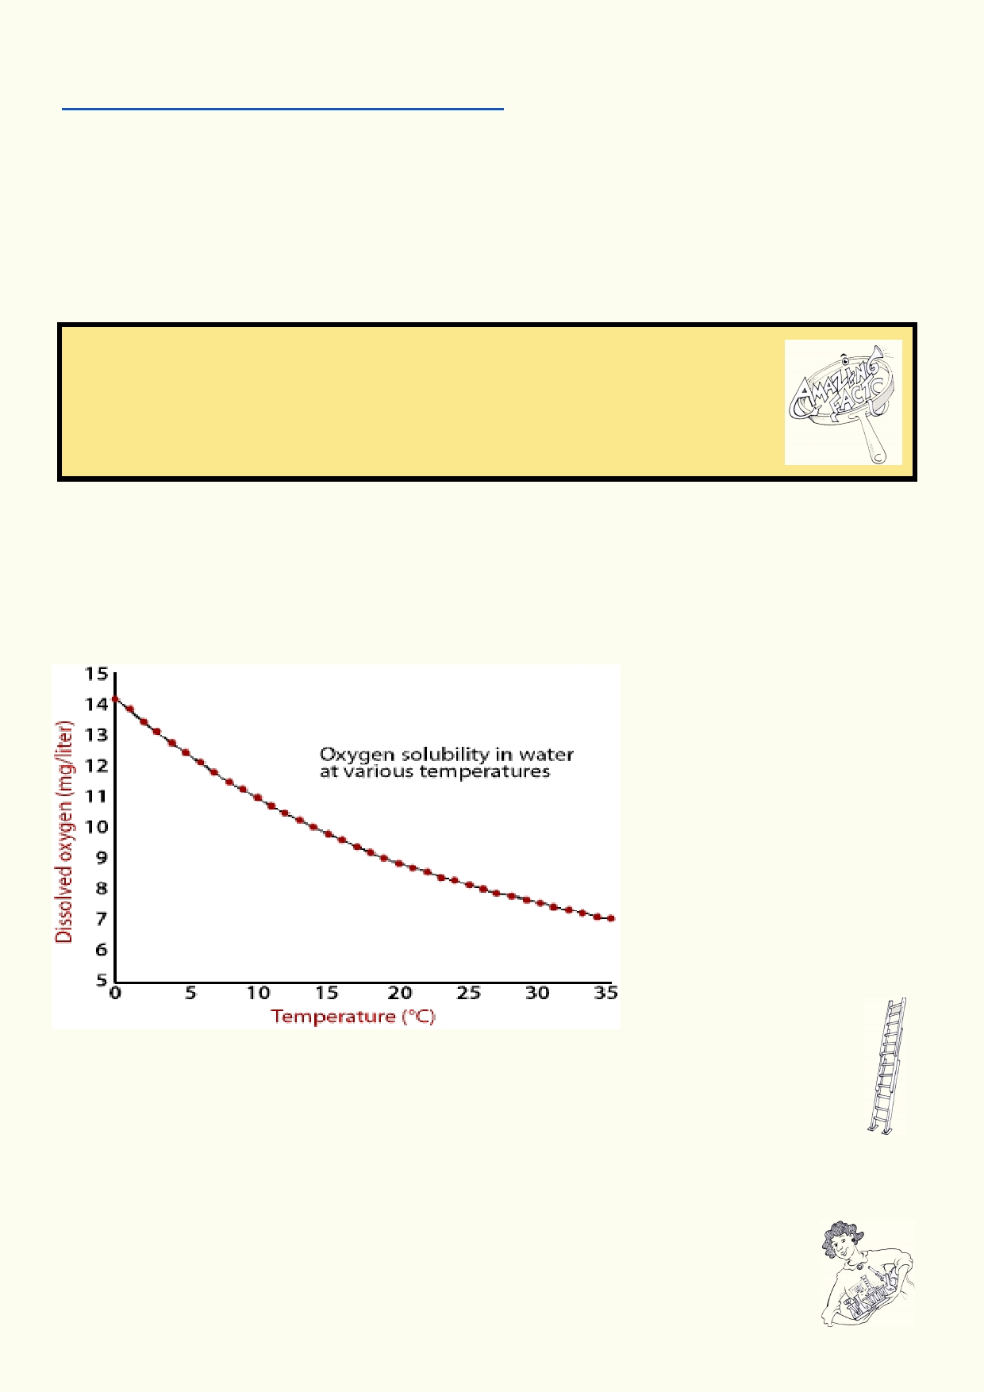This video explains how the shape of water molecules causes its interesting properties:
https://www.youtube.com/watch?v=3jwAGWky98c

Solutions (in solution)
Why is water called "the universal solvent"? It is because it can dissolve so many different things.
It is able to dissolve many substances because it is bipolar. A solution in water is when a
substance is dissolved evenly through the water. The substance can't be filtered out of the water
using filter paper. When the water is evaporated, the substance remains and retains the same properties.

Amazing fact
Are all solutions liquids? No, there are solid and gas solutions. Can you name
any?
The air you breathe is a solution. It consists of oxygen and other gases dissolved
in nitrogen. Brass is a solid solution. Tin is the solute and copper is the solvent.

Oxygen dissolves in water.

Look at the graph. The horizontal (bottom) axis is the temperature and the vertical (side) axis is the maximum amount of oxygen dissolved in the water. The graph shows the maximum amount of oxygen that can be dissolved at different temperatures.

According to the graph, what
temperature can water hold the
most oxygen?
______________
At what temperature does water
hold the least oxygen?
______________

Extension Question: Why might a graph like the one above be useful for an ecologist?

______________________________________________________________________

__________________________________________________________________________

Activity 5: Suspensions
A suspension is when materials float around in water. These are usually very small
particles. In this experiment you will find out what is different about solutions and
suspensions.

14

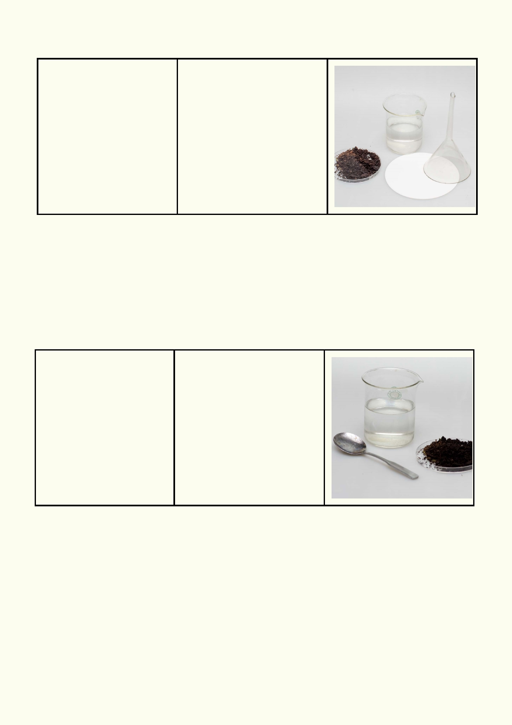Experiment: Suspending soil
Materials per trial: Method
• 2 beakers (250 ml) 1. Mix three or four spoons of
• Water - 200 ml soil in a jar half-filled with
• Soil - 20 g water and stir.
• Filter paper - 1 round 2. Record what you observe.
piece 3. Pour the contents of the jar
• Funnel through a funnel with a filter
• Spoon paper inside.
(keep the water with 4. Record your observations.
suspended soil for the next
experiment)

Prediction:
__________________________________________________________________________

__________________________________________________________________________

Observation:
__________________________________________________________________________

Experiment: Observing the changes in a suspension
Materials: Method

• Beaker of water from 1. Place the beaker with water
previous experiment and soil in a location where it
• Spoon won't be disturbed for half an
• Mobile phone camera hour .
2. Stir the water and then take
(keep water for next a photo of the beaker.
experiment) 3. Half an hour later take
another photo and compare
the two photos.

Prediction:
__________________________________________________________________________

__________________________________________________________________________

Observation:
__________________________________________________________________________

__________________________________________________________________________

What is the difference between a solution and a suspension?

__________________________________________________________________________

15

Experiment: Turbidity

Materials: Method
• Beaker or jar 1. Make a 1cm grid on 10 cm
• Water -100 ml square paper, using a thick • Soil - 50 ml black marker on white paper.
• Spoon use three to four spoons of
• Paper and thick black soil and stir in a half filled.
marker 2 . Place beaker on your
• Light source such as a graph. If you can't see the
torch or deck light graph through the water pour
off some water until you can. 3. Try the same with the water
in the previous experiment.
4. Shine a bright light through
the beaker.

A simple way of describing turbidity is how dirty the water looks. Turbidity is different from
pollution, although turbidity is often one of the measurements of how polluted water is. Turbidity
is actually the amount of particles suspended in the water.

Prediction:
__________________________________________________________________________

__________________________________________________________________________

Observation:
__________________________________________________________________________

__________________________________________________________________________

Explanation:
__________________________________________________________________________

How does dirty water affect the amount of light that can pass through the water? Does a bright
light shining onto the side of the beaker make much difference?

__________________________________________________________________________

__________________________________________________________________________

How are aquatic plants and animals affected if light can't penetrate the water?

__________________________________________________________________________

__________________________________________________________________________

How might suspended solids in the water affect fish, tadpoles and aquatic insects?

__________________________________________________________________________

__________________________________________________________________________

16

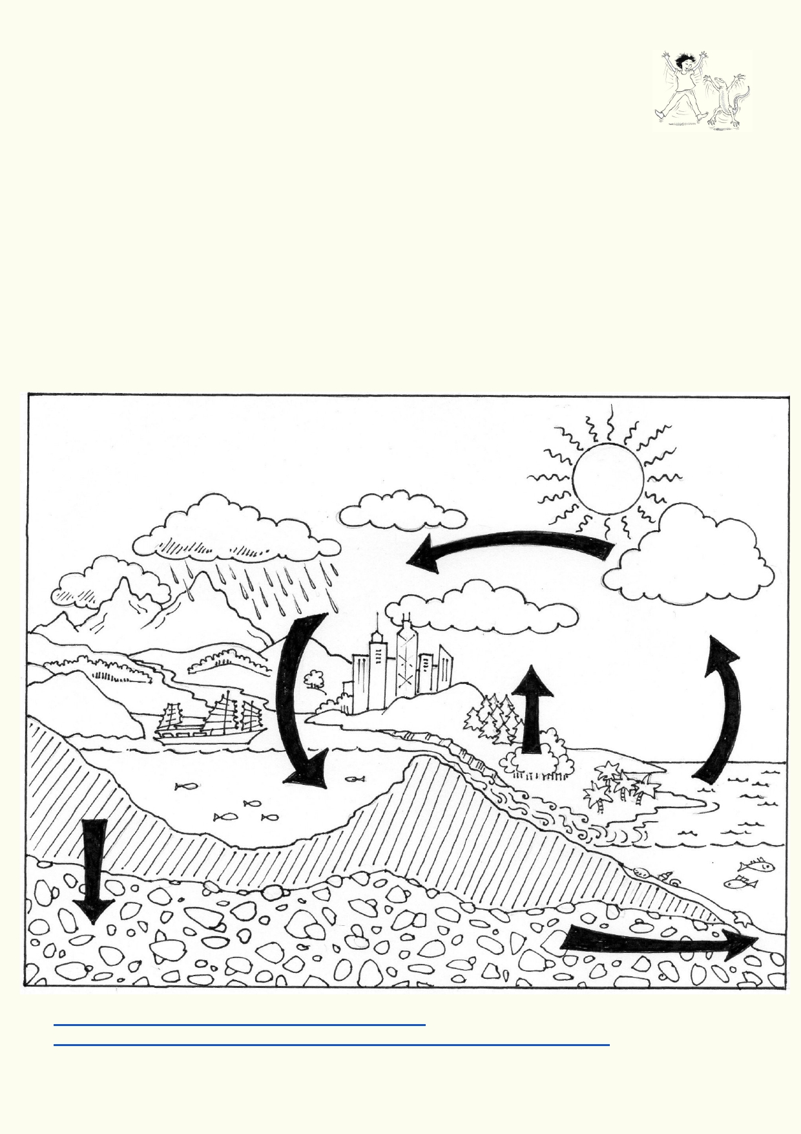Lesson 2 - Earth the water planet

Activity 1. Water cycle

Introduction
It's no joke! Some of the atoms of water inside your body will have passed through dinosaurs and probably some very famous people. All the water on Earth has been recycled for billions of years.
Who knows how many adventures the water in your body has gone through!

What do you know about the water cycle?
Annotate the water cycle diagram. Label the diagram and six arrows with the words below and
add two further arrows with their words:
Evaporation Evapotranspiration
Infiltration Condensation
Precipitation Runoff
Sublimation Throughflow
Look at these websites to make sure you have used the labels correctly.

http://aqwest.com.au/Students/TheWaterCycle.aspx
http://www.educationsoutheastwater.com.au/natural-water-cycle/#evaporation

17

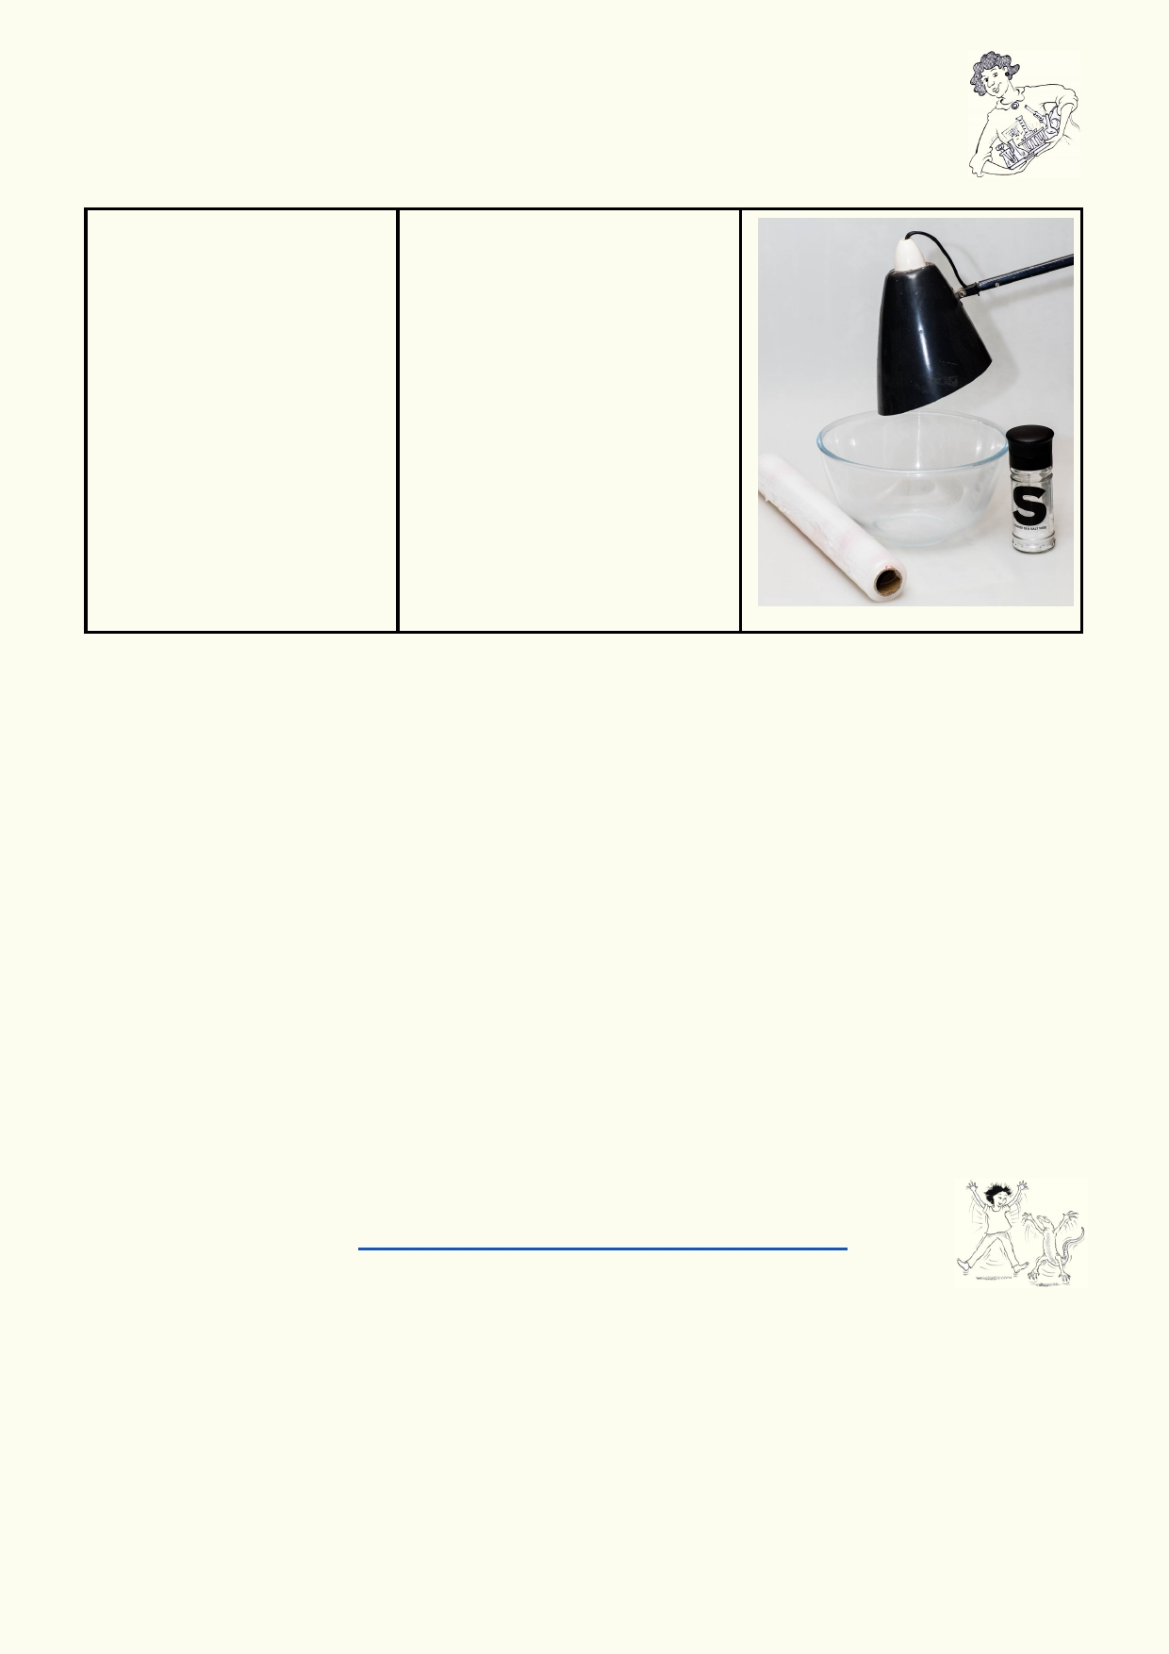Activity 2: Mini water cycle experiment

Experiment: Mini water cycle

Materials: Method:

• Bowl 1. Stir some salt into a bowl of
• Clear wrap water to represent the sea.
• Salt and spoon 2. If you are going to do the
• Heat lamp taste test, use drinking water
• Water to quarter fill and a clean spoon and bowl.
bowl 3. Place clear wrap over the
bowl.
4. Place a heat lamp over but
not touching the clear wrap. 5. Once water droplets have
formed on the wrap, taste a
droplet to find out if it is
salty.

Prediction:
__________________________________________________________________________

__________________________________________________________________________

Observation:
__________________________________________________________________________

__________________________________________________________________________

If the sea water keeps evaporating from the heat of the sun, why does it not keep getting saltier
and saltier all the time?

__________________________________________________________________________

__________________________________________________________________________

Activity 3: Rapped in the water cycle

If you look at Youtube you will find a few water cycle songs. These songs seem to
be made for younger kids. https://www.youtube.com/watch?v=T05djitkEFI

Your job is to write a short poem, song or rap that describes the water cycle for students your age.

An alternative activity can be to review several Youtube water cycle songs. The primary purpose
of your review is to note if they have all the required information, and write up what they have
gotten wrong or what they have left out.

18

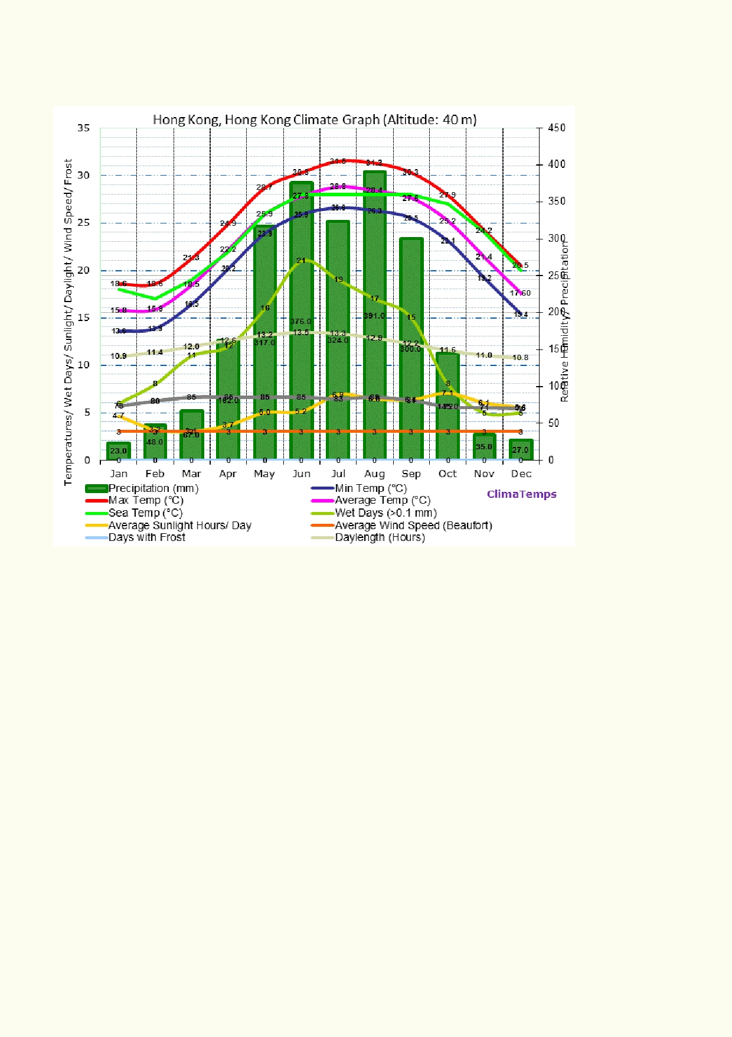Activity 4. Weather vs. Climate
Below is a Climate Chart of Hong Kong. Look at what the chart is measuring.

Source: http://www.kowloon.climatemps.com/

Over what period of time does the chart represent? ___________________________________

What properties are being measured? _____________________________________________
____________________________________________________________________________

How long has it taken to put the data together to get average measurements?
◻ 1 year ◻ 5 years
◻ Around 50 years

Answer - a lot longer than ten years.

19

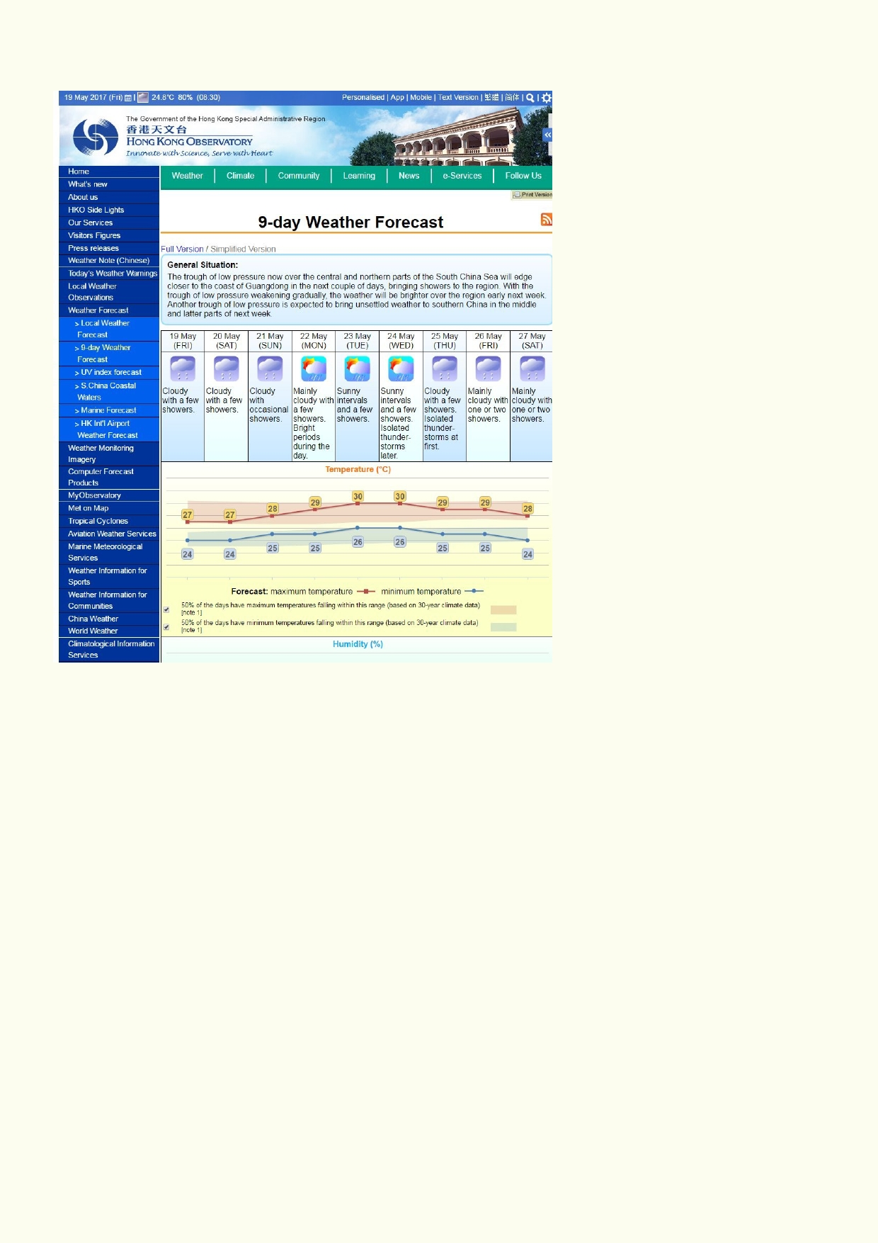This is an old Hong Kong weather forecast that includes a chart:

Source http://www.hko.gov.hk/wxinfo/currwx/fnd.htm

Over what period of time does the chart represent?
_____________________________________________

What properties are being measured?
_______________________________________________

____________________________________________________________________________

How long has it taken to put the data together?
◻ Last few days
◻ Last few weeks ◻ Last few years

Over time, would you expect big changes in a climate chart? ___________________________

Over time, would you expect big changes in the weather forecast? _______________________

What is the purpose of making a climate chart? ______________________________________

____________________________________________________________________________

20

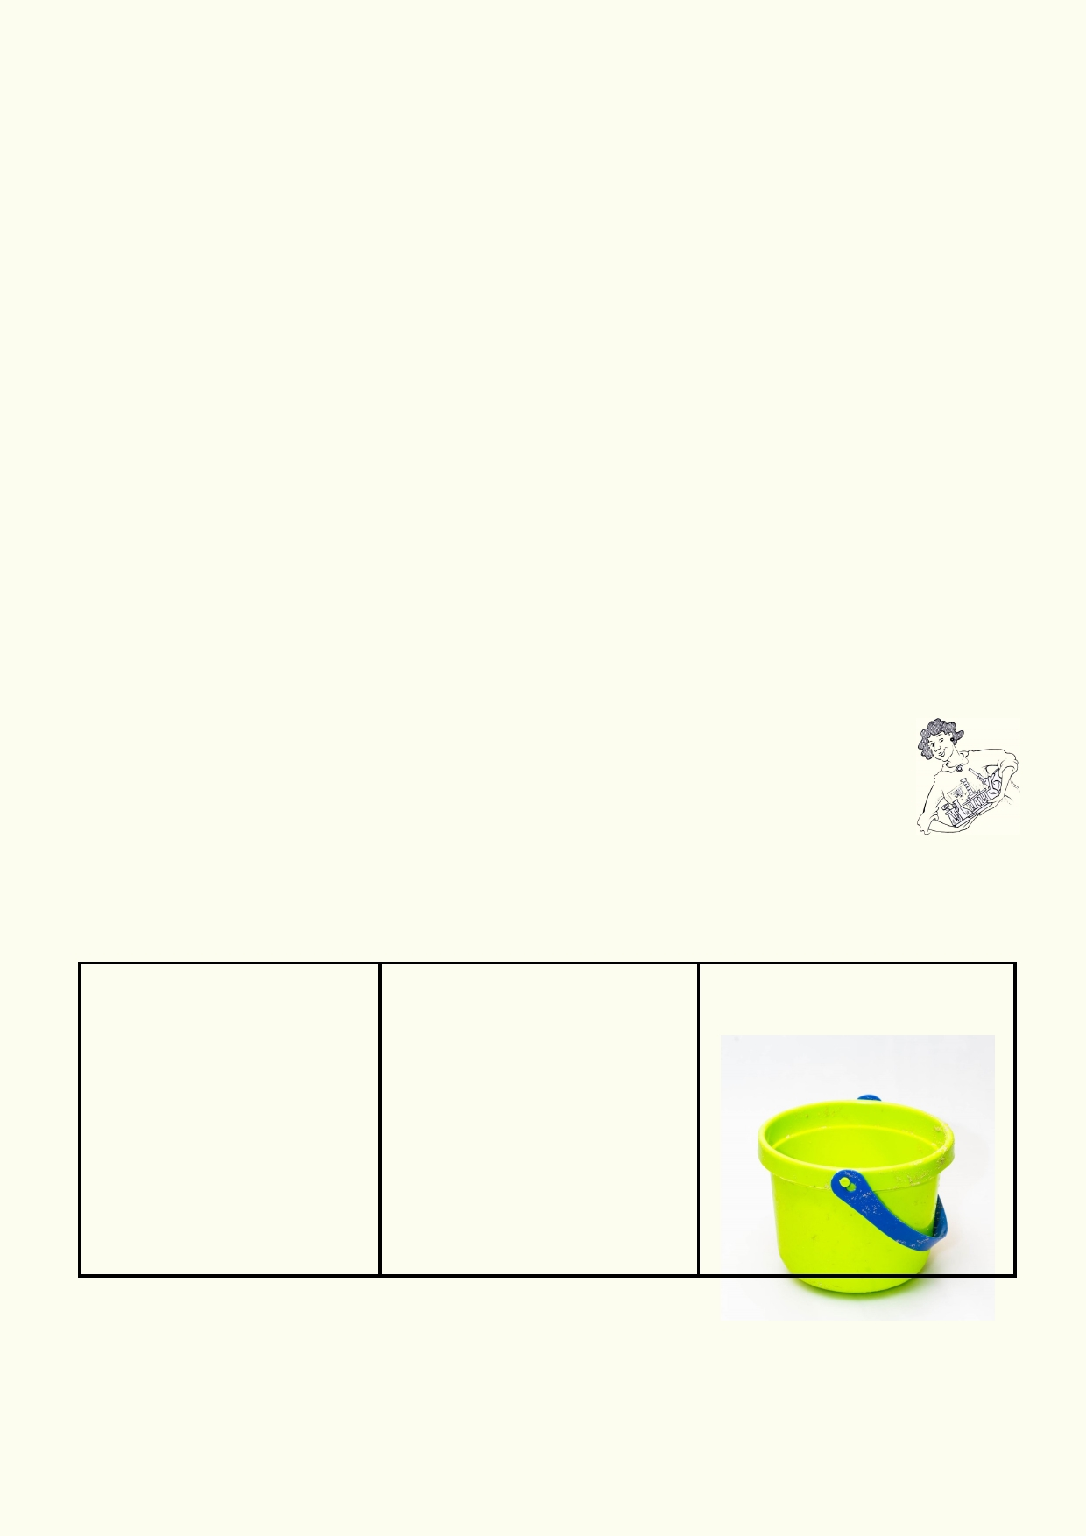How useful is the climate chart in predicting weather? __________________________________

_____________________________________________________________________________

Why does the weather forecast only predict 9 days? ___________________________________

_____________________________________________________________________________

What is the difference between weather and climate? __________________________________

_____________________________________________________________________________

_____________________________________________________________________________

Comparing the Hong Kong climate graph, use the internet to find a similar climate map for any
other place or region in the world. A good source for finding climate graphs is to look for
government meteorological websites.

Place or region ________________________________________________________________

How are the seasons different from Hong Kong? _____________________________________

_____________________________________________________________________________

____________________________________________________________________

Activity 5: Hidden water

Experiment: Permeable vs. Impermeable

You will go outdoors to find three different surfaces: footpath, bare soil and grass.
Discuss with your teacher where you will find these surfaces and how you will obtain buckets of
water. You will observe how the water responds to these surfaces when water is poured slowly and quickly onto them.

Materials: Method

• Small bucket with 1.Slowly pour around half a
handle litre of water on the following
• Water (about 3 l) surfaces:
• Outdoor area • footpath
• grass surface
• soil surface
2. Quickly pour the other half
litre of water on the same
surfaces.

What happens when water is poured onto a hard surface like a footpath?
____________________________________________________________________________

21

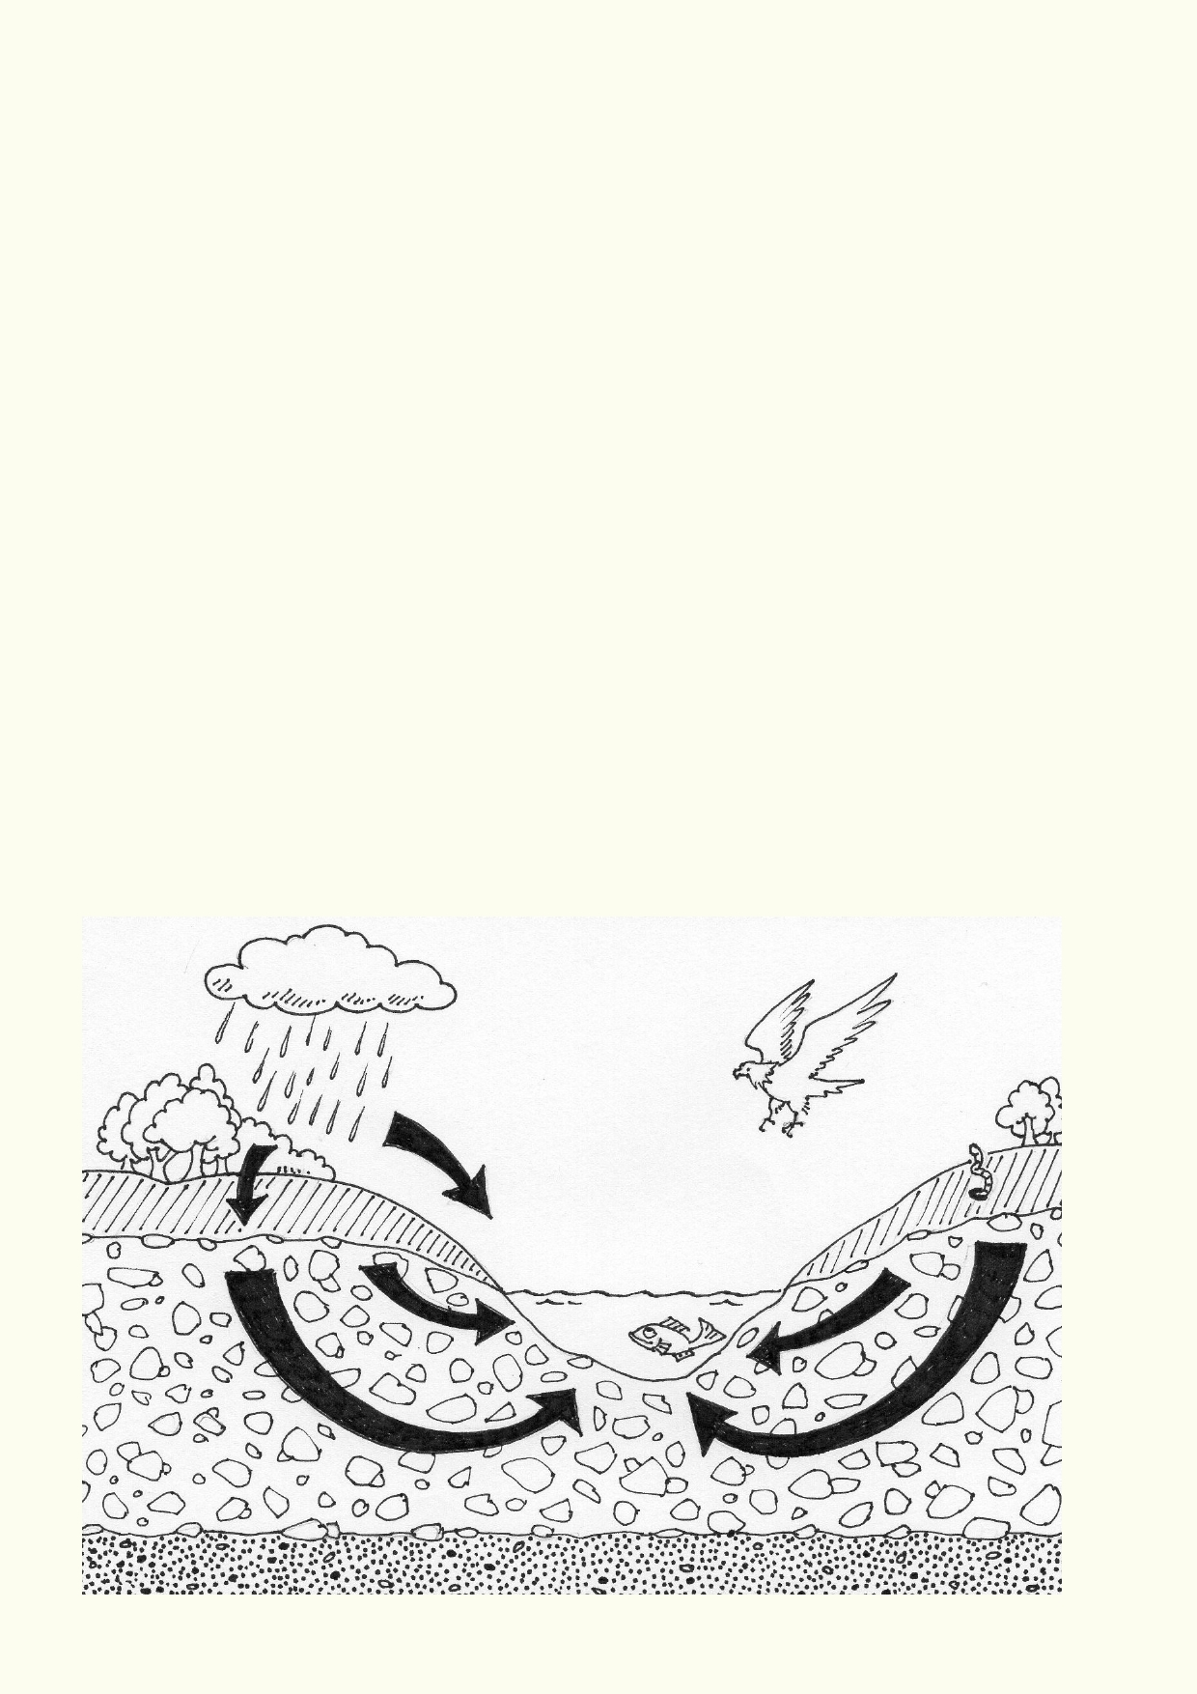What happens to water when poured onto grass and soil?

__________________________________________________________________________

Which surfaces are permeable to water?

__________________________________________________________________________

Which surfaces are impermeable to water?

__________________________________________________________________________

Did you notice any differences in what happens to the water when it is poured slowly vs. quickly
onto the surfaces? Why might this be important?

__________________________________________________________________________

Why do you think some surfaces are more permeable than others?

__________________________________________________________________________

The mysteries below the surface

All the water soaking into the ground must go somewhere. It travels down into the soil and rock
until it hits a layer of rock that is impermeable to water. Groundwater is the water that fills the
cracks and spaces in the rock and soil. The layer of groundwater can slowly flow downhill. When
the groundwater reaches the surface we call it a spring. Often groundwater comes out in a hollow
that creates a permanent lake.

22

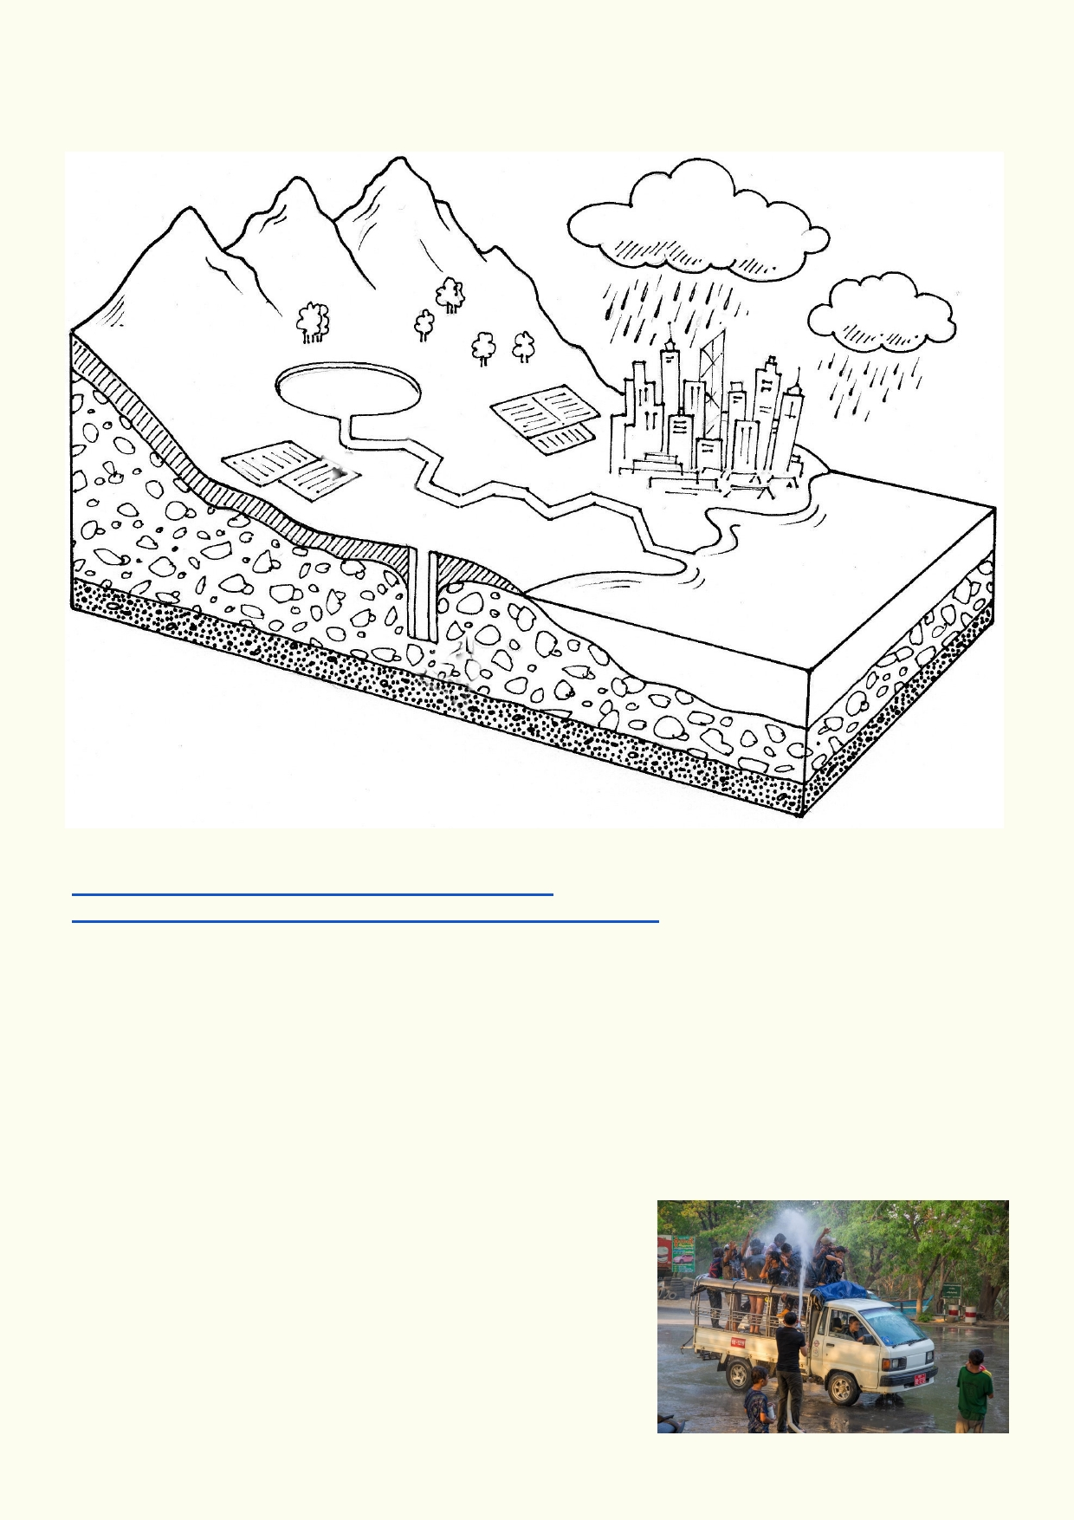Label the diagram to show how groundwater is a source of water storage and flows through the ground. On the diagram above, show some of the sources that could pollute the groundwater.

View the links below:
https://www.youtube.com/watch?v=oNWAerr_xEE
http://earthguide.ucsd.edu/earthguide/diagrams/groundwater/

Groundwater is replenished by rain. This is called groundwater recharge.
What would happen if more groundwater is removed by pumping and natural outflow than is
replaced by rain?
____________________________________________________________________________

____________________________________________________________________________

Choose one major weather event or climatic change that changes the amount of rainfall. Modify
the diagram to show what you think would happen to the water table. Examples of weather
events and climate change:
• A major flood
• Long drought
• Same amount of rain each year, but most of it comes
as much heavier bursts of rain
• Rain increases by 50% each year

23

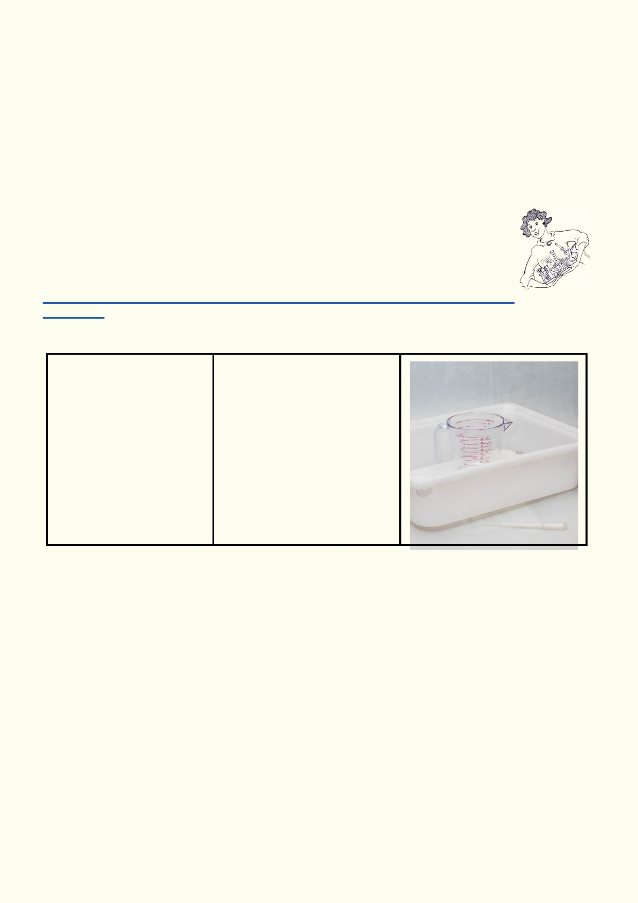Knowing what you do about permeable and impermeable surfaces, how do you think this affects
the amount of water entering the groundwater supply?
____________________________________________________________________________

____________________________________________________________________________

How does time on the surface affect the amount of water entering the groundwater supply?
____________________________________________________________________________

____________________________________________________________________________

Lesson 3 - The Power of Water

Activity 1: Erosion, shaping the landscape

The website provides videos of raindrops hitting different surfaces.
www.videoblocks.com/video/close-up-rain-drop-drip-in-meadow-dirt-drop-on-camera-glass
-4k-htpyyty/

Experiment: Drip vs splat - which causes the most erosion?

Materials: Method
• Large tray with sides 1. Place sand or cat litter in
(eg cat litter tray) tray.
• Sand or cat litter 2. Use the pipette to make a
• Water in jug constant drip onto one small
• Pipette section of the tray and note
what happens.
3. Pour water from the jug in a
long continuous stream onto
one small section of the tray and record what happens.

Prediction:
____________________________________________________________________________

____________________________________________________________________________

Observation:
____________________________________________________________________________

____________________________________________________________________________

Explanation:
____________________________________________________________________________

____________________________________________________________________________

24

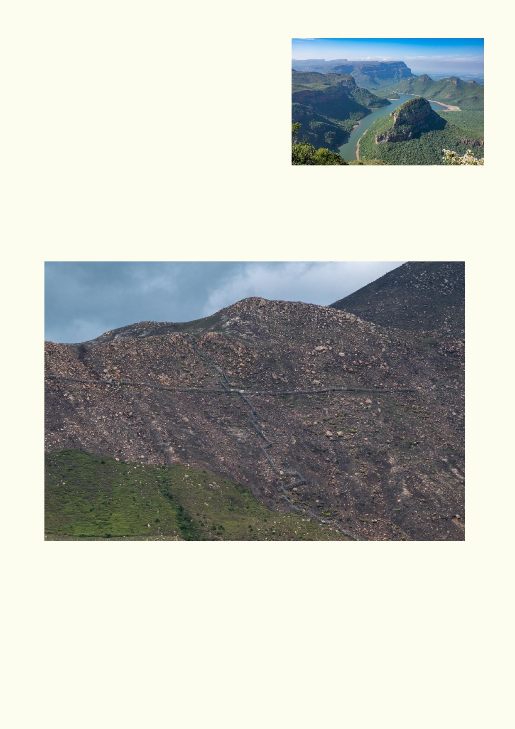Power of water on our environment

Water has carved up the landscape. All the tallest ancient mountains have been worn down by water.
They may be reduced to hills or no longer exist. Where water is having its biggest impact on the
landscape, we see erosion occurring. Water may have
stripped the land of soil. Water may create new gullies.
The very steep landscape around Hong Kong is prone
to erosion, sometimes resulting in dangerous,
collapsing hillsides. The landscape must be managed so our roads and people are safe, but we
should have as little impact on the environment as is necessary. Vegetation holds the soil in
place and reduce erosion. In the past, some of the efforts to reduce the impact of water by
concreting streams and rivers has destroyed their ecology.

Topsoil is more susceptible to erosion by rainfall when there is little or no vegetation present, like this recently burnt hillside on Lantau.

25

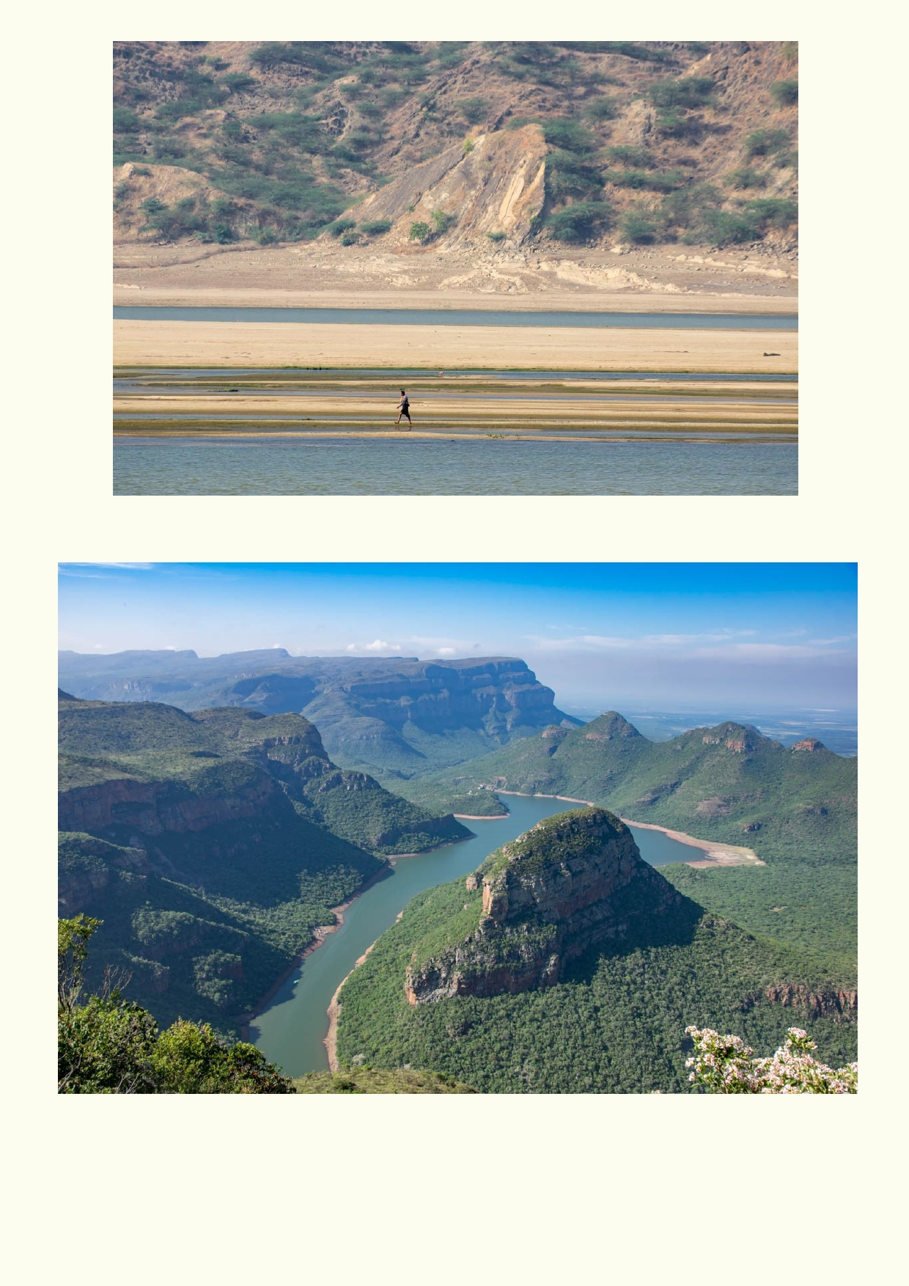Each year
annual floods eat into the hillside.

Water has worn away the softer rocks and created the world's second largest canyon which is in
South Africa. It is called the Motlatse River Canyon. The light blue speck in the water near the
bottom of the photo is a boat.

26

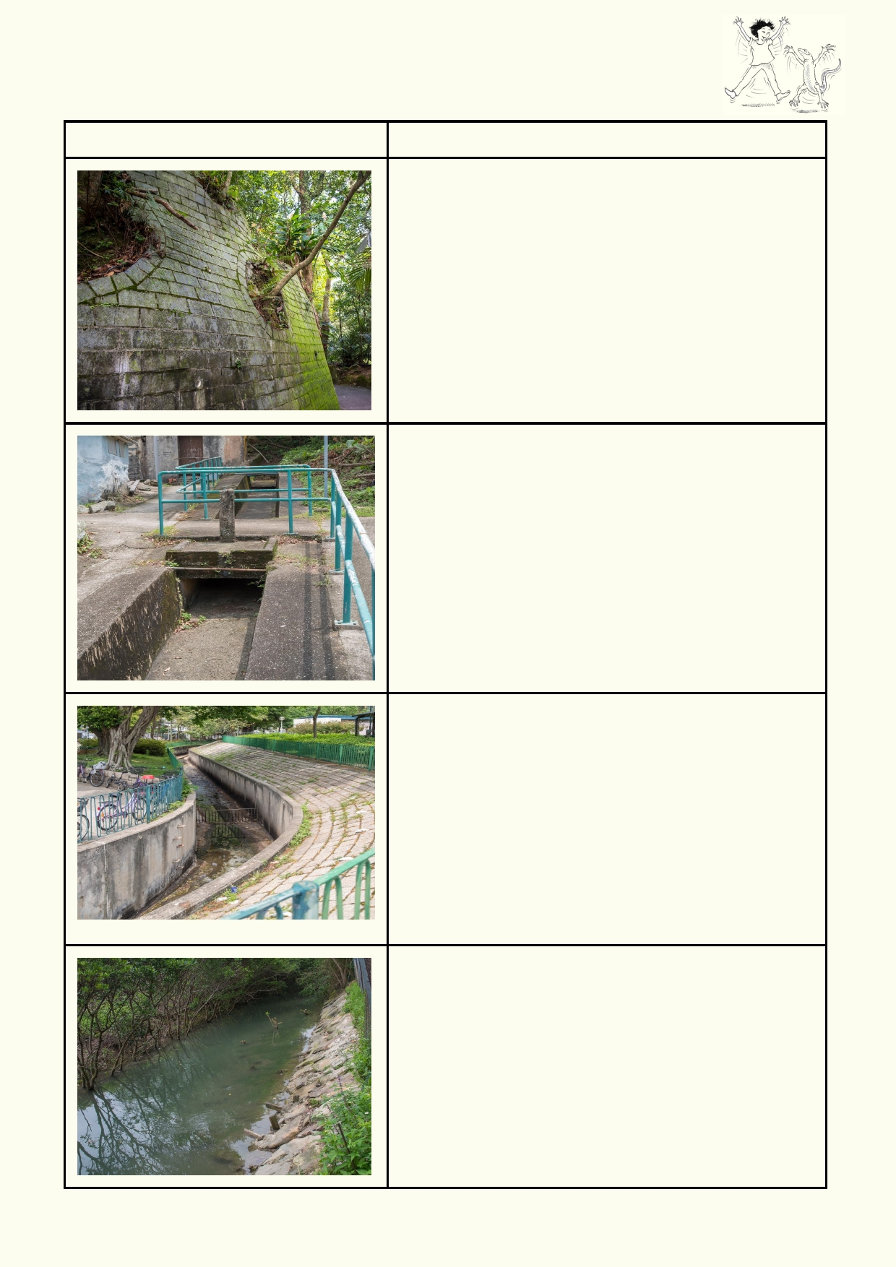Activity 2. Protecting the landscape

How do these structures in Hong Kong manage water to protect the landscape?

Structure What is the function?

27

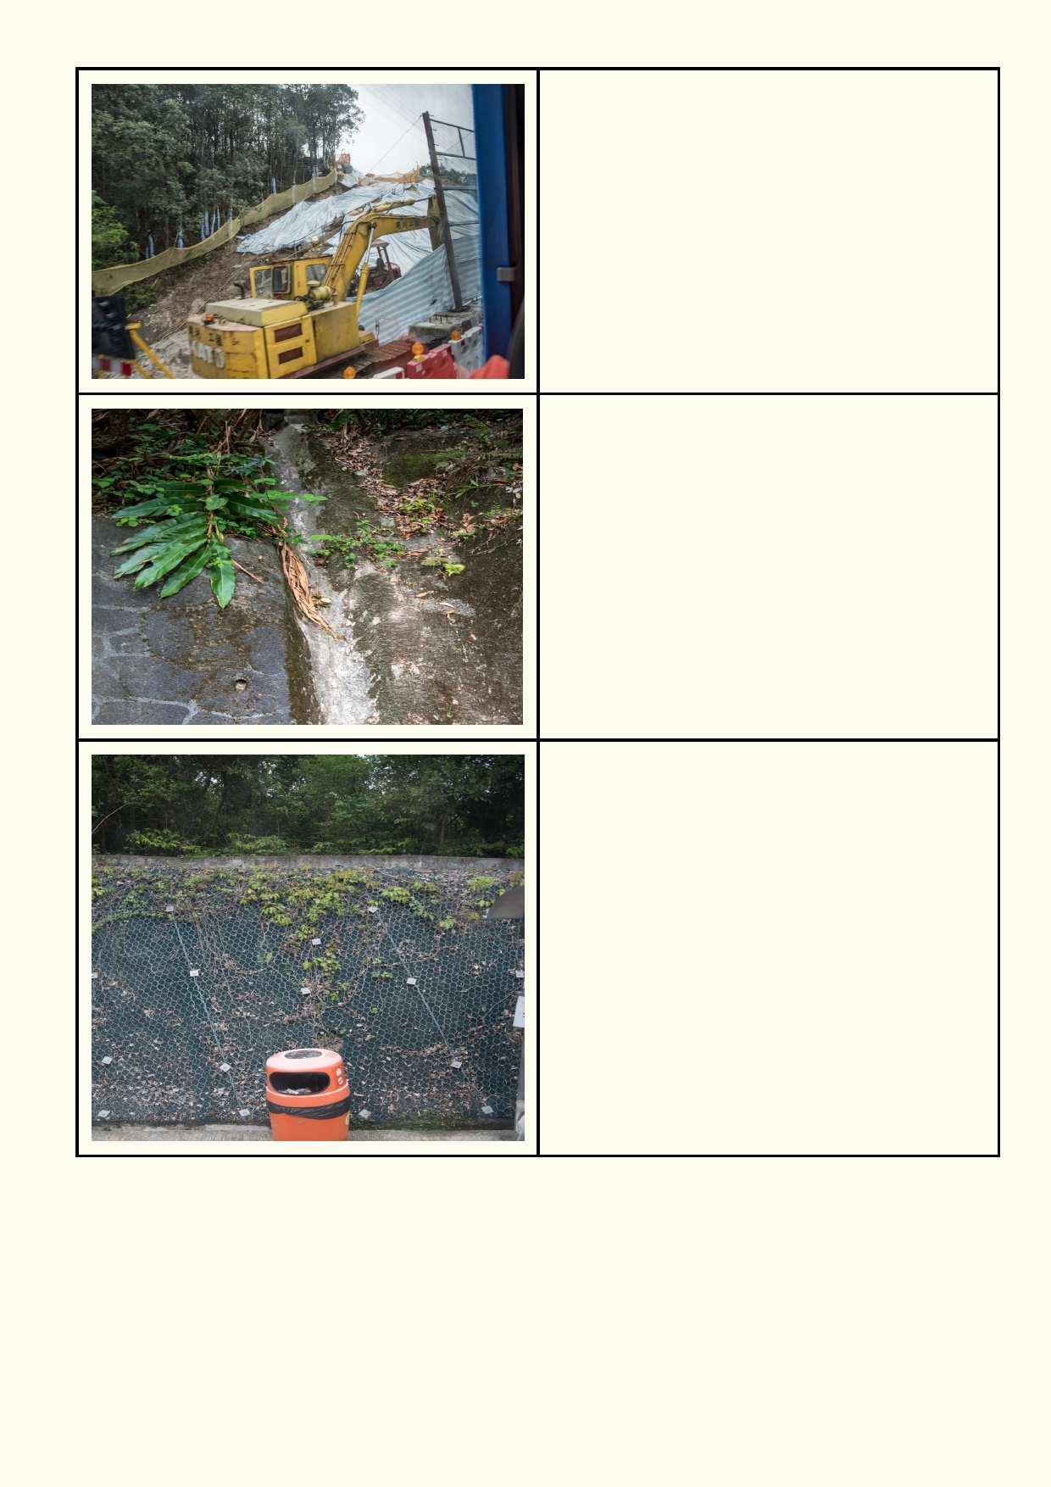

28

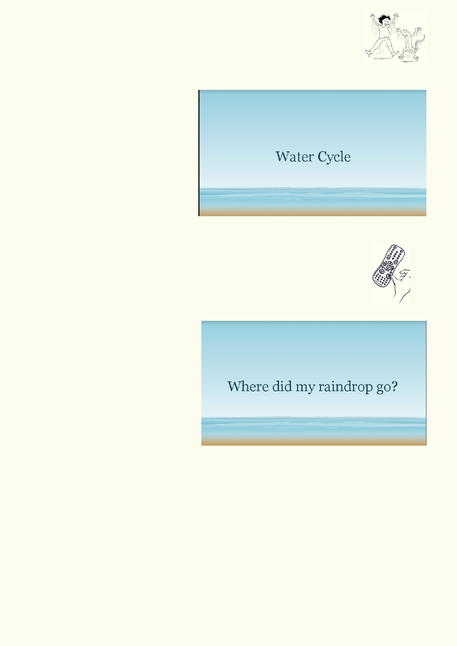Activity 3: Water Cycle Review - Make it Your Own

Download the Water Cycle Powerpoint from the resources.

This Powerpoint has a number of photos that show parts of the water cycle. Add text to the
photos to explain how the photos fit into the water cycle.

Get into groups of three and comment
on each other's water cycles. If you
found out more information from your
group, add this to your water cycle. If
you can't agree on some of the
information, discuss it with the class.

As a class, go through the slides,
confirming that what you have written
explains the water cycle.

Activity 4: Looking forward - Where did my raindrop go? - Powerpoint

Download the "Where did my raindrop go?" Powerpoint .

When rain falls it will start a journey. It may naturally end up in the sea or be transpired in a forest, or it could be diverted by our pipes, drains, etc.

Choose one of the five ways your
raindrop could have travelled when it fell
onto Hong Kong. Go through the entire
cycle so that your raindrop eventually
returns to the cloud. (Scientifically the molecules in a raindrop would mix with
other water and all the molecules would
be scattered). The raindrop:

1.
2.
3.
4. 5.
Landed in a stream then into a river
Landed on a farm
Went into a reservoir
Landed in the streets of Hong Kong
After it landed in a forest, it was absorbed by a tree

Only use the photos you need, deleting those that are not part of your raindrop's journey. Use the photos provided and add photos and diagrams to explain your story. When the stories are
complete, get In groups of five representing each of the five journeys and share your stories.

Tell the Story
Turn your water drop journey into a storybook for a lower grade class in your school.
1. Decide what storyline you would like to tell.
2. Your story will need a new, interesting title.
3. If you are making it into an adventure, make sure that the main points remain factual.

29

Acknowledgements
The Ocean Recovery Alliance thanks The Hong Kong Jockey Club Charities Trust for their
generous funding support on this education programme.

Project manager: Doug Woodring
Writer, photography and design : Bob Winters
Curriculum manager and editor : Charlotte Charny Nielsen
Editor and school outreach: Alex Hale
Additional thanks: Jasmine Nunns and Sandra Merazzi

© 2017 Ocean Recovery Alliance and Authors.
Outside the school environment, the text, photos and artwork may not be reproduced, except
where permitted by the relevant Copyright Act. These materials may not be modified and
distributed by print or electronic means without written permission. Teachers may modify these
education materials for the use of their students and school provided it is not distributed any
further. Those wishing to reproduce part of this publication must submit their application to the
Ocean Recovery Alliance. www.oceanrecov.org/contact-us.html

30

