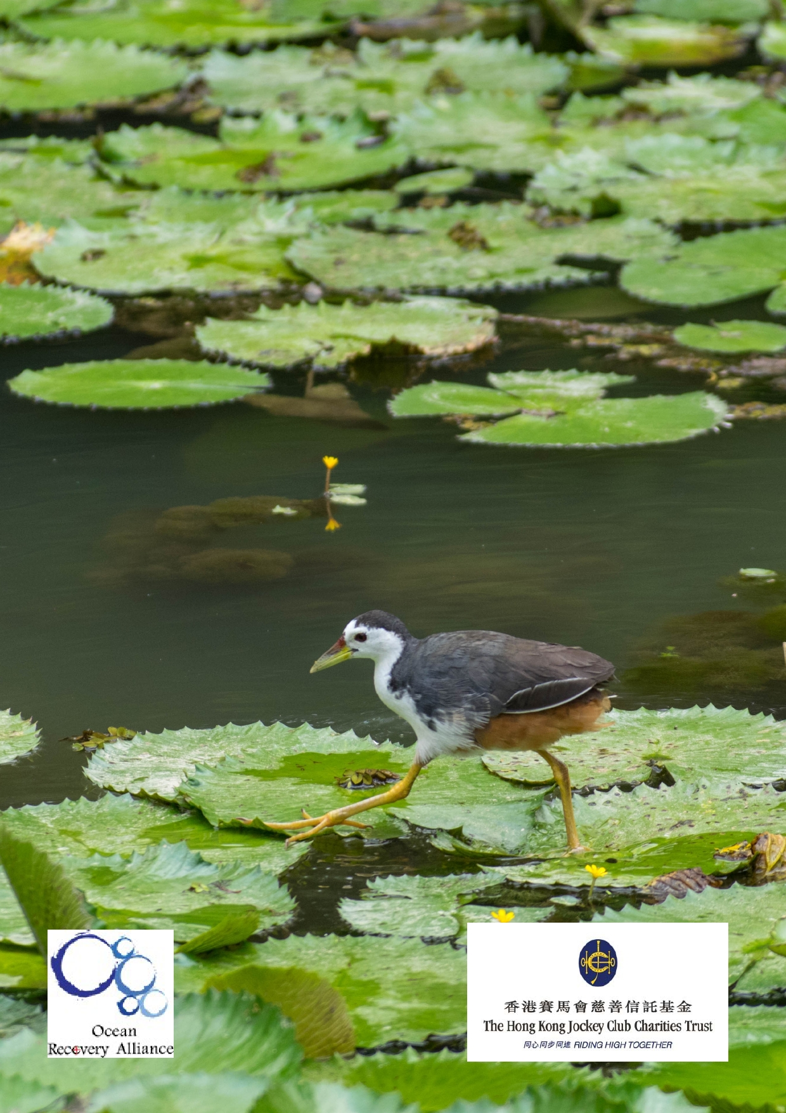Jockey Club Water Caretakers of
Tomorrow Programme
Water as Source -- Lifeblood of an Ecosystem
Unit 4

Organised by Funded by

1

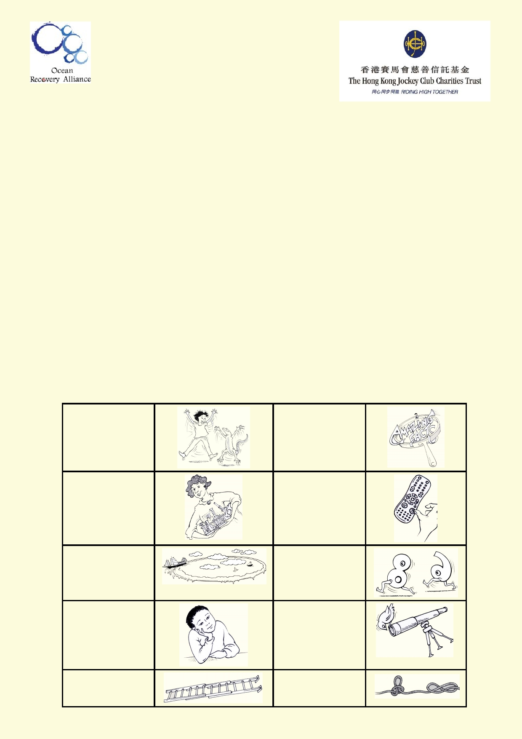About The Jockey Club Water Caretakers of Tomorrow Programme:

Jockey Club Water Caretakers of Tomorrow Programme is organised by Ocean Recovery Alli-
ance, Ltd and funded by The Hong Kong Jockey Club Charities Trust. There are eight units in
this program, and each of them is designed with you, a student in Hong Kong, in mind.

These are the goals for your lessons, to:
• Understand and appreciate how our water systems function on a local and global scale.
• Understand how watersheds function, and the interconnections of life within and between
these watersheds.
• Be able to assess threats, such as pollution and habitat destruction, and learn how to
lessen these effects.

Student introduction
• You will need access to the internet.
• In some activities using the camera in your smart phone or tablet will be useful.
• Your teacher will tell you if you if your work will be done on your computer, printed paper or
notebooks.
• Below is a key to the illustrations found in the student notes.

Start of a new activity. A new amazing fact.

Get ready to do an experiment.

Identify your
misconceptions
before your move on.

Identify your
prior learning.

Fast forward to make
your
contribution to
improving our world.

Data will be used to
solve
problems.

These are the goals for this unit.

An extension activity A cross-curricular
activity

2

Student aims:

At the end of this unit I will be able to:
• Describe a freshwater ecosystem and the factors that affect it.
• Compare differences in natural and polluted ecosystems.
• Understand appropriate conservation and management strategies for
freshwater ecosystems.
• Be able to identify most common flora and fauna in Hong Kong freshwater ecosystems.
• Understand how organisms are adapted to their unique environments.
• Collect data in the field for studying a freshwater environment

Glossary

Adaptation

Amphibian

Biodiversity

Ecology

Ecosystem

Endemic Species

Estuary

Flora/ Fauna/ Biota

Food Chain

Food Web

Indicator Species

Invasive Species

Microhabitat

Niche

Nutrients

Organism

Changes in an organism's structure or function that enable it to better
survive and reproduce in its environment.

An organism that is able to live in water and on land.

How rich in different lifeforms a system is.

The study of the relationship of organisms to each other and to their
surroundings.

A biologically interconnected community.

An organism found only in a particular place.

Partially enclosed coastal body of slightly salty water with one or
more rivers or streams flowing into it, with connection to the open
sea. It is a transition area between freshwater and marine
environments.

Plants/ animals/ all manner of life forms.

A linear feeding connection typically but not always starting with a
plant, and ending with an animal.

The feeding connections of all plants, herbivores, predators, prey
and decomposers within a given ecosystem.

An organism that reveals the state or health of an ecosystem.

An organism that has been introduced to another system other than
its own, that starts to rapidly outcompete local species.

A small home specific to a certain organism.

The specific position and role of an organism in an ecosystem.

Substances that nourish life, enabling survival and growth.

An individual living thing, such as a plant, animal,
bacterium, protist or fungus.

3

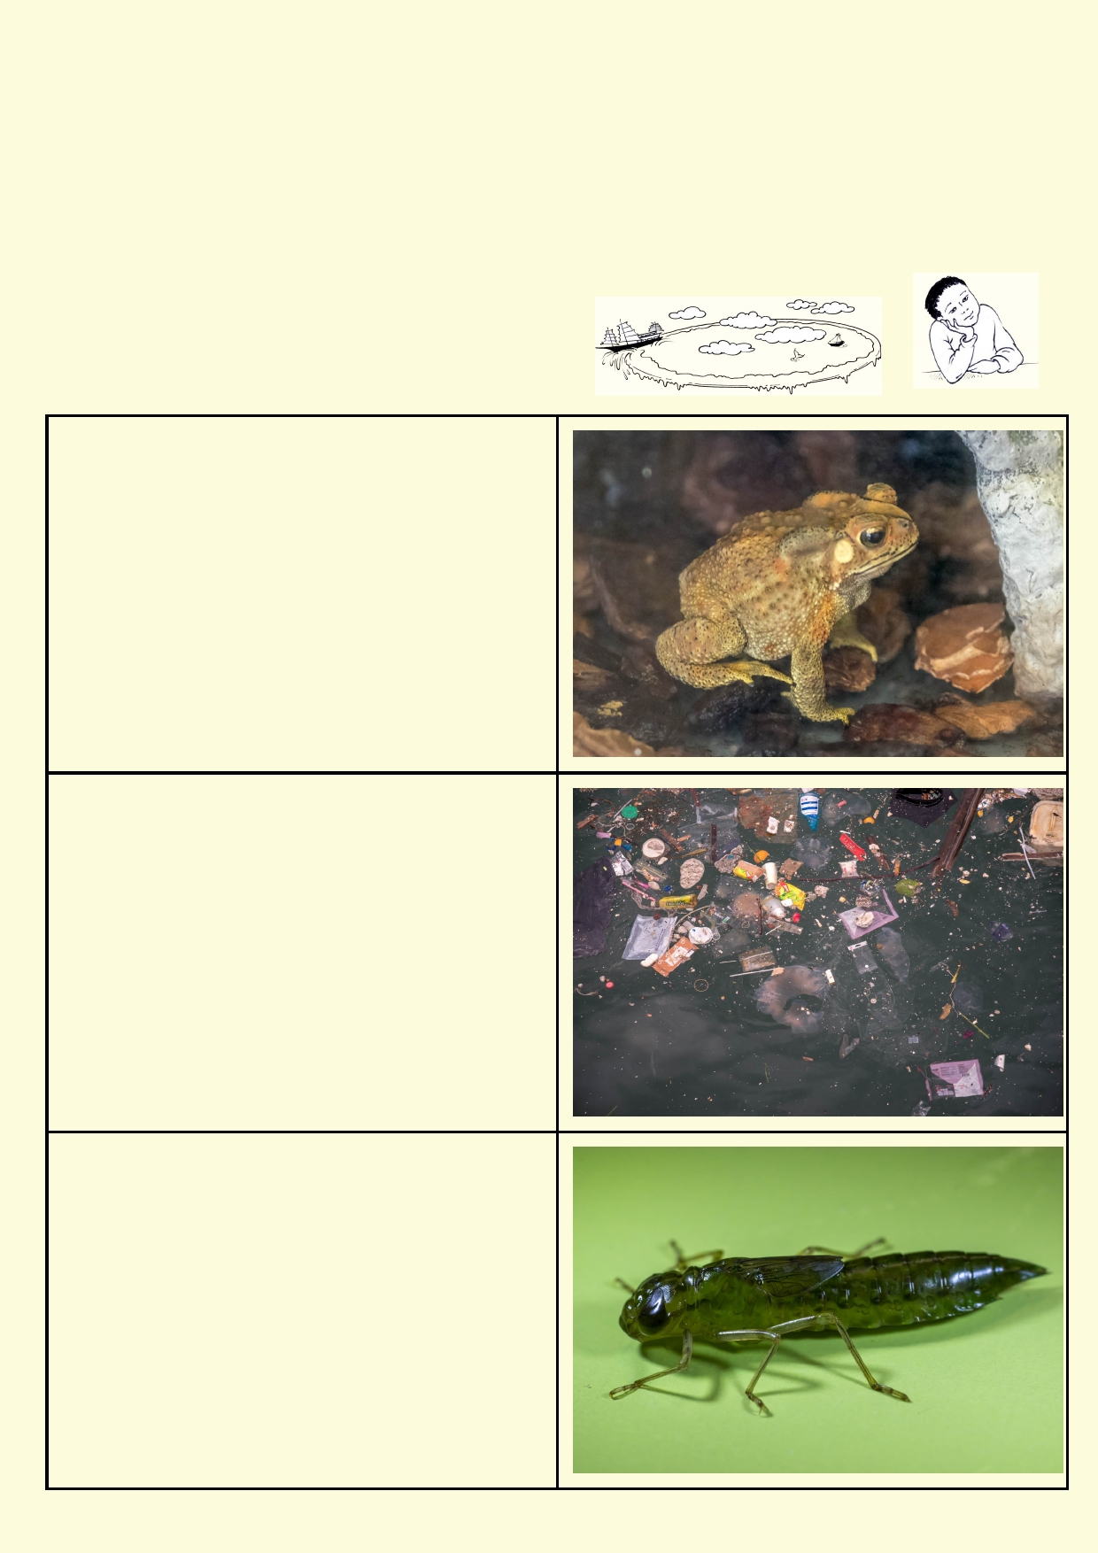Physical Factors (Dissolved Refers to the measurable characteristics of an
Oxygen, Temp, Humidity) environment or system.

Turbidity Measure of the murkiness or clarity of water.

Velocity flow Speed and direction at which something is moving.

What do you know? Skipping from stone
to stone

Answer these questions:

Why do frogs need clean water?

Why are amphibians generally an indicator
species for pollution?

Name some organisms you would find in
a freshwater system in Hong Kong.

4

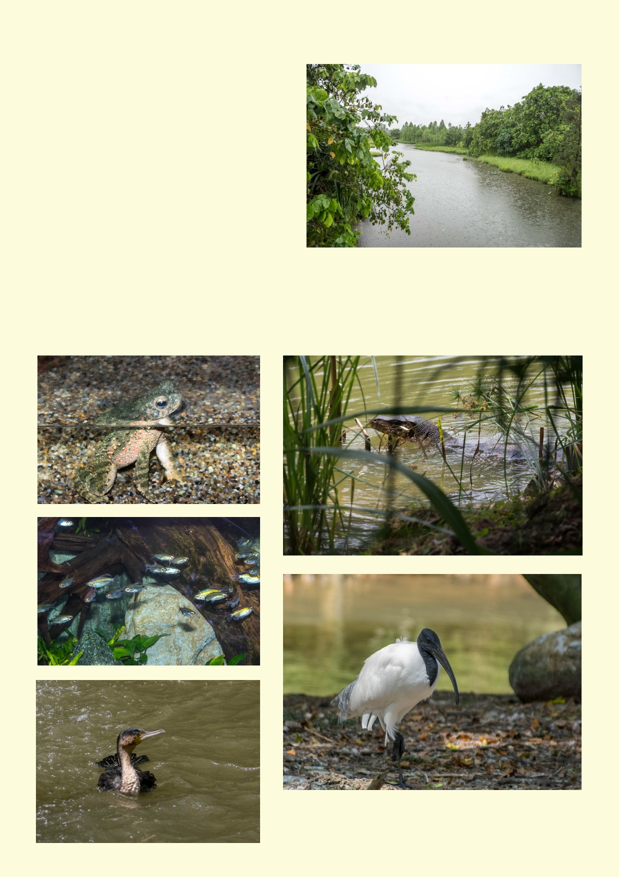Lesson 1. Ecology of freshwater ecosystems

An ecosystem is a community of all the living
animals, plants and bacteria interacting in their
physical environment. This includes the
process of decay which recycles nutrients in
that environment. Water is essential for all
living things in an ecosystem.

Freshwater ecosystems derive their food from
living plants as well as dead, organic materials such as leaves that enter the waterway.

Many people use the word wetland when they
are thinking of a marsh or swamp, but they are generally areas of land covered with water long
enough to support unique vegetation and have characteristic wetland soil. They include some
wetlands which have water for a portion of the year, drying out when there has been little rain for
a while. There are many kinds of wetlands that include both flowing water and stagnant water.
They can be freshwater or salty.

.

5

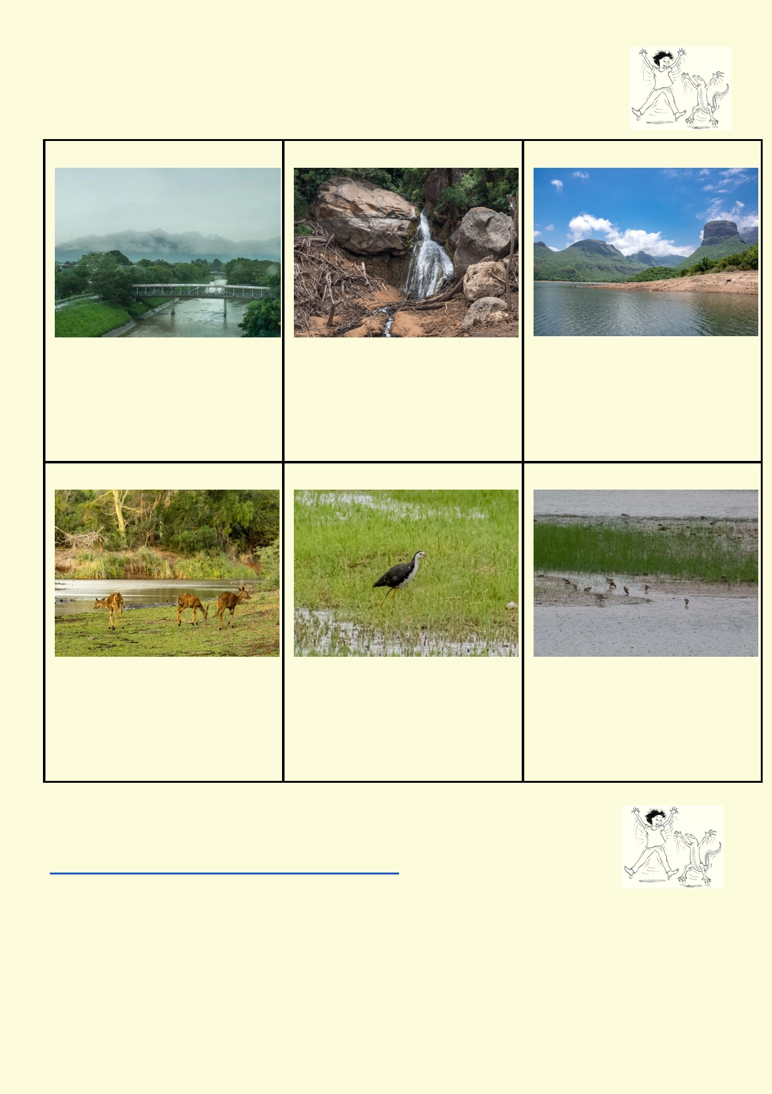Activity 1. Spot the different freshwater ecosystems

For each of these freshwater ecosystems, write three things that help to describe it.

River Fast moving stream Lake

_________________________ _________________________ _________________________

_________________________ _________________________ _________________________

_________________________ _________________________ _________________________

Pond Marsh or wetland Mudflat

_________________________ _________________________ _________________________

_________________________ _________________________ _________________________

_________________________ _________________________ _________________________

Activity 2. Physical characteristics of a river

While watching this video, take notes about the physical characteristics of the river
https://www.youtube.com/watch?v=QVUyBJqJneY

Physical characteristics that I observed were:

_____________________________________________________________________________

_____________________________________________________________________________

6

How did the physical conditions of the river change? This might include the dimen-
sions of the river, speed of the water, its colour, volume, the bottom and banks of the river, etc.

_____________________________________________________________________________

_____________________________________________________________________________

Amazing fact:
Colder water can hold higher con-
centrations of oxygen. Studies
show that some creatures can't
breath fast enough in warmer wa-
ter.

What you couldn't see in the video

These are the main physical characteristics that are measured to find out how clean or polluted
rivers and other wetlands are:

Oxygen: When the oxygen level drops many of the animals with gills will die. Aquatic plants and cascading water oxygenates the water.

Nutrients: Most of the nutrients in water come from land sources. Rotting leaves adds to the nu- trients along with fertilisers, detergents, human and animal feces etc. The amount of phosphorus
and nitrogen chemicals are measured to estimate the amount of nutrients. High nutrients can cause an explosion of bacteria and plant growth that reduces oxygen levels.

Bacteria: The measure of bacteria indicates the amount of human and animal feces that get into
the water and the likelihood of dangerous (to humans and other living things) bacteria species.

Conductivity: By finding out how well electricity is conducted by a water sample, the amount of salt can be estimated.

Temperature: When water has unusually high temperatures, there will be less oxygen. Also, dif- ferent organisms are adapted to living in specific temperature ranges. If the temperature of their water gets too high, they can sicken or die.

Turbidity: This is a measure of how far light can pass through the water. When water looks very dirty, light can't penetrate very deep. There is less opportunity for aquatic plants to grow with less
light.

pH: pH is a measure of how acidic or basic the water is. The pH affects many biological chemical reactions. The preferred pH is neutral.

7

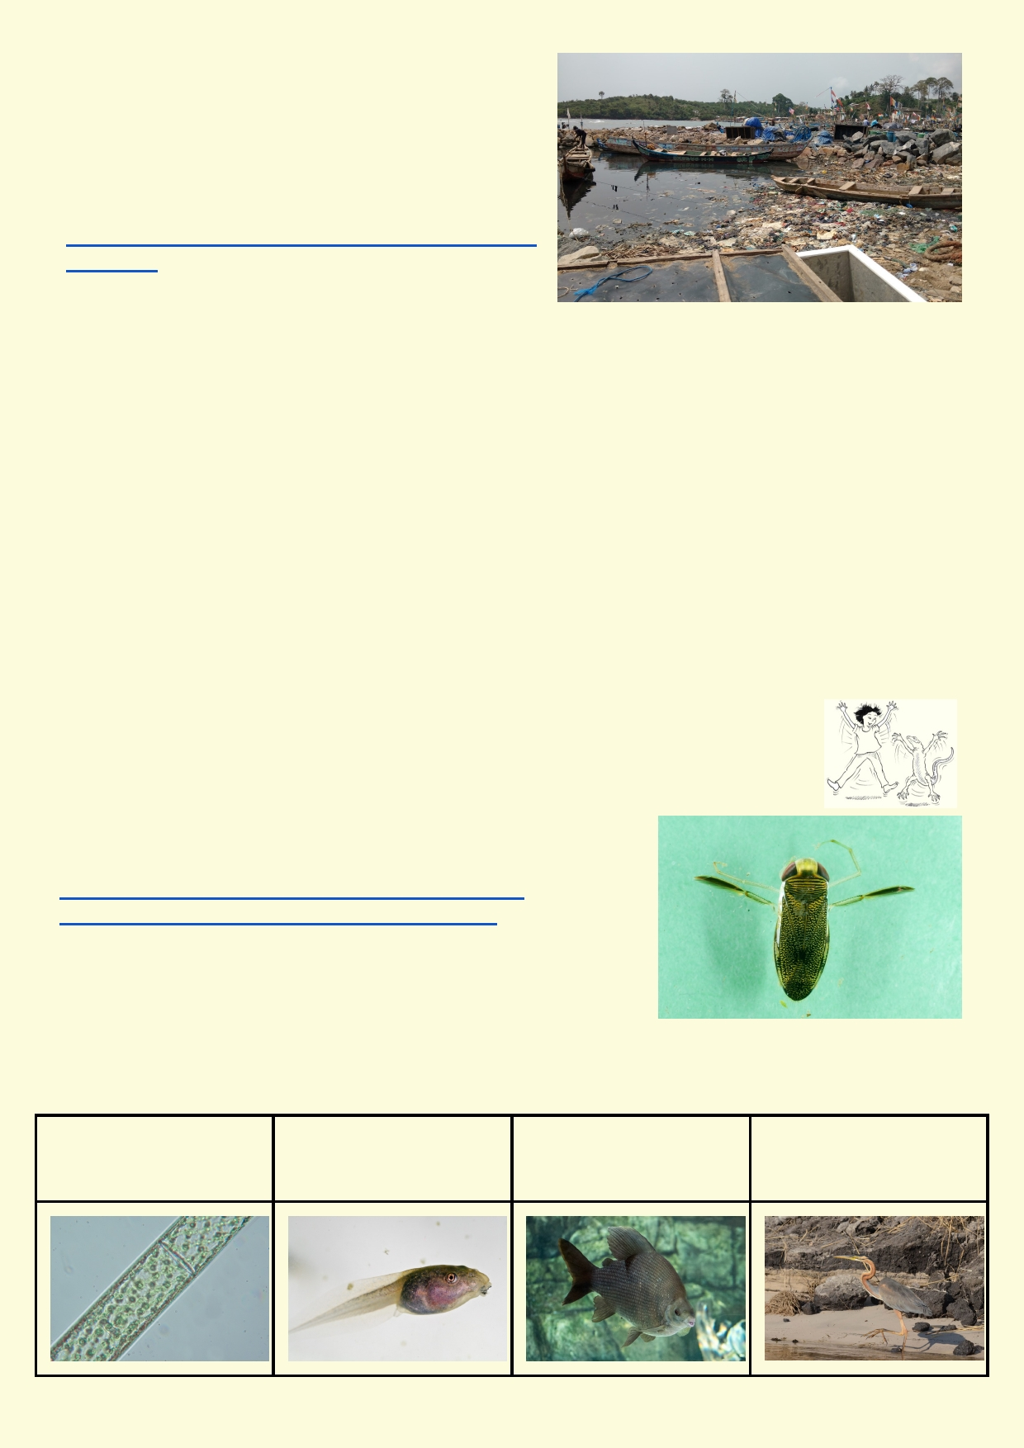World's most polluted rivers

This website suggests which 15 rivers in the world are most polluted. These rivers have high readings
for bacteria and most polluting chemicals. They will have low readings for oxygen.
http://listovative.com/top-15-most-polluted-rivers-in-
the-world/

Look at the website. What do these rivers have in
common? Which of the rivers are in watersheds that have very high populations?

_____________________________________________________________________________

_____________________________________________________________________________

_____________________________________________________________________________

Which continents are not represented in the list?

_____________________________________________________________________________

Activity 3. Freshwater ecosystems

There are more animals besides fish in a freshwater ecosystem. Most fish rely on eating small invertebrate animals. Invertebrates are those animals that don't have
a backbone.
Look at these videos to get an idea of some of the life in
freshwater and the ways people go about monitoring these
invertebrates.
https://www.youtube.com/watch?v=F6RKxeREHLc
https://www.youtube.com/watch?v=67G5jr_t_iM

Simple food chain

A food chain is a simplified way of showing how energy passes
through an environment. All forms of life need energy to survive and to grow. They get this energy
either directly from sunlight or simple chemicals, or from eating other living things.

Algae needs sunlight to Tadpoles use their Larger fish may eat Herons eat fish
make food and grow grinding teeth to eat tadpoles
plants

8

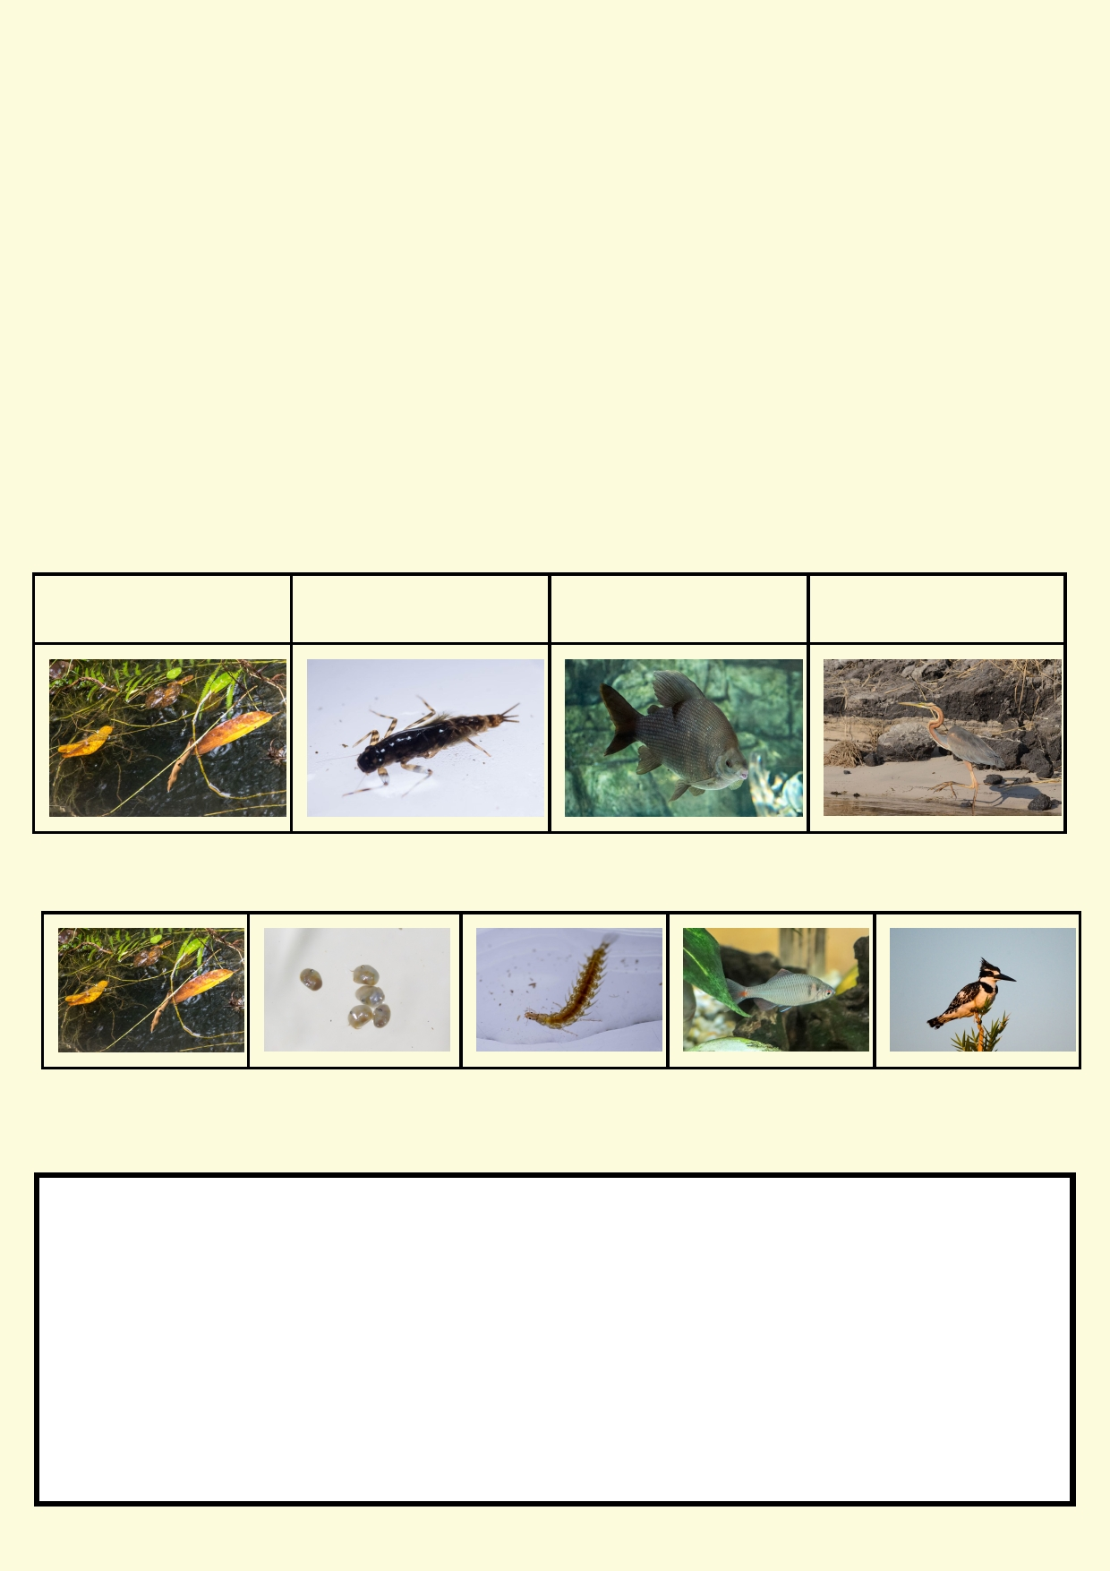In this food chain we start with a plant. It has obtained its energy from the sun through the process
of photosynthesis. Plants can use the energy from the sun and convert carbon dioxide and water
into a simple sugar, called glucose and oxygen.

Why did the food chain start with a plant?

______________________________________________________________________________

______________________________________________________________________________

What else might eat a fish?

______________________________________________________________________________

In freshwater, food also comes from decomposing plants. So we can make a food chain that starts differently.

Bacteria decomposing Mayflies eat decompos- Fish eating mayfly lar- Heron eats fish
leaves ing plants vae

Or we could make a longer food chain:

Draw a food chain using these organisms, mayfly adult (flies), decomposing plants, heron and a
frog.

9

Activity 4. Freshwater community and food web

Compared with a food chain, a food web is a more detailed way to see how plants and animals are interconnected. We can show more than one plant in a food web
and also include decomposers. In a food web we can draw how many animals eat
many different foods. It allows for many interconnections and that's why it starts looking a bit like
a web.

Materials:
Large sheet of paper (art paper)
Drawing materials
Scissors
Paper glue

What is an invertebrate?
Birds, mammals, fish, amphibians and reptiles have
backbones. The backbone is made up of vertebrae.
Animals that don't have backbones are often referred to as invertebrates. The majority of
animals in the animal kingdom are invertebrates which include insects, spiders, shrimps, snails,
segmented worms, sea stars and sponges.

Name some of the invertebrates you are likely to encounter around Hong Kong.

____________________________________________________________________________

____________________________________________________________________________

Designing a food web

Look at this website to see a generalised food web of a river.
http://www.lifeinfreshwater.org.uk/web%20pages/rivers/CarnivorFdWeb.htm

What does the direction of arrows in a food web indicate about the energy flow within a food web.
____________________________________________________________________________

____________________________________________________________________________

Use the images on pages 11 and 12. Read the text for each box to find out how each organism obtains its energy (food). Cut out each photo. Arrange the the photos to make a food web.
Connect the photos using arrows showing the flow of energy through the food web. Use the
diagram on page 13 for help.

10

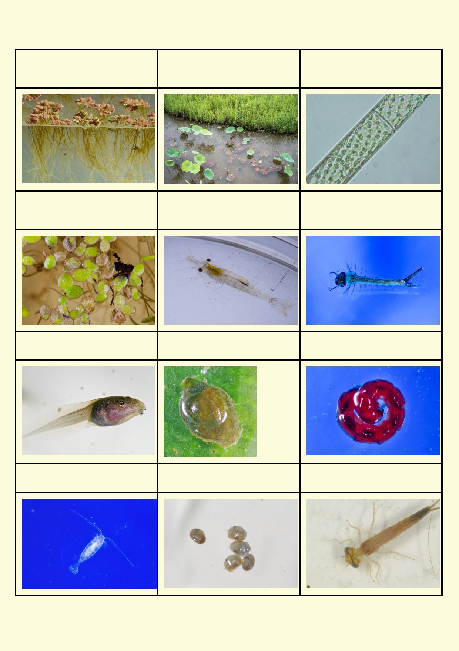Azolla (fern) - makes its food Plants emerging from the water Algae - makes its food from
from sunlight and carbon - makes its food from sunlight sunlight and carbon dioxide
dioxide. and carbon dioxide

Duck weed - makes its food Shrimp - eats algae and Mosquito (larva) - filter feeder of
from sunlight and carbon decaying plants bacteria, algae and microscopic
dioxide creatures

Tadpole - eats plants Snail - eats plants Bloodworm (fly larva) -eats
other invertebrates

Cyclops - eats algae Seed-shrimp - filter feeder of Damselfly - eats smaller
bacteria invertebrates

11

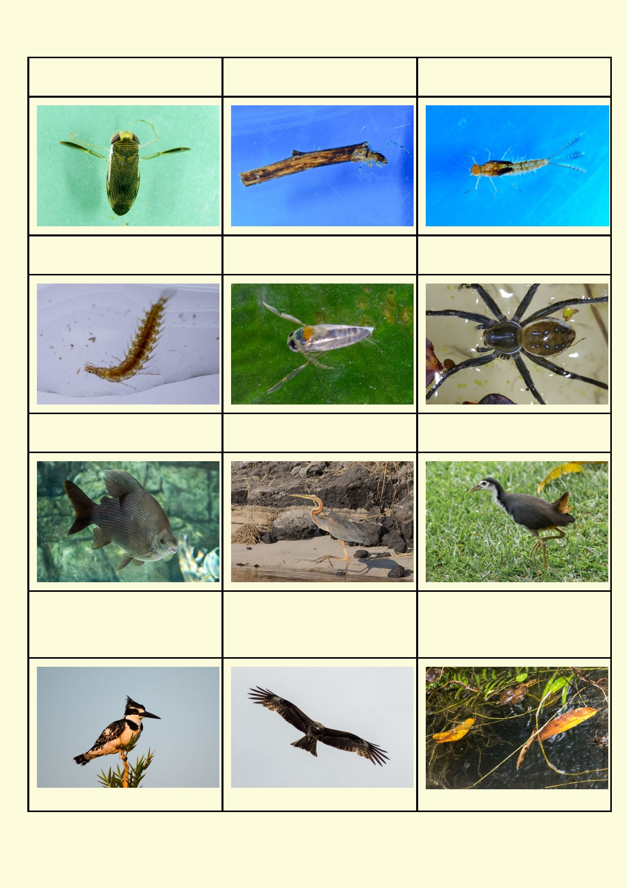Water boatman - eats smaller Caddisfly - eats smaller inverte- Mayfly - eats algae and rotting
invertebrates brates material

Beetle larva - eats smaller inver- Backswimmer - eats smaller in- Spider - eats smaller inverte-
tebrates vertebrates brates

Most fish eat smaller fish and Purple Heron - catches fish, White-breasted waterhen -
invertebrates frogs and larger invertebrates mostly eats invertebrates

Pied kingfishers catch fish Black Kite catches smaller ani- Bacteria and decomposing
mals such as frogs, reptiles, and plants. These are a major
insects source of food for filter feeders
and other invertebrates

12

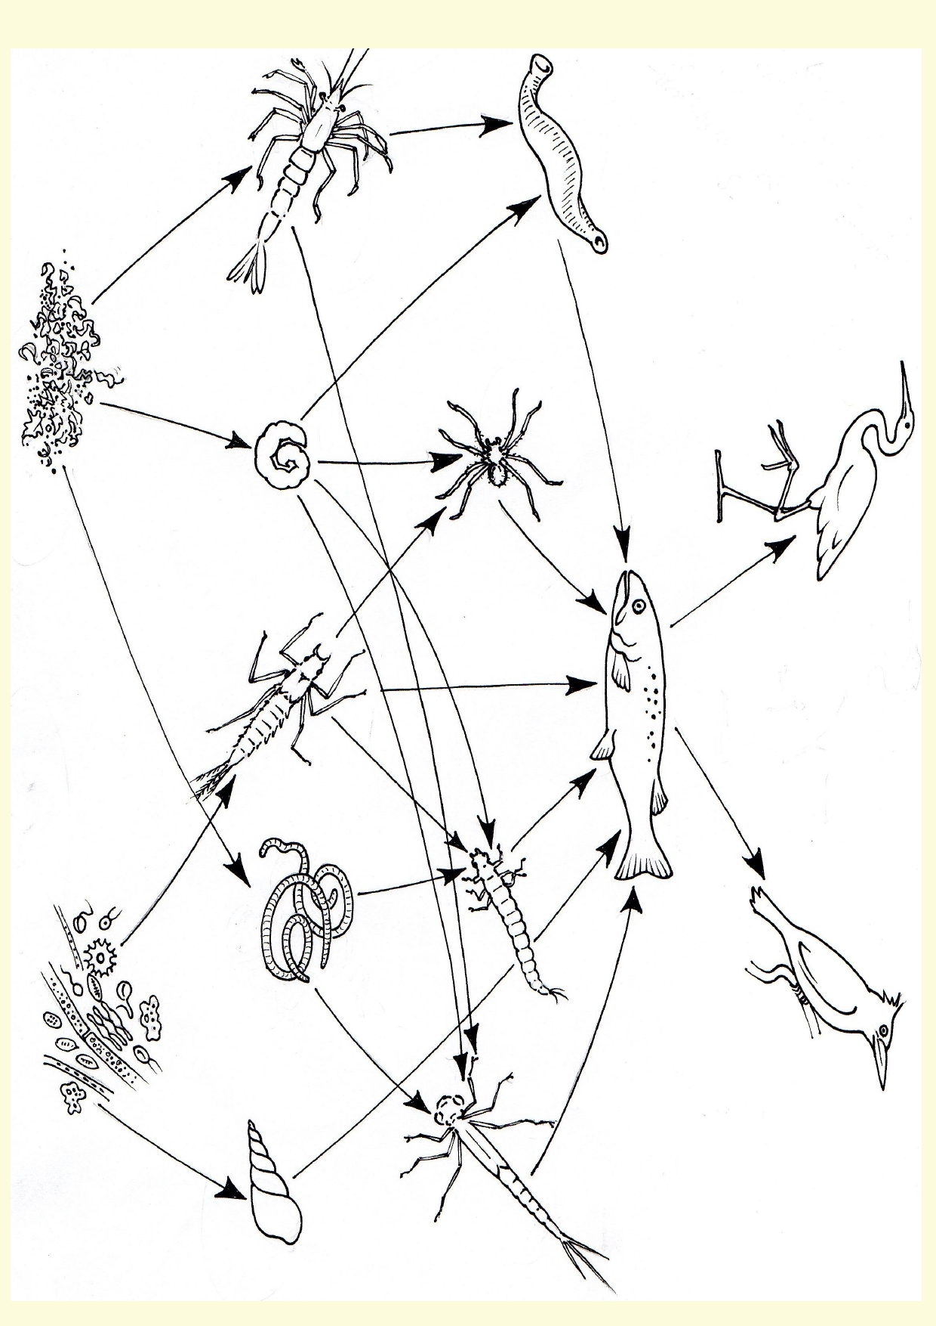
Wetland food web

13

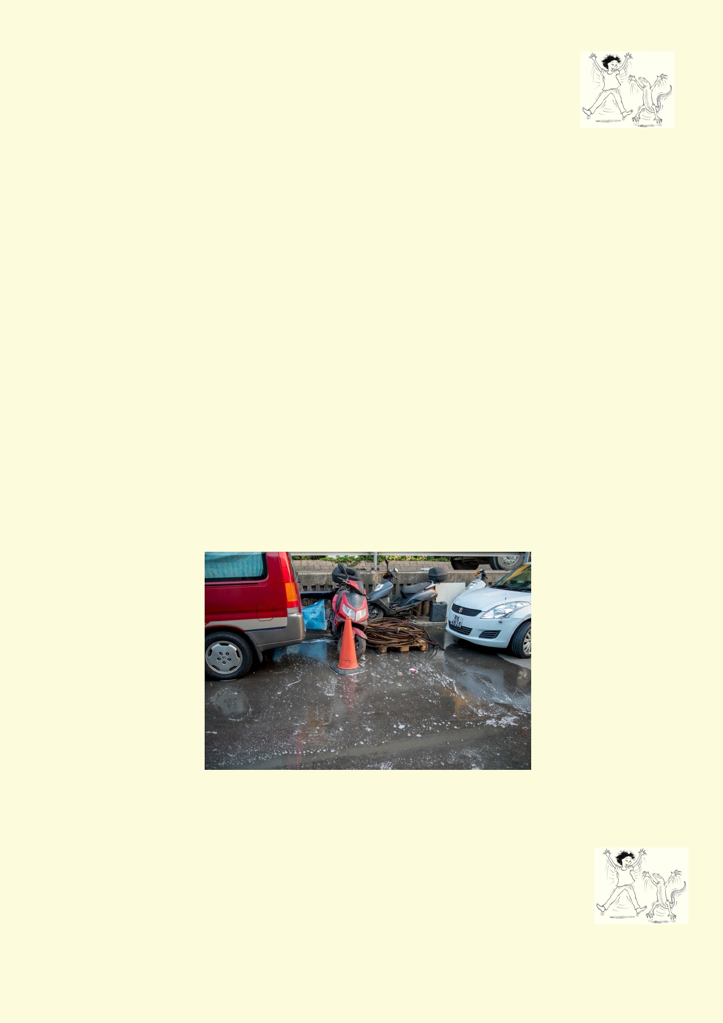Activity 5. Messing with the web

Materials
Around 60 pieces of string or wool 5 metres long
24 photos cut out

You will get your own card and then sit in a circle. String will be used to connect you to other students holding photos of things that your organism would eat and those that eat you. Keep
going making links until you have run out of string. You should now have a complex web inside
the circle.

Gently tug on your string to feel your connection with other organisms.

Below are three scenarios of how a river could be affected by outside impacts. Each scenario
states which organism dies. Students holding these photos drop their string. Other students drop
all of their strings if they no longer hold a string that is a source of food.

Keep doing this until the full effect of the scenario is completed. Think about how the impact flows through the web.

Reset the web and do the next scenarios:
1. Herbicide gets into the river killing all the plants
2. An introduced fish eats all the insects
3. An oil spill kills all the species that eat rotting material as well as the fish

Lesson 2. Who are you and what do you do?
A quick investigation into aquatic classification, biodiversity and adaptation.

Activity 1. Twenty questions

Materials
• Print and cut out images from Activity 4 (Freshwater Community and Food
Web) .
• Large paper clips.

14

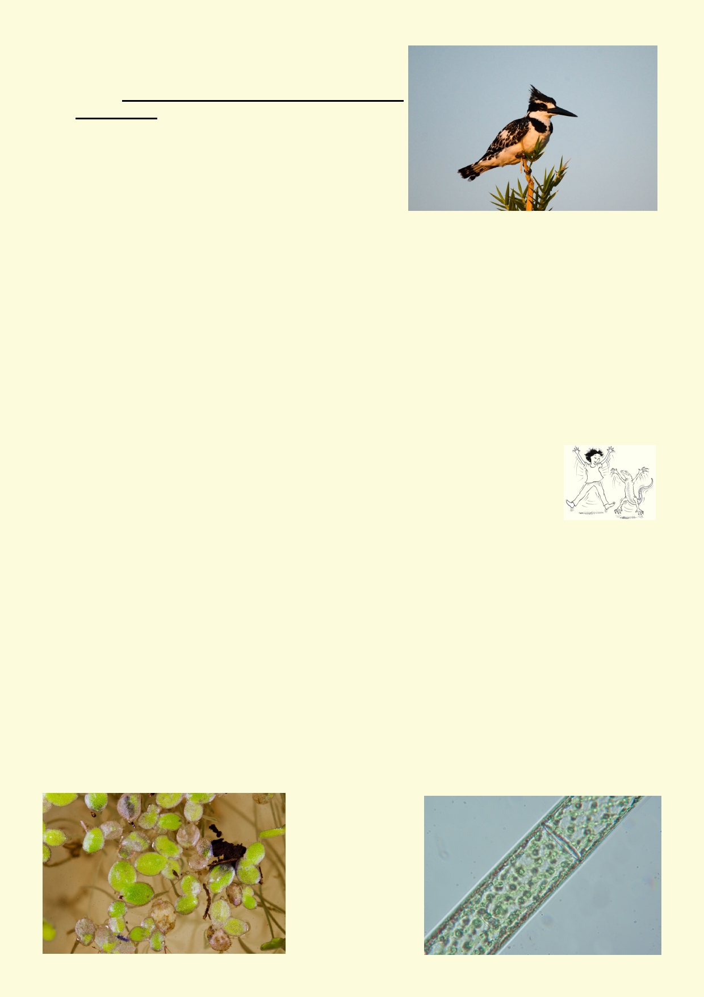1.

2.

3.

4.
Place an animal or plant on another student's collar
with a paper clip. The student must not see the
image. Make sure you don't scratch the student with
the paperclip.
You are to think about questions you can ask about
the plant's or animal's features, habitat and
behaviours so you can quickly narrow down what is
on your back.
You can ask questions of any other students, but
they can only reply yes or no. You only have up to 10 questions. Each time you ask a question, they put a line on your card.
How many questions will it take for you to find out your plant or animal? Could you only get
close to what it was?

Use the animal and plant photos from Lesson 1. Use a paper clip to place one of the pictures on the back collar of every student without them seeing the picture.

Students then ask other students questions about the features of the animal. The answer can
only be in the form of yes or no although the student being asked can pass if they can't answer.
Each student counts the number of questions until they can name the animal or get as close as they can.

Activity 2. Animal and plant keys

Aquatic plant key

To identify plants and animals, experts design dichotomous keys. They provide
two choices that use features that can separate the organism into two groups. More and more
choices are made until all the organisms are separated out into the desired groups.

In this plant key you are using some major features to find out which major group of plants the fsix photos of plants in Lesson 2, Activity 3 belong to. Once you have worked through the key,
write the name of the plant below the name of the group.

15

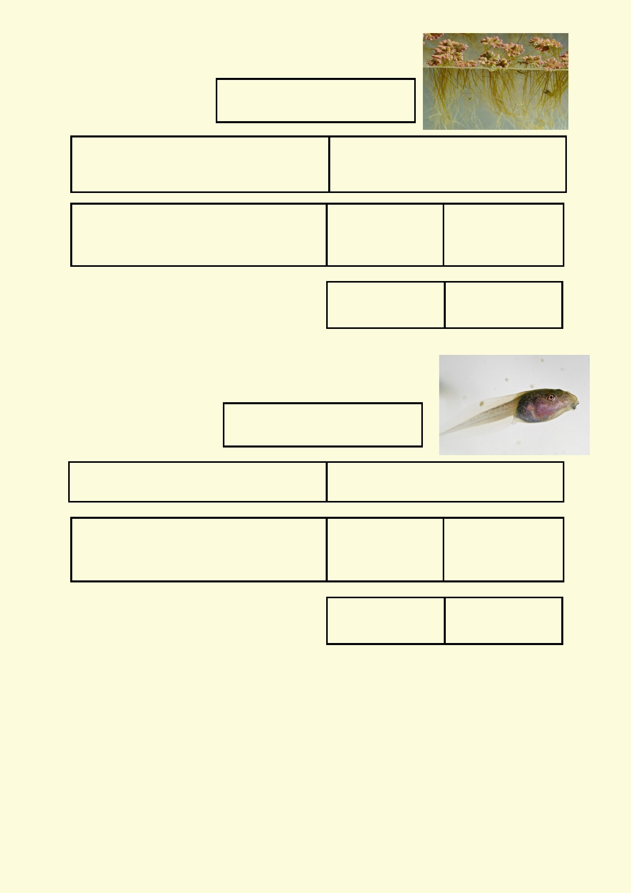Makes food through a process
called photosynthesis

Plant has no specialised structures
Go to 1

Has specialised structures such as
leaves and roots.
Go to 2

1. Algae

2. Reproduces us-
ing spores
Go to 3

3. Fern

2. Reproduces
using flowers and
seeds
Go to 4

4. Flowering plant

Vertebrate key
This key will divide the vertebrates in Activity 3 into major groups.

An animal with a backbone

Has feathers Does not have feathers
Go to 1 Go to 2

1. Bird 2. Body covered in 2. Body covered in
scales skin
Go to 3 Go to 4

3. Reptile 4. Amphibian

Invertebrate key

This key will divide the invertebrates in Activity 3 into major groups.

Often invertebrate keys are difficult because to find all the features, you would need to look at the
animals under a microscope. Another thing that sometimes makes identification difficult is that
some organisms look very different at different points in their lives. For example, some animals
have no legs in their larval stage and some only have six legs when they are an adult.

16

Animal without a backbone

Has a shell Has an exoskeleton
Go to 2 Go to 2

1. Mollusc
(snail, clam)

3. Spider

2. Has eight legs
Go to 3

3. Has walking
l egs
Go to 4

2. Does not have
eight
l egs
Go to 4

3. If they have legs
they are used for
swimming
Go to 7

4. Has 10 legs
Go to 5

5. Crustacean

7. Round, ball shaped body
Go to 8

4. Has less than 10 legs
Go to 6

6. Insect

7. Long body
Go to 9

8. Crustacean 9. Microscopic 9. Is easy to see
Go to 10 without a micro-
scope
go to 1 1

10. Crustacean 11. Insect

Activity 3. Major invertebrate groups

Do some research to find out what the main observable features are of these
groups of invertebrate animals. Make some notes in the boxes in the next page.
You might want to include such information as approximate numbers of species,
physical characteristics, habitat, food.

Use your biology textbook references or this website to fill in the gaps of your knowledge:
http://ecolinc.vic.edu.au/sites/default/files/uploaded_files/discovering_wetlands/objects/L11700/
index.htm

17

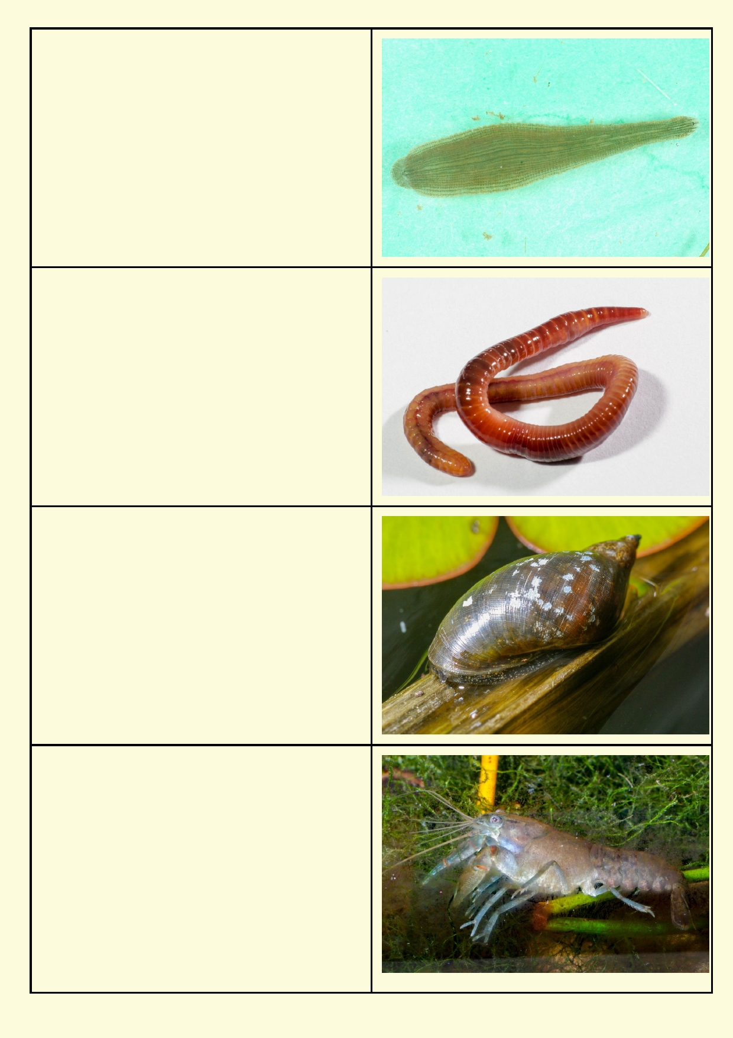Flatworms

Segmented worms

Molluscs

Crustaceans

18

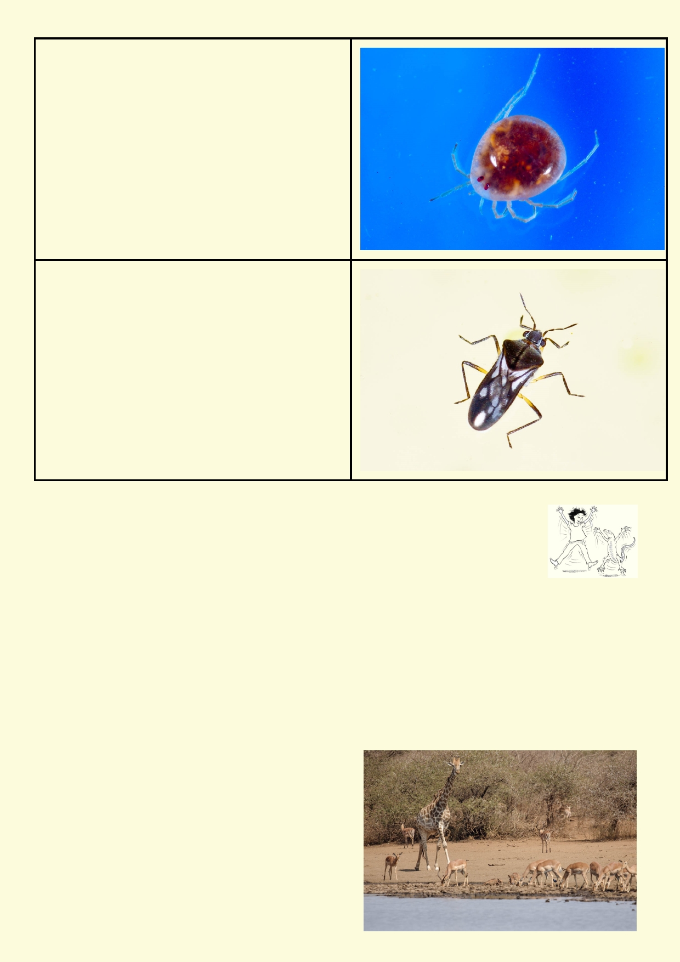Arachnids

Insects

Activity 4. Biodiversity

Biodiversity is an important new way of understanding and managing our
environment. Biodiversity is broken into three parts: Genetic diversity, species
diversity and ecosystem diversity.

Species diversity refers to the many different plants, animals, fungi, bacteria etc that live in a
region. Usually high species diversity is good for an ecosystem. Rainforests and coral reefs are
regions with very high diversity of species. The Antarctic naturally has a much lower diversity of
species. Often, in cities, many if not most of the plants and animals are introduced and interfere
with the natural ecosystem.

Genetic diversity refers to the amount of variation in the species' genes. Genetic diversity is
important for the future survival of species. There can be variation in genes from region to region.
When a population of organisms is wiped out it usually reduces genetic diversity. Small
conservation projects have the potential to maintain some of the local genetic diversity.

Ecosystem diversity refers to the variety of
ecosystems in a region or on our planet.
Ecosystems are the combination of all the living
organisms and nonliving factors which interact with
each other. Wetland ecosystems, for example,
depend on land ecosystems for their health.

19

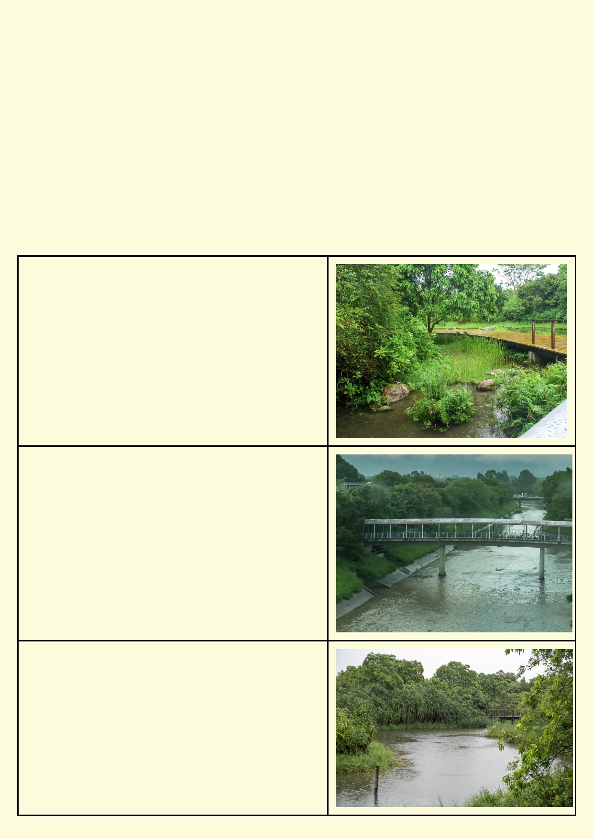Humans are affecting biodiversity
There are many ways people have affected biodiversity. These are some examples:
• Clearing land reduces habitat and prevents many animals and plants from moving around.
• Large construction leaves almost no habitat for plants and animals.
• When plants are introduced from other regions, the local animals may not be able to eat
them and the introduced plants may compete with the local plants for habitat.
• When animals are introduced they might compete for food, eat too many of the local plants
or animals or even spread disease.
• Agricultural practices modify or destroy many types of habitats.
• Different types of pollution can affect habitats as well as animal and plant species.
• Can you think of ways plants and animals can be accidently introduced into an ecosystem?

Ecosystem and species diversity
These are some ecosystems around Hong Kong. Explain why you think some of these ecosys-
tems might have high or low species diversity.

Small wetland surrounded by natural vegetation

Concrete-lined river

Large wetland lined with natural vegetation

20

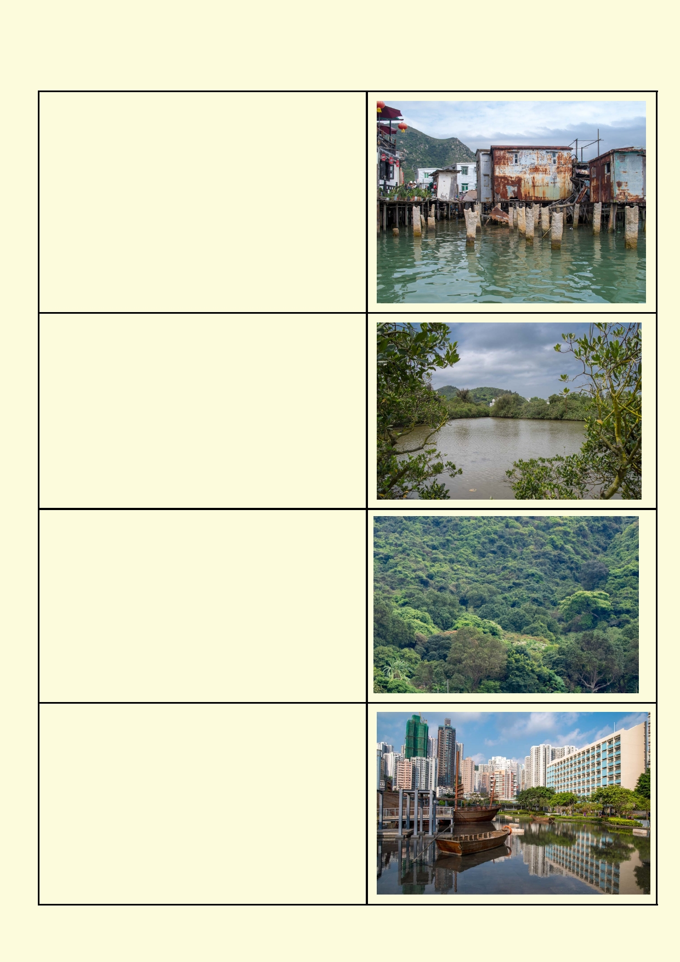Buildings in an estuary

Mangroves in an estuary

Hong Kong forest

Hong Kong park. Pond is lined with concrete and
kept looking clean through the application of
chemicals.

21

Quick species audit of school grounds:

Make a rough map of the school grounds. Put in
features such as pavements, grass, garden beds,
trees, buildings and lights. Assign groups of students
to different parts of the school ground so
they concentrate on just one school ground feature.
Look for the number of different species you can
observe. Those looking at garden beds could use a
ruler to poke around in the soil. Besides looking for the
animals, look for evidence of their presence, e.g.
chewed leaves, deformed leaves and stems due to insect action.

Each group has the same amount of time to look for species of plants and animals.

Helpful tools are a ruler or a spoon for digging in the garden soil. Look in the grass, in pavement cracks and building cracks. Be aware small flies will escape in seconds.

Hints:
• Pavement - look for things living in cracks, look for snail trails
• Trees - look for webs, things living under bark, galls, chewed leaves
• Garden beds - poke around the soil using a ruler for worms, pill bugs, millipedes etc. You
might find snail shells
• Grass/lawn - look for small piles of tiny dirt balls on the grass. These belong to earthworms.
Look for flies, snails and slugs among the grass. Use a portable vacuum to such up insects.
• Buildings and their walls and lights - look at cracks and windows. Look around outdoor lights
which attract nocturnal invertebrates.

Safety - Do not climb off the ground. Never handle animals that look like bees and wasps.

Predict which survey area will have the greatest diversity of species and give your reasons why.

_____________________________________________________________________________

_____________________________________________________________________________

Area being surveyed by your group :_____________________________________

What are the physical features of the survey area?

_____________________________________________________________________________

_____________________________________________________________________________

22

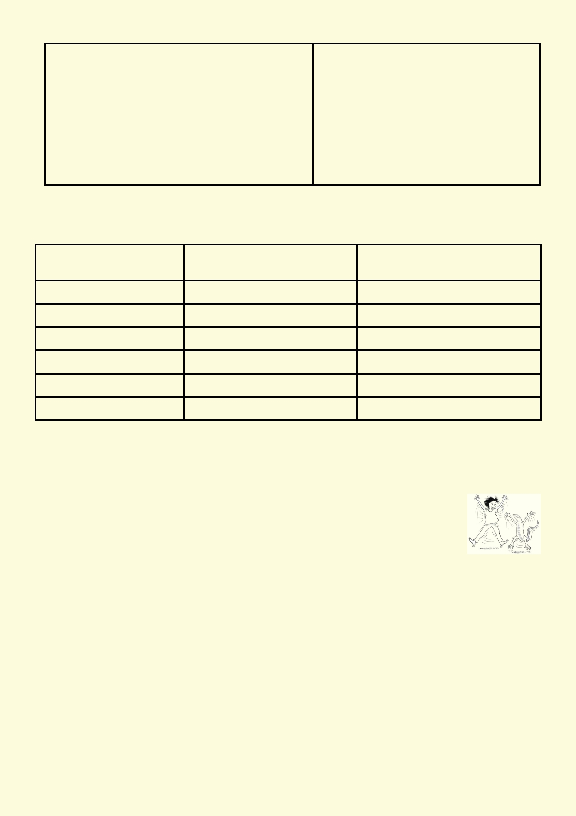Number of different plants Number of different animals

After the survey, complete the table below using the class' data. If you had more than one set of
data for any survey area, use the data with the highest score.

Survey area Highest number of different Highest number of different an-
plants imals

Pavement
T r ees

Garden beds

Grass/lawn
Building and lights

Other

Which survey area had the greatest diversity of plants? ________________________________

Which survey area had the greatest diversity of animals? _______________________________

Activity 5. Adaptation

All living organisms have their own way of surviving in their home. The way they survive is called adaptation.

Physical adaption
When we look at animal and plant features we can often see how their features are adapted to the
way they live. Some features will help them obtain food and water, while other features may help
in their protection. We can often work out how animals move, for example, by looking at their
physical features.

Behavioural adaption
Animals and plants might do things that help their survival. For example, the time of year that they reproduce maximises the chance of their young's survival. Some animal species huddle together
in large groups to keep warm. This is another behavioural adaptation.

23

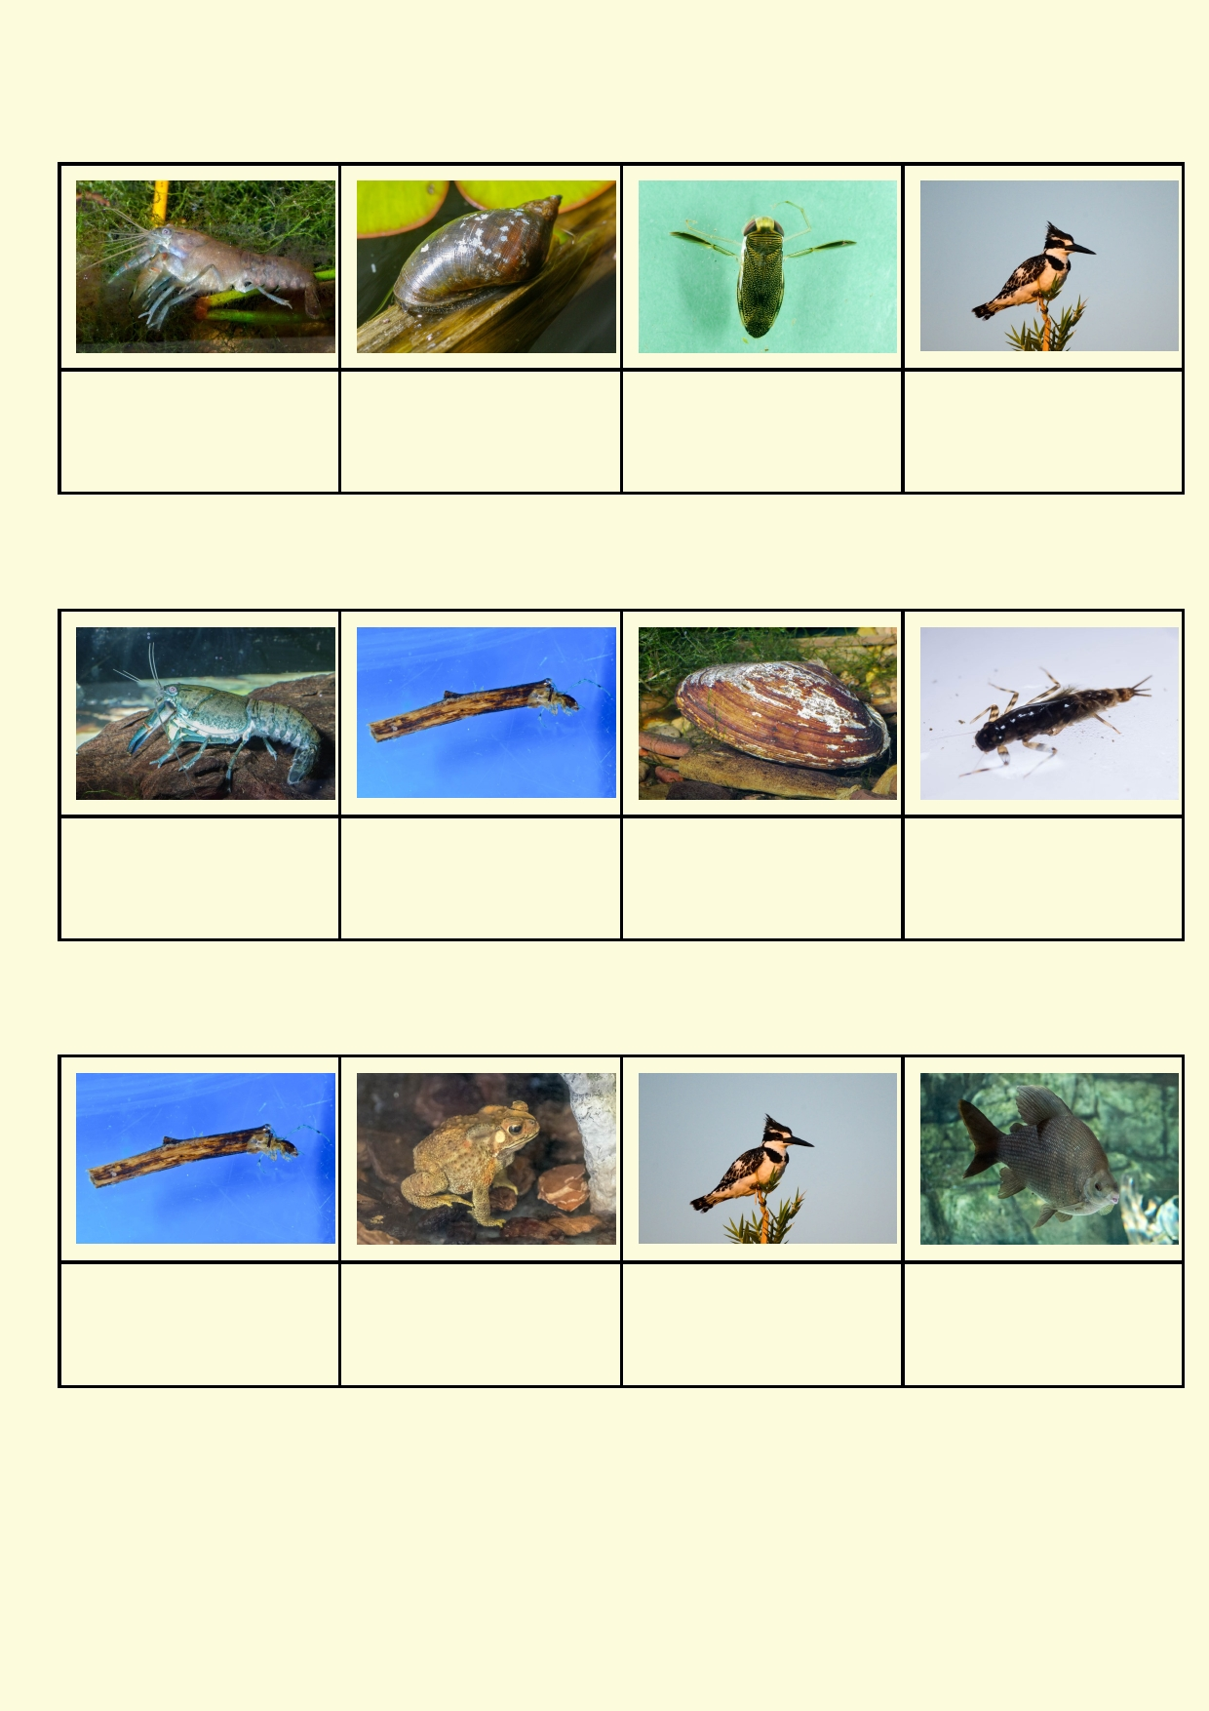Look at the animal features below. How do these organisms move? Note that some may have more than
one way of moving.

Freshwater grayfish Snail Waterboatman Kingfisher

Look at the animal features. How do these organisms protect themselves? Note that some may have
more than one way of protecting themselves.

Freshwater crayfish Caddisfly Freshwater clam Mayfly

Think about what these animals might do if they see danger. What can they do to best protect them-
selves?

Caddisfly F r og Kingfisher Fish

24

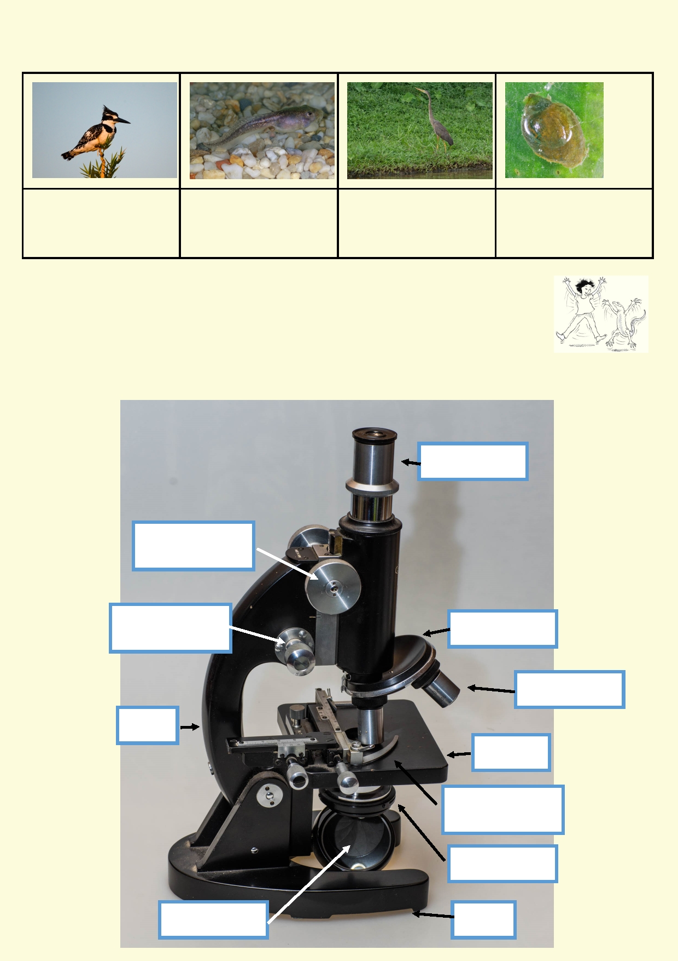Where do these animals prefer to feed and where do they prefer to rest?

Kingfisher Tadpole Heron Snail

Activity 6. Microscope

Meet your microscope

1. Familiarize yourself with the parts of the microscope. Listen carefully to your
teacher's instructions about how to handle the microscope. They are fragile and ex-
pensive items.

Eye piece

Coarse
adjustment knob

Fine
adjustment knob

Arm

Light source

Nosepiece

Stage

Stage clip

Diaphragm

Base

Objective lens

25

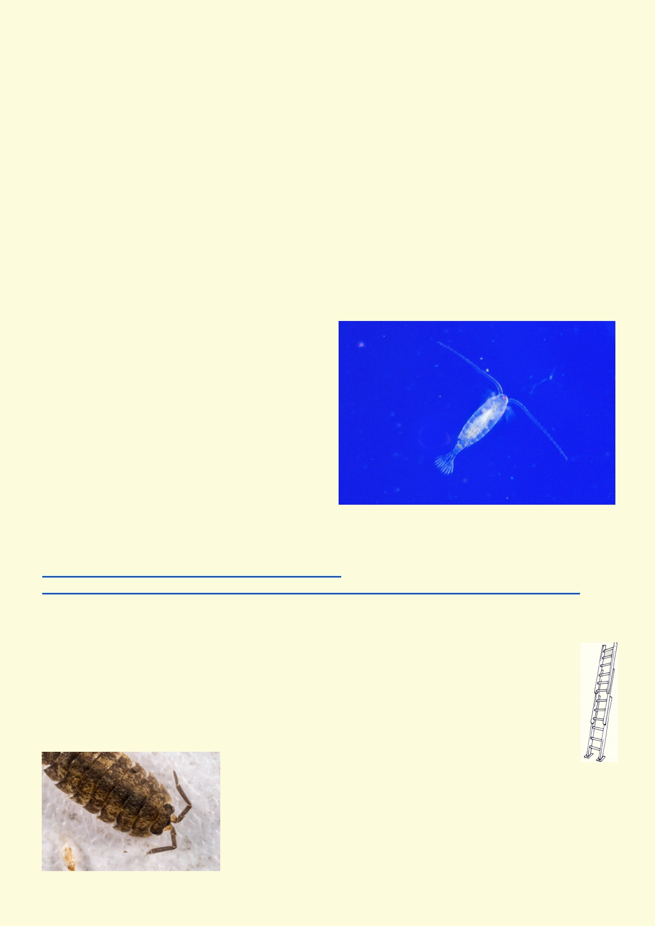2. Care and use of microscope:
Follow your teacher's instructions, using the worksheet provided to practice the steps in using the microscope.

3. Preparation of slides:
Follow these basic steps to prepare a wet mount slide from the aquarium or pond water you are
provided with:

a.

b.

c.

d.
With your dropper, stir up the liquid, trying to get as many "dirty" drops of liquid as possible. These will likely contain the most organisms to observe.
Place one or two drops on the middle of the slide. Avoid flooding the slide. You want the drops to be contained to a small area in the center of the slide.
Apply the coverslip very gently to avoid the formation of air bubbles. Slowly lower the cover down at an angle.
Carefully soak up any excess water outside the coverslip with the edge of a tissue.

4. Looking at stuff under the microscope

a.

b.

c.

d.
For each organism you observe, divide a paper into three sections.
Make a drawing at low, medium and high
magnifications, noting the total magnification for each.
Write down anything you observe about the
movement or feeding behaviour of the
organism(s) on your slide.
Use your drawings and observations to try to identify what you are looking at.

What is it?
Use the websites below to come up with some possible identification of your organism(s):
https://au.pinterest.com/pin/436356651368838841/
www.yumpu.com/en/document/view/11055554/guide-to-identification-of-fresh-water-microorganisms

Extension: Pillbugs and slaters

Pillbugs are common and have many names including wood lice, slaters and butcher boys.
Pillbugs and slaters are similar but belong to different groups. When gently prodded,
pillbugs roll into a ball, but slaters will try to run away. The photo is of a slater.

You can purchase pillbugs and slaters from outside Hong
Kong. However these animals are very common in gardens,
parks and even in compost bin. They are most likely to be found in
damp leaf litter, near the soil surface, under things left on the
ground and among the roots and base of large thick grasses. It is
most likely that the pillbugs and slaters that you will find are not
native to Hong Kong. These animals are easily transported in the soil of potted plants.

26

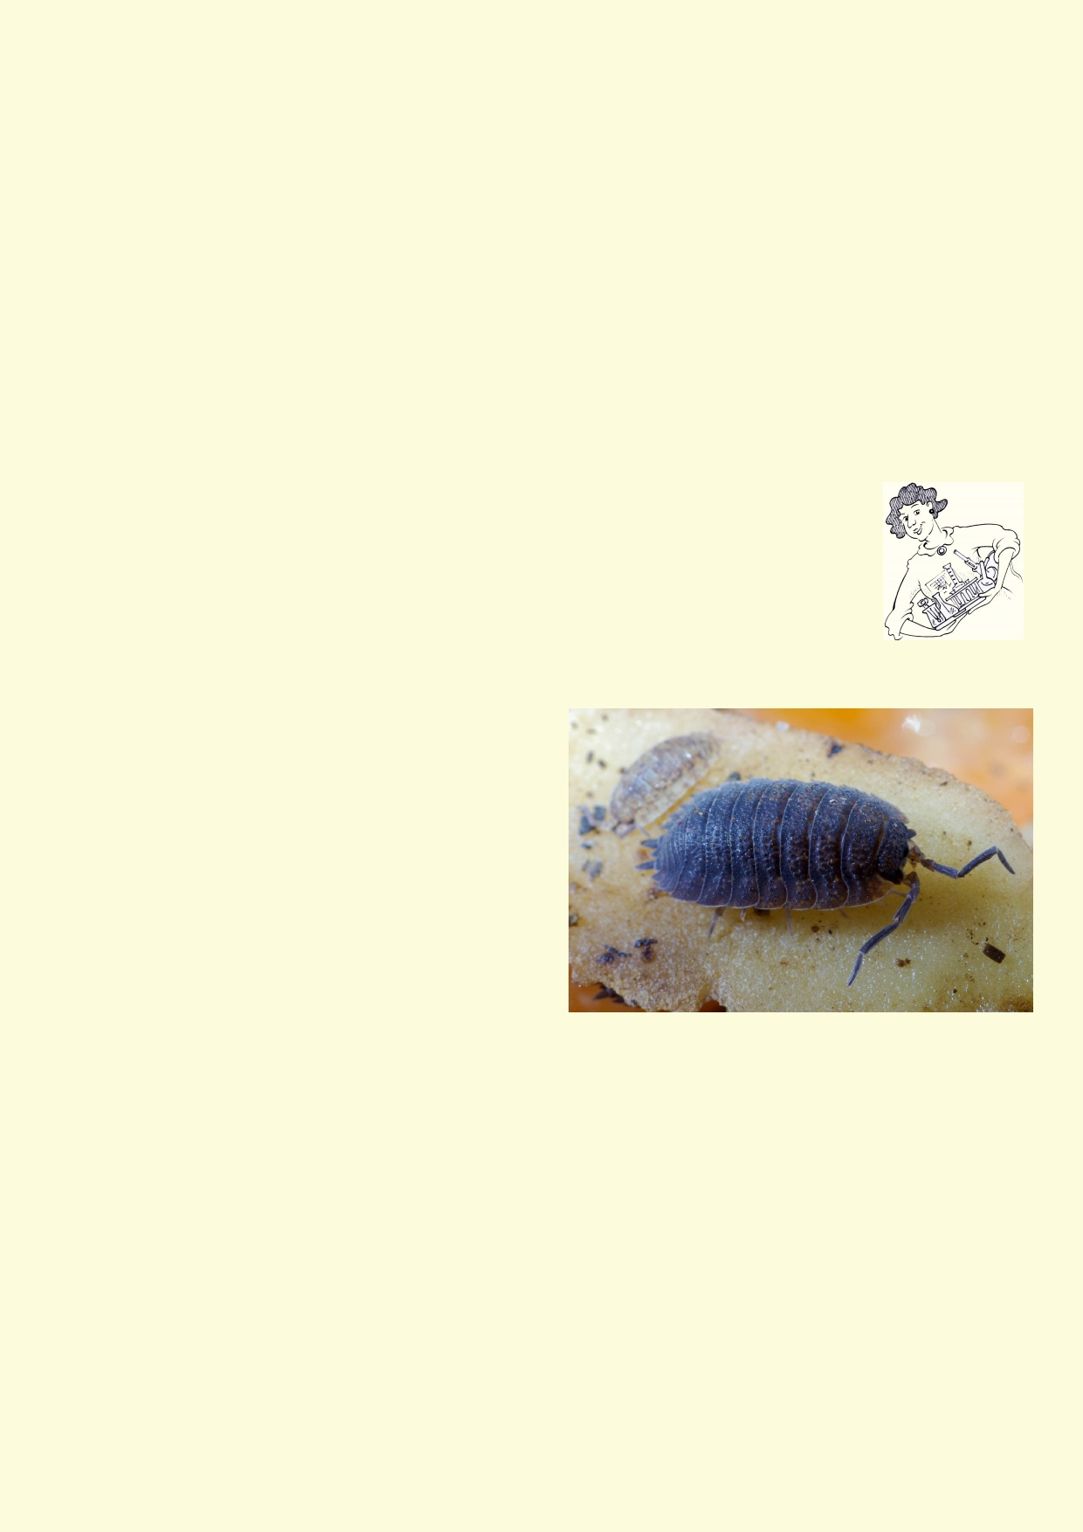You will be doing experiments on slaters. Before you go out and catch them you must make sure
you can look after them properly. This includes considering the following:
• Where and how will they be kept so they don't escape - if they escape in a building they will
di e.
• How will the animals be kept damp - the thing that will kill them quickest is drying out. Too
much water will allow their home to go mouldy. Do not worry about lack of oxygen, they will
go to sleep. Drying out is lethal. If they were in a large jar, you only need to open it every
second day.
• You must never do anything cruel to animals. If in doubt ask your teacher.
• Any experiment you want to do must first be designed and your teacher must evaluate if the
experiment could harm the animals.
• The home you make them must also have food and places for them to hide under.
• Figure out what will happen to the animals after they are not being used in experiments.

Designing your experiment
In your experiment you need to test just one thing. In many experiments it's
essential that nothing else changes.

You can do your experiment by providing your slater with a choice. Examples of
choices you could give a pillbug are:
• If they prefer to hide or stay in the open
• Preference for two different things they can hide under
• Choice of two foods
• Choice between a damp and dry place
• How fast they can move
• Trace where they move and see if the go in a
straight line
• Observe how they use their antennae to
interact with their environment
• Whether they prefer to be in groups or
remain on their own (need to make sure their
environment is the same all over)

What do you want to test in your experiment?

_____________________________________________________________________________

_____________________________________________________________________________

What kind of container will be used in the experiment? __________________________________

How many animals will be needed? _________________________________________________

What else will you need? _________________________________________________________

How will the animals be kept safe? _________________________________________________

What do you predict your animal will do? _____________________________________________

_____________________________________________________________________________

27

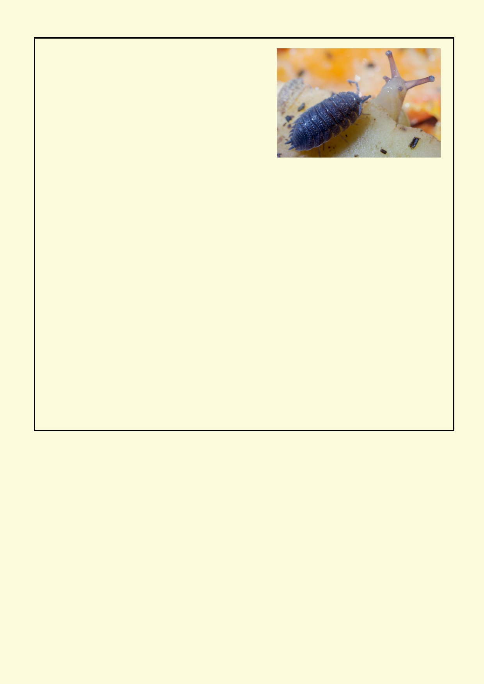Describe and illustrate your experiment

Submit your experimental design to your teacher for feedback .
Record your observations in your notebook. What did you conclude?

_____________________________________________________________________________

_____________________________________________________________________________

_____________________________________________________________________________

_____________________________________________________________________________

_____________________________________________________________________________

28

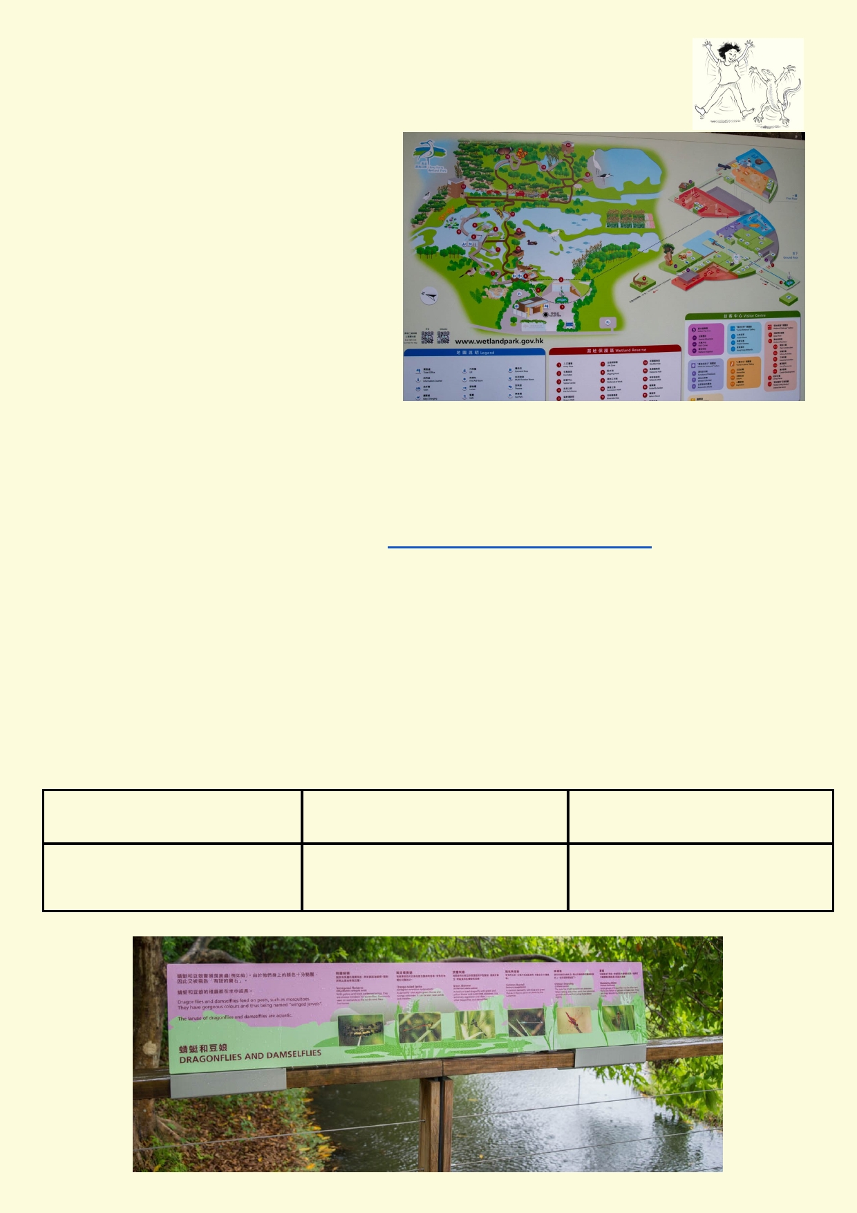Lesson 3 - Wetland field trip or excursion

Wetlands are very productive ecosystems. They are a source of fish, prawns and
shellfish for people. Healthy wetlands host a
wide range of microscopic plants and
animals, incredible life cycles of various
insects and frogs and many visiting and
permanent birds. Hong Kong Wetland Park has been developed to conserve, maintain
and expand many habitats for plants and
wildlife and for the enjoyment and education
of people.

Excursion to Hong Kong Wetland Park

If your school does not have the ability to
run a field trip to a couple of river sites, then
the Hong Kong Wetland Park is a good alternative to explore wetlands. There are extensive
walking tracks around the wetlands looking at many of the expected wetlands along with
mangroves, and tidal mudflats. It has an amazing diversity of wetland birds. The park also has
extensive graphic panels.

Use the Hong Kong Wetland Park website http://www.wetlandpark.gov.hk/en/ to find out how to
get there by train and plan a visit. Cameras to photograph habitats, plants and graphic panels and binoculars would be useful.

Gathering data
Use the information panels to gather data.
Design a plant, plant, animal and ecosystem datasheet using word or another application.
Making your own data recording sheets will allow you to insert photos back at school.

The data to be gathered could have these headings for plants:

Name of plant Adaptations to a wetland Insert photo, make drawing or
write description

29

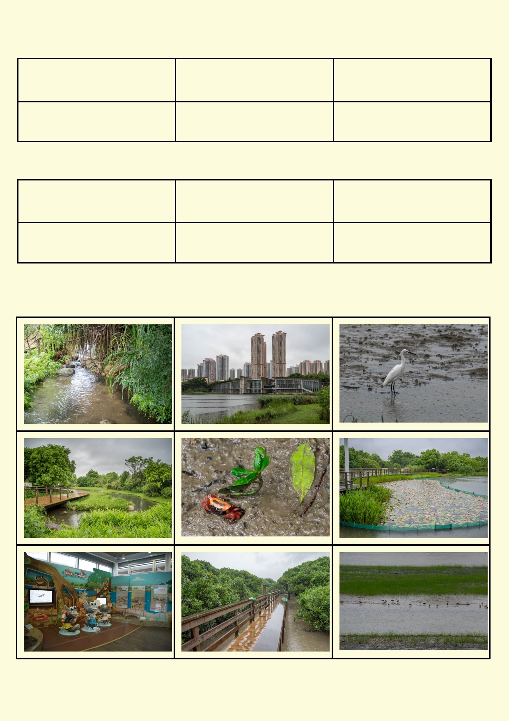The data to be gathered could have these headings for animals:

Name of animal Adaptations to a wetland Insert photo from graphic
panel, make drawing or write
description

The data to be gathered could have these headings for ecosystems:

Physical appearance of eco- How plants grow in the eco- How plants grow outside of
system system (waterbody) the ecosystem (outside water-
body)

These photos will help you in your preparation. These are some of the ecosystems and species you might see when you visit.

30

Gathering data on a field trip

Introduction:
In this activity students help to design a field
trip and fieldwork activities. It is preferable if
students can visit an urbanised site and a
more natural site, to see the contrast. Hong
Kong with its small size and variety of land- scapes, offers many possibilities.

To organise the field trip you will need to:

1.
2.

3. 4.
5.
Identify two locations to visit.
How the students will safely arrive at the sites and return back to school.
How students will remain safe and the safety procedures they will follow.
Who will be responsible for gathering and returning equipment.
If there will be any cost to students.

To gather fieldwork data:

1.

2. 3.
4.
5.
Decide which data activities students will do (some activities will depend on the availability of
equipment)
Review and modify fieldwork activities.
Collect and make equipment for the activities that will need them.
Ask chemistry teachers for training for chemistry equipment.
Design data gathering sheets for each activity.

Equipment:
• Thermometers.
• If your school has the following chemistry equipment for measuring pH, nitrates, phosphates
and conductivity would be useful.
• Stockings and wire coat hangers for making dip nets.
• Turbidity tube or tin lid, black pen permanent marker, drill, string, ruler to make a secchi disk.
• Writing materials.
• Cameras.

Safety:
Consider doing a safety audit before going on a fieldwork trip. Things that need to be considered
include:

1.
2.
3.

4. 5.

6. 7.

8.
School safety policy.
Getting to and from the transport you will be using.
Avoiding students falling into the water and having a plan if a student does. Seek locations
where students will not be in danger if they were to slip into the water.
How to avoid dangerous litter.
How to avoid harmful bacteria in the water eg wear rubber gloves, use hand disinfectant after water sampling, no eating food or drinking without cleaning hands with hand disinfectant.
Plan for wet weather and a plan B if the weather is really harsh.
Waders that are waist high or longer are not suitable for student to use in water half a metre
or more.
First aid kit.

31

Location suggestions:

Big Wave Bay

Bride's Pool

High Island Reservoir

Hong Kong Wetland Park

Kam Tin River

Kowloon Reservoir

Lake Egret Nature Park

Lam Tsuen River

Mai Po Nature Reserve

Plover Cove Reservoir

Pok Fu Lam Reservoir

Pui O

Shek Pik Reservoir

Shing Mun Reservoir

Shing Mun River

Tai Mo Shan Waterfall

Tai O

Tai Tam Reservoir

Tung Chung River

Wang Tong River

Waterfall Bay

Wong Lung Hang

Wong Lung Hang

Yan Chau Tong Marine
Park

Beach environment heavily used by people

Area rich in geomorphological features of a natural river course

Freshwater storage and supply

Tourist and information centre with abundance of estuarine birds
and animals in a wetland setting

River that drains surrounding mountains, with sections that have
been channelised

Freshwater storage and supply

Connected to Tai Po Kau Country Park dotted with streams and
rock pools that are mostly in a natural state. The Lake Egret
Nature Park is run as a tourist attraction and information centre

Flows out into Tolo Harbour, the river courses change from natural
stretches to modified ones

Large wetland nature reserve

Freshwater storage and supply

Freshwater storage and supply

Marsh and estuarine environments that have been affected by
human activities

Large water storage and supply on Lantau Island.

Freshwater storage and supply

Channelised urban river

Highest peak in HK, part of Country Park with natural waterways
including Ng Tung Chai waterfall, HK's biggest waterfall

Estuarine environment with traditional stilt village, some modified
and natural coastline and wetland

Freshwater storage and supply

Upper and middle courses are more natural with some modifica-
tions in the lower course

Example of channelisation

Waterfall into the sea, lower course runs through villages that
discharge into the river affecting water quality

Medium sized rocky river, easy access next from roads with some
well-known aquatic animals and plants occurring here.

Waterfall and streams along the river course

Some natural and some channelised estuarine environment
32

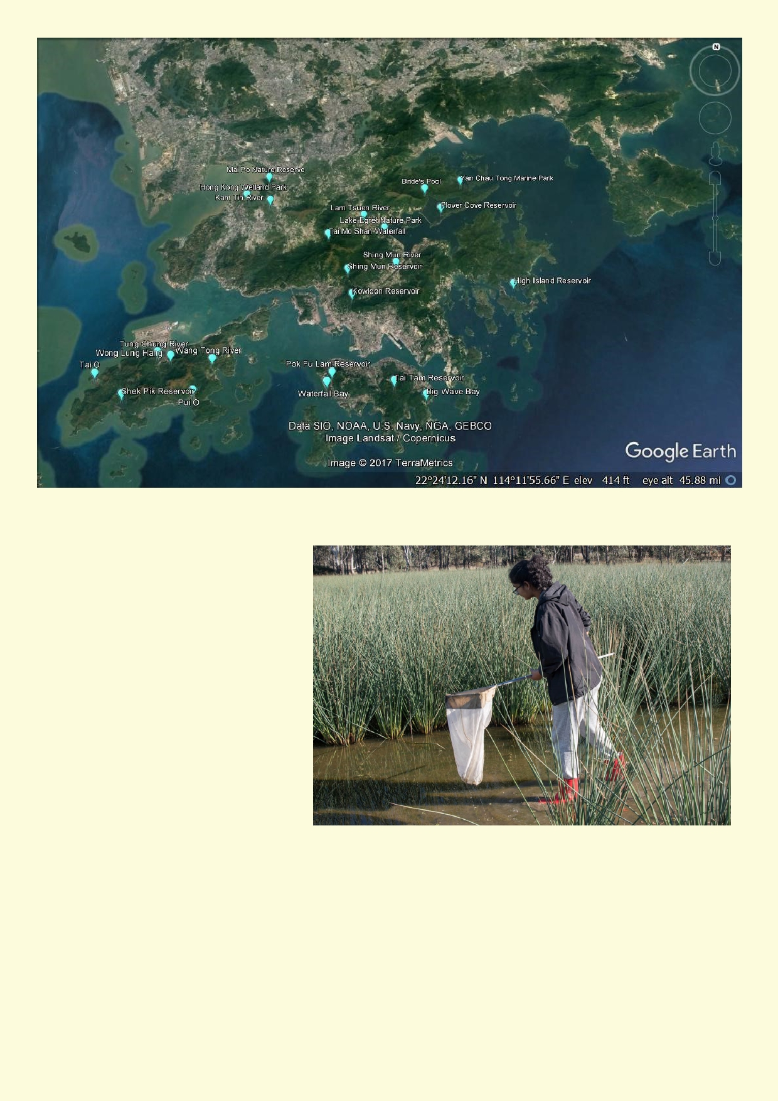
1. Sampling for water creatures

Equipment
• Dip net or wire coat hanger and
stockings to make a net
• Large shallow white tray
• Magnifiers
• Specimen jars with lids

Making a dip net
If you don't have a pond sampling
net then make a net a net using a
wire coat hanger and a pair of
stockings

1.

2. 3. 4.
5.
Bend the wire coat hanger so
make it into a square. Bend the
coat hanger hook so it is
straight.
Place the waist of the stockings around the rim of the coat hanger
Tie the two legs together into a tight knot at the crotch Cut off the ends of the legs below the knot.
You have a dip net.

33

Sampling technique:

1.
2.

3. 4.
Place one to two centimeters of river water into the bottom of the white tray.
Sweep the dip net through the water. Make sure that only one side of the net has water
entering it otherwise any animals already caught will be swept out. If the dip net fills with mud,
swish the net so its free of mud and start again.
When you think you have a sample, wash the inside of the net into the white tray.
Look for the movement of animals swimming, crawling and walking.

Interpreting data
The diversity of animals is a key indicator of ecosystem health. Try and record as many species as
you have found.
The absence of animals could mean several things:
• Reservoirs often have almost no animals because in clean water there is very little food.
• It may not have been possible with your nets to make a good collection of the animals
• In rivers many of the animals are under rocks and to sample the animals people kick the rocks
and gravel to collect the animals in their nets. It may not be safe you for to do so in deeper
rivers.

The table below will indicate the quality of the water in a river wetland or a river.

Sensitivity to pollution Invertebrate groups Score

Extremely sensitive and require Some beetles (screech beetle) ◻ 10

excellent water quality

Sensitive to tiny amounts of
pollution

Survive small amounts of pollu-
tion

Survive in moderately polluted
water

Survive in very polluted water
Mayfly

Cadisfly
Water mites
Damselfly
Dragonfly
Water fleas

Mosquito larvae
Some beetles (diving beetle)
Water striders
Backswimmers
Shrimps
Snails
Amphipods
Leech

Water boatman
Cyclops
Seed shrimp
Some fly larvae

Red coloured fly larvae
Flatworms
Segmented worms
◻ 8

◻ 7 ◻ 7
◻ 6
◻ 6
◻ 6

◻ 5 ◻ 5
◻ 5
◻ 5
◻ 5
◻ 5
◻ 5
◻ 5

◻ 4 ◻ 4
◻ 4
◻ 4

◻ 3 ◻ 3
◻ 1

Total

34

Tick off which animals were found on page 34 and add up the total score.

Rivers
0 to 44 = poor water quality
44 to 55 = fair water quality
56 to 73 = good water quality
74 to 110 = very good water quality
110+ = excellent water quality

Ponds and other still water
0 to 40 = poor water quality 41 to 50 = fair water quality
51 to 70 = good water quality
71 to 100 = very good water quality
100+ = excellent water quality

Below are examples of aquatic species recorded around Hong Kong (Taken from Kadoorie Farm
education display boards)
• Broken-band Hillstream Loach (Liniparhomaloptera disparis). The loaches' slim and
flattened body can allow it to withstand strong water flow in the upper course, especially
during the summer monsoon.
• Sucker-belly Loach (Pseudogastromyzon myersi). A common fish with a sucker-like
adhesive disc (modified fin) used to attach onto the surface of rocks in fast-flowing streams.
• Rose Bitterling (Rhodeus ocellatus). Mainly inhabits reservoirs and some stream
meanders. A highly restricted native species relies on a freshwater mussel (Anodonta
woodiana) to complete its reproductive cycle.
• Chinese Barb (Puntius semifasciolatus). Once common native fish has suffered from
stream pollution and habitat damage
• Predaceous Chub (Parazacco spilurus). The commonest native freshwater fish in local hill
streams. A voracious predator of invertebrates and small fish.
• Marsh Shrimp (Macrobrachium vietnamense). Normally nocturnal, this long-armed shrimp
predates organisms in rock pools. Territorial species.
• Freshwater Snail (Brotia hainanensis). A common freshwater snail in the upper course of
local streams. Small snails of this species are eaten by Big-headed Turtles and the Blue
Whistling Thrush.
• Freshwater Minnow (Opsariichthys acutipinnis). Widespread and common species primarily
found in the New Territories.
• Freshwater Goby (Rhinogobius duospilus). Most common freshwater goby in Hong Kong, it
lives and feeds on the stream floor.
• Atyid Shrimp (Caridina cantonensis). A small, widely distributed freshwater shrimp, it is
good at merging into the background to avoid predation.

35

2. Frog calls
The presence of frogs and tadpoles indicates that the
environment must be healthy because polluting
chemicals will quickly soak through the frogs' skin.
Animals like frogs are called indicator species.

The easiest way to monitor frogs is to listen for their calls.
They don't call all the time and are more likely to call
during and after heavy rain. Tadpoles can be
distinguished from small fish by looking for fins on the
side, back and under the body. Only fish have these fins and tadpoles need to make do with their
tail. Some species of frogs lay white frothy masses of eggs.

If you are lucky enough to hear frog calls, record the number of different calls. Only the males call
and they call when it's the best time to attract females and mate. Calling varies due to weather,
season, flooding, and time of day and night.

3. Litter
Equipment
Recording materials including clipboard and data sheet
Camera, e.g. smartphone or tablet

Review safety before you start doing your litter survey. Stay well away from syringes.

Litter survey
Classification of litter into types of material. The types of materials and their use include:
• Aluminium cans
• Steel cans and steel products
• Other metal
• Glass
• Plastic wrapping and wrappers
• Plastic bottles
• Plastic containers
• Other plastic
• Paper and cardboard
• Items made from rubber
• Clothing
• Other

Gathering data
• Walk along a stretch of the water way
• Measure the distance walked
• Make a separate count for litter found:
⇒ In the water including among the plants in the water
⇒ Along the water edge
⇒ Along the bank above the water edge
• Count the total number of each type of litter in the water, along the water edge and along
the bank
• Record the times it took to complete the count

36

Using a camera:
• Take photos of the area being surveyed for litter.
• Photograph examples of litter.
• Photograph the worsts examples of litter in the water, water edge and along the bank.
• Photograph any rubbish bins and litter around rubbish bins.
• Photograph any structures along the bank including picnic areas.

Interpreting data:
• What proportion of the litter was.
⇒ Industrial.
⇒ Waste from kitchens and shops.
⇒ From fast food, food wrappers and drink bottles.
⇒ Fishing waste.
• What proportion of the litter.
⇒ Was swept down the river (litter in the water and along water edge).
⇒ Dumped along the bank as waste from home, shops or industry (pile of litter).
⇒ Litter from people using the river or wetland (spread along the bank).

4. Litter hotspots
There may be litter hot spots in the areas you are doing your survey:
• Photograph any litter hotspots. If your camera or smartphone can record GPS coordinates
make sure it is turned on.
• Record what type of litter is in the hot spot.
• Identify why the location is a hot spot eg.
• Bend in a river or due to the current.
• Around a rubbish bin and litter has blown out, pulled out by an animal eg cat, bird etc.
• Convenient place to dump rubbish.
• Caught in aquatic vegetation.

Interpreting data
Distinguish litter hotspots due to:
• The forces of nature e.g. water currents, wind etc.
• Being caught in plants.
• The actions of people using the area.

5. Stormwater outlets
If there are any stormwater outlets along the river or wetland:

1.

2.

3.

4.
Observe if the water appears different around the outlet. Describe how the water is different
and if their is an oily scum on the surface.
Check if there is more litter on the bank and
in the water downstream from the outlet.
Record any other impacts the stormwater
drain seems to have on the river,
Photograph the outlet and around the outlet.
a.Describe the location.
b.Do you notice any Impact(s) on water.

37

6. Basic water quality measurements

Equipment
Secchi disk or turbidity tube (see materials for making secchi disk)
Thermometer
Tape measure

Temperature
Measure and record the temperature of the water near
the water's edge using a thermometer or other
temperature measuring device.

Interpreting the data
The temperature of the water should be cooler than the
temperature of the air. If the temperature is over 25
degrees celsius then there may not be enough oxygen
for animals with gills. Warm water holds less dissolved oxygen compared with cold water. Bacteria and other
organisms have higher metabolisms, thereby using up
the oxygen. Very warm water is often the result of the river water being used for industrial cooling
processes.

Flow
Time and record how fast the water flows in a minute.
• Find a stick.
• Mark your starting point.
• Throw the stick out into the water.
• Walk along the bank as the stick moves for one minute.
• Mark the spot after a minute.
• Use the measuring tape to find the distance in metres the stick moved in a minute.
• Divide the distance by 60 to find out the speed of the water in metres per second.

Turbidity
If you don't have a turbidity tube at your school, make a secchi disk:

You will need a metal lid with a hole drilled into the centre, string (or a ball of wool), black permanent marker and ruler
• Use the permanent marker and ruler to draw two lines
through the centre at 90 degrees to each other to make
four equal segments. Using the maker pens darken two of
the opposite segments.
• Thread string that is around two meters long through the
hol e
• Under the lid (opposite to the area coloured in) tie a large
knot so the string can't pull though.
• On the string opposite to the knot, mark the string every 10
cm using the permanent marker.
To use the secchi disk, lower the disk into the water. Allow it to
go down until it can no longer be seen. Record that distance.

38

Using a turbidity tube:
• Look down the tube and observe that grid at the bottom.
• Get a sample of water from the river/wetland.
• Pour it into the tube.
• Remove water from the tube until you can just see the grid.
• Record the height of the water in the tube.

Interpreting the data:
The shorter the distance the secchi disk or the amount of water in the turbidity tube, the higher
the turbidity. High turbidity means little light can penetrate the water so plants growing in the wa-
ter have less chance to grow. Turbidity is a measure of how much dirt is being washed into the
waterway. It is usually higher after rain.

7. Using field chemistry equipment
It will be up to your teachers to find out if your school has equipment for measuring dissolved ox- ygen, pH, nitrates, phosphates and conductivity. There is a range of equipment and methods for
doing these measurements. Teachers will either train you to use the equipment or use it as a
demonstration. Some equipment requires calibration. If the calibration is wrong, the settings on
the equipment aren't correct or the units of readings are misinterpreted, the data recorded can
be be significantly incorrect.

Interpreting data:
Oxygen: When the oxygen level drops many of the animals with gills will die. Aquatic plants and
cascading water oxygenates the water.
Nitrates and phosphates: Most of the nutrients in water come from land sources. Rotting
leaves adds to the nutrients along with fertilisers, detergents, human and animal feces etc. The
amount of phosphorus and nitrogen chemicals are measured to estimate the amount of nutri-
ents. High nutrients can cause an explosion of bacteria and plant growth that reduces oxygen
levels.
Conductivity: By finding out how well electricity is conducted by a water sample, the amount of
salt can be estimated.
pH: pH is a measure of how acid or basic the water is. The pH affects many biological chemical
reactions. The preferred pH is neutral.

Report of your data
Make a report of your data. Present your data in a form that is easy to communicate. Use the
photos taken during the field trip. Interpret your data and draw conclusions. Use word,
powerpoint or another application to produce your report.

39

8. Data sheets Name __________________________________

Date of field trip __________________

Location _________________________________________________________________

Weather
Temperature ________________________ Sun/cloud cover _______________________

Wind ______________________ Humidity _____________________________________

Rain _______________________ Air pollution __________________________________

Freshwater animals
  ◻ Fish
  ◻ Turtles
◻ Tadpoles
◻ Beetles
◻ Mayfly
◻ Cadisfly
◻ Water mites
◻ Damselfly
◻ Dragonfly
◻ Water fleas
◻ Mosquito larvae
◻ Water striders
◻ Backswimmers
◻ Shrimps
◻ Snails
◻ Amphipods
◻ Leech
◻ Water boatman
◻ Cyclops
◻ Seed shrimp
◻ Fly larvae
◻ Red coloured fly larvae
◻ Flatworms
◻ Segmented worms

Frog calls
◻ None
◻ 1 species
◻ 2 species
◻ 3 species
◻ Lots of frogs calling
◻ A few frogs calling
◻ No frogs calling

40

Litter

Location _________________________________ Time spent collecting data __________________

Distance along water body ______________________________________

Material In the water Water edge On the bank Total
Aluminium cans
Steel cans and other steel

Other metal
Glass
Plastic wrapping and
wrappers

Plastic bottles
Plastic containers

Other plastic

Paper and cardboard
Items made from rubber

Clothing
Fishing line or fishing net

Other

Litter hotspots
◻ Bend in a river or due to the current
◻ Around a rubbish bin and litter has blown out, pulled out by an animal eg cat, bird etc
◻ Convenient place to dump rubbish
◻ Caught in aquatic vegetation

◻ Other ________________________________________________________________

Describe and photograph litter hotspots

_____________________________________________________________________________

_____________________________________________________________________________

41

Water properties

Temperature

Flow
Turbidity
Dissolved oxygen

Nitrates

Phosphates
Conductivity

pH

Property

Measurement

42

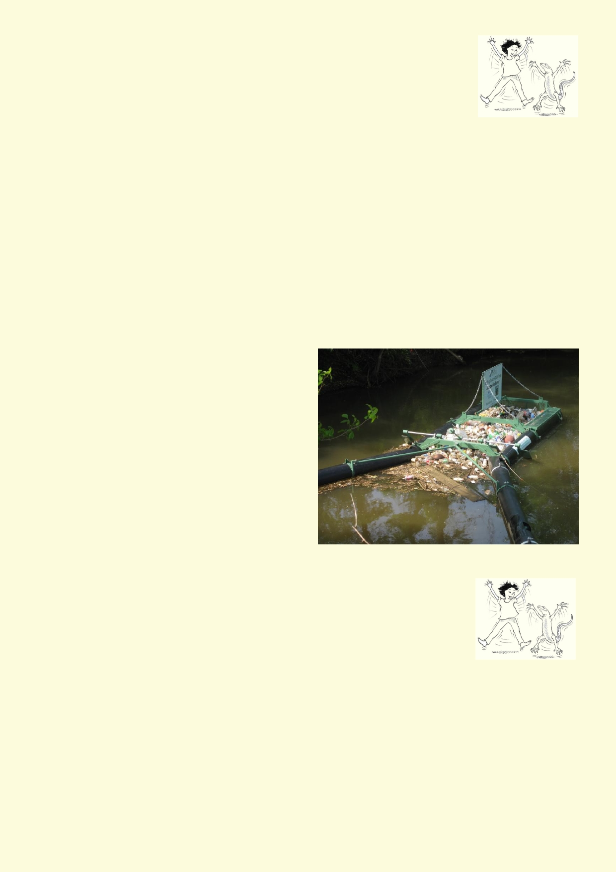Lesson 4. Conservation and management

Activity 1. Improve one of your field study sites with your
recommendations

How can the ecosystem be improved in one of the locations where you did
your field studies? What aspects of the ecosystem would be difficult or maybe impossible to
change?

Is it possible to:
◻ Grow trees on the bank.
◻ Grow shrubs and grasses along the bank.
◻ Grow aquatic plants on the water edge. ◻ Grow aquatic plants in the water.
◻ Completely remove constructed edges along the river.
◻ Replace constructed edges with a rocky edge with plenty of places for animals and plants
to live.
◻ Have shallow pools coming out of the side of the river.
◻ Reduce litter.
◻ Have a path for people.
◻ Have more rubbish bins.

Find a photo of what you would like the river to look like.
Are there nurseries in Hong Kong where you
could buy suitable plants?

List recommendations that you think would
improve the area and make it a more natural
ecosystem.
Make a map of the area and show where your
recommendations would be done.

Activity 2. Design a litter trap
Some countries place litter traps in their rivers. These traps catch the litter as it
floats down the river. They are often placed in river bends where the litter
floats towards the bank. The traps are regularly cleaned and the litter is sent to
a landfill.

Design a litter trap that could be used in Hong Kong.

In your design:
• How will it float? What material will be used to make it float?
• How will the trap be fixed to the bank so it doesn't float away?
• How will litter be channelled into the trap?
• How will the litter be caught in the trap so it doesn't float away? What material will be used
that allows water through?
• How will the litter trap survive flooding water?
• What features will it have so it is easy to remove the litter?

43

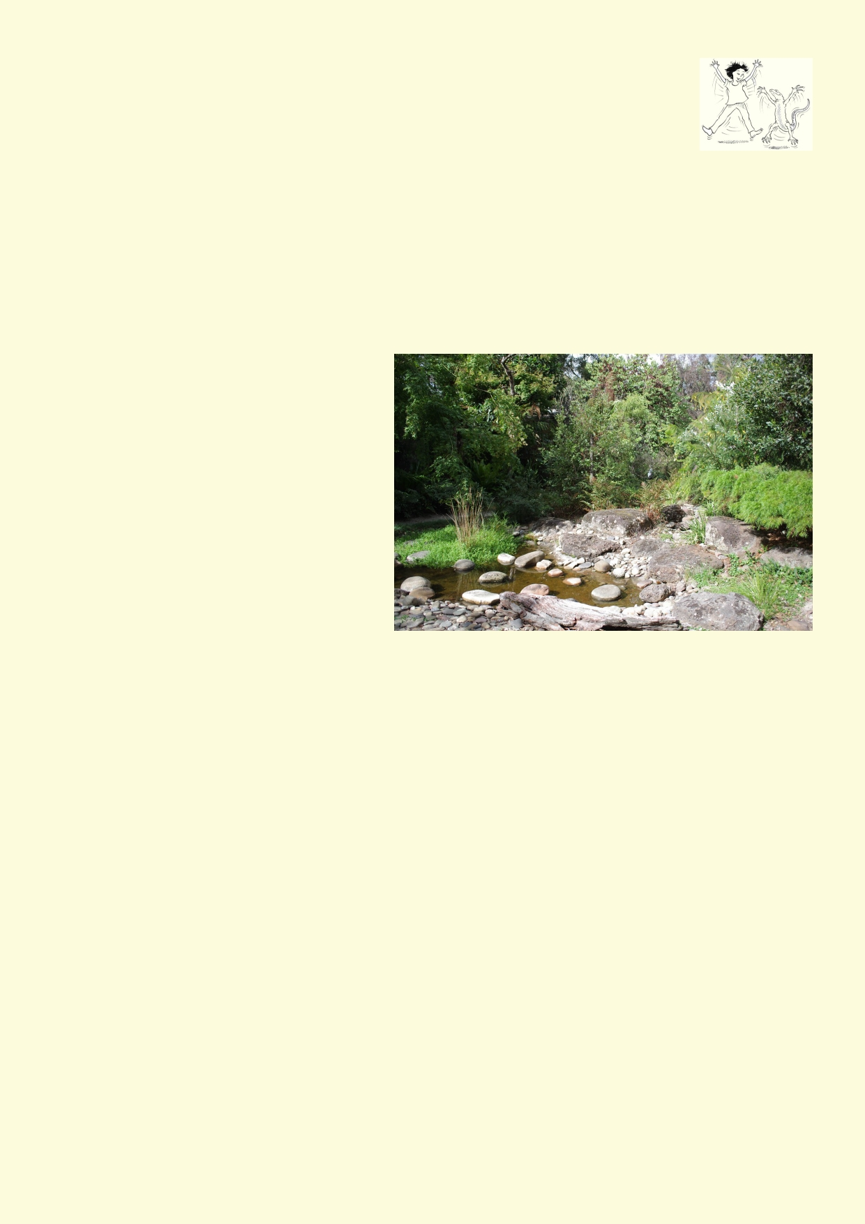Activity 3. Design your own wetland pond or aquarium

Design a wetland pond
Your school may have enough land to install their own wetland pond. Once the
pond is constructed, aquatic plants are placed in the pond. It only requires a few
plants, because the grow and reproduce quickly. It is more important to have a variety of plants.
Smaller ponds need to be lined by a thick plastic sheet, concrete or another surface to stop the
water from leaking away. It will also need to be topped up by rain or from a tap. Chlorine is used in
tap water to kill harmful bacteria. This chlorine can be harmful to aquatic animals. The water needs
to sit around for a couple of days before its used in the pond so the chlorine evaporates. Usually
many animals find their own way to the pond. You could also catch some pond animals and put
them in.

To design your pond.

1.
2.
3.
4.

5. 6.

7.

8.
Where will it be placed?
How large would it be?
How will it be lined?
If there is extra soil from digging a
hole, what will happen with the soil?
Where will you get aquatic plants?
What will be planted around the out-
side of the pond?
How will the pond be kept filled with
water?
If aquatic animals will be placed into
it, where will they come from?

Your pond should not have fish purchased from a aquarium shop.

Compare designs produced by the class.
• Which designs make the best habitats?
• Which designs would be the most practical at your school?
• Which designs are the easiest to build?

Design and make a wetland aquarium

Materials if you actually make a wetland aquarium:
• Large container for the aquarium. It could be a fish tank or a large sturdy plastic container
• Some aquatic plants.
• Dip net to catch some freshwater animals.
• A second container to let tap water sit for a couple of days.

To make a wetland aquarium your class will need to decide:
1. What kind of container or aquarium will be used. 2. Where it will be kept.
3. How long it can stay there before it has to be moved.
4. How the aquarium will be looked after.

44

Your aquarium will need plants. If it just has floating plants then you won't need anything on the bottom. If your plants have roots then you will need clean gravel or if they come in a flower pot,
keep them in the flower pot. Aquarium shops will sell you aquarium plants. You may also be able to
find a nursery that sells aquatic plants, but most of these are too large for an aquarium.

You will need to catch some aquatic animals to place in your aquarium once it has been set up. Allow the aquarium with its plants around a week to settle down.

Once the animals are in, observe the changes. It's normal for some of the animals to die out and
others to multiply quite quickly. It's also fascinating how two similar tanks can end up with different
animals dominating the tanks.

To look after the aquarium

1.

2.

3.

4.

5.

6.
Set tap water aside for 2 days before placing it into the aquarium to allow the chlorine to
disappear.
In a normal wetland, large amounts of nutrients eventually soak down into the muddy bottom.
In an aquarium there is nowhere for the water to soak down. Do not place anything in the
aquarium that will rot.
Do not place many predators into the water. There will be carnage with lots of dead rotting
animals upsetting the balance.
If the aquarium is shallow and has a large surface, it may not need aeration. Only use an
aerator pump to oxygenate the water. Do not use a water pump, as these pumps will chop up any small animals that pass through them.
Usually it's best not to do anything to the aquarium once it's established. Algae growing on the
glass or plastic is natural.
Do not have fish in the aquarium.

Quick alternative: Sea monkeys
The common name given to the brine shrimp, a small crustacean is the sea monkey. It is easy to
buy kits or just the eggs online. Do a search for sea monkey eggs or sea monkey kits.

You can watch the life cycle and the quick growth of these crustaceans and appreciate how the different features of sea monkeys are adapted to an aquatic environment.

Activity 4: Fish and culture

If you do a search on google images using Chinese fish as your search words, you will see an interesting selection of images. In this activity you will choose a
culture. You will then explore different aspects of how the culture has embraced
fish. Besides researching information, illustrate what you have learned.
What ancient myths and stories about fish have been passed down through the
generations?
• How have past artists used fish in their images, sculptures and textiles?
• How have current artists used fish in their images, sculptures and textiles?
• In what ways are fish kept as pets in aquariums or ornamental ponds?
• What is the role of fish in the culture's diet?

45

Which culture have you chosen? ___________________________

Do some research about the fish and the culture you have chosen. Describe what you have found out. Make an illustration or drawing.

Aspect of the culture Illustration/drawing

Ancient myths about the fish

Historical artistic inspiration

Modern artistic inspiration

Fish as pets and in ornamental ponds

Fish as staple food

Anything else you can add?

Activity 5: Looking forward - Monitoring a local waterway

Is there a waterway near your school? Do some students walk over a bridge on their way to
school? It may be possible to monitor your local waterway for unusual pollution. Unusual pollution
are things like:
• Oil covering the water
• Sudden increase in greasy substance covering the water
• Larger amount of litter in water when there hasn't been any rain
• Large amounts of litter and greasy substance from drains when there hasn't been any rain.
• Many dead fish floating in the water
• In these situations it is likely that people are purposely pouring their waste down stormwater
drains.

46

Activity 6. Looking forward

Monitoring a local waterway

Hong Kong citizens can report pollution to the Hong Kong Environmental Protection
Department (EPD). Information about pollution reporting can be found on this website.
http://www.epd.gov.hk/epd/english/how_help/report_pollution/reportpollution.html

Monitor your waterway for pollution for at least a week. Discuss what you observed. How much
litter and other polluting materials was normally observed? Take into account that after rain oil
and grease along with litter from roads and gutter will be washed into the stormwater. Decide
what your class believes is water pollution caused by people pouring their waste into the
stormwater pipes or along the river. Decide when the EPD should be contacted and who should
make the contact.

Plant a mini ecosystem

Materials:
• A square metre of garden bed.
• Small log.
• A few stones, around 1 to 2 kg.
• A few local grasses, herbs and one small bush.
• Leaf litter.
• Spade or garden fork.
You will find suitable plants from a local nursery or, for example, the Flower Market in Kowloon.

Method

1.
2.
3.
4.

5.

6. 7.
8.
9.
Dig over the square metre of soil.
Dig into the soil half of the leaf litter.
Place rocks and small log in garden
Dig holes for each of the plants. The holes need to be larger than the pots but the same
depth as the pots that hold the plants.
Squeeze the plastic pots to loosen the grip of the soil and then gently slide out the plant
supporting the weight of the stem.
Place the plant in the hole and fill the rest of the hole with soil. Lightly press the soil down.
Give the plants a long watering.
If it hasn't rained, water the plants each week.
Monitor your mini ecosystem once each month record what you see. Look under the log and
rocks for animals. Look among the plants and for evidence the plants have been chewed.
Can you see insects visiting flowers?

10. Remove weeds as they start growing.

47

Acknowledgements
The Ocean Recovery Alliance thanks The Hong Kong Jockey Club Charities Trust for their
generous funding support on this education programme.

Project manager: Doug Woodring
Writer, photography and design : Bob Winters
Curriculum manager and editor : Charlotte Charny Nielsen
Editor and school outreach: Alex Hale
Additional thanks: Jasmine Nunns and Sandra Merazzi

© 2017 Ocean Recovery Alliance and Authors.
Outside the school environment, the text, photos and artwork may not be reproduced, except
where permitted by the relevant Copyright Act. These materials may not be modified and
distributed by print or electronic means without written permission. Teachers may modify these
education materials for the use of their students and school provided it is not distributed any
further. Those wishing to reproduce part of this publication must submit their application to the
Ocean Recovery Alliance. www.oceanrecov.org/contact-us.html

48

