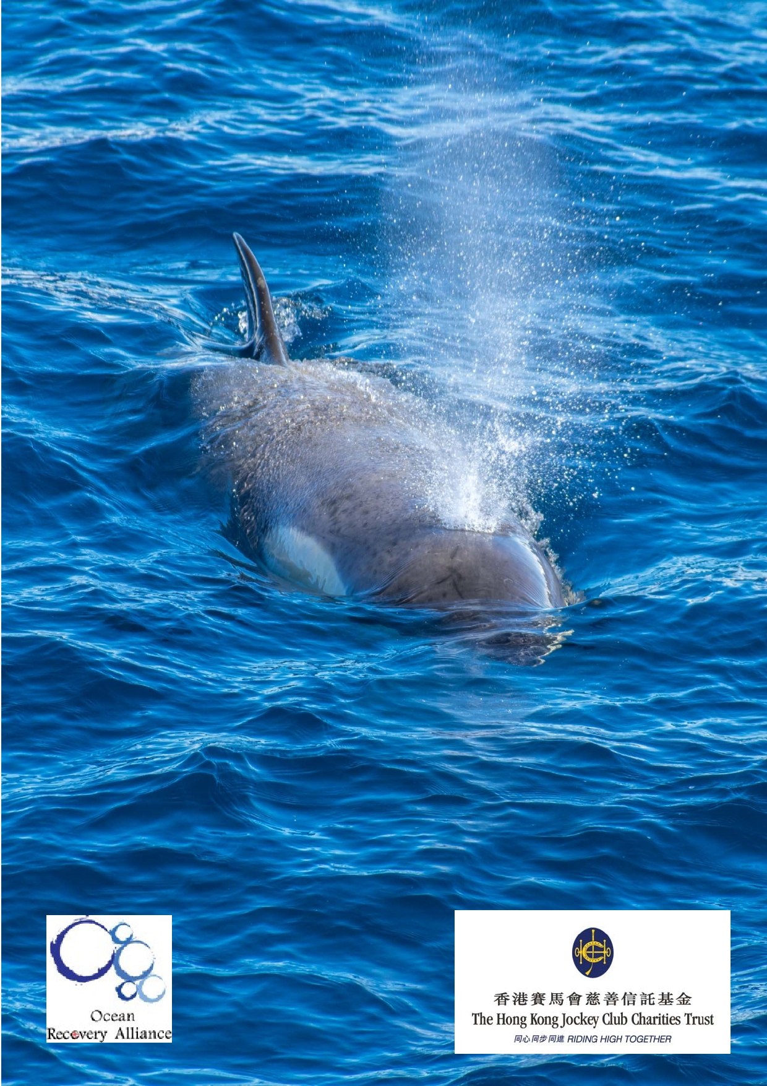Jockey Club Water Caretakers of
Tomorrow Programme
The Blues: Can we Save the Ocean?
- Unit 8

Organised by

Funded by

1

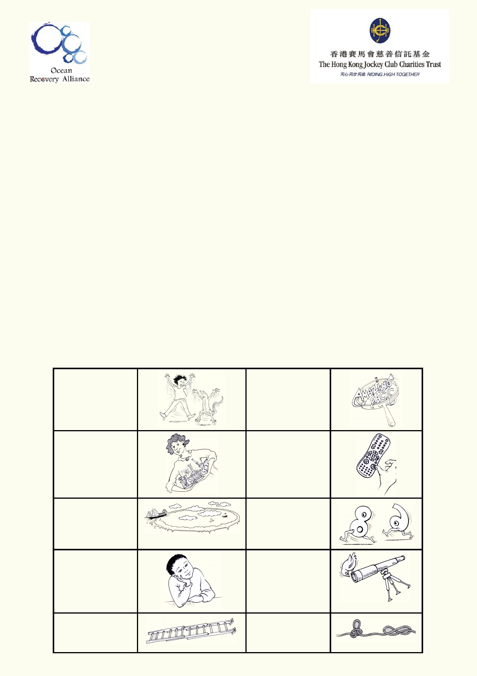About The Jockey Club Water Caretakers of Tomorrow Programme:

Jockey Club Water Caretakers of Tomorrow Programme is organised by Ocean Recovery
Alliance, Ltd and funded by The Hong Kong Jockey Club Charities Trust. There are eight units in
this program, and each of them is designed with you, a student in Hong Kong, in mind.

These are the goals for your lessons, to:
• Understand and appreciate how our water systems function on a local and global scale.
• Understand how watersheds function, and the interconnections of life within and between
these watersheds.
• Be able to assess threats, such as pollution and habitat destruction, and learn how to lessen
these effects.
• Be empowered to take an active role as caretakers of our water resources by sharing your
commitment with your communities.

Student introduction
• You will need access to the internet.
• In some activities using the camera in your smart phone or tablet will be useful.
• Your teacher will tell you if you if your work will be done on your computer, printed paper or
notebooks.

Start of a new A new amazing activity. f act .

Get ready to do an experiment.

Identify your
misconceptions
before your move on.
Identify your
prior learning.

An extension
activity

Fast forward to
make your
contribution to improving our world.
Data will be used
to solve
problems.

These are the goals for this unit.

A cross-
curricular
activity

2

Student aims

At the end of this unit, I will be able to:
• Understand basic ocean ecosystems and organisms.
• Understand the connection between ocean and land.
• Explain how the ocean is being managed and exploited.
• Understand the extent of the effects of plastic pollution in the ocean.
• Draw conclusions about potential future threats to the ocean.
• Implement simple strategies to help reduce our impact on the ocean.

Glossary

Acidification

Ballast water

Bilgewater

Bioaccumulation

Calcium carbonate

Continental Shelf

Coral reef

Currents/ Tides

Deep Sea Trench

El Nino/ La Nina

F et ch

Heavy metals

Hull

Microplastics

Migration

In the context of this unit, it refers to chemical changes to the ocean as a result of global warming whereby carbon dioxide reacts with seawater
to lower the pH of the oceans.

Large water tanks on ships that increase stability and manoeuvrability.

Dirty water that accumulates in a ship's hull where the sides meet the bottom of the ship.

The passing on of contaminants starting from the smallest organisms that get consumed by successively larger creatures all the way up the
food web.

A white mineral that makes up sea shells and coral skeletons.

Underwater landmass that extends from the land.

A collection of different corals forming a large single structure.

The direction and flow of a body of water in the sea or ocean.

Where the sea bed drops to a depth of many kilometres below the surface.

A climatic event in the Pacific known for reversing or changing weather
patterns in the region due to warming (El Nino) versus cooling (La
Nina).

The distance a wave travels in open water.

Group of metals with a high density, or large atomic mass. They can be hazardous to people and the environment, as a form of pollution.

The outer shell of a ship.

Plastic that has been broken down into tiny fragments by weathering processes.

The movement of people and animals from one region of the world to another.

3

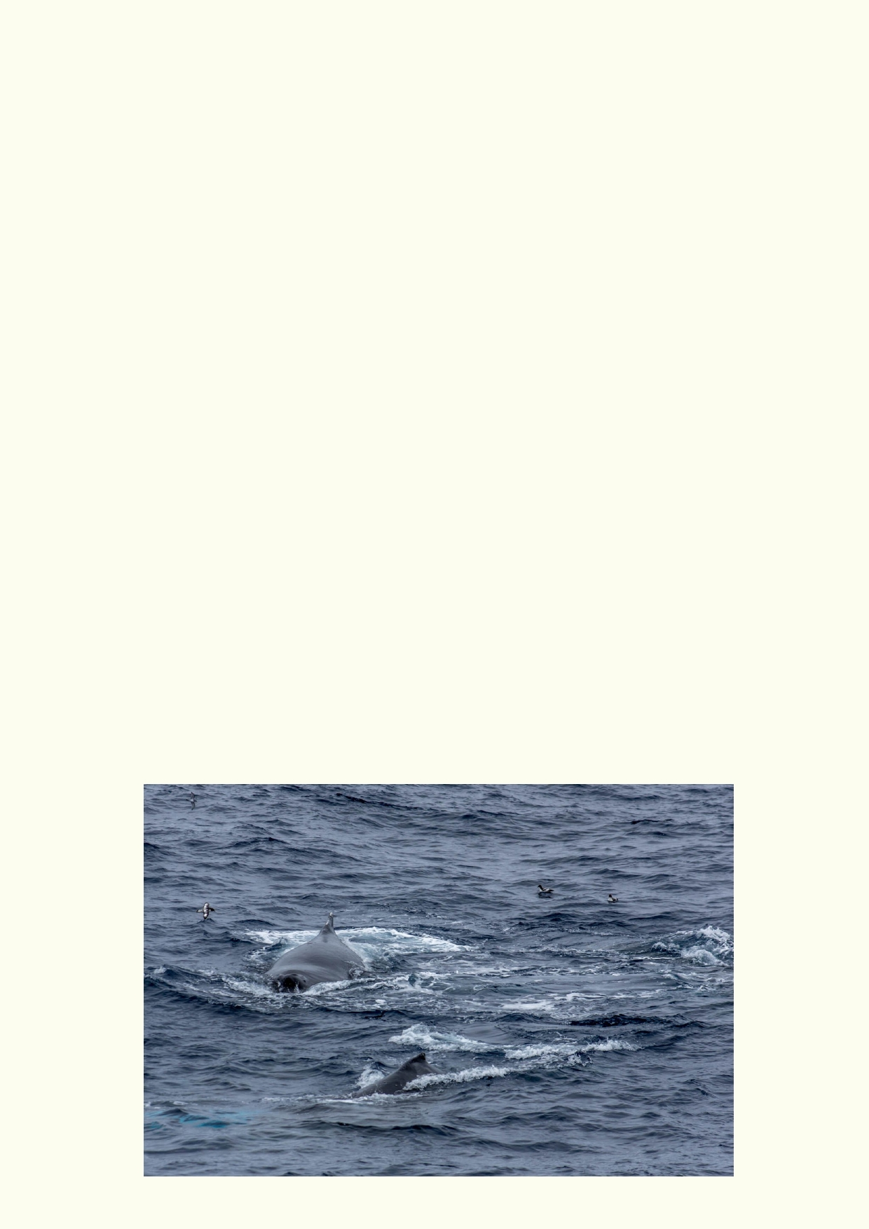Navigation

Ocean

PCBs

Pelagic

pH

Plankton

Salinity

School (of fish)

Tanker

Toxins

Trawling

Typhoon/ Cyclone/
Hurricane

Waves
The ability to accurately locate and move yourself in relation to the
surrounding environment.

A large expanse of uninterrupted sea.

Polychlorinated biphenyls (PCBs) are toxic compounds manufactured for
use as coolants or lubricants in electrical goods. They do not break
down or degrade readily, and easily enter the environment by air, water
and soil. They are linked with negative health consequences for animals
and people when exposed to these compounds.

Relates to the open sea, particularly the upper layers.

A measure of how acidic or how alkaline something is.

Microscopic plants and animals in the ocean.

Concentration of dissolved salts and minerals in a body of water.

Referring to a large group of fish, usually of the same species, that swim closely together.

Ship that transports large quantities of liquids.

Contaminants that are poisonous to people and animals.

A method of fishing that drags large nets from a boat.

Name given to severe storms, based on where they occur in the world, either in the Pacific/ Indian/ Atlantic ocean.

Waves are usually caused by wind moving over the water's surface. A wave's size depends on wind speed, wind duration, depth of the water
and size of the area over which it moves.

4

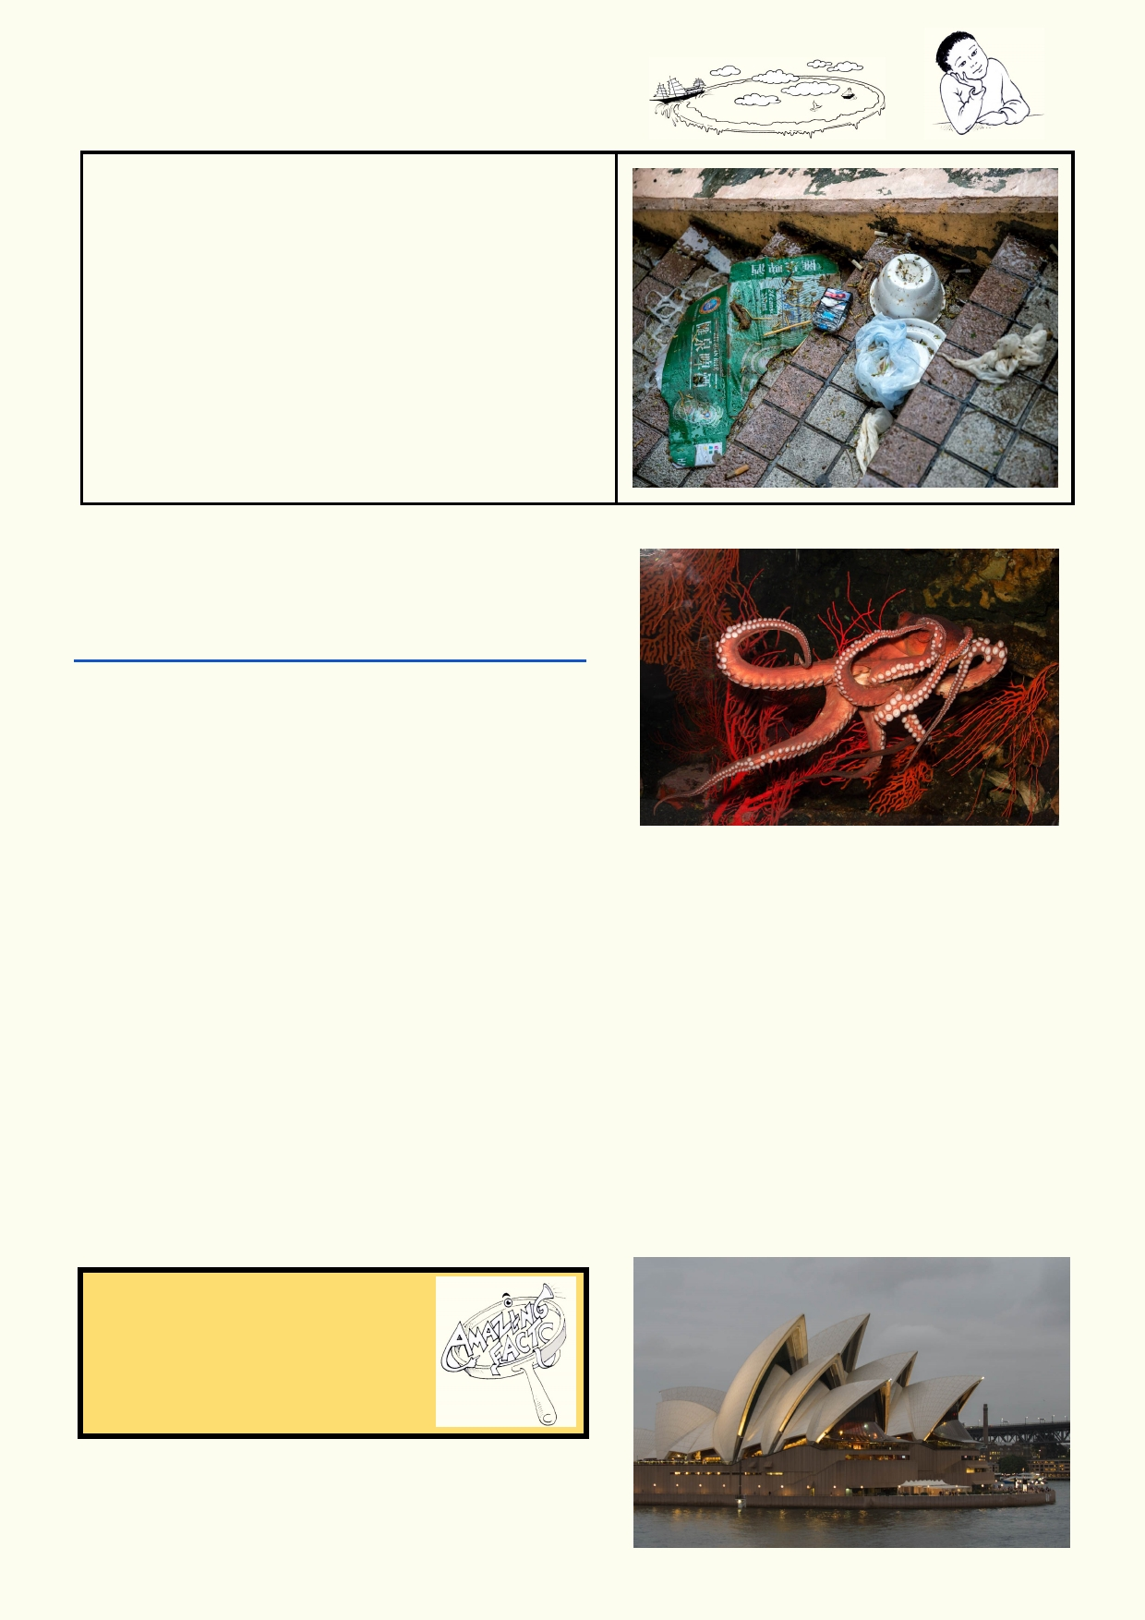Prior learning: What's going on?

How might the litter in this photo affect the
oceans?

Watch this music video for fun. It is an animation of a
classic Beatles song:
https://www.youtube.com/watch?v=lAeSiM4YTFM

Think about what you know about the ocean. Why are
the oceans important to us and to the planet? Jot
down some of your ideas below:

_____________________________________________________________________________

_____________________________________________________________________________

_____________________________________________________________________________

_____________________________________________________________________________

What is your best ocean or seaside experience?

_____________________________________________________________________________

_____________________________________________________________________________

Amazing fact
Octopuses are the most
intelligent animals of all the
invertebrates. They are as smart
as most mammals.

5

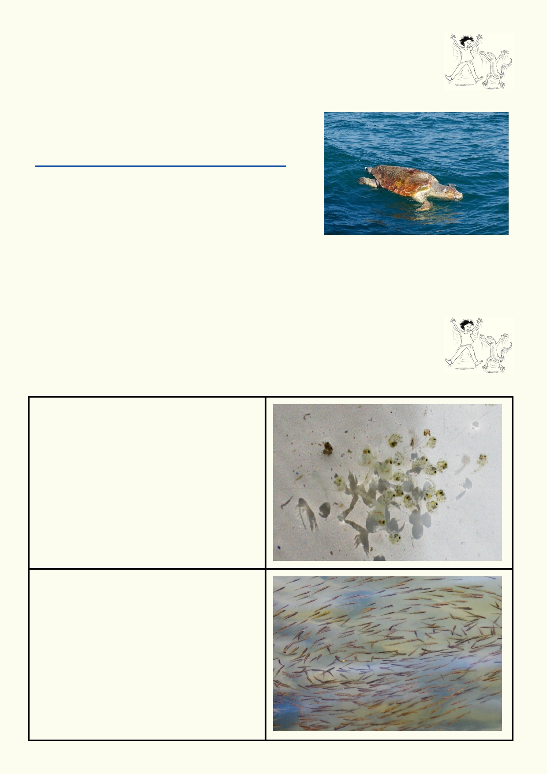Lesson 1 - Ocean Habitats and Ecosystems

Activity 1. Big ocean, big impact

The oceans might be big and take up two thirds of the Earth's surface, but humans can have a negative impact on every part of it.

Watch the first two minutes of the Ocean Recovery
Alliance video
https://www.youtube.com/watch?v=4cRkTUQVCNc
(photo on right is a dead sea turtle floating on top of the
ocean)

Describe some effects people can have on the ocean.

_____________________________________________________________________________

_____________________________________________________________________________

_____________________________________________________________________________

Activity 2. Life on top of the ocean

The oceans have a great diversity of life. Here are some that can be observed on or near the surface.

From little things, big things grow. Life in the ocean depends on the smallest microscopic
plants and animals. These are the food for larger animals.

Find the definition of plankton.

Some of the ocean life is seen near the surface such as this school of baby fish.
Almost everything in the sea is food for something else.

Why do many ocean fish swim in schools?

6

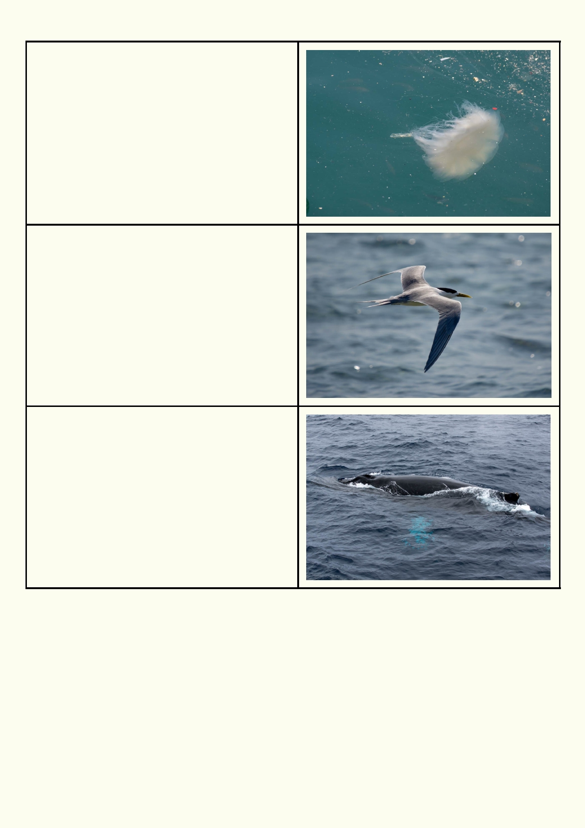Jellyfish are often seen near the surface. In this
photo there is litter and pollution floating in the
water.

Why are plastic bags in the ocean a hazard for
turtles?

Many species of marine birds are constantly on the hunt over the vast oceans of the world.

Where do terns rest?

Where to do these birds breed?

Whales and turtles need to come to the surface to breathe air.

This whale feeds in the Antarctic during summer.
Where do whales give birth?

Where do turtles lay their eggs?

7

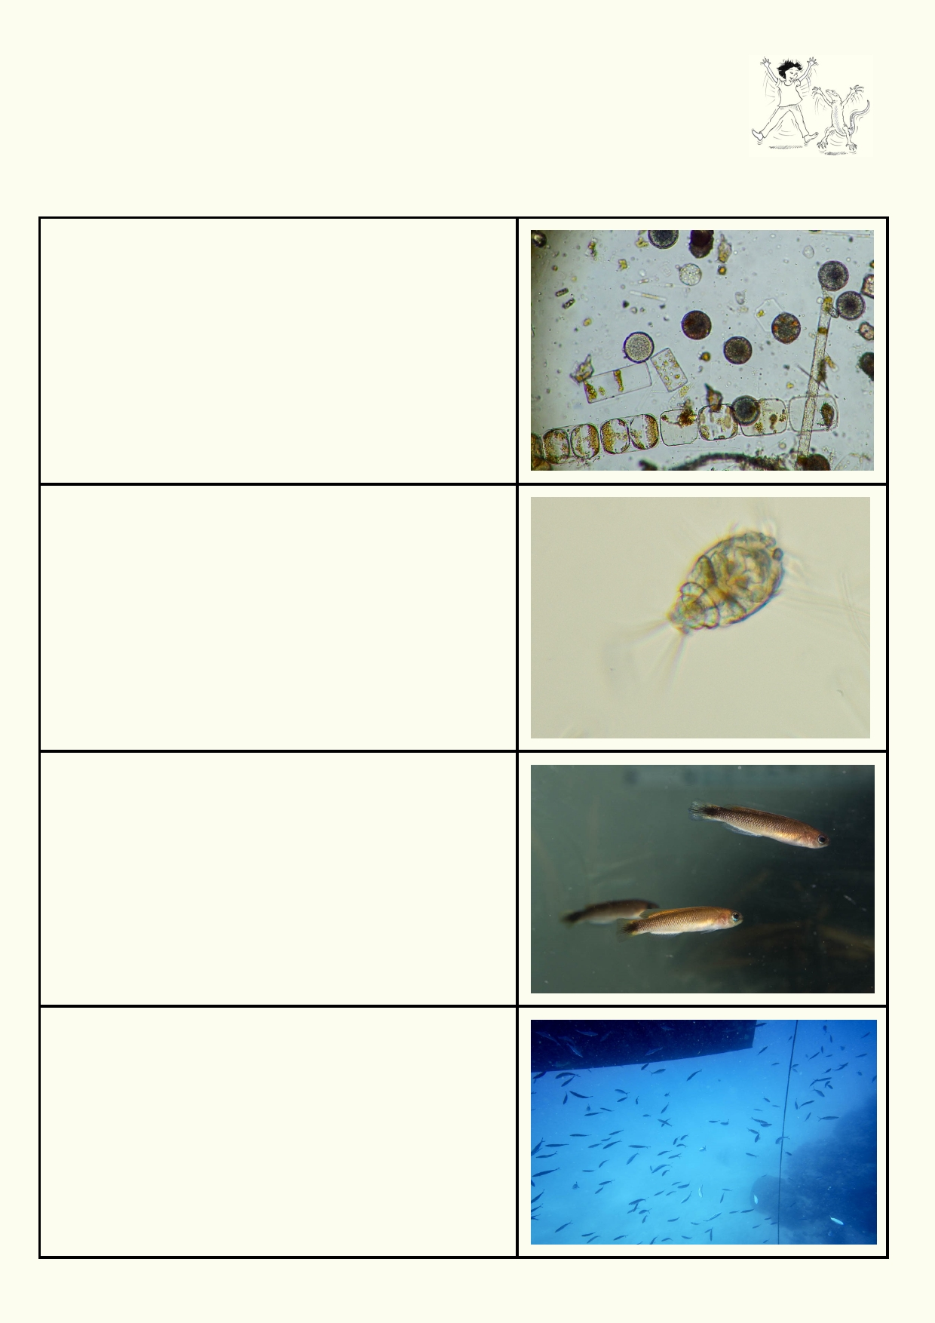Activity 3. Life underneath
Ocean life as a food chain
Life under the water has some advantages including constant temperature and
plenty of water. Also, organisms can easily move in all directions.

In the ocean, most of the algae is microscopic. It's
called phytoplankton. It must float near the surface
where there is light.

What do plants including algae need to grow?

We call the smallest animals in the ocean zooplankton. They eat phytoplankton and smaller zooplankton. Most
marine creatures hatch from small eggs. So all their tiny young start life as zooplankton.

How would you catch such small animals to study?

The smallest fish feast on zooplankton or on phytoplankton.

Why do we need large populations of smaller
organisms in a food web?

The fish next size up will be eating small fish and other marine creatures you can see with your eyes.

How can this fish tell there is danger?

What could these fish do if there is danger?

8

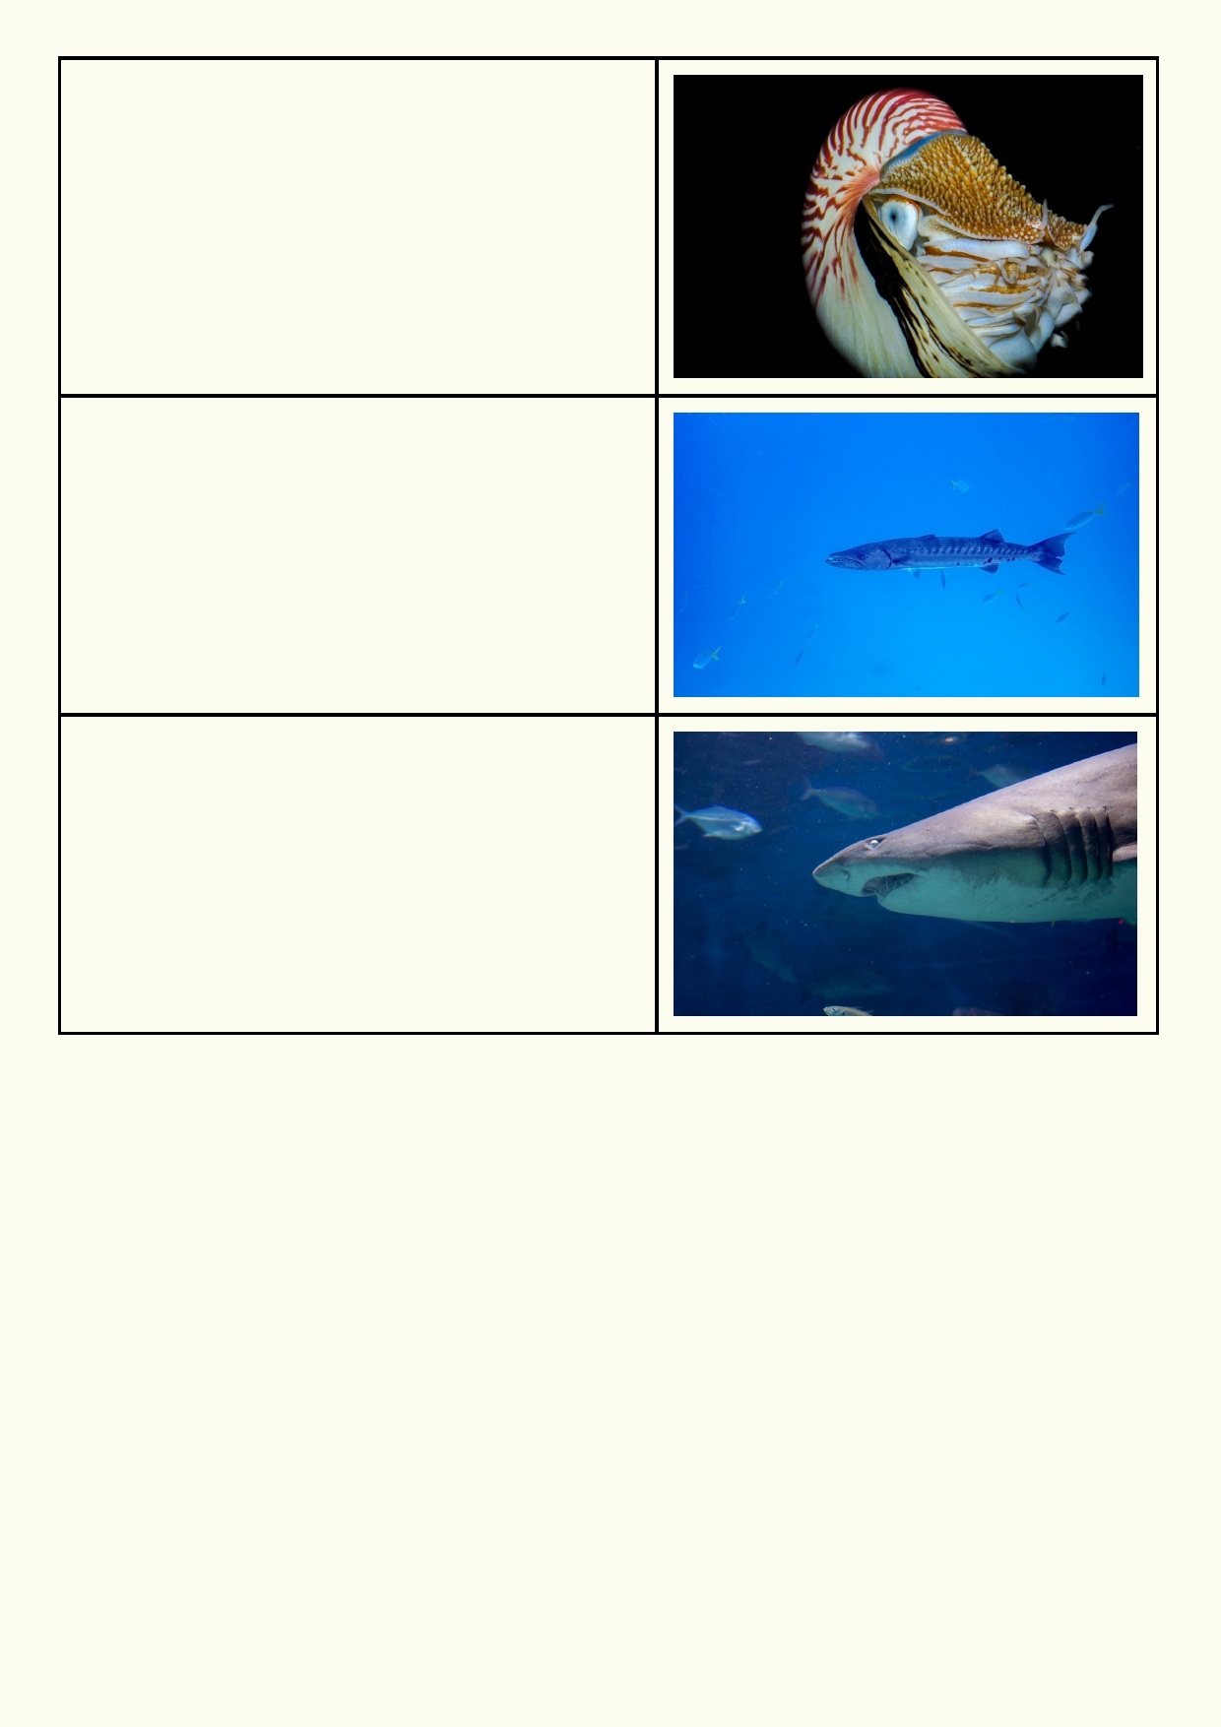Fish are not the only marine predators. This nautilus
also stalks the ocean waters.
What is unusual about a nautilus?

How can you tell it's a night hunter?

Barracuda are fast hunters. They often hunt in
packs. Lucky for us, we are not on their menu.
What do you notice about the barracuda that
enables it to swim so fast?

Sharks may be among the biggest ocean predators,
but they also help to keep the sea clean by eating
any dead animals before they get rotten.
Why is removing flesh of dead animals in the sea
important?

Why isn't the shark or the barracuda going to eat the nautilus?
_____________________________________________________________________________

_____________________________________________________________________________

Pelagic zone

Pelagic zone is the scientific term used to describe the open sea or ocean that covers the
majority of the Earth's surface. The pelagic zone excludes the sea near the coast and the bottom of the sea and ocean. It is all the water in between.

If you are a plant or animal in the pelagic zone, how is life different from land and life close to the
coast? For example, is there anywhere to hide? How can you rest?

Plant ________________________________________________________________________

Animal _______________________________________________________________________

_____________________________________________________________________________

9

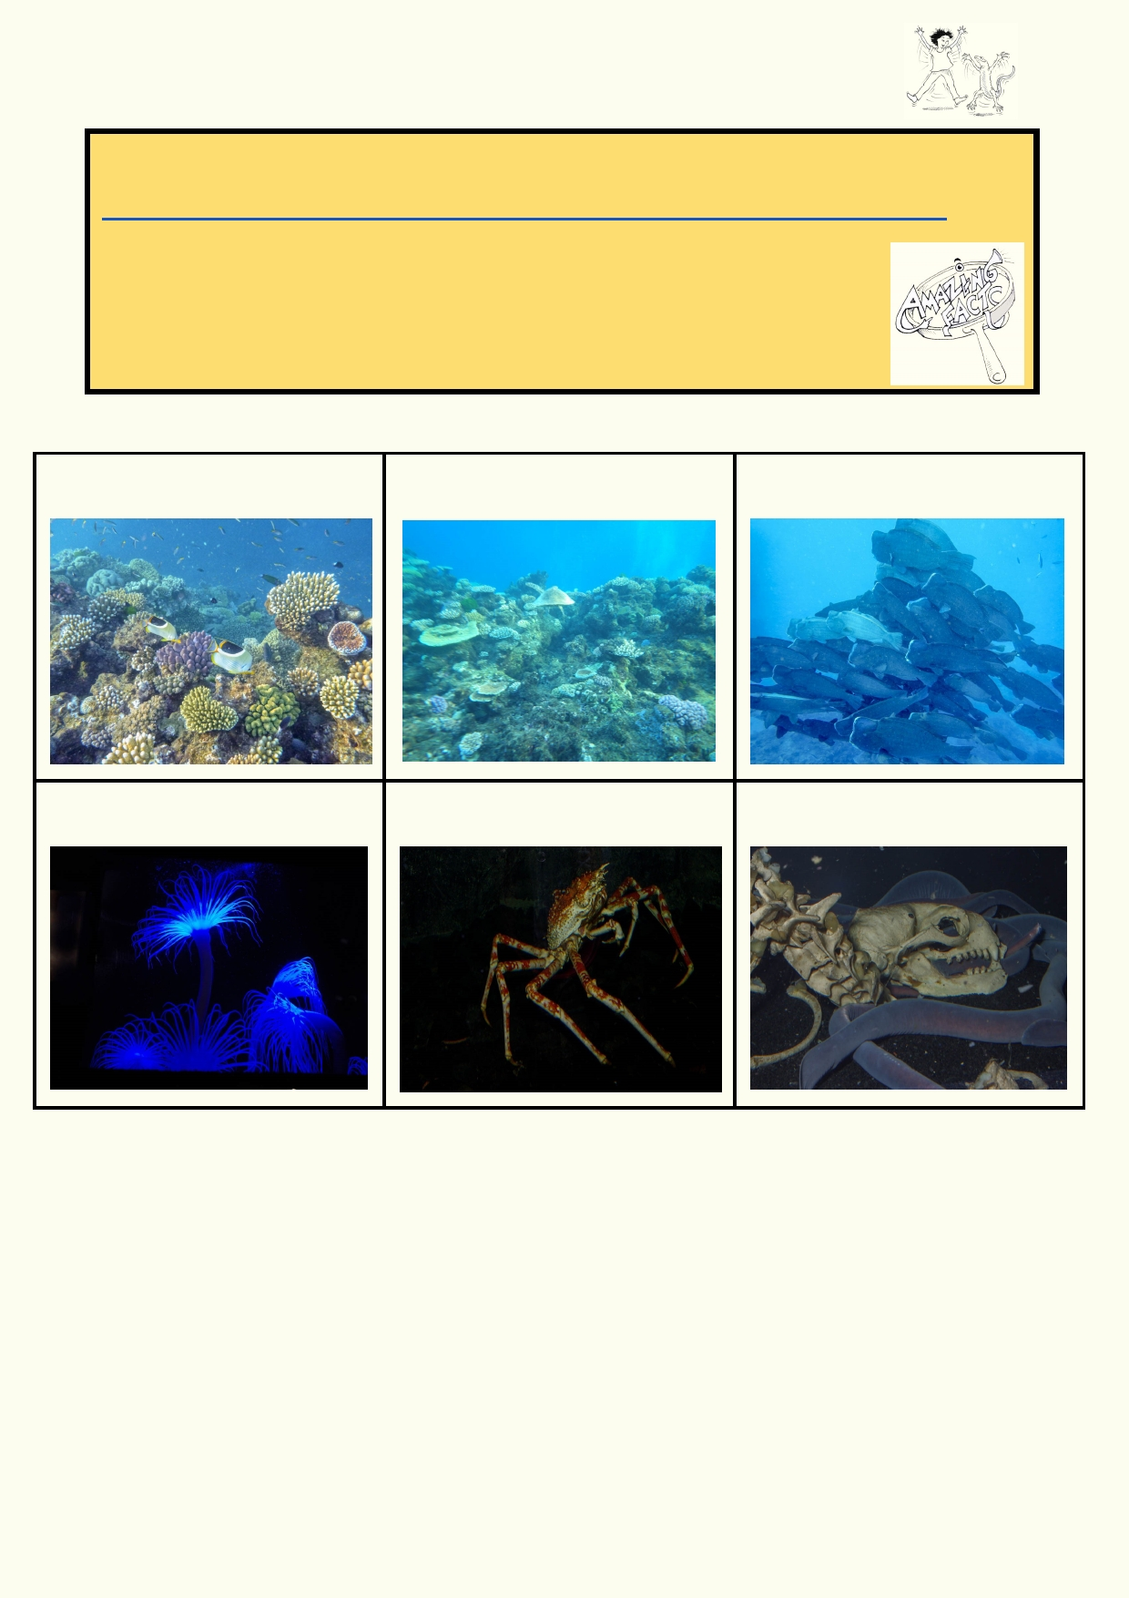Activity 4. Filtering and fading light

Amazing facts
Even at the bottom of the deep dark ocean, plastic litter is found. Have a look at this article
(http://www.newsweek.com/theres-even-more-plastic-ocean-floor-its-surface-292715).
Even in the cleanest water you can't see very far. The first thing you notice is
loss of colour. Then the light becomes duller. In these photos we gradually go
deeper. At great depth we need artificial light to see anything unless the
animals can glow (have luminescence).

Rich colours of the coral can be The deeper water has filtered As you go even deeper there is
seen near the surface. out many of the colours. much less light.

In the deep sea there is no light In the deep, some animals feel The hagfish used smell to find a
at all. their way around. dead seal on the sea floor.

Which are the colours are lost between photo one and photo two?

_____________________________________________________________________________
Which colour remains in the photo top right?
_____________________________________________________________________________
What does this fading light mean for algae?
_____________________________________________________________________________
What do pelagic algae do to survive?
_____________________________________________________________________________

10

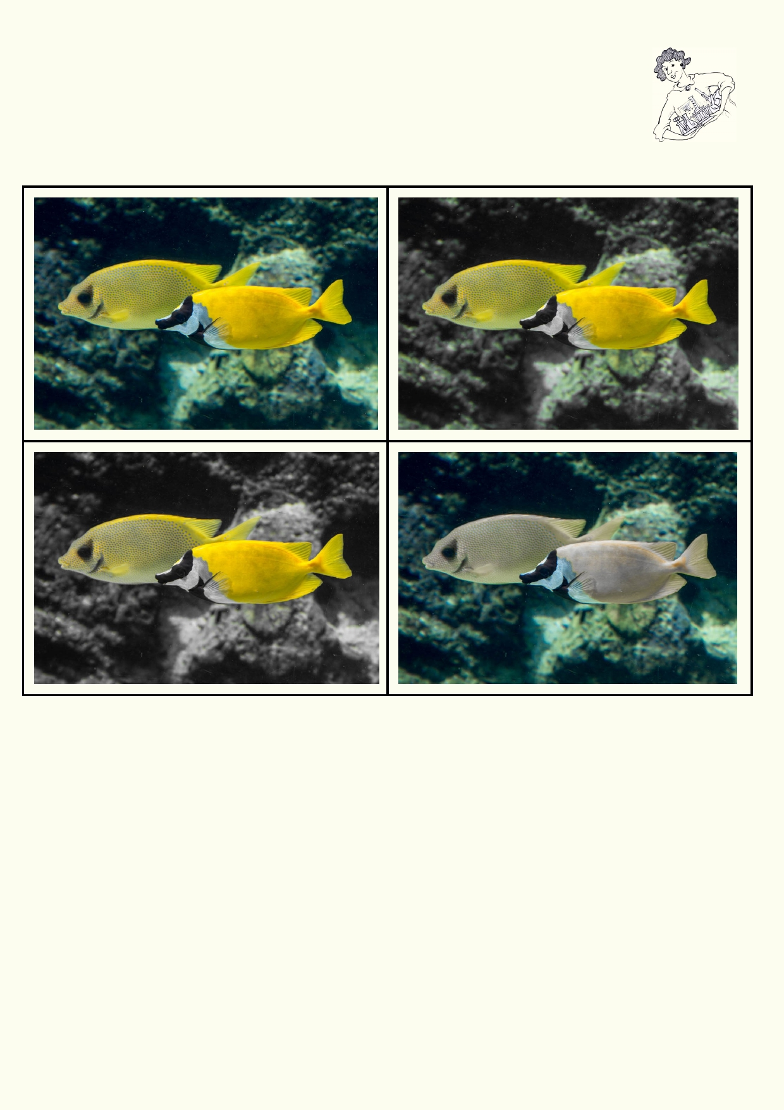Filter experiment

As we travel down in the oceans some wavelengths are filtered out more quickly than others. Everything starts to look more blue. The first photo on the top left has not had
its colours altered. Look at how the colours of the fish and background have changed
when one of the colours has been deleted using a graphic package.

Material
• Clear plastic packaging
• Permanent markers with different colours or materials of your choice.

Method

1.
2.
3. 4.

5.
Design an experiment to look through filters.
Make your own filters.
They could be filters to go over eyeglasses.
You might be able to obtain different colour cellophane or transparent colour plastic. You
could colour clear plastic bags with different colour permanent markers.
Describe how the world looks with different colours filtered out.

Which colour filter produces the colour as you go deeper into the sea?

_____________________________________________________________________________

_____________________________________________________________________________

11

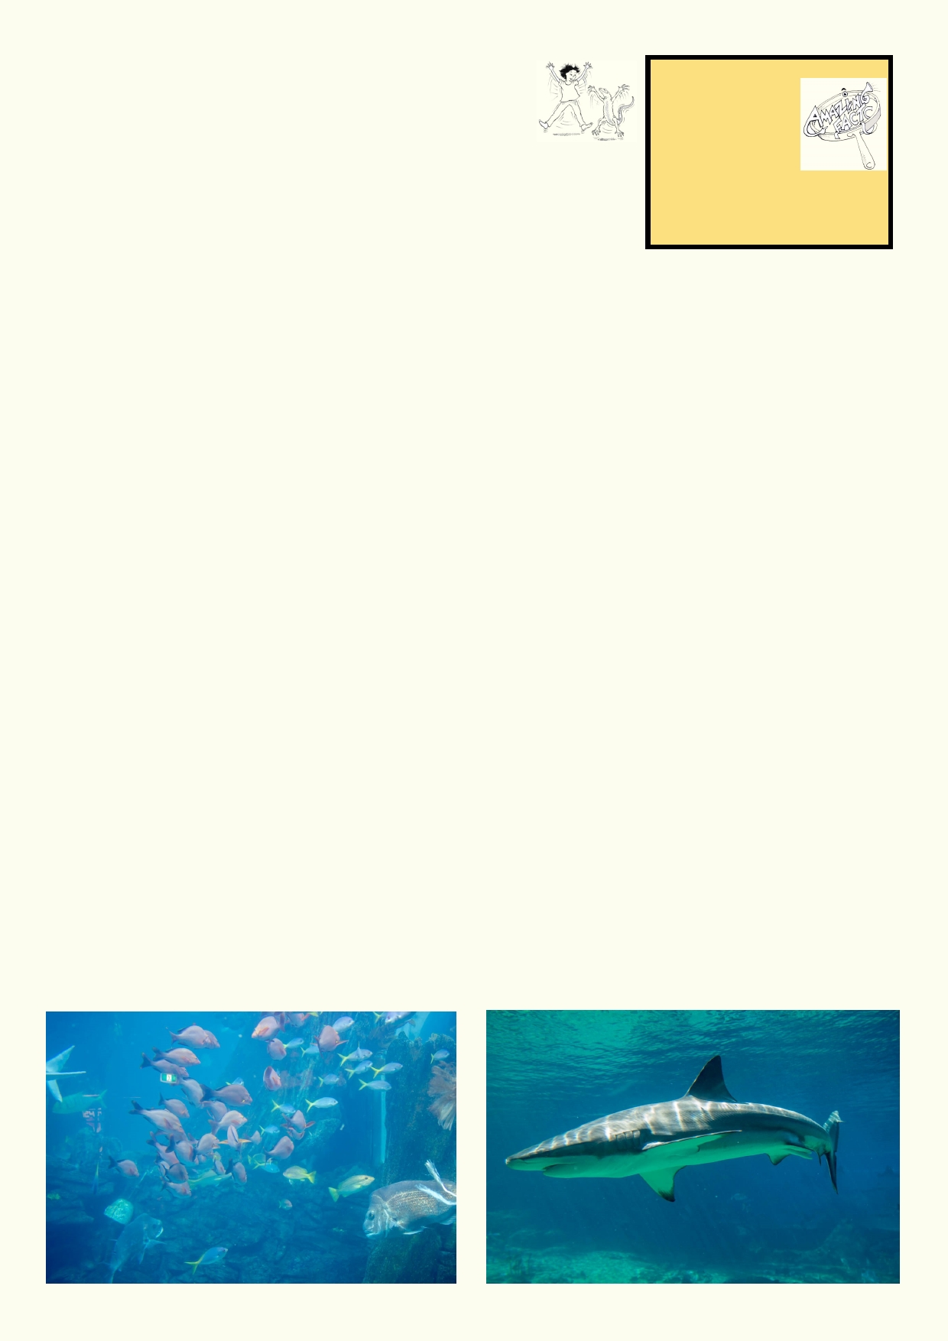Activity 5. Ocean food web

Introduction

Food webs help us see how energy flows through an ecosystem. Energy comes from the sun. Plants and some bacteria are able to
capture the sun's energy to produce food. These food-producing
organisms are then consumed by other organisms. These
consumers are usually animals. Some of these animals may just eat
Amazing facts
Tiny shrimp like
krill are the main
food for the
largest animal
that has ever lived - the
blue whale.

other animals. Some bacteria, fungus and animals help in the decomposition of dead organisms.
This helps to recycle nutrients and is also part of the food web. In a food web we can draw arrows to show how energy moves from the sun to plants and then through animals.

One of the simplest ocean food chains is phytoplankton, krill and baleen whales. A food web is a
more detailed way to see how plants and animals are interconnected. We can show that many
animals eat many different foods. It allows for many interconnections and that's why it starts
looking a bit like a web.

Materials
• Printed sheet of ocean life on page 13
• Scissors
• Paste/glue
• Marker
• Sheet of paper to stick animals to

Use Google Images to find examples of ocean food webs. Use the phrase "ocean food web". You should see many illustrations of marine food webs.

To construct your food web:

1.
2.
3.
4. 5.
6.
Cut out each of the squares.
Lay out each square on a large piece of paper to approximate a food web.
You might like to place the top carnivores at the top and the plankton towards the bottom
Decide where the hagfish will go. It eats dead animals. Glue the squares down.
Link the food web together with your marker. Point the arrow in the direction of how energy
is passing through the web. For example, if a lion eats an impala, the arrow goes towards
the lion.

12

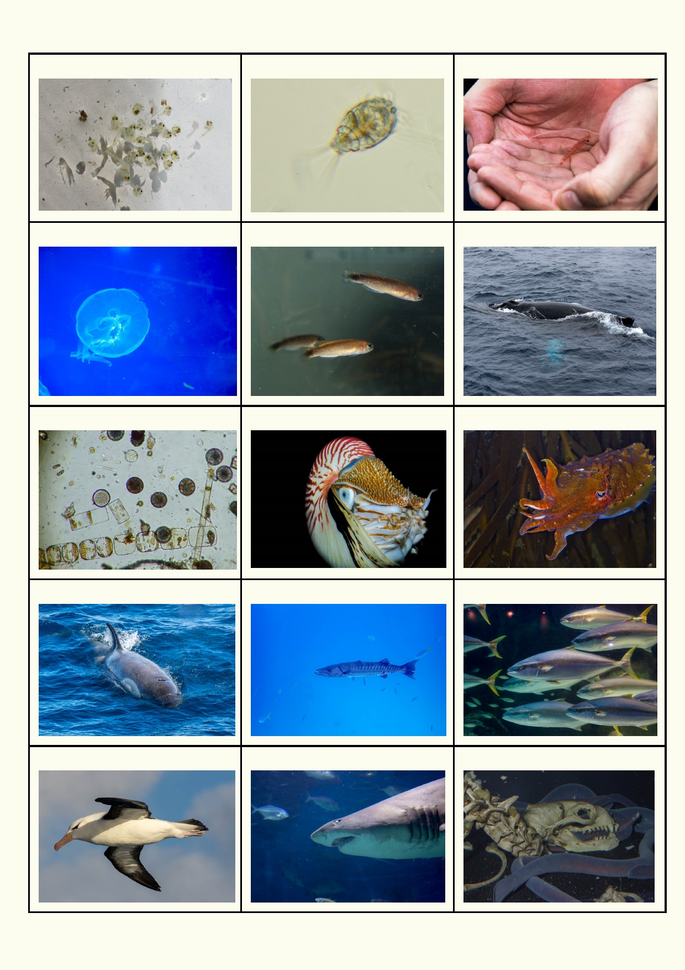Zooplankton Zooplankton Krill

Sea jelly Small fish Baleen whale

Phytoplankton Nautilus Cuttlefish

Orca or killer whale Barracuda School of large fish

Albatross Shark Hagfish

13

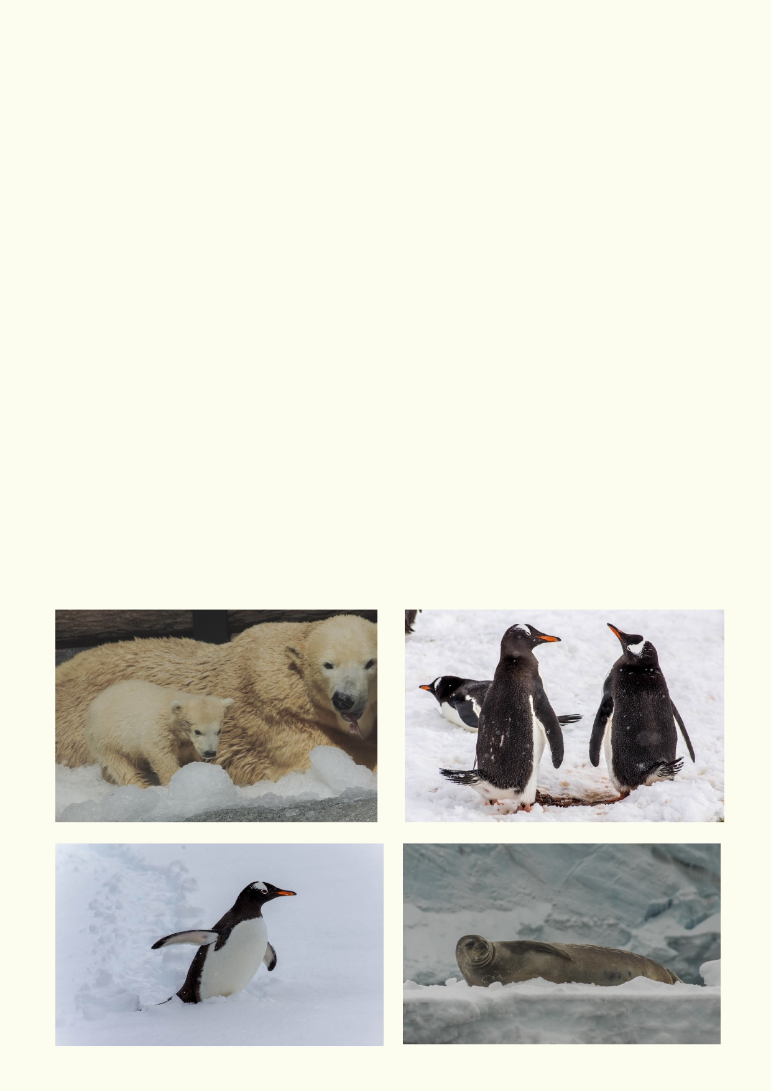Which part of the web has the fewest links?

_____________________________________________________________________________

Which part of the web has the largest number of links?

_____________________________________________________________________________

_____________________________________________________________________________

In waters with low nutrients, there will be a lot less phytoplankton. How might this affect the
number of animals and the species of animals?

_____________________________________________________________________________

_____________________________________________________________________________

What would happen to the web if most of the zooplankton died?

_____________________________________________________________________________

_____________________________________________________________________________

Where would you find a food web with a polar bear? ___________________________________

Where would you find a food web with penguins? _____________________________________

Use the internet to find out where you would find Weddell seals:__________________________

14

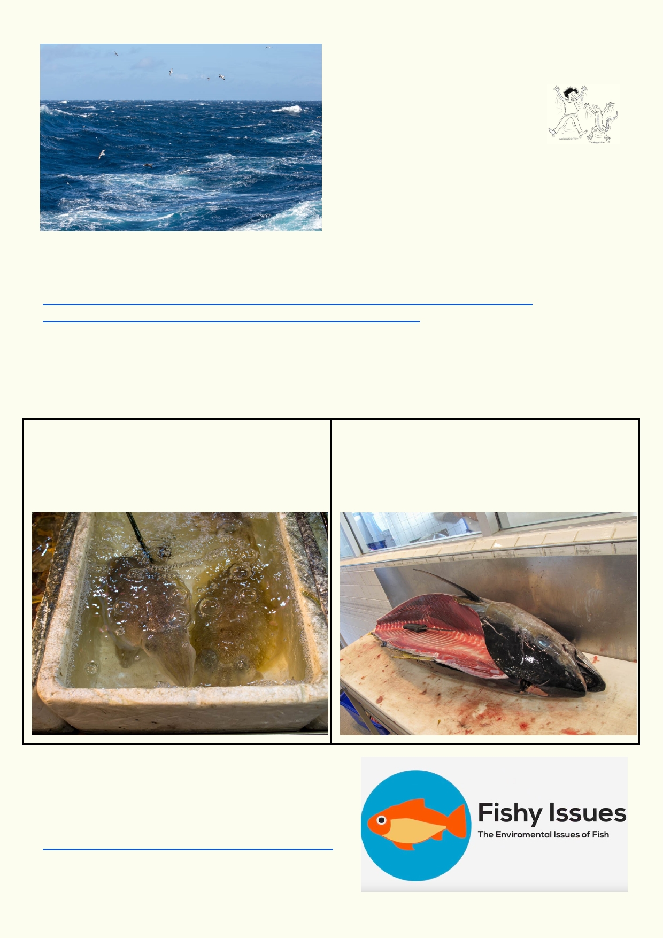Lesson 2. Ocean productivity

Activity 1. It's all about nutrients
and sustainable fishing

Upwellings
Most of the sea's nutrients on the
surface are quickly used up. Only some of these
nutrients are constantly replaced. The bottom of
the sea is full of nutrients because the dead algae
and animals sink to the bottom. Currents run
along the bottom of the ocean. These currents
come to the surface when they hit continents and islands. Its along the coastlines where major
undercurrents come to the surface that the world's most productive fisheries can be found.
Where the currents come to the surface are called upwellings.
https://oceanservice.noaa.gov/education/tutorial_currents/media/supp_cur03b.html
http://www.eorc.jaxa.jp/en/earthview/2004/img/tp040405_01.jpg

Sustainable fishing
It makes sense to only take the number of fish which won't reduce the total population. For some
species that is easy but for others it is much more difficult.

This species of squid only live for around a year.
They breed very quickly replacing themselves
every 12 months. Any changes in population can
be easily observed and populations can bounce
back quickly.

Tuna is a long-lived species. Some species can
live over 40 years. They are much slower to
breed. It is more difficult to observe fluctuations in
their population. It would take a decade for the
population to bounce back.

Where do your fish come from?

Watch this video about sustainable fisheries in Hong
Kong, made by a Middle School student in Hong
Kong:
https://www.youtube.com/watch?v=r7E61IcQcNc

15

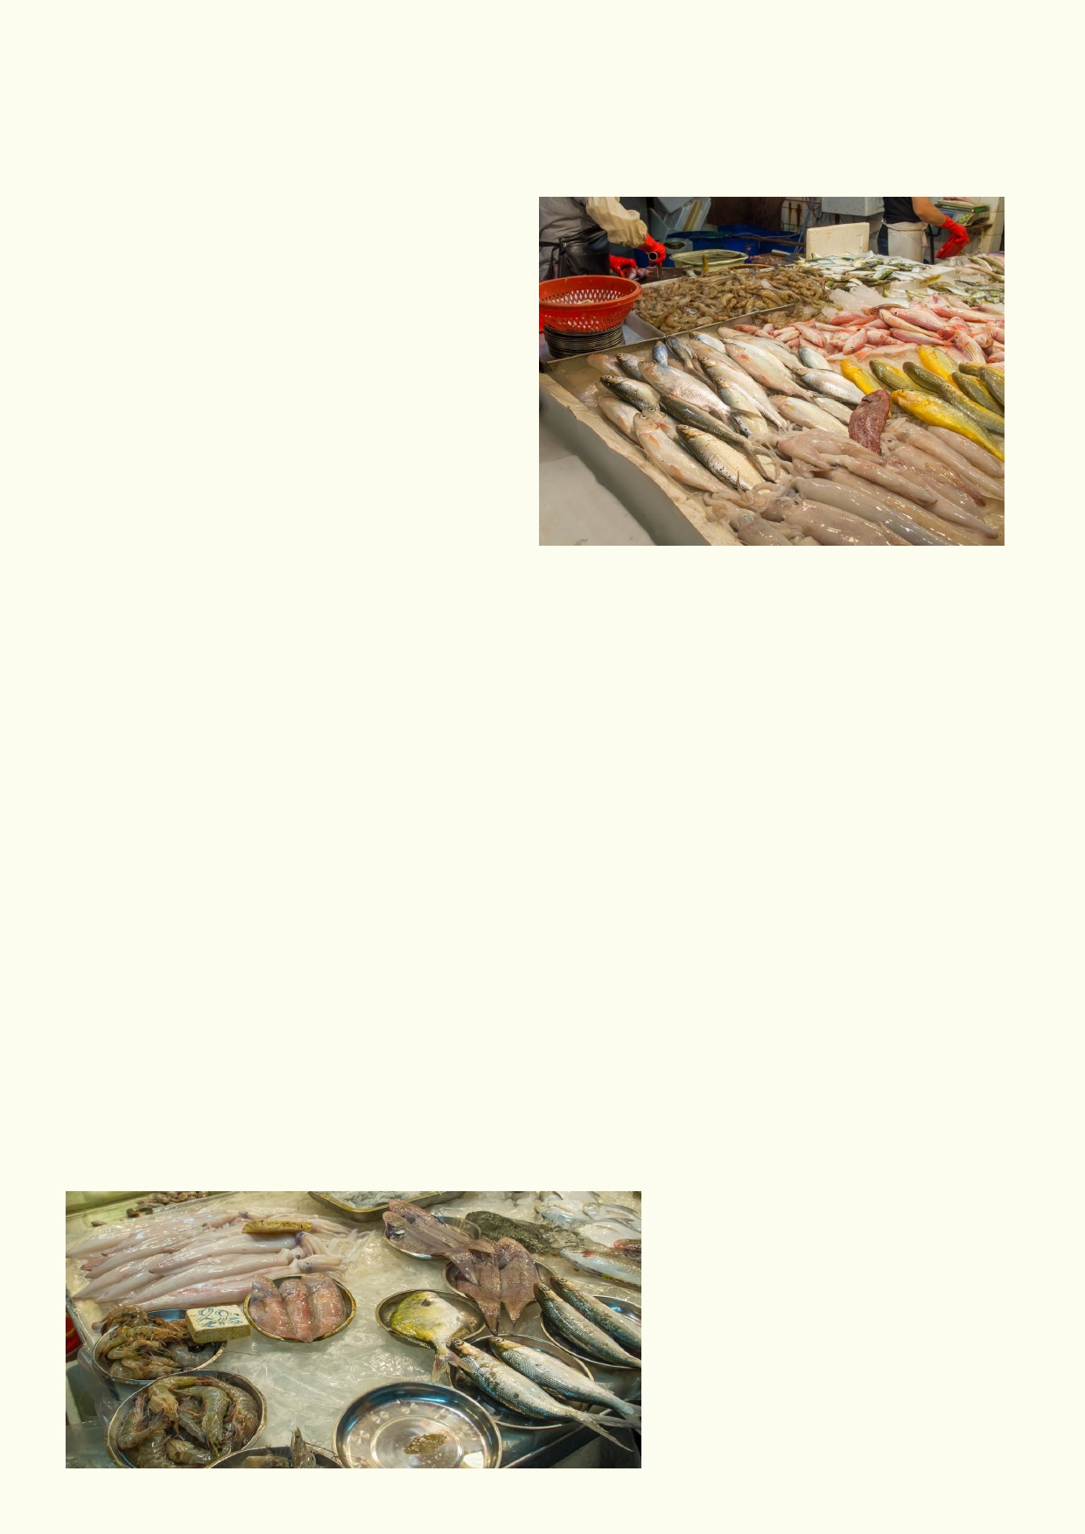Take a few photos at the local fish market of the fish on display. Ask the shopkeeper for the
names of the fish and write the names down.

Typical fish and other marine life found in the Hong Kong fish market are:
• T una
• Squid
• Clams
• Groupers
• Prawns
• Snappers
• Mackerel
• Mullet
• Crabs
• Sea Cucumbers
• Eels
• Sea-Bream
• Herring
• Sole

Name of the seafood you will research: ___________________________________________

Where was the seafood caught? _________________________________________________

How long does the marine animal live?____________________________________________

Does it have any conservation issues? ____________________________________________

____________________________________________________________________________

Does it seem easy or difficult to have sustainable fishing of this species? _________________

Explain what you think needs to be done to make sure the species is fished sustainably:

_____________________________________________________________________________

_____________________________________________________________________________

_____________________________________________________________________________

16

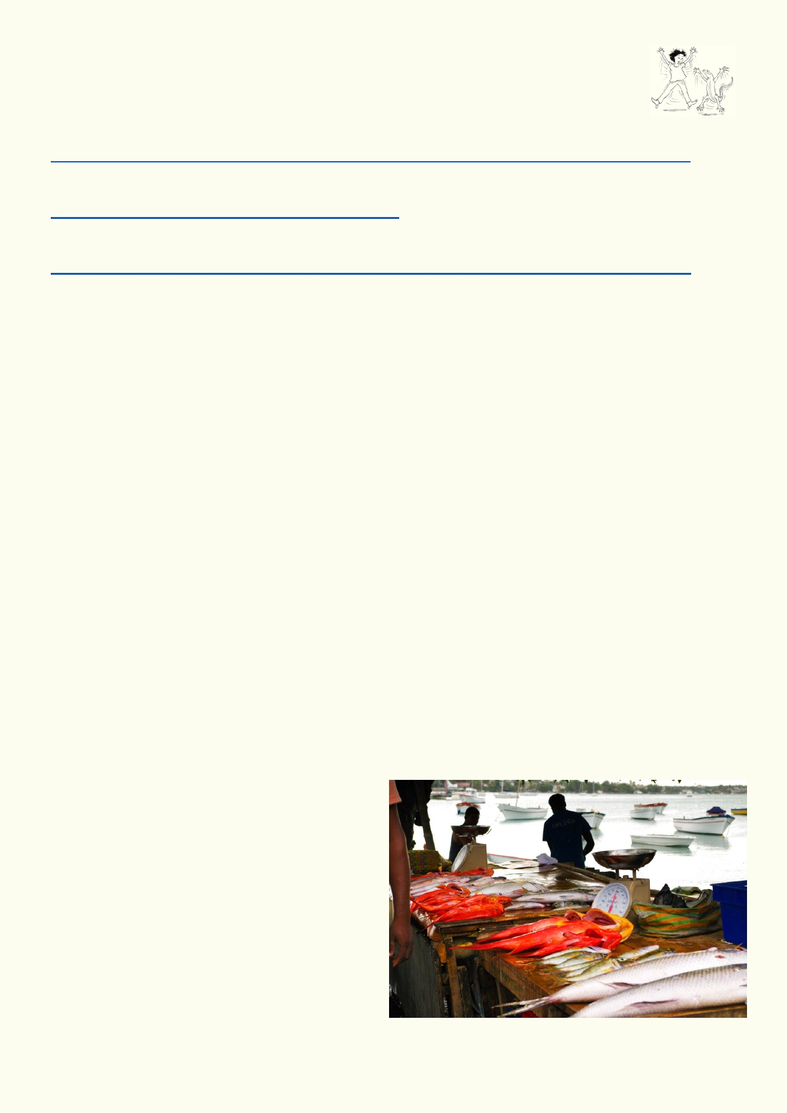Activity 2. Trawling - what is it?

Very large trawling ships have a much greater impact on fish stocks than small
fishing boats or line fishing. Watch this video about trawling and learn about what
"bycatch" means:
www.youtube.com/watch?v=NklxOhr2faI&index=2&list=PLk9ubBtvFgmvxhV1yllnHXwDV-s_VB0VN

Then watch this video which shows what bottom trawling looks like:
https://www.youtube.com/watch?v=lbSQhy0axH0

To learn more about the costs and benefits of trawling, look at this article about the practice: https://marine-conservation.org/what-we-do/program-areas/how-we-fish/destructive-fishing/

What are the disadvantages of this type of fishing?

___________________________________________________________________________

___________________________________________________________________________

Why do you think trawling was popular in Hong Kong and then banned?

____________________________________________________________________________

____________________________________________________________________________

What could happen if more large trawling ships were built? Consider the size of fish stocks, the
rights of small fishing boats and how different countries divide up fish stocks. You may need to do
some research about how fishery rights are determined.

____________________________________________________________________________

____________________________________________________________________________

It's not just about you

Why is fishing very important for small island nations?

_____________________________________

_____________________________________

_____________________________________

_____________________________________

_____________________________________

_____________________________________

17

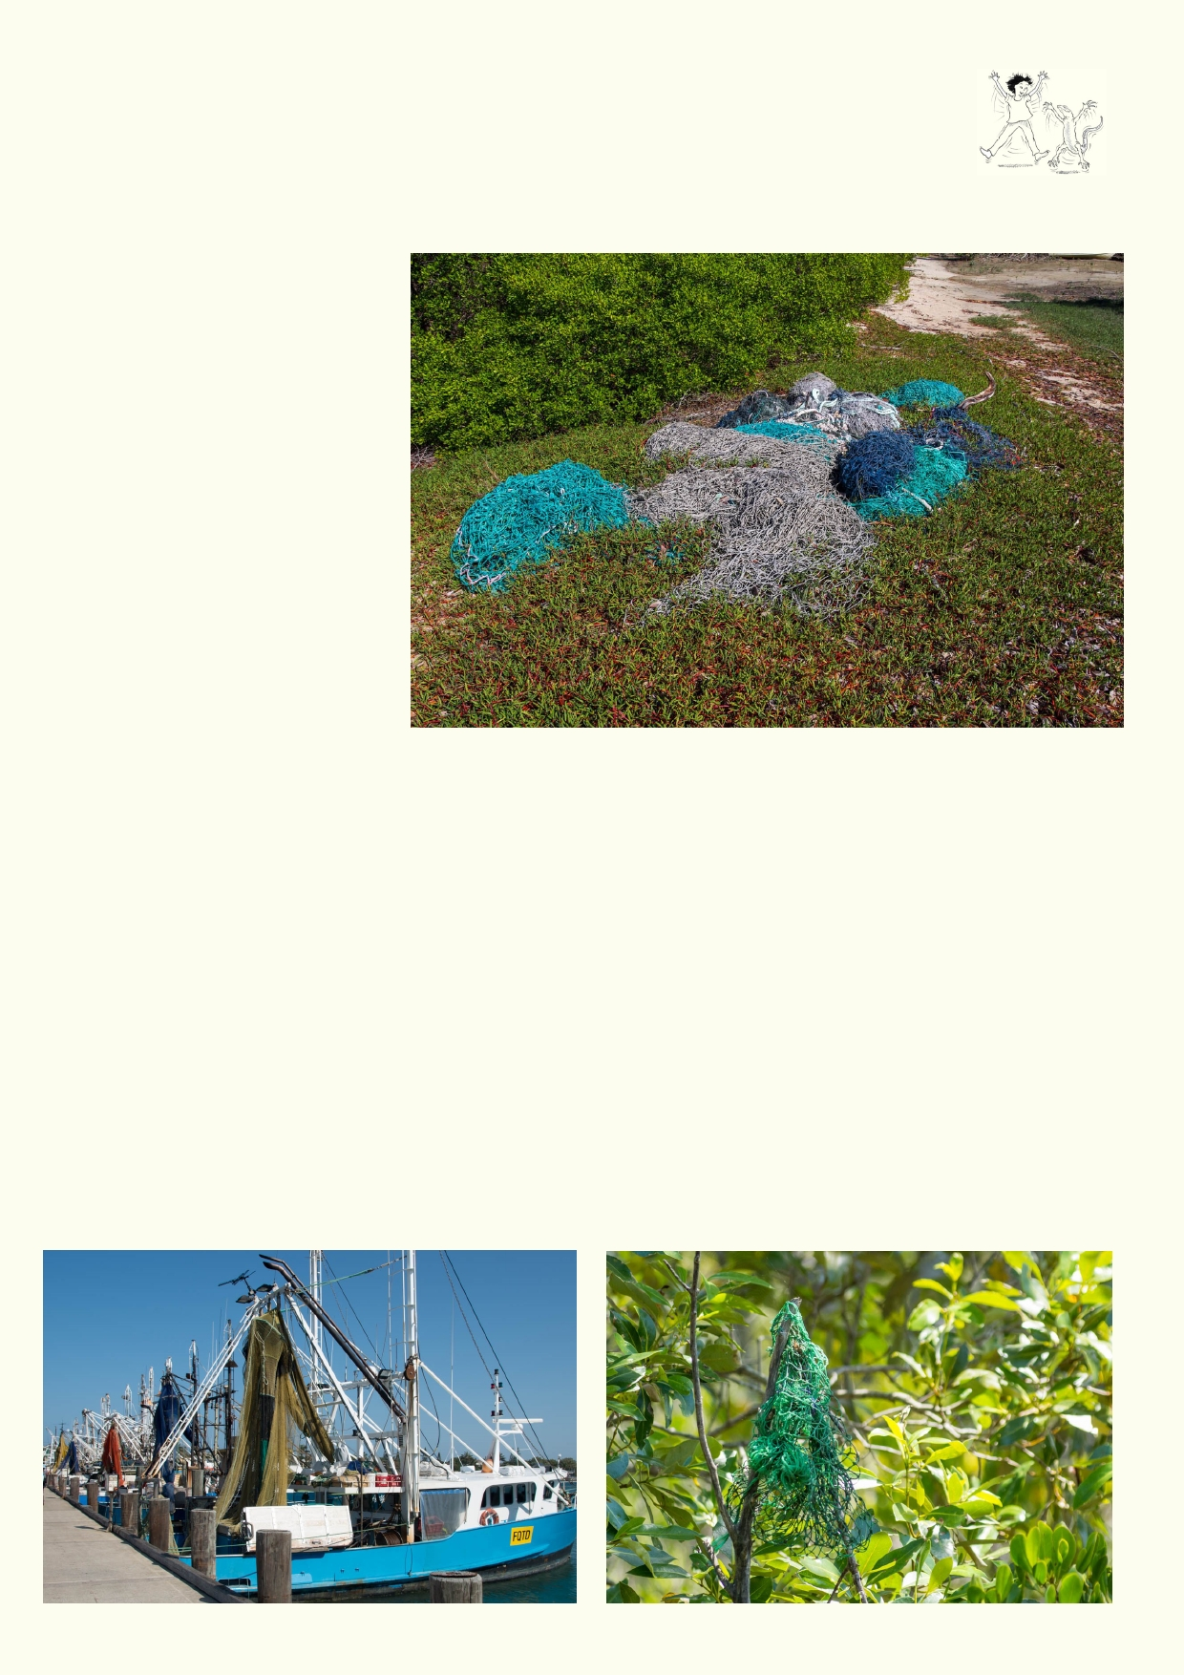Ghost nets

Ghost nets is the name given to fishing nets that have been lost at sea or dumped at
sea when they have become too damaged to repair. These freely drifting nets will
still catch and kill fish along with whales, turtles and sea birds. They will keep killing until they
finally wash up on a beach.

These ghost nets have been washed up on the beaches of
Horne Island. It is one of a
string of Islands between Papua New Guinea and
Australia, in an isolated part of
the world. Locals have
dragged the nets back from
the beach. Ghost nets are also
washed up around Hong
Kong. Floating nets damage
ships when they get tangled in
the propellers.

Look up ghost nets on the internet.

If you were a "Ghost Net Buster" - what would you do and what would you require fishermen to
do in order to prevent fishing nets from roaming the seas?

____________________________________________________________________________

____________________________________________________________________________

____________________________________________________________________________

____________________________________________________________________________

____________________________________________________________________________

____________________________________________________________________________

18

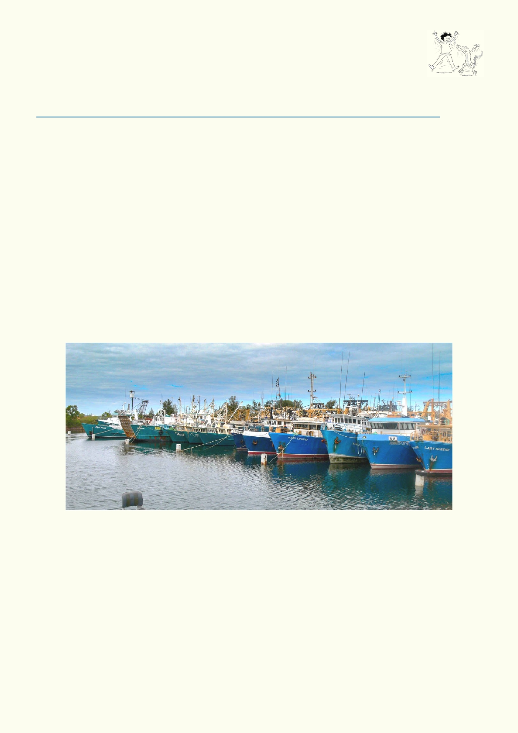Activity 3. The commons:
The game is called Tragedy of the Commons. Your teacher will explain the
rules to you.

Materials:
Use this Google Presentation link to introduce the activity.
https://docs.google.com/presentation/d/1CL6fYohqwwabiSkaVbAYuD6IhWxO2dcrdOG3KCKZDz4/edit#slide=id.g76d12a94c_0_62
A projector or computer screen to show presentation to the class.
Straws (1 per student),
Paper strips,
M&Ms - about 50
Blue tray
Tissues,
Tally sheet (copy sheet at end of this activity)

In some old farming cultures everyone used the same common land to graze their cattle, sheep goats etc. There was no interest in just one or two people looking after the common land when it
was being trashed by overgrazing by everyone else. Often common land became degraded. To
improve agriculture, common land was converted to private ownership. Usually it was a bad
decision for those using the land as they ended up with nothing. The tragedy of the commons is
that when we have common resources that nobody owns, it is likely to be trashed with over-
exploitation.

Activity 4 . Researching our oceans

Many countries have large research ships like this one that belongs to South Africa. These ships
transport many scientists who do a wide range of investigations. They include investigating
marine life, fisheries, pollution, climate change, effects of currents and weather, chemistry of the
seawater, photosynthesis of phytoplankton, general health of the ocean, etc.

Pretend that you were given a grant to research the topic(s) of your choice about Pacific Ocean
issues. Write a proposal for what you want to study and why you think it is important to the health
of the ocean.

19

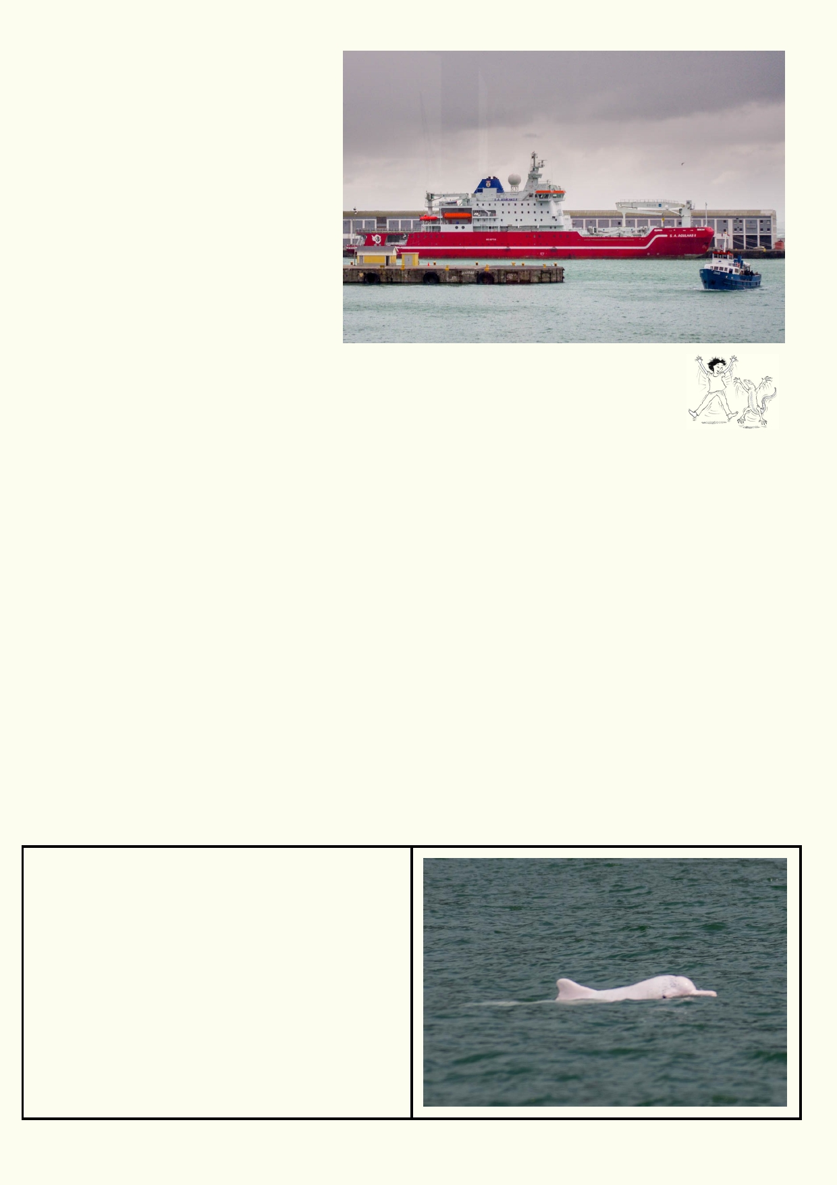You must include the following
general topics in your proposal:
• Ocean habitat/ecology
• Fisheries and/or Transportation
• Pollution
• Reasons for why your research
is important for the future health
of the ocean

You can also specify the research
ship of your choice and explain how it
is outfitted for your purposes.

Activity 5. Biography

A biography is usually the life story of a person. It is factual, but the biography is
written about the parts of the person's life that are most interesting and relevant to
the story that the writer wants to tell.

Choose one of the animals and write its biography from the time it is born or hatched. You will
need to use some imagination, but still keep it factual. Explain where it lives in the sea and how it
survives. What does it eat? How does it move? Does it have special senses? What are some of
the natural dangers it has to avoid? What are some of the human dangers that can affect its
survival? Does it hang out with its own species? If it does, what is the advantage of being in a
group? You might like to decide how your animal dies.

• Your biography should be around 600 words.
• You will need to do some research before you can write.
• Jot down some notes as you do your research.
• Decide which location in the sea or ocean your animal lives. You will need to describe the
habitat.
• You can use images, sketches or cartoons.

Below are the animals to be researched. The questions above are the most important ones to
answer in your biography. There are some more questions below for each animal that might help
you gather your information.

Pink dolphin
How many pink dolphins are left?
Where are the remaining populations?
What are some reasons given for their rarity?

20

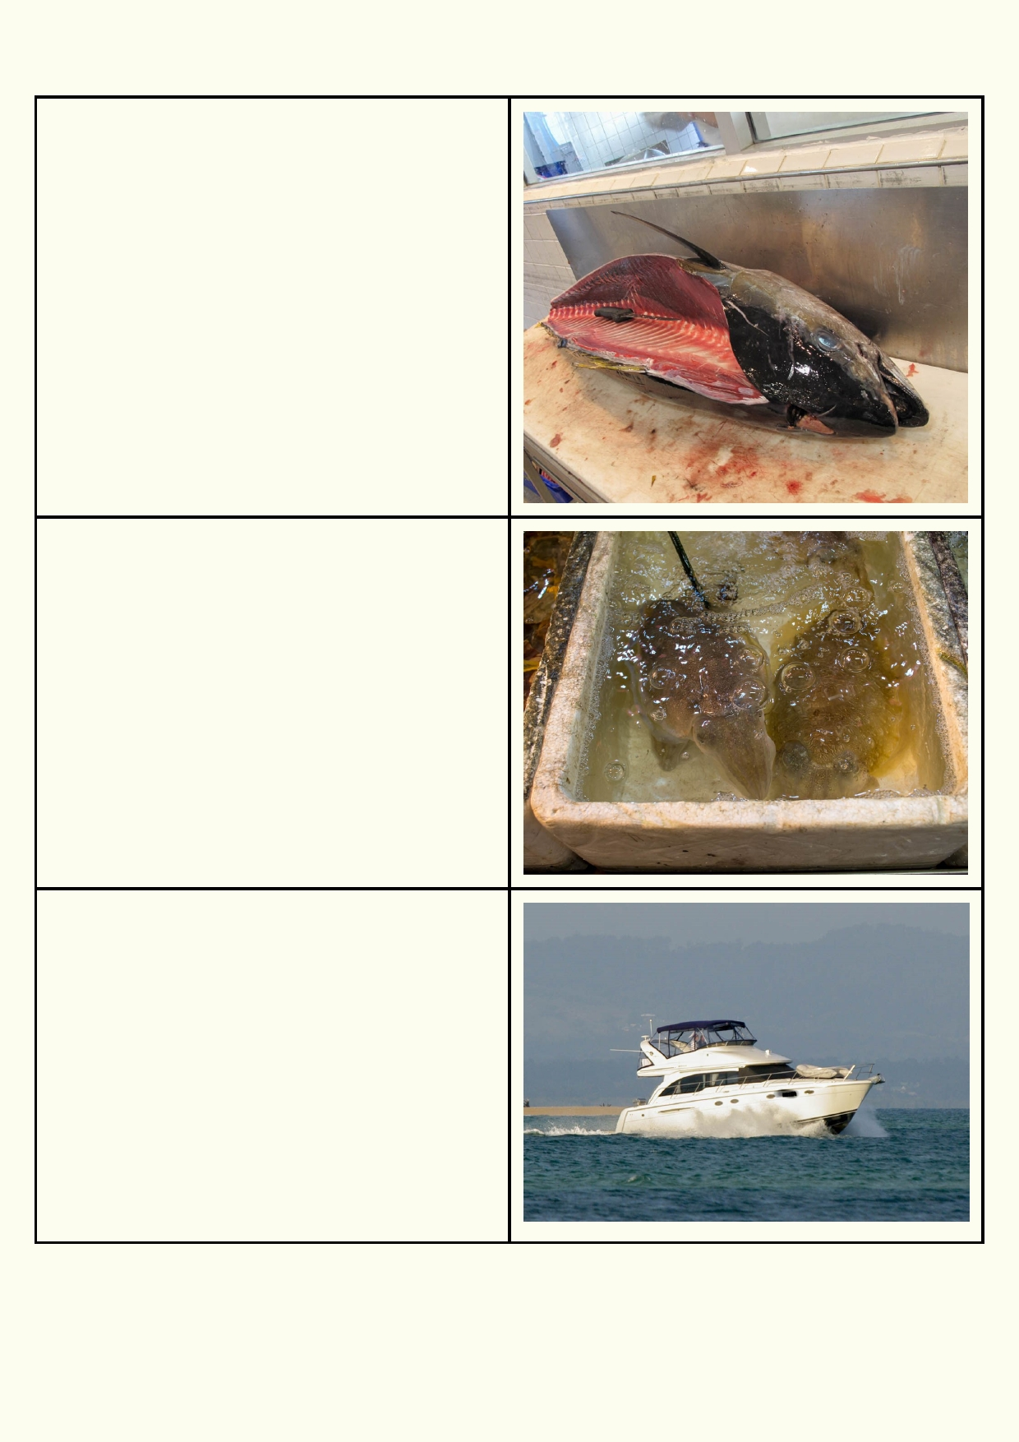Tuna
How big are tuna? Are there different species of
tuna?
What would it be like for the fish being attacked
by a school of tuna?
How fast are they?
Is there anything unique about tuna compared to
other fish species, which enables them to move
so fast?
Why do you think that some species grow so
large?
Where does most of the tuna fishing occur?
Is tuna fishing sustainable? Why should we make
sure it is sustainable?
Why is it a popular food?

Squid
How are squid caught by fishermen?
What animals like eating squid?
What are some of the unusual features of squid?
How do they move fast and slow?
What's unusual about their eyes?
When are squid active?
Why is fishing for squid likely to be more
sustainable than other marine animals?

Marlin
Boats like this are hired by sports fishermen to go
out to sea and try to catch marlin.
What is special about marlin?
Are there many marlin?
How quickly can they reproduce?
Do you think it's fair to catch a marlin if you put it
back? Why or why not?

21

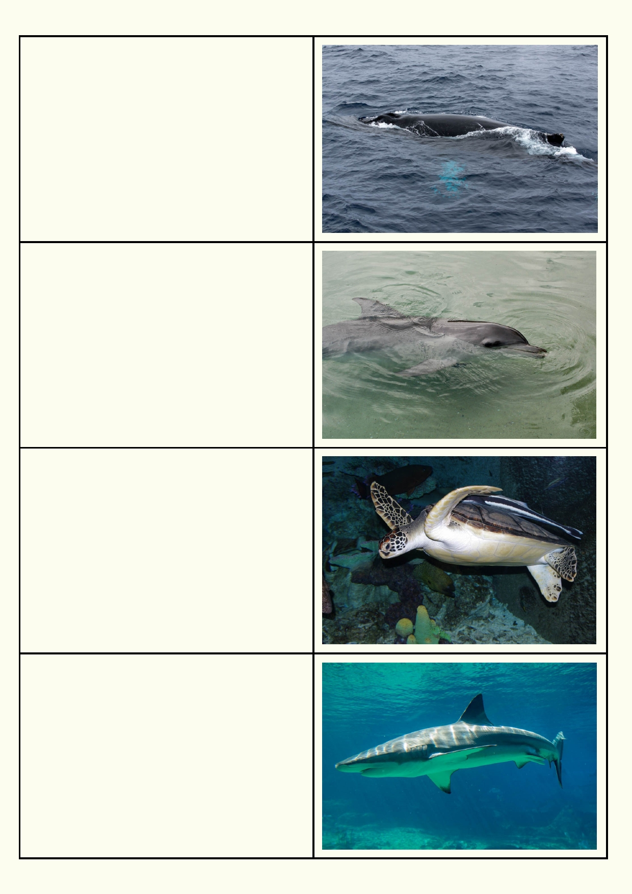Baleen whales (a family of whales that
includes the humpback, blue and fin whales)
In the past, why were whales hunted?
Where do they breed, feed and migrate?
How do they catch their food?
How do they give birth to young, feed and protect
them?
What has happened to their numbers since
people stopped hunting them?

Dolphin
What makes you think dolphins are social?
What makes you think dolphins are intelligent?
What do dolphins have that helps them catch
fish?
How can they protect themselves from larger
animals like sharks?
What do you think about dolphins being trained to
do tricks in an aquarium?

Turtle
Where do turtles lay eggs?
Why are many of the locations where turtles lay
eggs under threat?
Why is litter in the ocean a problem for turtles?
Why are ghost nets (nets that have become litter)
a danger to turtles?
Why would someone buy a dead stuffed turtle as
a souvenir?
Is it acceptable for an islander who has lived off
the sea to eat turtle?

Shark
Why are people scared of sharks?
Why are sharks important for a balanced food
web?
How many people have been killed by sharks
yearly?
How many sharks get killed by people yearly?
How is the hunting of sharks for just their fins a
bad example of using sea resources?

22

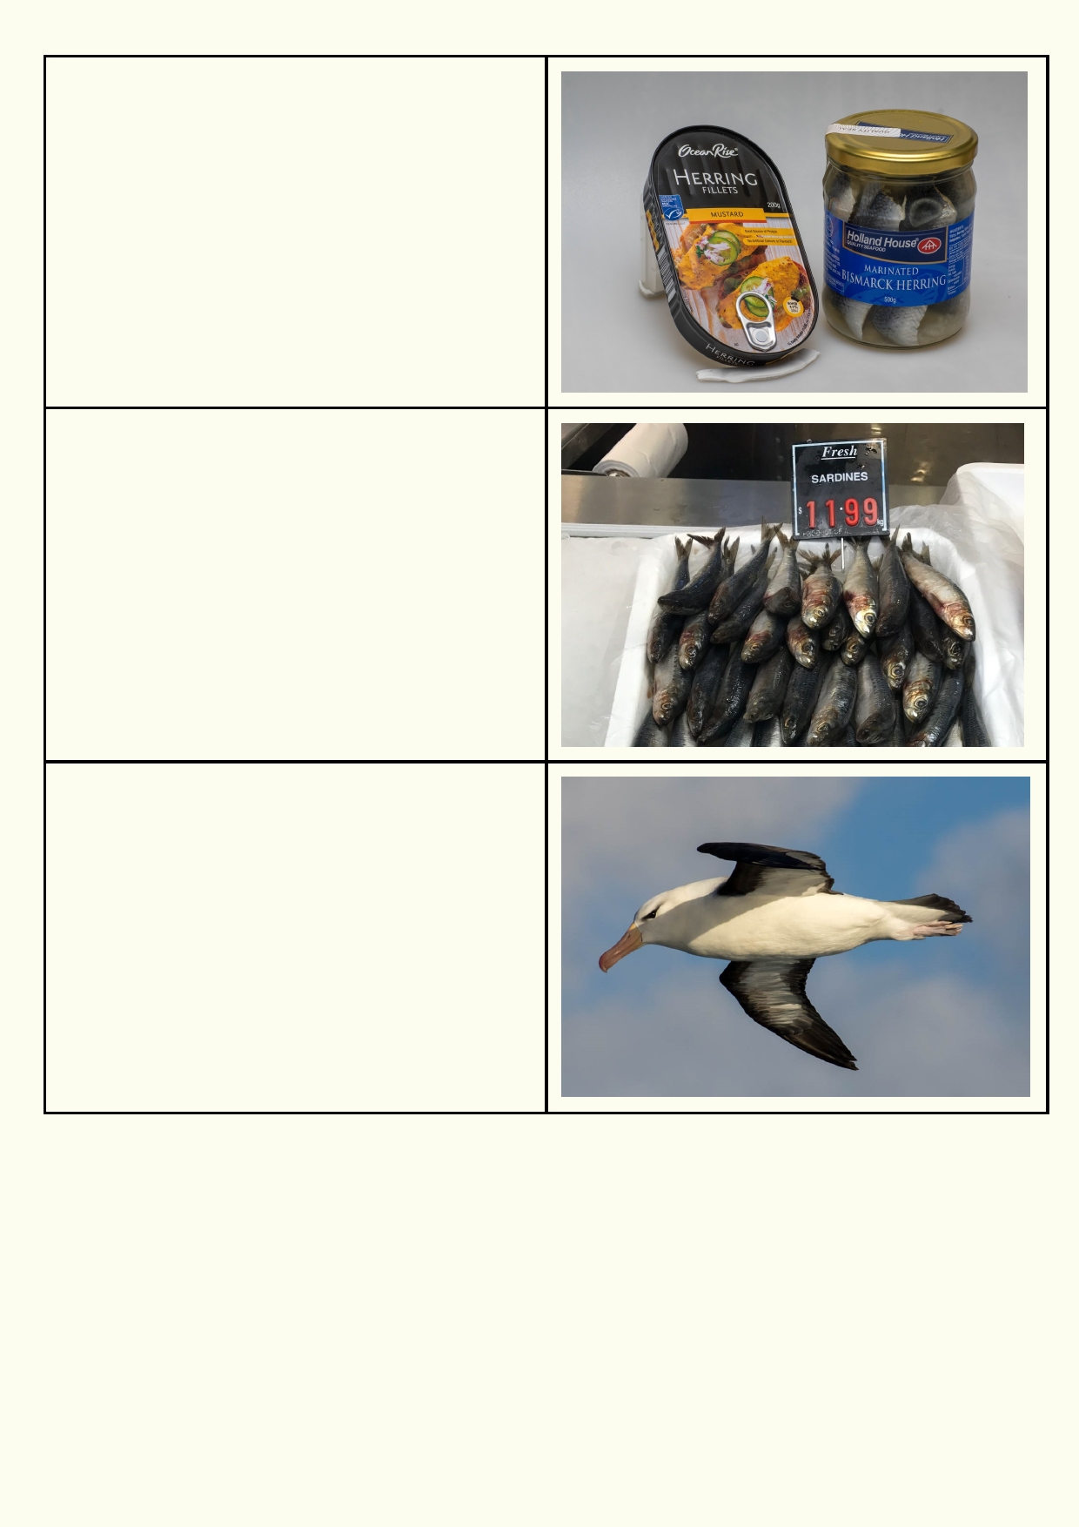Herring
What has happened to the population of herring
around the world?
What new methods are being used to catch
herring?
How have governments tried to regulate the
fishing of herring?

Sardines
Where are you likely to come across sardines?
How big are sardines?
How many would you see in a school of
sardines?
Sardines refers to more than one species. What
do the different species have in common?
Why are sardines important food sources for
other marine animals and humans?

Albatross
When is the only time albatrosses go onto land?
Why do albatrosses follow fishing boats?
Why is plastic litter in the sea a problem for
albatrosses?
What are some of the unique characteristics of
this bird?
What are some of the biggest threats to these
birds while feeding at sea and nesting on remote
islands?

23

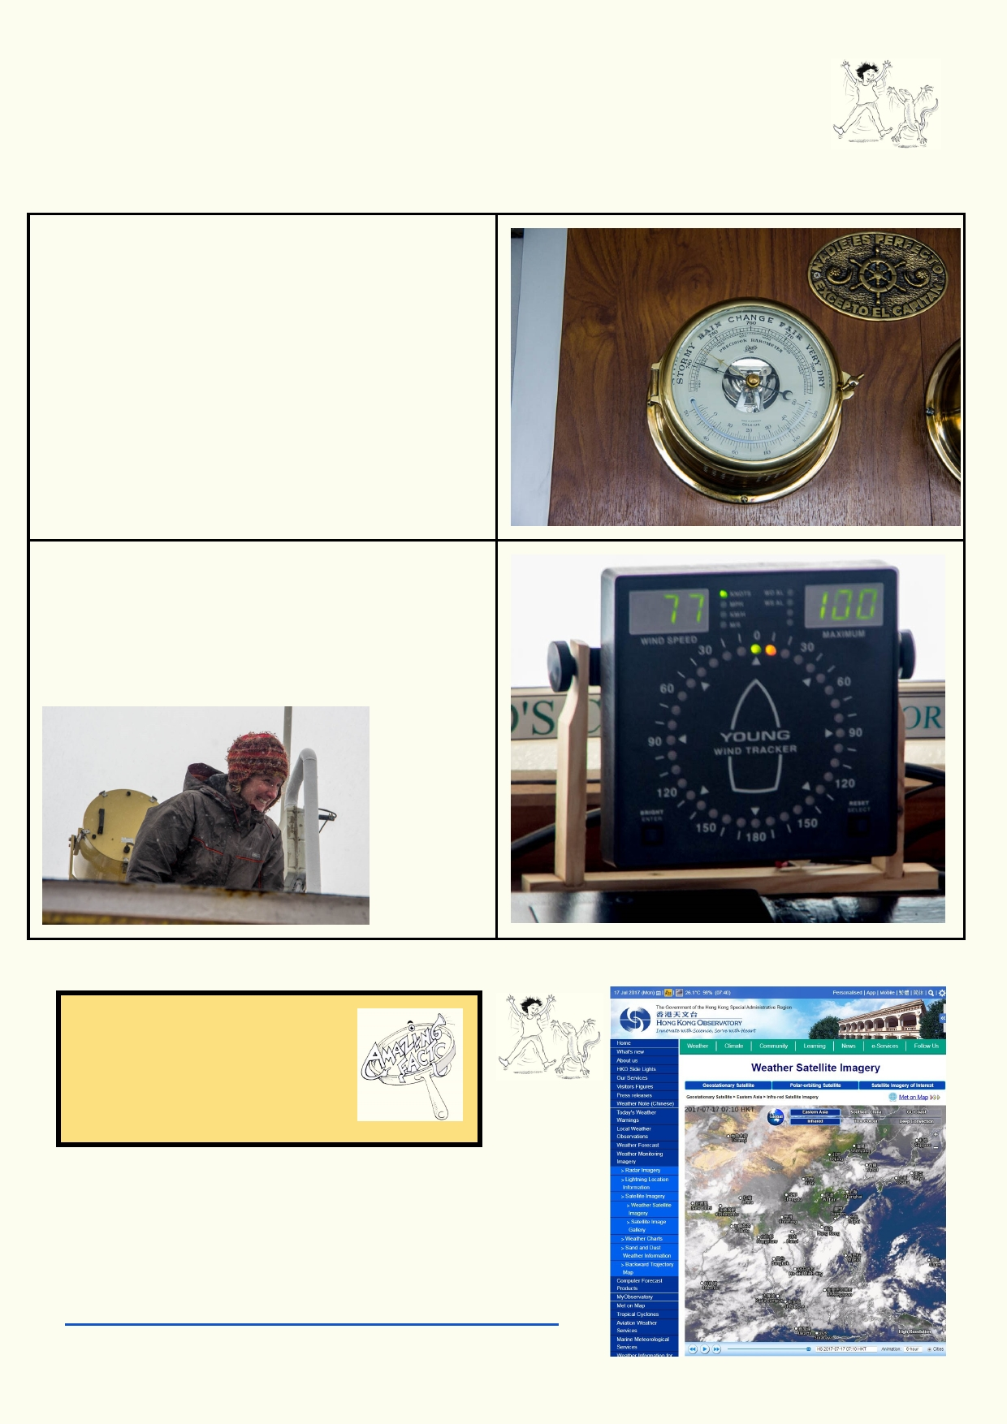Lesson 3. Oceans and Weather - Commotion in the Ocean

The oceans in the past were always a dangerous place for humans to sail, not knowing when the next big storm would strike. Intense winds whip up massive
waves along with strong gusts.

Barometers were the first instruments that
indicated that storms could be on the way. The
barometer measures air pressure.

This barometer is showing very low air pressure. Outside are hurricane force winds.

This ship's wind monitor is recording 77 knots which is about 150km per hour. The maximum
gust of wind was 100 knots which is about 200km
per hour. When people go outside on the deck
they must strap themselves to the boat or hang
on tightly.

Amazing fact
It requires the world's most
powerful computers to predict
the weather over the next
week.

Activity 1. Weather from satellite and radar

Use these websites to look at radar and satellite information provided by Hong Kong Observatory. Press the play button
on the bottom left of the image.
http://www.hko.gov.hk/wxinfo/intersat/satellite/sate.htm

24

Go to the radar page:
http://www.hko.gov.hk/wxinfo/radars/radar_range1.htm

What information do satellites provide?
_____________________________________________________________________________

_____________________________________________________________________________

What information does radar provide?

_____________________________________________________________________________

_________________________________________________________________________

Extension
Find out about the Beaufort scale. What is its history and how is it used today?

Activity 2. Ocean circulation
Blood circulates around your body. Water circulates around the ocean. The
circulation on the surface of the ocean can be different to that on the
seafloor. These ocean currents are linked to, and help drive, atmospheric
processes as well. This relationship is key in determining weather and climate
patterns around the world.

Watch this video: https://www.youtube.com/watch?v=-aESMZyrQ1Y

See if you can find Hong Kong in the animation of the ocean currents. (go to approximately 7 min.
20 sec.) What is the direction of the movement of ocean currents around Hong Kong? Are they clockwise or counterclockwise? Describe the patterns.
_____________________________________________________________________________

_____________________________________________________________________________

_____________________________________________________________________________

How do you think it is possible for litter from your region to end up thousands of kilometers away?

_____________________________________________________________________________

_____________________________________________________________________________

Scientists have actually learned a lot about ocean currents from tracking the path of containers lost
on ships in storms, which end up on beaches. Read these articles to learn more:

...about the organisms and plastic that move around in currents:
https://www.sciencedaily.com/releases/2016/04/160419130133.htm
….and the incredible trips of rubber duckies:
https://www.csmonitor.com/2003/0731/p01s04-woeu.html
www.mnn.com/earth-matters/wilderness-resources/stories/what-can-28000-rubber-duckies-lost-at-sea-teach-us-about

25

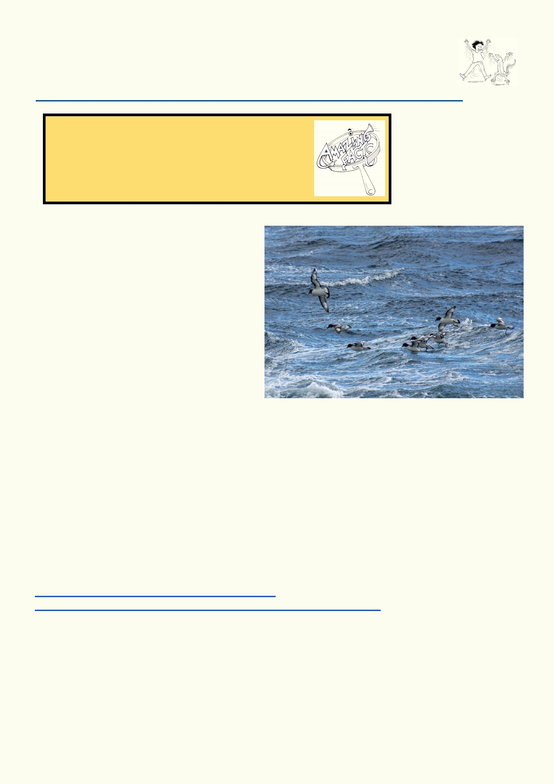Activity 3. Rubber Ducky Science

Your teacher will provide you with the worksheets for an activity that explores ocean currents by tracking the rubber duckies you have just read about.
https://dps.instructure.com/courses/574084/files/41708625/download?download_frd=1

Amazing facts
The water at the bottom of the deep ocean is always
at around 0 to 3 degrees Celsius. To form ice, water
must expand. The pressure is so great deep down,
that water can't expand and freeze into ice.

El Nino and La Nina

The phenomena known as El Nino and La
Nina refer to a reversal, or change, of normal
oceanic and atmospheric currents. They
were first observed in South America by the
fishing communities. In a normal year during
the winter, fish stocks were plentiful off the
western coast of South America. But in
some years, the fish stocks were very low
and catches were very low. They called the
years with low fish stocks "El Nino" meaning "little boy" in Spanish.

Scientists had noticed that these fish stock observations were the result of oceanic and
atmospheric abnormalities, and these had corresponding effects on the other side of the Pacific.
When scientists compared the changes in winds and sea surface temperature, they found that
they matched the El Nino and La Nina years. La Nina years are associated with cooling effects in the equatorial Pacific Ocean.

This new information has helped millions of farmers and fishermen predict how much rain they
are likely to have. It can also indicate if there will be devastation due to floods or droughts. However, no El Nino or La Nina events are identical.

Activity 4.
The two short videos below provide you with further explanation about El Nino and La Nina.
https://www.youtube.com/watch?v=tyPq86yM_Ic
http://video.nationalgeographic.com.au/video/news/101-videos/el-nino

• Choose any country that might be affected by El Nino and La Nina
• Annotate a diagram or make a table that compares the effects of the two events in that
country.

26

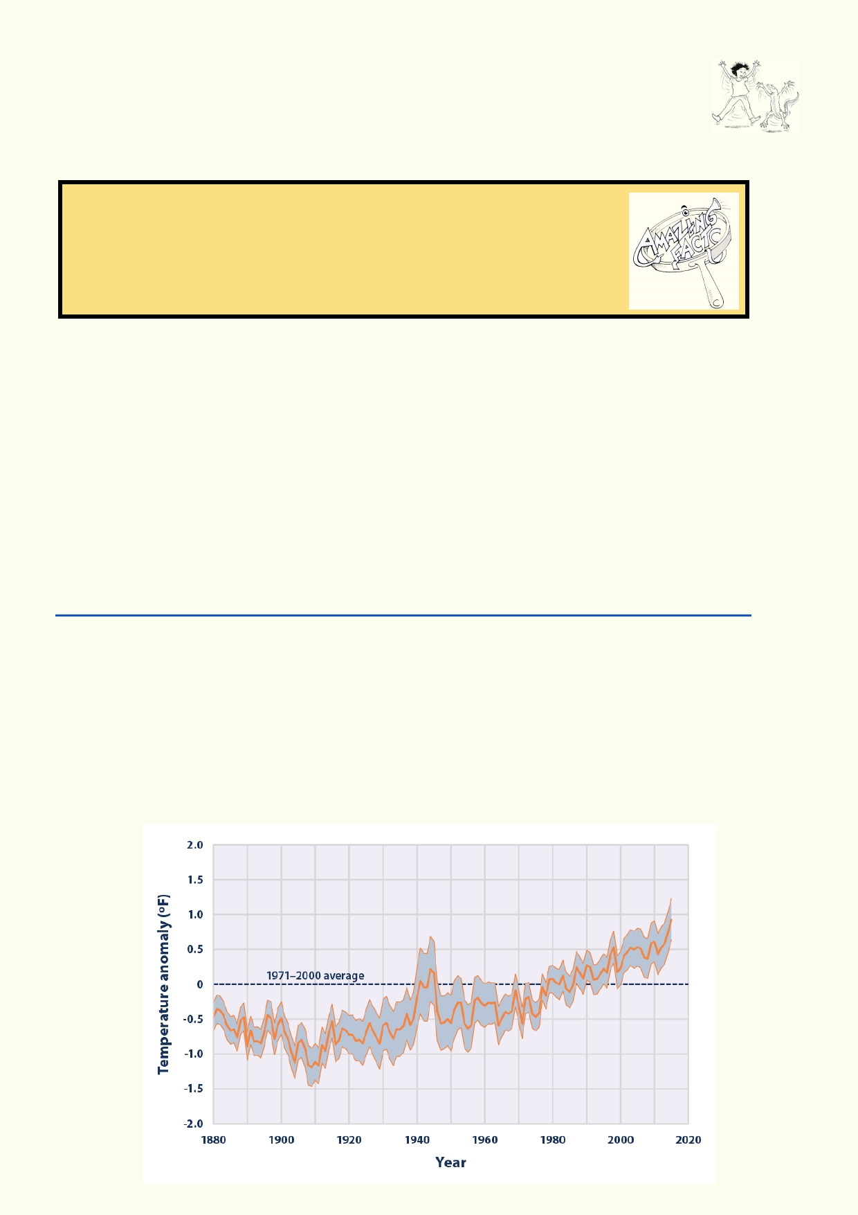Activity 5. Are the oceans the biggest heat sink?

Natural changes in currents and ocean temperature have always influenced the
climate. Now the oceans are also being affected by increases in the Earth's
temperature due to greenhouse gases.

Amazing facts
Most of the 15 cm rise in sea level in the past 100 years has been due to
the expansion of water in the oceans. The expansion of water is due to
the sea's temperature rise. Melting glaciers and Antarctic ice will
contribute more to sea level rise in the future.

What is a heat sink?
A heat sink is a material that holds heat for a long period of time. Water can store heat for a long
time, but air loses heat quickly. When the sun goes down, the air starts to cool and will keep
cooling until the sun is back the next day. The sea temperature hardly changes over 24 hours
unless the water is very shallow.

Rising ocean temperatures and sea levels

Read the first three paragraphs of this website. The articles provide a graph of the amount of extra energy the oceans have absorbed since 1965. The units used to measure energy is joules.
It takes about 4 joules to heat a gram of water by 1 degree centigrade. Since around 1985 the
oceans have absorbed around 15 followed by 22 zeros (1022) or
150,000,000,000,000,000,000,000 joules of energy.
www.climate.gov/news-features/understanding-climate/climate-change-ocean-heat-content

Why are the oceans getting warmer?

_____________________________________________________________________________

_____________________________________________________________________________

_____________________________________________________________________________

27

Source: USA EPA
https://www.epa.gov/climate-indicators/climate-change-indicators-sea-surface-temperature

Compare the four graphs showing changes in the ocean's heat, temperature and sea levels on these four webpages.
https://www.epa.gov/climate-indicators/climate-change-indicators-ocean-heat
https://www.epa.gov/climate-indicators/climate-change-indicators-sea-surface-temperature
https://www.epa.gov/climate-indicators/climate-change-indicators-sea-level
http://www.hko.gov.hk/climate_change/obs_hk_sea_level_e.htm

What is similar in the four graphs?

_____________________________________________________________________________

_____________________________________________________________________________

Predict what will happen to the ocean over the next 30 years;

Temperature increase________________________

Sea level rise ______________________________

Activity 6. Ocean heat sink - looking for trouble

The sea level will continue to rise because water expands as it is heated. Also glaciers are melting, adding to the amount of water in the sea.

A small increase in sea level might not be very noticeable until there are bad weather events. It
becomes more difficult for flood waters to reach the sea, so more land gets flooded. When waves surge onto the coast during typhoons, the seawater will reach further inland.

Consequences - sea level rise

These are two references to sea level rise. It seems to be happening, but very slowly.
http://www.nationalgeographic.com/environment/oceans/critical-issues-sea-temperature-rise/
www.scmp.com/news/hong-kong/health-environment/article/1877284/rising-sea-levels-set-displace-45-million-people
Look up further online references.

What are the consequences of sea levels rising?

_____________________________________________________________________________

_____________________________________________________________________________

Explain if you think the predictions about cities being flooded are objective or biased:

_____________________________________________________________________________

_____________________________________________________________________________

28

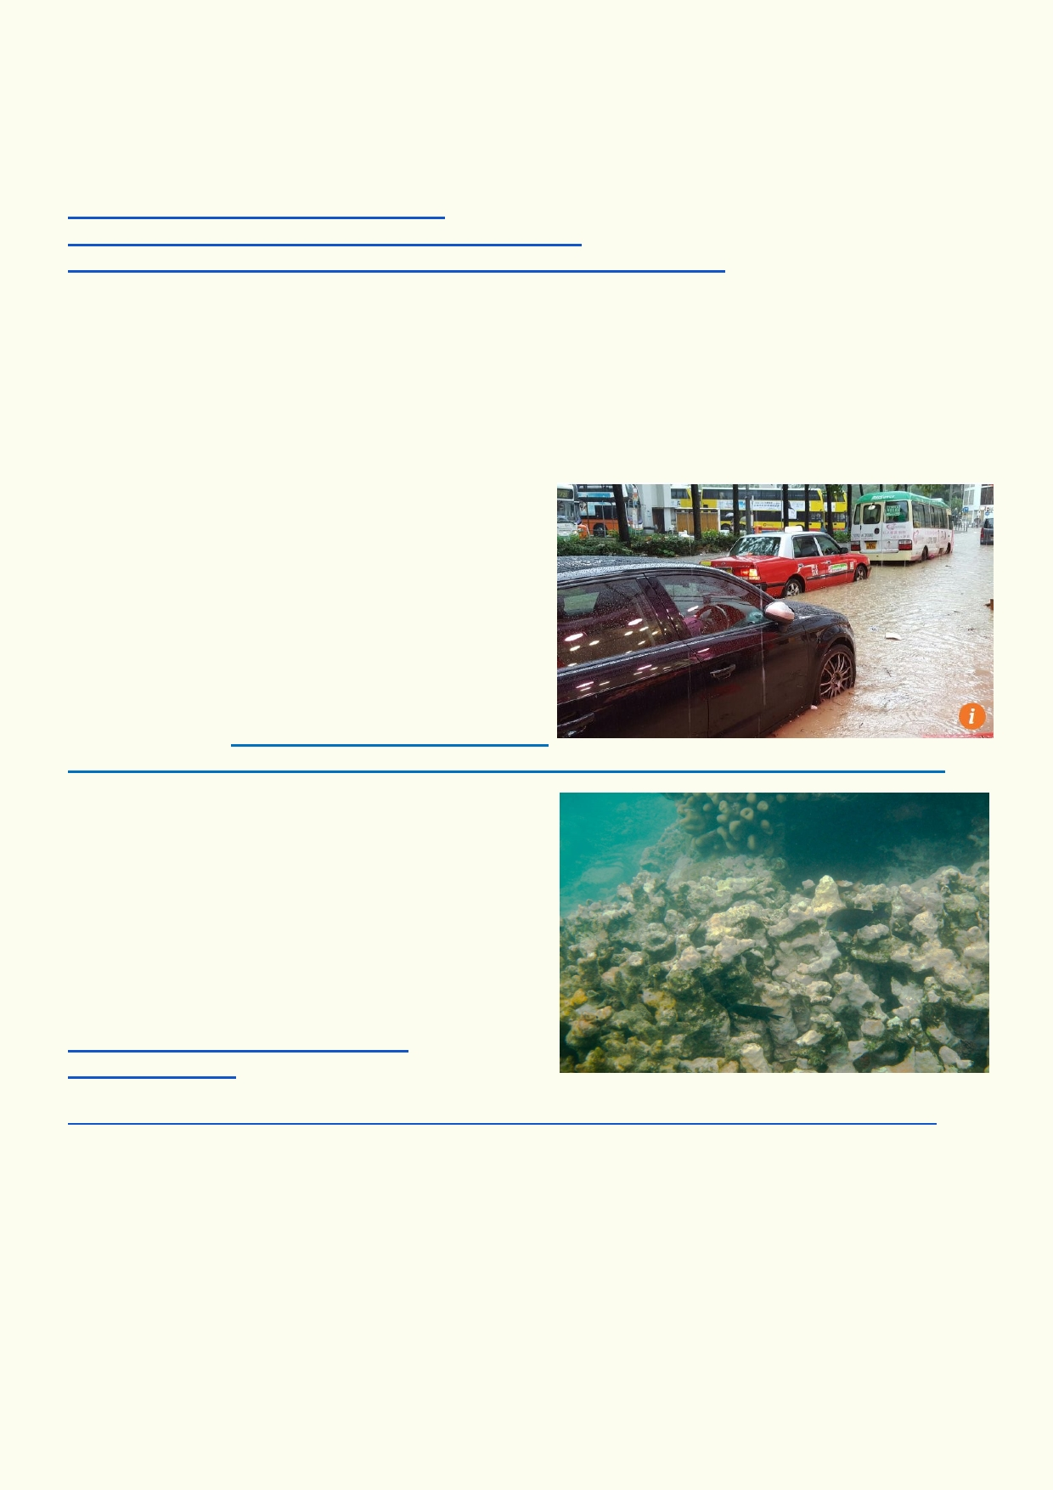Consequences - storms, hurricanes, floods etc.

There has been a lot of research into how higher atmospheric and sea temperatures will affect
weather. We have also known for a long time that warmer oceans increases atmospheric
moisture. Use these links to find out more climate change influences damaging weather events.
https://scijinks.gov/hurricane-simulation/
http://www.nhc.noaa.gov/outreach/games/canelab.htm
https://earthobservatory.nasa.gov/Features/ClimateStorms/page2.php

Explain why warmer oceans increases the amount of water in the atmosphere and can lead to more devastating weather events.

_____________________________________________________________________________

_____________________________________________________________________________

________________________________________

________________________________________

________________________________________

________________________________________

________________________________________

Source of photo: http://www.scmp.com/news/hong-
kong/health-environment/article/2095537/hong-kong-grinds-halt-amid-rainstorm-leaves-social

Consequences - coral bleaching events

Over some summers, coral sea reefs around the
world have had large increases in temperature.
During these periods, the coral turns white. Often
the coral die and it can take up to a decade for the
corals to recover, provided there are no new
stresses. Learn more from these links.
https://oceanservice.noaa.gov/facts/
coral_bleach.html
More in-depth link:
www.gbrmpa.gov.au/managing-the-reef/threats-to-the-reef/climate-change/what-does-this-mean-for-species/corals/what-is-coral-bleaching

How are increasing sea temperatures currently affecting coral reefs?

_____________________________________________________________________________

_____________________________________________________________________________

_____________________________________________________________________________

29

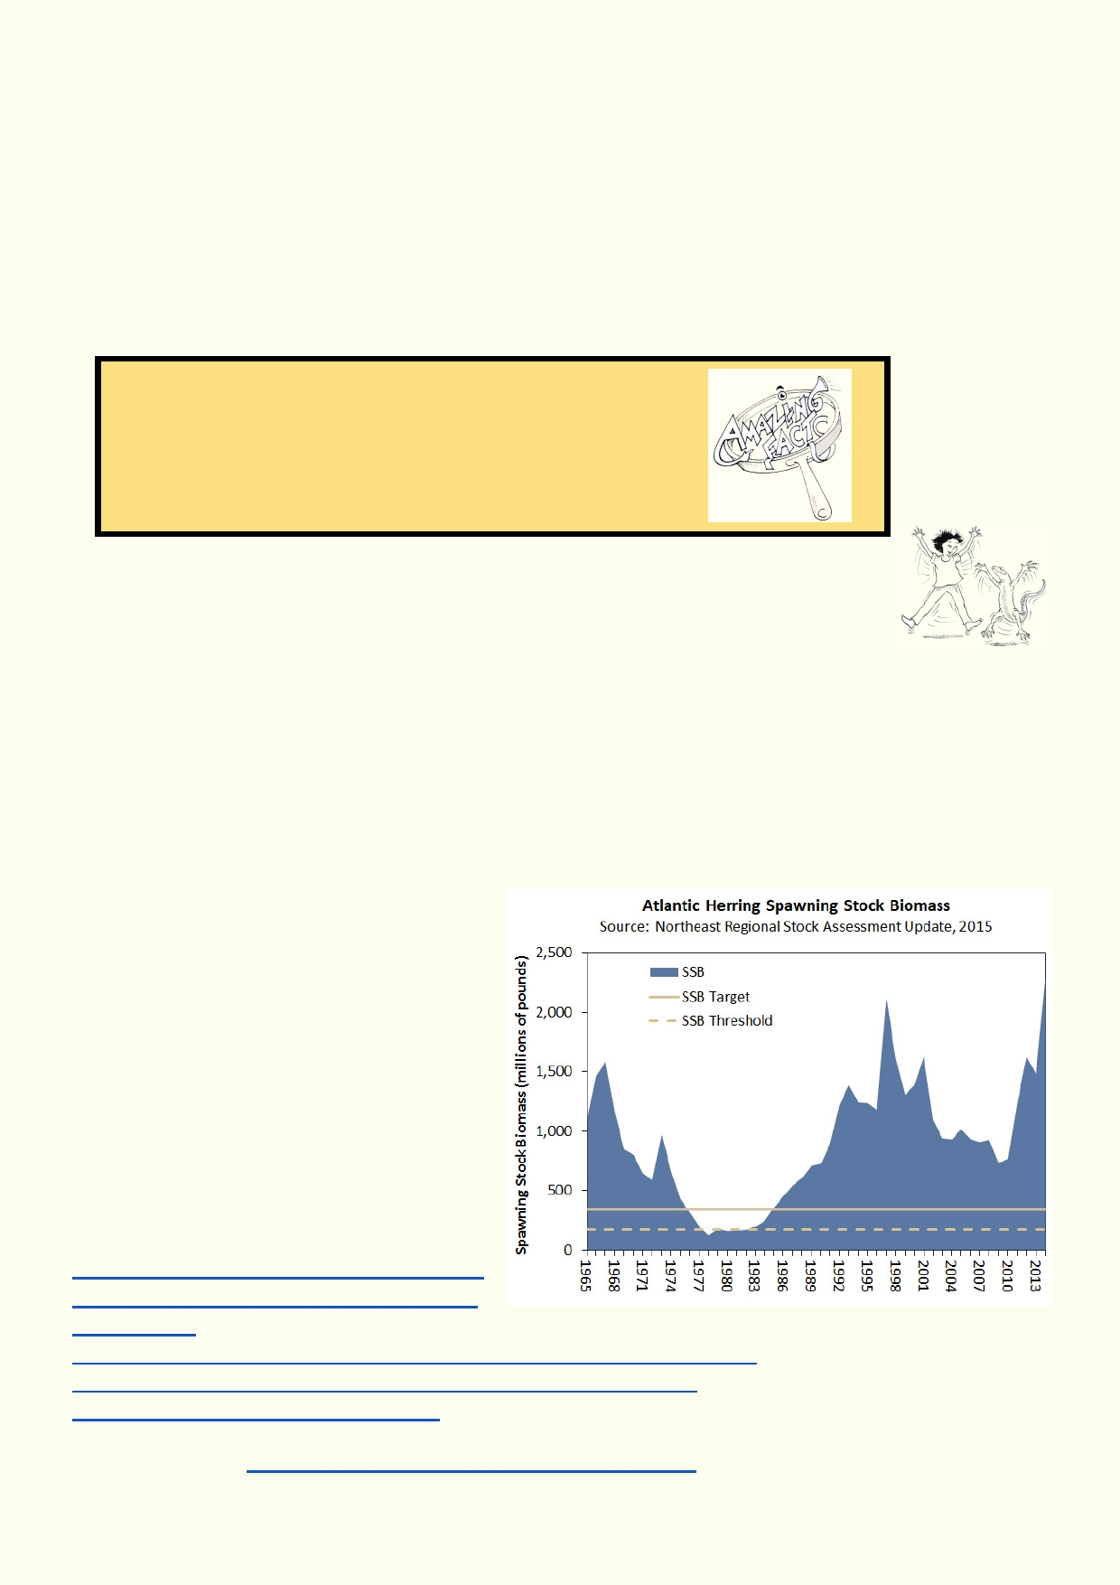Lesson 4 - Ocean resources

Nobody owns the oceans. This can make it difficult to control how the oceans are used. There
are many international conventions that aim to protect the oceans. Ships crossing between
countries must comply with a wide range of safeguards to make sure the ship and its crew are
safe and the environment is not polluted. It is more difficult to regulate things like ocean fishing
when countries or fishing companies don't want to be regulated. Also, while some fishing
grounds are close to a nation's coastline, others are in open ocean, which is technically open to all. This makes fair and reasonable divisions of resources hard to enforce.

Amazing facts
Herrings keep their mouths open so they can catch small
creatures as they swim. Some of their schools can take up
four square kilometers of ocean.

Activity 1. Fishing - when do we say, "no thank you"?

Where did your latest fish dinner come from? In the past that was an easy
question to answer as it would have only been caught locally. As powered fishing
boats became bigger and their nets larger, more fish can be caught. By using
sonar and even helicopters, fishermen know where to drop their nets. Our increased efficiency in
fishing has greatly contributed to the decline in certain fish populations. Your last fish dinner
could have come from anywhere in the world. It's quite unlikely it was caught just off the coast.

The story of the Atlantic herring

Herring is a culturally iconic fish for many European countries. They have been catching them for
centuries, economies were based on
them, and many countries prepare them
in unique and flavourful ways.

Herring do not start breeding until they are four or five years old. They can live for 20
years. In the 1970s and 80s it was feared
that herring were being fished close to
extinction. Countries were forced to almost
stop fishing herring to allow the fish
populations to recover. By weight, it is one
of the most abundant fish in the sea.

Have a look at these sites about herring: https://www.edf.org/blog/2013/11/14/fish- fight-climate-change-hits-fisheries-north-
east-atlantic
http://www.arkive.org/atlantic-herring/clupea-harengus/video-00.html
http://www.asmfc.org/uploads/file//58f8d115AtlanticHerring.pdf
http://slideplayer.com/slide/9445714/

Source of graph: http://www.asmfc.org/species/atlantic-herring/

30

Describe the fluctuation (ups and downs) of herring stock.

_____________________________________________________________________________

_____________________________________________________________________________

What could have happened if fishing continued as usual throughout the 1980s to 90s?

_____________________________________________________________________________

_____________________________________________________________________________

Use this online powerpoint to find out more about herring. If you lack time, read the last two slides
- slide 24 and 25. http://slideplayer.com/slide/9445714/

What is special about herring spawning?

_____________________________________________________________________________

_____________________________________________________________________________

How did the herring population recover?

_____________________________________________________________________________

_____________________________________________________________________________

How does everyone win when fishing is done sustainably?
https://www.nationalgeographic.org/encyclopedia/sustainable-fishing/

_____________________________________________________________________________

_____________________________________________________________________________

This fish guide shows the herring being fished in one region of the North Atlantic.
http://www.goodfishguide.org/fish/herring-or-sild-175 How is it helpful to have consumer fish
guides like this? What information did you find useful?

_____________________________________________________________________________

_____________________________________________________________________________

_____________________________________________________________________________

_____________________________________________________________________________

Have a look at the World Wildlife Federation's seafood guide which outlines fish that are
commonly eaten in Hong Kong. You can find this on the following website:
http://www.wwf.org.hk/en/whatwedo/oceans/supporting_sustainable_seafood/

31

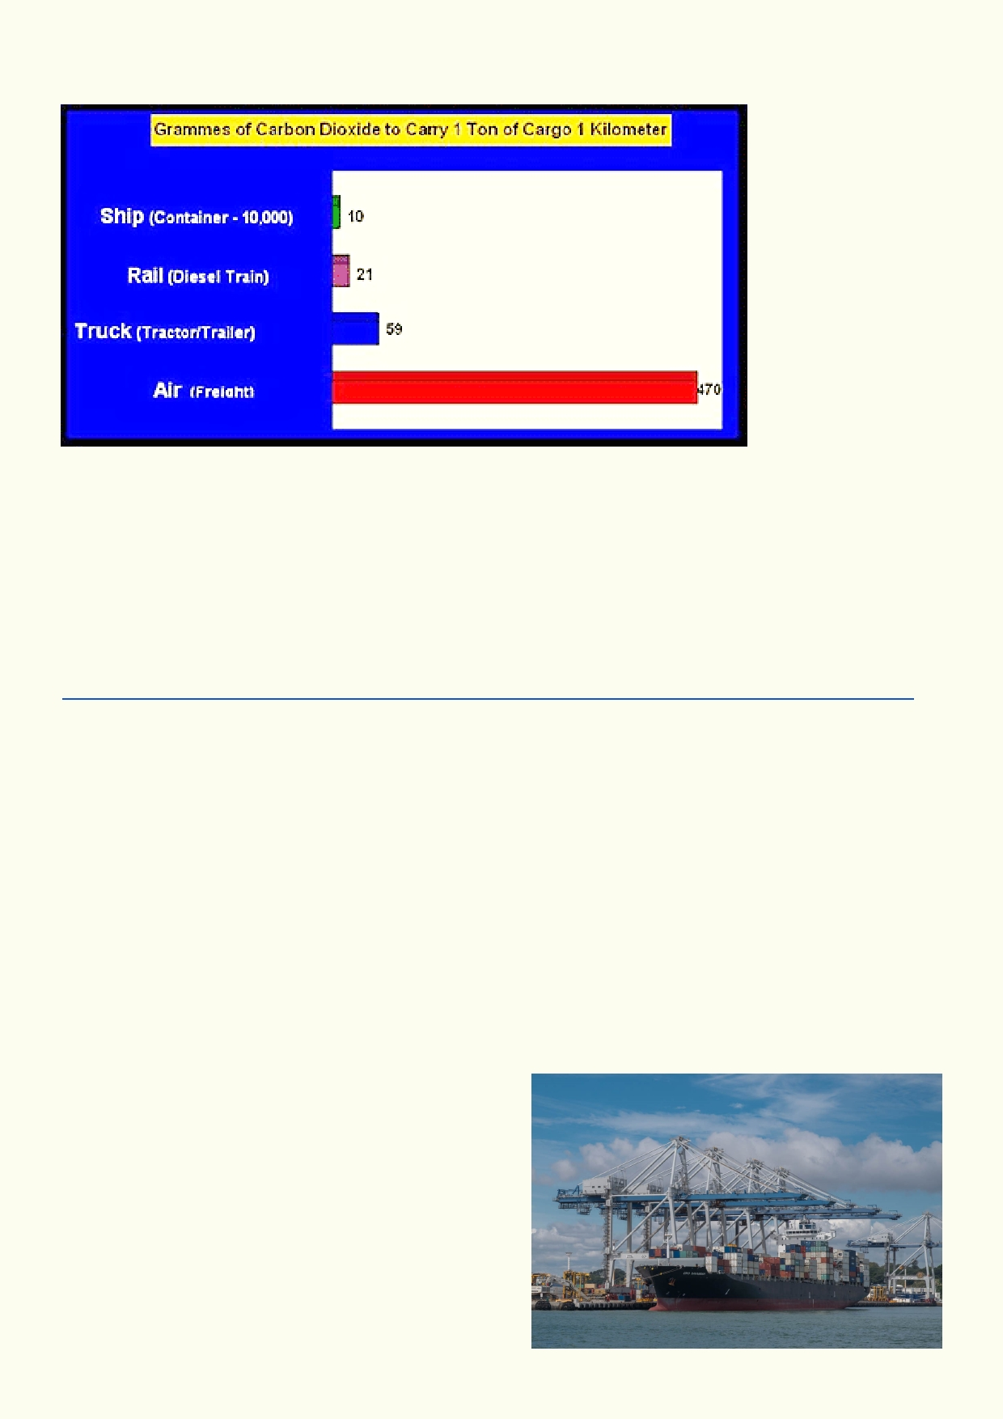Activity 2. Accidents at sea

Source: Network for
Transport and the Environment

Using the graph above, explain why shipping is more fuel-efficient than other forms of transport.

____________________________________________________________________________

____________________________________________________________________________

What kinds of pollution from ships can affect the oceans?
www.ausmepa.org.au/ships-and-the-marine-environment/marine-environment-what-if/types-of-pollution/

____________________________________________________________________________

____________________________________________________________________________

When accidents happen at sea, the consequences can be severe. Use a search engine to look
up shipping accidents. Use the search words "shipping disaster". Pick one shipping disaster and
explain why it happened and what the consequences were.

____________________________________________________________________________

____________________________________________________________________________

How might the disaster have affected the environment?

________________________________________

________________________________________

________________________________________

________________________________________

________________________________________

32

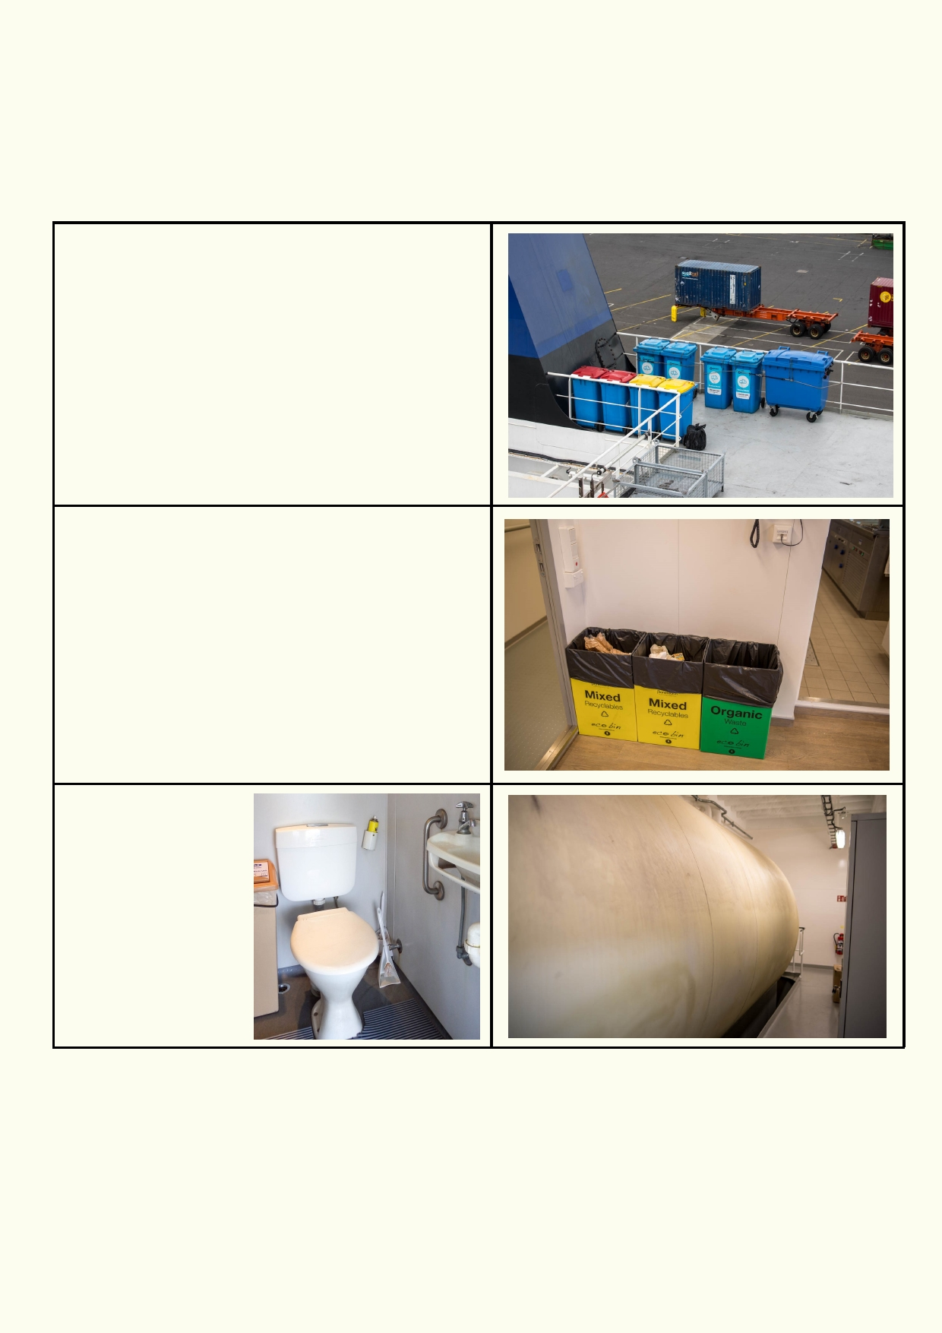What should be done and could be done.
Ships are required to manage and log all their waste and its disposal. Inspectors can look at the
logs. Many of the waste materials must be disposed of when the ship is in port. Some waste
materials can be treated and disposed of at sea. It is easy to police big ships, but smaller vessels
and private boats can get away when no one's looking.

Larger ships are supposed to have a waste
system so that rubbish is safely stored and
removed once in port. These bins are securely
tied to the metal railing.

On this ship waste is also recycled.

Untreated toilet waste
must not be released
into the sea. It must
stored onboard in
large tanks like the
one below.

33

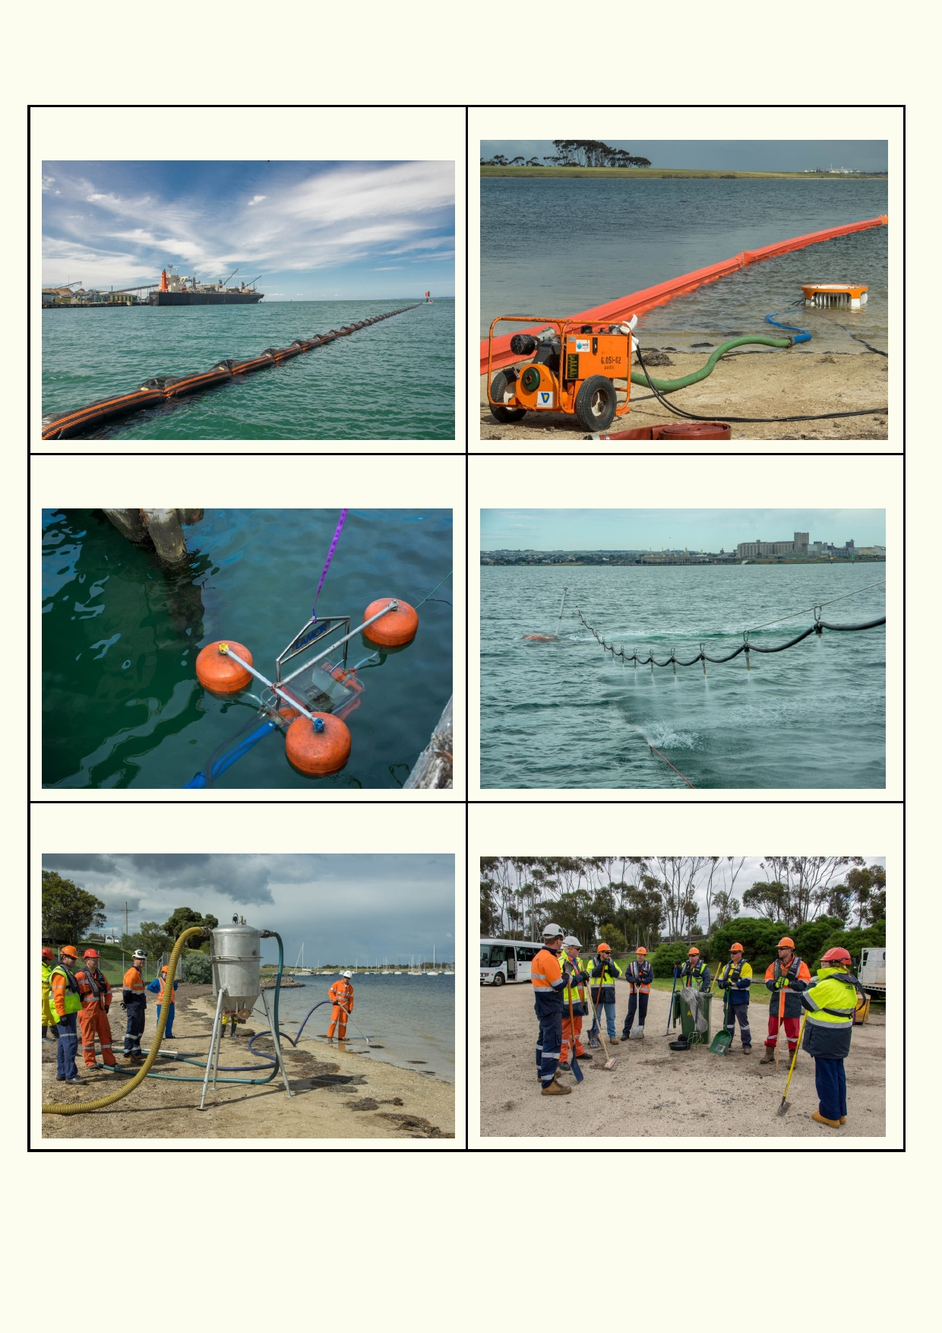Cleaning up

Long boom being placed around a floating oil The machine in the water filters out floating oil.
slick stops it from spreading.

Another type of machine that can remove floating Spraying chemicals to break oil slicks should only
oil. be used as a last resort.

This is a beach vacuum cleaner for removing oil. Getting ready to use shovels and rakes to remove
oil from the sand.

34

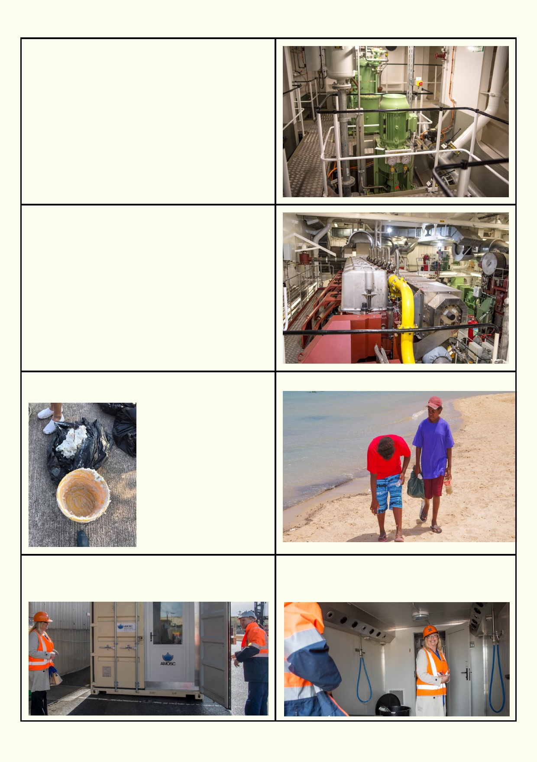A ship's engines will produce waste water mixed
with waste oil. This sinks to the bottom of the
engine called the bilge. In this photo the bilge
pump, pumps the oil contaminated water into a
storage tank. In port this bilge liquid will be
pumped into a waiting tanker (truck).

There are heavy penalties for any ship caught releasing bilge water at sea.

This is one of a new type of ship. It can run on
both oil and gas (methane). The yellow pipe is for
the gas. Gas produces a lot less air pollution.

Palm oil being cleaned up on a Hong Kong Students picking up litter along the coast.
harbour.

This container can be driven and then flown Inside the standard sized container is
anywhere in Australia to help rescue oil affected everything needed to clean and rehabilitate
wildlife. wildlife the animals rescued from oil spills.

35

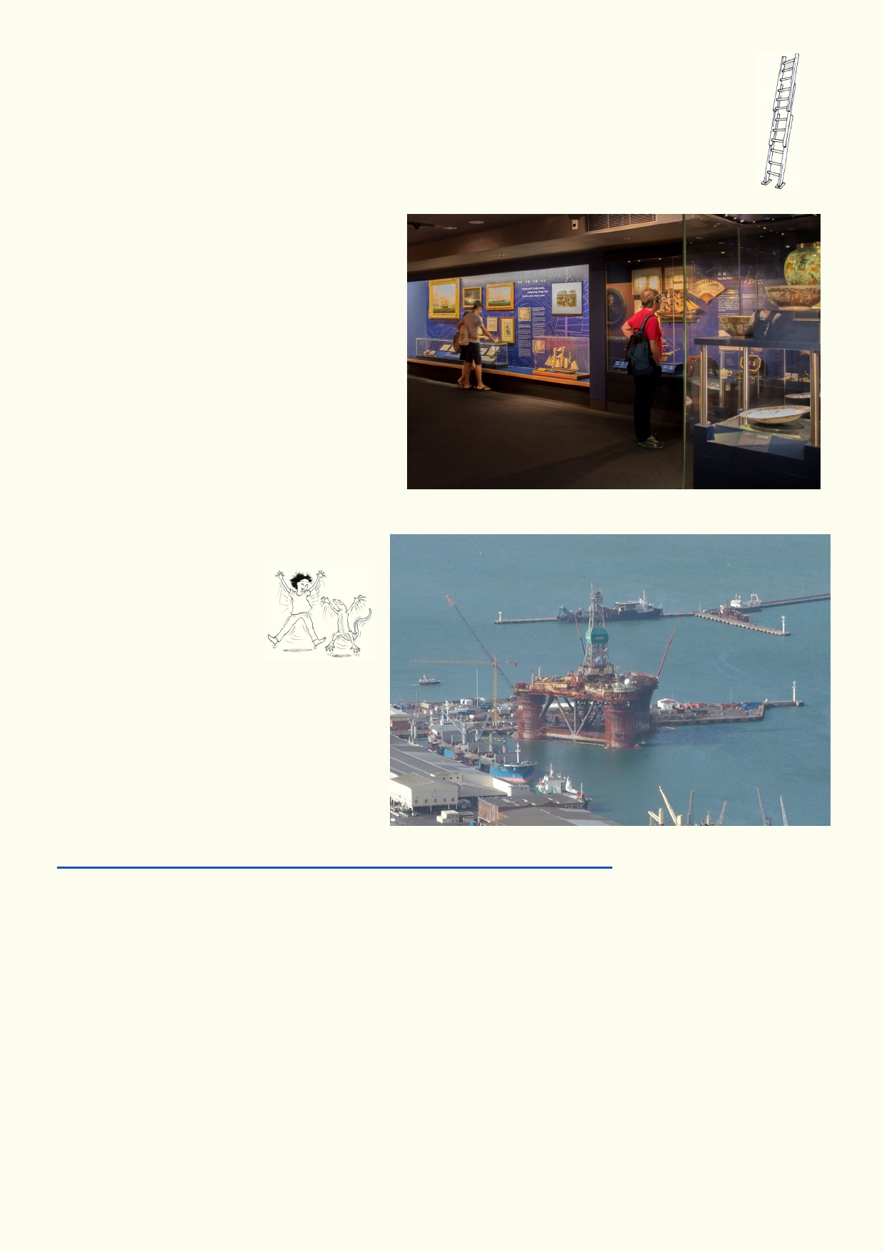Extension
Visit the Hong Kong Maritime museum at the Central Ferry Piers. To prepare for your
visit, identify which topics you would like to explore. They might include:

1.
2.

3. 4.

5. 6.
7.

8. 9.
The history of shipping around Hong Kong.
How shipping of goods around the world provided the need to establish Hong
Kong.
The current role of shipping today.
How shipping and its cargo is managed.
How ports are operated.
Water transport around Hong Kong.
How Ports and Shipping look after the
environment.
Training of ship crews
Water recreation around Hong Kong

Activity 3. Oil drilling - big risks when things go wrong

Does Deep Water
Horizon mean anything
to you?

________________________________

Where did it occur?

________________________________

Watch the video from CNN. Read some of the text if you have time.
http://edition.cnn.com/2015/04/14/us/gulf-oil-spill-unknowns/index.html

What are some of the impacts of this oil disaster?

_____________________________________________________________________________

_____________________________________________________________________________

How much oil escaped (measured in barrels; 1 barrel = 159 L) ___________________________

How much has been spent up until 2015 cleaning up the oil?_____________________________

Do a search using the search words - world biggest oil spill. Find out which oil spills are the fault of people and which have been caused by natural events.

36

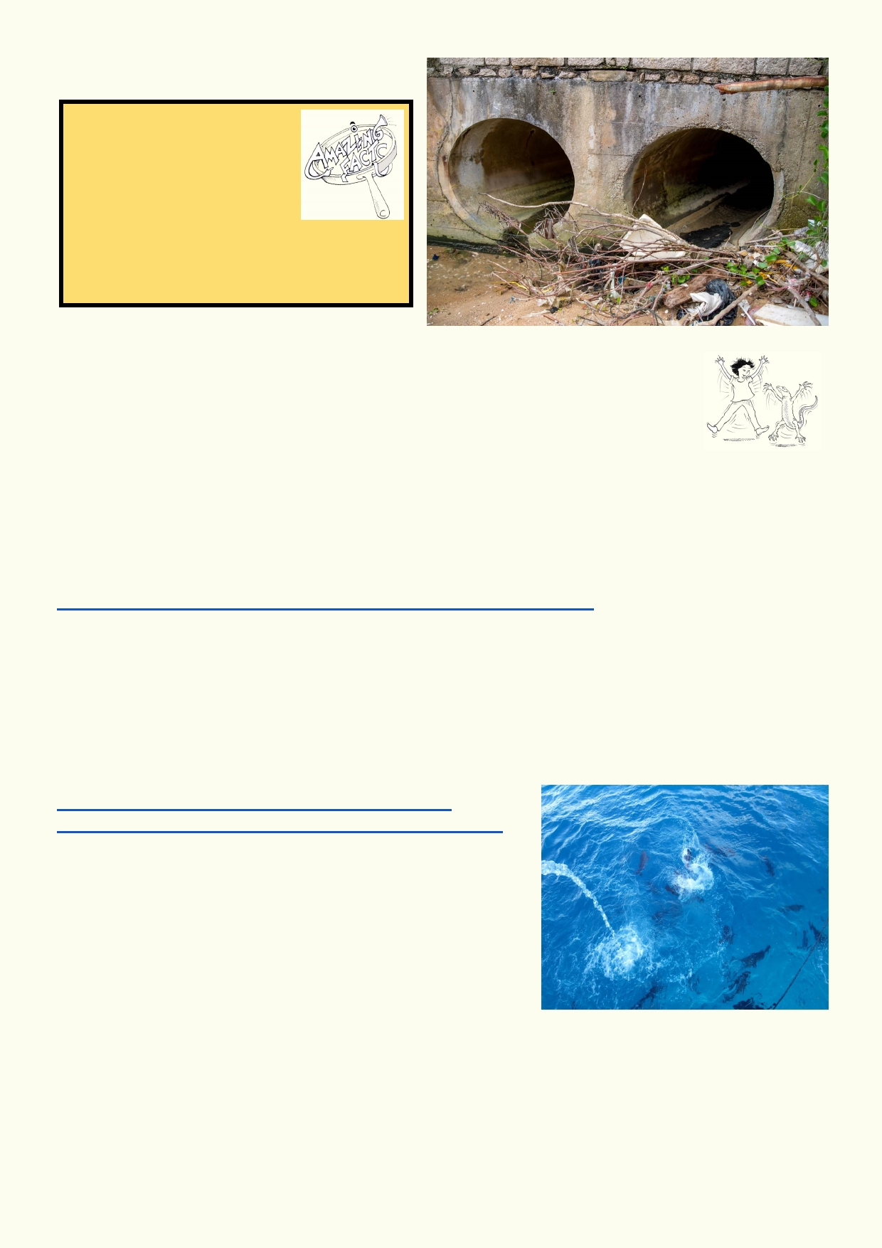Lesson 5 - Ocean Pollution

Just the facts
Litter does not disappear. It
lasts a long time..
Aluminium cans: at least 80
years.
Plastic bottles: 450 years.
Fine fishing net: at least 600
years (much longer for heavier nets). Glass bottles: 1 million years.

Activity 1. Land based pollution - was it
you?

In this photo, stormwater drains release their water on a Hong Kong beach. The
plastics and other litter are easy to see. Other pollution such as oil, grease,
chemicals, dangerous bacteria, etc. can't be seen. Most of the ocean's pollution
comes from the land. It's a good approximation that the amount of litter on the beach is equal to
the amount of other harmful pollution in the water.

Marine debris is the term often used for the litter that reaches the sea.

Look at this webpage about marine debris.
http://nellhamilton.com/10-astonishing-alarming-facts-marine-debris/

Choose the most shocking fact on the website.

My shocking fact is _____________________________________________________________

_____________________________________________________________________________

Watch these two videos about plastics in the ocean:
https://www.youtube.com/watch?v=cwTDvqaqPlM
https://www.youtube.com/watch?v=FjT8GG0ETQg&t=1s

What solutions can you come up with that might help to
reduce the impact that plastics are having on the sea?

____________________________________________

_____________________________________________________________________________

Why do you think we are so dependent on plastic?

_____________________________________________________________________________

37

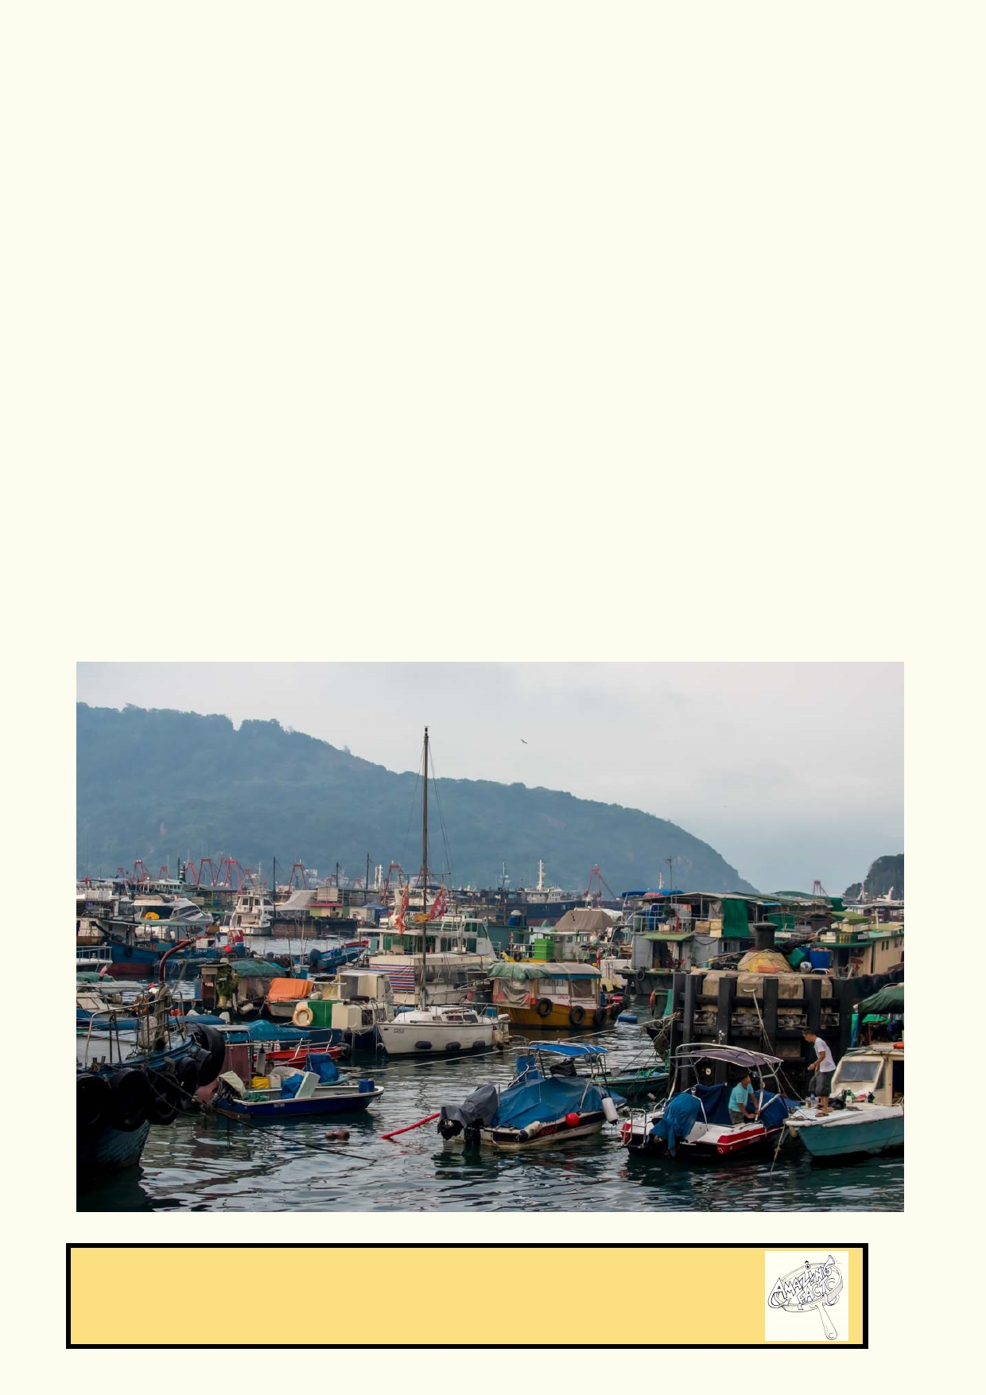What would you do if you just landed a job to regulate boat owners including fishermen in the Hong
Kong Region? You have to write regulations about what boat owners must do with their waste and
what they need to carry on their boat to avoid waste being emptied or lost at sea.

Regulation 1. Rubbish ____________________________________________________________

______________________________________________________________________________

Regulation 2. Toilet waste _________________________________________________________

______________________________________________________________________________

Regulation 3. Fishing lines and fishing nets ___________________________________________

______________________________________________________________________________

Regulation 4. Securing items on board of boats ________________________________________

______________________________________________________________________________

Regulation 5. Oil, petrol and other chemicals __________________________________________

______________________________________________________________________________

Amazing facts
According to a study by the World Economic Forum, eight million metric
tonnes of plastic waste enter the marine environment each year.

38

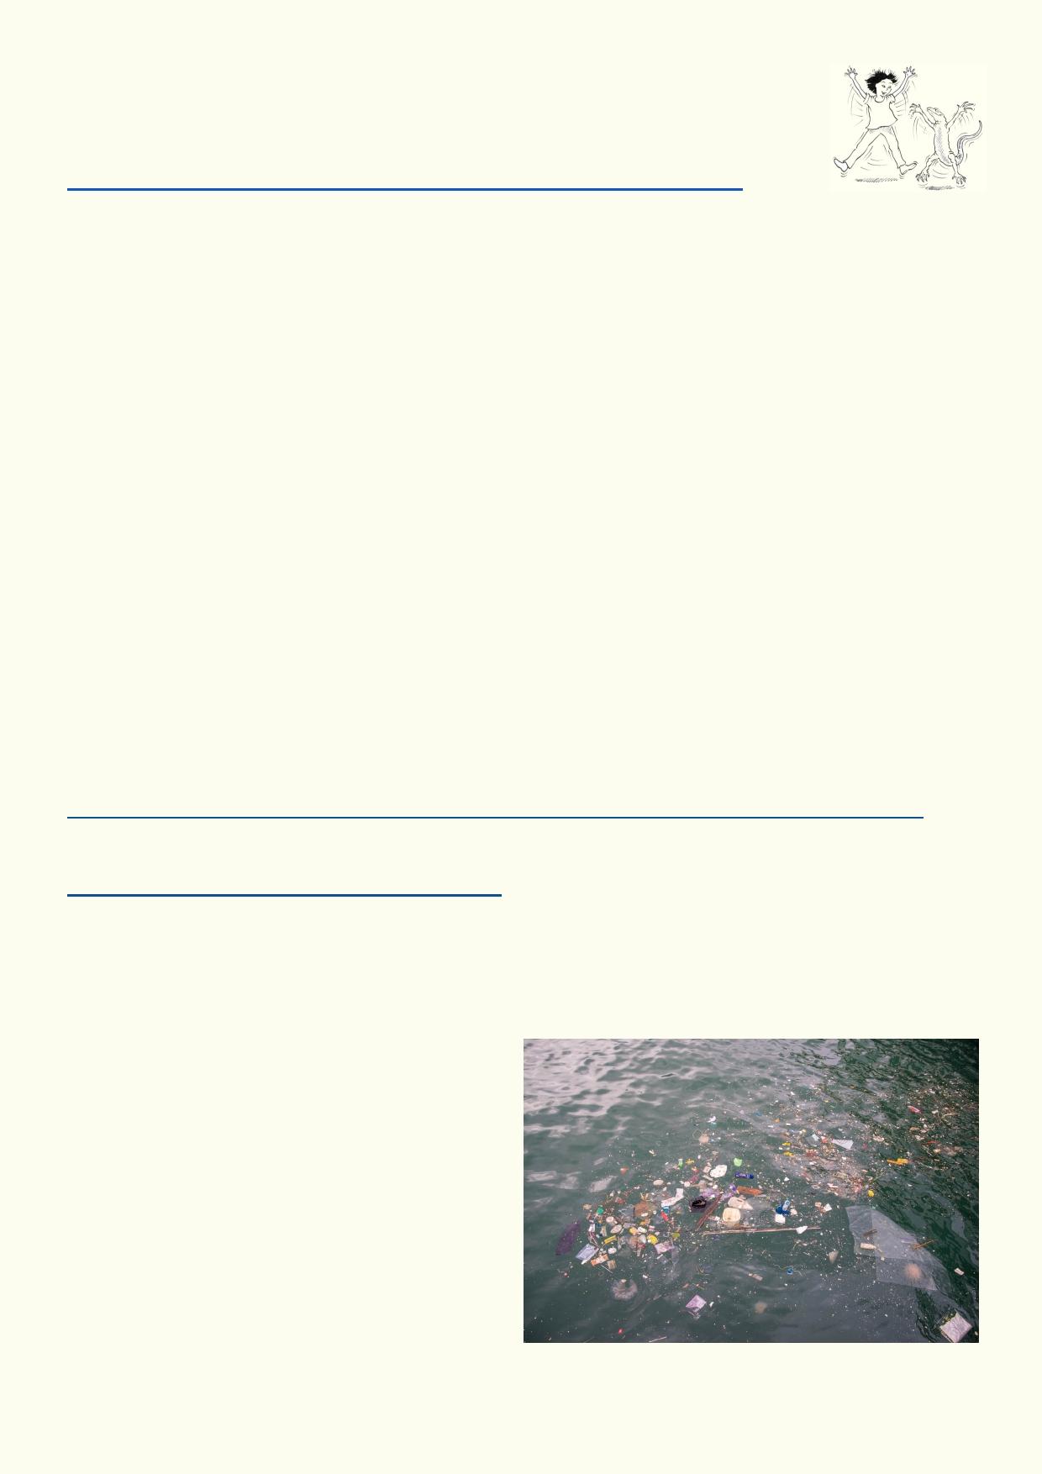Activity 2. Microplastics - small but deadly: it's double trouble

UN deeply concerned!
Look at this website and play the video
http://www.un.org/apps/news/story.asp?NewsID=56638#.WZTe_1UjEuX

Why is the United Nations deeply concerned about plastics in the ocean?

_____________________________________________________________________________

_____________________________________________________________________________

_____________________________________________________________________________

Microplastic has two main sources:

1. Plastic litter in the sea such as plastic bottles, break up into smaller and smaller pieces.
Eventually the pieces are microscopic.
2. Every time we wash synthetic clothing, fibres are removed. These miniscule threads can
pass through the sewage system and out to sea.

Some makeups and toothpastes use plastic microbeads. Microbeads are defined as plastic beads
Typically between 0.5 to 500 micrometres in diameter. They get washed down the drain, pass
right through sewage treatment plants and then enter the waterways and the ocean. Once in the
water they absorb toxins and are eaten by organisms. They make their way up the food chain and eventually, when we eat fish, we are ingesting large concentrations of these toxins.

These are some examples of the effects of public pressure on companies that were using
microplastics in their products:
www.greenpeace.org/international/en/news/Blogs/makingwaves/microbeads-companies-response/blog/57314/

This is a list of products that contain plastic microbeads:
http://www.beatthemicrobead.org/product-lists/

A double sting in the tail

Many of the smallest marine animals filter the water for food. These animals will quickly build up
the plastic in their bodies. As these get eaten by larger animals, they will collect all the plastic from
the animals they have consumed.

This is what makes the microplastic so
dangerous. Many chemicals including pesticides
and other toxic substances are absorbed by the
plastic. This is a new pathway for toxic
chemicals to be build up as it is passed down
the food chain.

39

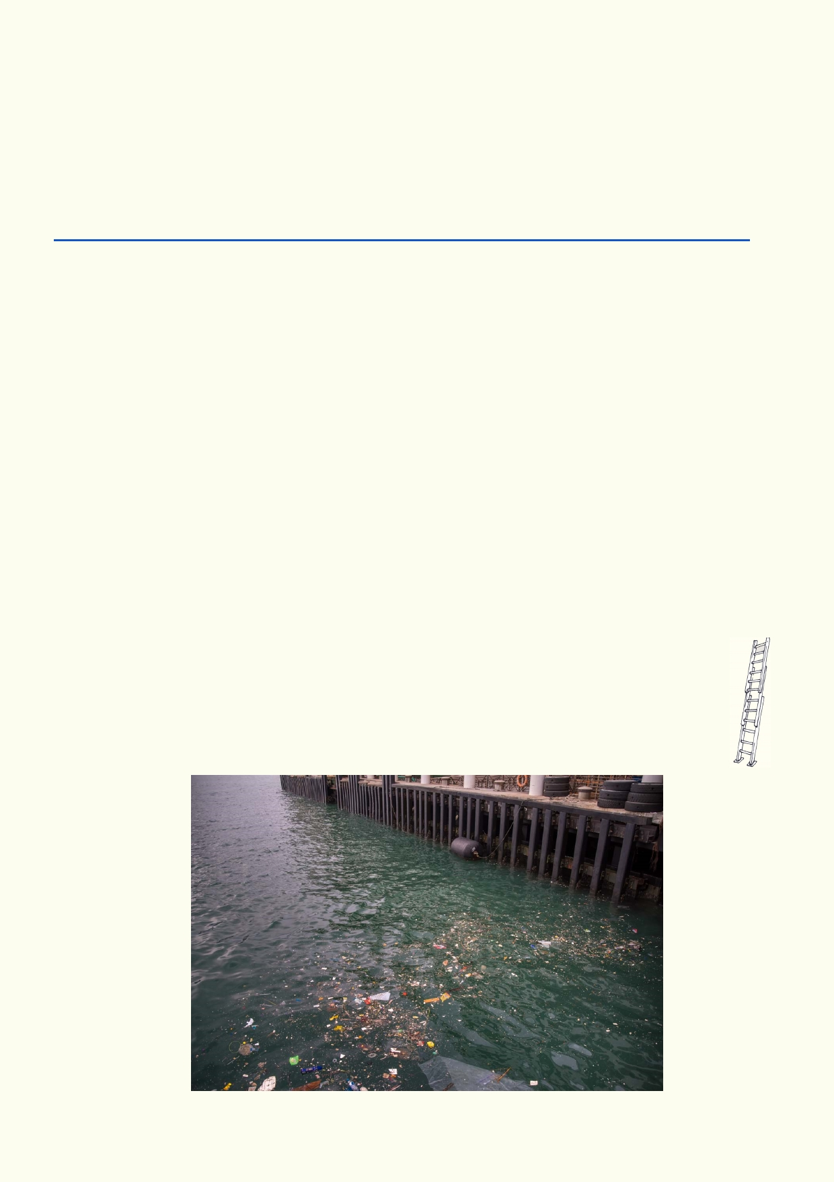News report
In small groups, create a short news report about microplastics.

1.
2.
3.
4.
5.
6.
It can be for a newspaper, magazine, online, TV or radio.
Use the web link below to source your information.
Come up with a gripping heading.
Explain the source of microplastics.
Explain how it affects the food chain.
Make a statement about what can be done.

http://www.tangaroablue.org/resources/fact-sheets.html?download=61:what-are-microplastics

My reusable water bottle

Write three reasons for using your own reusable water bottle.

1. ______________________________________________________________________

2.______________________________________________________________________

3.______________________________________________________________________

What reasons might you have for buying water in a disposable bottle?

_______________________________________________________________________

_______________________________________________________________________

_______________________________________________________________________

Extension:
1. Research a few alternatives to plastic that are being developed or used at this time.
2. Research some experimental cleanup techniques that are being developed to
address the problem of plastic waste in the oceans.

40

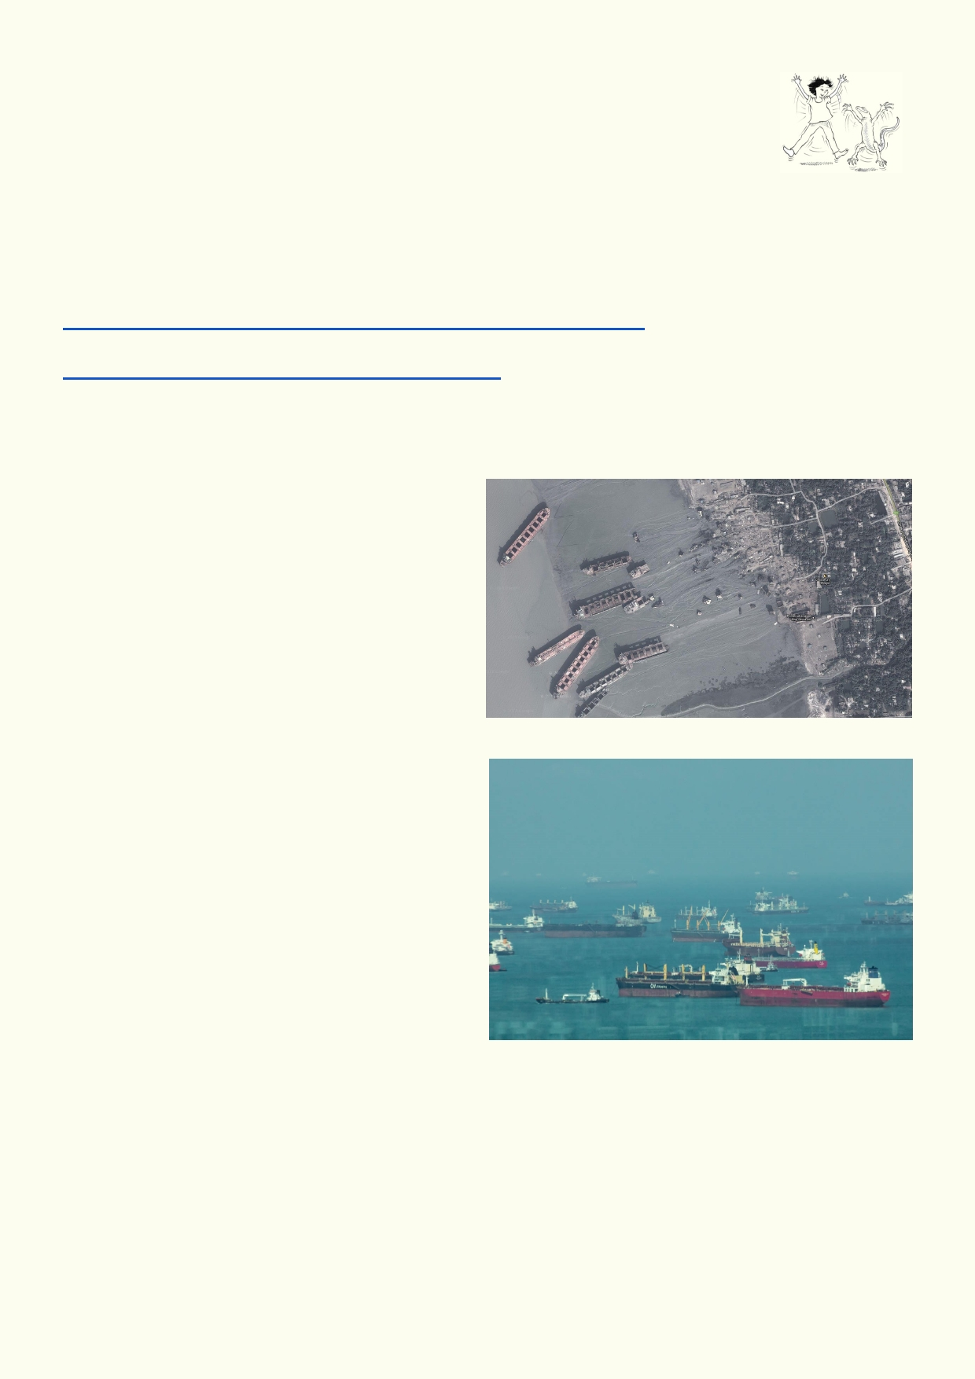Activity 3. Ship breaking in Bangladesh- deadliest jobs for people and the
sea

When ships get to the end of their life, they need to be recycled. It is difficult to
break up a ship because ships are designed to be battered by the sea. Before a ship can be
broken up it needs to have the polluting materials removed, so it doesn't contaminate the sea.
Many parts of the ship hold oil, asbestos, heavy metals and other dangerous chemicals.

Read the National Geographic article and watch as much of the video as you can.
http://ngm.nationalgeographic.com/2014/05/shipbreakers/gwin-text
Watch the first 13 minutes of this video if you have time:
https://www.youtube.com/watch?v=qhIaEEW63Sc

Use Google Maps. Change the map to Earth. Use the information about places in Bangladesh
where ships are broken up to do a search. Then find by scrolling along the coast of Google maps
where ships are being broken up.

How many ships did you find?

____________________________

The sea around Singapore is some of the
busiest shipping lanes in the world. Many of the ships that have no cargo to carry are anchored
off the Singapore coast. These are often older
ships and may be sold for scrap in the next few
years. Use Google Maps to take a look at the
sea around Singapore. Take exactly one minute to see how many ships you can find anchored at
sea.

__________________________________

Ships anchored off the Singapore coast.

41

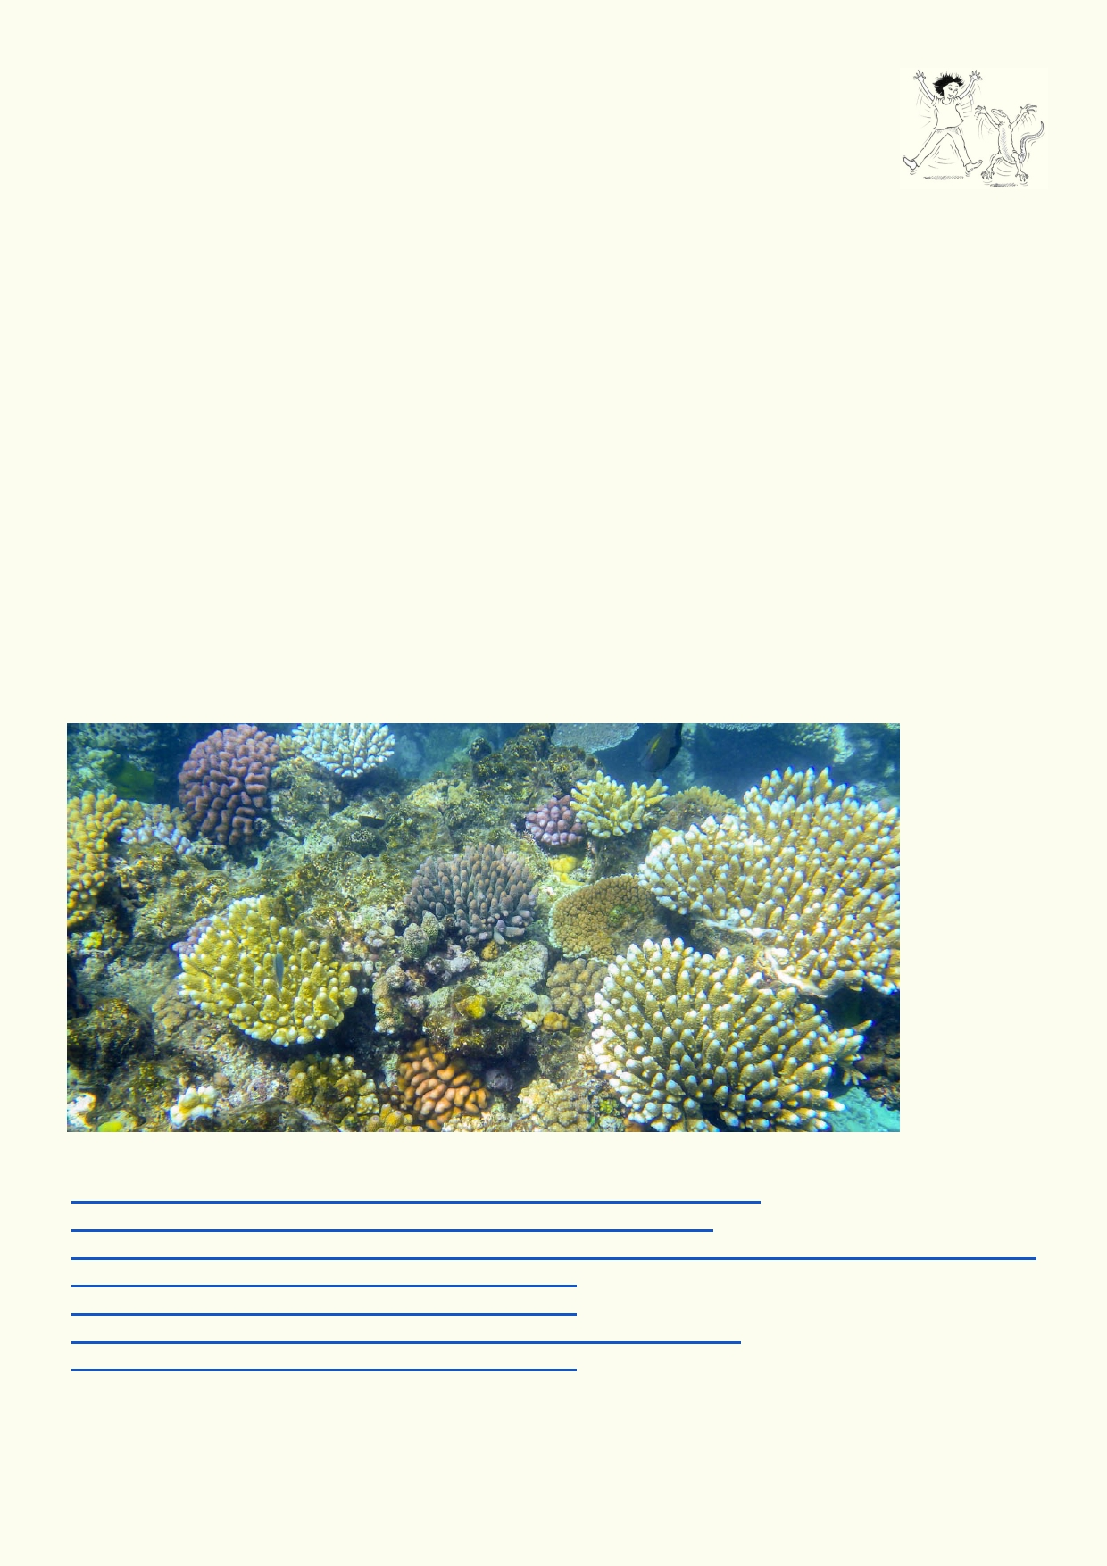Activity 4. Acidification - destroying the ocean's chemistry

It seems like a good thing. The oceans absorb a lot of the extra CO2 we are
producing. If it didn't, we might have increased the world's temperature by as much
as 3 degrees. But there is a catch to this good news. As the seas absorb more
CO2, its chemistry will go from being slightly basic to slightly acidic.

A slightly acidic sea would be much, much weaker than lemon juice, but the impact on the sea
would be an ecological catastrophe. Thousands of species of animals and some plants that use
calcium in the sea, wouldn't be able to perform the necessary chemical reactions.
• All corals would die because they can't make their coral skeleton
• Half the species of shellfish would die because they can't make their shells
• One of the most abundant microscopic plankton called foraminifera would also disappear
because their shells would dissolve.

Draw a cartoon of how coral and shellfish will be affected by ocean acidification.
• It can look realistic.
• It can be more like a newspaper cartoon with the sealife having something to say.
• The cartoon can be before and after.
• It could have chemicals in the water doing chemical reactions.
• It could imagine how weakened shells could make some of the creatures more vulnerable to
predators

These
websites
might help:
https://theotherco2problem.wordpress.com/what-happens-chemically/
http://climateinterpreter.org/content/chemistry-ocean-acidification
https://emmachutchinson.com/2015/02/12/ocean-acidification-a-hidden-impact-of-climate-change/
https://au.pinterest.com/pin/572097958895744804/
https://au.pinterest.com/pin/300896818824248784/
https://360exposure.wordpress.com/2016/04/14/ocean-acidification/
https://au.pinterest.com/pin/192317846562575135/

42

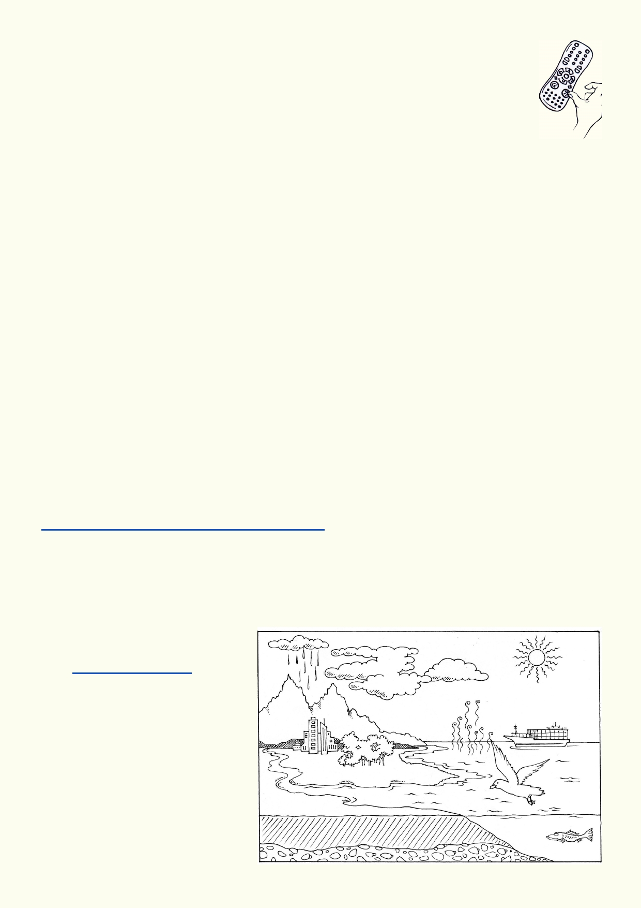Activity 5. Looking forward

What will you do to help our oceans?

Purchasing sustainable fish
Find the most appropriate App for Hong Kong to help you choose the most sustainable fish at the market.

Social media project
Get together with some classmates, friends or family.
• Decide what social media platform you would like to use.
• Get permission from your teachers and parents. Explain to them your procedures for staying
safe on the web (includes no link to names and addresses).
• Decide what issues you want to explore.
• Design your campaign.
• Plan how you will keep adding content.
• Link up with like minded groups.
• Provide feedback provided it complies with your web safety procedures.

Follow an ocean experience of interest
• Decide what kind of scientific research, sea recreation or location you are interested in eg a
scientific vessel, Antarctica surfing.
• Identify what digital platform will most likely have what you are interested in.
• Find a link to your area of interest.
• Follow it for at least the next couple of weeks.
• If you can ,communicate with those conducting the research to find out more. Find out what
qualifications they have.
• Find out what it is like to do research on the ocean.

Music about the seas and oceans
https://www.youtube.com/watch?v=q3EE83q6tzw
• Put together a music list of no more than ten tunes that includes the sea and oceans with
web links.
• Share your list with friends and family.
• With friends, compose your own music to share.

Woods Hole Oceanographic
institute, Massachusetts
• Explore the institute's website
http://www.whoi.edu/
• Find out what people are doing
and the research that is being
conducted.
• Identify and describe the three
coolest things you would like to
do.

43

Acknowledgements
The Ocean Recovery Alliance thanks The Hong Kong Jockey Club Charities Trust for their
generous funding support on this education programme.

Project manager: Doug Woodring
Writer, photography and design : Bob Winters
Curriculum manager and editor : Charlotte Charny Nielsen
Editor and school outreach: Alex Hale
Additional thanks: Jasmine Nunns and Sandra Merazzi

© 2017 Ocean Recovery Alliance and Authors.
Outside the school environment, the text, photos and artwork may not be reproduced, except
where permitted by the relevant Copyright Act. These materials may not be modified and
distributed by print or electronic means without written permission. Teachers may modify these
education materials for the use of their students and school provided it is not distributed any
further. Those wishing to reproduce part of this publication must submit their application to the
Ocean Recovery Alliance: www.oceanrecov.org/contact-us.html

44

